

Assessment 1 – Reading Task Template
PART 1: Upload your photo of your A3 in-class notes here:
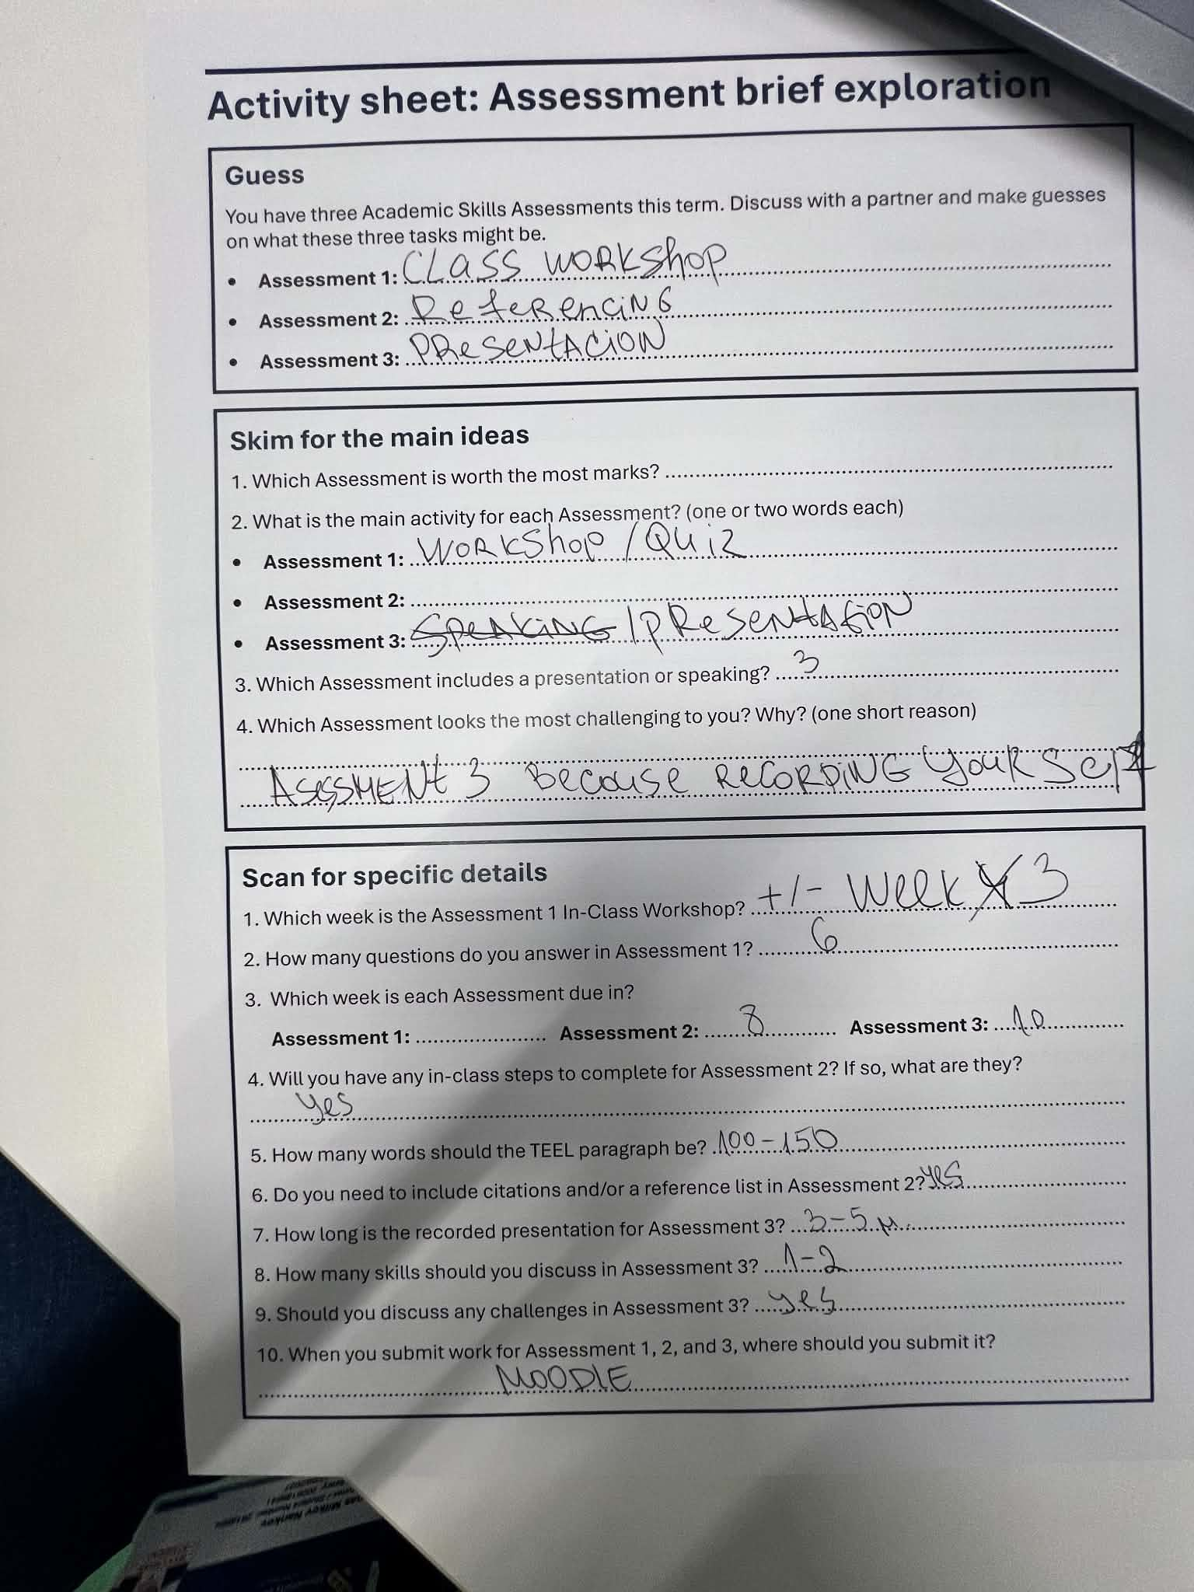

PART 2:
- Answer every question below in 1-3 full sentences.
- Use your own words. Do not use generative AI to answer these questions.
- Include a specific detail from the text when asked.
REMINDER
- The main idea is the overall message of the whole text.
- A key point helps to explain the main idea.
- A specific detail or example from the text shows that the key point is true.

- What is the main idea of the whole text?

Social media platforms like TikTok and Instagram help small local businesses reach huge numbers of pll far beyond their local area, turning online attention into real customers.

- What is one key point that supports the main idea, and which specific example from the text shows this?
One key point is that customers will travel very long distances just because they saw a business on social media. For example, customers travel three hours to reach Honywood Sandwich shop just to try its chiken burger after seeing it online.

- What is a different key point that supports the main idea, and which specific example from the text shows this?
Another key point is that social media helps businesses reach international coustomers. – Lindy Loo’s Boutique.

- Which part of the text do you think is most important, and why?
I hink the most important part is that ‘’people buy from people’’

Reflection:
- What did you find difficult in this task (including in-class components), and why was it difficult?
The all points are tricky at first. It took time to see whith details were most important.

- What helped you with this difficulty, and how did it help you?
To read carefully and scan informacion. That’s I know from this task. And by the professor at Academic Skills Class.

