

Assessment 1 – Reading Task Template
PART 1: Upload your photo of your A3 in-class notes here:
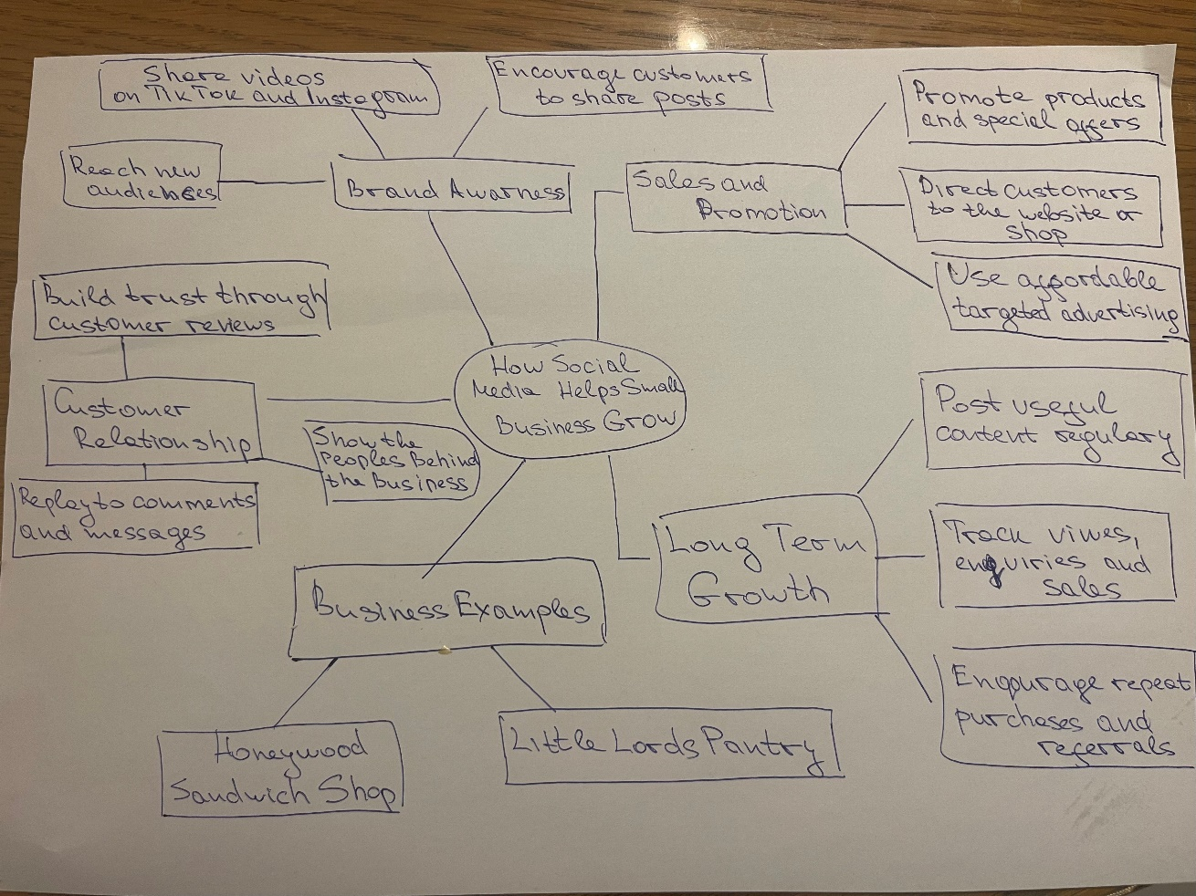

PART 2:
- Answer every question below in 1-3 full sentences.
- Use your own words. Do not use generative AI to answer these questions.
- Include a specific detail from the text when asked.
REMINDER
- The main idea is the overall message of the whole text.
- A key point helps to explain the main idea.
- A specific detail or example from the text shows that the key point is true.

- What is the main idea of the whole text?

- What is one key point that supports the main idea, and which specific example from the text shows this?

- What is a different key point that supports the main idea, and which specific example from the text shows this?

- Which part of the text do you think is most important, and why?

Reflection:
- What did you find difficult in this task (including in-class components), and why was it difficult?

- What helped you with this difficulty, and how did it help you?

