DS 1 ASSINGMENT

Screenshot/Photo 1
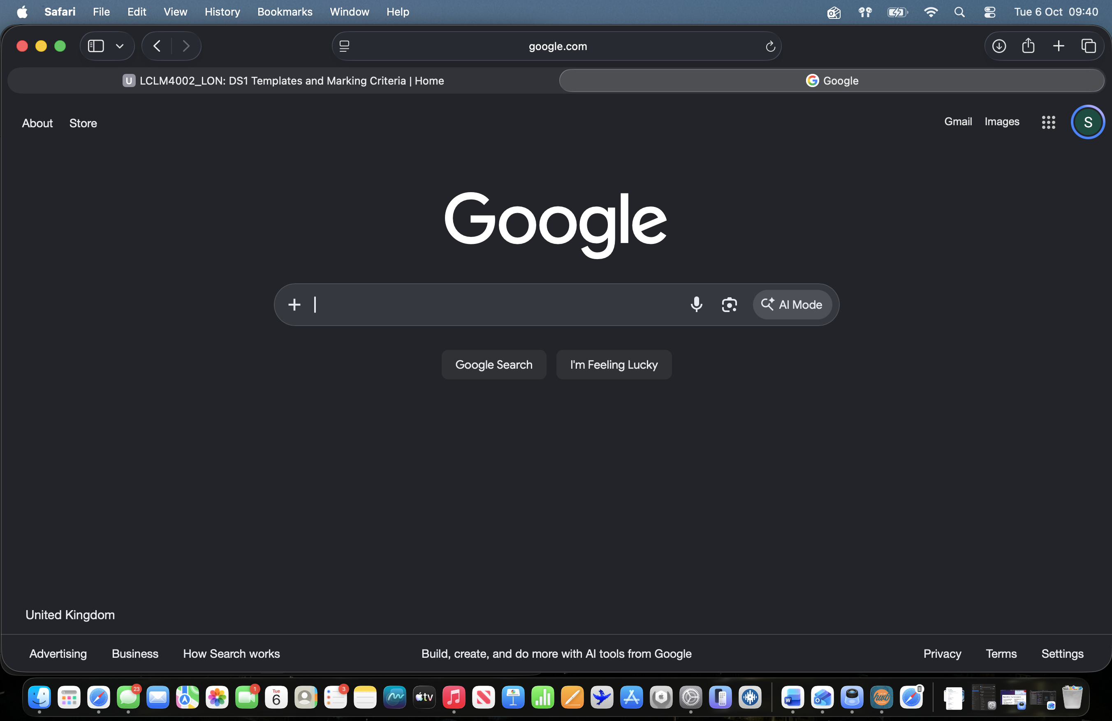
The screenshot I have attached above is safari specifically google as I use this in my day to day life to research things online along with finding out information that may be useful to me. I believe that this is useful to me as information I find can be stored in my memory so that I know for the next time.

Screenshot/Photo 2
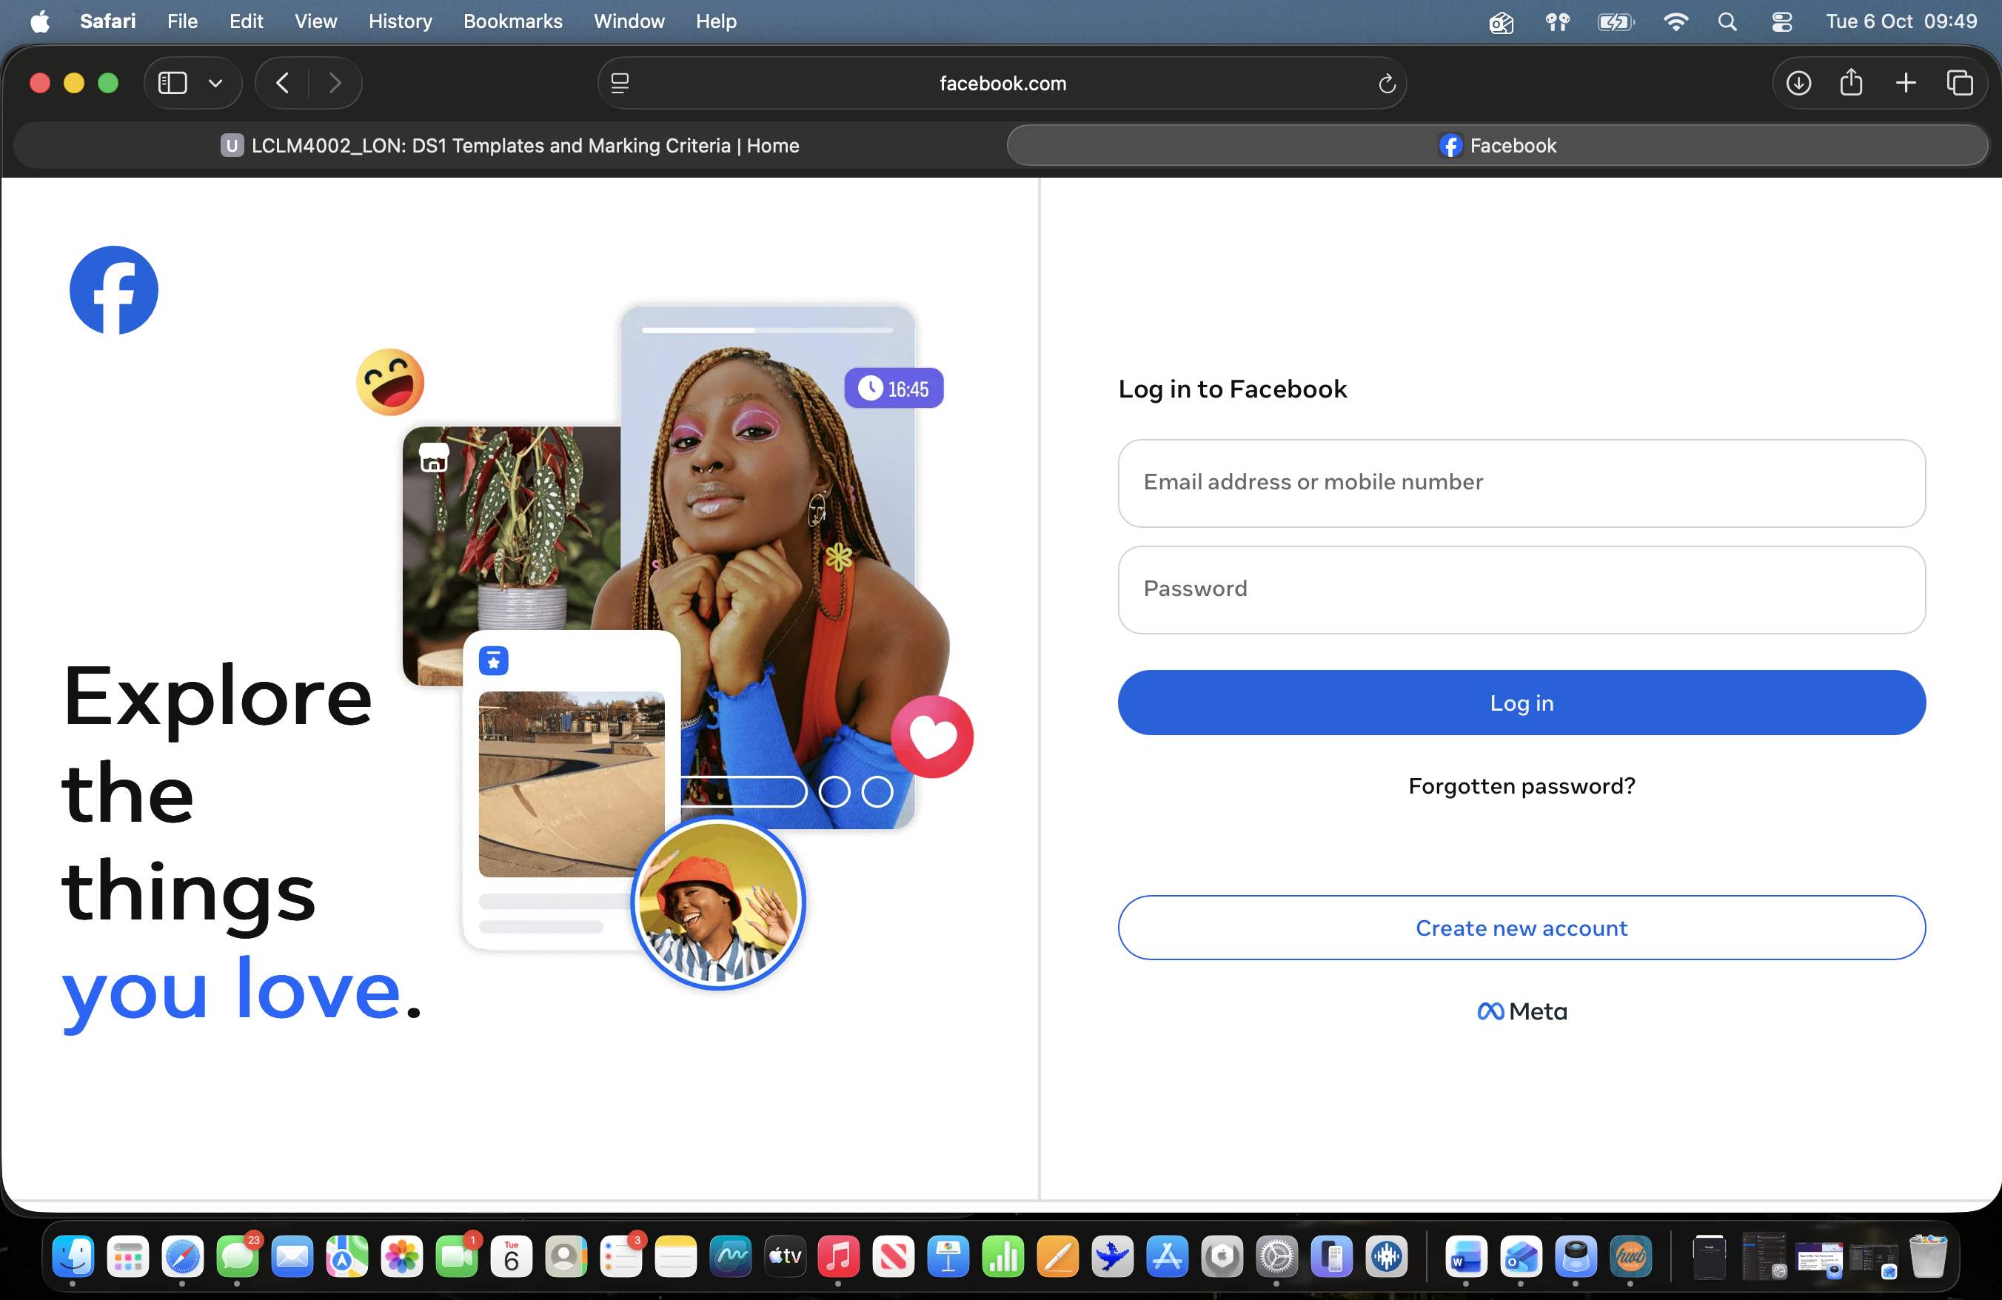
The screenshot I have included of Facebook is a social media platform that I use to communicate with family and friends along with shopping on marketplace to see if they have any items for my household or car shopping as I am planning to drive eventually.

Screenshot/Photo 3
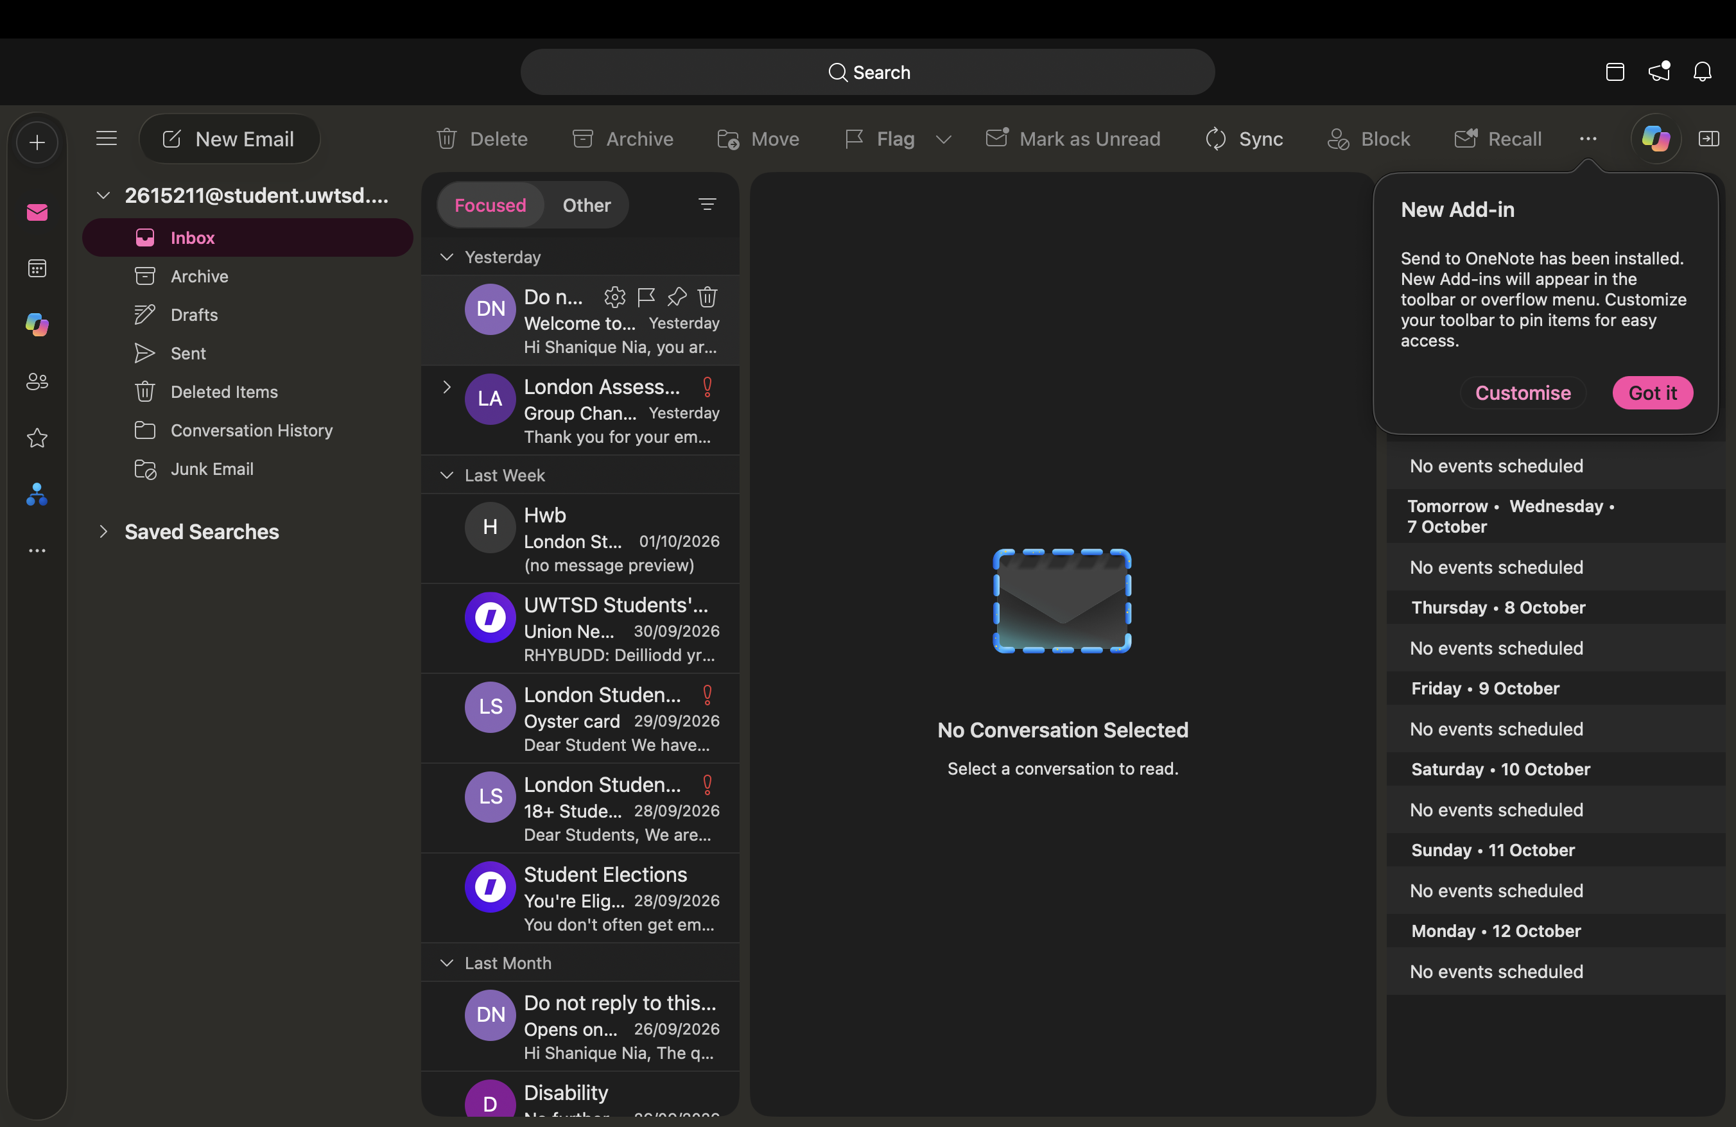
I use outlook daily since starting university to make sure that I am up to date with my lecture days, times and assignment deadlines. I find this is useful to me because it will helps me to prepare for any upcoming things to do and add balance into my daily routine as I will be updated with everything.

Screenshot/Photo 4
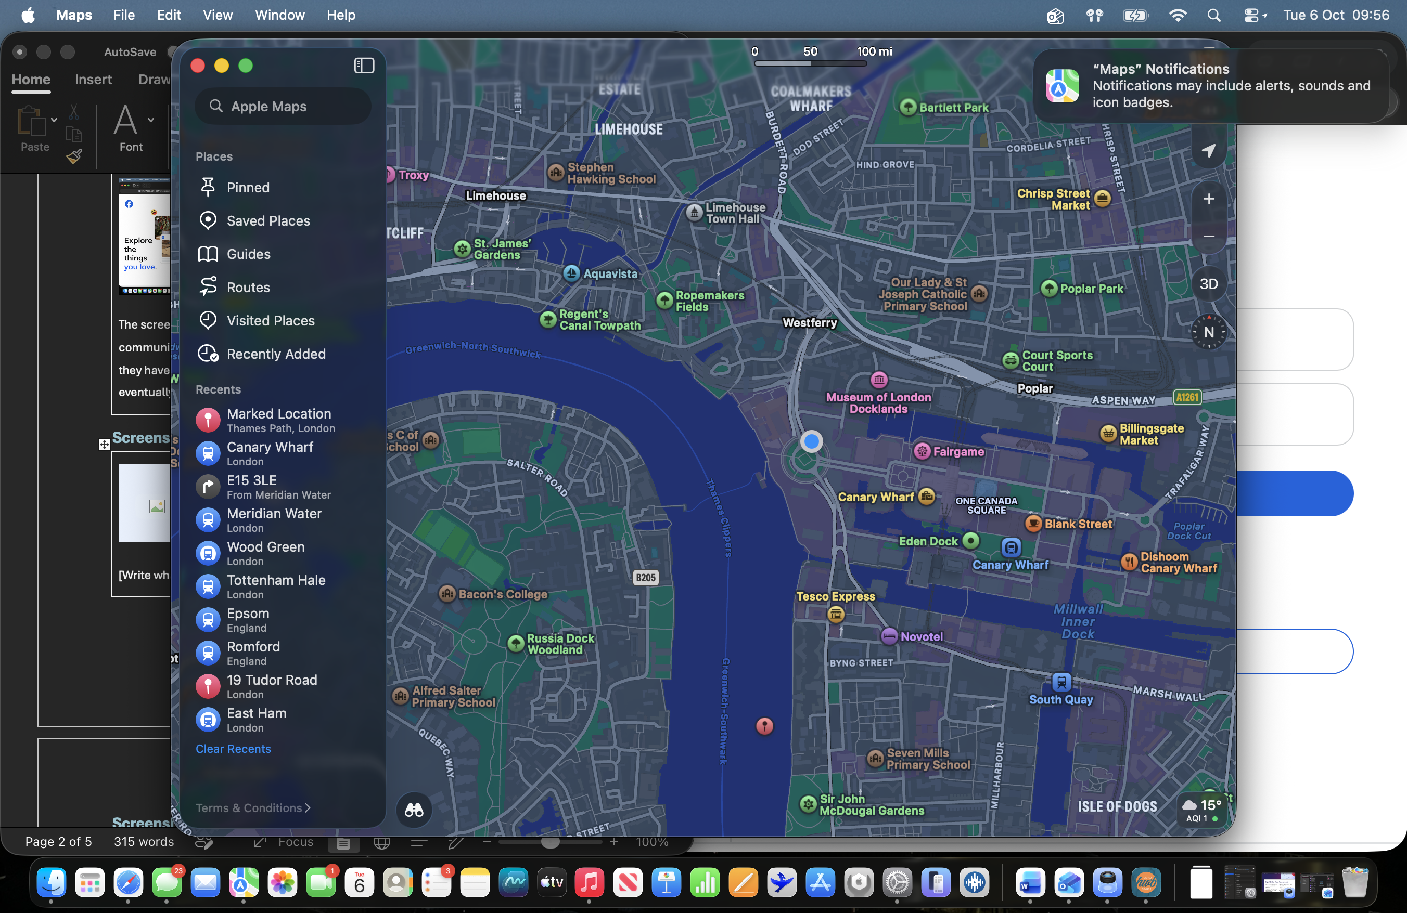
In the image I have put above shows apple maps which I need when I am travelling in the Uk or overseas. I find this platform to be useful as it will help navigate myself to the correct places, so I do not end up getting lost.

Screenshot/Photo 5
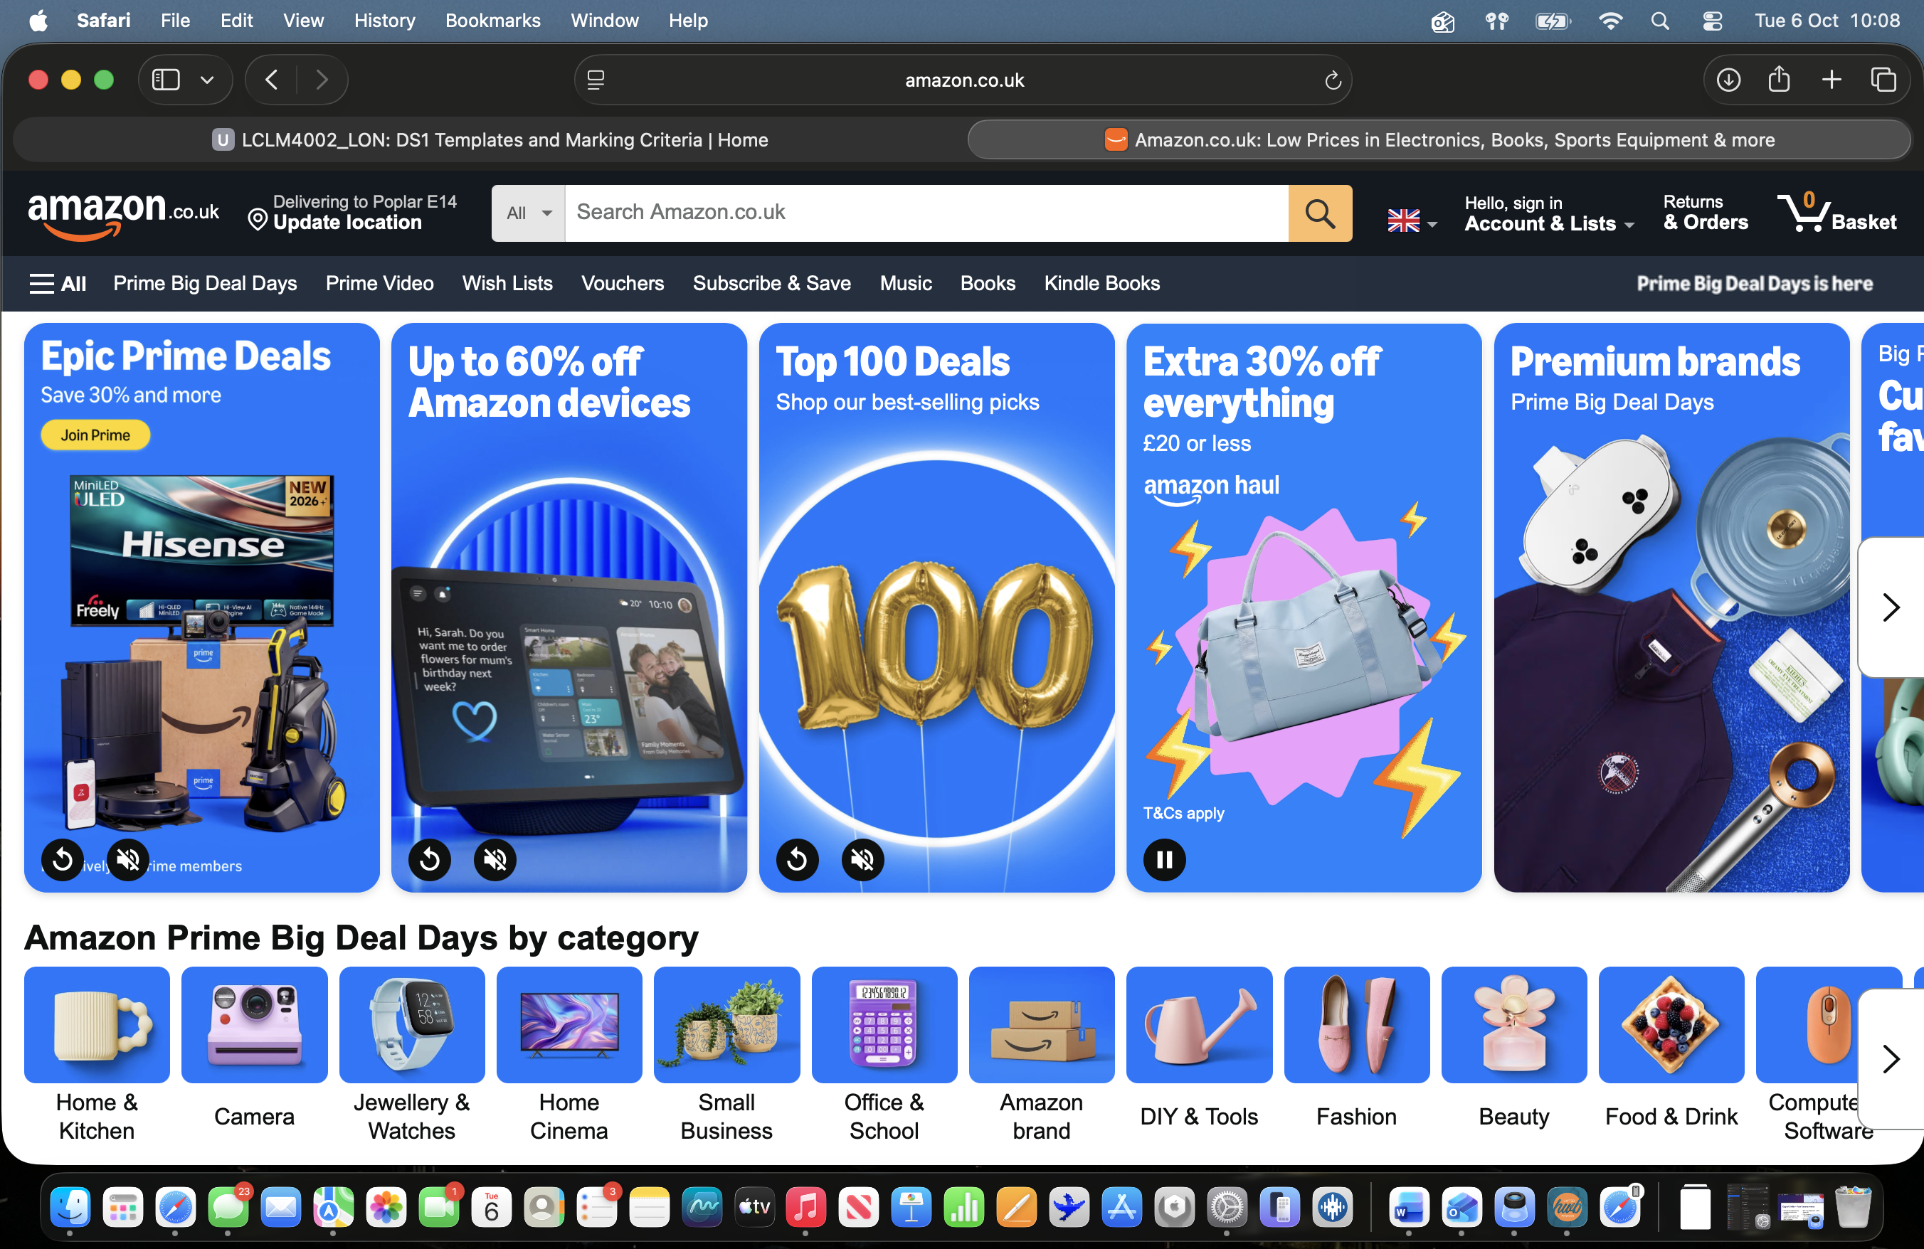
In this image I have put is the amazon website which has been one of the most handy websites/apps to use as it helps me to shop and have things delivered on the same day or next day. I also find that it is more convenient as I have children so quite often I have order things urgently.

Screenshot/Photo 6
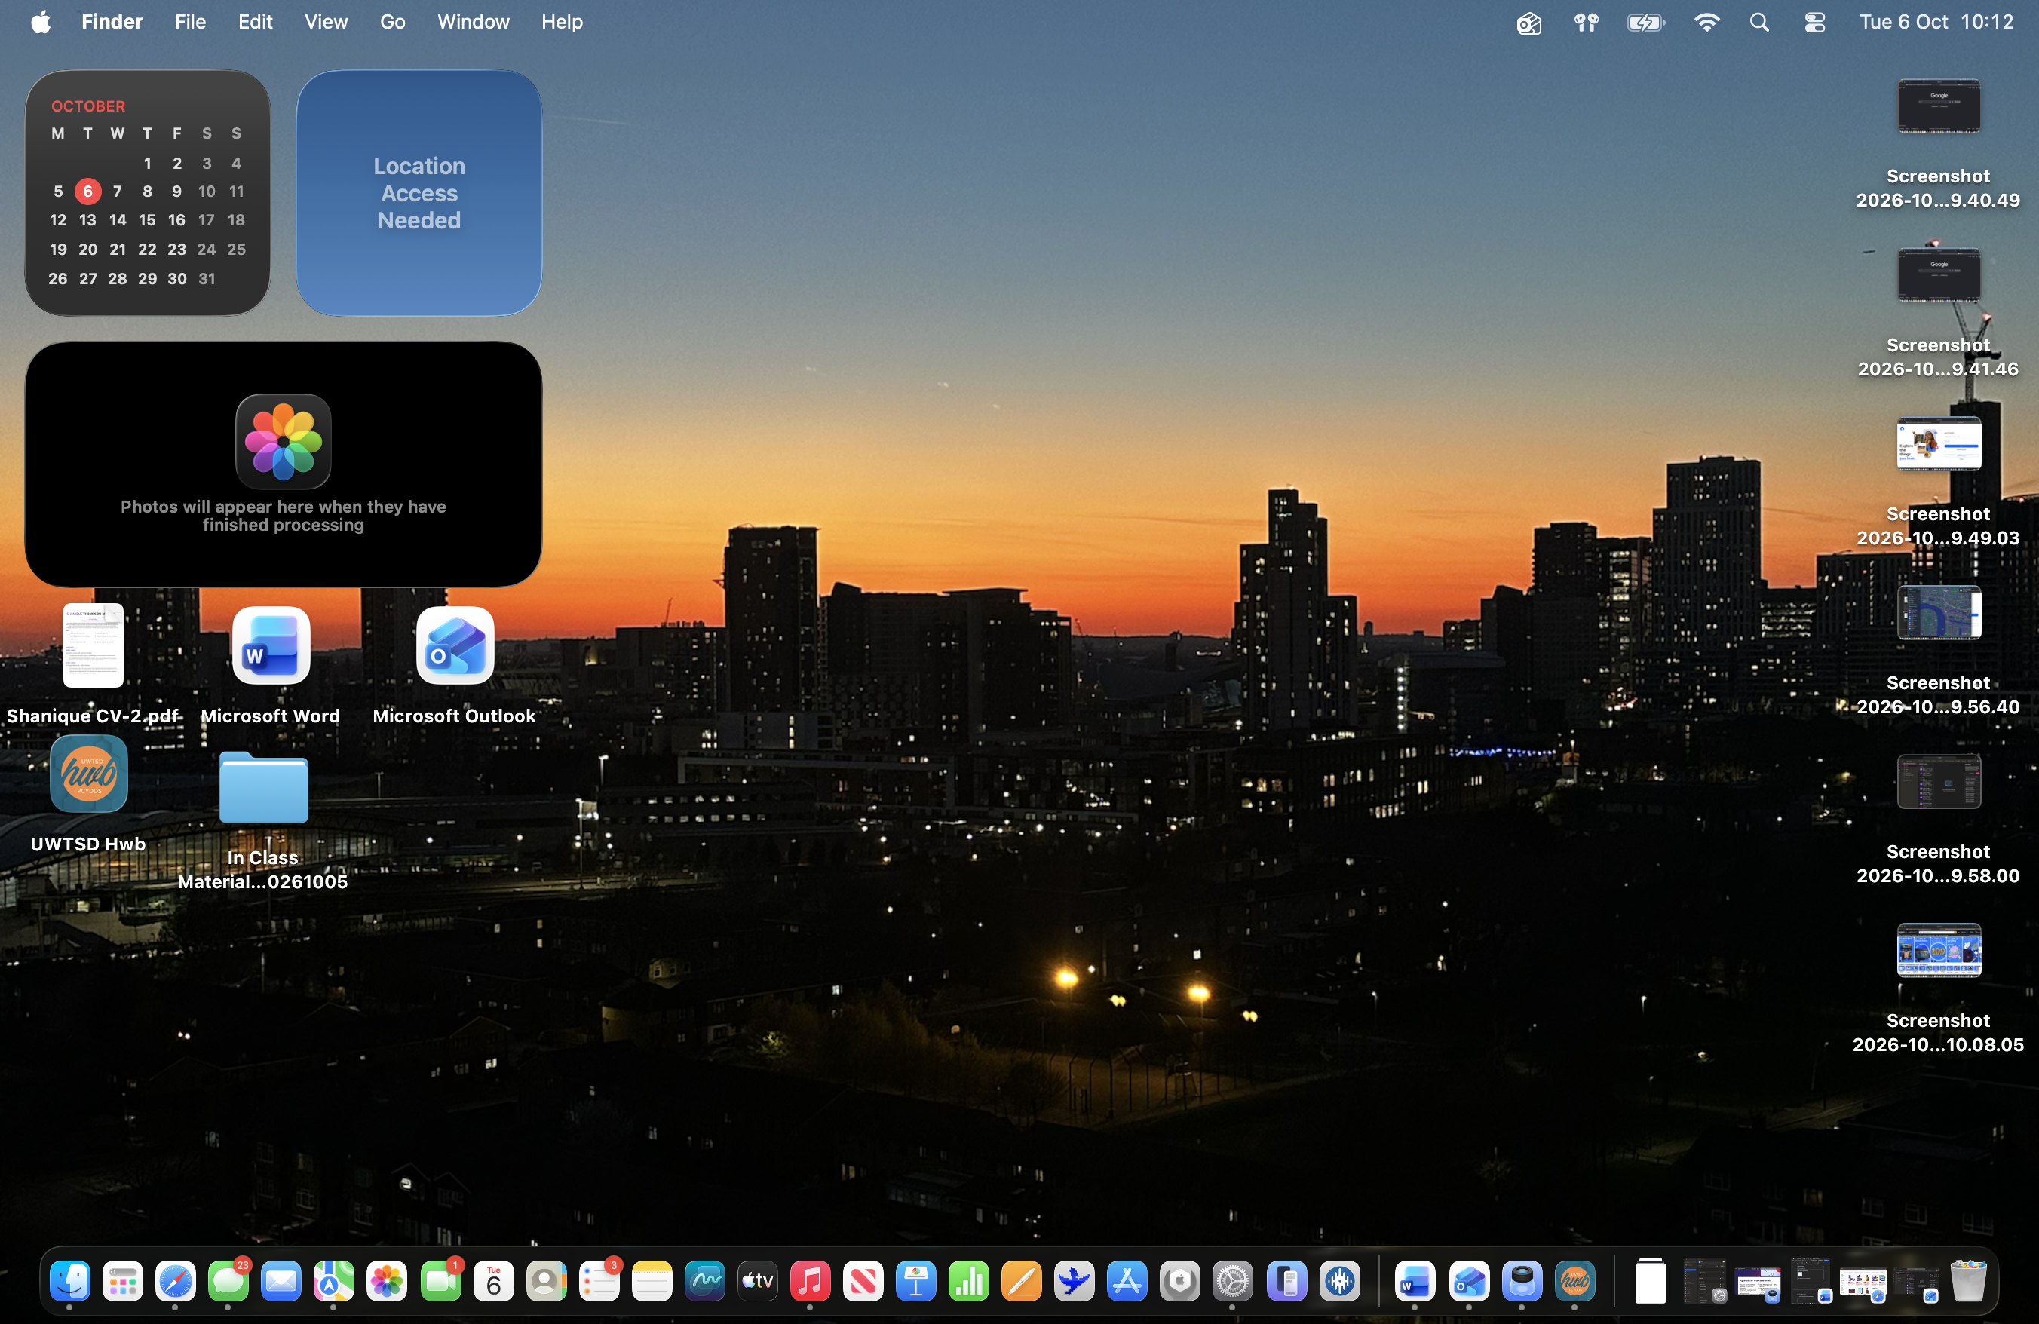
In the image above I have included a image of my MacBook home screen which consists of many tools that are relevant to me in my daily life along with university studies. I currently use my MacBook to help me with my university work along using it in lectures to take down necessary information that will help me with my studies.

My Short Reflection
- Write 5–8 simple sentences about your digital life.
- You can use the sentence starters below if helpful.
I use digital tools every day for different things such as my university work, shopping, keeping in contact with people, researching and navigating myself around when outside. I mainly use Gmail or Outlook Mail to keep up important emails that could be to do with bills or studies. I want to improve and gain more skills that will help more within my studies along with when I eventually go into the work industry again, I would have gained the correct skills that may be used in jobs.

Submission Checklist
Before you submit, please check:
​​​ ☐ I added 4–6 screenshots
☐ I wrote short sentences for each screenshot
☐ I wrote my short reflection
☐ My work is my own
☐ My file opens correctly
​​☐ My file opens correctly

