
Building Services and Energy Performance Analysis
Case Study: Innovation Matrix Building
Student Number: 2219508
Course: MSc Facilities and Property Management
University: University of Wales Trinity Saint David
Module: Building Services and Energy Performance
Date: 20/04/2026

Table of Contents Page

1.0 Introduction ..........................................................................1

2.0 Building Overview .................................................................. 2
2.1 Location ...............................................................................2
2.2 Purpose ............................................................................... 3
2.3 Significance of Maintenance ................................................. 3
2.4 Importance of Energy Efficiency .............................................4

3.0 Building Engineering Services .................................................. 5
3.1 Objectives: How Building Engineering Services Are Delivered….5
3.2 Structure: Schematic Diagrams and Photographs ....................6
3.3 Major Items of Plant (MoP) ..................................................... 8
3.4 Mechanical Services ............................................................ 10
3.5 Ventilation System ............................................................... 10
3.6 MVHR Systems .....................................................................11

4.0 Heating System ......................................................................12
4.1 Renewable Energy Integration ...............................................13

5.0 Electrical Services ..................................................................14
5.1 Containment Systems .......................................................... 14
5.2 Low-Level Containment ........................................................15
5.3 Small Power .........................................................................15
5.4 Lighting Systems ................................................................. 16
5.5 Fire Detection and Alarm Systems ........................................ 17
5.6 Security Systems .................................................................18
5.7 Lightning Protection ........................................................... 19

8.0 Energy Performance ............................................................ 20
8.1 Energy Consumption Data ................................................ 21
8.2 Energy Consumption Data Analysis .....................................22
8.3 Baseline Modeling.............................................................. 23
8.4 Recommendations............................................................. 24
8.5 Performance Improvement ................................................ 25
8.6 Recommendation ...............................................................27
8.7 Improved Energy Performance ............................................ 29
8.8 PHPP Analysis – Impact of Double Wall Insulation ................30
8.9 PHPP Analysis – Impact of Double Roof Insulation ................32
8.10 PHPP Analysis of Wall, Roof, and Window Improvement ...... 34
8.11 PHPP Analysis – Impact of Replacing Windows with
Passivhaus Triple-Glazed Windows ........................................ 36

9.0 Cost-Benefit Analysis ............................................................ 38
9.1 Cost-Benefit Analysis / SPONS Justification ..........................39
9.2 Recommendation ............................................................... 40

10.0 References .........................................................................41

1.0 Introduction: This report evaluates the building engineering services, energy performance, and operational efficiency of the Innovation Matrix building at the University of Wales Trinity Saint David (UWTSD). The analysis focuses on mechanical and electrical systems, maintenance strategies, and energy optimisation aligned with sustainability objectives. The study adopts a facilities management perspective, integrating performance evaluation with industry standards to assess building functionality and long-term efficiency (UWTSD, 2023).

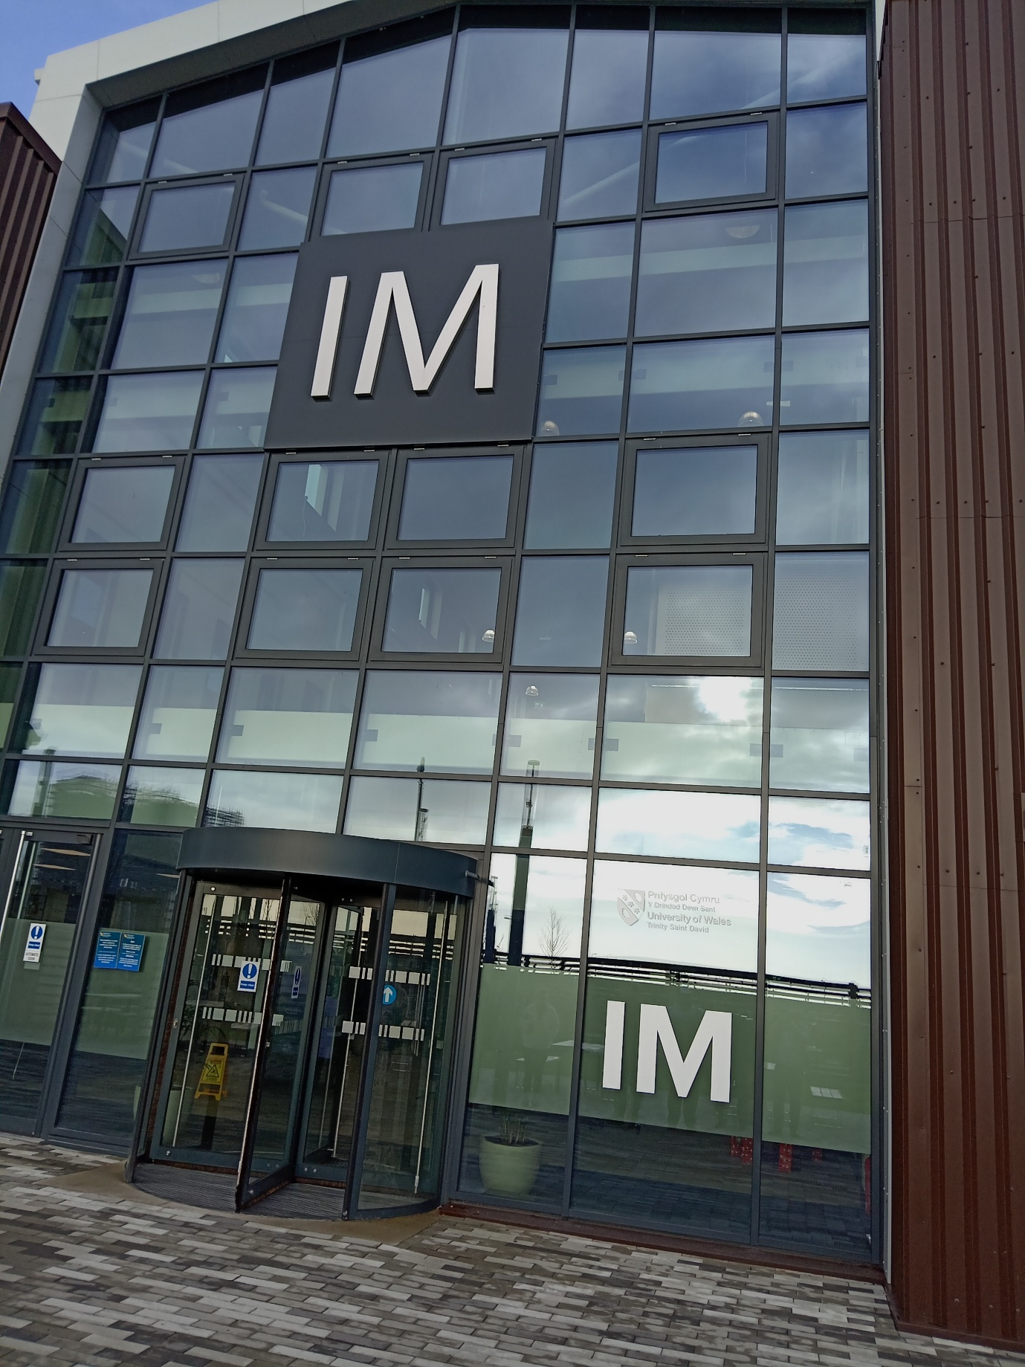
Innovation matrix building

2.1 Location

The Innovation Matrix is located within the SA1 Innovation Quarter in Swansea, a strategically important waterfront development that supports academic–industry collaboration. Its proximity to Swansea city centre, transport infrastructure, and the M4 corridor enhances accessibility and operational viability.
The site benefits from sustainable transport provisions, including EV charging, cycling infrastructure, and alignment with the Swansea Bay Healthy Travel Charter. This positioning supports both environmental objectives and user accessibility

2.2 Purpose

The building provides flexible workspace, collaborative environments, and research facilities designed to support digital innovation and enterprise engagement. It operates as a hybrid academic–commercial environment, facilitating knowledge exchange and applied research.
Its design incorporates adaptable layouts, shared facilities, and technology-enabled environments to support varying occupancy demands and interdisciplinary collaboration

2.3 Significance of Maintenance

Maintenance is critical to sustaining operational efficiency, asset longevity, and regulatory compliance. A proactive Planned Preventative Maintenance (PPM) regime ensures optimal system performance, reduces lifecycle costs, and mitigates system failures.
HVAC systems, for example, require routine inspection, filter replacement, and calibration to maintain indoor air quality and energy efficiency. Effective maintenance aligns with best practice guidance from CIBSE and supports long-term asset reliability

2.4 Importance of Energy Efficiency
Energy efficiency is central to the building’s design, reducing operational costs and carbon emissions. The integration of renewable energy systems and efficient building services contributes to improved environmental performance and asset value.
Energy-efficient buildings demonstrate resilience against rising energy costs and regulatory pressures, aligning with sustainability frameworks and institutional ESG targets.

3.1 Objectives: How building engineering services are delivered
Building engineering services are delivered through an integrated system combining HVAC, electrical systems, and smart controls.
A Building Management System (BMS) enables real-time monitoring and optimisation of environmental conditions, improving efficiency and occupant comfort. Natural ventilation strategies and automated shading further reduce reliance on mechanical systems, supporting a low-energy operational model.

3.2 Structure: Schematic diagrams and photographs
The building incorporates a modern structural and services layout, including:
- Open-plan floorplates supporting flexibility
- Integrated service zones for MEP systems
- Rooftop photovoltaic (PV) installations
- Clearly defined plant and distribution areas
These design elements support efficient operation, maintenance accessibility, and adaptability.

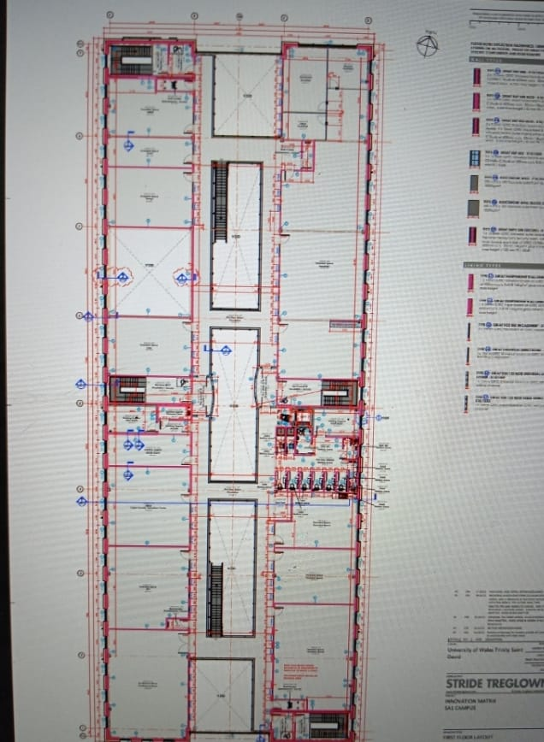

Ground floor layout fig 2

First floor layout fig 3

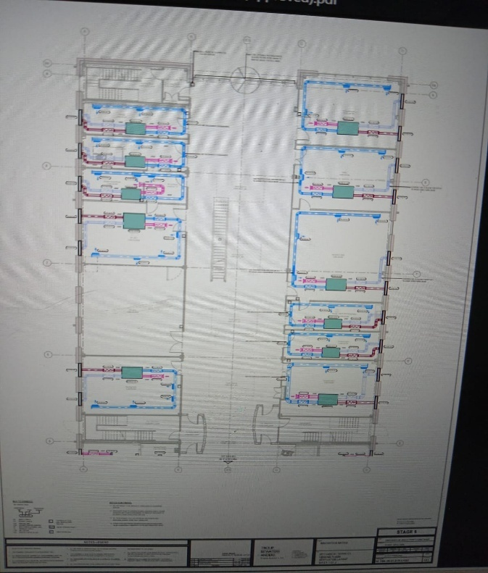
Mechanical service ground floor

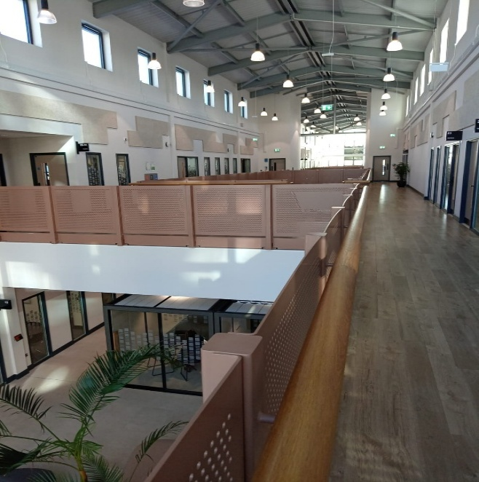
First-floor innovation matrix building

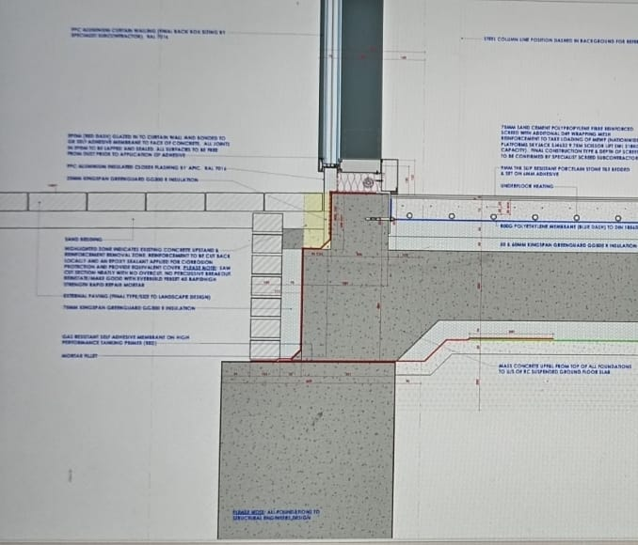 EXTERNAL FINISHES TO GLAZING PANEL INTERFACE DETAIL

Typical foundation/build-up cladding details

PV Layout on the rooftop

3.3 Major Items of Plant (MoP)
The Major Items of Plant include air source heat pumps, MVHR systems, calorifiers, pumps, and electrical distribution systems.
The asset register demonstrates structured asset management, supporting:
- Planned maintenance scheduling
- Compliance monitoring
- Lifecycle planning
This aligns with best practice in asset management and facilities maintenance standards (CIBSE, 2021).

Manufacturer/Product Supplier name |  | Level 4 asset description |  | Asset reference/Model No. |  |  | Serial Number |  | Size/Capacity |  | Installer/Subcontractor contact details
 |  |  |  |  |  |  |  |  |  |  | location maintenance |  | install date life span
Lochinvar |  | Air Source Heat Pump |  | LAHP-1202HTXL |  |  | 304891 |  | 101k |  | IM QUARTERLY |  | 2024
Lochinvar |  | Air Source Heat Pump |  | LAHP-1202HTXL |  |  | 304890 |  | 101kW |  | IM QUARTELY |  | 2024
Lochinvar |  | DHW Calorifier |  | LSTR 110 |  |  | N/A |  | 500L |  | IM QUARTERLY |  | 2024
Lochinvar |  | LTHW THERMAL STORE |  | LBT500 |  |  | N/A |  | 500L |  | IM QUARTERLY |  | 2024
Lochinvar |  | LTHW THERMAL STORE |  | LBT500 |  |  | N/A |  | 500L |  | IM QUARTERLY |  | 2024
Lochinvar |  | DHW Plate Heat Exchanger |  | LM900065A |  |  | N/A |  | 140kW |  | IM QUARTERLY |  | 2024
Lochinvar |  | Pressurisation Unit |  | LM900270A |  |  | N/A |  | N/A |  | IM QUARTERLY |  | 2024
DutyPoint/Lowara |  | ASHP Primary Circulator |  | LNEEH40-160/30/P25RCS4/4 |  |  | LNEEH40-160/30/P25RCS4/4 |  | N/A |  | IM QUARTERLY |  | 2024
DutyPoint/Lowara |  | LTHW Secondary Circulator |  | LNTEH32-160/22/P25RCS4/4 |  |  | LNEEH40-160/30/P25RCS4/4 |  | N/A |  | IM QUARTERLY |  | 2024
DutyPoint/Lowara |  | Cold Water Booster Set Package |  | ScubaTank WX2-9040-1650.A |  |  | 00972-20230904 |  | N/A |  | IM QUARTERLY |  | 2024
DutyPoint/Lowara |  | Domestic Hot Water Return Pump |  | Ecocirc XLplus N 32-120 F |  |  | E510110AA |  | N/A |  | IM QUARTERLY |  | 2024
Merriott |  | Radiant Panel |  | S600T12 |  |  | N/A |  | 1200mm/265kW |  | IM QUARTERLY |  | 2024
Merriott |  | Radiant Panel |  | S600T18 |  |  | N/A |  | 1800mm/398kW |  | IM QUARTERLY |  | 2024
Merriott |  | Radiant Panel |  | S600T24 |  |  | N/A |  | 2400mm/531kW |  | IM QUARTERLY |  | 2024
Stelrad |  | Low Surface Temperature Radiator |  | LST i PLUS |  |  | 145240 |  | 800x650mm 615kW |  | IM QUARTERLY |  | 2034
Stelrad |  | Low Surface Temperature Radiator |  | LST i PLUS |  |  | 145224 |  | 500x650mm 348kW |  | IM QUARTERLY |  | 2024
Airtecnics |  | Overdoor Curtain Heater (north) |  | Model Zen M 2500 P |  |  | N/A |  | 23.48kW |  | IM QUARTERLY |  | 2024
Airtecnics |  | Overdoor Curtain Heater (south) |  | Model Zen M 2500 P |  |  | N/A |  | 23.48kW |  | IM QUARTERLY |  | 2024
Mitsubishi |  | Comms Room Air Conditioning Indoor Wall Hung Unit 1. |  | PKA-M100KA2 |  |  | 31M00259 |  | 4.5-10.5kW Cooling |  | IM QUARTERLY |  | 2024
Mitsubishi |  | Comms Room Air Conditioning Indoor Wall Hung Unit 2. |  | PKA-M100KA2 |  |  | 31M00261 |  | 4.5-10.5kW Cooling |  | IM QUARTERLY |  | 2024
Mitsubishi |  | Comms Room Air Conditioning Indoor Wall Hung Unit 3. |  | PKA-M100KA2 |  |  | 31M00251 |  | 4.5-10.5kW Cooling |  | IM QUARTERLY |  | 2024
Mitsubishi |  | Comms Room Air Conditioning Indoor Wall Hung Unit 4. |  | PKA-M100KA2 |  |  | 31M00254 |  | 4.5-10.5kW Cooling |  | IM QUARTERLY |  | 2024
Mitsubishi |  | Comms Room Air Conditioning Indoor Ceiling Mounted Unit 1. |  | PLA-ZM100EA2 |  |  | 3G00500 |  | 4.5-10.5kW Cooling |  | IM QUARTERLY |  | 2024
Mitsubishi |  | Comms Room Air Conditioning Indoor Ceiling Mounted Unit 2. |  | PLA-ZM100EA2 |  |  | 3G00534 |  | 4.5-10.5kW Cooling |  | IM QUARTERLY |  | 2024
Mitsubishi |  | Comms Room Air Conditioning Indoor Ceiling Mounted Unit 3. |  | PLA-ZM100EA2 |  |  | 3D00340 |  | 4.5-10.5kW Cooling |  | IM QUARTERLY |  | 2024
Mitsubishi |  | Comms Room Air Conditioning Indoor Ceiling Mounted Unit 4. |  | PLA-ZM100EA2 |  |  | 3G00533 |  | 4.5-10.5kW Cooling |  | IM QUARTERLY |  | 2024
Mitsubishi |  | Outdoor Condencing Unit 1. |  | PUZ-ZM200YKA |  |  | 3C00049 |  | 19kW Cooling |  | IM QUARTERLY |  | 2024
Mitsubishi |  | Outdoor Condencing Unit 2. |  | PUZ-ZM200YKA |  |  | 3C00042 |  | 19kW Cooling |  | IM QUARTERLY |  | 2024
Mitsubishi |  | Outdoor Condencing Unit 3. |  | PUZ-ZM200YKA |  |  | 3C00022 |  | 19kW Cooling |  | IM QUARTELY |  | 2024
Mitsubishi |  | Outdoor Condencing Unit 4. |  | PUZ-ZM200YKA |  |  | 3C00011 |  | 19kW Cooling |  | IM QUARTERLY |  | 2024
BSB |  | Fire Damper 1. |  | FD-C |  |  | 2831-CPB-P0008 |  | 100ø |  | IM QUARTERLY |  | 2024
BSB |  | Fire Damper 2. |  | FD-C |  |  | 2831-CPB-P0008 |  | 100ø |  | IM QUARTERLY |  | 2024
BSB |  | Fire Damper 3. |  | FD-C |  |  | 2831-CPB-P0008 |  | 100ø |  | IM QUARTERLY |  | 2024
Swegon |  | Fire Smoke Damper |  | Trans Sheild ACS 8415101090 |  |  | 8415101090 |  | 200x200mm |  | IM QUARTERLY |  | 2024
Swegon |  | Fire Smoke Damper |  | Trans Sheild ACS 8415101090 |  |  | 8415101090 |  | 200x200mm |  | IM QUARTERLY |  | 2024
Hyco |  | Unvented Water Heater (S.INO.00.002) |  | Speedflow SF05K |  |  | N/A |  | 5litre |  | IM QUARTERLY |  | 2024
Hyco |  | Unvented Water Heater (S.INO.00.008) |  | Speedflow SF05K |  |  | N/A |  | 5litre |  | IM QUARTERLY |  | 2024
Armitage Shanks/Ideal Standard |  | Belfast Sink |  | ASH-BSLB |  |  | N/A |  | 610x460x260 |  | IM QUARTERLY |  | 2024
Kelda |  | Shower |  | Deluxe Shower Panel, 6mm white toughened glass fascia. |  |  | 93007005 |  | N/A |  | IM QUARTERLY |  | 2024
Armitage Shanks/Ideal Standard |  | Shower Tray |  | Ultra Flat S-Square Shower Tray |  |  | N/A |  | 900x900 |  | IM QUARTERLY |  | 2024
Oventrop |  | Differential Pressure Control Valve's |  | Hydromat DTR |  |  | 106 45 08 |  | 25ø |  | IM QUARTERLY |  | 2024
Oventrop |  | Differential Pressure Control Valve's |  | Hydromat DTR |  |  | 107 45 10 |  | 32ø |  | IM QUARTERLY |  | 2024
Oventrop |  | Differential Pressure Control Valve's |  | Hydromat DTR |  |  | 108 45 12 |  | 50ø |  | IM QUARTERLY |  | 2024
Oventrop |  | Double Regulating Valve |  | HydroControl MTR |  |  | 106 04 04 |  | 15ø |  | IM QUARTERLY |  | 2024
Oventrop |  | Double Regulating Valve |  | HydroControl MTR |  |  | 106 04 32 |  | 15ø MF |  | IM QUARTERLY |  | 2024
Oventrop |  | Double Regulating Valve |  | HydroControl MTR |  |  | 106 04 64 |  | 15ø LF |  | IM QUARTERLY |  | 2024
Oventrop |  | Double Regulating Valve |  | HydroControl MTR |  |  | 106 04 06 |  | 20ø |  | IM QUARTERLY |  | 2024
Oventrop |  | Double Regulating Valve |  | HydroControl MTR |  |  | 106 04 08 |  | 25ø |  | IM QUARTERLY |  | 2024
Oventrop |  | Double Regulating Valve |  | HydroControl MTR |  |  | 106 04 10 |  | 32ø |  | IM QUARTERLY |  | 2024
Oventrop |  | Double Regulating Valve |  | HydroControl MTR |  |  | 106 04 16 |  | 50ø |  | IM QUARTERLY |  | 2024
Nuaire |  | MVHR/00/001 |  | XBC15HA-NNN-EPLB1S |  |  | 5821132 |  | N/A |  | IM QUARTERLY |  | 2024
Nuaire |  | MVHR/00/002 |  | XBC15HA-NNN-EPLB1S |  |  | 5821132 |  | N/A |  | IM QUARTERLY |  | 2024
Nuaire |  | MVHR/00/003 |  | XBC15HA-NNN-EPLB1S |  |  | 5821132 |  | N/A |  | IM QUARTERLY |  | 2024
Nuaire |  | MVHR/00/004 |  | XBC25HA-NNN-EPLB4W |  |  | 5844687 |  | N/A |  | IM QUARTERLY |  | 2024
Nuaire |  | MVHR/00/005 |  | XBC25HA-NNN-EPLB4W |  |  | 5844687 |  | N/A |  | IM QUARTERLY |  | 2024
Nuaire |  | MVHR/00/006 |  | XBC25HA-NNN-EPLB1S |  |  | 5844687 |  | N/A |  | IM QUARTERLY |  | 2024
Nuaire |  | MVHR/00/007 |  | XBC25HA-NNN-EPLB1S |  |  | 5844687 |  | N/A |  | IM QUARTERLY |  | 2024
Nuaire |  | MVHR/00/008 |  | XBC25HA-NNN-EPLB1S |  |  | 5844687 |  | N/A |  | IM QUARTERLY |  | 2024
Nuaire |  | MVHR/00/009 |  | XBC25HA-NNN-EPLB1S |  |  | 5844687 |  | N/A |  | IM QUARTERLY |  | 2024
Nuaire |  | MVHR/00/010 |  | XBC15HA-NNN-EPLB1S |  |  | 5821132 |  | N/A |  | IM QUARTERLY |  | 2024
Nuaire |  | MVHR/00/011 |  | XBC15HA-NNN-EPLB1S |  |  | 5821132 |  | N/A |  | IM QUARTERLY |  | 2024
Nuaire |  | MVHR/00/012 |  | XBC25HA-NNN-EPLB1S |  |  | 5844687 |  | N/A |  | IM QUARTERLY |  | 2024
Nuaire |  | MVHR/00/013 |  | XBC25HA-NNN-EPLB1S |  |  | 5844687 |  | N/A |  | IM QUARTERLY |  | 2024
Nuaire |  | MVHR/00/014 |  | XBC25HA-NNN-EPLB1S |  |  | 5844687 |  | N/A |  | IM QUARTERLY |  | 2024
Nuaire |  | MVHR/00/015 |  | XBC25HA-NNN-EPLB1S |  |  | 5844687 |  | N/A |  | IM QUARTERLY |  | 2024
Nuaire |  | MVHR/00/016 |  | XBC25HA-NNN-EPLB1S |  |  | 5844687 |  | N/A |  | IM QUARTERLY |  | 2024
Nuaire |  | MVHR/00/017 |  | XBC25HA-NNN-EPLB1S |  |  | 5844687 |  | N/A |  | IM QUARTERLY |  | 2024
Nuaire |  | MVHR/00/018 |  | XBC25HA-NNN-EPLB1S |  |  | 5844687 |  | N/A |  | IM QUARTERLY |  | 2024
Nuaire |  | MVHR/00/019 |  | XBC25HA-NNN-EPLB1S |  |  | 5844687 |  | N/A |  | IM QUARTERLY |  | 2024
Nuaire |  | MVHR/00/020 |  | XBC25HA-NNN-EPLB1S |  |  | 5844687 |  | N/A |  | IM QUARTERLY |  | 2024
Nuaire |  | MVHR/00/021 |  | XBC25HA-NNN-EPLB1S |  |  | 5844687 |  | N/A |  | IM QUARTERLY |  | 2024
Nuaire |  | MVHR/01/001 |  | XBC25HA-NNN-EPLB1S |  |  | 5844687 |  | N/A |  | IM QUARTERLY |  | 2024
Nuaire |  | MVHR/01/002 |  | XBC15HA-NNN-EPLB1S |  |  | 5821132 |  | N/A |  | IM QUARTERLY |  | 2024
Nuaire |  | MVHR/01/003 |  | XBC25HA-NNN-EPLB1S |  |  | 5844687 |  | N/A |  | IM QUARTERLY |  | 2024
Nuaire |  | MVHR/01/004 |  | XBC25HA-NNN-EPLB1S |  |  | 5844687 |  | N/A |  | IM QUARTERLY |  | 2024
Nuaire |  | MVHR/01/005 |  | XBC25HA-NNN-EPLB1S |  |  | 5844687 |  | N/A |  | IM QUARTERLY |  | 2024
Nuaire |  | MVHR/01/006 |  | XBC25HA-NNN-EPLB1S |  |  | 5844687 |  | N/A |  | IM QUARTERLY |  | 2024
Nuaire |  | MVHR/01/007 |  | XBC25HA-NNN-EPLB1S |  |  | 5844687 |  | N/A |  | IM QUARTERLY |  | 2024
Nuaire |  | MVHR/01/008 |  | XBC25HA-NNN-EPLB1S |  |  | 5844687 |  | N/A |  | IM QUARTERLY |  | 2024
Nuaire |  | MVHR/01/009 |  | XBC25HA-NNN-EPLB1S |  |  | 5844687 |  | N/A |  | IM QUARTERLY |  | 2024
Nuaire |  | MVHR/01/010 |  | XBC25HA-NNN-EPLB1S |  |  | 5844687 |  | N/A |  | IM QUARTERLY |  | 2024
Nuaire |  | MVHR/01/011 |  | XBC25HA-NNN-EPLB1S |  |  | 5844687 |  | N/A |  | IM QUARTERLY |  | 2024
Nuaire |  | MVHR/01/012 |  | XBC25HA-NNN-EPLB1S |  |  | 5844687 |  | N/A |  | IM QUARTERLY |  | 2024
Nuaire |  | MVHR/01/013 |  | XBC25HA-NNN-EPLB1S |  |  | 5844687 |  | N/A |  | IM QUARTERLY |  | 2024
Nuaire |  | MVHR/01/014 |  | XBC25HA-NNN-EPLB1S |  |  | 5844687 |  | N/A |  | IM QUARTERLY |  | 2024
Nuaire |  | MVHR/01/015 |  | XBC25HA-NNN-EPLB1S |  |  | 5844687 |  | N/A |  | IM QUARTERLY |  | 2024
Nuaire |  | MVHR/01/016 |  | XBC25HA-NNN-EPLB1S |  |  | 5844687 |  | N/A |  | IM QUARTERLY |  | 2024

3.0 Building Engineering Services
The engineering services strategy is designed to balance energy efficiency, occupant comfort, safety, and operational resilience. The approach integrates mechanical and electrical systems in line with recognised industry standards, including CIBSE, BRE, and BSI, ensuring compliance with best practice and performance targets.

3.1 Mechanical Services

3.2 Ventilation system
The building adopts a hybrid ventilation strategy, combining natural ventilation with Mechanical Ventilation with Heat Recovery (MVHR) systems. CO₂ sensors regulate airflow based on occupancy levels, optimizing indoor air quality and reducing unnecessary energy consumption.
3.3 MVHR Systems:
MVHR units recover heat from exhaust air to pre-condition incoming fresh air, significantly reducing heating demand and improving overall system efficiency. This approach aligns with low-carbon design principles and current CIBSE guidance.

MVHR System

4.0 Heating System
The heating strategy integrates underfloor heating with air source heat pumps (ASHPs) to deliver efficient, low-temperature heating.
- Underfloor Heating: Provides uniform heat distribution and operates efficiently at lower flow temperatures, improving thermal comfort.
- Air Source Heat Pumps: Extract ambient heat to provide low-carbon heating and cooling, reducing reliance on fossil fuels.
The system is zoned to accommodate varying occupancy patterns, ensuring responsive and efficient energy use across different spaces.

underground heating system

Air Source Heat Pumps

4.1 Renewable Energy Integration
Rooftop photovoltaic (PV) panels provide on-site renewable energy generation, offsetting both heating and electrical loads. This contributes to carbon reduction targets and enhances energy resilience.
Rationale:
The integration of MVHR, heat pumps, and PV systems reduces peak energy demand and lowers net grid dependency, supporting a low-carbon building strategy

Heating layout first floor

PV Roof-top solar panel

5.0 Electrical Services
5.1 Containment Systems
Containment systems provide structured pathways for power, data, and control cabling, ensuring minimal interference and future adaptability.
- Raised floors and accessible trunking allow easy reconfiguration
- Prefabricated and modular systems reduce installation time
Rationale:
Flexibility is critical in innovation environments where tenant requirements frequently change

5.2 Low-Level Containment
Low-level containment supports additional power and data distribution while maintaining clean ceiling spaces and ease of maintenance.
- Underfloor systems enable cooling integration
- Suitable for high-bandwidth and specialist environments

5.3 Small Power
Small power systems support:
- Office equipment
- AV systems
- Shared facilities
Integration with smart controls ensures efficient operation and reduced energy consumption.

5.4 Lighting Systems
High-efficiency LED lighting is installed throughout the building, supported by:
- Daylight-responsive controls
- Occupancy sensors
- Smart scheduling systems
This enhances user comfort while minimising energy demand.

Lighting layout first floor

5.5 Fire Detection and Alarm Systems
Fire safety systems comply with BS 5839, incorporating:
- Addressable fire detection systems
- Audible and visual alarms
- Integration with building management systems (BMS)
Zonal configurations ensure effective evacuation, supported by routine testing and maintenance

3.3.2.5 Fire Detection and Alarms
Fire evacuation on the first floor

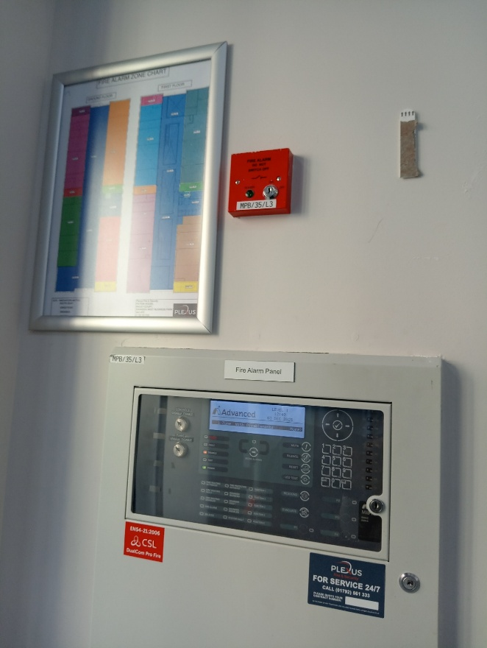
Fire alarm panel

5.6 Security Systems
Security provisions include:
- Access control systems
- CCTV surveillance
- Intrusion detection and intercom systems
Integration with BMS enables real-time monitoring and rapid incident response, while maintaining privacy-by-design principles

5.7 Lightning Protection
Lightning protection systems safeguard both the building structure and sensitive electrical infrastructure.
- Reduces risk of system failure and damage
- Requires regular inspection and maintenance
- Integrated with structural design for resilience

Plant room

8.0 Energy Performance

4.1 Current Energy Performance
4. Energy Performance
4.1 Current Energy Performance
The Innovation Matrix demonstrates strong energy performance, achieving:
- EPC Rating: A
- BREEAM Rating: Excellent
These ratings reflect a combination of:
- High-performance building envelope (insulation and airtightness)
- Efficient mechanical systems (MVHR and heat pumps)
- On-site renewable energy generation (PV panels)
- Intelligent building management systems

Energy performance certificate for Innovation Matrix Building

8.1 Energy Consumption Data

Month | Grid Consumption (kWh) | Cost (of grid consumption) | Solar Generation (kWh) | Total building Consumption (kWh)
JAN | 31160.00 | £8,065.08 | 1640.00 | 32800.00
FEB | 29330.90 | £7,547.63 | 2560.00 | 31890.90
MAR | 23014.70 | £6,133.62 | 7040.00 | 30054.70
APR | 16127.60 | £3,789.89 | 10190.00 | 26317.60
MAY | 9536.40 | £2,231.47 | 12510.00 | 22046.40
JUN | 8773.30 | £2,105.79 | 11810.00 | 20583.30
JUL | 8008.90 | £1,965.88 | 12150.00 | 20158.90
AUG | 7036.10 | £1,708.42 | 10160.00 | 17196.10
SEP | 10165.00 | £2,359.43 | 6690.00 | 16855.00
OCT | 23328.20 | £5,895.92 | 3670.00 | 26998.20
NOV | 22331.30 | £5,926.33 | 1680.00 | 24011.30
DEC | 20569.70 | £5,525.91 | 1190.00 | 21759.70

8.2 Energy consumption data analysis:
The energy consumption data shows a clear seasonal trend, with higher demand in winter and lower demand in summer. Consumption peaks in January (32,800 kWh) and February (31,890 kWh), while the lowest levels occur in August (17,196 kWh) and September (16,855 kWh). This variation is mainly driven by increased heating demand in colder months, leading to greater reliance on grid electricity (CIBSE, 2021).
Solar generation significantly offsets grid consumption during summer, exceeding 12,000 kWh in months such as May and July. However, winter generation is minimal (below 2,000 kWh), leading to high grid dependence when demand is highest (BRE, 2020). This highlights that while the building performs efficiently in summer, it lacks energy autonomy in winter.
Energy costs follow this pattern, with the highest costs in January (£8,065) and February (£7,547), and the lowest in August (£1,708). This confirms that grid electricity is the main cost driver and that reducing winter demand is essential (BSI, 2020).
Improving building insulation is a key priority. Enhancing the performance of roofs, walls, and glazing reduces heat loss by lowering U-values, thereby decreasing heating demand and improving thermal efficiency (BRE, 2020).
In addition, adopting efficient heating systems, such as air source heat pumps, can significantly reduce energy use. These systems operate with higher efficiency than conventional heating, reducing electricity consumption while maintaining comfort (CIBSE, 2021).
Enhancing heat recovery systems, particularly MVHR, is also critical. MVHR reduces ventilation heat losses by recovering heat from exhaust air, improving efficiency and indoor air quality (CIBSE, 2021).
In conclusion, while the building performs well in summer, winter energy demand remains high. A combined strategy of improved insulation, efficient heating, and enhanced heat recovery would reduce grid reliance, lower costs, and improve overall energy performance, supporting a low-carbon approach (BRE, 2020).

8.3 Baseline modelling

8.4 Recommendations
8. 5 Performance improvement
The PHPP energy balance analysis indicates that the building demonstrates a moderate level of energy performance; however, it is not fully optimised when assessed against low-energy or Passivhaus standards. The annual heating demand of approximately 31.7 kWh/m²·yr indicates that the building performs reasonably well but still has significant opportunities for improvement, particularly in ventilation and glazing losses (Feist et al., 2015).

One of the building's key strengths is the contribution of internal heat gains (10.0 kWh/m²·yr) and solar gains (4.4 kWh/m²·yr), which help offset heating demand. These gains indicate that the building benefits from passive energy inputs, reducing reliance on mechanical heating systems. Additionally, relatively low thermal bridge losses (approximately 1.1 kWh/m²·yr) and moderate floor losses (4.2 kWh/m²·yr) suggest that construction detailing is reasonably effective, aligning with good practice in building fabric design (CIBSE, 2021).

Despite these strengths, the analysis highlights several critical weaknesses. Ventilation heat losses (approximately 15.7 kWh/m²·yr) are the largest single contributor to total heat loss, suggesting inefficient ventilation or inadequate heat recovery. This is a significant issue, as ventilation losses tend to dominate once fabric performance improves (de Wilde, 2014). Similarly, window heat losses (17.3 kWh/m²·yr) are notably high, suggesting that the glazing system is underperforming, likely due to double glazing or poor thermal specification. Roof losses (7.5 kWh/m²·yr) and wall losses (approximately 5.9 kWh/m²·yr) further indicate that the building envelope, while adequate, does not meet high-performance standards (BRE, 2020).

From a critical perspective, the results demonstrate that the building is not limited by a single element but rather by a combination of inefficient systems and suboptimal fabric performance. This aligns with established research indicating that improving isolated components yields limited benefits due to interactions among multiple heat-loss pathways and diminishing returns (Allouhi et al., 2015). Therefore, a whole-building approach is required to achieve meaningful energy performance improvements.

Rationale:
Lower U-values reduce heat loss in winter and lower cooling loads in summer, thereby reducing energy demand and improving occupant comfort.

8. 6 Recommendation
To address these deficiencies, a targeted and integrated retrofit strategy is required. The first priority is the optimisation of the HVAC system to ensure efficient heating, cooling, and ventilation performance across the building. Upgrading to high-efficiency HVAC systems, such as air-source heat pumps paired with advanced air-handling units, can significantly improve overall system efficiency. When properly designed and commissioned, HVAC optimisation can reduce ventilation and heating-related energy losses by approximately 40–60%, contributing to an overall reduction in heating demand of around 10–20% (CIBSE, 2021).
In parallel, the integration of advanced building control systems is essential to maximise HVAC performance. Implementing a dynamic heating schedule aligned with occupancy patterns ensures heating is delivered only when needed, reducing energy waste during unoccupied periods. The use of temperature sensors, occupancy sensors, and automated control systems enables real-time monitoring and adjustment of internal conditions, improving both energy efficiency and occupant comfort. Such smart control strategies are recognised as critical in reducing operational energy demand in modern buildings (BSI, 2020).
Secondly, upgrading to Passivhaus-standard triple glazing would significantly improve thermal performance. Reducing window U-values to approximately 0.6–0.8 W/m²·K could reduce window heat losses by 50–60%, making glazing a key intervention to reduce overall heat loss. Improved glazing also enhances internal comfort by reducing cold surfaces and draughts, while maintaining useful solar gains (Feist et al., 2015).
Thirdly, improving roof and wall insulation would further enhance the building envelope. Roof insulation upgrades can reduce heat loss by approximately 50%, while wall insulation improvements can reduce it by 40–45%, resulting in a combined fabric heat loss reduction of over 40% when implemented together. This fabric-first approach is fundamental in reducing baseline heating demand and improving overall building efficiency (HM Government, 2021).
In addition, enhancing the lighting system in the Innovation Matrix building offers another opportunity for energy savings. The adoption of high-efficiency LED lighting, combined with daylight sensors, occupancy detection, and automated dimming controls, can reduce lighting energy consumption by approximately 20–40%. This not only lowers electricity demand but also reduces unnecessary internal heat gains, improving overall system efficiency (BRE, 2020).
Overall, the integration of HVAC optimisation, smart building controls, improved glazing, enhanced insulation, and efficient lighting systems provides a comprehensive strategy for reducing energy demand. This coordinated approach ensures that both fabric and services operate efficiently together, delivering significant reductions in energy consumption, operational costs, and carbon emissions, while improving occupant comfort and building performance (CIBSE, 2021).

8. 7 Improved Energy Performance

8. 8 PHPP Analysis – impact of double wall insulation
An analysis of the PHPP energy balance indicates that increasing the insulation thickness from 210 mm to 420 mm has improved the thermal performance of the building envelope. Total heat losses reduced from approximately 52 kWh/m²·yr to 49 kWh/m²·yr, while heating demand decreased from 31.7 kWh/m²·yr to 29.1 kWh/m²·yr. This demonstrates the effectiveness of enhanced insulation in reducing conductive heat transfer (CIBSE, 2021).
An evaluation of the PHPP energy balance demonstrates that increasing the insulation thickness from 210 mm to 420 mm has improved the building envelope's thermal performance. The results indicate that total heat losses have reduced from approximately 52 kWh/m²·yr in the baseline scenario to 49 kWh/m²·yr following the upgrade. Correspondingly, heating demand has decreased from 31.7 kWh/m²·yr to 29.1 kWh/m²·yr, representing an improvement of approximately 8%. This demonstrates the effectiveness of enhanced insulation in reducing conductive heat transfer (CIBSE, 2021).
The findings confirm that increasing insulation thickness is an effective strategy within a fabric-first approach to improving energy performance. By reducing U-values, the building envelope becomes more thermally efficient, enabling lower space-heating requirements and improving operational energy performance. This aligns with established guidance, which emphasises the importance of minimising heat loss through building fabric as a fundamental step toward achieving low-energy buildings (HM Government, 2021).

Parameter | Before | After | Change
Heat Loss (kWh/m²·yr) | 52 | 49 | -3
Heating Demand (kWh/m²·yr) | 31.7 | 29.1 | -2.5
The results confirm that while insulation improvements are beneficial, overall performance is still influenced by other dominant factors such as glazing and ventilation losses (HM Government, 2021; Feist et al., 2015).

8.9 PHPP ANALYSIS: IMPACT OF DOUBLE ROOF INSULATION
The PHPP modelling results demonstrate a clear improvement in thermal performance following the upgrade of roof insulation within the Innovation Matrix building. In the baseline scenario, the roof and ceiling heat losses were recorded at 7.5 kWh/m²·yr, representing a significant proportion of total fabric heat loss. Following the insulation upgrade (left-hand graph), this value is reduced to 3.8 kWh/m²·yr, equating to an approximate 49% reduction. This improvement is attributed to increased insulation thickness, which enhances thermal resistance and lowers the overall U-value of the roof element.
This reduction in roof heat loss directly decreases total building heat loss, which falls from approximately 51–52 kWh/m²·yr in the baseline case to around 47–48 kWh/m²·yr following the upgrade. As a result, the annual space heating demand decreases from 31.7 kWh/m²·yr to approximately 27.9 kWh/m²·yr, representing an improvement of approximately 12% in energy performance. This confirms the effectiveness of a fabric-first approach, where improvements to the building envelope reduce reliance on active heating systems.
Importantly, internal and solar heat gains remain largely consistent between both scenarios, with internal gains at approximately 15.0–15.5 kWh/m²·yr and solar gains at 4.4–4.5 kWh/m²·yr. Consequently, a greater proportion of these gains is retained within the building following the insulation upgrade, further reducing heating demand.
However, despite the improvement in roof performance, other elements such as windows (≈17.2–17.3 kWh/m²·yr) and ventilation losses (≈15.7 kWh/m²·yr) continue to dominate the energy balance. Therefore, while the roof insulation upgrade provides a significant improvement, a holistic retrofit strategy incorporating glazing and ventilation enhancements is required to achieve optimal building performance (CIBSE, 2021; HM Government, 2021; Feist et al., 2015).

8. 10 PHPP Analysis of the three components: Wall, roof, and window improvement
The comparison between the baseline PHPP scenario and the improved energy model demonstrates a clear enhancement in overall thermal performance following the upgrade of the external wall, roof, and windows from double to triple glazing. Total heat losses decrease from approximately 51.2 kWh/m²·yr to 45.2 kWh/m²·yr, while annual heating demand reduces from 31.7 kWh/m²·yr to 25.3 kWh/m²·yr, representing an improvement of around 20%. This reduction highlights the effectiveness of improving the building envelope as a primary strategy for reducing energy demand and enhancing thermal efficiency (CIBSE, 2021).
The most significant improvement is associated with the roof insulation upgrade. Heat loss through the roof decreases from 7.5 kWh/m²·yr to 3.8 kWh/m²·yr, equating to a reduction of approximately 49%. This substantial improvement reflects the impact of increased insulation thickness and improved thermal resistance, which lowers the U-value of the roof element and reduces heat transfer to the external environment. Such results are consistent with fabric-first design principles, where prioritising highly exposed elements such as roofs can deliver substantial energy savings (HM Government, 2021).
The external wall upgrade also contributes significantly to the overall performance improvement. Heat losses through the wall reduce from 5.3 kWh/m²·yr to 3.2 kWh/m²·yr, representing a reduction of approximately 40%. This demonstrates that improving wall insulation enhances the building’s ability to retain heat and reduces transmission losses through the façade. Enhanced wall performance is a key component of low-energy building design, particularly in climates where heat loss through vertical elements remains a critical factor (CIBSE, 2021).
In contrast, the glazing upgrade from double to triple glazing results in only a modest reduction in window heat losses, decreasing slightly from 17.3 kWh/m²·yr to 17.2 kWh/m²·yr. While triple glazing improves the thermal performance of the window element by reducing U-values, its overall impact within the PHPP model is limited compared to the roof and wall upgrades. Nevertheless, high-performance glazing remains important for improving occupant comfort, reducing draughts, and supporting overall building efficiency (Feist et al., 2015).
Finally, useful heat gains show a slight increase in the improved model, with internal gains rising from 15.0 to 15.5 kWh/m²·yr and solar gains increasing from 4.4 to 4.5 kWh/m²·yr. This indicates that, in addition to reducing heat losses, the upgraded building fabric is more effective at retaining useful heat gains within the internal environment. Overall, the results confirm that a combined retrofit strategy targeting roof, wall, and glazing improvements is effective, with the greatest impact achieved through enhancements to the most thermally exposed elements of the building envelope (Feist et al., 2015).

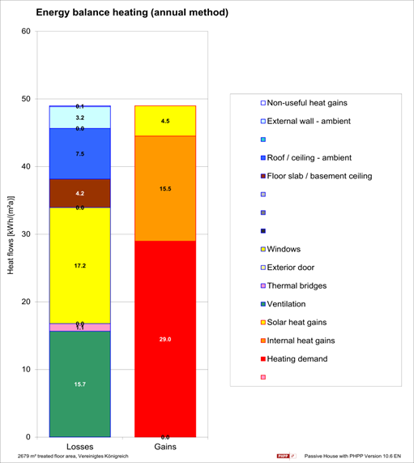

8.11 PHPP Analysis-Impact of replacing windows with Passivhaus Triple -Glazed window
After upgrading from double glazing to triple glazing, it results in a measurable improvement in the building’s thermal performance. In the baseline scenario with double glazing, the annual heating demand is calculated at 31.7 kWh/m²·yr, driven by total heat losses of approximately 51–52 kWh/m²·yr. Following the installation of triple glazing, the heating demand reduces to 29.0 kWh/m²·yr, representing a reduction of approximately 8.5%.

This improvement is primarily attributed to reduced transmission heat losses through the building envelope, particularly at the window element, where improved U-values limit conductive heat transfer. In addition, external wall losses decrease from 5.3 to 3.2 kWh/m²·yr, contributing further to the overall reduction in heat loss. Importantly, internal and solar heat gains are maintained or slightly increased (from 15.0 to 15.5 kWh/m²·yr and from 4.4 to 4.5 kWh/m²·yr, respectively), ensuring that passive heat contributions remain effective. As a result, the energy balance shifts favourably, reducing reliance on active heating systems.

This outcome reflects the principles of fabric-first design, where improvements to the building envelope enhance energy efficiency and thermal comfort (CIBSE, 2021). Furthermore, the results align with the Passivhaus methodology, which emphasises high-performance glazing and reduced heat losses as key strategies for minimising space-heating demand (Feist et al., 2015). Overall, the triple glazing upgrade provides a balanced improvement in energy performance without compromising solar gains.

While the proposed improvements significantly reduce heating demand, the results indicate that ventilation losses remain a dominant factor. This suggests that further optimisation through enhanced heat recovery systems or airtightness improvements would be necessary to achieve near-Passivhaus performance.

Parameter | Double Glazing (Baseline) | Triple Glazing (Improved) | Change
Heating Demand (kWh/m²·yr) | 31.7 | 29.0 | ↓ 2.7 (≈ 8.5%)
Total Heat Losses (kWh/m²·yr) | ~51–52 | ~48–49 | ↓ ~3
Window Losses (kWh/m²·yr) | 17.3 | 17.2 | ↓ slight
External Wall Losses (kWh/m²·yr) | 5.3 | 3.2 | ↓ significant
Ventilation Losses (kWh/m²·yr) | 15.7 | 15.7 | No change
Internal Gains (kWh/m²·yr) | 15.0 | 15.5 | ↑ slight
Solar Gains (kWh/m²·yr) | 4.4 | 4.5 | ↑ slight

9. 0 Cost-benefit analysis

Benefit Analysis (20-Year Lifecycle)
Component | Non-Upgraded Specification | Upgraded Specification | Capital Cost (£) (SPONS) | Annual kWh Saved | Annual £ Saved (£0.254/kWh) | 20-Year £ Saved | ROI (%) | Payback (Years)
Walls | Standard insulation (U ≈ 0.16 W/m²K) | High-performance insulation (U ≈ 0.08 W/m²K) | £80,000 | 5,720 kWh | £1,453 | £29,060 | 36% | 55.1
Roof | Standard insulation (U ≈ 0.15 W/m²K) | Enhanced insulation (U ≈ 0.076 W/m²K) | £75,000 | 8,360 kWh | £2,123 | £42,460 | 57% | 35.3
Windows | Double glazing | Triple glazing (low-E, argon) | £180,000 | 5,940 kWh | £1,509 | £30,180 | 17% | 119.3
TOTAL | — | — | £335,000 | 20,020 kWh | £5,085 | £101,700 | 30% | 65.9

Annual energy saving (kWh/yr)
= Reduction in heating demand × floor area
Annual cost saving (£/yr)
= Annual energy saving × electricity tariff
Simple ROI (%)
= Annual cost saving ÷ capital cost × 100
Payback period (years)
= Capital cost ÷ annual cost saving

9. 1 Cost-benefit analysis / SPONS Justification
The capital costs shown are based on benchmark rates collected from the SPONS Architects' and Builders' Price Book, a widely accepted industry standard for estimating building costs in the United Kingdom. The prices of wall insulation, roof insulation, and triple glazing were determined using a cost-per-square-metre technique based on the expected building element areas and SPONS unit rates. This method assures that the financial analysis represents realistic market circumstances and is consistent with professional cost planning practice.
The use of a 20-year lifespan assessment gives a more realistic evaluation of financial performance, in line with the whole-life costing concepts espoused in RICS advice. Roof insulation seems to provide the best economic return owing to its cheap initial cost and large energy savings. Wall insulation has modest feasibility, however triple glazing has poor financial performance, owing mostly to high installation costs compared to energy savings.
It is critical to understand that SPONS rates are typical benchmark values that may change based on project-specific variables such as procurement route, specification, contractor price, and market volatility. As a result, although the study gives a solid comparative evaluation, comprehensive cost validation via competitive bidding would be necessary later in the project lifecycle.

9. 2 Recommendation
The Innovation Matrix building's research shows that, although the asset operates well, it can be further optimised using a coordinated fabric-first and systems integration strategy. The most important improvement is to the building envelope, primarily via improved roof insulation, followed by exterior wall insulation and triple glazing, which together minimise heat losses and heating demand.
Furthermore, optimisation of the HVAC and MVHR systems is critical, since ventilation losses continue to contribute significantly to total energy consumption. Improved Building Management System (BMS) controls, demand-driven operation, and routine maintenance will all improve system efficiency and indoor environmental quality.
Additional energy savings may be realised by optimising lighting, including the use of smart controls and occupancy sensors, while extending renewable energy systems, such as solar panels and battery storage, would increase energy resilience and minimise grid reliance.
Finally, implementing a strong Planned Preventative Maintenance (PPM) plan will assure long-term asset performance, reduce operational risks, and improve lifetime cost efficiency. To optimize building performance and sustainability, a comprehensive strategy integrating fabric, services, and management systems is recommended.

10.0 References
Allouhi, A., El Fouih, Y., Kousksou, T., Jamil, A., Zeraouli, Y. and Mourad, Y. (2015) ‘Energy consumption and efficiency in buildings: Current status and future trends’, Journal of Cleaner Production, 109, pp. 118–130.
BRE (2020) BREEAM UK New Construction: Technical Manual. Watford: Building Research Establishment.
BSI (2020) BS 8210: Guide to Facilities Maintenance Management. London: British Standards Institution.
CIBSE (2021a) CIBSE Guide B: Heating, Ventilation, Air Conditioning and Refrigeration. London: Chartered Institution of Building Services Engineers.
CIBSE (2021b) CIBSE Guide F: Energy Efficiency in Buildings. London: Chartered Institution of Building Services Engineers.
CIBSE (2023) CIBSE Guide M: Maintenance Engineering and Management. London: Chartered Institution of Building Services Engineers.
Corner, D.B., Füllinger, J.C., and Kwok, A.G. (2018). Passive House Details: Solutions for High-Performance Design. London: Routledge.
de Wilde, P. (2014) ‘The gap between predicted and measured energy performance of buildings: A framework for investigation’, Building Research & Information, 42(1), pp. 41–49.
Evans, H.M.A. (2015) Guide to the Building Regulations. 3rd edn. London: RIBA Enterprises Ltd.
Feist, W., Schnieders, J., Dorer, V. and Haas, A. (2015) ‘Re-inventing air heating: Convenient and comfortable within the frame of the Passive House concept’, Energy and Buildings, 35(7), pp. 1–12.
Feist, W., Schnieders, J., and Dorer, V. (2015). Passivhaus Planning Package (PHPP). Darmstadt: Passivhaus Institute.
Glover, P. (2018). Building Surveys. 8th edn. London: Routledge, Taylor & Francis Group.
HM Government (2015) The Building Regulations 2010: Approved Document F – Ventilation. London: The Stationery Office.
HM Government (2021) Approved Document L: Conservation of Fuel and Power (England). London: The Stationery Office.
International Energy Agency (IEA) (2022) Energy Efficiency 2022. Paris: IEA.
ISO (2018) ISO 50001: Energy Management Systems – Requirements with Guidance for Use. Geneva: International Organization for Standardization.
Pullen, T. (2013) The Sustainable Building Bible. Totnes: Green Books.
RICS (2021) Whole Life Carbon Assessment for the Built Environment. London: Royal Institution of Chartered Surveyors.
Schifman, M.R. (2018) Building a Sustainable Home: Practical Green Design Choices for Your Health, Wealth, and Soul. New York: Skyhorse Publishing.
UWTSD (2023) SA1 Innovation Quarter Development Overview. Available at: https://www.uwtsd.ac.uk (Accessed: 29 March 2026).
Wood, B. (2019) Building Maintenance. Oxford: Wiley-Blackwell.

