

Programme: Master of Business Administration
Module: International Marketing: Principles and Practices
Module code: LCMB7026
Lecturer: Tushara Balendran (London)
Assignment Title: International Marketing: Principles and Practices of BMW in Germany and Australia
Student Name and ID: Shitanshu Pankaj Galledar 2428869
Word Count: 6093
Submission deadline: 19th December 2025

Table of Contents
1. Introduction 4
2. Brand and country overview of BMW 4
2.1. Brief history 4
2.2. Global positioning and brand identity 4
2.3. BMW’s operations in Germany and Australia 5
2.4. Rationale of selecting Germany and Australia 5
3. Comparison of socio-cultural context of Germany and Australia 6
3.1. PESTLE framework 6
3.1.1. Key elements from PESTEL 6
3.1.2. Social Factor Advantage and Disadvantage 9
3.1.3. Comparison of similarities and differences 9
3.2. Cultural factors 10
3.2.1. Hofstede’s six cultural dimensions 10
3.2.2. Similarities and differences of Hofstede 12
3.2.3. Advantage and Disadvantages of Hofstede’s model 12
4. Comparison of BMW’s STP strategies in Germany and Australia 12
4.1. STP Analysis 12
4.2. Similarities and differences of STP 15
5. Comparison of the Marketing Mix (7Ps) in Germany and Australia 16
5.1. Product 16
5.2. Price 17
5.3. Promotion 17
5.4. Place 18
5.5. People 20
5.6. Process 21
5.7. Physical Evidence 21
5.8. Similarities and differences 22
6. Evaluation of marketing strategy performance 23
6.1 Performance in Australia 23
6.2 Performance in Germany 24
6.3 Similarities and Differences 25
7. Evaluation of Marketing Ethics Practice 25
7.1. Ethical issues 25
7.2. Overall ethical judgement 26
8. Recommendations and Conclusion 26
8.1. Recommendations 26
8.2. Conclusion 27
Reference list 28
Appendices 32
Appendix 1: Hofstede’s Cultural Dimensions 32
Appendix 2: BMW 7Ps 33
Appendix 3: Sales, Market Share and Social Media Metrics 34
Appendix 4: EV adoption readiness and consumer behaviour 35

1. Introduction
BMW or BayischeMotorenWerke AG is one of the most reputable motor vehicle producers in the world and it is located in Munich, Germany. BMW has become a universal icon of high performance, creative and manufacturing quality. However, the brand in the luxury automotive industry with its competitors such as Mercedes-Benz, Audi, and Lexus has a wide range of products, in terms of internal combustion, and EVs under BMW i-series. The brand image of BMW is attached on the potential of delivering Ultimate Driving Machine that embodies the focus of the company on its design and technological development being performance-driven. BMW AG's automobiles are marketed under the BMW, Mini, and Rolls-Royce brands while its motorcycles are marketed under the BMW Motorrad brand. In 2023, BMW became the world's ninth-largest producer of motor vehicles with 2,555,341 vehicles made) as well as 6th largest automaker by revenue.
In this report, Germany and Australia are the two countries that will be compared. Germany is a country where BMW has its home market from where its history, production, and research and development facilities are centralised. It is also a leading automotive market in Europe that is technologically sophisticated with strict environmental policies. Australia in case is a key global market where BMW plays a role of an importer and retailer of luxury cars in the market. The Australian automotive industry is lesser and shows promising growth in the sale of high-quality vehicles, in the category of Sports Utility Vehicle (SUV) and Electric Vehicle (EV). The comparison enables a critical assessment of how BMW is changing its marketing strategies in response to varying macroeconomic, cultural, and regulatory conditions.
The key aim of this report is to offer a critical analysis of the marketing strategies of BMW in Germany and Australia. It will focus on how the brand can fit into 2 markets based on macro-environment factors (PESTLE), Segmentation Targeting Positioning (STP) and Marketing Mix (7Ps). The report also measures the effectiveness of these strategies based on quantifiable performance variables like sales volume, market share and brand name and evaluation of marketing ethics and suggestions on future strategic improvement.

2. Brand and country overview of BMW

2.1. Brief history
BMW was established in 1916 in Munich, Germany, where the company was initially producing engines used in aircrafts but later ventured into other activities such as producing motorcycles in 1923 and automobiles in 1928. BMW was at the centre of the reincarnation of the German industry following the war and it became one of the leading makers of high-quality automobile. BMW operates across 140 countries at present with electrification and digital innovation being a part of its long-term vision. BMW became an automobile manufacturer in 1928 when it purchased Fahrzeugfabrik Eisenach, which, at the time, built Austin 7 under licence from Automobilwerk Eisenach, badged as the Dixi.

2.2. Global positioning and brand identity
BMW is positioned as a “luxury premium car manufacturer" across the world that is offering Ultimate Driving Machine to focus on performance and innovation. The brand competes in the luxury car market competing with other automakers like Mercedes-Benz Audi, and Lexus. From the article published in BMW Group (2019), the premium image of BMW is strengthened by its emphasis on driver-centric experiences, emotional storytelling, and product excellence. Over the past years, BMW has been putting more resources in electromobility, with the BMW i-series taking forefront of its innovation initiatives. This change aligns with sustainability vision of BMW Group in order to be carbon-neutral and supply chain responsible (BMW Annual Report, 2024).

2.3. BMW’s operations in Germany and Australia
Germany is the home market and centre of innovation of BMW, as it has its global headquarters in Munich (BMW Group, 2019). The country is home to major manufacturing and research facilities such as Munich, Dingolfing, Leipzig, and Regensburg that contribute a big portion of the global output of BMW. German consumers see BMW as a national symbol of engineering perfection, and a combination of luxury and reliability.
BMW first entered the Australian market in 1979 as BMW Australia Ltd with headquarters in Mulgrave, Victoria. The company functions as an importer and distributor, and has a wide network of dealerships in Sydney, Melbourne, Brisbane and Perth. In 2023, BMW Australia registered a record sale of 26,184 units, which was 15.4% above the 2022 sales. According to Brogan (2023), it had a market share of 2% for becoming the highest selling German luxury car brand in Australia. Its sales were dominated by SUVs, which is more than 61.6% of its sales with BMW X1 and X3 being the most popular.

2.4. Rationale of selecting Germany and Australia
Germany, being the home market for BMW and largest car market of Europe integrates strong purchasing power, advanced EV and plug-in hybrid vehicles and premium demand of vehicles. In contrast, Australian market is specifically important to universal growth strategy by BMW, as it is a dynamic luxury market where consumer interest in SUVs and EVs is on the rise. By comparing these 2 markets, it allows evaluating how BMW adopts product portfolio, branding and channel strategies to different regulatory and mobility conditions. During its operation, BMW was based in its country of origin, Germany where it produced and was a full market. Australia is a host country, which is entered by import distribution. BMW ventured into Australia to tap a luxury and SUV market. The Uppsala model reflects its gradual international development that includes entering distant markets by strengthening operations in nearby areas.

3. Comparison of socio-cultural context of Germany and Australia

3.1. PESTLE framework
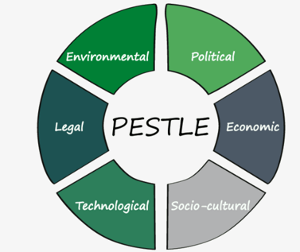
Figure 1: PESTLE Framework
(Source: Buehring, 2023)

3.1.1. Key elements from PESTEL
Political:
Germany: In case of political factors, Germany has a stable parliamentary democracy within the EU. The single market has favourable policy environment to support advanced manufacturing, exports and cross border trade.
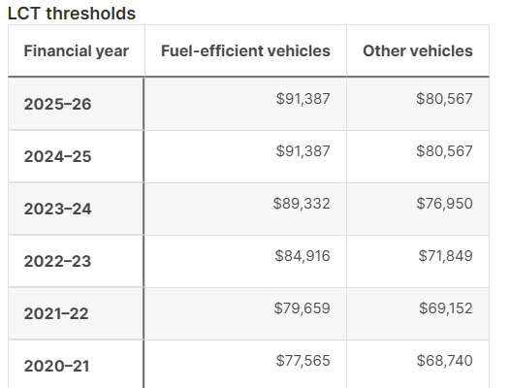
Figure 2: LCT (Luxury car tax) thresholds in Australia
(Source: ATO, 2025)
Australia: This country is a secure and free economy and has strong trade links to Europe and Asia. The existing LCT (Luxury car tax) thresholds 91,387 Australian dollars in fuel-efficient vehicles while 80,567 AUD in other vehicles (ATO, 2025).
Favourable and Unfavourable
The stable political environment is favourable for BMW, as it will allow the organisation to smoothly run the business operations and make significant investments. However, luxury car tax is unfavourable as it creates challenges to increase sales and generate profit margins.
Economic:
Germany: Germany remains a key automotive hub with large base of suppliers, labour force, and good logistics. The car market in 2025 is negative by small margin, as the level of registrations has declined by about 0.4% to an estimated figure of 2.10 million (Focus 2 Move, 2025). The increased investment done by BMW for the electrification of their drivetrain systems, which is responsible for providing power to the wheels that can increase its costs significantly.
Australia: The market is not as big as Germany but is still appealing to the premium brands. In 2023, there were 26,184 vehicles sales in 2022, which equals to 2% of the market share, which made BMW a high-selling German luxury brand in Australia (Brogan, 2023).
Favourable and Unfavourable
The growing eco-friendly automobile market is favourable for the organisation as it enables BMW to increase production and attract more customers to spend on the premium cars. On the other hand, high import price is unfavourable as it can increase operational costs, thereby, reducing operational risks.
Social:
Germany: Towards social factors, there is a high disposable income and loyalty of German consumers on local high-end brands. Environment awareness is strong in Germany, since the customers consider sustainability and actual world efficiency. BMW is focused on increasing its customer satisfaction. Apart from growing customer satisfaction from its vehicles itself, BMW aims to provide extra services to improve their experience.
Australia: Australian consumers are very fond of SUVs and lifestyle cars. According to Brogan (2023), 61.6% of its sales of BMW in Australia include the X series SUV with X3 and X5 being the top models. However, marketing leans into space, versatility, safety, and adventure-oriented image that increase performance and status of the brand.
Favourable and Unfavourable
The increasing disposable income is favourable for BMW as customers would be able to spend on luxury vehicles, which will support the company to boost sales. Apart from that, intense local competition is unfavourable as customers have the option to switch to alternatives.
Technological:
Germany: BMW markets connected services and premium digital experiences to define perceived value towards purchase in Germany. BMW has opened an Autonomous Driving Campus in Germany recently which will be a organiser in designing of the automated vehicles. The Campus has formed around 1300 jobs for the people belonging to the IT sector.
Australia: In Australia, BMW uses new technology, content collaboration, and engagement mechanisms to launch electric models to the new customers (WARC, 2024).
Favourable and Unfavourable
The growth of EV infrastructure is favourable for BMW as it will significantly support the business in increasing the production of EV vehicles and invest in R&D. However, constant upgradation of technology can be costly for the business as it can increase operational, R&D and innovation costs.
Legal:
Germany: Legally, Germany places high standards on emissions, data protection and safety. In addition, there are strict EU emissions law, and high data protection, which needs to be followed by companies like BMW.
Australia: Australia has its own safety guidelines, consumer legislation and emissions rules. In this country as well, there are strict safety laws while import duties increase costs.
Favourable and Unfavourable
Legal compliance to consumer data protection and safety is favourable for the company as it helps in building consumer and stakeholder trust. However, there can be production complexity due to stringent legal standards, as it will require making continuous adjustments in marketing and production activities.
Environment:
Germany: The policy and consumer sentiment of Germany favour electrification of products segments. Therefore, there is high ecological expectations and strong EV push.
Australia: Towards environmental factors, EV-centric marketing has emerged as a strategic tool in Australia to protect premium positioning and access growth of zero emission segment. Apart from that, there is increasing climate issues but adoption slower.
Favourable and Unfavourable
The development of EV infrastructure and green technology is favourable to BMW as it considerably helps in expanding EV charging stations, which will not only help customers but will contribute in reducing carbon emissions. On the other hand, pressure to meet high environmental standards on regular basis is unfavourable for the company as can increase R&D and operational costs.

3.1.2. Social Factor Advantage and Disadvantage
The social environment of Germany is usually favourable to BMW since consumers have high buying power and strong culture of premium engineering. Besides, BMW holds 6.9% of German car market, which reflects trust in local luxury brands (Focus2Move, 2025). However, German customers appreciate safety, efficiency, and sustainable mobility, which align with rising electric product line of German cars and increasing national interest in low emission transport. In Australia, the favourable conditions include lifestyle culture on space, comfort, and status display. Such preferences reinforce the SUV success of BMW whereby 61.6% of the sales include the X-series (GoAuto, 2024). Further, rising urban interest in electric mobility promotes i-series, which is promoted by technological campaigns. Moreover, Germany has very high sustainability expectations on the society that raises more questions on claims made by BMW on emission. In quest, EV reluctance remains a problem in Australia because of range anxiety and lack of familiarity with charging, which is delaying the transition to full electrification.

3.1.3. Comparison of similarities and differences
The macro-environment in Germany and Australia has a number of similarities that influence operations of BMW. The political systems of both nations are stable, while the populations of these countries include high-income ones, as the customers are willing to buy high-quality cars. These factors help BMW in sustaining luxury image and enable the company to have standardised brand image in both markets. Sustainability is also becoming a significant value in both countries, and this prompts BMW to market its electric and hybrids. In addition, both markets appreciate hi-tech technology, high safety and electronic features, which align with innovation-driven approach of BMW. Thus, both nations offer attractive opportunities to a high-end brand that seeks strong customer loyalty and long-term market presence.
Nonetheless, some differences are obvious. Germany i.e. is the native country of BMW has advantages in terms of manufacturing, better brand understanding, and greater confidence in quality of engineering. In case, Australia is fully import-reliant, which increases the expenses and sensitivity of prices owing to LCT (ATO, 2025). Another aspect lies in cultural expectations, as German buyers are focused on technical accuracy and sustainability, whereas Australian buyers are focused on comfort, lifestyle and SUVs. The regulatory conditions also differ, where Germany has high EU emission requirements, and Australia has less regulatory pressures but higher import barriers. These variations require BMW to use modified pricing, product orientation and marketing methods in both markets.

3.2. Cultural factors

3.2.1. Hofstede’s six cultural dimensions
According to Chessum, Liu and Frommholz (2022), Hofstede’s cultural dimensions analyse the six key elements, which will be analysed in case of BMW’s cultural orientation in Germany and Australia, as shown in the figure below. In case of Power distance, Germany scored 35, which indicates that people like flat structures, open communication and face-to-face communication. This is effective in case of BMW, since the German consumers will demand transparent information about products and technical explanations. On the contrary, Australia has a slightly higher score of 38, which indicates that customers also do not enjoy strict hierarchy but prefer a relaxed social environment. Towards individualism, the score of Germany is 79, where people value individual success but tends to consider collective values like responsible consumption (Culture Factor, 2020). This is favourable to BMW’s German engineering identity because customers associate ownership to cars with competence and reliability. Australia records a score of 79, which shows one of the individualistic societies. For instance, BMW consequently puts focus on customisation, status, lifestyle fit, and personal freedom in Australian campaign than in Germany. (Refer to Appendix 1).
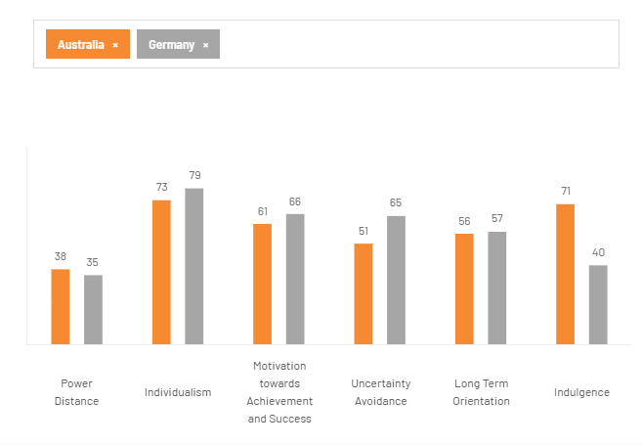
Figure 3: Hofstede’s key dimensions on Germany and Australia
(Source: Culture Factor, 2020)
The masculinity index of Germany is 66, which is an indicator of a competitive culture with emphasis on technical success and achievement. This favours performance-oriented messaging of BMW like the M-series or Ultimate Driving Machine (BMW Group Press, 2024). In contrast, the score of 61 in Australia is low sine Australians are competitive by owning comfortable and high-status SUVs, which aligns with the country high BMW X-series cars purchases. Towards uncertainty avoidance, Germany scores 65 that define its focus on safety, longevity, battery testing and long-term reliability in marketing EVs. In quest, Australia scores 51, which indicates that people are less apprehensive about new technologies. This is the reason why online advertising of i-series by BMW in Australia works well and they are likely to embrace new technologies in interior and infotainment in cars. In case of long-term orientation, both countries have a similar score line of 57 in Germany and 56 in Australia, which evidences that BMW has to emphasise on instant savings, performance or car comfort, instead of long-term sustainability (Culture Factor, 2020). Towards indulgence, Germany scores 40, which analyses its restrictive culture, as German buyers appreciate high quality vehicles but do not highlight their luxury. In contrast, Australia scores 71, which shows that people like to be comfortable, happy, and noticeable. For instance, BMW capitalises by promoting design, enjoyment and spacious comfort, which is aligned with the Australian market for long-distance driving, holidays and outdoor activities.

3.2.2. Similarities and differences of Hofstede
The similarity is analysed by high individualism that favours BMW to emphasise on personal identity, luxury and success .Australia is very high to reinforce BMW to sell their cars as a lifestyle and an achievement symbol since (Brogan, 2023). Further, high masculinity and high uncertainty avoidance of Germany fits BMW’sestablished strengths in terms of precision, engineering and safety. The high level of indulgence among Australians also stimulates demand of premium comfort that aligns with strong purchases of BMW’s SUVs. However, the low long-term orientation in either economy offers differences that undermine EV narratives based on future benefits. The high uncertainty avoidance level in Germany means that EV adoption will be slower unless BMW presents a lot of durability and safety. The low indulgence score in Germany restricts pleasure-driven advertising, where BMW needs a more restrained communication approach (Refer to Appendix 4).

3.2.3. Advantage and Disadvantages of Hofstede’s model
The cultural bias in terms of precision, quality and technical achievement supports BMW as a high-quality engineering brand. Both markets are very receptive to high performance messages, as masculinity scores are high. Further, high level of indulgence will be a great boost to BMW’s SUV market and X-series vehicles. The moderate uncertainty avoidance also enables buyers to be more receptive to BMW’s digital features.
The high uncertainty avoidance slows radical innovation acceptance, which demands BMW to offer more safety and testing data on EVs. The market having a very high individualism means that personalisation is highly demanded, and this increases the costs of adapting BMW. Both markets have low long-term orientation, which decreases the efficiency of sustainability-led messaging. This forces BMW to focus on instant lifestyle rewards instead of long-term environmental gains.

4. Comparison of BMW’s STP strategies in Germany and Australia

4.1. STP Analysis
Segmentation
Demographic
In Germany, BMW focuses its marketing efforts mostly on high-end professionals, and car enthusiasts who attach prestige and identity to owning a vehicle demographically. In Australia, the segmentation of BMW is based on wealthy urban residents, SUV buyers, EV buyers, and luxury buyers whose lifestyles are driven by status for age group of 18-45.
Psychographic
In case of psychographic factors, the German consumers appreciate engineering accuracy, safety and technology that reflect national pride of automotive technology (Sauer et al., 2020). In case of psychographic factors, buyers of Australia are driven by status, comfort, and technology, as they seek the brand to symbolise success and uniqueness.
Behavioural
The behavioural factors of Germany include development of an environmentally aware consumerism that has caused BMW to divide clients willing to buy electric mobility, which can be observed in its advertisement of BMW i-series (i4, iX, and i7). However, the lifestyle orientation can be evidenced by supremacy of SUVs in the national market where majority of BMW sales in Australia are of X-series (Brogan, 2023).
Geographic
The target group is comprised of high-income level people of ages 30-60 who live in metropolitan areas of Sydney, Melbourne or Brisbane.
Targeting
Germany
BMW, Germany uses differentiated marketing where they target high-income earners that require best performance, crafts, and brand history. The company’s message, “The Ultimate Driving Machine”, reinforces emotional and rational appeal of design, power, and innovation (BMW Annual Report, 2024). The target professionals include people aged from 30-55, which BMW focuses through campaigns having disposable income and believe in advanced driving technologies, digital connectivity, and environmental responsibility. BMW i-series will be sold to early consumers of electric mobility, whereas the models of M-series will be offered to those who value speed and accuracy (BMW Annual Report, 2024).
Australia
In Australia, BMW uses a concentrated targeting strategy to focus on SUV buyers and lifestyle-driven customers. For instance, the success of X-series of SUVs shows that BMW concentrates its marketing on dominant segment, rather than multiple groups. BMW, Australia uses a narrow targeting approach on high-end market to increase its range of EV customers. Its advertising is suited to consumers who are interested in luxury SUVs and performance sedans, but it also has been encouraging sustainability and innovation with its EV models (BMW Annual Report, 2024). The firm will specifically aim at EV-based wealthy customers, since EV penetration in Australian urban centres is rising. The marketing campaign, like “forwardism by BMW”, emphasises on new design and new technology that appeal to younger and tech-savvy consumers.
Positioning
BMW plays an significant role in the automobile industry. Continuous brand awareness of its product offerings has been an important reason for luxury cars to be known as the ultimate driving machine. BMW Cars like Rolls Royce and Electric Cars are luxury cars that every upper-class individual and families covet over any other car or brand because the riding experience is sheer luxury. BMW has positioned itself as a brand like no other.
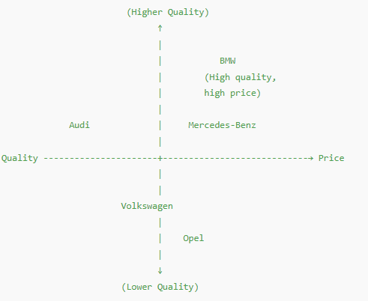
Figure4: Positioning map of BMW in Germany
(Source: Self-created)
In Germany, BMW markets itself with a German engineering culture that integrates luxury, accuracy, and performance. BMW Annual Report (2024) claimed that its marketing policy in Germany focuses on innovation-based differentiation to shore up a high-quality technological image. The local advertising of BMW focuses on its heritage that is made in Germany to establish credibility and trust among local buyers, where it competes with Audi, Mercedes-Benz, Opel and Volkswagen. The launch of NeueKlasse EV platform in 2025 will help BMW to position itself as a luxurious brand that to evolve into future in its native country.
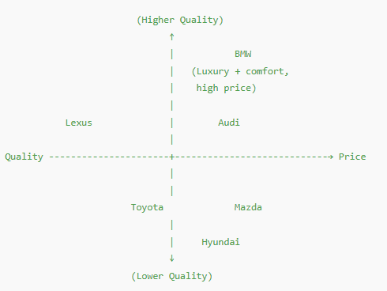
Figure5: Positioning map of BMW in Australia
(Source: Self-created)
In Australia, BMW positions as a luxury brand, which integrates engineering and performance with technological mobility to suit nation’s lifestyle market, with competitor such as Lexus, Audi, Mazda and Toyota. BMW in Australia also emphasises dominance, mostly on premium cars, as the sales in 2023 was 26,184 units in SUV share (Misoyannis, 2024).

4.2. Similarities and differences of STP
There are certain similar strategies employed by BMW in Germany and Australia. In both locations, it targets high-income customers or individuals who prefer high-quality products and customers that are fond of modern technology. In these two markets, segmentation is based on income, age and lifestyle. A similar positioning is also maintained by BMW, where it is promoted as a high-quality and luxury brand with strong performance and additional features.
The differences however arise from what each country values. The interests in engineering, quality and EV technology influence segmentation in Germany. The segmentation in Australia is related to lifestyle, comfort and SUV-oriented. The targeting of BMW in Germany is differentiated, as it includes the EVs, performance cars and premium sedans. In Australia, the focus on targeting is narrower and more focused on SUV and comfort-seeking buyers. In Germany, positioning emphasises precision and engineering whereas in Australia emphasis is put on comfort, adventure and practicality.

5. Comparison of the Marketing Mix (7Ps) in Germany and Australia
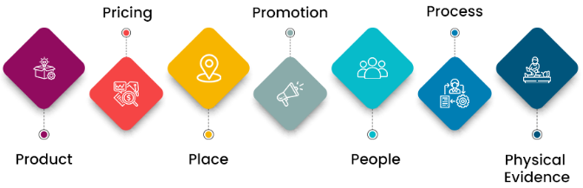
Figure 6: 7Ps of Marketing Mix
(Source: College Vidya, 2024)
(Refer to Appendix 2)

5.1. Product
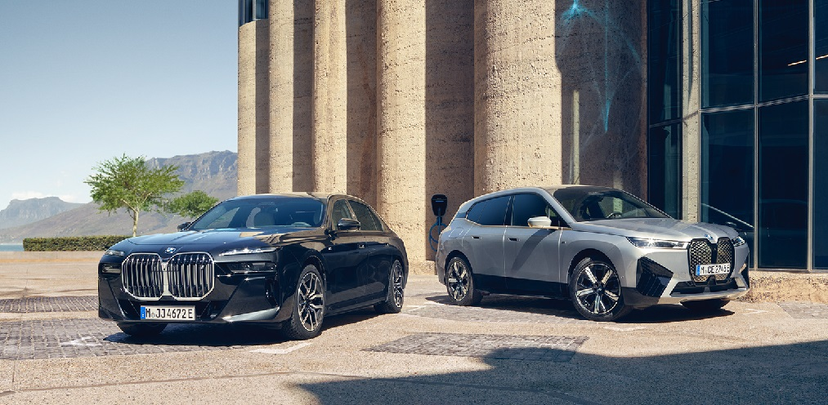
Figure 7: BMW Models, Germany
(Source: Mobility Portal, 2024)
Product Width
In Germany, BMW offers an extensive product width, such as sedans, coupes, EVs and M-performance cars, with deep options like multiple engines, trims and technology packages.
Product Depth
Considering product depth, it can also be mentioned that BMW has extensive trims and configurations, special editions and localised variants such as Alpina models. BMW plays an important role in the automobile industry as it is one of the prominent manufacturers of both four-wheel and two-wheel automobiles for the worldwide market.
The brand strategy used by BMW in both countries is quite similar as it positions itself as a high-end, innovative and performance-driven manufacturer. Nonetheless, the engineering accuracy is more important to Germany, whereas comfort, versatility and SUV practicability are important to Australia. In Germany, the core product is based on sedan performance (3-Series, 5-Series) and high-performance EVs (i4, iX).
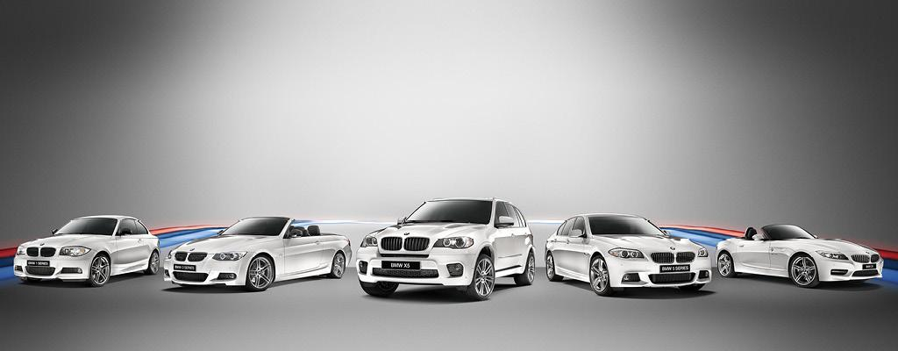
Figure 8: BMW M Models, Australia
(Source: Tutu, 2025)
Product Width
In Australia, the core emphasis is on X-series SUVs that constituted 61.6% of BMW national sales in 2023 (GoAuto, 2024).The width focuses mainly on SUVs (X1-X7), EVs (iSeries), Z4 roadster and M performance cars.
Product Depth
The depth includes comfort features, heat-protection packages, lifestyle add-ons, and fewer trims.
Besides, packaging is also standardised globally, but Australian versions include more heating features, coloured glass and a larger interior storage due to weather conditions and lifestyle. Both countries have auxiliary services, which includes BMW Connected Drive (BMW of Roseville, 2025). However, digital innovations and autonomous driving updates are higher in Germany due to specific favourable regulations that support earlier testing. Hence, BMW standardises its overall design but adapt variants, trims, battery sizes, and climate packages between Australia and Germany.

5.2. Price
BMW follows a premium-pricing objective in both markets but adjusts the end-price point because of taxes and local cost base. Germany is highly dependent on competitive pricing by maintaining prices at a close level with Mercedes and Audi. For instance, the 2024,BMW 320i Cabriohas a price of around €51,500 in Germany (E90 Post, 2024). Further, value-added pricing is applied to Australian cars since the effect of import duties and LCT increases price extremely. The 320i begins at approximately A$63910, which is quite higher in Germany(Cars Guide, 2024). This variation is mainly due to the 33% LCT applied above a threshold ofA$80,567 for petrol cars. BMW adapts its premium pricing, but changes the actual prices in response to taxes, delivery expenses, and local competition. The marketing strategy of BMW Group ensures that the brand has adopted a premium pricing strategy for its products because BMW is a premium car brand with a high production cost.

5.3. Promotion
The promotional objectives of BMW in both countries are focused on high-end brand building, digital innovation and sustainability. However, the tone and attraction are different. The media advertising in Germany is focused on accuracy, quality engineering, EV efficiency, and responsible mobility. Further, German campaigns have used technical credibility that is backed by EU policy and sustainability claims. Besides, BMW’s communication highlights the use of advanced battery technology and innovation, which reflects high sustainability standards in Germany. On the other hand, BMW Germany use various sales promotion strategies such as loyalty programs, carrying out seasonal campaigns and limited time offers on hybrid and EVs model. In case of public relations, the organisation conducts PR campaigns and media coverage to create awareness about the products. In addition, heavy investment is done by the organisation in AI-driven personalisation and influencer-led campaigns to engage German customers. The most popular slogan of the luxury vehicles brands BMW AG is the “Ultimate Driving Machine”.
In Australia, BMW uses lifestyle, comfort and adventure-based appeals. Moreover, the recent EV marketing of BMW and “Forwardism” campaign uses bold images and aspirational narratives to appeal younger demographic (WARC, 2024). Australian digital and social media tactics are more aggressive since it has more users on Instagram and YouTube. Germany is more concerned with product configurators and technical instructors. Hence, the core brand is standardised, but the tone of messages and emotional appeal to the emotions are adapted. In addition, sales promotion by BMW Australia is tailored to lifestyle buyers and campaigns are conducted around performance and SUVs vehicles. Moreover, the organisation sponsors sports such as Australian Open Tennis, which helps in building strong brand image. In addition, EV storytelling is used for engaging targeted customers.

5.4. Place
Germany
BMW GROUP
Indirect Channels
Direct Channels
Company-owned showrooms
Online direct ordering/website
Authorised Franchise Dealers

Used-Car Networks

Third-party marketplaces
Figure 9: Distribution Channels- BMW Germany
(Source: Self Developed)
The distribution channel in Germany is shorter as BMW is produced locally, as it direct channels, like BMW-owned showrooms, authorised dealers and online configurators. In context to indirect channels, the organisation operates through authorised independent dealers, used dealer network and third party brokers or marketplaces.
Australia
BMW GROUP
Indirect Channels
Direct Channels
Company-owned retail sites
Corporate/Fleet Sales
Authorised Franchise Dealers
Used-Car Networks
Brokers/Marketplaces
Figure 10: Distribution Channels, BMW Australia
(Source: Self-Developed)
In Australia, BMW relies on the indirect channels, which include independent dealers, leasing/fleet resellers, authorised franchise dealers, independent used-car dealers and import distributors since all vehicles arrive from the overseas. Australia is fully adapted on imports, which has led to increased supply chain such as sea freight, customs clearance and land transportation. The direct channels include BMW Group Australia and company-owned retail sites and corporate/fleet sales.
Market entry mode
Australia uses an export-based market entry, as the dealer networks are located in Sydney, Melbourne and Brisbane. This has ensured the advantage of investment risk along with flexibility, and reduced operational complexity (Divrik, 2023). Further, the disadvantages are linked with longer delivery times, limited configuration options along with dependency on import regulations of the country.

5.5. People
In Germany, the employees of BMW dealerships are trained well in technical knowledge to reflect customer expectations towards engineering accuracy. Germany has over 80000 BMW employees with focused motivation and technical training (Hoffmann-Topp, 2025). The German’s service culture is formal, detail-oriented and aligns with precision values in case of standardisation. Further, it is to be indicated that advanced technical training in EVs, AI and Industry 4.0 technologies are provided to German staff. In addition, career development pathways, competitive salaries and performance-based bonuses help in motivating staff to make significant contribution to the organisation.
Australia has conversational customer service culture, where staffs emphasise on relationships, comfort, and lifestyle in contrast to deep technical explanation. Moreover, Australia has about 1500 staff in terms of dealerships, focused in product knowledge and customer services, which is supported via incentives and ongoing BMW academy programme (Dowling, 2020). On the other hand, BMW emphasises on providing product knowledge and customer service training, which are customised according to the local market. In addition, EV education is provided to assist growing electric line-up. Further, incentives are offered based on customer satisfaction and sales performance along with using recognition programs for motivating the employees.

5.6. Process
Both the markets include digital booking systems, online configurations and BMW Connection Drive services (BMW of Roseville, 2025). German buyers, however, desire a well-organised, evidence-based experience when making a purchase like technical specifications, efficiency, and sustainability details. In Germany, customers use BMW’s online portal and authorised service centres for the fast technical review. The Australian customers standardise with a high-comfort experience with test-drive options, prompt update on delivery, and after-sales convenience. In Australia, complaints go via dealers, BMW Customer Care, and ACCC-supported resolution process. The low uncertainty avoidance of Australia will be favourable to faster acceptance of new digital tools.

5.7. Physical Evidence
(Refer to Appendix 5)
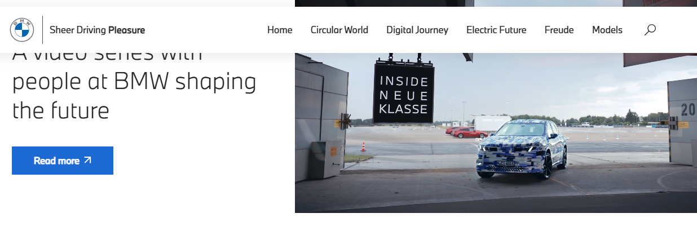
Figure11: Website of BMW Germany
(Source: BMW Germany, 2024)
Germany has large high-end showrooms that specialise in technical exhibitions, minimalistic style, and engineering tradition. BMW Welt in Munich serves as a flagship experience centre in terms of innovation and sustainability (BMW Welt, 2023). Further, BMW staff uniforms reflect engineering heritage of the organisation and are customised according to cold weather and factory environments. The colour scheme of the uniform includes black, white and navy.
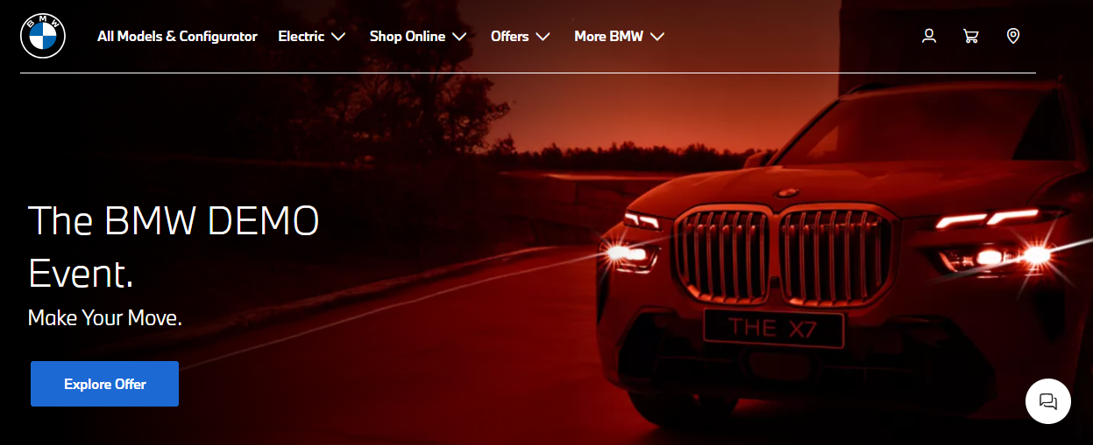
Figure12: Website of BMW Australia
(Source: BMW Australia, 2025)
The Australian showrooms are visionary towards the lifestyle exhibitions, like SUVs displays, interior comfort zone and outdoor visuals. BMW website in Australia allows customers to browse all BMW models and provide options to customise the design, colours, trims, etc. Uniforms of BMW staff in Australia are adapted for climate and comfort and same colour scheme is used like in Germany.

5.8. Similarities and differences
In Germany and Australia, the dealership staffs undergoes structured BMW training while showrooms follow universal premium design guidelines with signature lighting and branded zones. However, there are certain differences. The People dimension in Germany is oriented to technical skills, where advisers offer extensive engineering-related explanations, whereas in Australia the priorities are on relationship and casual communication. The Process element of Germany is more structured with technical briefings while Australia prefers flexible test-drive arrangements. Physical Evidence is also different, as German stores emphasise engineering tradition and EV development, whereas in Australia, the showrooms are lifestyle-oriented with emphasis on SUVs and comfort-related design.

6. Evaluation of marketing strategy performance

6.1 Performance in Australia
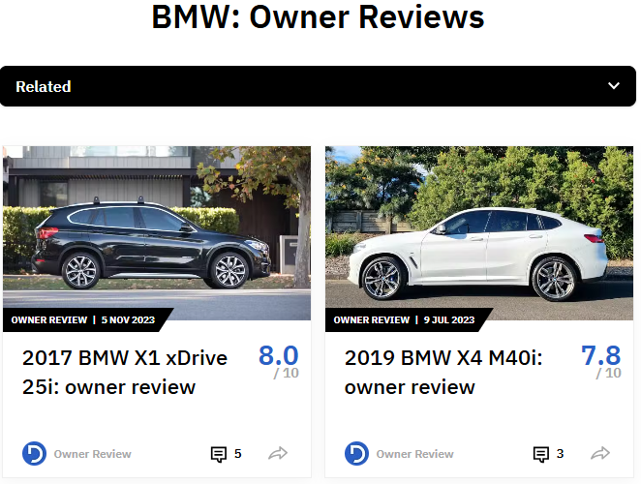
Figure13: BMW Australia customer reviews
(Source: Drive, 2025
The performance of BMW in Australia has improved remarkably, with the high demand of high-end SUVs and effective digital marketing. BMW has sold 26,184 vehicles in 2023 through its 56 official locations, registering 15.4% annual growth (GoAuto, 2024). BMW in Australia benefits not only from strong sales growth but also from active digital engagement. This success can be attributed to superiority of the X-series where SUVs accounted over 61.6% of BMW sales globally. This means they are strongly aligned with the lifestyle preferences in the Australian market. Further, BMW’s digital and social media plan in Australia is also effective. A recent national digital campaign attained a 48%engagement rate and 62% growth in website traffic among high-income segments (Adcreators, 2025). These data reveal the presence of a younger tech-orientedurban buyer in Sydney, Melbourne and Brisbane. However, the feedback on customers is generally favourable, asProductReview.com.au indicates a steady demand of comfort, interior design and infotainment technology of BMW(Product Review, 2025). Moreover, there is also high awareness because BMW attends partnerships and luxury lifestyle events at Australian Open. Moreover, BMW’s global sales reached 2.55 million units in 2023 to meet EV targets and develop profitability of the group(BMW Group Press, 2023).

6.2 Performance in Germany
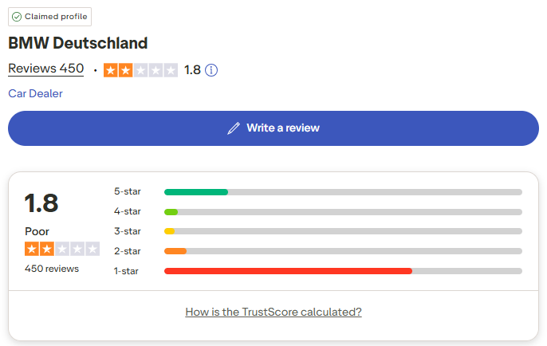
Figure14: BMW Germany customer reviews
(Source: Trustpilot, 2019)
Germany is still the best strategic market of BMW because of brand heritage, engineering credibility and well-developed dealer network. BMW and MINI sold 281,986 vehicles from over 800 official storefronts in Germany in 2023, which is 11.7% more than the last year (BMW Group Press, 2023). This volume makes Germany a major single country leader in BMW’s European performance. Further, brand heritage is another key strength. The brand image of a German engineering icon also helps BMW to have strong loyalty among the local consumers. The domestic market of luxury cars is competitive in Germany, but BMW ranks top three car brands, which are competing with established brands like Mercedes-Benz and Audi. The expansion of market share is facilitated by the EV launch of BMW, which includes i4, i5 and iX that is based on the sustainability transition in Germany(BMW Group, 2024). The recent data from a social media shows that BMW Germany’s Instagram account with or 327,000 follower’s posts regularly and receives engagement rates around 1.45%-1.46%, which is above many competitors in automotive industry (Social Insider, 2025).
However, the retention of customer loyalty is due to extensive after-sales network of BMW. German customers are also demanding a high-level of service accuracy, which can be achieved through BMW service centres that offer state-of-art diagnostics and maintenance to increase repeat buying behaviour. The larger percentage of EV and plug-in hybrid sales in Germany reflects trust in technical leadership of BMW. As the profit margins are influenced by European regulatory costs, the global automotive EBIT margin of BMW Group reached to 9.8% in 2023(Sychev, 2024).
(Refer to Appendix 3)

6.3 Similarities and Differences
It can be analysed that both markets are strong performers, although they succeed for diverse reasons. Australia is increasing more rapidly with 15.4% growth in 2023, because of SUVs demand, lifestyle-oriented campaigns and strong online presence(GoAuto, 2024). Germany in case offers more volume with 281,986 units and long-term strategic stability with brand heritage, customer loyalty and after-sales network. Australia has done well in growth rate, engagement and responsiveness due to flexible and concentrated SUV portfolio. Moreover, Germany does well in absolute sales volume, EV adoption and brand loyalty through engineering value, heritage and regulatory alignment. In Australia, BMW has achieved success through adaptation-SUV focus, high level of digitalisation and strong promotional stories (Refer to appendix 4). In Germany, success is based on the foundation of heritage marketing that is characterised by accuracy of engineering and transition to EV that is backed by high level of customer trust.

7. Evaluation of Marketing Ethics Practice

7.1. Ethical issues
Segmentation and targeting
BMW focuses on high-income earners, urban professionals and lifestyle consumers that are motivated in Australian cities of Sydney, Melbourne and Brisbane. This kind of segmentation is ethically right when it indicates purchasing power, although the issue of economic exclusivity arises concerns. The presence of premium SUVs and luxury accessories may involuntarily reinforce social inequality by promoting aspiring products far beyond average affordability. Nevertheless, BMW does not target any vulnerable segments or target low-income segments, which align with expectations of responsible segmentation.
Standardisation vs. adaptation
The ethics of BMW’s adaptation strategy in Australia like heat mitigation features, large interior space and lifestyle-oriented car is acceptable because it aligns with climate and customer demands. Besides, problems arise when certain features accessible in Germany are being delayed, which develops an ethical question regarding fairness in universal product access. However, BMW tends to keep global safety and engineering standards for minimising the possibility of inequality of products(BMW Group, 2024).
Pricing and LCT
Pricing is the most serious ethical concern. The 33%LCT in Australia makes the cost of final vehicles much higher, like the BMW 320i around A$63910, which is quite higher than cost of the car in Germany (ATO, 2025).
Advertising ethics
The lifestyle-oriented advertising undertaken by BMW has a high degree of emotional appeal, i.e. adventure, status, comfort, without the use of misleading claims. EVs have sustainability messages that correlate with reality. Ethical issues can be seen where promotional storytelling overshadows the cost transparency, mainly for imported models.

7.2. Overall ethical judgement
The ethics of marketing that can be analysed in relation to BMW in Australia using Cultural Relativism and Justice Approach. According to Cultural Relativism by Österman (2021), the marketing of BMW aligns well with the Australian culture. Cultural relativism is the view that the values (such as moral values) of a culture must be understood in their own cultural context and not judged according to the standards of a different culture. Besides, Australia scores high on individualism and indulgence, which means that consumers value brands that emphasise on lifestyle, pleasure, and personal success. Further, BMW’s key focus on SUV comfort, premium identity, and long-distance suitability fits naturally with the expectations. The emotional narrative of BMW, application of outdoor images, and promotion of convenience-based technology are not manipulative but culturally appropriate. This implies that BMW does not impose overly German-centric messaging, which can offend the local norms, but conversely respects them.
From the Justice Approach, BMW defines its key strengths and weaknesses (Call et al., 2022). The justice approach is a moral framework that evaluates the ethics of an action based on its adherence to principles of fairness, equality, and individual rights. This focuses on ensuring that all people are treated justly and that no one is unfairly disadvantaged or discriminated against. BMW is procedurally fair, as it offers clear information about products, makes honest sustainability claims, and offers uniform service quality across dealerships. Besides, there is no sign of false advertising or exploitative labour. In quest, distributive fairness is however difficult. The integration of BMW’s premium pricing and LCT in Australia makes the cost of the vehicles much higher in contrast to vehicles prices in Germany.

8. Recommendations and Conclusion

8.1. Recommendations
For Germany
- For developing its EV strategy, BMW needs to focus on reliability of batteries, efficiency in the charging process, and develop technical safety, since uncertainty avoidance of Germany is high, and there is a need to provide clear evidence of innovation.
- Besides, measurable sustainability outcomes should be communicated to respond to environmental expectations. The product strategy of BMW needs to focus on high-performance sedans and growing i-series.
- Towards pricing, BMW can come up with flexible financing of EVs to allow easy adoption. Even, advertisements need to emphasise on engineering heritage and transparent efficiency data.
For Australia
- BMW needs to strengthen its product strategy by offering customised comfort features, which is suited to long-distance driving and Australia’s weather conditions. The LCT means that pricing transparency is essential, as BMW may add visible breakdowns and more value-added packages to increase fairness perceptions.
- Further, the promotion of BMW in Australia needs to rely more on lifestyle storytelling and digital engagement, which may reflect on individualism and strong indulgence in the market. Moreover, BMW’s marketing should focus more on short-term oriented culture by increasing instant benefits of EV, like reduced running costs. Moreover, customer satisfaction will also be improved in Australia by increasing after-sale convenience, mobile servicing, and fast delivery services.

8.2. Conclusion
The report concludes the comparison of marketing practises adopted by BMW in Germany and Australia in relation to PESTEL, Hofstede model, and STP and 7Ps frameworks. Germany performs strongly because of brand heritage, engineering credibility and high customer loyalty, which is backed by a well-organised market that values technical quality and sustainability leadership. Australia in case defines quicker growth due to lifestyle choice, demand of SUVs, and high level of digital interactions. There is a great difference between expectations of both markets in terms of culture, regulatory landscape and product priorities, which requires BMW to use selective adaptation instead of full standardisation. In general, BMW’s strategies are effective in both countries but competitiveness will rely on deeper EV integration, better pricing transparency, and capability to tailor product value and communication to each of the cultural situations of the markets.

Reference list
Adcreators (2025) BMW - Creative Digital Marketing Agency Sydney Australia - Adcreators, Adcreators. Available at: https://adcreatorsmena.com/case-studies/bmw/?(Accessed: 22 November 2025).
ATO (2025) Luxury car tax rate and thresholds | Australian Taxation Office, Ato.gov.au.Available at: https://www.ato.gov.au/tax-rates-and-codes/luxury-car-tax-rate-and-thresholds?(Accessed: 27 October 2025).
Blenkinsop, P. (2025) ‘EU says it sticks to zero-emission car path to 2035’, Reuters, 5 March. Available at: https://www.reuters.com/business/autos-transportation/eu-sticks-2035-zero-emissions-target-new-cars-2025-03-05/ (Accessed: 27 October 2025).
BMW Annual Report (2024) Company Reports, www.bmwgroup.com. Available at: https://www.bmwgroup.com/en/investor-relations/company-reports.html (Accessed: 27 October 2025).
BMW Group (2017) BMW and Snapchat show BMW X2 ahead of market launch. BMW becomes first brand to use Snapchat’s innovative new augmented reality trial technology.,BMW Group PressClub. Available at: https://www.press.bmwgroup.com/global/article/detail/T0276368EN/bmw-and-snapchat-show-bmw-x2-ahead-of-market-launch-bmw-becomes-first-brand-to-use-snapchat%E2%80%99s-innovative-new-augmented-reality-trial-technology? (Accessed: 27 October 2025).
BMW Group (2019) A BMW is as individual as its driver.,BMW Group PressClub. Available at: https://www.press.bmwgroup.com/global/article/detail/T0302492EN/a-bmw-is-as-individual-as-its-driver?language=en (Accessed: 27 October 2025).
BMW Group (2024) BMW Group posts significant BEV growth in challenging market conditions, BMW Group PressClub. Available at: https://www.press.bmwgroup.com/global/article/detail/T0445536EN/bmw-group-posts-significant-bev-growth-in-challenging-market-conditions?language=en (Accessed: 22 November 2025).
BMW Group (2025) BMW Group Connected Car Technology, Bmwgroup.com. Available at: https://www.bmwgroup.com/en/innovation/connected-car.html?(Accessed: 27 October 2025).
BMW Group Press (2023) A successful 2023: BMW Group posts record sales, meets ambitious e-mobility growth targets, BMW Group PressClub. Available at: https://www.press.bmwgroup.com/global/article/detail/T0438999EN/ (Accessed: 22 November 2025).
BMW Group Press (2024) BMW M Mixed Reality: New features to enhance the digital driving experience.,BMW Group PressClub. Available at: https://www.press.bmwgroup.com/united-kingdom/article/detail/T0445320EN_GB/bmw-m-mixed-reality:-new-features-to-enhance-the-digital-driving-experience?language=en_GB (Accessed: 22 November 2025).
BMW of Roseville (2025) BMW ConnectedDrive | BMW of Roseville, Bmwofroseville.com. Available at: https://www.bmwofroseville.com/connecteddrive-features-roseville-ca.htm (Accessed: 22 November 2025).
BMW Sydney.(2023) BMW Cars- BMW Sydney.Available at: https://www.sydneybmw.com.au/ (Accessed: 25 November 2025).
BMW Welt (2023) WELCOME TO BMW WELT AND BMW MUSEUM, www.bmw-welt.com. Available at: https://www.bmw-welt.com/en/index.html (Accessed: 22 November 2025).
Brogan, M. (2023) BMW is Australia’s best-selling German luxury car, GoAuto. Available at: https://www.goauto.com.au/news/bmw/bmw-is-australia-rsquo-s-best-selling-german-luxury-car/2024-01-10/92783.html?(Accessed: 27 October 2025).
Buehring, S. (2023). Uncovering the benefits of PESTLE analysis for informed decision-making. Available at: https://www.knowledgetrain.co.uk/business-analysis/business-analyst-course/business-analysis-technique-pestle?srsltid=AfmBOoo5gOWLyoOXL7D6ybtqmTvdGWSsTrQmJRSSNus83KrN7H4LgqRZ (Accessed 3 December 2025).
Call, C.C., Eckstrand, K.L., Kasparek, S.W., Boness, C.L., Blatt, L., Jamal-Orozco, N., Novacek, D.M. and Foti, D. (2022) ‘An Ethics and Social-Justice Approach to Collecting and Using Demographic Data for Psychological Researchers’, Perspectives on Psychological Science, 18(5), p. 174569162211373. Available at: https://doi.org/10.1177/17456916221137350.
Cars Guide (2024) BMW 320i Price & Specs, CarsGuide. Available at: https://www.carsguide.com.au/bmw/3-series/320i/price (Accessed: 22 November 2025).
Chessum, K., Liu, H. and Frommholz, I. (2022) ‘A Study of Search User Interface Design based on Hofstede’s Six Cultural Dimensions’, Proceedings of the 6th International Conference on Computer-Human Interaction Research and Applications, pp. 145–154. Available at: https://doi.org/10.5220/0011528700003323.
College Vidya (2024). What are the 7ps of marketing. Available at: https://collegevidya.com/blog/7-ps-of-marketing-explained/ (Accessed 3 December 2025).
Culture Factor (2020) Country comparison tool, Theculturefactor.com. Available at: https://www.theculturefactor.com/country-comparison-tool?countries=australia%2Cgermany (Accessed: 22 November 2025).
DeMattia, N. (2023) BMW to Reduce Dealership Partners in Germany Over the Next Few Years- bmwblog. Available at: https://www.bmwblog.com/2023/04/05/bmw-reduce-dealerships-germany/ (Accessed: 25 November 2025).
Divrik, B. (2023). International market entry strategies. In Origin and Branding in International Market Entry Processes (pp. 1-10). IGI Global.
E90 Post (2024) Any idea when the prices for the e93 will be released?,E90post.com. Available at: https://www.e90post.com/forums/showthread.php?t=41141&page=2 (Accessed: 22 November 2025).
EC Europa (2019) Light-duty vehicles, Climate Action.Available at: https://climate.ec.europa.eu/eu-action/transport-decarbonisation/road-transport/light-duty-vehicles_en?(Accessed: 27 October 2025).
Focus 2 Move (2025) Germany 2025. EVs Boom With Volkswagen On Top And Cupra On The Rise, Focus 2 Move. Available at: https://www.focus2move.com/german-cars/?utm_source=chatgpt.com (Accessed: 27 October 2025).
Ludwig, C. (2016) BMW’s ‘connected’ logistics: Shaping a self-steering supply chain | Feature | Automotive Logistics, Automotivelogistics.media. Automotive Logistics. Available at: https://www.automotivelogistics.media/digitalisation/bmws-connected-logistics-shaping-a-self-steering-supply-chain/195951 (Accessed: 22 November 2025).
Misoyannis, A. (2024) VFACTS 2023: BMW beats Mercedes-Benz in Australia for first time in 11 years, Drive. Available at: https://www.drive.com.au/news/vfacts-2023-bmw-beats-mercedes-benz/ (Accessed: 22 November 2025).
Mobility Portal (2024). BMW leads as top-selling German premium car brand in first half. Available at: https://mobilityportal.eu/bmw-top-selling-german-car-brand/ (Accessed 10 December 2025).
Österman, T. (2021) ‘Cultural relativism and understanding difference’, Language & Communication, 80(80), pp. 124–135. Available at: https://doi.org/10.1016/j.langcom.2021.06.004 (Accessed: 22 November 2025).
Product Review (2025) BMW Dealers, ProductReview.com.au. Available at: https://www.productreview.com.au/listings/bmw-dealers (Accessed: 22 November 2025).
Sauer, V., Mertens, A., Groß, S., Heitland, J. and Nitsch, V. (2020) ‘Designing Automated Vehicle Interiors for Different Cultures: Evidence From China, Germany, and the United States’, Ergonomics in Design: The Quarterly of Human Factors Applications, p. 106480462096615. Available at: https://doi.org/10.1177/1064804620966158.
Sychev, A. (2024) BMW shares hit by 2023 margin disappointment, profit drop, Reuters. Available at: https://www.reuters.com/business/autos-transportation/bmws-q4-automotive-margin-beats-expectations-2024-03-14/ (Accessed: 22 November 2025).
Tutu, A. (2025). BMW M Sport Limited Edition Models Released in Australia. Available at: https://www.autoevolution.com/news/bmw-m-sport-limited-edition-models-released-in-australia-54758.html (Accessed 10 December 2025).
WARC (2024) How EVs are powering BMW marketing in Australia and NZ | WARC | The Feed, Warc.com. Available at: https://www.warc.com/content/feed/how-evs-are-powering-bmw-marketing-in-australia-and-nz/en-GB/8898 (Accessed: 27 October 2025).

Appendices

Appendix 1: Hofstede’s Cultural Dimensions
Dimension | Germany (Score) | Australia (Score) | Advantages for BMW | Disadvantages for BMW
Power Distance | 35 | 38 | Easy to use, and open communication in both markets | Requires approachable staff, and cannot rely on exclusive premium tone.
Individualism | 79 | 73 | Supports premium positioning, andstrong identity-based marketing | Australia’s extreme individualism increases adaptation cost for personalised messaging
Masculinity | 66 | 61 | Performance and success messaging works in both markets | BMW should balance performance with pragmatism in Australia.
Uncertainty Avoidance | 65 | 51 | Germany’s strong trust in technical excellence | EV adoption is slower in Germany without strong evidence and testing evidence
Long-Term Orientation | 57 | 56 | Germany still accepts forward-thinking and sustainability efforts | Australia prefers immediate benefits, and there is weakening of long-term EV messaging
Indulgence | 40 | 71 | Australia’s lifestyle and enjoyment strategies are highly effective | Germany resists flashy emotional advertising

Table 1: Hofstede’s Cultural dimensions scores of Germany and Australia

Appendix 2: BMW 7Ps
7Ps | Germany | Australia
Product | Performance sedans, faster EV adoption, and engineering focus | SUV-heavy portfolio, comfort features, and heat-adapted options
Price | Competitive premium pricing | Higher prices due to LCT and imports
Place | Strong domestic manufacturing and dense dealer network | Import-led supply chain, and concentrated urban dealers
Promotion | Rational, technical, and sustainability-focused | Emotional, lifestyle, and outdoor-oriented
People | Technically trained and formal advisors | Friendly and relationship-driven staff
Process | Detailed consultations and structured test-drives | Convenience-based, flexible service experience
Physical Evidence | BMW Welt, engineering displays, and minimalist design | Lifestyle-oriented showrooms with SUV platforms

Table 2: BMW’s 7Ps of Germany and Australia

Appendix 3: Sales, Market Share and Social Media Metrics
Metric | Germany | Australia
Sales Volume in 2023 | 281,986 units(BMW Group Press, 2023) | 26,184 units (GoAuto, 2024)
Growth Rate | +11.7% | +15.4%
Market Share (Premium) | Top 3 with Mercedes & Audi | Best-selling German premium brand
SUV Share | Nearly 45% | 61.6%
Digital Engagement | High configurator use | +48% engagement, and +62% traffic (Adcreators, 2025)

Table 3: Financial metrics of BMW in Germany and Australia

Appendix 4: EV adoption readiness and consumer behaviour
Category | Germany | Australia
EV Market Maturity | Germany is a highly developed EV market with effective governmental incentives, better density of charging networks and severe EU carbon policies. Germany is among the best EV markets in Europe with sales of 500,000 units in 2023. | The market of EVs in Australia is expanding but smaller. The sales of National EV have reached over 98,000 units in 2023, but they are rapidly growing, with poorer infrastructure and lower incentives during purchase.
Consumer Attitudes | Germans highly trust the EV technology because of their high culture in engineering and consistent regulations. Purchasers are concerned about battery security, range dependability and environmental impact. | The Australian consumers are increasing in interest but range anxiety and concern about availability of charging are increasing. The practicality of SUVs, fast charging and reduced running costs are what buyers are seeking at present.
Impact on BMW | The fact that the EVs are adopted early in Germany because customers trust i4, i5, and iX models, which is a great advantage to BMW. | BMW should promote immediate benefits in Australia, such as fuel savings and comfort, rather than long-term sustainability.
Strategic Implication | Germany favours engineering-based EV communication. | Australia inclines towards EV communication that is based on lifestyle and convenience.

Table 4: EV adoption readiness and consumer behaviour
Appendix 5: BMW Store
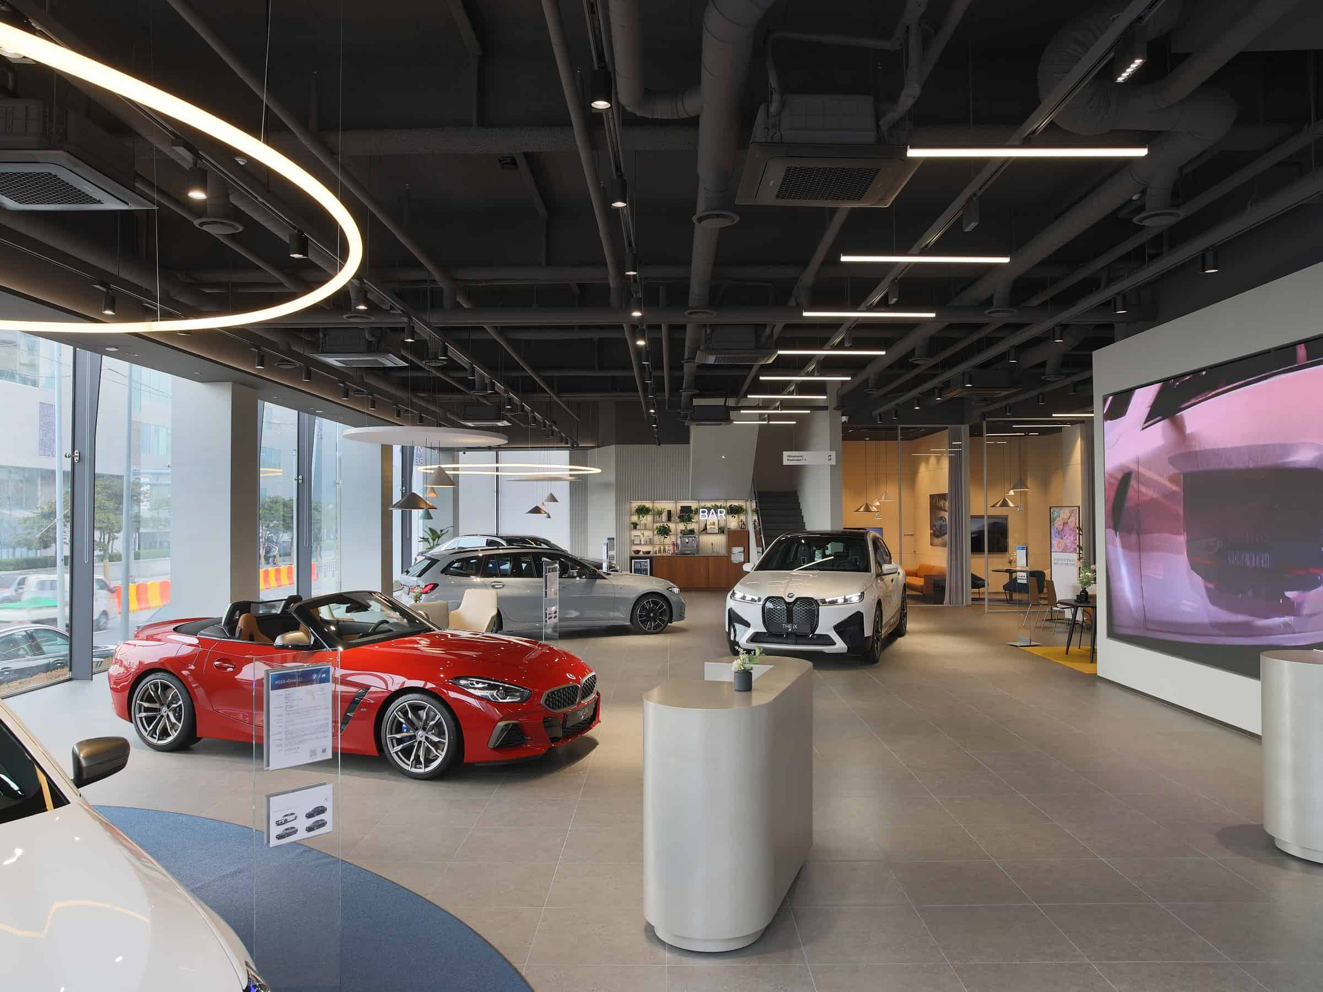
Figure 15: BMW store in Germany
(Source: DeMattia, 2023)
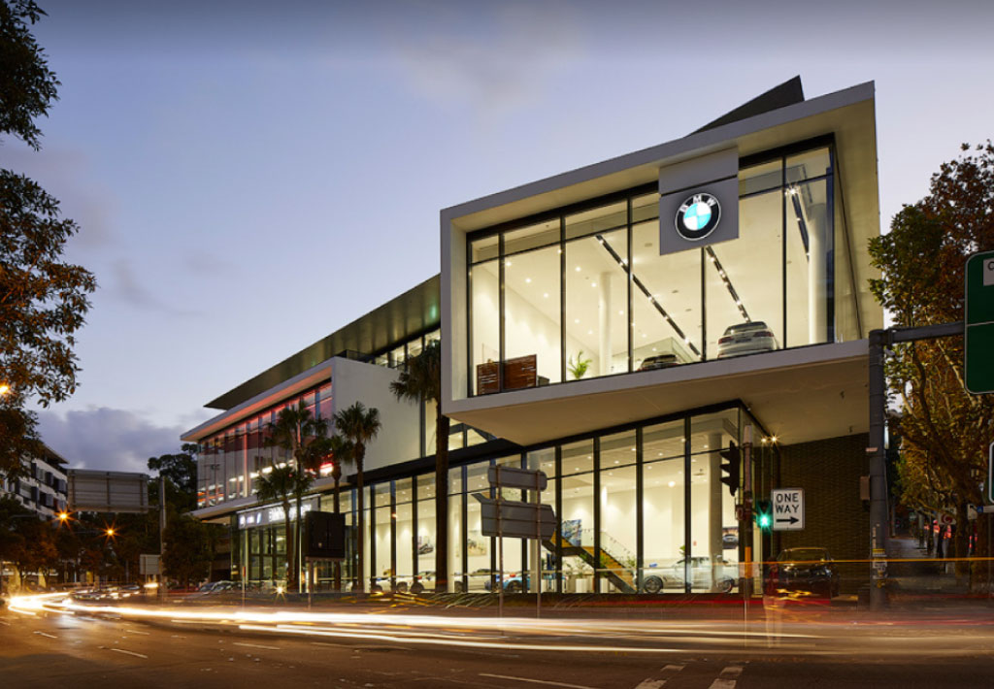
Figure 16: BMW store in Australia
(Source: BMW Sydney, 2023)

