ACBA5017 –
Building Services 2 - Integration
Assignment 1: M&E Specification
David Deeth (2223671)

Contents
Contents 1
List of Figures 2
List of Abbreviations 2
1. Introduction 3
1. M&E Designs 5
1.1. Lighting 5
1.2. Small Power 6
1.3. Above & Below Drainage 7
1.4. Ventilation (MVHR) 8
a) Step 1: Locate MVHR Unit 9
b) Step 2: Establish Supply, Extract and Transfer Areas 9
c) Step 3: Calculate Supply Rates 10
1.5. Heating 12
1.6. Services (DHW / WATER) 13
1.7. Sprinklers 13
1.8. Telecoms 13
2. Summary/Conclusion 14
3. References 15
4. Appendix 16
4.1. Figures: 16

List of Figures
Figure 1: The Litchard Semi House 3
Figure 2: The Litchard Floor Plans 3
Figure 3: Lighting Plan 5
Figure 4: Small Power 6
Figure 5: Above & Below Drainage 7
Figure 6: MVHR Ducting 8
Figure 7: Supply, Extract & Transfer Zones 10
Figure 8: Extract Ventilation Rates 10
Figure 9: Minimum Extract Ventilation Rates 11
Figure 10: Heating Plan 12
Figure 11: AD: F – Extract Ventilation Rates 16
Figure 12: AD: F – Whole Dwelling Ventilation Rates 16
Figure 13: Heat Recovery Example 17
Figure 14: Ground Floor Plan 17
Figure 15: First Floor Plan 17

List of Abbreviations
AD: * | Approved Document: *
DHW | Domestic Hot Water
M&E | Mechanical & Electrical
MSES | Mechanical Supply & Extract
MVHR | Mechanical Ventilation & Heat Recovery
RCD | Residual Current Detection
TFA | Treatable Floor Area (total floor area of internal spaces)
WHQS | Welsh Housing Quality Standard

Introduction

This assignment will present a full a Mechanical & Electrical (M&E) design for a scenario building: the “Litchard Semi House” from Llanmoor Homes’ St Sannans Field housing development. (Llanmoor Homes, 2025)
A 3-bedroom detached property with 69m2 of internal total floor area (TFA)

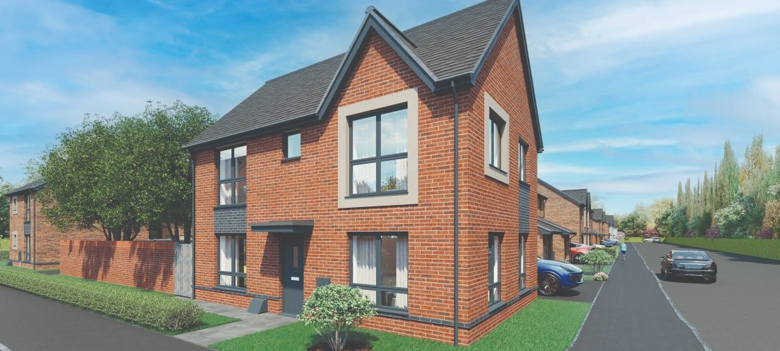
Figure 1: The Litchard Semi House

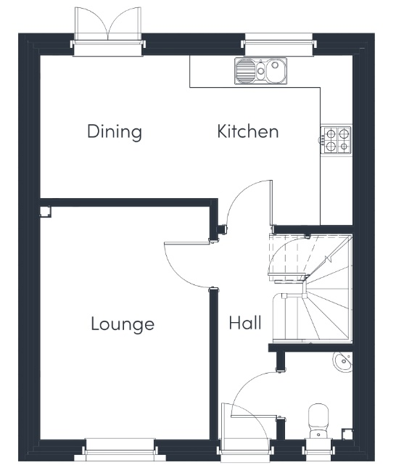 | 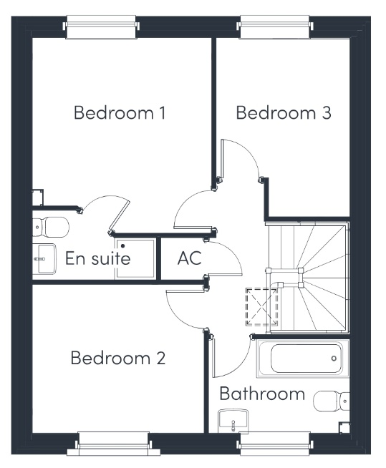
Figure 2: The Litchard Floor Plans

Mechanical and Electrical services are the building’s installed infrastructure to make them comfortable, functional, efficient, and safe.

Mechanical Services:
These elements primarily focus on heating, ventilation, air conditioning, plumbing, and fire protection.
Efficiently designed and competently installed systems can greatly improve the building’s occupant comfort, energy usage, and lifetime operational efficiency.

Electrical Services:
Working in tandem with mechanical, electrical services focus on the power supply and lighting aspects of the building.
With the increasing integration of technology into everyday life, the electrical systems are essential for supporting the building’s technological infrastructure, and long-term futureproofing.

The design choices will focus on occupant comfort, energy efficiency, and sustainability.
All systems must comply with the current UK Building Regulations, Welsh Housing Quality Standards (WHQS), and Building Standard’s Approved Documents (AD):
- B – fire safety
- F – ventilation
- G – Sanitation (hot water – water retention)
- H – Drainage / waste disposal
- L – Conservation of Fuel and Power

M&E Design Elements:
- Lighting
- Small Power
- Above & Below Drainage
- Ventilation
- Heating
- Water
- Sprinklers
- Telecoms

M&E Designs

Lighting

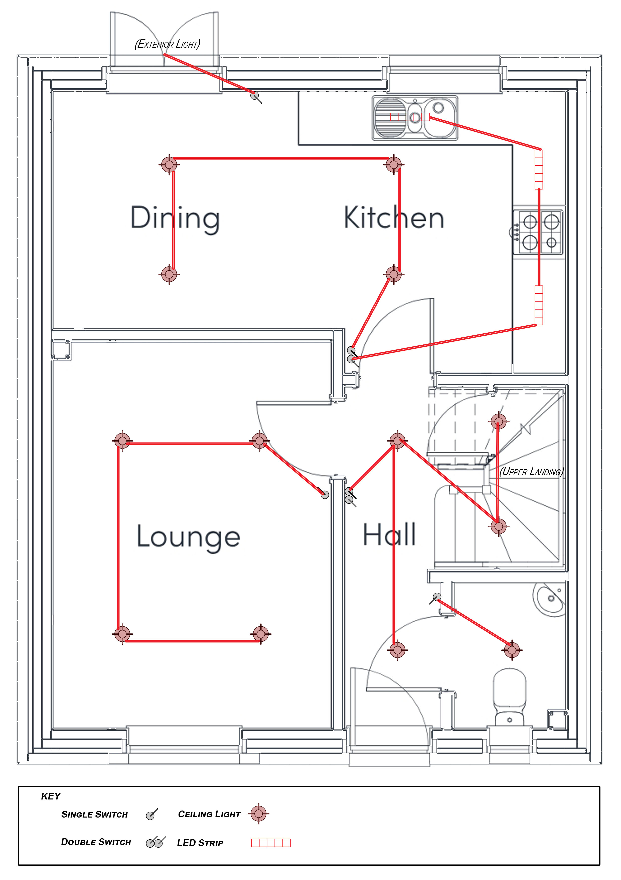 | 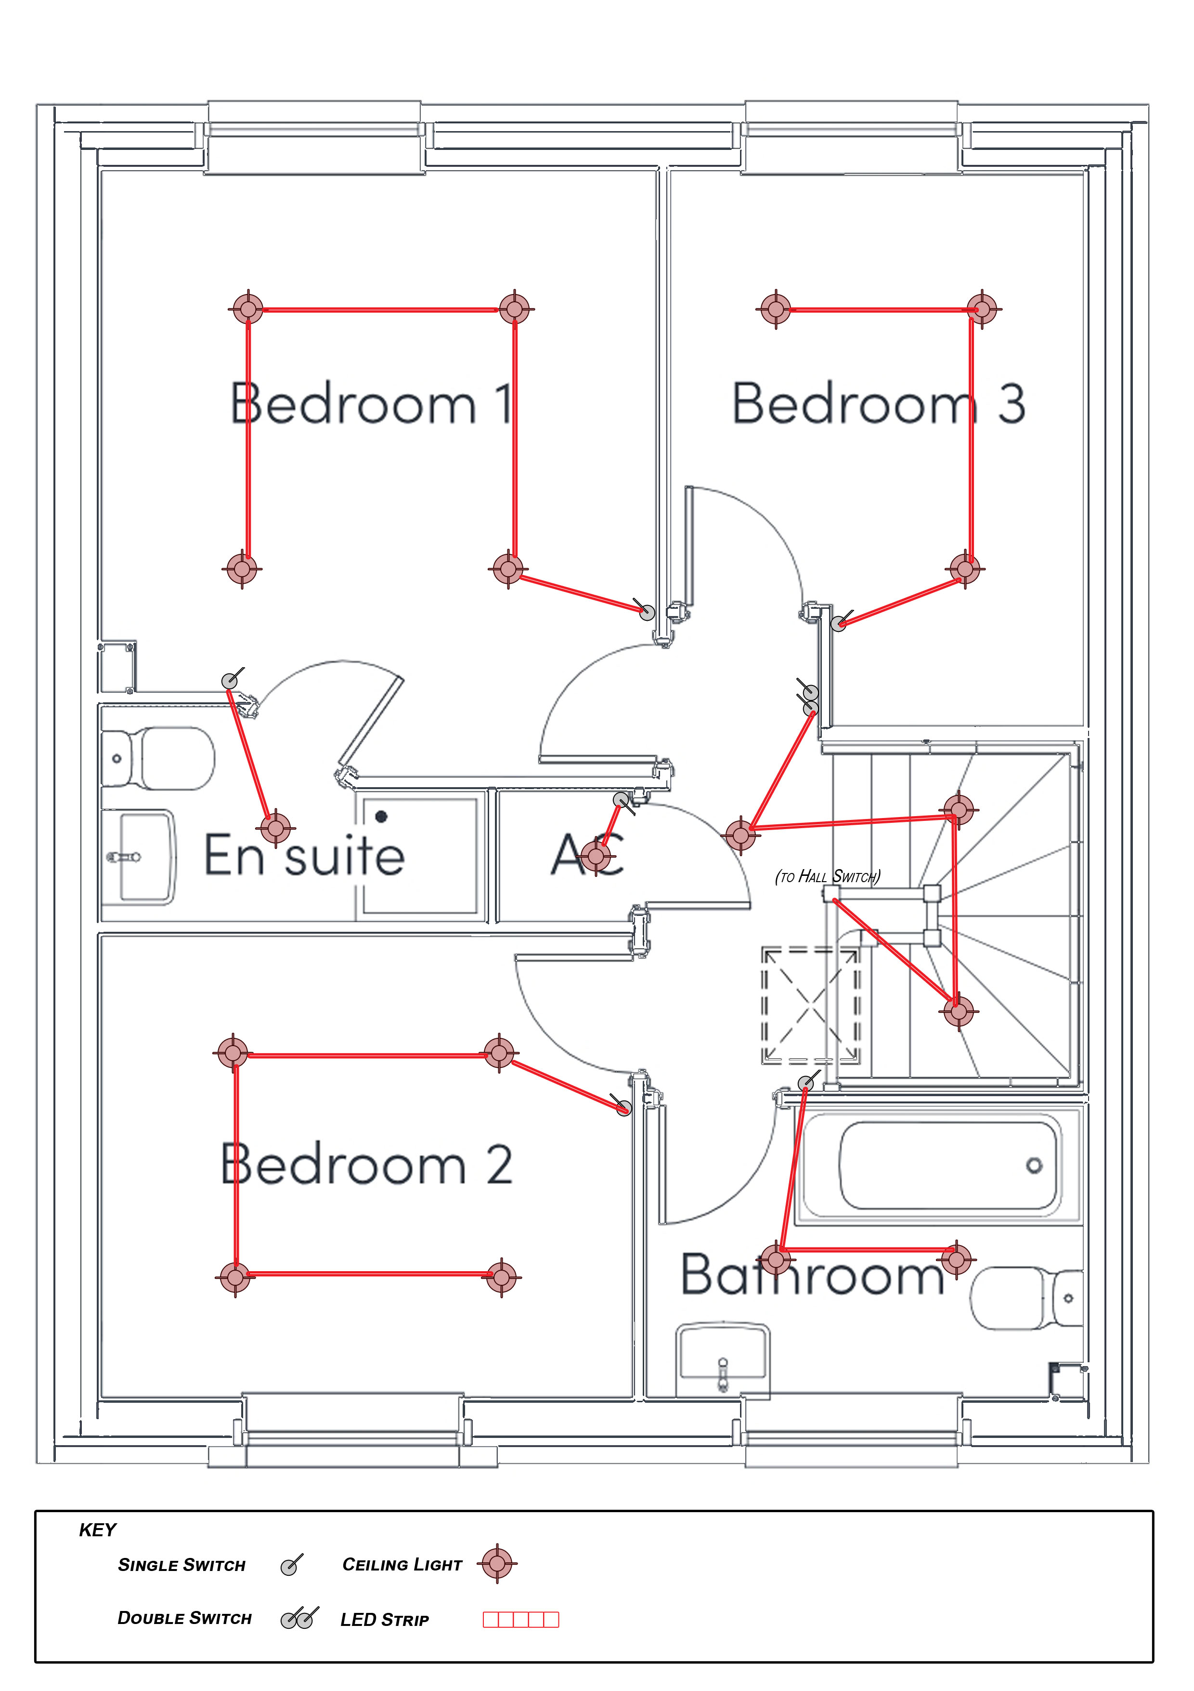
Figure 3: Lighting Plan

Specifications:
- LED ceiling mounted spot lighting throughout
- LED strip lighting in kitchen worktops
- Bathroom ventilation extraction linked to lighting
- Optional: presence sensor-controlled lighting in living areas

Justification:
- LED lighting has a significantly lower energy consumption rate compared to incandescent or fluorescent lighting with equivalent illumination output
- Supports AD: L compliance by reducing running costs
- Optional presence-controlled lighting could further reduce operational demands by avoiding unnecessary usage

Small Power

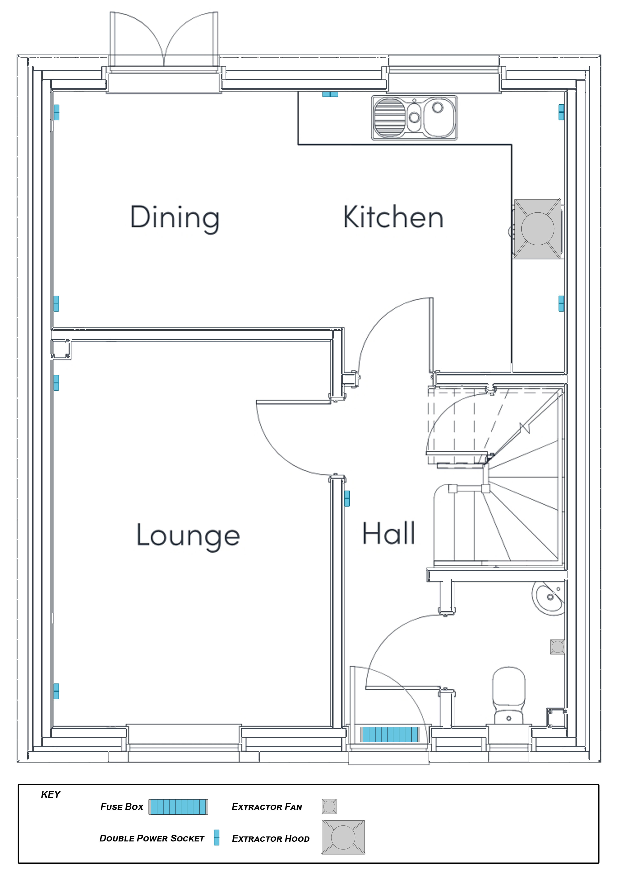 | 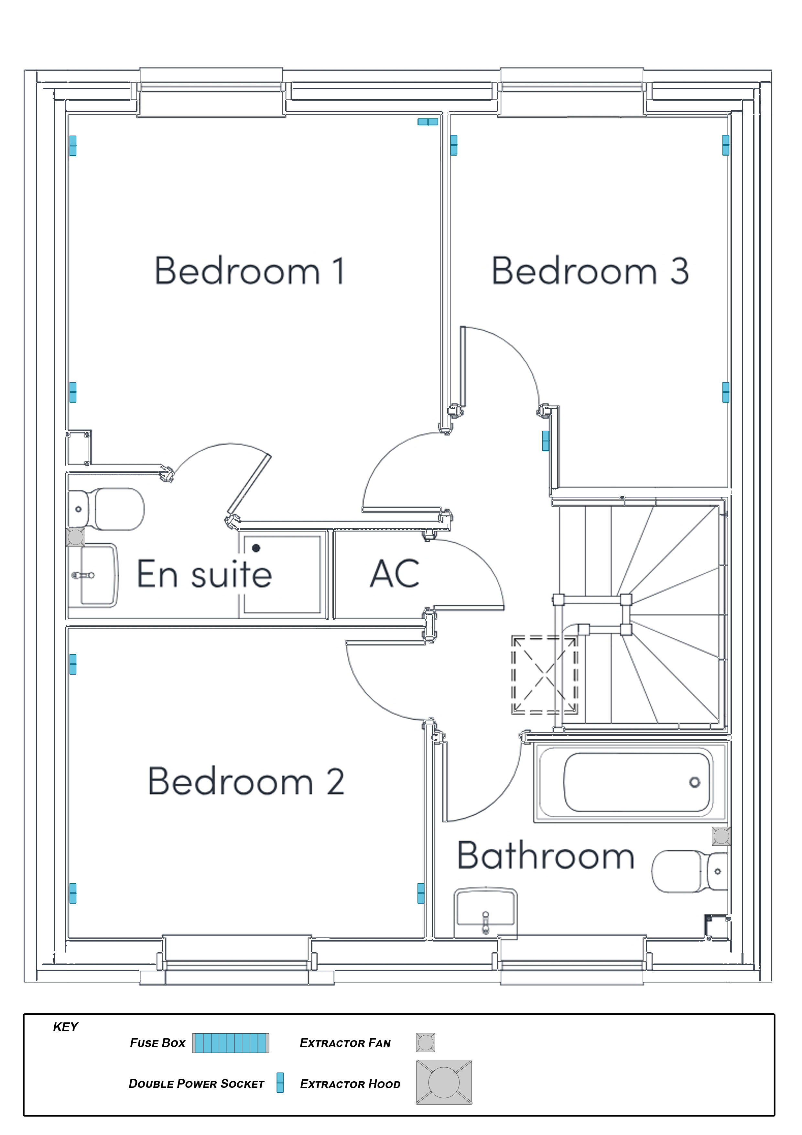
Figure 4: Small Power

Specification:
- Provide ample sockets located throughout
- Separate ring circuits for ground and first floor
- Dedicated circuit rings for kitchen appliances
- Extraction fans linked to kitchen and bathroom
- Ethernet connection to living areas
- Mains-powered smoke detectors in circulation areas and bedrooms
- Mains-powered heat/smoke alarm in kitchen
- Mains-powered CO² alarm in boiler room

Justification:
- Compliance with AD: P – Electrical Safety
- Power cables and sockets for appliances as per the manufacturer's specifications
- Armoured power cables to fire alarm / safety systems
- Follow WHQS guidance for distribution of power sockets and smoke/heat/CO² alarms
- Install Residual Current Devices (RCD): protects against shock, electrocution, and fires by continuous monitoring of the live and neutral wiring and cuts the power if an imbalance is detected (trips the switch).

Above & Below Drainage

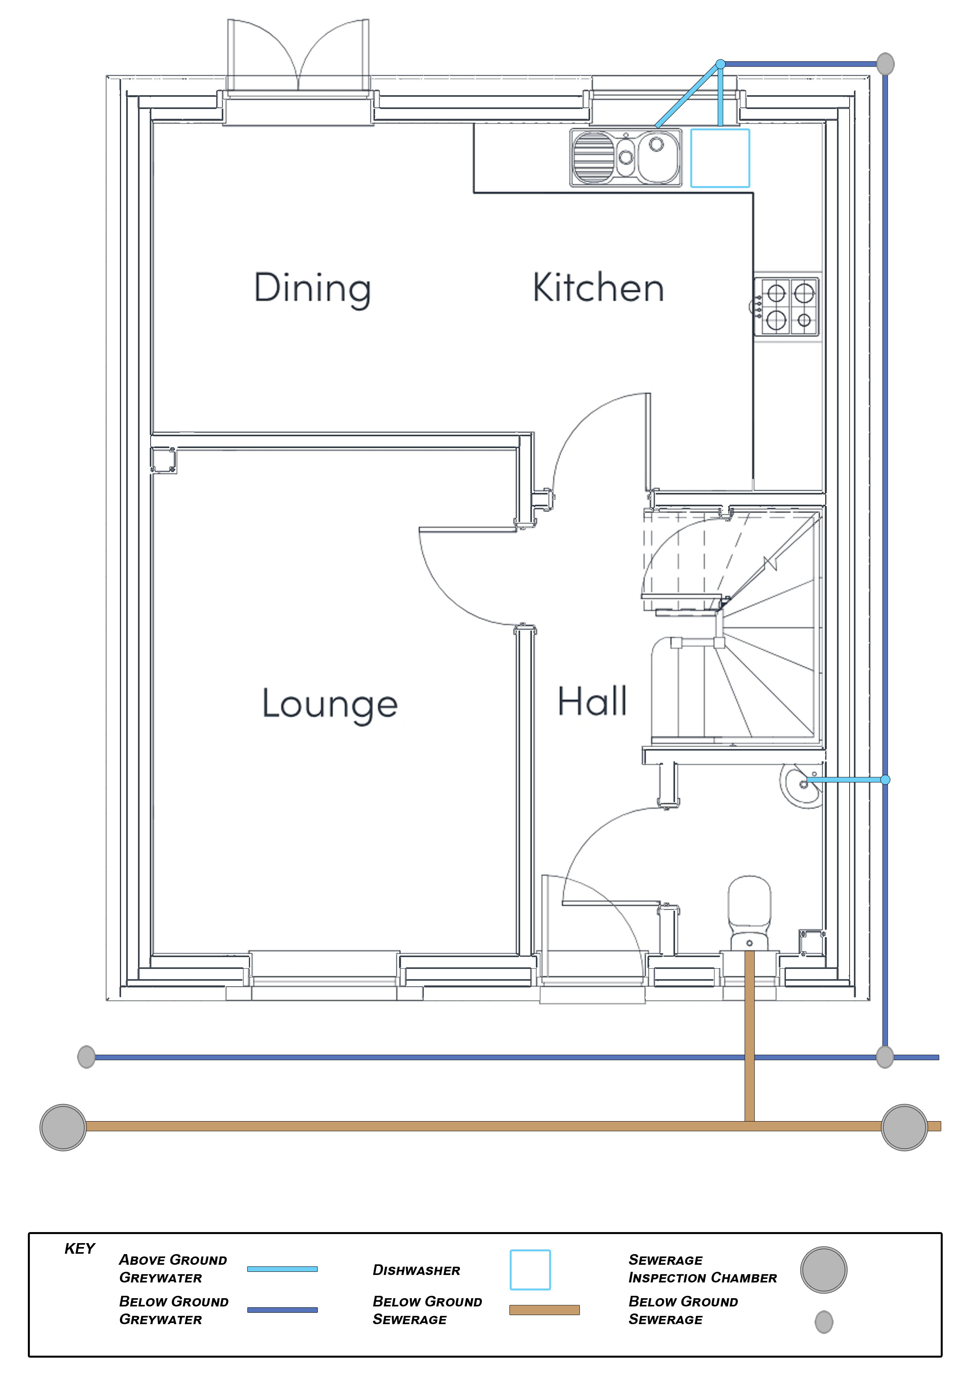 | 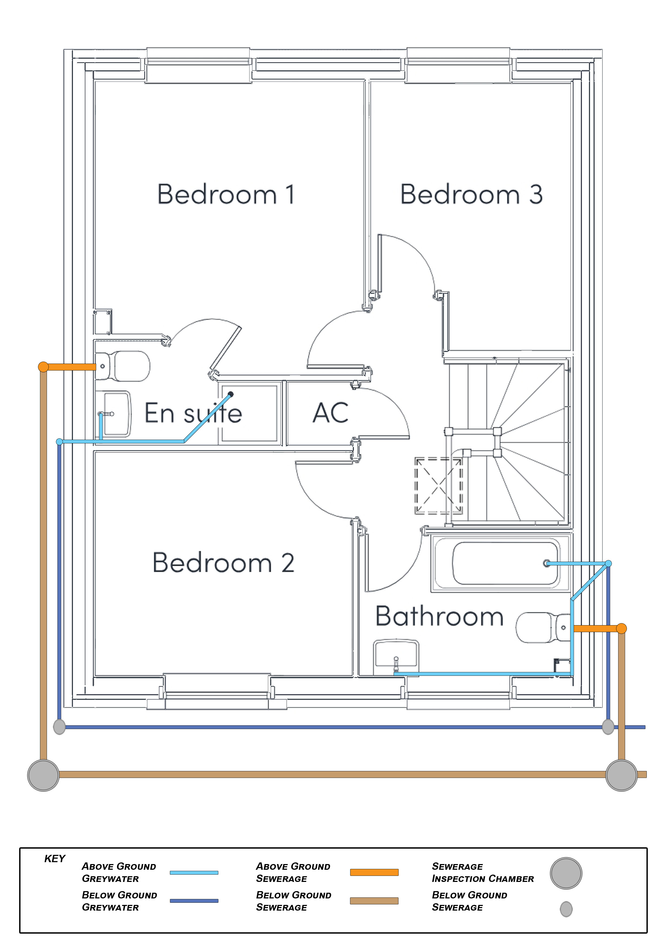
Figure 5: Above & Below Drainage

Specification:
- Foul/wastewater, grey water, and surface water drainage designed as per AD: H
- Foul/wastewater on separate route from grey & rainwater systems, draining into public sewer system
- Install leak detection systems and auto-shutoff taps

Justification:
- Compliance with AD: H – provide adequate systems to dispose foul and wastewater
- Separation of drainage systems to prevent cross-contamination
- Monitor and control water usage through leak detection and water efficient taps
(GOV.WALES, n.d.)

Ventilation (MVHR)

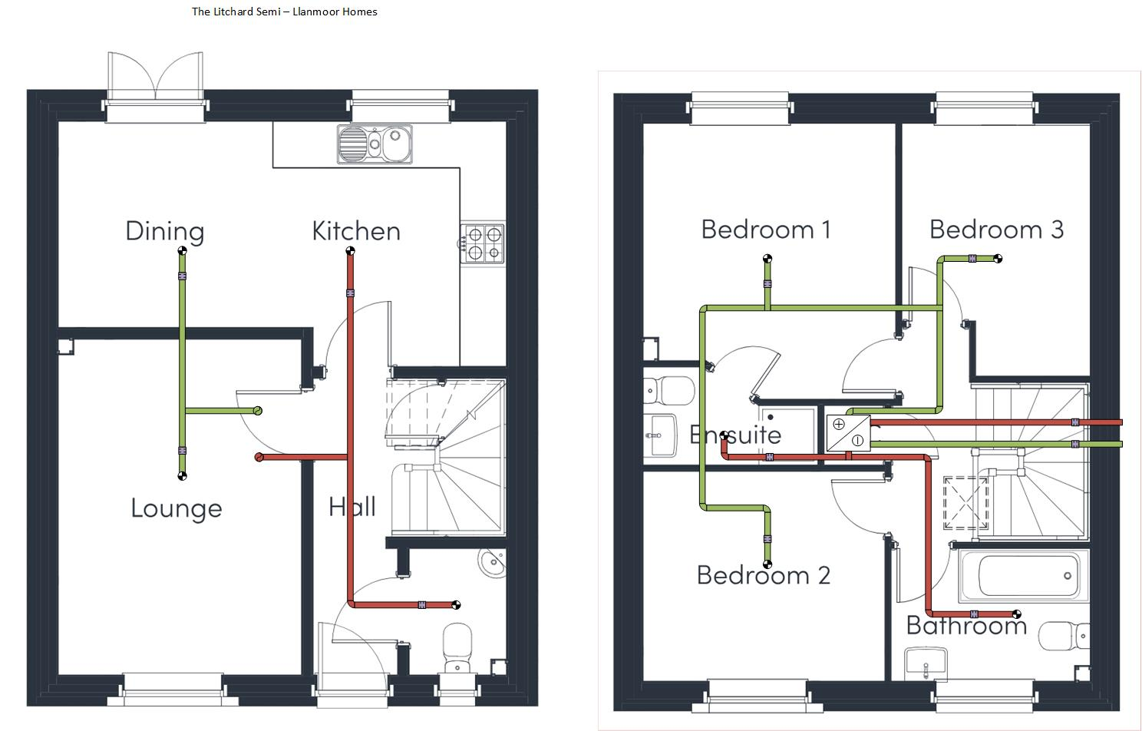 | 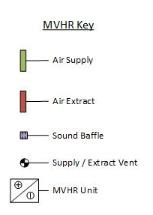
Figure 6: MVHR Ducting

Specification:
- Mechanical Ventilation and Heat Recovery (MVHR) unit to supply whole-house ventilation with heat recovery
- Ducting sized to comply with ventilation flow and distribution rates
- Summer bypass and variable speed controls
- Low noise fans/pumps
- Ducting routed through posi-joints, with baffles/silencers to reduce operational noise

Justification:
- MVHR unit provides controlled fresh air supply, stale air extraction, and lower heat loss through ventilation.
- Indoor Air Quality (IAQ): Continuous ventilation, extraction in kitchen & bathroom.
  - 800-1000ppm CO₂

Number of Bedrooms | Expected Occupancy | Ventilation Rate (L/s)
3 | 4 | 21
CIBSE Domestic Heating Design Guide (2021) Table 1.7

Calculation for Ventilation Flow Rates.

Step 1: Locate MVHR Unit
Suggested location for the MVHR unit: in or above the First Floor Airing Cupboard.
- Centralised location, allows easy routing throughout the building
- Isolated in loft space to minimise noise to the living areas
- Close to loft hatch to allow easy access for maintenance

Step 2: Establish Supply, Extract and Transfer Areas
“Extract ventilation
1.17 Extract ventilation to outside should be provided in all of the following spaces:
• kitchens
• utility rooms
• bathrooms
• sanitary accommodation”
(2022 edition - For use in Wales, n.d.)

Supply Areas:  - Bedrooms  - Lounge  - Dining Room | Extract Areas:  - Kitchen  - Bathroom  - W.C  - Ensuite | Transfer Areas:  - Hallway  - Stairwell  - Landing

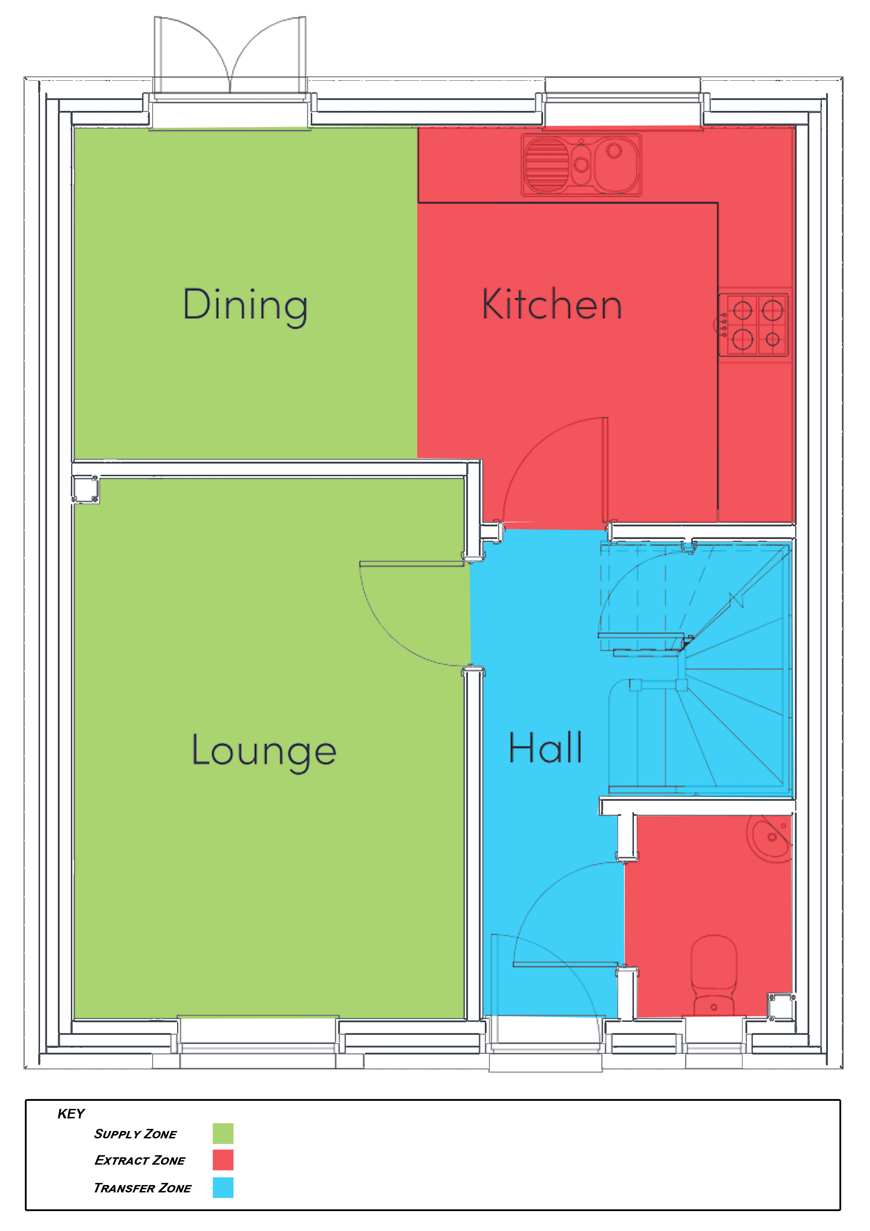 | 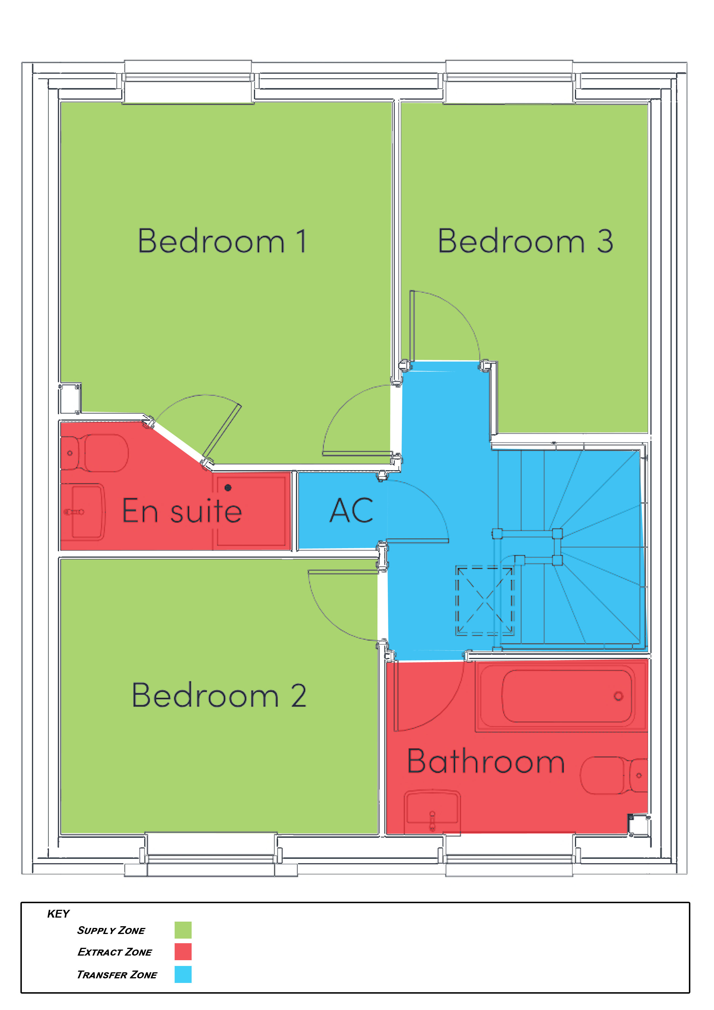
Figure 7: Supply, Extract & Transfer Zones

Referring to Table 1.3 Minimum Whole House Dwelling Ventilation Rates, a 3-bedroom house requires a minimum of 31m³/h/p (cubic metres, per hour, per person).

Location | Imperial | Metric Conversion | AREA
Lounge: | 10’ 3” x 14’ 2” | 3.124 m x 4.318 m | 13.489 m
Kitchen/Dining: | 18' 11" x 10' 4" (max) | 5.766 m x 3.15 m | 18.163 m
Cloaks: (airing cupboard) | 4' 3" x 5' 5" | 1.295 m x 1.651 m | 2.138 m
Bedroom 1 | 10' 8" x 11' 6" | 3.251 m x 3.505 m | 11.395 m
Ensuite | 7' 5" (max) x 4' 2" (max) | 2.261 m x 1.27 m | 2.871 m
Bedroom 2 | 10' 3" x 8' 9" | 3.124 m x 2.667 m | 8.332 m
Bedroom 3 | 7' 11" x 10' 7" | 2.413 m x 3.226 m | 7.784 m
Bathroom | 8' 6" x 5' 8" | 2.591 m x 1.727 m | 4.475 m
 |  | Total Floor Area | 68.647 m²
 |  | Rounded up | 69m²
(Converted from imperial measurements (Llanmoor Homes, 2025: Key Features)

Table 5.1a: minimum ventilation rate = 0.3l/s/m² (liters per second, per square meter).

0.3l x 69m² = 20.7m²/s

Convert from per second into per hour:
1 hour = 60 minutes
1 minute = 60 seconds
60 seconds x 60 minutes = 3600 seconds per hour

20.7m²/s x 3.6 = 74.52m³/h

Step 3: Calculate Supply Rates

Run 125mm ducting through posi-joists in the floors/ceilings to avoid the need for bulkheads of boxing.

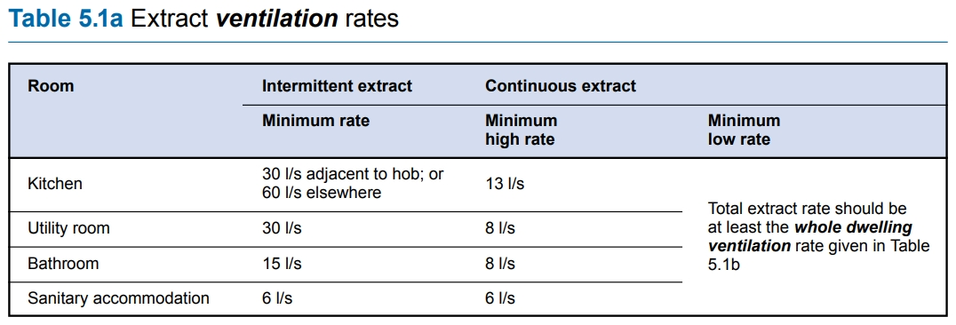
Figure 8: Extract Ventilation Rates

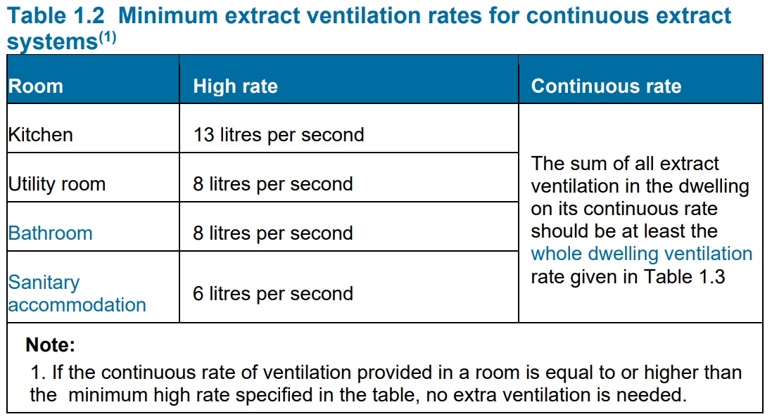
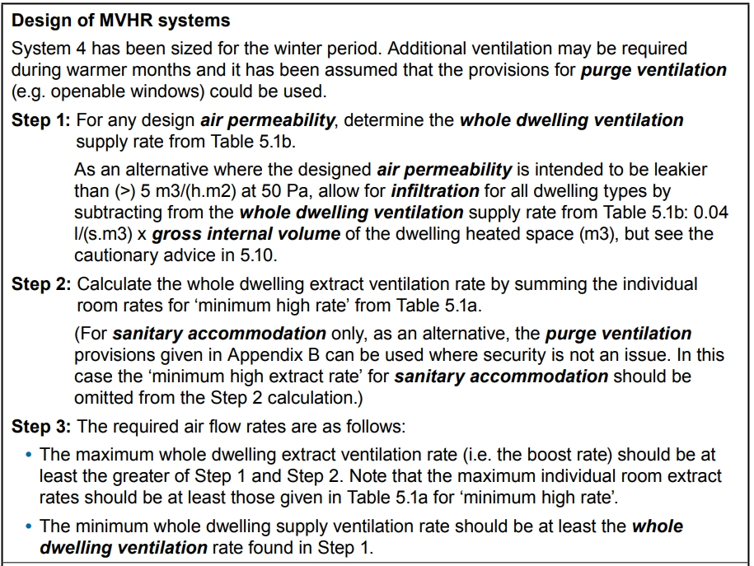
Figure 9: Minimum Extract Ventilation Rates

Total Minimum Extract Rates:

Kitchen | 13_{lp/s} | x | 1 | = | 13_{lp/s}
Utility Room: | 8_{lp/s} | x | 0 | = | 0
Bathroom: | 8_{lp/s} | x | 3 | = | 24_{lp/s}
Total: |  |  |  |  | 37_{lp/s}

Heating

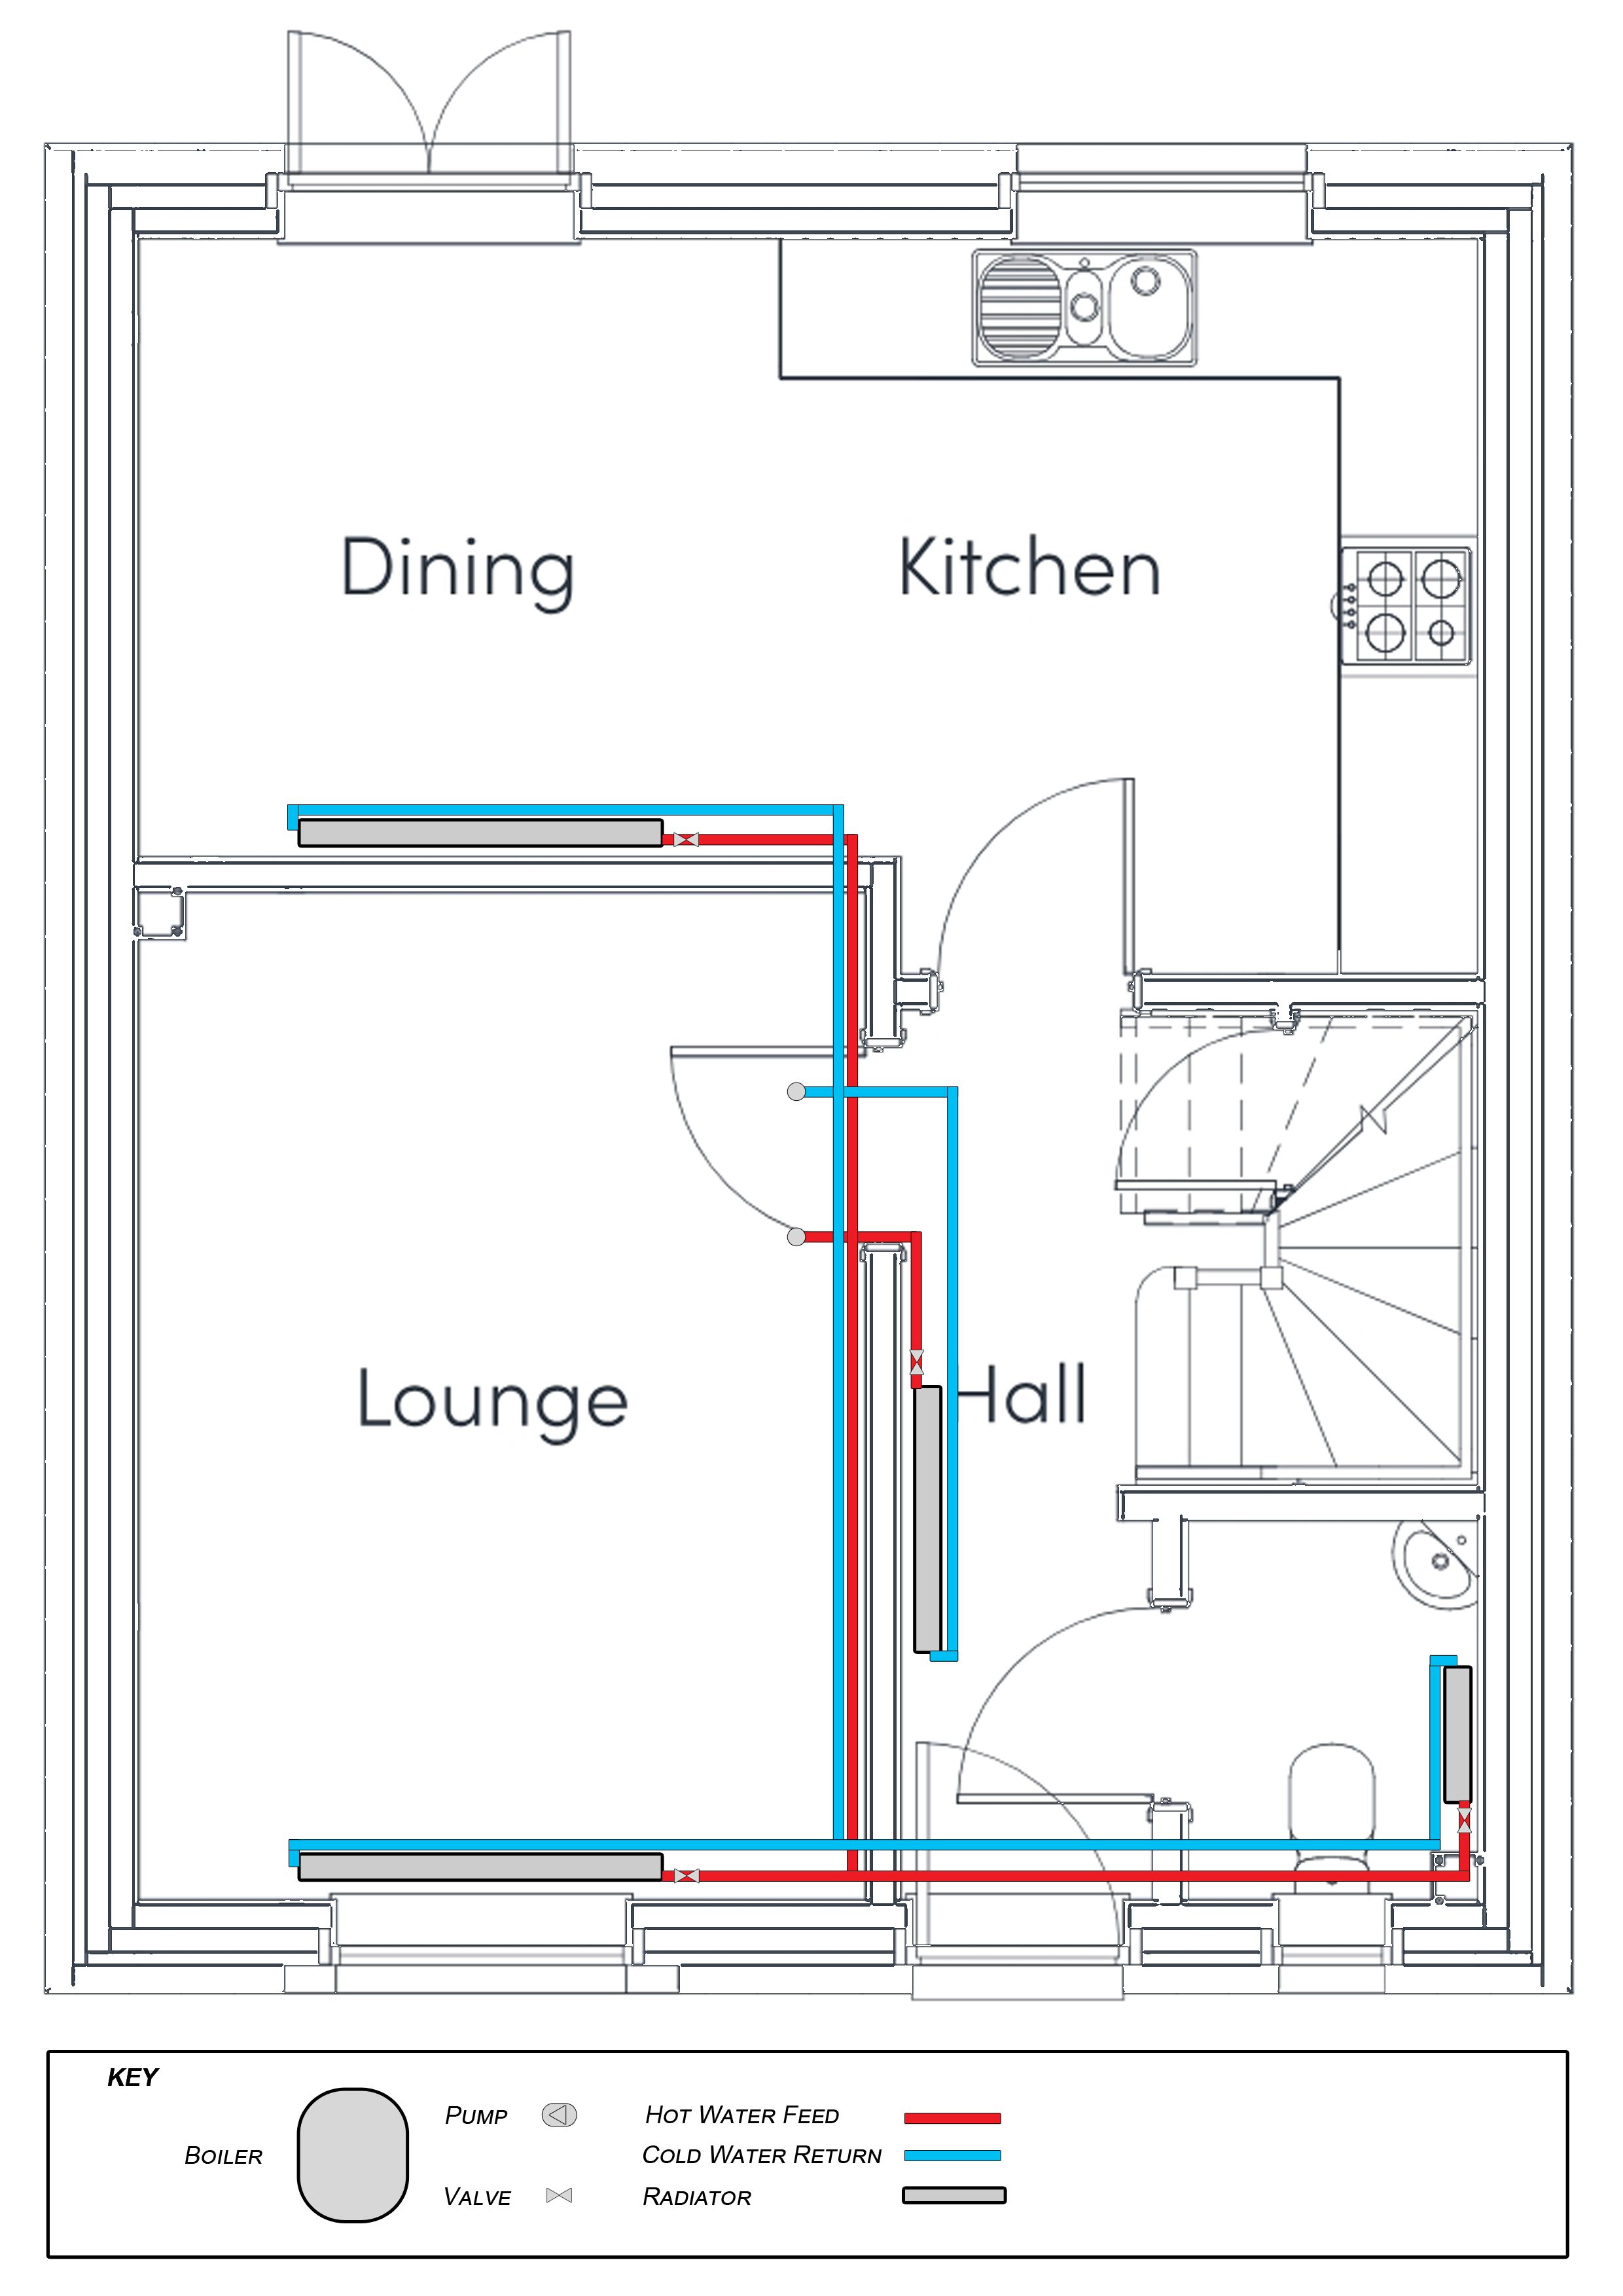 | 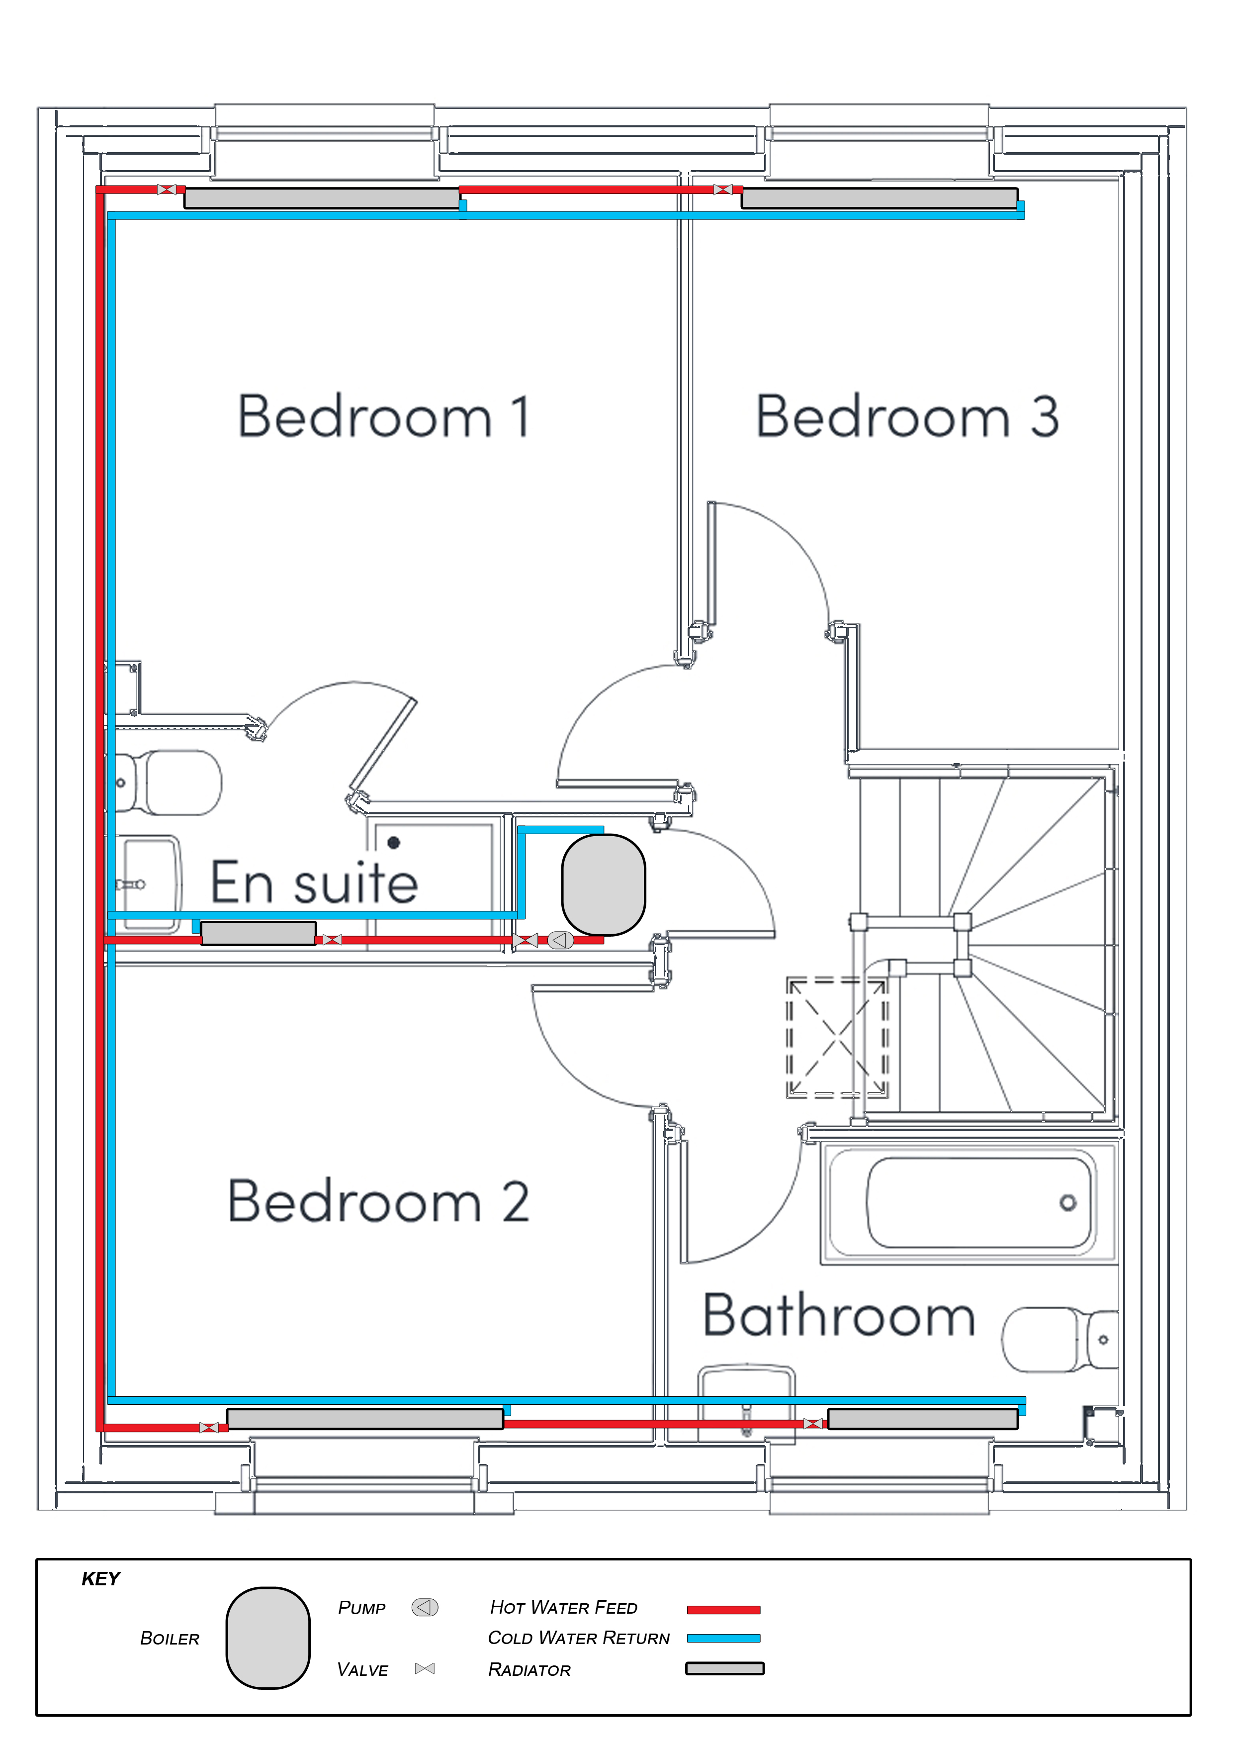
Figure 10: Heating Plan

Specification:
- High-efficiency gas combi boiler
- Radiators sized and located according to heat loss calculations per room
- Programmable thermostat with zoned area controls
- Thermal Comfort: 21ºC in living areas
- Flow and return to each radiator

Justification:
- Combi boilers provide
- Compliance with AD: L
- Programmable controls allow for more effective management, and reduced heat loss and energy usage

Services (DHW / WATER)

Specification:
- Heat-on-demand hot water provided by the combi boiler
- Sink outlets fixed with mixed hot/cold water taps

Justification:
- On-demand hot water reduces standing heat loss
- Compliance with AD: L

Sprinklers

Not normally required in domestic house buildings such as the Litchard Semi House.
Can be installed if required by local authorities. For example: high-rise residential buildings, care homes or converted flats.

- Smoke alarms in Living Room, Hallway and Landing
- Smoke/heat detector in kitchen
- CO² detector in boiler cupboard

Telecoms

Specification:
- Connected to available network exchange hub for ethernet or fibreoptic services
- Provision for TV and broadband connection

(add ethernet ports to bedrooms, lounge and kitchen)

Justification:
- Structured cable routing for occupant’s ease of use and quality of life
- Follow WHQS guidance on socket layout for occupant comfort and wellbeing

Summary

System | Chosen Design | Justification
Lighting | LED lighting | High energy efficiency, with optional presence sensor-controls to mitigate lighting unused rooms
Small Power | AD: P compliant design | Compliance with AD: P.  Separate circuit rings for ground, first floor, and appliances.
Drainage | Separated fowl, grey, and surface water | Compliance with AD: H.  Leak detection systems and auto-shutoff taps to mitigate wastage and lower running costs.
Ventilation | MVHR | Energy efficient heating and air purification.  Summer bypass and variable speed controls.  Extraction fans in high humidity areas to assist ventilation.
Heating | Gas combi-boiler | High-efficiency gas combi boiler.  Programmable thermostat with zoned area controls.  Heat-on-demand hot water.  High thermal performance glazing and airtight building design.
Services | Connection to available urban services | Mains water and gas.
Sprinklers | AD: B & WHQS design | Wired smoke, heat and CO² detectors
Telecoms | Connection to available urban services | Ethernet or fibreoptic broadband internet.  Landline and TV connection.

References

2022 edition -For use in Wales*. (n.d.). Available at: https://www.gov.wales/sites/default/files/publications/2022-10/building-regulations-approved-document-f-vol-1.pdf.

Beadle, S. (n.d.). GADE VALLEY PRIMARY SCHOOL MECHANICAL CONDITION SURVEY AND PROPOSED SCOPE OF WORKS REPORT. [online] Available at: https://thegrid.org.uk/assets/sample-1-mechanical-and-electrical-condition-report.pdf.

Boilerhut. (2024). Boiler Types Explained. [online] Available at: https://boilerhut.co.uk/boiler-types/.

Butcher, K. and Chartered Institution Of Building Services Engineers (2016). Heating, ventilating, air conditioning and refrigeration. London: Chartered Institution Of Building Services Engineers.

Byra Admin (2023). What is M & E in Construction? - Hamlet Commercial. [online] Hamlet Commercial. Available at: https://hamletcommercial.co.uk/what-is-m-e-in-construction/.

EvalCommunity. (n.d.). Monitoring and evaluation (M&E) Reports. [online] Available at: https://www.evalcommunity.com/career-center/monitoring-and-evaluation-me-reports/.

Good Practice Guide: MVHR for single dwellings Good Practice Guide MVHR for single dwellings Good Practice Guide: MVHR for single dwellings. (2018). Available at: https://www.passivhaustrust.org.uk/UserFiles/File/Technical%20Papers/2018%20MVHR%20Good%20Practice%20Guide%20rev%201.2(1).pdf.

GOV.WALES. (n.d.). Building regulations: approved documents. [online] Available at: https://www.gov.wales/building-regulations-approved-documents.

Llanmoor Homes. (2024). Saint Sannans Field - Llanmoor Homes. [online] Available at: https://www.llanmoor-homes.com/development/saint-sannans-field/.

Llanmoor Homes. (2025). Three Bedroom Semi-Detached Home | The Litchard 3 Bed House. [online] Available at: https://www.llanmoor-homes.com/house-type/the-litchard-semi-2024/?development=34142.

Look for me on site plans! →. (n.d.). Available at: https://www.llanmoor-homes.com/wp-content/uploads/2024/08/The-Litchard-Semi-3B19S-Llanmoor-Homes-House-Type-Lealet-2023.pdf.

PlumbHQ. (n.d.). Your Central Heating System Explained | PlumbHQ Hub. [online] Available at: https://plumbhq.uk/a/central/articles/your-central-heating-system-explained.

The Building Regulations 2010 Ventilation F1 Means of ventilation F Approved Document. (2010). Available at: https://www.gov.wales/sites/default/files/publications/2022-10/building-regulations-guidance-part-f-ventilation_0.pdf.

The Government’s Standard Assessment Procedure for Energy Rating of Dwellings. (n.d.). Available at: https://files.bregroup.com/SAP/SAP%2010.2%20-%2017-12-2021.pdf.

Ventilation and ductwork CIBSE Guide B2. (n.d.). Available at: https://products.ihserc.com/tmp_stamp/00316150801/VVBFTIAAAAAAAAAA.pdf?sess=00316150801&prod=CIS1 [Accessed 4 Mar. 2026].

wiki.diyfaq.org.uk. (n.d.). Central heating design - DIYWiki. [online] Available at: https://wiki.diyfaq.org.uk/index.php/Central_heating_design.

‌

Appendix

Figures:

Figure 11: AD: F – Extract Ventilation Rates

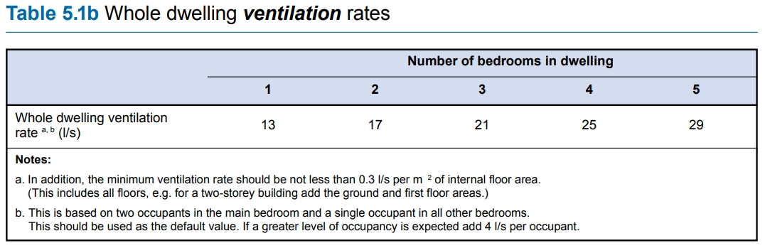
Figure 12: AD: F – Whole Dwelling Ventilation Rates

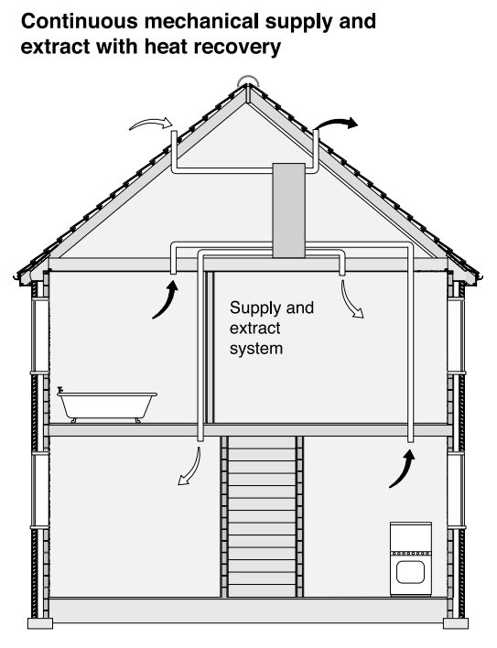
Figure 13: Heat Recovery Example

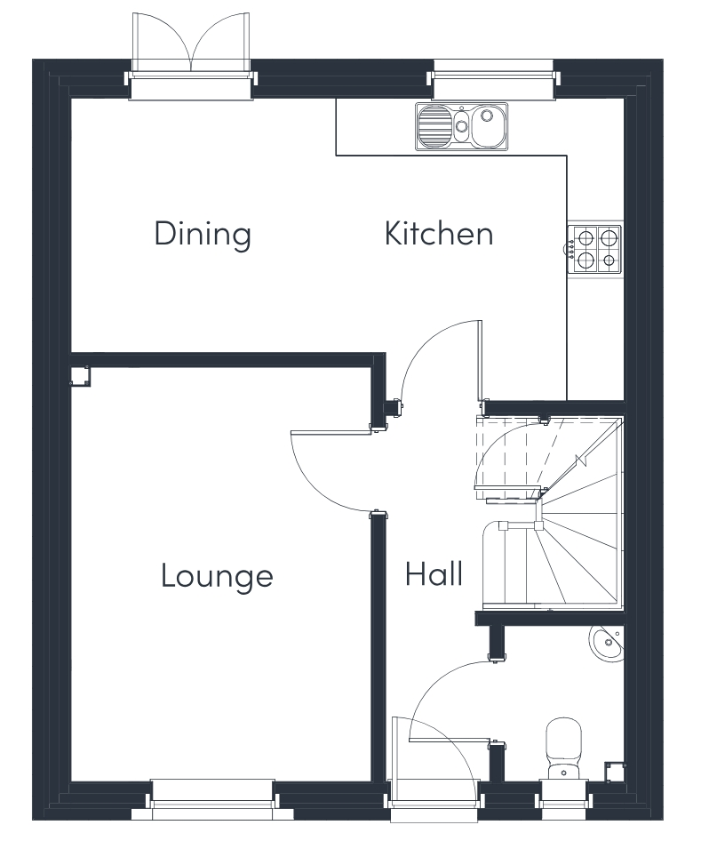  Figure 14: Ground Floor Plan | 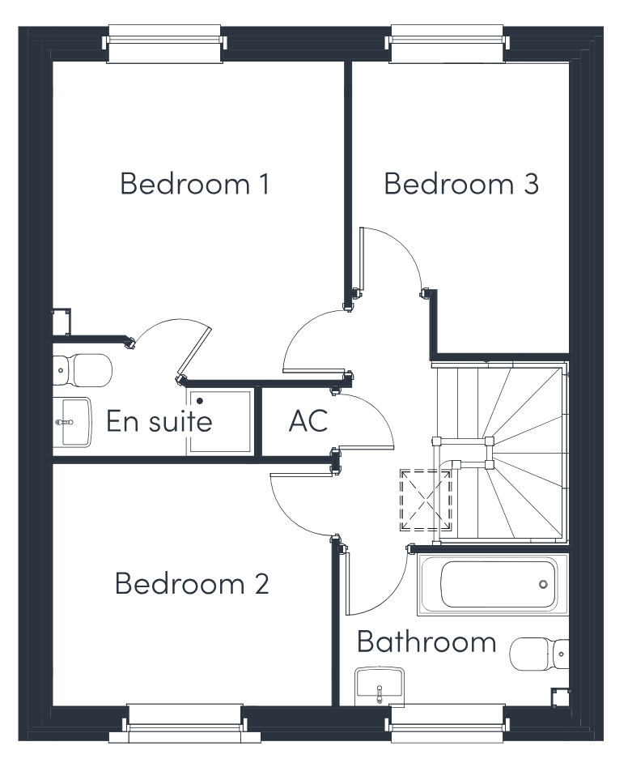  Figure 15: First Floor Plan

