
Student name: Alexandra Elena Chiran
Student ID: 2410882

Module name: Introduction in Physiology
Module code: BMHP_5023
Lecturer name: Soban Sadiq

Assessment: Written assignment: Case Study Report: Diabetes

Table of content

Introduction.............................................................................................................3
Blood Sugar Regulation........................................................................................5
Cellular Metabolism................................................................................................ 6
Recording and tracking blood sugar levels for type 2 diabetes.........................8
Recommendations..................................................................................................9
Conclusion..............................................................................................................11
References..............................................................................................................12

1.Introduction

As a practice nurse in a GP surgery, I ‘ve noticed an increasing number of patients diagnosed with diabetes. Many of them could greatly benefit from a better understanding of their condition and the lifestyle factors that influence their health.
By gathering and sharing this information, I aim to help my patients gain the tools they need to manage their diabetes effectively.

Diabetes also known as diabetes mellitus is the most prevalent endocrine disorder. And is a chronic condition defined by high blood glucose levels because of insufficient insulin production or the body’s inability to use insulin effectively. (WHO,2024).
Primary diabetes is classified in two types: Type 1 and Type 2. Secondary diabetes occurs due to other medical conditions, while gestational diabetes arises during pregnancy (Waugh. et al., 2018).
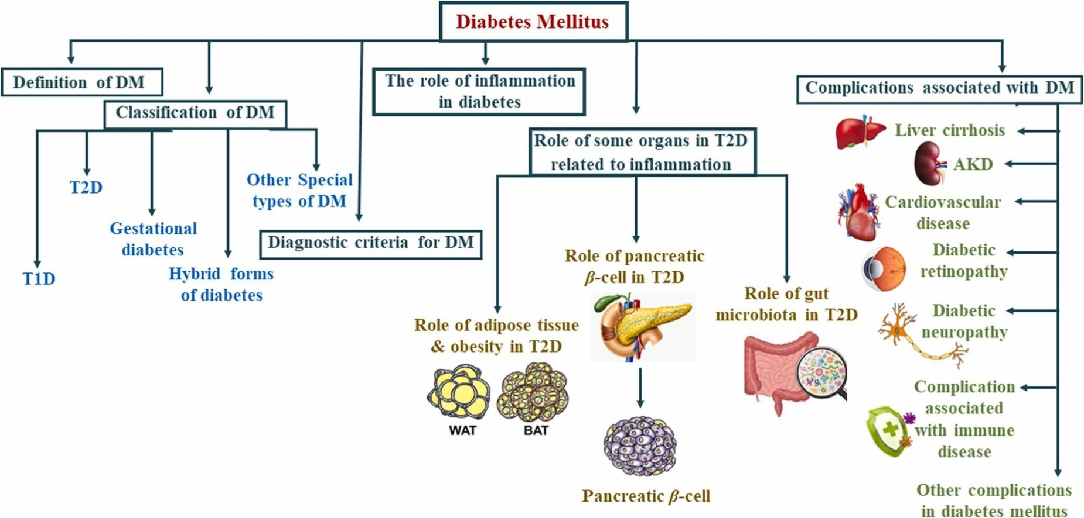Fig.1 https://www.sciencedirect.com/science/article/pii/S0753332223015329

Risk factors
Type 1 is typically diagnosed in childhood but can occur at any age and is not preventable.
Type 2 diabetes is influenced by various risk factors that can be addressed through lifestyle modification. Obesity stands out as a significant contributor, particularly excess fat around the abdomen, which leads to insulin resistance. Additionally, a sedentary lifestyle exacerbates this risk; lack of physical activity can lead to weight gain and decreased insulin sensitivity. Another critical risk factor is family history. Genetics play a vital role in the risk of developing Type 2 diabetes, as individuals with a family history of the condition are more likely to experience similar challenges. Age is also a significant factor; the risk increases after 45 years. A poor diet is also one of the risk factors as a poor diet can lead to obesity and insulin resistance. Other risk factors are high blood pressure, gestational diabetes, ethnicity with certain groups (African American, Hispanic Americans, and Native Americans) show a higher incidence of Type 2 diabetes and lastly smoking that not only affects overall health but also increases the likelihood of developing diabetes.
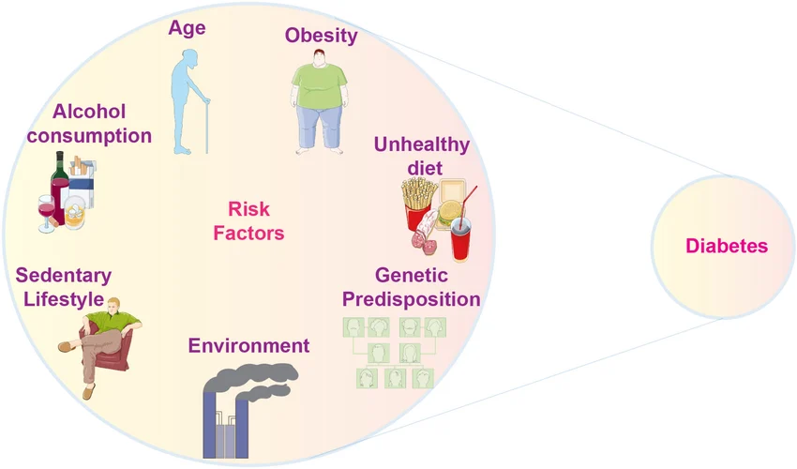Fig.2 https://www.researchgate.net/figure/Risk-factors-associated-with-Diabetes-Mellitus_fig3_375892560

2.Blood Sugar Regulation
Blood sugar levels are maintained within a safe range through a series of hormonal and metabolic processes. The pancreas plays a critical role by producing insulin and glucagon. When blood glucose level rise, such as after eating, betta cells in the pancreas release insulin. Insulin facilitates the uptake of glucose by cells, particularly in muscle and adipose tissues, and promotes the storage of excess glucose as glycogen in the liver (Nair& Peate, 2011).
On the other hand, when blood sugar levels fall, alpha cells in the pancreas secrete glucagon, which stimulates the liver to convert glycogen back into glucose, releasing it into the bloodstream ((Scanlon & Sander, 2019).
Additionally other hormones like cortisol and epinephrine can influence glucose levels, particularly during stress or fasting, by promoting gluconeogenesis, and inhibiting insulin action (Tucker, 2015). This intricate balance ensures that blood sugar levels remain stable ,meeting the body’s energy needs while preventing complications associated with hyperglycaemia or hypoglycaemia (Odya,2018).

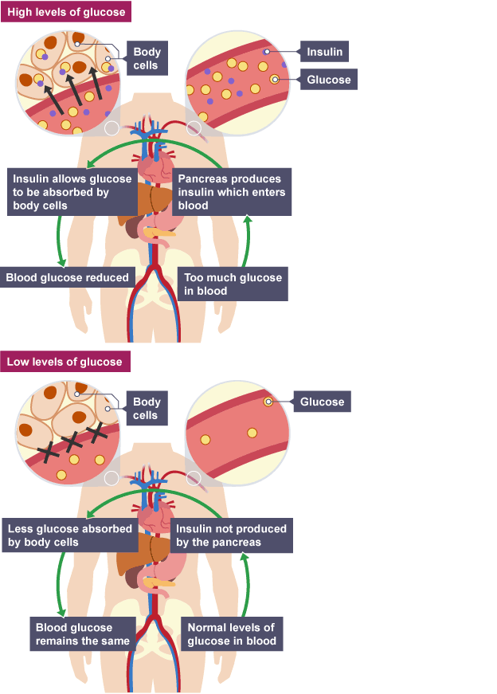
Fig.3 https://www.bbc.co.uk/bitesize/guides/zgqcmsg/revision/3

3.Cellular Metabolism

Oxygen and glucose are fundamental to energy production in cells throughout a method known as cellular respiration, which occurs primarily in the mitochondria. This multi-step mechanism happens in three main stages: glycolysis, the Krebs cycle (also known as citric acid cycle), and oxidative phosphorylation.
Glycolysis
Cellular respiration begins with glycolysis, which occurs in the cytoplasm of the cell. During glycoses, one molecule of glucose (a six-carbon sugar) is broken down into two molecules of pyruvate (three carbons each). This process is anaerobic, not requiring oxygen. Glycolysis consists of ten enzymatic reactions, resulting in a net gain of two ATP (adenosine triphosphate) molecules, which serve as energy currency for the cell, and two molecules of NADH, an electron conveyor that transports high-energy electrons to the next stages of metabolism (Tucker, 2015).
Krebs cycle
if oxygen is available, the pyruvate produced during glycolysis is carried into the mitochondria, where it undergoes conversion into acetyl-CoA. This molecule then enters the Krebs Cycle. The cycle operates in the mitochondrial matrix and involves a series of enzymatic reactions that oxidize acetyl-Coa, releasing carbon dioxides a waste product. Each turn of the Kerbs cycle generates ATP, along with electron carriers NADH and FADH₂ (Scanlon & Sander, 2019) These careers are crucial for the next stage of cellular respiration, as they store high-energy electrons that will be used to generate additional ATP.
Oxidative Phosphorylation
The last stage of cellular respiration, oxidative phosphorylation, occurs in the inner mitochondrial membrane and is aerobic, requiring oxygen. Here the NASDH and FADH₂ made in the previous stages donate their high energy electrons transport chain (ETC), a series of proteins embedded in the mitochondrial membrane. As electrons pass through the ETC, they release energy, which is utilized to pump protons (H⁺ ions) from the mitochondrial matric into the intermembrane space, creating a proton gradient.
This gradient generates potential energy, which is harnessed by ATP synthase as protons flow back into the matrix. Oxygen acts as the final electron acceptor in the chain, combining with electrons and protons the form water, a crucial byproduct of cellular respiration (Nair& Peate, 2011).
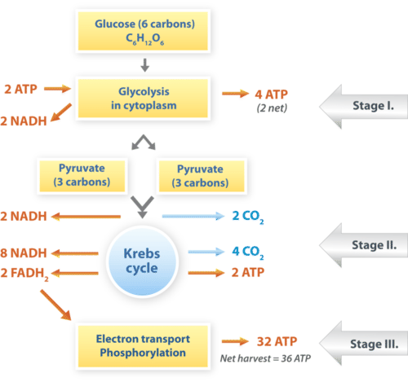Fig.4 https://bio.libretexts.org/Bookshelves/Introductory_and_General_Biology/Introductory_Biology_%28CK-12%29/02%3A_Cell_Biology/2.26%3A_Cellular_Respiration

4. Recording and tracking blood sugar levels for type 2 diabetes.

Tracking and recording blood sugar is very important for individuals with Type 2 diabetes as it empowers them to manage their condition effectively. This process involves regularly measuring blood glucose levels and maintaining a record that can be analysed over time.
Here are several reasons why this practice is vital:
Regular monitoring permits people to identify patterns in their blood sugar levels in relation to food intake, physical activity, medication, and stress. For instance, a patient may notice spikes in blood glucose after consuming certain carbohydrates or decrease after exercising. This information can help in making informed dietary and lifestyle choices. (Tucker, 2015).
Not controlling glycaemia can cause serious health complications, for example: neuropathy, retinopathy, and cardiovascular disease. By tracking blood sugar levels, patients can recognise when their levels are outside the target range and take corrective actions, such as adjusting their diet or medication (Scanlon & Sander, 2019). Early detection of abnormal levels can prevent the progression of complications associated with diabetes.
Self-monitoring enhances patient engagement in their care plans. When individuals take an active role in managing their diabetes. They are more likely to adhere to their treatment regimens. This empowerment can lead to better health outcomes and increased confidence in managing their condition (Nair& Peate, 2011).
Records of blood sugar levels provide valuable information for healthcare providers during consultation. These records can help clinicians make more informed decisions regarding medical adjustments or additional interventions. For example, if a patient shows consistently high blood sugar levels, their providers may consider changing their insulin treatment or introducing new medications (Odya, 2018).
Monitoring blood sugar allows patients to set and achieve realistic health goals. By understanding how their lifestyle choices impact their glucose levels, individuals can work toward specific objectives, such as weight loss or improved physical fitness, which are essential for effective diabetes management (Sturgeon, 2018).
Failing to monitor blood sugar levels can have threatening consequences for individuals with Type 2 diabetes. Without regular tracking, patients may experience uncontrolled blood sugar fluctuations. Hyperglycaemia (high blood sugar) can lead to symptoms such as excessive thirst, frequent, urination, coma and fatigue. In severe cases, it can result in diabetic ketoacidosis a potentially life-threatening condition ((Tucker, 2015). Conversely hypoglycaemia (low blood sugar) can cause dizziness, confusion, and even loss of consciousness.
When blood sugar levels are not tracked, patients may remain unaware of worsening control over their condition. This delay can lead to complication that could have been managed or prevented through timely intervention, resulting in increased healthcare costs and a lower quality of life (Nair &Peate,2011)
Chronic high blood sugar levels can lead to long-term complications such as kidney failure, neuropathy, and cardiovascular disease. Without regular monitoring, individuals may not recognise their need for lifestyle modifications or medication adjustments, ultimately compromising their overall health (Scanlon & Sander, 2019).

5.Recommendations

To boost the overall health and wellness of individuals with Type 2 diabetes, research–backed strategies are essential. These interventions can enhance glycaemic control, reduce risk of complications, and promote a healthier lifestyle.
A healthy diet is critical for diabetes management. Evidence suggests that patients benefit from working with registered dietitians to develop personalized meal plans.
Focus on whole foods, such as whole grains, lean proteins, fruits, and vegetables, while minimizing processed foods high in sugars and unhealthy fats, can significantly improve blood glucose levels (Tucker, 2015). Carbohydrates counting and understanding the glycaemic index can also empower patients to make better food choices.
Regular exercise is very important for managing diabetes. The American Diabetes Association recommend at least 150 minutes of moderate intensity aerobic exercise each week, along with resistance training twice a week (Scanlon& Sanders, 2019). Physical activity improves insulin sensitivity, aids in weight management, and enhances cardiovascular health. Patients should be encouraged to find enjoyable activities to promote adherence.
Achieving and maintaining a healthy weight can significantly improve insulin sensitivity. Studies shows tha a modest weight loss of 5-10% can lead to substantial improvements in glycemic control and reduce the risk of diabetes- related complications (Nair& Peate, 2011). Interventions could include personalizes weight-loss programs that incorporate nutritional adjustments and movement.
Regularly tracking blood sugar levels helps individuals understand how their lifestyle affects their diabetes. Self-monitoring cand lead to real-time adjustments in diet and medication, promoting better adherence to treatment plans (Odya, 2018). Patients should be educated on how to interpret their readings and respond appropriately.
Smoking increases the risk of cardiovascular diseases and complications in patients with diabetes. Health promotion initiatives should include support systems for quitting smoking, such as counselling and pharmacotherapy. Research shows that cessation can significantly improve overall health and reduce complications (Sturgeon, 2018).
Managing a chronic condition can lead to stress and anxiety, which may negatively impact diabetes management. Integrating mental health services and support groups can help individuals cope with their diagnosis. Cognitive-behavioural therapy and counseling can improve emotional well-being and adherence to lifestyle changes (Tucker, 2015).
Engaging community resources, such as diabetes training programs and support groups, can supply additional information and encouragement. These programs can help individuals connect with others facing similar challenges, fostering a sense of community and support.

6.Conclusion

In conclusion, the report underscores the critical role of recording and tracking blood sugar levels for individuals with Type 2 diabetes, highlighting that this practice is essential for effective condition management. Regular monitoring enables individuals to recognize patterns in their bllod sugar levels, prevent complications, and enpower them to communicate effectively with healthcare providers. On the other hand, failing to monitor can lead to uncontrolled fluctuations, increased risk of complications, and overall deterioration in health.
To increase diabetes management, several evidence-based strategies are recommended. Engaging in nutritional conseling can help individuals adopt balanced meal plans focused on whole food, while encouraging at least 150 minutes of moderate exercise can significantly improve insulin sensitivity. Additionally, achieving a modest weight loss of 5-10% can further add to glycaemic control. Regular self-monitoring of blood glucose levels facilitates real-time adjustments in lifestyle and treatment, and support for smoking cessation can reduce cardiovascular risks.
Moreover, addressing mental health through counselling and support groups is vital for managing the emotional challenges associated with diabetes. Finally, leveraging community resources and support programs can bolster education and provide necessary encouragement, enhancing adherence to lifestyle changes.
Ultimately, effective management of Type 2 diabetes hinges on the integration of blood sugar monitoring and lifestyle modifications, reinforced by evidence-based strategies, to promote overall health and wellbeing.

References

BBC Available at: https://www.bbc.co.uk/bitesize/guides/zgqcmsg/revision/3 (Accessed 7 April 2026).
Louise Tucker (2015) An Introductory Guide to Anatomy & Physiology. 5th edition. London: EMS Publishing. Available at: EBSCOhost Ebooks (Accessed: 6 April 2026).
Nair, M. and Peate, I. (2011) Fundamentals of anatomy and physiology for student nurses. Chichester, West Sussex, U.K: Wiley-Blackwell. Available at: https://www-vlebooks-com.uwtsd.idm.oclc.org/Product/Index/44116?page=0&startBookmarkId=-1 (Accessed 7 April 2026).
NHS Available at: https://www.nhs.uk/conditions/diabetes/ (Accessed 5 April 2026)
Odya, E. (2018) Anatomy & physiology workbook. Third edition with online practice. Hoboken, New Jersey: John Wiley and Sons, Inc. Available at: ProQuest Ebook Central (Accessed 5 April 2026).
Scanlon, V.C. and Sanders, T. (2019) Essentials of anatomy and physiology. Eighth edition. Philadelphia, Pennsylvania: F. A. Davis Company. Available at: ProQuest Ebook Central (Accessed: 7 April 2026).
Sturgeon, D. (2018) Introduction to anatomy and physiology for healthcare students. London ; Routledge, Taylor & Francis Group. Available at: ProQuest Ebook Central (Accessed 5 April 2026).
Waugh, A., Grant, A. and Ross, J.S. (2018) Ross and Wilson anatomy & physiology in health and illness. Thirteenth edition. Amsterdam: Elsevier. Available at: Askews and Holts - VLeBooks (Accessed: online 6 April 2026).
WHO Available at: https://www.who.int/news-room/fact-sheets/detail/diabetes (Accessed 6 April 2026).

