Control System Design

Matt Claridge

Instrumentation and Control

Wales Institute for Science and Art
University of Wales Trinity Saint David



Abstract
This report details the design and validation of a Closed loop control system for a Close-In Weapon System (CIWS). A controller was developed which had to bring the system under control within two seconds and less than 5% overshoot.

The system was created on MATLAB and Simulink, then tuned resulting in a settling time of 0.147s and overshoot of 0.199%. Stability was confirmed using an assortment of data and then validated manually. K_{p} = 93.6, K_{i} = 13.3, K_{d} = 146.

Whilst the simulation delivered positive results, it should be noted that real world implementation is likely to less successful. This is due to extremely fast response times, the extreme weight of the real system and external influences such as friction.

Introduction
[1] Control systems are devices used to manage the behaviour of a system. They work by measuring where a system is against its desired state, resulting in a measured output which tells the system what to do. Control systems are used to achieve stability, accuracy and speed. Common uses of control systems include cruise control, heating controls, a toilet flush and traffic light controls.
[2] There are two types of control systems, open loop and closed loop systems. Open loop control systems operate based on initial inputs and the output is unaffected during the systems operation. They are unable to utilise feedback for precise outputs as a Closed loop control systems do. Closed loop systems provide the ability to adjust the output based on mitigating factors, and use corrective measures based on an error signal. Traffic lights provide a good example of the differences between open and closed loop control systems. Some lights are open loop – they turn green for a defined period regardless of the amount of traffic. Many newer traffic light systems are closed loop – inductive loops or cameras detect the amount of traffic and adjusts the timing sequence of the lights to adjust for heavier traffic.
[3] CIWS (close-in weapon systems) are an example of closed loop systems. They need to be precise and operate in variable environments which can affect system output. The closed loop system allows the CIWS to monitor its precise position, account for external influences such as friction, momentum, resistance and wind, and improve performance by reducing or removing oscillations from braking. The CIWS closed loop control system uses PID controllers to control the turret movement when aiming.
PID stands for Proportional, Integral and Derivative. It is a way controllers compare the input and output of a system to calculate the required output of machinery. [4] Its formulation, based on the combination of proportional, integral, and derivative actions, provides a balanced trade-off between response speed, steady-state error elimination, and oscillation damping.
[5] Proportional control systems multiply an error signal by a constant to give the system a target result. An issue with proportional systems is that the system will often never reach its final target position. That is because as the error signal reduces, it can leave the system with such a small signal that it lacks the power to remove the remaining delta. [6] Integral systems manage to negate this issue by additionally considering time in its error response. The output of an integral control system is proportional to error signal added up over time, so the longer the error lasts the higher the output will be. For this reason, integral controllers can ensure that even the smallest error signals are eventually resolved. A limit of integral controllers is that they can take a long time to eventually resolve error signals, this is called over dampening. The issue can be resolved my increasing the response but doing so will often lead to oscillations. The system overshoots it target position, the output stops, the system falls back below its target position and the situation repeats. PIDs use these methods plus derivative control. [7] This multiplies the rate of change in an error by a constant and adds the proportional, integral and derivative terms to find the output. If the controller is rapidly driving towards the target output, the derivative control slows the output down to prevent it from overshooting to avoid oscillation.
[8] The transfer function is the mathematical representation of how the systems output responds to inputs. The formula for the transfer function is $G\left(s\right)=\frac{N(s)}{D(s)}$ or $G\left(s\right)=\frac{1}{{as}^{2}+bs+c}$ where the numerator is the response and the denominator is the input signal. The transfer function allows you to determine gain, stability and response time.
A pole-zero diagram shows the S plane of the system. [9] This is the plotting of poles on a graph which demonstrates a systems behaviour. The horizontal plane is the real axis, and the vertical plane is the imaginary. Poles sitting on the left side of the graph are known to be stable, and the right shows an unstable system meaning the system will oscillate continuously. The further from the centre of the imaginary axis shows higher oscillations. Positions on the S plane can explain a system in four ways. Over damped shows a slow system which never overshoots. Critically damped is a well balance system which quickly achieves its target without over shooting. Under damped systems have a fast response but overshoot and oscillate before settling. Undamped are unstable and continuously oscillate.
A Nyquist plot is used to determine the stability of a control system in the frequency domain. [10] It plots gain and lag vs frequency, showing if a specific frequency will cause the system to become unstable.

Method
A PID control system was built using Simulink in MATLAB. It consisted of a Step which is used to generate an input signal. An add block was included which performs addition or subtraction to the input signal. It was set to + - which adds the first input and subtracts the second. This creates the error action. The PID controller was added to the system which calculates the difference between the input signal and the feedback signal to deliver the control signal. A transfer function which provides the process calculation and defines how the system behaves. The last three digits plus one of a student number were used, so this resulted in 6, 2, 7. Therefore the process equalled $\frac{1}{6s^{2}+2s+7}$. In addition to the control system, a scope was also added with four inputs. The scope works as measurement tool providing a visual result at each step. The system is presented in Figure 3-1 below.
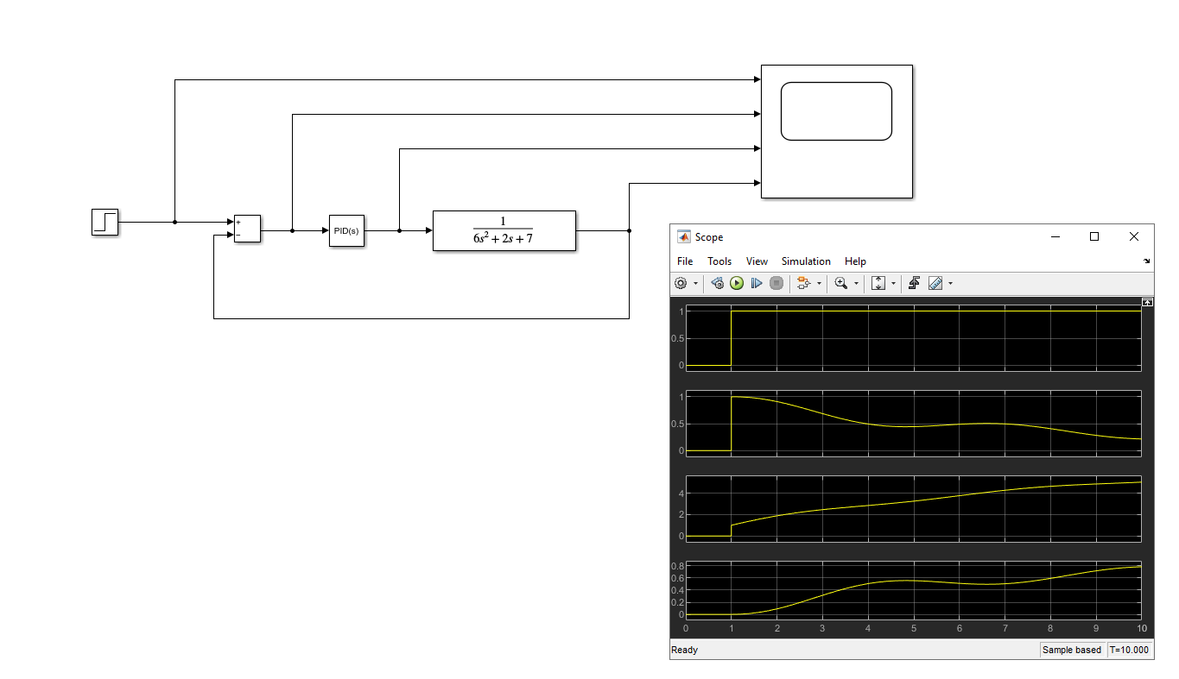
Figure 2-1 Simulink System Untuned
The PID was then tuned by adjusting the response time and transient behaviour to meet the specification of less than 5% overshoot and under control within two seconds. The autotune function within MATLAB was utilised which changed the response to what the software saw as most efficient. This result was then manually fine-tuned by increasing the response time and transient behaviour for the quickest response with minimal overshoot. These results are shown in Figure 3-2 below.
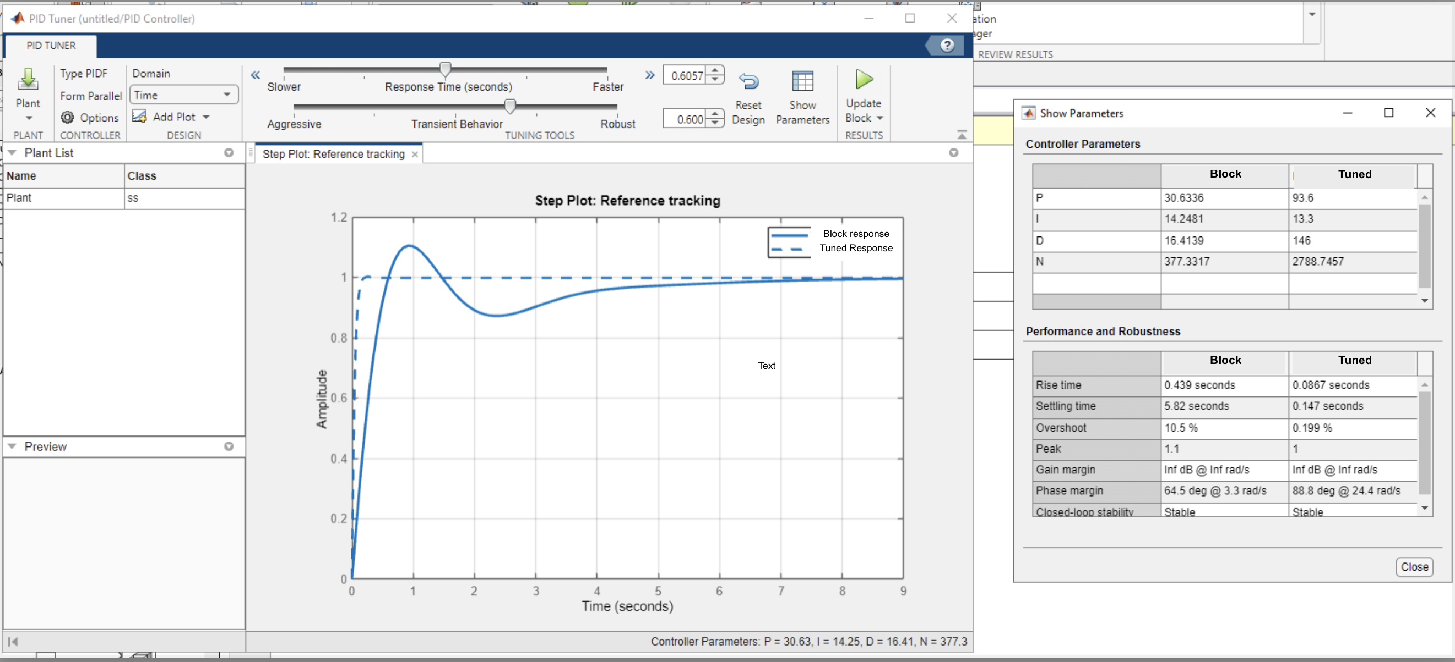
Figure 2-2 manually tuned results
The manually tuned system gave the K_{p} (proportional) result as 13.3, K_{i} (integral) as 13.3 and K_{d} (Derivative) was 146. The filter coefficent (N) was 2788.7457 meaning that the time constant is $\frac{1}{N}=\frac{1}{2788.7456}=0.000358 \left(6 decimal places\right).$
The key figures were put into MATLAB and commands were made to perform the complex maths required to simulate the results. These have been recorded in Figure 7-3 in Appendix A2.

Results

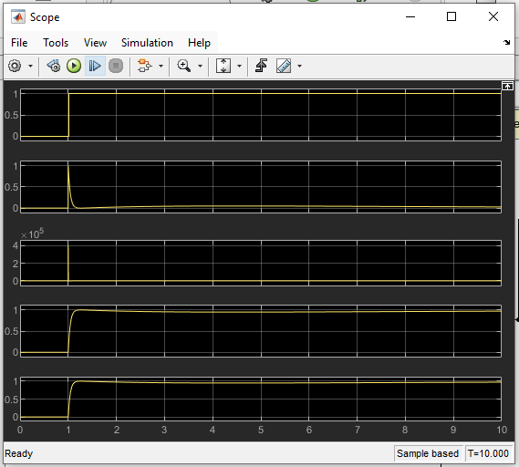
Validation
Control Effort
Plant output
Error Signal
Set Point – Targeting position
Figure 3-1 - Scope Block Results
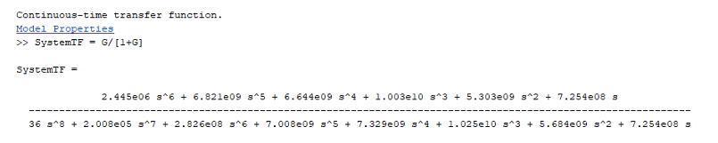
Figure 3-2 - Matlab Transfer Function
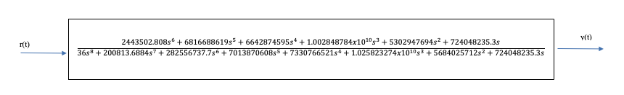
Figure 3-3 - Calculated Transfer Function
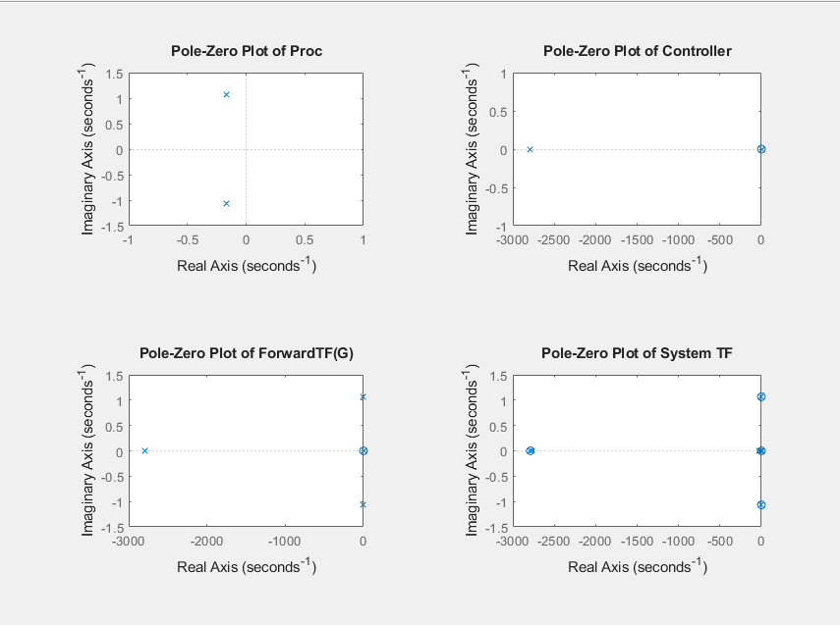
Figure 3-4- Pole-Zero Plots
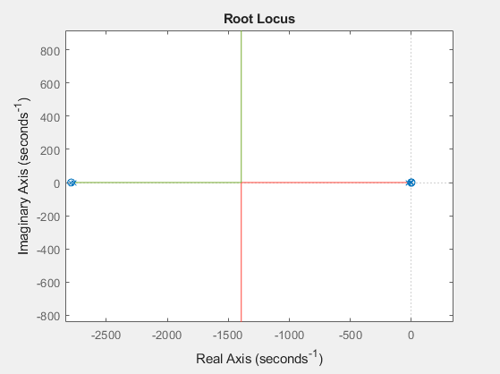
Figure 3-5 - Root Locus Plot
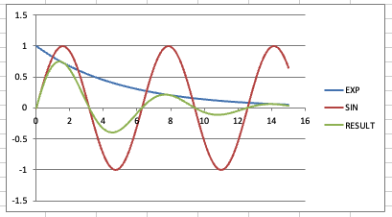
Figure 3-6 - Waveform from Pole Zero Diagrams
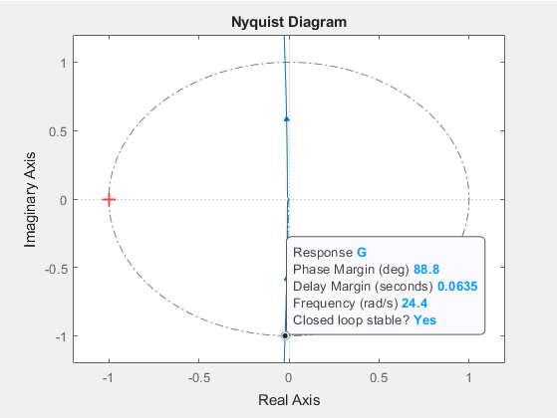
Figure 3-7 - Nyquist Diagram

Discussion
The brief was to design a closed loop control system capable of controlling an automatic CIWS turret which the transfer function given by:
$G\left(s\right)=\frac{1}{{as}^{2}+bs+c}$ when a = 6, b = 2, c = 7.
The control system should be able to bring the process under control within two seconds, with an overshoot of less than 5%.
The results from the computer simulation demonstrate that the PID controller design will meet the requirements set out in the brief. The results in Figure 2-2 and Figure 3-1 show that the system was under control (settled) within 0.147 seconds and has an overshoot of 0.199%. This was achieved by having high Proportional gain, K_{p} = 93.6, to quickly move the system, and a high Derivative gain, K_{d} = 146, to dampen the system and prevent it from overshooting the target. Whilst this has worked well on paper, in the physical world the mass of a CIWS turret is so great that the ability for it to accelerate quickly enough and maintain stability whilst slowing at that rate seems unlikely. The K_{i} is the Integral gain. The value of this was low at 13.3 which was a result of the K_{p} and K_{d} being efficient meaning there wasn’t a lot of work for the integer to do.
Figure 3-4 shows the pole zero plots. The process plots are at -0.2, 1 and -0.2, -1 which are left of 0, meaning the system has an oscillating decaying transient. This makes the system stable as the oscillations are reducing. The rate of decay is given by the horizontal position and is shown as the blue line in Figure 3-6. The red SIN wave comes from the vertical position of the poles, and the combined result is shown as green.
Figure 3-4 shows the Pole Zero Plots. The top left is of the controller with a Pole and Zero close to 0 on the real axis. The pole is around -2800 which means the system will have an incredibly fast response. The Pole-Zero Plot Forward is a multiplication of the Process Pole-Zero and the Control Pole-Zero. The final graph, System TF, includes validation that the controller will work as intended. The zeros on top of the poles from the process show that the final system will not oscillate. The zero on the far-left controller pole shows the response will be tempered. Everything is in the negative real axis meaning the system will not oscillate.
The Root Locus is shown in Figure 3-5. This represents the behaviour of system when the proportional gain is changed. As proportional gain is increased the system will go from over damped to under damped. Critical dampening is at approximately 0,-1400s⁻¹. The Nyquist diagram in Figure 3-7 displays the robustness of the system. The critical point is the point at which a system transitions from being stable to unstable. It is marked on the diagram by the red cross at -1, 0j. The blue line is the path of the Transfer function (G) as the frequency varies. As the blue line is distant from the critical point, the diagram indicates that the system is stable. The phase margin is 88.8° which is large phase shift which would be required for the system to become unstable. For the CIWS an example of where this might be useful is mechanical friction.
To validate the computational Math, completed on MATLAB, a second manual version was also completed. The results are in Figure 7-4 in Appendix A3. The closed loop transfer function was calculated by multiplying the PID controller by the Process to find the forward path transfer function G(s). Then the feedback loop was removed to calculate the transfer function of the whole system, using TF=$\frac{1}{1+GH}$. The results matched the software confirming the accuracy of the work. One notable point being that the T_{f} was quite well. This shows strong simulated performance but could be another real-world issue of the system shaking due to its weight and extreme reaction to inputs. The T_{f} may need to be gradually increased to resolve this issue.

Conclusions
This report notes several key findings regarding the use of PID controllers.

Closed loop controllers provide better accuracy than open loop controllers due to their ability to react to external influences. They balance Proportional, Integral and Derivative controls to quickly respond whilst maintaining stability. [7] Tuning is critical part of setting up a closed loop controller. The tuning allows the controller to behave in the desired system performance. Mathematical tools such as the graphs in this report are used to predict the systems behaviour from the simulation. Finally, even a well set up correctly simulated system can still have unintended real-world behaviours.

Bibliography

[1] | O. M. Anssari, “Introduction to Control Systems,” 6 11 2021. [Online]. Available: https://www.researchgate.net/publication/361162948_Introduction_to_Control_Systems. [Accessed 10 01 2026].
[2] | H. Touchette and S. Lloyd, “Information-theoretic approach to the study of control systems,” Physica, vol. 331, pp. 140-172, 2004.
[3] | NavWeaps, “20 mm Phalanx Close-in Weapon System (CIWS) Vulcan Air Defense System (VADS),” 2022. [Online]. Available: http://www.navweaps.com/Weapons/WNUS_Phalanx.php. [Accessed 21 03 2026].
[4] | D. Ibarra-Pérez, S. García- Nieto and J. Sanchis Saez, “Q-Learning for Online PID Controller Tuning in Continuous Dynamic Systems: An Interpretable Framework for Exploring Multi-Agent Systems,” Mathematics, vol. 13, no. 3461, pp. 1-29, 2025.
[5] | S. Alahmad and A. Ibreik, “Practical approachin Industrial Training in close loop Control Systems, problems solution” Case of PID- Level Control”,” International Journal of Engineering Research and Applications, vol. 14, no. 9, pp. 13-34, 2024.
[6] | J. Long, “Performance analysis of proportional feedback control and integral control in DC motors and speed control,” Theoretical and Natural Science, vol. 26, pp. 81-88, 2023.
[7] | J. M. Barrera-Fernandez, J. P. M. Hernandez, K. M. Escobedo, A. Vazquez-Cervantes and J.-C. Solano-Vargas, “PI-DÆ: An Adaptive PID Controller Utilizing a New Adaptive Exponent (Æ) Algorithm to Solve Derivative Term Issues,” Algorithms, vol. 18, no. 7, 2025.
[8] | D. Piriadarshani and S. Sathiya Sujitha, “THE ROLE OF TRANSFER FUNCTION IN THE STUDY OF STABILITY ANALYSIS OF FEEDBACK CONTROL SYSTEM WITH DELAY,” International Journal of Applied Mathematics, vol. 31, no. 6, pp. 727-736, 2018.
[9] | O. I. Elgerd and W. C. Stephens, “Effect of Closed-Loop Transfer Function Pole and Zero Locations on the Transient Response of Linear Control Systems,” Transactions of the American Institute of Electrical Engineers, Part II: Applications and Industry, vol. 78, no. 2, pp. 121-128, 1959.
[10] | C. K. Pang, F. Hong and X. Wang, “Integrated servo-mechanical control systems design using Nyquist plots for high-performance mechatronics,” Technical Paper, vol. 18, pp. 1719-1729, 2012.
[11] | Z. Janin, H. M. Kaidi, R. Ahmad and S. Khan, “Derivative Proportional –Integral Controller Using Nelder-Mead Optimization for Glycerine Purification Heating Process,” INTERNATIONAL JOURNALOF INTEGRATED ENGINEERING, vol. 12, no. 6, pp. 200-206, 2020.

Appendices

A1 PID Tuning
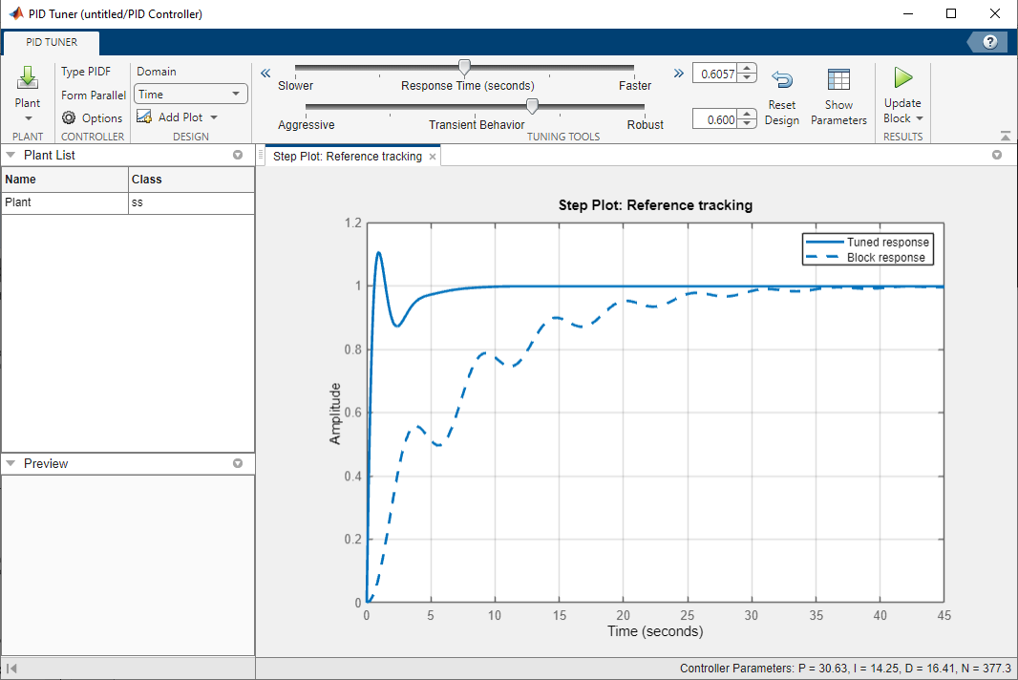
Figure 7-1 PID autotune
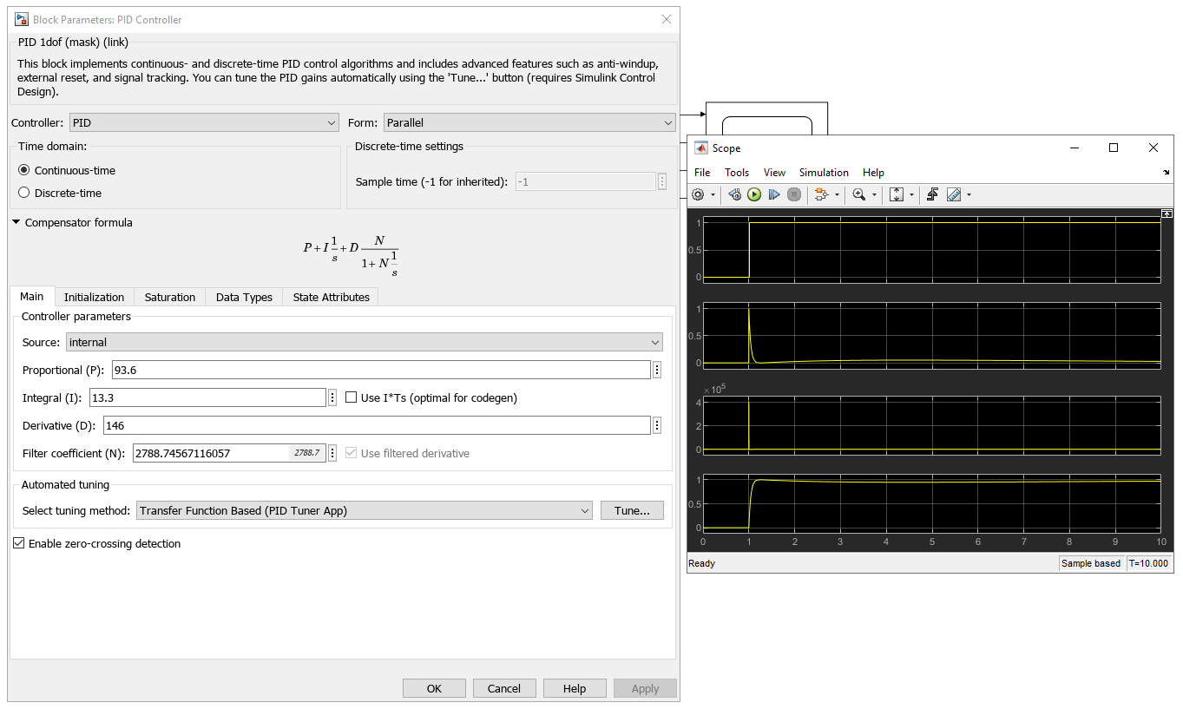
Figure 7-2 Manually tuned parameters and scope

A2 MATLAB Calculations

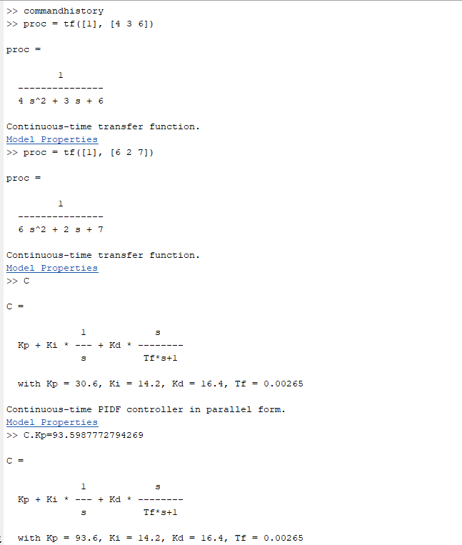

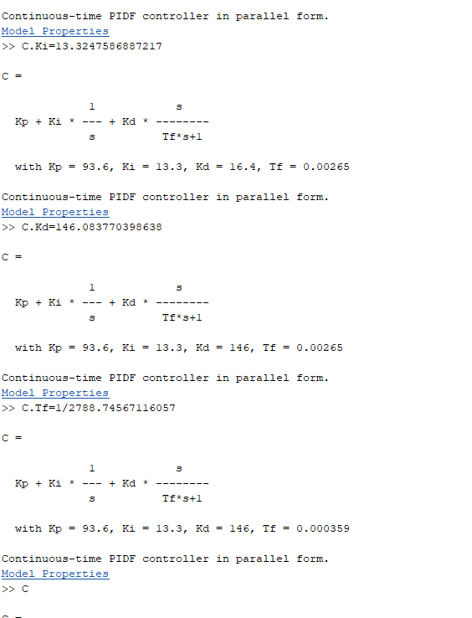
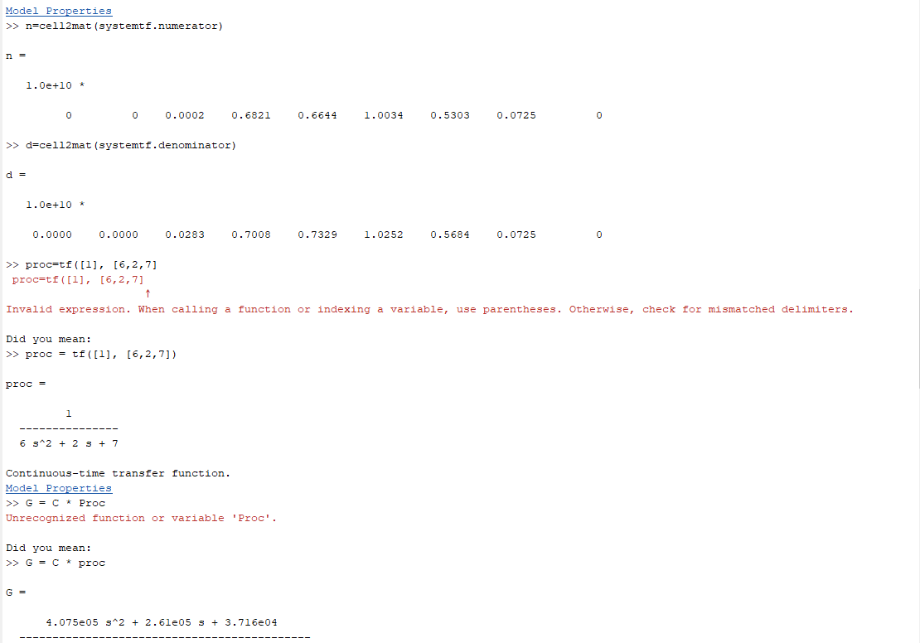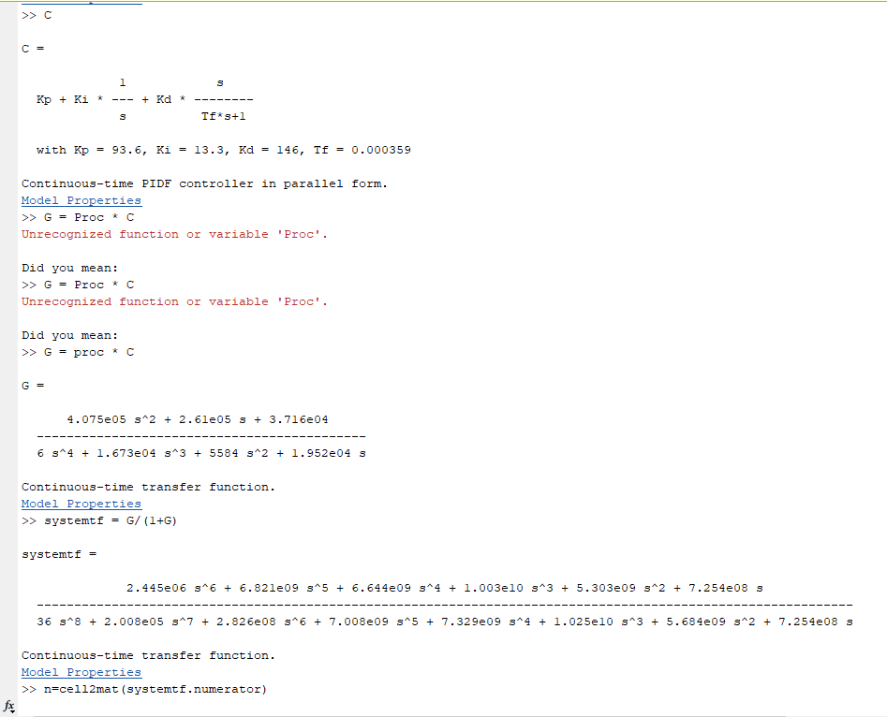
Figure 7-3 MATLAB Calculated Transfer Functions

A3 Validation Calculations

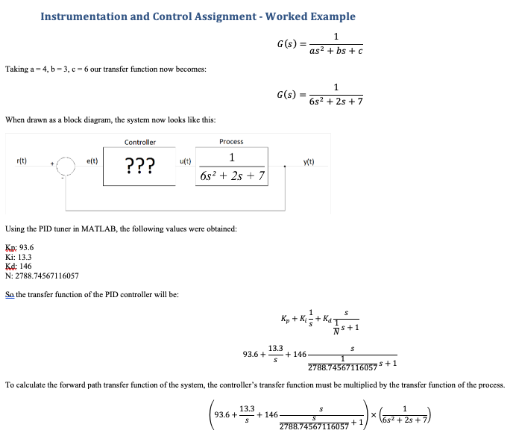
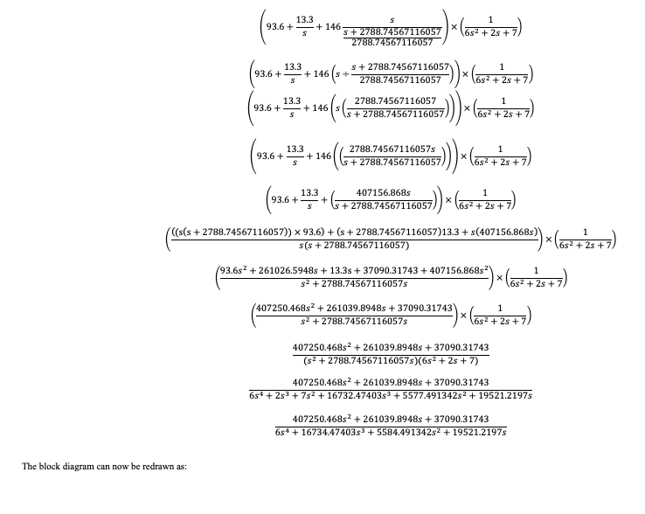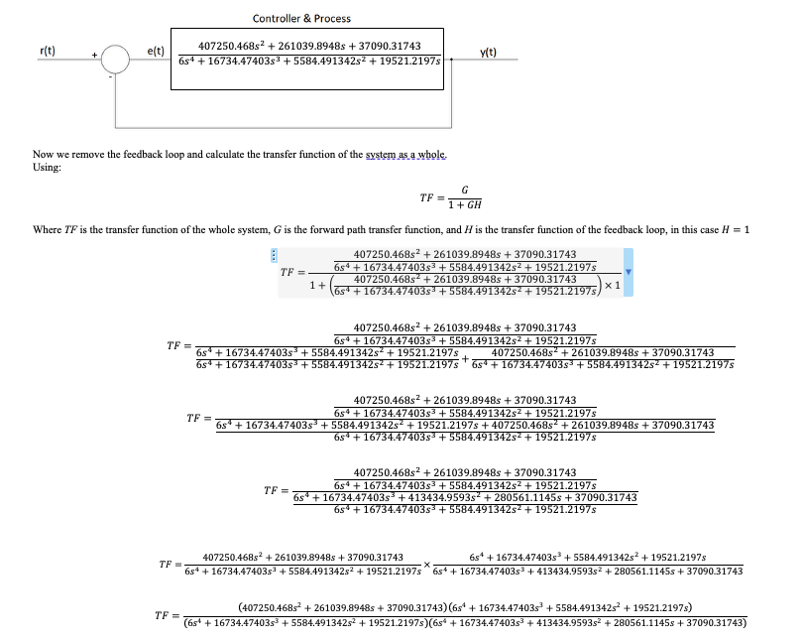
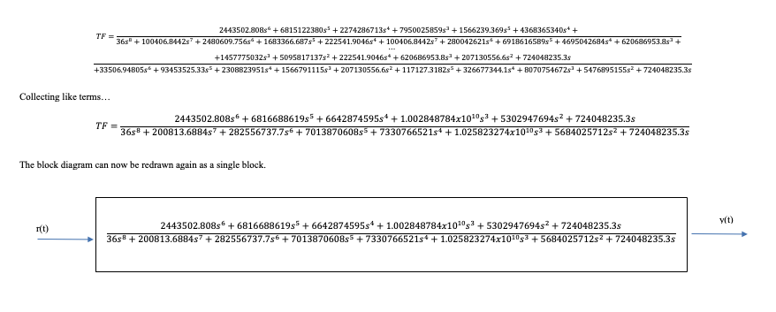
Figure 7-4 Validation Calculations

