University of Wales Trinity Saint David’s
L4 - Introduction to Web and Database Concepts (ACCA4023) + (ACCA4018 IT&S) (Gareth)
Cybersecurity (Computing and Networking)
Connor Michael Anthony Wilson (2011592@student.uwtsd.ac.uk)



Contents
Introduction – Page 1
Requirements – Page 2
Implementation – Page 3 – Page 7
Validation – Page 8 – Page 16
Evaluation – Page 17 – Page 18
References – Page 19
Appendix – Page 20 – Page 50

Introduction
In this report, I will be detailed information about the website that I have decided to produce, discussing the purpose, the subject matter of the website and it is overall relevance of the website so I can make sure that I am meeting the requirements for my website.
In the next section, I will be providing screenshots of my five completed web pages for my website and then I will be completing a validation to make sure that the HTML code for the homepage as well as the main style sheet (CSS file) meets the web standards so that the website can be displayed correctly across all different devices from mobile phones to computers.
I will be talking about any of the errors that may appear and why I think that the error has appeared and how it can be fixed by adjusting the website.
An evaluation will then be completed to look at the search engine optimization, usability of the website and the accessibility of the said website.

Requirements
I will be creating a website on the music artist Frank Ocean; this website will be designed for fans of the artist and can be used as a platform for them to access content from frank like his social media’s as well as music and videos of the artist. The website will also contain a merchandise page for the artist where they can purchase clothing items and other miscellaneous items.
The website will be the go-to place for Frank Ocean fans as it will condense all the access to his over pages and resources such as music to one page to help fans be more efficient with their time when access media by the artist rather than searching through individual sites to keep update to date, etc.

Implementation
I will firstly be showing screenshots of all the pages that have been created for the website. The web pages I have created for the website contain an initial homepage which will load when the user enters the site, a video page that contains music videos and related media by the artist, an audio tab that contains Spotify/YouTube links to all of Frank’s currently released music in one place for the convenience of the user, A shop page which will have different merchandise available for fans to purchase and an about us page which will contain information related to Frank as well as the website creator.
Video’s
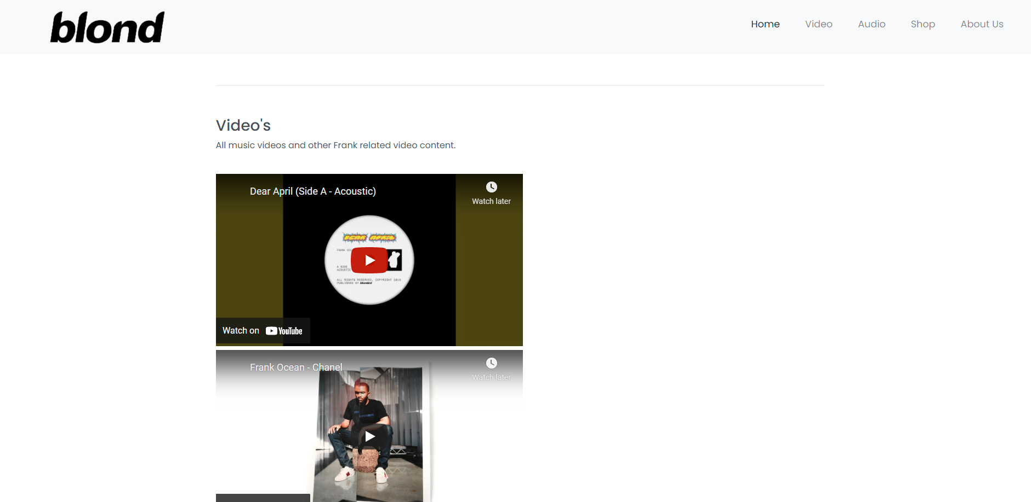
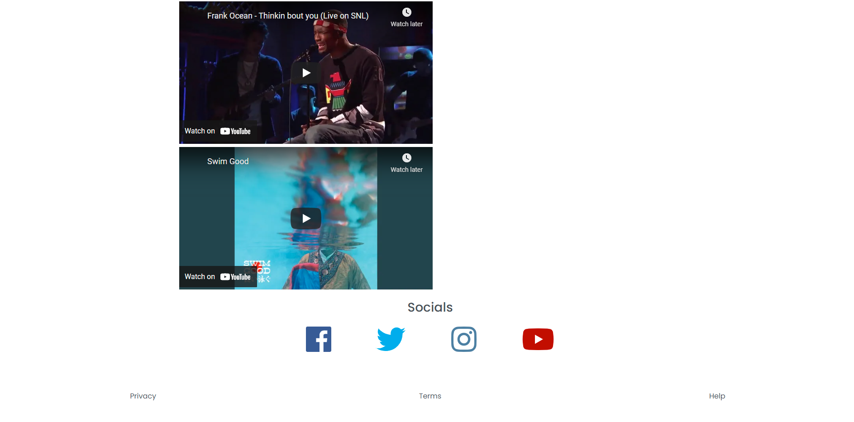

Music
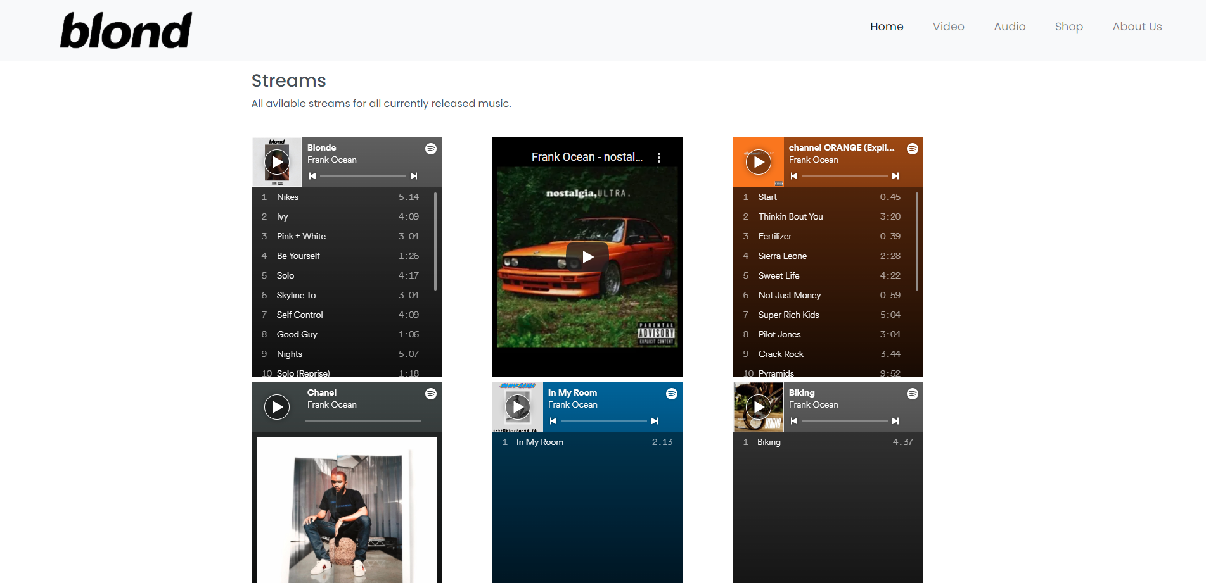
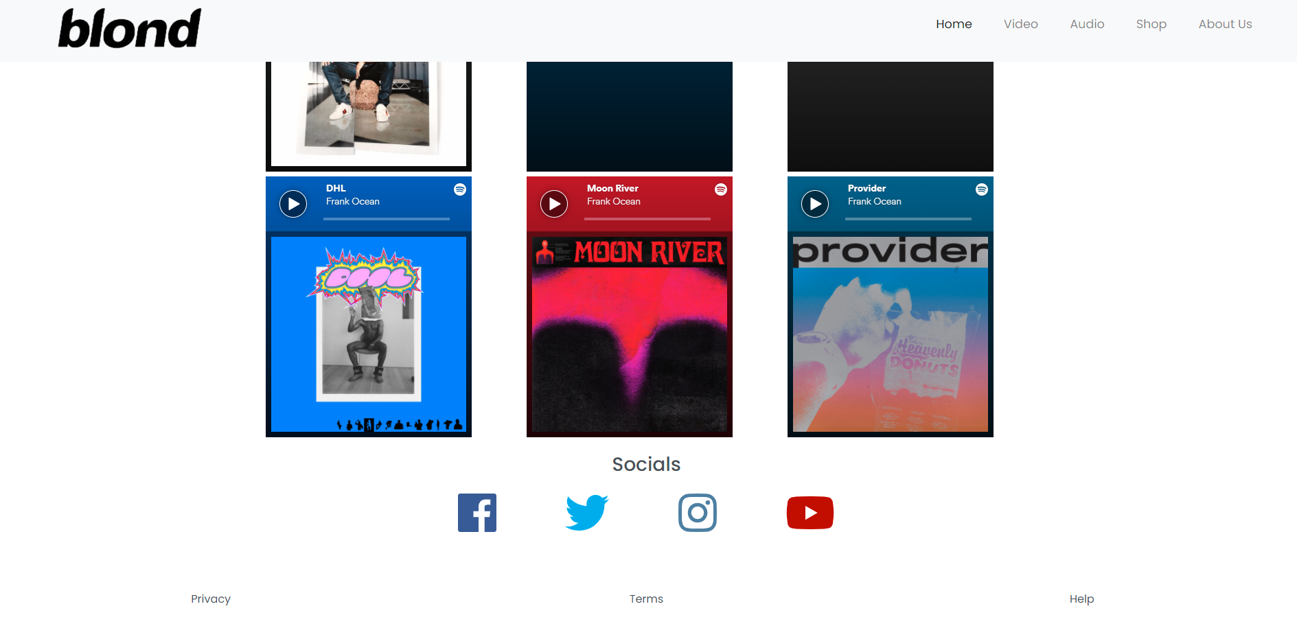

Shop
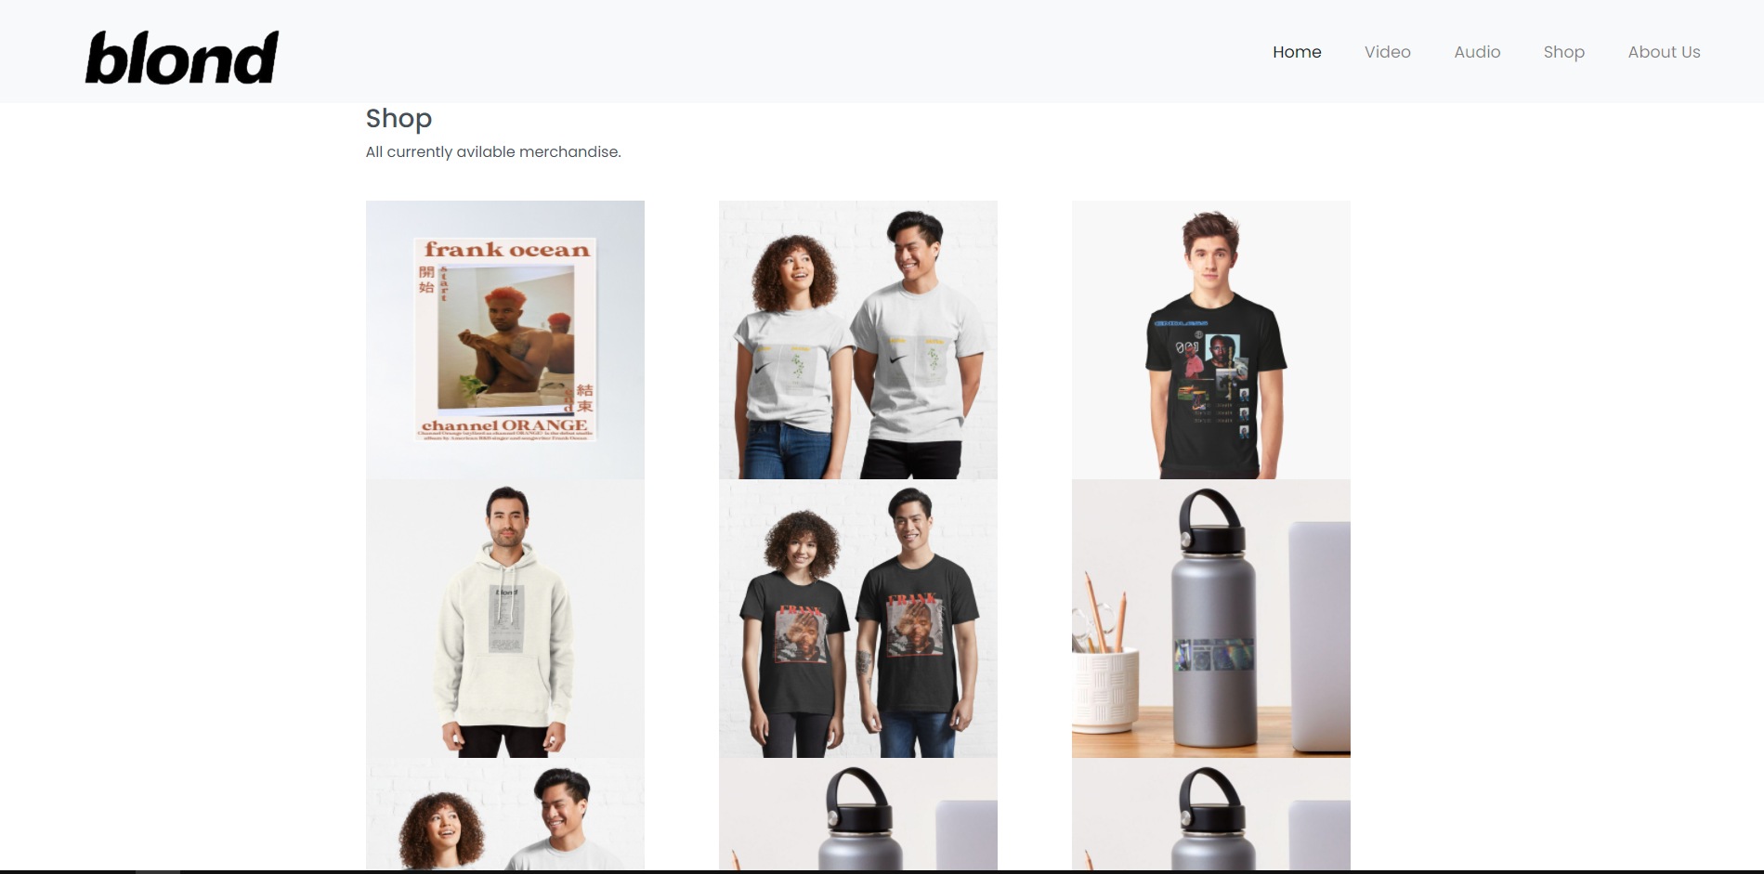
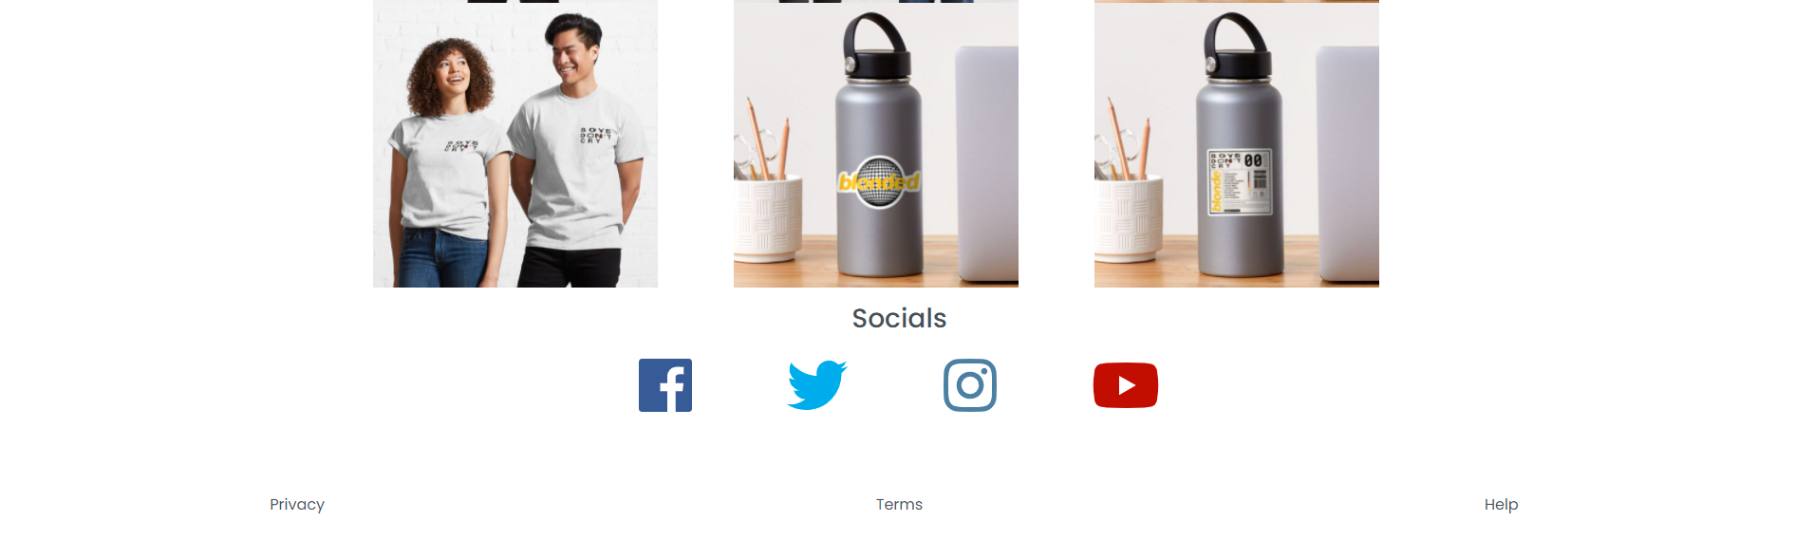

Home
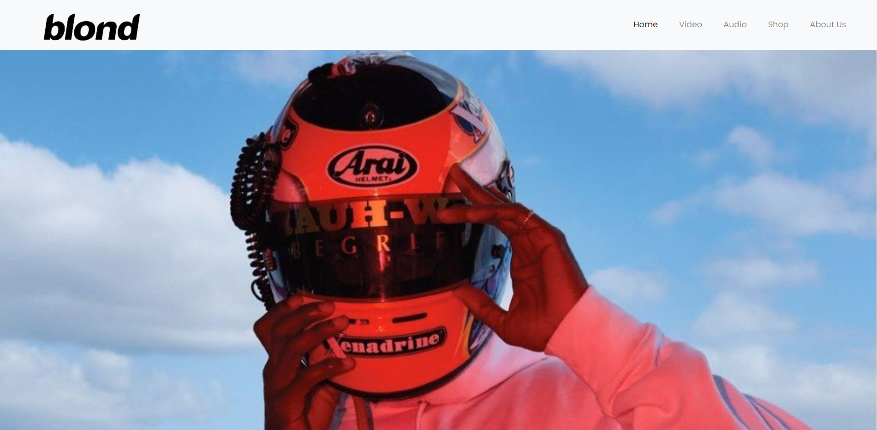
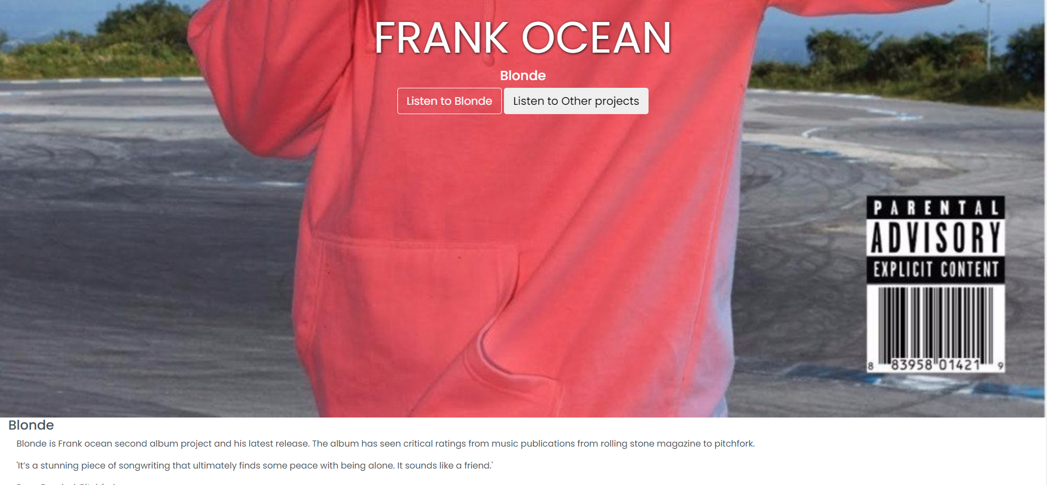
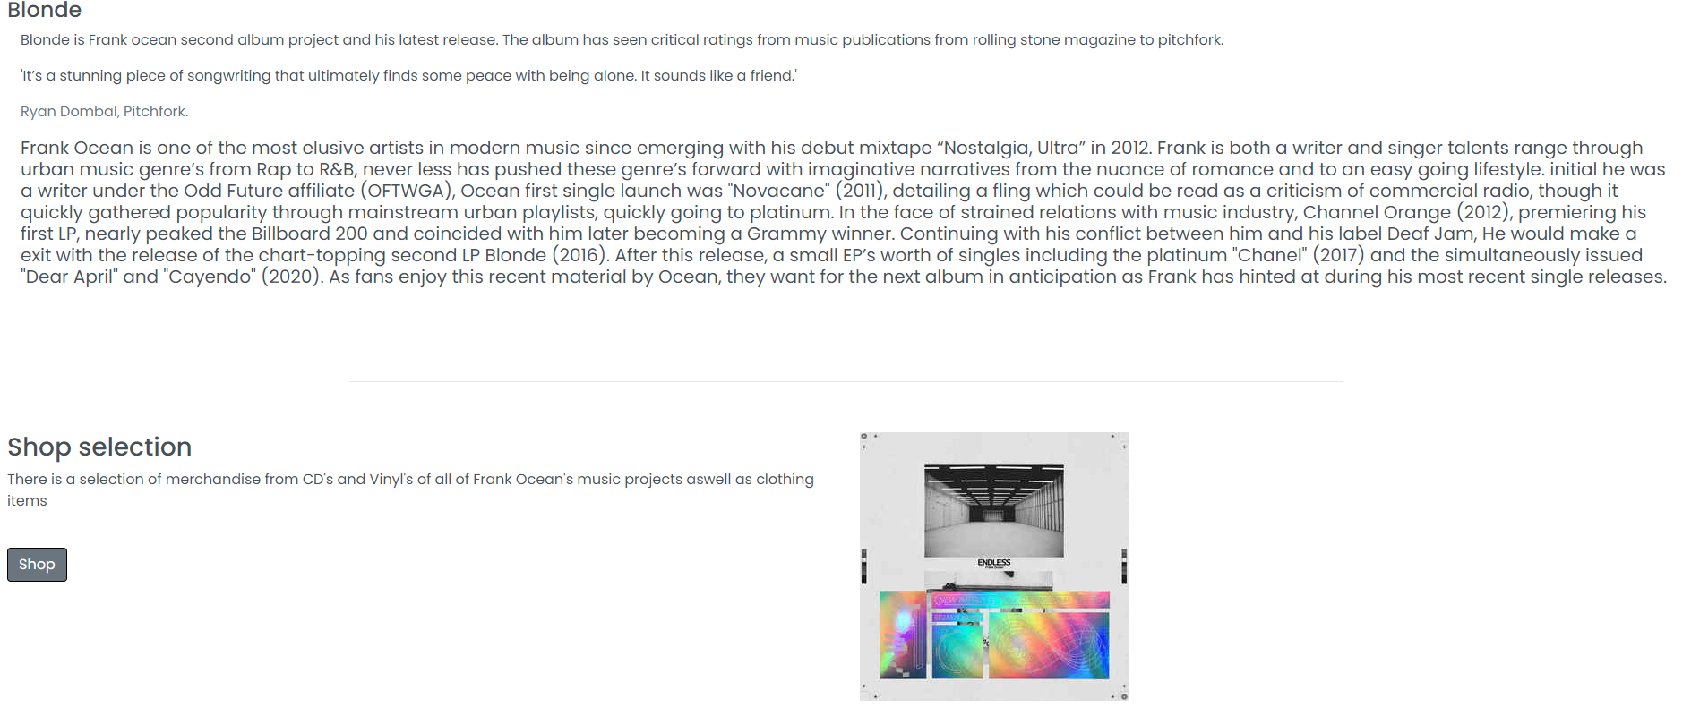

About Us
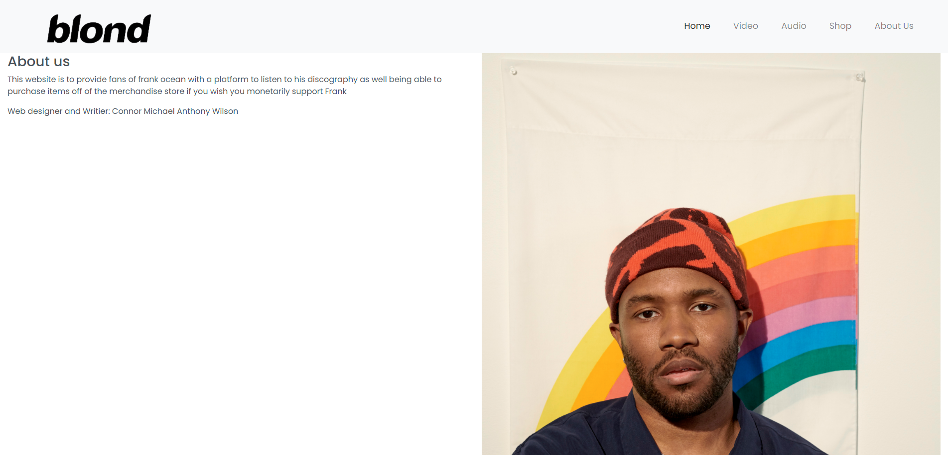
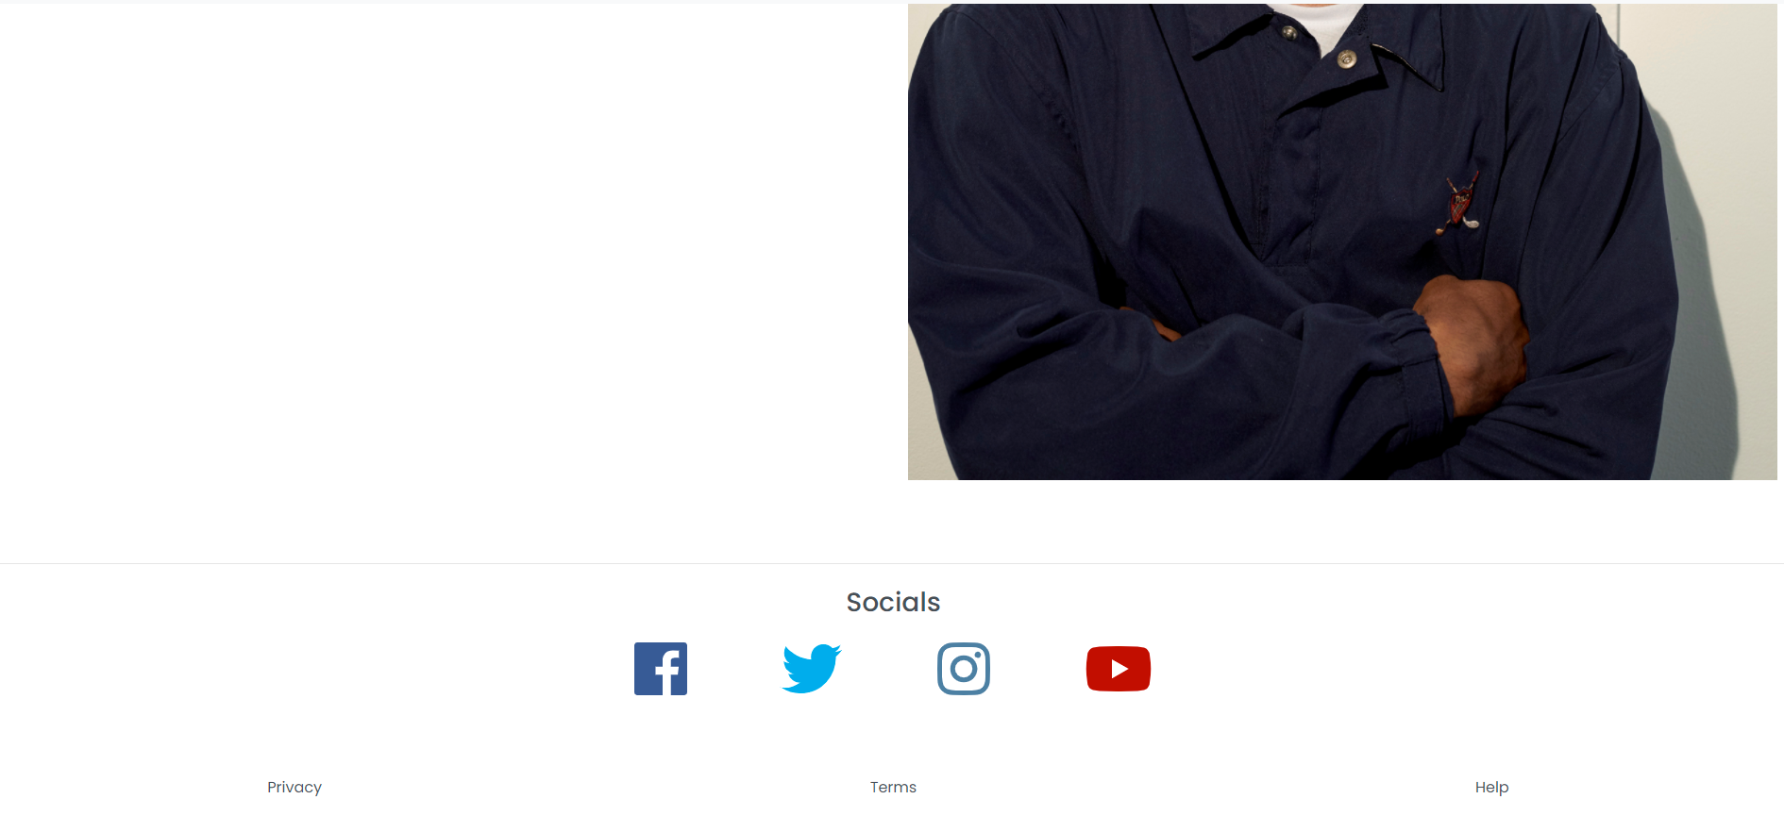

Validation
I will be completing some validations on my website next this is important as I can make sure that my website meets the W3C web standards.
The importance of these web standards is important as they allow consistency and compatibility overall for websites on the internet to make sure that they are compatible with anything from a mobile device such as an iPhone to up to a desktop device.
These standards were introduced when the internet was forming and initial websites were being created this allowed for a lot of compatibility issues and less consistency over all the websites that were being created.
Formed in 1994, W3C is an organization that articulates web standards so websites look and perform the same in all browsers. Its goal is to lead the Web to its full potential by creating standards, protocols and guidelines that help develop long-term growth. [1]
Follow the web standards that are set out by the W3C and using validation can help to make sure that the website is easier to maintain by having a clean and logical flow to its layout which can be taking advantage of by using HTML 5 when creating a website which I am utilizing by making use of bootstrap 4 for my website.
It helps to make sure that my website has compatibility with not only different browsers but also older versions of said browsers and that CSS is compatible with older browser versions.
A website using definitively correct HTML allows a site to appear higher in search results. Following Web Standards while creating a website guarantees that the code created will be indexed more appropriately by search engine bots. [2]
Another factor that web validation helps with is making sure that websites comply with the Accessibility and the Equality Act 2010 (UK). The purpose of this act is to ensure that all websites can be accessed by all users regardless of what device they are on as well as making it so that websites are legally required to ensure that the website is accessible to those with disabilities as well.
Websites must use contrasting text against the background, making the content easier to read for users. Colours (such as red and blue, and yellow and white) cannot be used together. The content in links must also describe the content of the link rather than simply saying ‘click here. These are just a few of the vast list of Web Accessibility Standards. I will be writing a post dedicated to it Web Accessibility, due to the importance of it. [3]

HTML validation
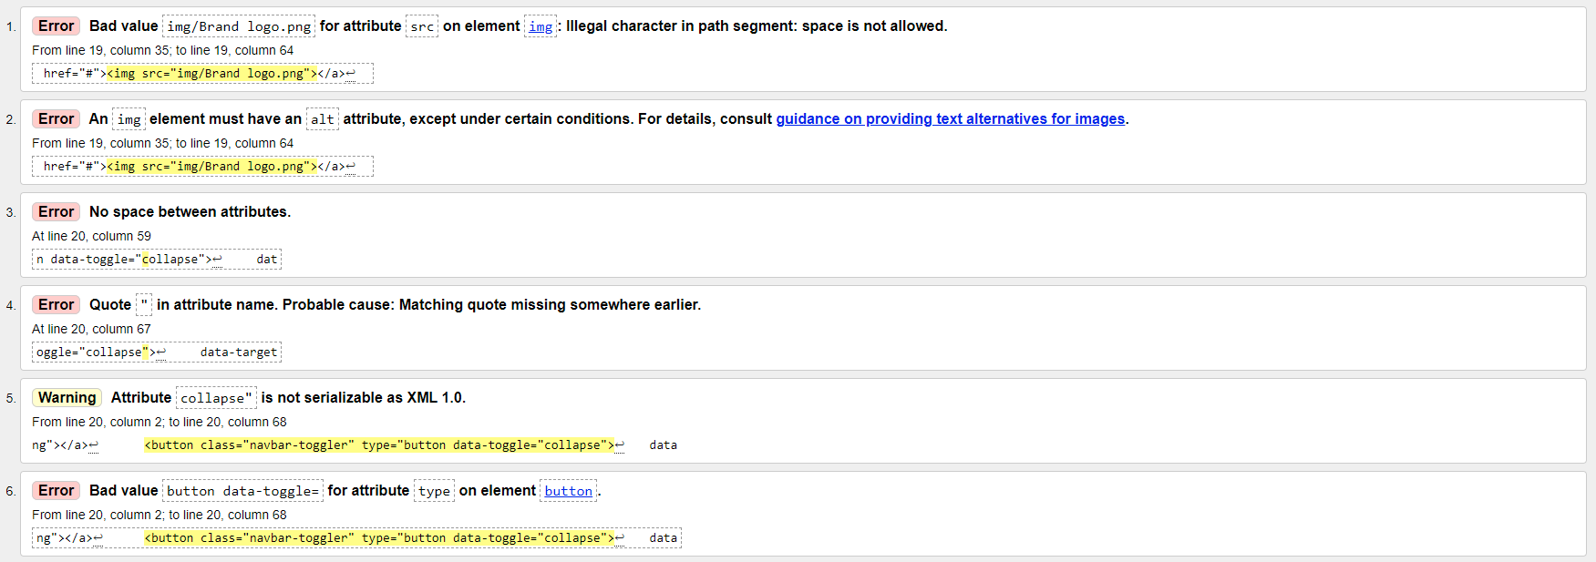
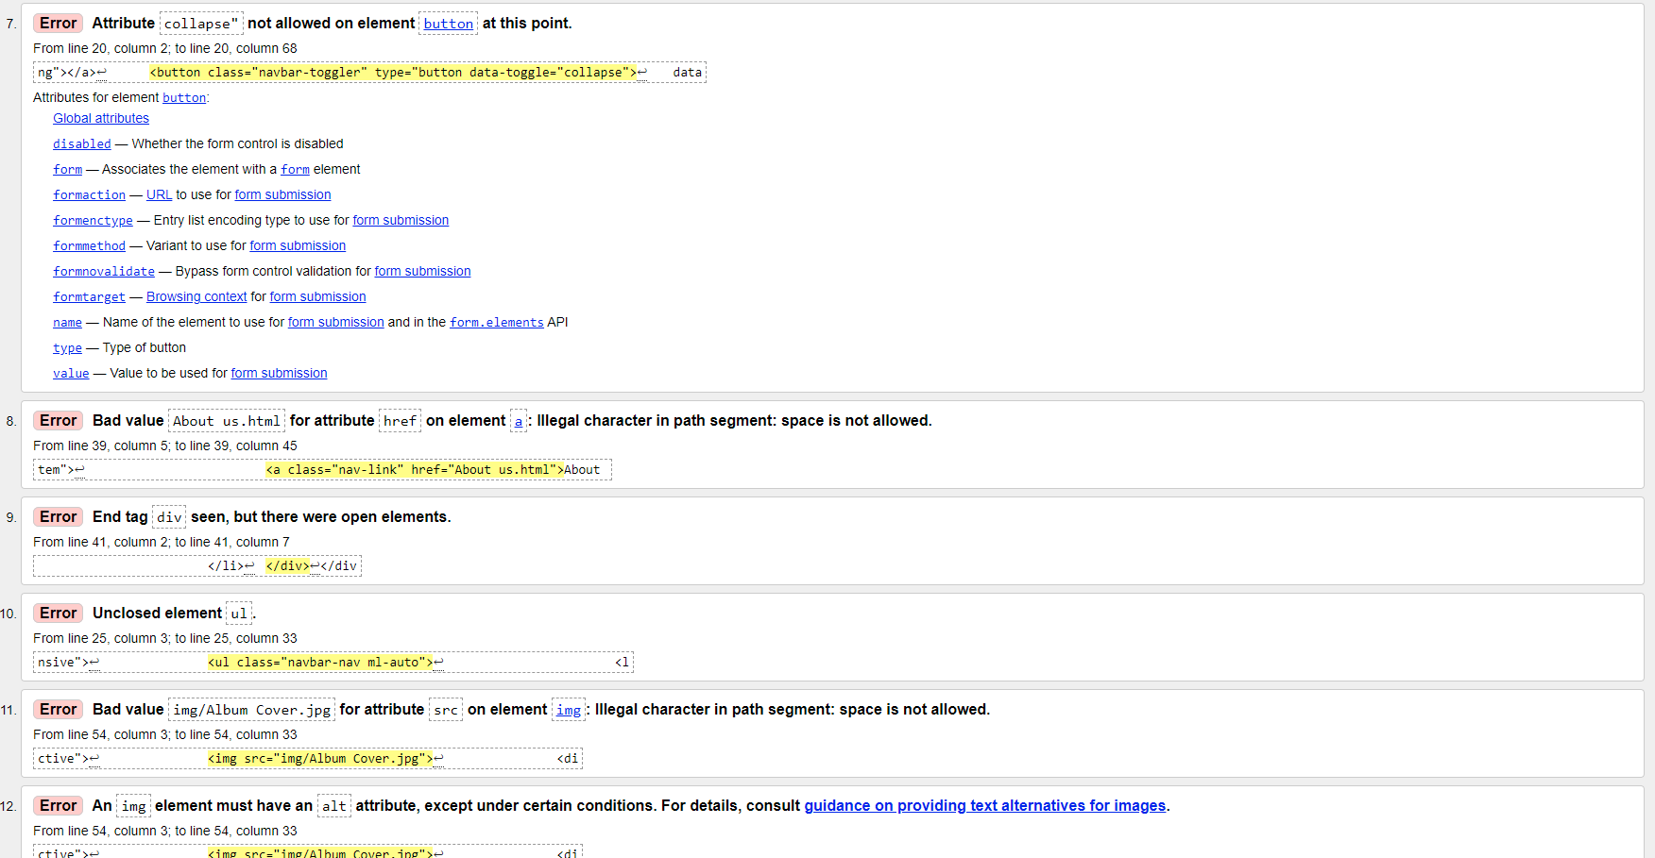
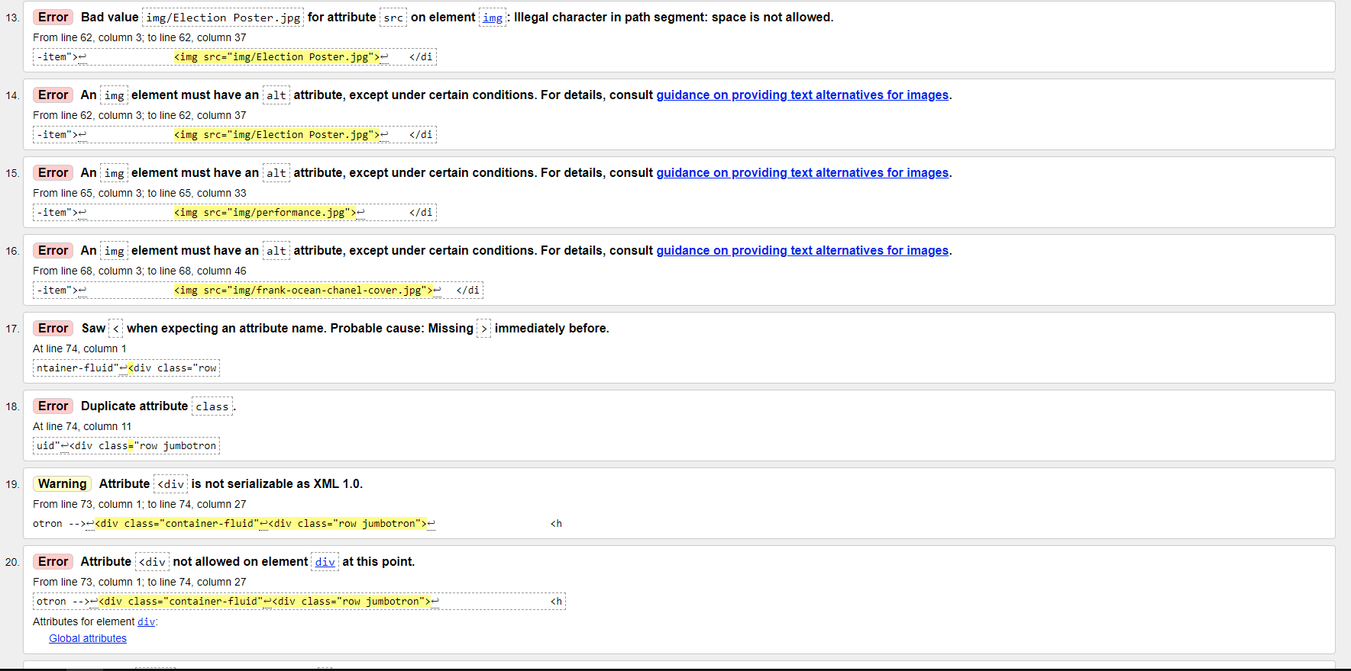

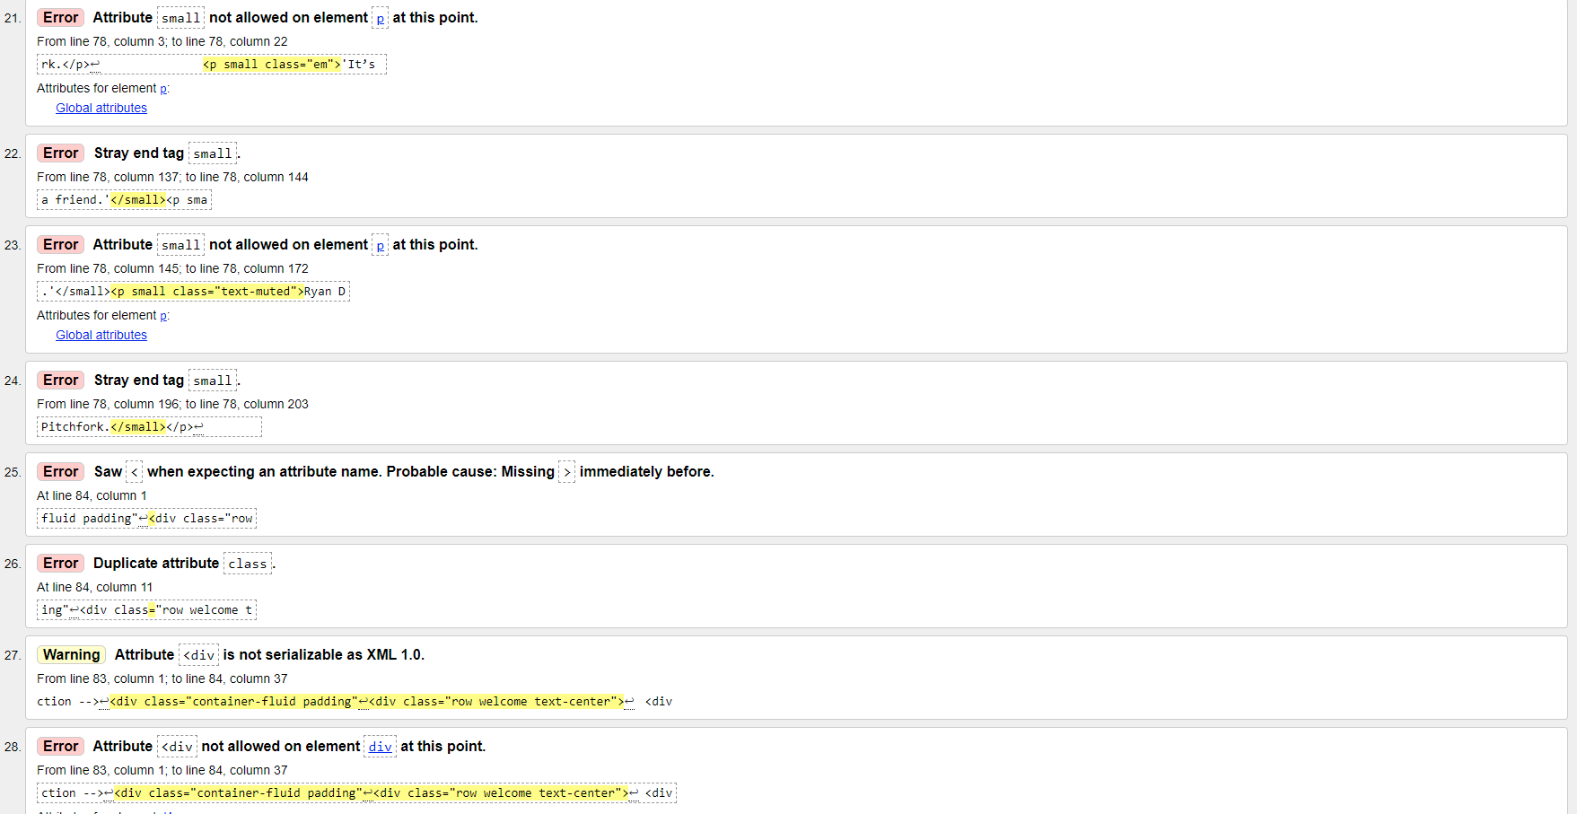
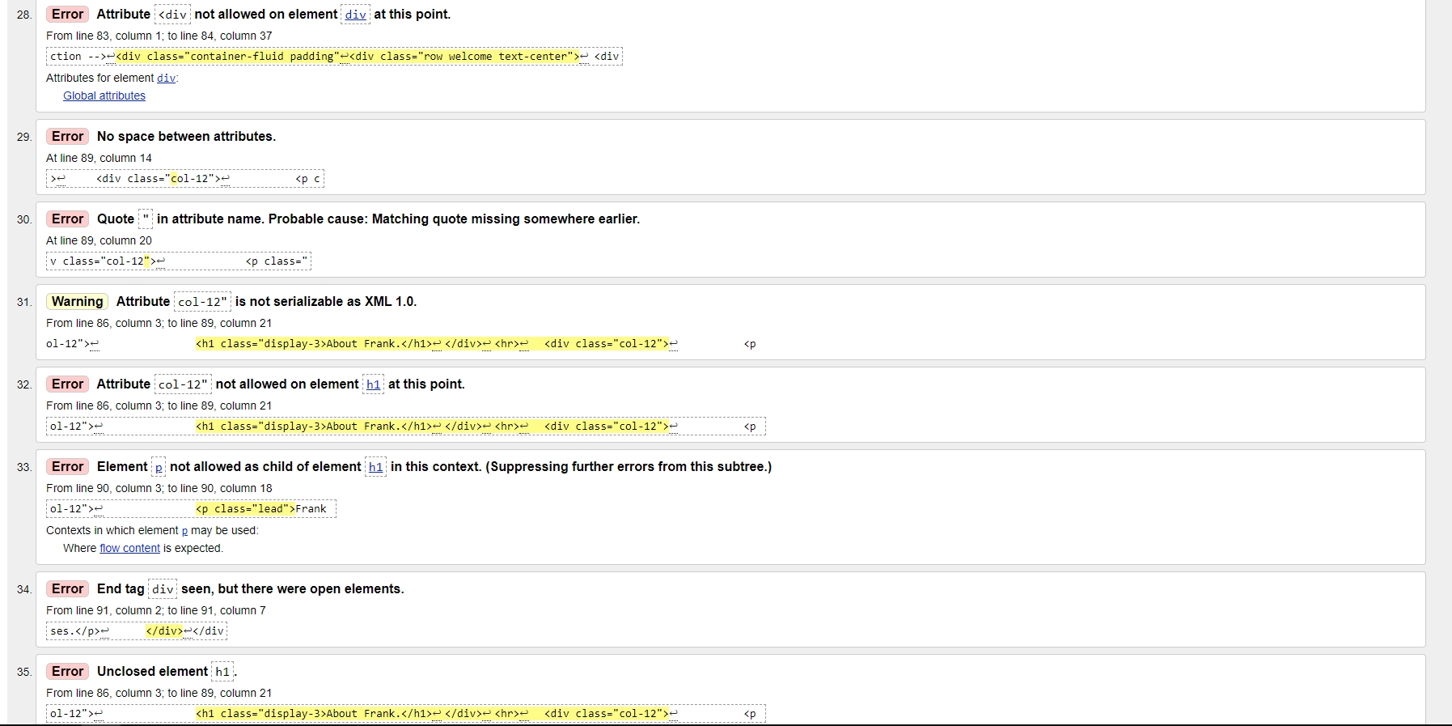
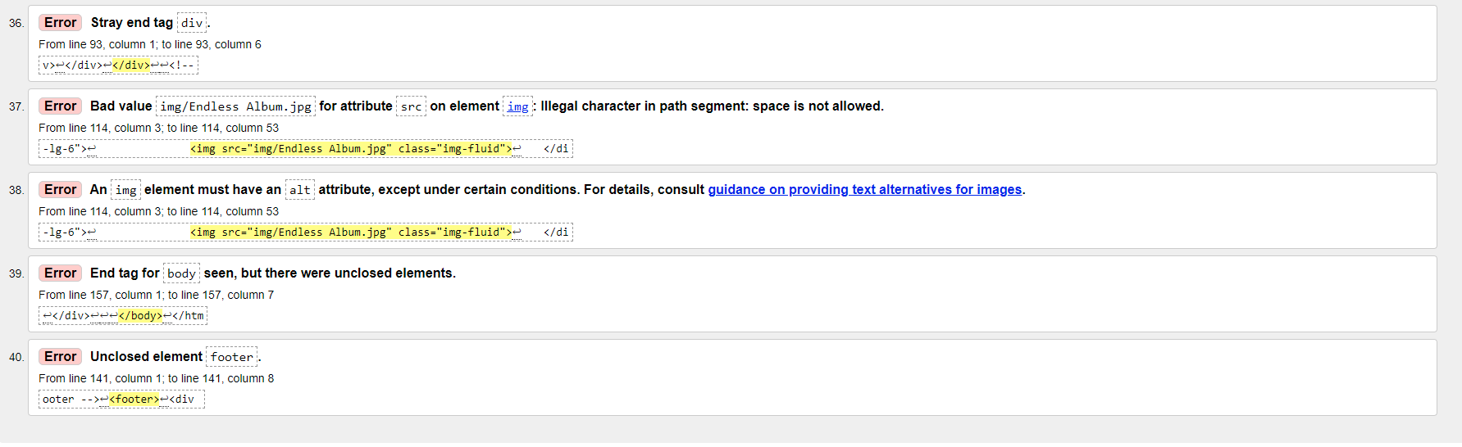
Above are all the error included from the validation test on the HTML document show improvements that need to be made to the code. A lot of these errors are a result of the naming of my images used on the slideshow on the main website as naming solutions on as I have included spaces in the naming which has come as an error so I would make sure not to include this in the future when I am constructing a website.
W3C validation is a procedure of checking web code to decide if it follows the formatting standards. If validation fails to meet the W3C standards, the website will likely suffer from errors or poor traffic owing to poor formatting and readability. [4]
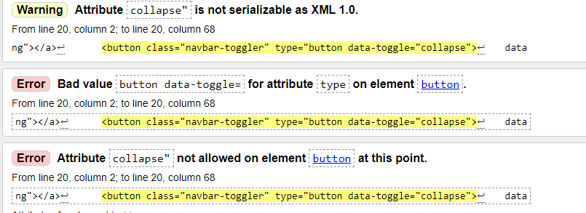
The first major error I went through was for the collapse toggle. I needed to remove the quotations from this line of code as this was flagging up the wrong errors for this is not serializable as well not be allowed due to the quotations, so I have now amended that by removing it in my code. This was due to the incorrect quotation positioning and spacing which has now been amended.

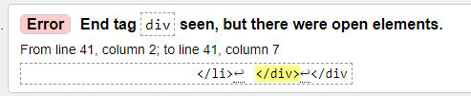
An extra div had been included which has now been cleaned up and removed from the code.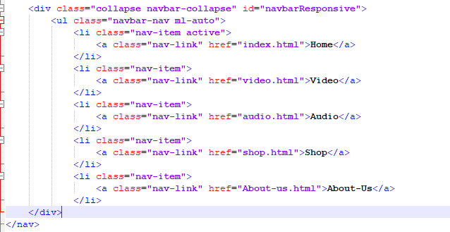
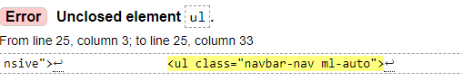
The ul had not been closed so I added code for this to be closed.
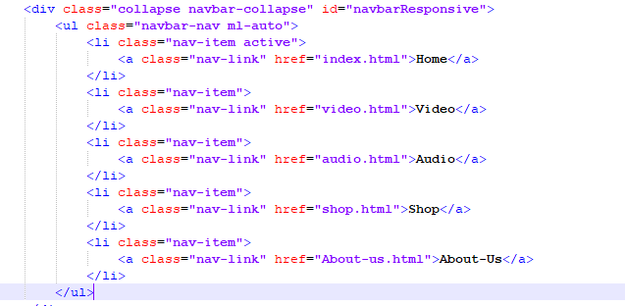
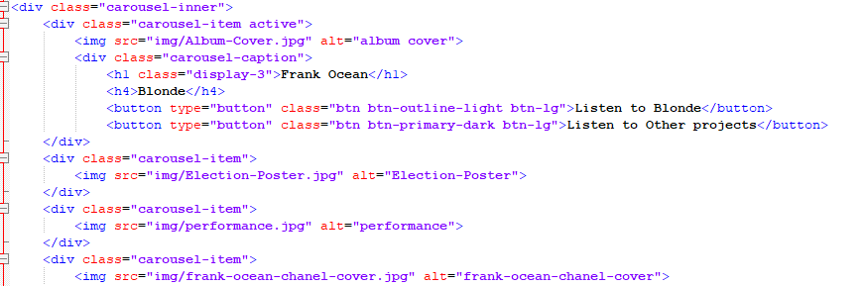
Above is the corrected code as the images were missing the alt tag in the line of code which has been added for all the images in the carousel and helps to clean up this section of the code. In the future, I would have included the alt-tab in the image lines of the code so that this error does not flag up in the code.

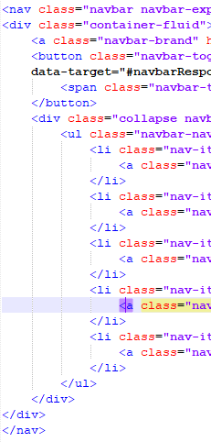
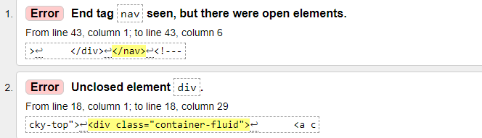

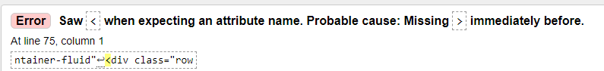
T The code was missing closing elements for the beginning div tag, so I have added this and corrected this.

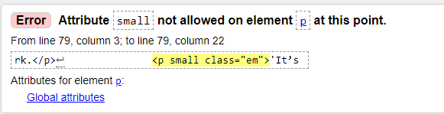
The tag above was missing a div bracket which has now been amended and added to the end of the tag.
I have corrected this element by reordering the typing as I had entered this incorrectly.tly.
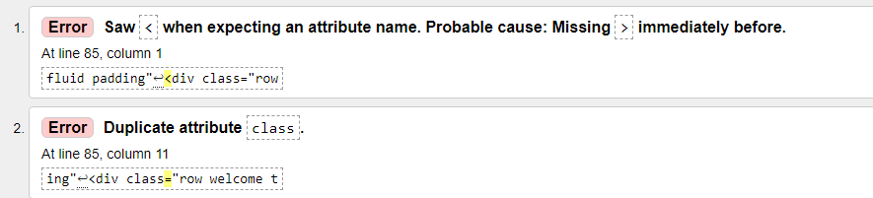
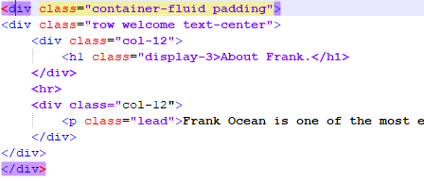
Div ending tag was missing from the first div class field which has now been amended by adding the div bracket on the end of the field.

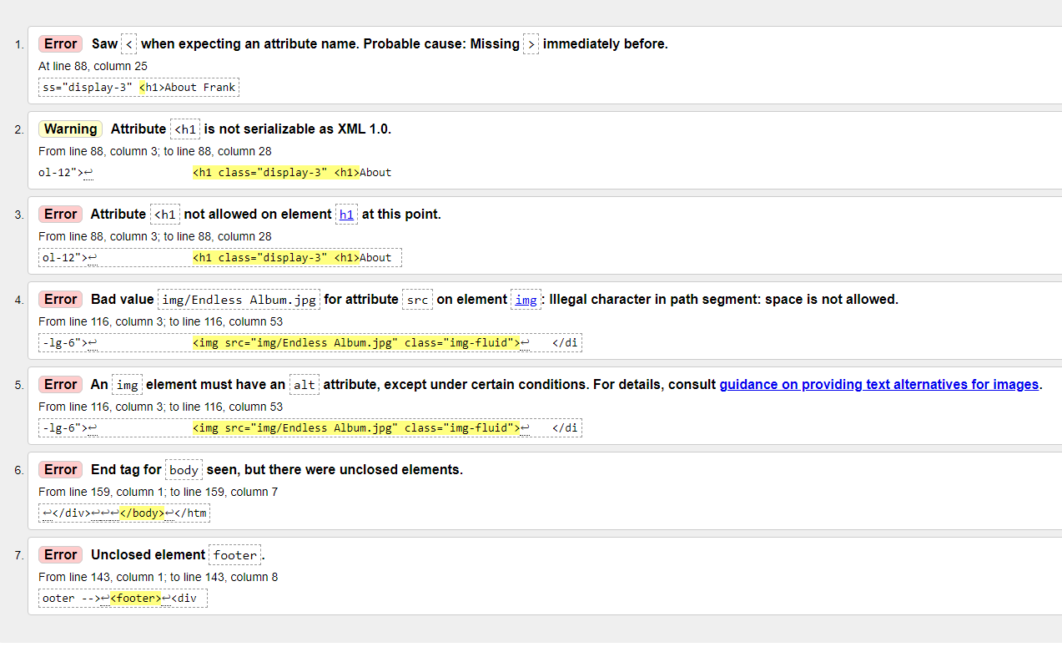

The remaining errors cover the rest of the document the first three errors are related to an error due to me using two “<h1>” in a single line of code so I removed one fixing this code.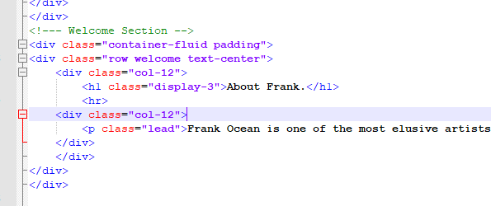
The next error required an alt tag to be added to the image source code line which I have now added and amended.
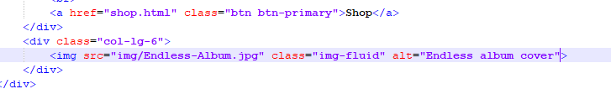
The final two errors were due to tags being left off for the footer section and the main body section of the website which have been corrected now. This was just a personal error of me missing to add these at the time. I would just pre-add the body and footer tags in the future before adding any code.
CSS validation check

CSS validation check
I am now going to be completing a CSS validation check for my website to make sure that there are no errors in the style presentation of the content on the website. This way it can be kept looking consistent and make sure that everything is displayed correctly.
All the errors included for the CSS document were due to spelling errors and one down to incorrectly placing a semicolon. This meant that this would not be applied to the website correctly when it comes to the style of the website. This has now been amended in the future I would make sure to double-check as I am making changes/creating the style sheet to make sure that are no errors, and that performance is consistent.
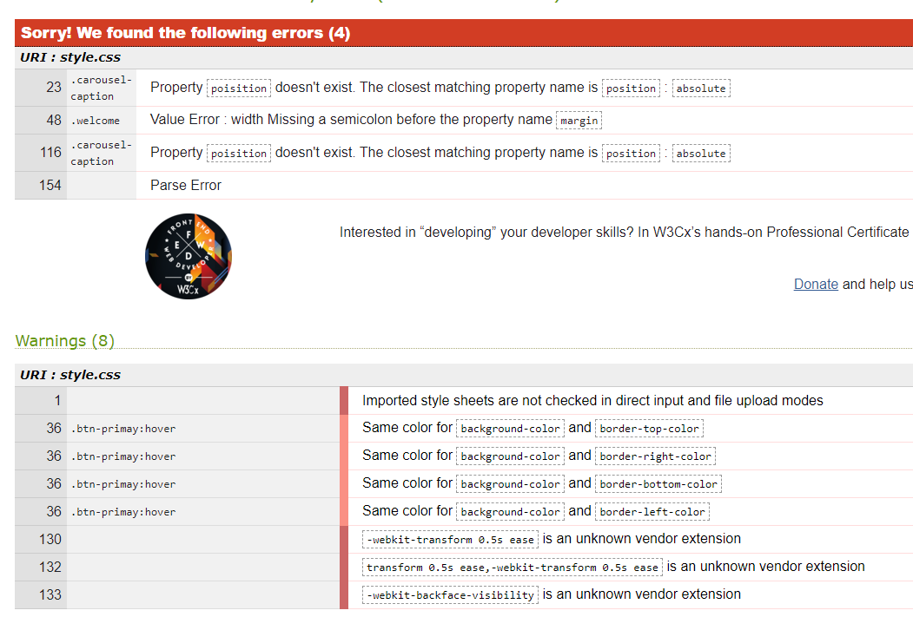

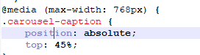
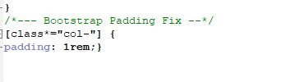

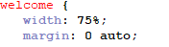

All the amendments above for the CSS style sheet have been made for this website.
Evaluation
The usability, accessibility and search engine optimisation are all an important part of having a successful website and qualitive website that meets its purpose. To understand more about what these factors are and how they succeed in making a high-quality website I will be looking at some peer reviewed articles for research purposes and then discuss and summarizing my findings.
Web usability testing
The usability, accessibility and search engine optimisation are all important part of having a successful website and qualitative website that meets its purpose. To understand more about what these factors are and how they succeed in making a high-quality website I will be looking at some peer-reviewed articles for research purposes and then discuss and summarizing my findings.
Web usability testing is a method of testing the functionality of a website where the overall goal to be to improve the user's experience as much as possible.
Usability testing is completed by authentic users, who reveal problems people familiar with a website are unable to identity—often, knowledge can blind designers, marketers, and product owners to a website's usability problems. [5]
Essentially bug testing the website to make sure that they can navigate throughout the website without any issues and that experience is seamless and functional.
There are serval types of testing for web usability that can be completed some of these are as follows: remote/in-person, moderated and unmoderated, scripted, etc. Doing these varieties of tests helps to uncover things that need to be improved on the website to allow for a better quality of life for users making use of the website in the hope to make it a success.
It’s important from the initial point that the website has been created as a prototype that testing is completed to ensure that before the website is developed fully the basic functions and concept of the website are enough for users to find the website entertaining, informative or whatever the process is meant to be. This stops a lot of resources from being used on the website if isn’t a success before being developed further.
It’s important to use people outside of your organization or company when completing testing.
Companies use in house software testing all the time, though this is not usability testing. staff are biased, making the results of testing not as impactful as those outsides of your company that do not hold these biases. [6]
Ideally, I would run either paid trials or beta testing for my website but looking at the available but due to not having the facilities or funding to provide this for my website, I will try to do this as best as I can.
My website has functionality though it is simplistic on the homepage it makes use of buttons in the top right-hand corner of the webpage so it can make for easy navigation to all the webpages that are available on the site. the links are all linked to the required pages e.g to go to listen to the Blonde album a user can do this by pressing the button which then sends them to the Audio page. I think it is also clear what each webpage does as well by the naming that has been given to them.
The usability of the website is good but can be improved if I had more time to refine its design. The website makes use of a white background in slightly off-white colour as to not strain the user's eyes too much compared to quite a strong white with the use of a dark grey text over the top which also contrasts with the white while not being as hard to look at as black on white text and it should still be readable by users that have disabilities and maybe required to use colour overlays on their screens to have an easier reading experience. The text is large and visible across all pages while using a clear and defined font which isn’t hard for the user to read. Pictures are also large and sharp so that all the detail in the images should be viewable even to those that may suffer from visibility issues.
The content of the website is lacklustre, I would add additional information so that more information can be provided to the users. The information that is included on the website however is easily digestible with it being small sentences to small paragraphs on the site with titles above each of the pieces of writing to give an idea to what the context of the writing is about before the users start to read it.
If given more time I would add to the visuals of the website so that elements can be more refined adding to the professionality of the website but also the user experience and on top of that I would add more content in way of written content and images to the site to give more detail to users that are visiting the site to give them a clear idea of what the website is about if they are not already a fan of Frank Ocean.

Search Engine Optimisation (SEO)
Search engine optimization is the process of improving a sites reach and visibility to relevant searches e.g I would hope that my website would appear if a user was to search in something that is Frank Ocean related into a search engine e.g. Google.
Search engines use bots to crawl pages on the web, collecting information about the pages and collecting the information into an index. Secondly, algorithms analyze the index, processing and ranking factors or signals, to determine the order pages that should appear in the search results for a given query. [7]
The search algorithms are made to locate relevant, authoritative pages and giving users an efficient experience. Optimizing your site with these factors in mind can improve your overall page ranking. [8]

References

[1] Jordan , “The Importance of W3C Standards,” Bop Design Blog, Jun. 26, 2013. [Online] Available: https://www.bopdesign.com/bop-blog/2013/06/the-importance-of-w3c-standards/#:~:text=Why%20are%20these%20standards%20important,the%20same%20on%20any%20browser. [Accessed May. 22, 2021].
[2] Jordan , “The Importance of W3C Standards,” Bop Design Blog, Jun. 26, 2013. [Online] Available: https://www.bopdesign.com/bop-blog/2013/06/the-importance-of-w3c-standards/#:~:text=Why%20are%20these%20standards%20important,the%20same%20on%20any%20browser. [Accessed May. 22, 2021].
[3] Team LoginRadius , “W3C Validation: What is it and why to use it?,”ASYNC blog, Jan. 26, 2015. [Online] Available:https://www.loginradius.com/blog/async/w3cvalidation/#:~:text=Validation%20improves%20usability%20and%20functionality,active%20content%2C%20and%20multimedia%20presentations. [Accessed May. 22, 2021].
[4] N.Roberts, “Web Standards: Why are they so Important?,”Nick Roberts blog, 2021. [Online] Available: https://nickroberts.ninja/web-standards/importance-web-standards/. [Accessed May. 22, 2021].
[5] hotjar, “A beginner's guide to user & usability testing,” hotjar, Apr, 19, 2021. [Online] Available: https://www.hotjar.com/usability-testing/#:~:text=Usability%20testing%20is%20a%20method,researchers%20working%20for%20a%20business. [Accessed May. 22, 2021].
[6] hotjar, “A beginner's guide to user & usability testing,” hotjar, Apr, 19, 2021. [Online] Available: https://www.hotjar.com/usability-testing/#:~:text=Usability%20testing%20is%20a%20method,researchers%20working%20for%20a%20business. [Accessed May. 22, 2021].
[7] Search Engine Land, “What Is SEO / Search Engine Optimization?,” Search Engine Land, Unavailable. [Online] Available: https://searchengineland.com/guide/what-is-seo. [Accessed May. 22, 2021].
[8] Search Engine Land, “What Is SEO / Search Engine Optimization?,” Search Engine Land, Unavailable. [Online] Available: https://searchengineland.com/guide/what-is-seo. [Accessed May. 22, 2021].

Appendix
Index
<!DOCTYPE html>
<html lang="en">
<head>
<meta charset="utf-8">
<meta name="viewport" content="width=device-width, initial-scale=1">
<title>Blond website</title>
<link rel="stylesheet" href="https://maxcdn.bootstrapcdn.com/bootstrap/4.0.0/css/bootstrap.min.css">
<script src="https://ajax.googleapis.com/ajax/libs/jquery/3.3.1/jquery.min.js"></script>
<script src="https://cdnjs.cloudflare.com/ajax/libs/popper.js/1.12.9/umd/popper.min.js"></script>
<script src="https://maxcdn.bootstrapcdn.com/bootstrap/4.0.0/js/bootstrap.min.js"></script>
<script src="https://use.fontawesome.com/releases/v5.0.8/js/all.js"></script>
<link href="style.css" rel="stylesheet">
</head>
<body>

<!-- Navigation bar -->
<nav class="navbar navbar-expand-md navbar-light bg-light sticky-top">
<div class="container-fluid">
<a class="navbar-brand" href="#"><img src="img/Brand-logo.png" alt="Blonde logo" width="335" height="85"></a>
<button class="navbar-toggler" type=button data-toggle= "collapse">
data-target="#navbarResponsive">
<span class="navbar-toggler-icon"></span>
</button>
<div class="collapse navbar-collapse" id="navbarResponsive">
<ul class="navbar-nav ml-auto">
<li class="nav-item active">
<a class="nav-link" href="index.html">Home</a>
</li>
<li class="nav-item">
<a class="nav-link" href="video.html">Video</a>
</li>
<li class="nav-item">
<a class="nav-link" href="audio.html">Audio</a>
</li>
<li class="nav-item">
<a class="nav-link" href="shop.html">Shop</a>
</li>
<li class="nav-item">
<a class="nav-link" href="About-us.html">About Us</a>
</li>
</ul>
</div>
</div>
</nav>
<!--- Image Slideshow -->
<div id="slides" class="carousel slide" data-ride="carousel">
<ul class="carousel-indicators">
<li data-target="#slides" data-slide-to="0" class="active"></li>
<li data-target="#slides" data-slide-to="1" ></li>
<li data-target="#slides" data-slide-to="2" ></li>
<li data-target="#slides" data-slide-to="3" ></li>
</ul>
<div class="carousel-inner">
<div class="carousel-item active">
<img src="img/Album-Cover.jpg" alt="album cover">
<div class="carousel-caption">
<h1 class="display-3">Frank Ocean</h1>
<h4>Blonde</h4>
<button type="button" class="btn btn-outline-light btn-lg">Listen to Blonde</button>
<button type="button" class="btn btn-primary-dark btn-lg">Listen to Other projects</button>
</div>
</div>
<div class="carousel-item">
<img src="img/Election-Poster.jpg" alt="Election-Poster">
</div>
<div class="carousel-item">
<img src="img/performance.jpg" alt="performance">
</div>
<div class="carousel-item">
<img src="img/Chanel-cover.jpg" alt="frank-ocean-chanel-cover">
</div>
</div>
</div>
<!--- Jumbotron -->
<div class="container-fluid">
<div class="row jumbotron">
<h4>Blonde</h4>
<div class="col-xs-12 col-sm-12 col-md-9 col-lg-9 col-xl-10">
<p class="strong">Blonde is Frank ocean second album project and his latest release. The album has seen critical ratings from music publications from rolling stone magazine to pitchfork.</p>
<p class ="em">'It’s a stunning piece of songwriting that ultimately finds some peace with being alone. It sounds like a friend.'</p><p class="text-muted">Ryan Dombal, Pitchfork.</p>
</div>
</div>
</div>
<!--- Welcome Section -->
<div class="container-fluid padding">
<div class="row welcome text-center">
<div class="col-12">
<h1 class="display-3">About Frank.</h1>
<hr>
<div class="col-12">
<p class="lead">Frank Ocean is one of the most elusive artists in modern music since emerging with his debut mixtape “Nostalgia, Ultra” in 2012. Frank is both a writer and singer talents range through urban music genre’s from Rap to R&B, never less has pushed these genre’s forward with imaginative narratives from the nuance of romance and to an easy going lifestyle. initial he was a writer under the Odd Future affiliate (OFTWGA), Ocean first single launch was "Novacane" (2011), detailing a fling which could be read as a criticism of commercial radio, though it quickly gathered popularity through mainstream urban playlists, quickly going to platinum. In the face of strained relations with music industry, Channel Orange (2012), premiering his first LP, nearly peaked the Billboard 200 and coincided with him later becoming a Grammy winner. Continuing with his conflict between him and his label Deaf Jam, He would make a exit with the release of the chart-topping second LP Blonde (2016). After this release, a small EP’s worth of singles including the platinum "Chanel" (2017) and the simultaneously issued "Dear April" and "Cayendo" (2020). As fans enjoy this recent material by Ocean, they want for the next album in anticipation as Frank has hinted at during his most recent single releases.</p>
</div>
</div>
</div>
</div>

<!--- three column intro -->
<div class="container fluid padding">
<div class="row text center padding">
<div class="col-xs-12 col-sm-6 col-md-4">
</div>
</div>
<hr class="my-4">
</div>

<!--- Shop Columns -->
<div class="container-fluid padding">
<div class="row padding">
<div class="col-lg-6">
<h3>Shop selection</h3>
<p>There is a selection of merchandise from CD's and Vinyl's of all of Frank Ocean's music projects aswell as clothing items</p>
<br>
<a href="shop.html" class="btn btn-primary">Shop</a>
</div>
<div class="col-lg-6">
<img src="img/Endless-Album.jpg" class="img-fluid" alt="Endless album cover">
</div>
</div>
</div>
<hr class="my-4">
<!--- background -->
<figure>
<div class="fixed-wrap">
<div id="fixed">
</div>
</div>
</figure>
<!--- Socials -->
<div class="container-fluid">
<div class="row text-center padding">
<div class="col-12">
<h3>Socials</h3>
</div>
<div class="col-12 social padding">
<a href="https://www.facebook.com/frankocean"><i class="fab fa-facebook"></i></a>
<a href="https://twitter.com/teamfrankdaily?lang=en"><i class="fab fa-twitter"></i></a>
<a href="https://www.instagram.com/blonded/"><i class="fab fa-instagram"></i></a>
<a href="https://www.youtube.com/channel/UCqf-kTp9ERV5T1rPayno7LA"><i class="fab fa-youtube"></i></a>
</div>
</div>
</div>
<!--- Footer -->
<footer>
<div class="container-fluid padding">
<div class="row text-center">
<div class="col-md-4">
<p>Privacy</p>
</div>
<div class="col-md-4">
<p>Terms</p>
</div>
<div class="col-md-4">
<p>Help</p>
</div>
</div>
</div>
</footer>

</body>
</html>

About Us
<!DOCTYPE html>
<html lang="en">
<head>
<meta charset="utf-8">
<meta name="viewport" content="width=device-width, initial-scale=1">
<title>Blond website</title>
<link rel="stylesheet" href="https://maxcdn.bootstrapcdn.com/bootstrap/4.0.0/css/bootstrap.min.css">
<script src="https://ajax.googleapis.com/ajax/libs/jquery/3.3.1/jquery.min.js"></script>
<script src="https://cdnjs.cloudflare.com/ajax/libs/popper.js/1.12.9/umd/popper.min.js"></script>
<script src="https://maxcdn.bootstrapcdn.com/bootstrap/4.0.0/js/bootstrap.min.js"></script>
<script src="https://use.fontawesome.com/releases/v5.0.8/js/all.js"></script>
<link href="style.css" rel="stylesheet">
</head>
<body>

<!-- Navigation bar -->
<nav class="navbar navbar-expand-md navbar-light bg-light sticky-top">
<div class="container-fluid">
<a class="navbar-brand" href="#"><img src="img/Brand logo.png"></a>
<button class="navbar-toggler" type="button data-toggle="collapse">
data-target="#navbarResponsive">
<span class="navbar-toggler-icon"></span>
</button>
<div class="collapse navbar-collapse" id="navbarResponsive">
<ul class="navbar-nav ml-auto">
<li class="nav-item active">
<a class="nav-link" href="#">Home</a>
</li>
<li class="nav-item">
<a class="nav-link" href="#">Video</a>
</li>
<li class="nav-item">
<a class="nav-link" href="#">Audio</a>
</li>
<li class="nav-item">
<a class="nav-link" href="#">Shop</a>
</li>
<li class="nav-item">
<a class="nav-link" href="#">About Us</a>
</li>
</div>
</div>
</nav>
<!--- Shop Columns -->
<div class="container-fluid padding">
<div class="row padding">
<div class="col-lg-6">
<h3>About us</h3>
<p>This website is to provide fans of frank ocean with a platform to listen to his discography as well being able to purchase items off of the merchandise store if you wish you monetarily support Frank</p>
<p>Web designer and Writier: Connor Michael Anthony Wilson</p>
<br>
</div>
<div class="col-lg-6">
<img src="img/FRANK_OCEAN_COLLIER_SCHORR_GAYLETTER_Shot_03_034_02.jpg" class="img-fluid">
</div>
</div>
</div>
<hr class="my-4">
<!--- background -->
<figure>
<div class="fixed-wrap">
<div id="fixed">
</div>
</div>
</figure>
<!--- Socials -->
<div class="container-fluid">
<div class="row text-center padding">
<div class="col-12">
<h3>Socials</h3>
</div>
<div class="col-12 social padding">
<a href="#"><i class="fab fa-facebook"></i></a>
<a href="#"><i class="fab fa-twitter"></i></a>
<a href="#"><i class="fab fa-instagram"></i></a>
<a href="#"><i class="fab fa-youtube"></i></a>
</div>
</div>
</div>
<!--- Footer -->
<footer>
<div class="container-fluid padding">
<div class="row text-center">
<div class="col-md-4">
<p>Privacy</p>
</div>
<div class="col-md-4">
<p>Terms</p>
</div>
<div class="col-md-4">
<p>Help</p>
</div>
</div>
</div>

</body>
</html>

Audio
<!DOCTYPE html>
<html lang="en">
<head>
<meta charset="utf-8">
<meta name="viewport" content="width=device-width, initial-scale=1">
<title>Blond website</title>
<link rel="stylesheet" href="https://maxcdn.bootstrapcdn.com/bootstrap/4.0.0/css/bootstrap.min.css">
<script src="https://ajax.googleapis.com/ajax/libs/jquery/3.3.1/jquery.min.js"></script>
<script src="https://cdnjs.cloudflare.com/ajax/libs/popper.js/1.12.9/umd/popper.min.js"></script>
<script src="https://maxcdn.bootstrapcdn.com/bootstrap/4.0.0/js/bootstrap.min.js"></script>
<script src="https://use.fontawesome.com/releases/v5.0.8/js/all.js"></script>
<link href="style.css" rel="stylesheet">
</head>
<body>

<!-- Navigation bar -->
<nav class="navbar navbar-expand-md navbar-light bg-light sticky-top">
<div class="container-fluid">
<a class="navbar-brand" href="#"><img src="img/Brand logo.png"></a>
<button class="navbar-toggler" type="button data-toggle="collapse">
data-target="#navbarResponsive">
<span class="navbar-toggler-icon"></span>
</button>
<div class="collapse navbar-collapse" id="navbarResponsive">
<ul class="navbar-nav ml-auto">
<li class="nav-item active">
<a class="nav-link" href="index.html">Home</a>
</li>
<li class="nav-item">
<a class="nav-link" href="video.html">Video</a>
</li>
<li class="nav-item">
<a class="nav-link" href="audio.html">Audio</a>
</li>
<li class="nav-item">
<a class="nav-link" href="shop.html">Shop</a>
</li>
<li class="nav-item">
<a class="nav-link" href="About us.html">About Us</a>
</li>
</div>
</div>
</nav>

<!--- three column intro -->
<div class="container fluid padding">
<div class="row text center padding">
<div class="col-xs-12 col-sm-6 col-md-4">
</div>
</div>
<hr class="my-4">
</div>

<!--- Shop Columns -->
<div class="container">
<h3>Streams</h3>
<p>All avilable streams for all currently released music.</p>
<br>
<div class="row align-items-start">
<div class="col">
<iframe class="embed-responsive-item" src="https://open.spotify.com/embed/album/3mH6qwIy9crq0I9YQbOuDf" width="300" height="380" frameborder="0" allowtransparency="true" allow="encrypted-media"></iframe>
</div>
<div class="col">
<iframe class="embed-responsive-item" width="300" height="380" src="https://www.youtube.com/embed/TtdXD2E-03k" title="YouTube video player" frameborder="0" allow="accelerometer; autoplay; clipboard-write; encrypted-media; gyroscope; picture-in-picture" allowfullscreen></iframe>
</div>
<div class="col">
<iframe class="embed-responsive-item" src="https://open.spotify.com/embed/album/623Ef2ZEB3Njklix4PC0Rs" width="300" height="380" frameborder="0" allowtransparency="true" allow="encrypted-media"></iframe>
</div>
</div>
<div class="row align-items-center">
<div class="col">
<iframe class="embed-responsive-item" src="https://open.spotify.com/embed/track/6Nle9hKrkL1wQpwNfEkxjh" width="300" height="380" frameborder="0" allowtransparency="true" allow="encrypted-media"></iframe>
</div>
<div class="col">
<iframe src="https://open.spotify.com/embed/album/71VX8yv9T2hNIYVZJVUWVp" width="300" height="380" frameborder="0" allowtransparency="true" allow="encrypted-media"></iframe>
</div>
<div class="col">
<iframe src="https://open.spotify.com/embed/album/7yOOPJjNelITCaYMqk8V6r" width="300" height="380" frameborder="0" allowtransparency="true" allow="encrypted-media"></iframe>
</div>
</div>
<div class="row align-items-end">
<div class="col">
<iframe src="https://open.spotify.com/embed/track/2INhKpUdzh7v0j041gZNsz" width="300" height="380" frameborder="0" allowtransparency="true" allow="encrypted-media"></iframe>
</div>
<div class="col">
<iframe src="https://open.spotify.com/embed/track/41cpvQ2GyGb2BRdIRSsTqK" width="300" height="380" frameborder="0" allowtransparency="true" allow="encrypted-media"></iframe>
</div>
<div class="col">
<iframe src="https://open.spotify.com/embed/track/6R6ihJhRbgu7JxJKIbW57w" width="300" height="380" frameborder="0" allowtransparency="true" allow="encrypted-media"></iframe>
</div>
<br>
<br>
<br>
</div>
</div>
<!--- background -->
<figure>
<div class="fixed-wrap">
<div id="fixed">
</div>
</div>
</figure>
<!--- Socials -->
<div class="container-fluid">
<div class="row text-center padding">
<div class="col-12">
<h3>Socials</h3>
</div>
<div class="col-12 social padding">
<a href="https://www.facebook.com/frankocean"><i class="fab fa-facebook"></i></a>
<a href="https://twitter.com/teamfrankdaily?lang=en"><i class="fab fa-twitter"></i></a>
<a href="https://www.instagram.com/blonded/"><i class="fab fa-instagram"></i></a>
<a href="https://www.youtube.com/channel/UCqf-kTp9ERV5T1rPayno7LA"><i class="fab fa-youtube"></i></a>
</div>
</div>
</div>
<!--- Footer -->
<footer>
<div class="container-fluid padding">
<div class="row text-center">
<div class="col-md-4">
<p>Privacy</p>
</div>
<div class="col-md-4">
<p>Terms</p>
</div>
<div class="col-md-4">
<p>Help</p>
</div>
</div>
</div>

</body>
</html>

Shop
<!DOCTYPE html>
<html lang="en">
<head>
<meta charset="utf-8">
<meta name="viewport" content="width=device-width, initial-scale=1">
<title>Blond website</title>
<link rel="stylesheet" href="https://maxcdn.bootstrapcdn.com/bootstrap/4.0.0/css/bootstrap.min.css">
<script src="https://ajax.googleapis.com/ajax/libs/jquery/3.3.1/jquery.min.js"></script>
<script src="https://cdnjs.cloudflare.com/ajax/libs/popper.js/1.12.9/umd/popper.min.js"></script>
<script src="https://maxcdn.bootstrapcdn.com/bootstrap/4.0.0/js/bootstrap.min.js"></script>
<script src="https://use.fontawesome.com/releases/v5.0.8/js/all.js"></script>
<link href="style.css" rel="stylesheet">
</head>
<body>

<!-- Navigation bar -->
<nav class="navbar navbar-expand-md navbar-light bg-light sticky-top">
<div class="container-fluid">
<a class="navbar-brand" href="#"><img src="img/Brand logo.png"></a>
<button class="navbar-toggler" type="button data-toggle="collapse">
data-target="#navbarResponsive">
<span class="navbar-toggler-icon"></span>
</button>
<div class="collapse navbar-collapse" id="navbarResponsive">
<ul class="navbar-nav ml-auto">
<li class="nav-item active">
<a class="nav-link" href="index.html">Home</a>
</li>
<li class="nav-item">
<a class="nav-link" href="video.html">Video</a>
</li>
<li class="nav-item">
<a class="nav-link" href="audio.html">Audio</a>
</li>
<li class="nav-item">
<a class="nav-link" href="shop.html">Shop</a>
</li>
<li class="nav-item">
<a class="nav-link" href="About us.html">About Us</a>
</li>
</div>
</div>
</nav>
<!--- Shop Columns -->
<div class="container">
<h3>Shop</h3>
<p>All currently avilable merchandise.</p>
<br>
<div class="row align-items-start">
<div class="col">
<a href="https://www.redbubble.com/i/poster/Frank-Ocean-Channel-Orange-Poster-by-joedowd0810/45429283.LVTDI" title=""><img src="img/fposter,small,wall_texture,product,750x1000.jpg" width="300" height="300" class="img-responsive"></a>
</div>
<div class="col">
<a href="https://www.redbubble.com/i/t-shirt/Frank-Ocean-Blonde-by-ujikmnbvcfd/75130285.WFLAH" title=""><img src="img/ssrco,classic_tee,two_models,fafafa_ca443f4786,front,square_three_quarter,1000x1000 (1).jpg" width="300" height="300" class="img-responsive"></a>
</div>
<div class="col">
<a href="https://www.redbubble.com/i/t-shirt/Frank-Ocean-by-hannahbev/39766596.1YYVU" title=""><img src="img/gptr,1400x,front,black-c,188,133,1000,1000-bg,f8f8f8.u2.jpg" width="300" height="300" class="img-responsive"></a>
</div>
</div>
<div class="row align-items-center">
<div class="col">
<a href="https://www.redbubble.com/i/hoodie/Blond-Frank-Ocean-Receipt-Print-by-annelisev/42066429.O16E3" title=""><img src="img/ssrco,mhoodie,mens,oatmeal_heather,front,square_three_quarter,x1000-bg,f8f8f8.1.jpg" width="300" height="300" class="img-responsive"></a>
</div>
<div class="col">
<a href="https://www.redbubble.com/i/t-shirt/Frank-Ocean-by-daisylramirez/41392797.FB110.XYZ" title=""><img src="img/ssrco,slim_fit_t_shirt,two_model,101010_01c5ca27c6,front,square_three_quarter,1000x1000.jpg" width="300" height="300" class="img-responsive"></a>
</div>
<div class="col">
<a href="https://www.redbubble.com/i/sticker/Endless-Holographic-by-blondeddepot/31231972.O9UDB" title=""><img src="img/tsss,small,product_square,1000x1000.jpg" width="300" height="300" class="img-responsive"></a>
</div>
</div>
<div class="row align-items-end">
<div class="col">
<a href="https://www.redbubble.com/i/t-shirt/Boys-Frank-Ocean-by-CorgiOnFleek/26207571.WFLAH.XYZ" title=""><img src="img/ssrco,classic_tee,two_models,fafafa_ca443f4786,front,square_three_quarter,1000x1000.jpg" width="300" height="300" class="img-responsive"></a>
</div>
<div class="col">
<a href="https://www.redbubble.com/i/sticker/blonded-frank-ocean-by-feli18/66260859.EJUG5" title=""><img src="img/sss,small,product_square,1000x1000.jpg" width="300" height="300" class="img-responsive"></a>
</div>
<div class="col">
<a href="https://www.redbubble.com/i/sticker/BOYS-DON-T-CRY-by-matthewkwong/38656011.EJUG5" title=""><img src="img/sss,small,product_square,1000x1000.u1.jpg" width="300" height="300" class="img-responsive"></a>
</div>
</div>
</div>
<!--- background -->
<figure>
<div class="fixed-wrap">
<div id="fixed">
</div>
</div>
</figure>
<!--- Socials -->
<div class="container-fluid">
<div class="row text-center padding">
<div class="col-12">
<h3>Socials</h3>
</div>
<div class="col-12 social padding">
<a href="https://www.facebook.com/frankocean"><i class="fab fa-facebook"></i></a>
<a href="https://twitter.com/teamfrankdaily?lang=en"><i class="fab fa-twitter"></i></a>
<a href="https://www.instagram.com/blonded/"><i class="fab fa-instagram"></i></a>
<a href="https://www.youtube.com/channel/UCqf-kTp9ERV5T1rPayno7LA"><i class="fab fa-youtube"></i></a>
</div>
</div>
</div>
<!--- Footer -->
<footer>
<div class="container-fluid padding">
<div class="row text-center">
<div class="col-md-4">
<p>Privacy</p>
</div>
<div class="col-md-4">
<p>Terms</p>
</div>
<div class="col-md-4">
<p>Help</p>
</div>
</div>
</div>

</body>
</html>

Video
<!DOCTYPE html>
<html lang="en">
<head>
<meta charset="utf-8">
<meta name="viewport" content="width=device-width, initial-scale=1">
<title>Blond website</title>
<link rel="stylesheet" href="https://maxcdn.bootstrapcdn.com/bootstrap/4.0.0/css/bootstrap.min.css">
<script src="https://ajax.googleapis.com/ajax/libs/jquery/3.3.1/jquery.min.js"></script>
<script src="https://cdnjs.cloudflare.com/ajax/libs/popper.js/1.12.9/umd/popper.min.js"></script>
<script src="https://maxcdn.bootstrapcdn.com/bootstrap/4.0.0/js/bootstrap.min.js"></script>
<script src="https://use.fontawesome.com/releases/v5.0.8/js/all.js"></script>
<link href="style.css" rel="stylesheet">
</head>
<body>

<!-- Navigation bar -->
<nav class="navbar navbar-expand-md navbar-light bg-light sticky-top">
<div class="container-fluid">
<a class="navbar-brand" href="#"><img src="img/Brand logo.png"></a>
<button class="navbar-toggler" type="button data-toggle="collapse">
data-target="#navbarResponsive">
<span class="navbar-toggler-icon"></span>
</button>
<div class="collapse navbar-collapse" id="navbarResponsive">
<ul class="navbar-nav ml-auto">
<li class="nav-item active">
<a class="nav-link" href="index.html">Home</a>
</li>
<li class="nav-item">
<a class="nav-link" href="video.html">Video</a>
</li>
<li class="nav-item">
<a class="nav-link" href="audio.html">Audio</a>
</li>
<li class="nav-item">
<a class="nav-link" href="shop.html">Shop</a>
</li>
<li class="nav-item">
<a class="nav-link" href="About us.html">About Us</a>
</li>
</div>
</div>
</nav>

<!--- three column intro -->
<div class="container fluid padding">
<div class="row text center padding">
<div class="col-xs-12 col-sm-6 col-md-4">
</div>
</div>
<hr class="my-4">
</div>

<!--- Shop Columns -->
<div class="container">
<h3>Video's</h3>
<p>All music videos and other Frank related video content.</p>
<br>
<div class="row">
<div class="col-sm">
<iframe class="embed-responsive-item" width="560" height="315" src="https://www.youtube.com/embed/pvU4b4N1-QU" title="YouTube video player" frameborder="0" allow="accelerometer; autoplay; clipboard-write; encrypted-media; gyroscope; picture-in-picture" allowfullscreen></iframe>
</div>
<div class="col-sm">
<iframe class="embed-responsive-item" width="560" height="315" src="https://www.youtube.com/embed/XnbsIl2BnWw" title="YouTube video player" frameborder="0" allow="accelerometer; autoplay; clipboard-write; encrypted-media; gyroscope; picture-in-picture" allowfullscreen></iframe>
</div>
<div class="col-sm">
<iframe class="embed-responsive-item" width="560" height="315" src="https://www.youtube.com/embed/r4l9bFqgMaQ" title="YouTube video player" frameborder="0" allow="accelerometer; autoplay; clipboard-write; encrypted-media; gyroscope; picture-in-picture" allowfullscreen></iframe>
</div>
<div class="col-sm">
<iframe class="embed-responsive-item" width="560" height="315" src="https://www.youtube.com/embed/PtvlmOsNV4E" title="YouTube video player" frameborder="0" allow="accelerometer; autoplay; clipboard-write; encrypted-media; gyroscope; picture-in-picture" allowfullscreen></iframe>
</div>
<div class="col-sm">
<iframe class="embed-responsive-item" width="560" height="315" src="https://www.youtube.com/embed/hq-8wDOqRPU" title="YouTube video player" frameborder="0" allow="accelerometer; autoplay; clipboard-write; encrypted-media; gyroscope; picture-in-picture" allowfullscreen></iframe>
</div>
<div class="col-sm">
<iframe class="embed-responsive-item" width="560" height="315" src="https://www.youtube.com/embed/ic1nhvWBvIo" title="YouTube video player" frameborder="0" allow="accelerometer; autoplay; clipboard-write; encrypted-media; gyroscope; picture-in-picture" allowfullscreen></iframe>
</div>
</div>
</div>
<!--- background -->
<figure>
<div class="fixed-wrap">
<div id="fixed">
</div>
</div>
</figure>
<!--- Socials -->
<div class="container-fluid">
<div class="row text-center padding">
<div class="col-12">
<h3>Socials</h3>
</div>
<div class="col-12 social padding">
<a href="https://www.facebook.com/frankocean"><i class="fab fa-facebook"></i></a>
<a href="https://twitter.com/teamfrankdaily?lang=en"><i class="fab fa-twitter"></i></a>
<a href="https://www.instagram.com/blonded/"><i class="fab fa-instagram"></i></a>
<a href="https://www.youtube.com/channel/UCqf-kTp9ERV5T1rPayno7LA"><i class="fab fa-youtube"></i></a>
</div>
</div>
</div>
<!--- Footer -->
<footer>
<div class="container-fluid padding">
<div class="row text-center">
<div class="col-md-4">
<p>Privacy</p>
</div>
<div class="col-md-4">
<p>Terms</p>
</div>
<div class="col-md-4">
<p>Help</p>
</div>
</div>
</div>

</body>
</html>

style.css
@import url('https://fonts.googleapis.com/css?family=Poppins:400,500,700');

html, body {
height: 100%;
width: 100%;
font-family: 'Poppins', Abadi;
color: #495057
}
navbar {
padding: .8rem;
}
.navbar-nav li {
padding-right: 30px;
}
.nav-link {
font-size: 1.1em !important
}
.carousel-inner img {
width: 100%;
height: 100%;
}
.carousel-caption {
position: absolute;
top: 60%;
}
.carousel-caption h1 {
font-size: 500%;
text-transform: uppercase;
text-shadow: 1px 1px 5px #000;
}
.btn-primary {
background-color: #6c757d;
border: 1px solid #000
}
.btn-primay:hover {
background-color: #000;
border: 1px solid #000
}
.jumbotron {
padding: 1rem;
border-radius: 0;
}
.padding {
padding-bottom: 2rem;
}
.welcome {
width: 75%;
margin: 0 auto;
padding-top: 2rem;
}
.welcome hr {
border-top: 2px solid #6c757d;
width: 95%;
margin-top: .3rem;
margin-bottom: 1rem;
}
.fa-code{
color:#6c757d;
}
.fa-bold {
color:#6c757d;
}
.fa-css3 {
color:#dee2e6;
}
.fa-code, .fa-bold, .fa-css3 {
font-size: 4em;
margin: 1rem;
}
.fun {
width: 100%;
margin-bottom: 2rem;
}
.social a {
font-size: 4em;
padding: 3rem;
}
.fa-facebook {
color: #3b5998;
}
.fa-twitter {
color: #00aced;
}
.fa-instagram {
color: #517fa4;
}
.fa-youtube {
color: #bb0000;
}
.fa-facebook:hover,
.fa-twitter:hover,
.fa-instagram:hover,
.fa-youtube:hover {
color: #6c757d;
}
.footer {
background-color: #adb5bd;
color: #181818;
padding-top: 2rem;
}
hr.light {
border-top: 1px solid #6c757d;
width: 75%;
margin-top: .8rem;
margin-bottom: 1rem;
}
/*---Media Queries --*/
@media (max-width: 992px) {
.social a {
font-size: 4em;
padding: 2rem;

}
@media (max-width: 768px) {
.carousel-caption {
position: absolute;
top: 45%;
}
.carousel-caption h1 {
font-size: 350%;
}
}
@media (max-width: 576px) {

}

/*---Firefox Bug Fix --*/
.carousel-item {
transition: -webkit-transform 0.5s ease;
transition: transform 0.5s ease;
transition: transform 0.5s ease, -webkit-transform 0.5s ease;
-webkit-backface-visibility: visible;
backface-visibility: visible;
}
/*--- Fixed Background Image --*/
figure {
position: relative;
width: 100%;
height: 60%;
margin: 0!important;
}
.fixed-wrap {
clip: rect(0, auto, auto, 0);
position: absolute;
top: 0;
left: 0;
width: 100%;
height: 100%;
}
/*--- Bootstrap Padding Fix --*/
[class*="col-"] {
padding: 1rem;}

/*
Extra small (xs) devices (portrait phones, less than 576px)
No media query since this is the default in Bootstrap

Small (sm) devices (landscape phones, 576px and up)
@media (min-width: 576px) { ... }

Medium (md) devices (tablets, 768px and up)
@media (min-width: 768px) { ... }

Large (lg) devices (desktops, 992px and up)
@media (min-width: 992px) { ... }

Extra (xl) large devices (large desktops, 1200px and up)
@media (min-width: 1200px) { ... }
*/

