
[PROFESSIONAL CAREER dEVELOPMENT(BWSW4005)
STUDENT NUMBER:1913335

1: INTRODUCTION
2: FINDINGS
3: PERSONAL DEVLELOPMENT PLAN
4: CONCLUSION
5: REFERENCE
6: APPENDIX

INTRODUCTION
DEFINITION OF SELF AWARENESS
Self-awareness is gaining a deep awareness of yourself, a willingness to keep going towards achieving a goal (Contrell, 2015). It is described as knowing our strengths and weakness.
Self-development is defined as a significant personality trait that is needed in achieving our desired goal (Brooks, 2009). Self-awareness is a vital factor towards effective learning and development (Steiner, 2014).
Both are important because it is seen as a path to career development and growth. It awakens our ability to focus in achieving in our goal (Mmamta, 2011).
In this following report I will be working at self-development by implementing the SMART and SWOT analysis in developing my employability skills. I will also be explaining the learning styles that are suitable to my personality in achieving my goals which will help me to achieve my long-term goal.
To achieve our goals, we need to recognise our self-awareness, which involves our weakness, strength, personality, beliefs, preferences, what I like and dislike and most importantly my driving force and what motivates me to do something better.

I will be implementing the Stephen Covey theory into my career development analysis which states that:

The first step in achieving this is by proactively seeking my goal by starting an online course or learning new styles on YouTube, also applying as a volunteer in a hair salon to know the pros and cons.
Secondly, I will keep in mind the end result, that is, what will this degree or module do for me in achieving the goal? Also how will volunteering help or partake in helping me achieve my goal of becoming a hair stylist.
Seeking first to understand and be understood, this connotes being able to have listening ears, accepting criticisms and advice from others.
Synergizing by showing respect and giving back respect. Cooperating by respecting people’s opinions, beliefs and differences. Also building on strengths.
Stephen Covey also talks about sharpening the saw. Relating this to my goal means building myself, working on my weaknesses and improving my strengths.
Thirdly, first things first, organising and putting my action plan in place
Fourthly, think win-win which is knowing the mutual benefits of what will help me and others around me. Putting others into consideration and how will they benefit from your goal.
Every goal that we have planned to achieve must be smart (Morgan,2017)
The SMART and SWOT analysis by Stephen R. Covey 1989. In continuation in the process of developing my skills I will also be implementing the two learning styles by and Honey & Mumford (1986). I will also be relating my skills audit of my personal development plan using the self-awareness tool by Johari window (1950). And David kolbs (1984) experimental circle. And would also implement the Robbinson1974 theory of learning a new skill
I will be implementing how to achieve my goal by using the Stephen Covey theory to develop my career development. I am working towards starting my own business as an entrepreneur (Hair Stylist) in the next five years as my long-term goal.
According to Stephen Covey, reality check is needed in achieving employability skills, for me to be an entrepreneur, I need to act responsibly and stay positive and be ready for the labour market and its competitive nature.

SMART GOAL
S.M.A.R.T is a strategy used in setting our priorities right, in order to evaluate how we can achieve our goal, a smart tool is needed. We need to convert our plan into a smart goal. All goals need a smart and well detailed structure which can be followed step by step in achieving our goal (Gallagher, 2010).
My goal in the next five 5 years is to be a successful hair beautician and consultant. For me to achieve my goal I need to implement the smart objective by Stephen Covey.
- SPECIFIC: The specific goal I want to achieve is to become a hair beautician and consultant in the next five years. According to Stephen Covey’s theory, I need to proactively seek it and pursue my goals.
- MEASURABLE: This is measurable by me applying in a hair salon to volunteer in order to learn new styles, watching videos on You tube, researching new styles in Vogue. This is measuring my progress.
- Achievable: This is achievable by planning on days to volunteer, conducting research in the field, when I am focused and working towards gaining more experience via volunteering and watching videos.
- REALISTIC: This is how realistic it is to achieve this goal. What are the things I need, such as the experience, skills, online courses and videos on hair styling. Also getting a degree in skills for workplace on how to manage a business.
- TIME BOUND: In the next five years I should have achieved my set goal. My academic year in university is a starting point in getting my employability skills.

SWOT ANALYSIS.
This is defined as taking stock of your situation (Contrell,2015). It is a quick tool in analysing what stage you are in the process of achieving your goal. The acronym for SWOT is:
- STRENGTH
- WEAKNESS
- OPPORTUNITY
- THREATS
I will be relating this to my self-development progress. This is theory by Albert Humphrey (1960), which I will be implementing in my employability skills.
- STRENGTH: This is that unique thing that differentiates me from others. What makes me stand out in the midst of people or my environment. My selling point in the competitive world. My strength lies in the skills that I have, which are people skills, time management, organisation and confidence.
- WEAKNESS: This is perceived as a hindrance or set back in achieving my goal. One of my weaknesses in achieving my goal is less focus, few I.T. skills, language barrier and procrastination.
- OPPORTUNITIES: What will help me grow, that I can take advantage of in achieving my goal. This could be getting a university degree, training, researching online and volunteering which will enable me gain more experience in achieving my plan.
- THREATS: Some of the threat factors are less experience, few qualifications and location.

TOWS ANALYSIS
This is termed as matching and conversion. I will be implementing the Tows analysis to my career development. This tool helps us to analyse our current situation and planning ahead for the future (Morrison,2016).
- STRENGTH TO OPPORTUNITY(SO): One of my strengths is people skills and time management. I will therefore match my strength to opportunity by searching for a volunteering job where I will be able to interact with people and listen to their problems showing empathy. Time management skills will help me get things done at the appropriate time and organisation will enable me to plan ahead of time to achieve my goal.
- STRENGTH TO THREAT(ST): To achieve my goal, I will take advantage of my strength to avoid any threat. Volunteering in a salon will help me gain more experience in achieving my goal, less experience will not be a threat in achieving my plan.
- WEAKNESS TO OPPORTUNITY(WO): This is converting my weakness to an opportunity. One of my weaknesses is creativity skills and I.T. skills. To achieve this conversion means I have to develop my skills in creativity by watching Youtube videos, watching talent shows and most importantly, practising my creativity styles.
- WEAKNESS TO THREAT(WT): Working on the area of my weakness to eliminate threat. One of my weaknesses is I.T. skills and I can work on this so it no longer presents a threat to me in achieving my goal through going online, watching online tutorials on how to use the computer efficiently, watching Youtube videos. Attending computer classes will also help me overcome my weakness in IT skills. One of the major tools needed in achieving my goal as a hair beautician is be able to use the computer to book in appointments and using Word and Excel.

SKILLS AUDIT
Skills are the special traits that we possess in us that distinguish us from others (Northhouse, 2015). This will make us perform excellently in our different field or career and for us to develop our skills we need to always practise them in order for us to improve both academically and at any workplace we find ourselves.
Skills audit helps us know the skills that are most important for us in our job or career and the skills that will be more important for us in the future.
- Communication skills (presentation, listening, speaking, writing, interpersonal).
- Teamwork skills
- Time management skills
- People skills
- Organisational skills.
- IT skills
- Creativity skills
There are two types of skills which are referred to as the basic skills (Soft Skills and Hard Skills)
- Soft Skills: These are the traits we have in us that we learn as we grow, such as empathy, being a good listener, good communication with people which is my soft skill.
- Hard Skills: These are physical skills that are teachable technically or academically. Getting into university for a degree (I am currently in university to get a degree in skills for workplace, this my hard skill that I will help me improve my career development learning how to make hair etc. These are skills that are seen.
I will be implementing the Jo Hari Window (self-awareness tool) by J. Luft and H .Ingram in 1950 in my skill disclosure.
- OPEN AREA: These are the skills that I have that I know and the people around me also know about. Everyone knows I can make hair (creativity) and also having good communication skills in speaking and writing.
- HIDDEN AREA: These are skills that we have but we don’t show the world or people around us. I wouldn’t want the people around me to know my people skills such as being a good listener and having empathy.
- BLIND AREA: These are traits that are known to others, but I am unaware of. People think I am good at presentations, but I am unaware of it.
- UNKNOWN AREA: These traits I have but have not been discovered by me and are also unknown and hidden to others too.
Implementing the Jo Hari Window, I would develop my presentation skills based on the feedback I received from my colleagues in class. After we did a short presentation in class, they commended me that I was good at it and this was a skill I never knew I was good at..
Learning requires two basic things which are external and internal.
- EXTERNAL LEARNING: I can learn through relationships that I have with friends, family and colleagues in class. I can also learn within my environment; it could be where I am volunteering or my university. I can also learn through different methods such as our tutors, facilities (library)also through online learning.
- INTERNAL LEARNING: Through motivation from friends and colleagues, my memory intake, my ability to assimilate, emotions, my thinking and perception towards things.
According to David Kolbs Experimental Learning Circle 1984 is another way of learning. It says we can learn in four different ways. In the pursuit of my career development, I will therefore relate this learning circle to my own strategy.
Learning by experience: I have learnt to make different styles of hair from my elder sister who also a hair beautician. I watch her make hair for her client, this has given me so much experience in hair making and styling.
Learning by observation and reflecting on it.in the process of me watching her making different hair styles for her clients ,I started trying out some of those styles on her and children at home thereby reflecting on the styles I had learnt at the salon.
Learning by developing of concepts(concluding)I was able to develop my learning skills by practising more on different styles, making hair for some of her clients.
Robbinson (1994) states four stages of how we can learn a new skill and I will be implementing this strategy in my career development.
New skills can be learnt by unconscious incompetence: I have no idea that I could do presentation of a topic and use power point. At the last lecture in Joanne’s class I was able to do a short presentation using Powerpoint.
Conscious incompetence: Being aware that I am not good at IT skills but by practising more presentation in class and online, I will improve my IT skills.
Conscious competence: I have developed my communication skills in speaking, I can stand in front of the class and speak about a topic. I can also communicate verbally among my colleagues.
Unconscious- competence: I am good at communication skills in writing and speaking therefore at this moment I don’t need to put more effort.
Next step that I will be implementing in my report is the self- development tool, according Abraham Maslow theory in the hierarchy of needs, I am currently on the self -esteem hierarchy of need in achieving my goal by working towards becoming a unique individual and having special skill that will be needed in my career. My self- actualization is to become a successful entrepreneur. And to develop my skill I will be working at two learning styles theory by Honey &Mumford (1986).
According to the questionnaire and proven tool by P.& Mumford (1986) I am a REFLECTOR (Appendix 2) and I will be exploring it in my writing and this tool will help me to build myself. The experience I gained from making hair was through observing my elder sister making hair for others I was able to review it by making hair for her clients. I learn through observing other people
I learn through what I am being taught in class by my tutor, the feedback she writes on my assignment, I learn through what my colleagues think about me in work group. This would be included in my appendix.
The second learning style is by questionnaire that I answered by VARK by Fleming & Mills 1992, learning style, this tells me the best way I can easily learn which is by Aural(hearing).I will learn best by hearing. To achieve my academic skill, hearing is the best way I can learn best to achieve my career development most importantly by attending lectures and group discussions. Listening to recorded tapes of lectures which I often do when in class. I go back to listen well to the lectures. This is my preference way of learning.
PERSONAL DEVELOPMENT PLAN
I will be reflecting on the three major skills I need to develop that will get me ready for employment world. Making a pdp will help us improve our educational and personal skill(G. peter)This is perceived as a self- improving and a plan set in place for personal growth(Western,2008)
- IT SKILLS: This is one of the major skills I need to improve in achieving my goal. Specific action I need to take is implementing the Humford theory as a reflector by watching online tutorial video, YouTube, attending computer class sections.one of the hindrance is time constraint, I will plan and make time table to attend computer classes and avoid missing lectures. The support I need is having a personal laptop that will make me practise more. To check my progress, when I can use the power point to do slides on topics, making research on internet and send emails.
- COMMUNICATION SKILL (writing skills): To develop this skill is by attending lectures and taking notes, reading books, articles, online journals and eBook and also by using spell checkers frequently. Blocking factor is not using the library and attending lectures. The support I require is getting access to library and using the internet often to improve on my spellings. To know if I had achieved this skill is the feedback I get from my tutors on my assignments.
- TIME MANAGEMENT: specific action action needed to achieve this goal is by being organised, planning, punctual for lectures, setting out my timetable. preparation of time. blocking factor is procrastination, which I need to work on by getting things done on time. A timetable would thereby support me in being organised. To know my that I have achieved this goal is when I am punctual at lectures, my plans are well organised.
CONCLUSION.
The more we know ourselves the more improved we are in becoming a better person, and as such self- awareness that helps in learning new skills and developing the existing ones.
APPENDIX
Attached is the learning styles questionnaire of Peter and Alan Mumford and Vark learning style.

REFERENCES
Gautam, M. (2011) ‘Self-assessment: Key to career growth’. Medical Post. 47 (12), pp. 25.
Greenan, P. (2016) ‘Personal Development Plans: insights from a case-based approach’. Journal of Workplace Learning. 28(5), pp. 322-334.
Brooks, I. (2009) Organisational behavioural. 4th edn. Place: Pearson Education Limited.
Gallagher, K. (2013) Skills Development for Business and Management Students. 2nd edn. Place: Oxford University Press.
Morrison, M. (2019) ‘SWOT analysis’. [Online article]. Available at: https://www.rapidbi.com. (Accessed: 12 February 2020).
Northhouse, P.G. (2013) Leadership: Theory and Practice. 6th edn. London: Sage Publications Inc.
Morgan, P. (2017) The Business Student’s Guide and Employability. 1st edn. London: Sage Publications Ltd.
Western, S. (2008) Leadership: A Critical Text. London: Sage Publications Limited.
Steiner, P. (2014) ‘The Impact of Self-Awareness Process on Learning and Leading’. [Online Article] Available at: https://eric.ed.gov/?id=EJ1043390. (Accessed: 11 February 2020).
Contrell, S. (2015) Skills for Success, Personal Development and Employability. 3rd edn. London: Macmillan education.

Appendix 1

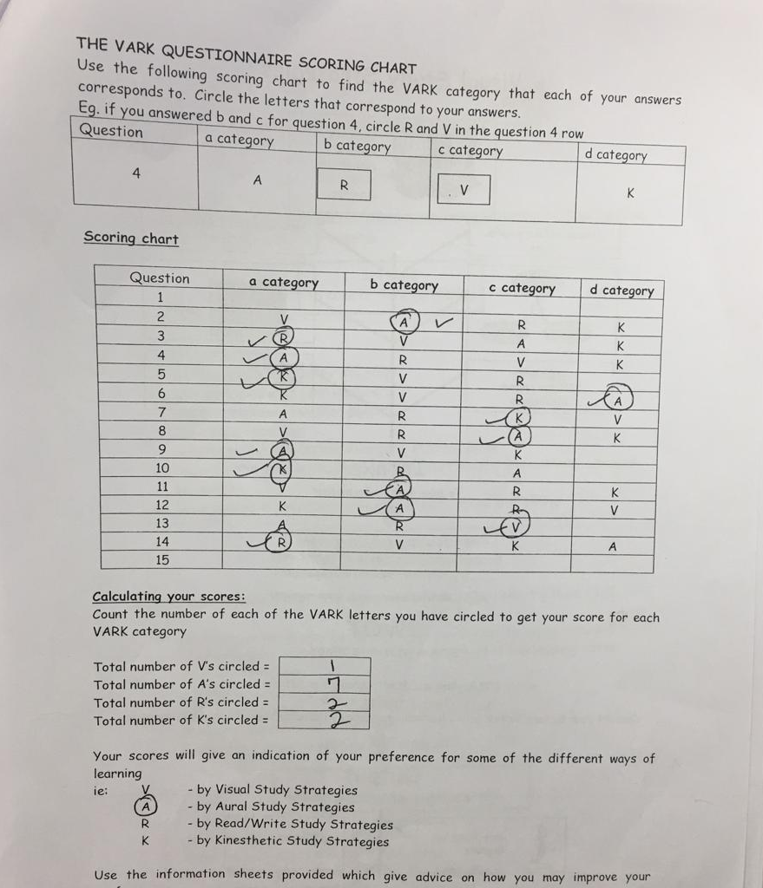

Appendix 2



