Introduction to the module
The module looks to develop independent study into the understanding of progression, using statutory documentation and relevant policies. The module provides a good understanding of the professional relationships needed in education. It also helps broaden knowledge around the role that teachers’ relationships with school staff has on children and the importance multi-agency connections play in supporting children’s learning and life. The module covers areas such as the consideration of stakeholders in school and their role in education. All the skills developed within the module will broaden the understanding an individual will have when considering interventions and presenting these to an audience in future careers.

Background reading
The initial ideas into the intervention came from previous PTE in a school which was fortunate to have a wooded area within the school grounds. The school utilised the natural environment whenever possible and this was wonderful to see as the children observed appeared to really connect and enjoy their outdoor learning. Early reading delivered information about transitions between primary and secondary contexts, back by Donaldson (2015), stating more needs to be done to reduce the impact switching school contexts has on learners. This led to some reading focussing on what external forces further impact on transitions; with parental splits and a lack of emotional support at home being highlighted. This raised a topic to consider, if parents could be more involved in their children’s life through school interventions, then this may negate the impact the home-life had in some way. Bowlby (1969) discussed the fact that if children experience more secure connections in early life then they are less likely to be fazed when facing alarming situations in the wider world. There was a strong link to Bronfenbrenner and an understanding of how to use his model (Appendix 3) in a more physical way, through working with families and visits to the local community (1998, quoted in Dunlop and Fabian, 2011). Background reading provided some ideas for activities to include in the intervention, such as a personalised book for children to add to, reminding them of their journey. The reading also considered a safeguarding and progression element when feedback on pupil behaviour was discussed. Many questions within the reading led to new and more focussed direction for the intervention, considering how to engage parents and about the therapeutic elements of nature. A key document in the research was ESTYN (2016), this report focussed on one school where the outdoor environment was being used in several ways. The document discussed various benefits to the outdoor classroom and gave key points to consider when planning an intervention of this type. After looking at the individual school website it was decided to research the governors and utilise their skillset to benefit the intervention further.

Intervention
There has been much focus in recent years on adult's mental health and the devastating effect it can have on individual lives and the lives of families left behind. As with many issues we face as adults, much can be attributed to our childhood and the impact it has on us in later life. Much research has been carried out into the correlation of childhood neglect/abuse and how this manifests itself into ‘chronic interpersonal stress’ in adults, ultimately leading to depression. This is further compounded as disruption to children’s social development leads to a reduction in wellbeing and decreases the mental capacity to defend themselves from future stressors (Turner and Butler, 2003, pp 89–103). The need for more support of mental health at a young age is one of the main reasons this intervention was chosen. Already highlighted in a Scottish perspective, well-being should be prioritised, as a lack of emotional strength can fuel underachievement (Humes, 2011). Although this is a severe world-wide problem, Thorburn (2015) discusses how the UK and New Zealand are among the only two countries to have reviewed well-being in a secondary-school context. This highlights the previous lack of focus on well-being and a lack of understanding of how much of a concern this is. On a positive note, the new curriculum has prioritised Health and Well-being in an Area of Learning and Experience with one of five key statements focussing on ‘healthy relationships’ and how they are beneficial to children’s ‘sense of belonging and well-being' (WG, 2019, p.49). When discussing children’s well-being and the importance we should place on it, a key report to consider is The United Nations Convention of the Rights of the Child (UNCRC). This treaty, created in 1989, has a major role to play in children’s well-being. It sets out the political, social, health, cultural and economic rights of children around the world. Countries that agree to the UNCRC are legally bound by it and the acknowledgement it gives to children and their rights is a key step in ensuring everyone is respected and listened to equally. There are 54 rights within the convention, rights 1-43 relating to children and 43-54 covering how adults and governments can work together to ensure these rights are delivered (UNICEF, 2019). The intervention will look at all rights when planning and carrying out activities but particular focus is on; Article 15- ‘Every child has the right to meet with other children and to join groups’ and Article 31- ‘Every child has the right to relax, play and take part in a wide range of cultural and artistic activities’ (UNICEF, 2019). The activities carried out during the Wild-Woods Club look to counteract the lack of control some pupils experience in life, which can later develop into a lack of confidence and emotional control. The main target for the activities will be through more child-led learning opportunities. This style of learning, supported through the Reggio Emelia approach, sees nature as the ‘third teacher’ and the child as a researcher and constructor of knowledge (Hewett, 2001, p. 96). The activities will also harness Bloom’s Taxonomy (Appendix 2.) when children extend thinking skills as they attempt to apply knowledge to new situations and create using the natural environment (Darwazeh, 2017). Well-being of Future Generations Act (Wales) (Future Generations Commissioner for Wales, 2015) talks of how public bodies have a duty to provide tools to improve well-being. It discusses the need to publish these goals in order to make them more attainable. This is a similar understanding to that of the Wild-Woods Charter, to be introduced during the intervention. The Act looks to highlight well-being and hold bodies accountable much as the charter sets a standard to aim for and helps the learners understand how they are responsible for their actions. The Act has several ‘goals’ including a ‘resilient’, ‘healthier’ and ‘globally responsible Wales’ (WG, 2015, p.4). These aims coincide with the new curriculum and the old SEN code of practice, supporting the need for children to develop into healthy adults and are ‘ethical, informed citizens of Wales and the world’ (Department for Education, 2015 and Donaldson, 2015, p. 29). The proposed SEN code of practice WG (2018), fails to include emotional well-being, this could impact on funding, however, as this is deemed a priority for School A, this is still something to be supported. In fact, the shortage of government funding for projects which support people’s emotional and mental health means this club is even more valuable to the children. The Montessori approach believes the child should learn through hands-on, concrete experiences (Chen, 2013). This develops future skills through real-life experiences (Donaldson, 2015). Further support for this method has come more recently from ESTYN (2014) publicizing how this type of learning will result in ‘motivated, curious and confident children’. This type of learning will form part of the foundations for the Wild-Woods Club, giving children first-hand experience to build their skills in a range of ways. The club will be an inclusive group where social connections are made through shared experiences and communication with peers and adults. Support for this comes from the Department for Education (2015) and Welsh Government (2019) which talks of the need for pupils to form friendships and develop supportive relationships. The policy goes on to talk about learners playing a role in their local community, support for this coming from Malaguzzi (1993) who believes this strengthens the learners’ sense of belonging. ERW (2019) have identified a regional priority to improve the well-being for all pupils and ensure that vulnerable pupils have targeted support. This target will be integrated in the Wild-Woods Club, which looks to initially welcome those that require the most emotional support and pending a successful trial period, the club will welcome learners from throughout the school. Dunlop and Fabian (2011) talk of the social exclusion of minority groups, in this case, children. This is addressed by the Children's Commissioner for Wales (2019), investigating best-practice examples, noting that of importance is the way schools can embed ‘rights in all aspects of school life’. A key concept of the Wild-Woods Club will be The Rights of the Child, putting children on a level platform with adults, where their views are listened to and respected and where safety is paramount.
The impact this club will have on children, their parents, the school and wider community will be far reaching and lifelong. The children will flourish in the supportive yet liberating environment, helping them to grow physically and mentally. A key benefit to the intervention is that children who usually shy away from physical exercise in a standard school setting may engage with the physical elements of the outdoor environment and physically thrive in this setting. Maslow’s Hierarchy of Needs shows how a child develops self-esteem through a mental security (Maslow and Town, 2013). Once the child feels safe and secure, they are seen to have better mental potential to engage with the new curriculum (WG, 2019). As Desforges (2003) notes, there is much greater impact due to levels of parental involvement than due to the quality of the school. Bronfenbrenner (1998, quoted in Dunlop and Fabian, 2011) sees this parental involvement, contained within the child’s ‘microsystem’ as vital to the child’s development. After the trial period for the club has run, parents will be invited to join the children in the outdoor environment. Here they will develop their own set of skills and establish strong bonds with their child, through social interactions and shared experiences. Bronfenbrenner (1998, quoted in Dunlop and Fabian, 2011, p. 23) looks at the change from home to school as an ecological transition, this leads to ‘changes in identity, relations and roles’. Integrating parents into the learning in the after-school club will mean the child’s view of these social contexts will be clearer, leading to smoother transitions. This will provide less emotional impact and children will be better able to focus on their enjoyment of learning.

Evaluation
The initial lectures on the module provided interest about what was to come and the possibilities that could be achieved. There are so many aspects to school life that need addressing and this assignment is a brilliant way to practice the skills needed to deliver change within schools in a multi-faceted way. My initial ideas about which direction to take took me quickly down an outdoor learning route and through wider reading and annotation of published work and websites I gained a much broader understanding of the advantages and disadvantages of delivering learning when using nature as the teacher. One aspect that kept appearing in my wider reading was the involvement of parents in their child’s learning. This is not something I had experienced when on PTE, but it was something I was keen to include in my intervention. I felt that parental engagement held the key to much deeper development of the child’s emotional stability. While researching ERW and the impact they have on schools, I discovered a document of real interest. It is a follow-up report from ETSYN concerning a previous inspection they had carried out into ERW. A key point was that ERW had showed a lack of real progress in addressing issues in schools, in the year since ESTYN’s previous inspection of the consortia in 2016. More research will be carried out into the consortia, but this documentation did make me question ERW as an alliance and helped me understand that no organisation is without flaws. The module helped me develop a range of skills to help me in my future career as a teacher. One of the skills I developed was in identifying areas of interest and the research needed to understand them more fully. Another aspect to my professional development was the planning of my script and considering my audience and how to deliver to them in a professional, yet engaging manner. One issue I overcame was that initially I wrote my script thinking about governors I had worked with on PTE. The issue with this was that I had developed a good working relationship with some of the governors and this was reflected in my script when I was using more informal language. Through discussion about this with peers I quickly adapted my script to deliver a presentation in a more professional dialogue. Vital to practitioners understanding of how to show these qualities in everyday settings are the Professional Teaching Standards (PTS). These new standards explicitly set out certain attitudes and habits to be adopted by educational professionals. When looking at an intervention that focusses on well-being, it is positive to see the professional standards reference ‘the importance of positive involvement of parents/care givers and other partners’ and good pedagogy which develops ‘improved learning and a heightened sense of well-being'. The PTS goes further still, discussing how independent research from practitioners into ‘cognitive, social, emotional and physical development’ will benefit their own pedagogy (WG, 2019, p. 27, p. 41 & p. 54). It is worthwhile to note that by achieving the PTS, practitioners are not only benefiting the learners, but also furthering their own professional knowledge and capabilities. I had initially considered filming myself during the whole presentation, reading from a teleprompter while talking to camera. Following a conversation with a PTE class teacher I had worked with, I revised my idea and decided to present using a PowerPoint (Appendix 1). After developing my plans for this I settled on an iMovie presentation as I could synchronize pictures with my voice, I would initially be shown on camera to welcome the governors to my presentation. The issues I envisaged were that I would need to find all the pictures I would use during my presentation and save these to my phone memory.

Reference List

Ashton Gate Out of School Care. (2019) Ashton Gate Out of School Care.
Available at: https://agosc.com/after-school-club/
(Accessed: 09/11/2019).

Bowlby, J. (1969) Attachment and Loss. New York: Basic Books.
Available at: https://www.abebe.org.br/files/John-Bowlby-Attachment-Second-Edition-Attachment-and-Loss-Series-Vol-1-1983.pdf
(Accessed: 08/11/2019).

Cadle Primary School. (2019) School Development Plan.
Available at: https://www.cadleprimaryschool.co.uk/sdp/
(Accessed: 11/11/2019).

Chen, G. (2013) 10 Benefits of a Montessori Preschool.
Available at: https://www.education.com/magazine/article/10-benefits-montessori-preschool/
(Accessed: 09/11/2019).

Children’s Commissioner for Wales. (2019) A Children’s Rights Approach.
Available at: https://www.childcomwales.org.uk/resources/childrens-rights-approach/
(Accessed: 14/11/2019).

Child Mind. (2017) 2017 Children’s Mental Health Report.
Available at: https://childmind.org/report/2017-childrens-mental-health-report/
(Accessed: 09/11/2019).

City & County of Swansea. (2019). Visit Swansea Bay.
Available at: https://www.visitswanseabay.com/blog/2015/07/24/7-days-7-beaches/
(Accessed: 14/11/2019).

Cray, M. and Nicholas, A. (2019). Wild Woods: An Explorer's Guide to Britain's Woods and Forests
Image available at: https://www.amazon.co.uk/Wild-Woods-Explorers-Britains-Forests/dp/1784776416
Accessed: 10/11/2019).

Darwazeh, A. (2017). A New Revision of the [Revised] Bloom's Taxonomy. Distance Learning, 14(3), 13-28.

Damariscotta Montessori School. (2019).
Image available at: http://www.damariscottamontessori.org/
(Accessed: 10/11/2019).

Department for Education. (2015) Special educational needs and disability code of practice: 0 to 25 years.
Available at: https://assets.publishing.service.gov.uk/government/uploads/system/uploads/attachment_data/file/398815/SEND_Code_of_Practice_January_2015.pdf
(Accessed: 09/11/2019).

Desforges, C. and A. Abouchaar (2003). The Impact of Parental Involvement, Parental Support and Family Education on Pupil Achievement and Adjustment: A Literature Review. Department for Education and Skills.
Available at: https://www.nationalnumeracy.org.uk/sites/default/files/the_impact_of_parental_involvement.pdf
(Accessed: 08/11/2019).

Donaldson, G. (2015) Successful Futures. Cardiff: Crown.

Dunlop, A. and Fabian, H. (2011). Informing transitions in the early years. Maidenhead: McGraw-Hill/Open Univ. Press.

Eco-Schools. (2019) Why Become an Eco School?
Available at: https://www.eco-schools.org.uk/about/benefits-of-joining/
(Accessed: 10/11/2019).

Eisenberg, N.E., Damon, W.E. and Lerner, R.M., 2006. Handbook of child psychology: Social, emotional, and personality development, Vol. 3. John Wiley & Sons Inc.

ERW. (2019) Regional Strategy.
Available at: http://www.erw.wales/media/1340/erw-regional-strategy.doc
(Accessed: 10/11/20/19).

ESTYN. (2016) A school environment that benefits pupil wellbeing. Cardiff.
https://www.estyn.gov.wales/effective-practice/school-environment-benefits-pupil-wellbeing
(Accessed: 06/11/2019).

ESTYN. (2014) Children learn best from first hand experiences.
Available: https://www.estyn.gov.wales/effective-practice/children-learn-best-first-hand-experiences
(Accessed: 09/11/2019).

ESTYN. (2019). Happy and Healthy, school impact on pupils’ health and wellbeing.
Available at: https://www.estyn.gov.wales/thematic-reports/healthy-and-happy
(Accessed: 11/11/2019).

ESTYN. (2017) Report following the monitoring of ERW consortium.
Available at: https://www.estyn.gov.wales/sites/www.estyn.gov.wales/files/documents/ERW.pdf
(Accessed: 13/11/2019).

ESTYN. (2016) Using the outdoors to increase pupils’ wellbeing. ESTYN. Cardiff.
https://www.estyn.gov.wales/effective-practice/using-outdoors-increase-pupils%E2%80%99-wellbeing
(Accessed: 06/11/2019).

ESTYN. (2017) A report on Whitestone Primary School. ESTYN. Cardiff.
Available at:
https://www.estyn.gov.wales/sites/www.estyn.gov.wales/files/documents/Whitestone%20Primary%20School.pdf
(Accessed: 10/11/2019).

Flip Flops or Wellies. (2019) Wayford Woods.
Image available at: https://www.flipflopsorwellies.co.uk/wayford-woods/
(Accessed: 08/11/2019).

Forestry England. (2019) Learning at Cardinham Woods.
Image available at: https://www.forestryengland.uk/cardinham-woods/learning-cardinham-woods
(Accessed: 10/11/2019).

Future Generations Commissioner for Wales. (2015) Well-being of Future Generations (Wales) Act 2015. Cardiff.
Available at: https://futuregenerations.wales/about-us/future-generations-act/
(Accessed: 10/11/2019).

Hewett, VM. (2001) ‘Examining the Reggio Emilia Approach to Early Childhood Education’, Early Childhood Education Journal, 29(2), pp. 95-100.
Available at: https://static1.squarespace.com/static/51ed94d0e4b03bd18bdcc998/t/526c8eabe4b0f35a9f0216e3/1382846123076/ExaminingtheReggioEmiliaApproach.pdf
(Accessed: 09/11/2019).

Humes, W. (2011) ‘Creativity and wellbeing: Possibilities, tensions and personal journeys’, Tean Journal 2 (1), April (Online). Available at: http://insight.cumbria.ac.uk/id/eprint/1371/1/69-366-1-PB.pdf
(Accessed 09/11/2019).

Independent. (2019). 10 Best Festival Wellies for Woman.
Image available at: https://www.independent.co.uk/extras/indybest/fashion-beauty/womens-shoes/best-festival-wellies-women-cheap-asos-hunter-wellington-boots-black-a7743211.html
(Accessed: 08/11/2019).

Malaguzzi, Loris. 1993. ‘For an Education Based on Relationships’, National Association for the Education of Young People, 49 (1). Pp. 9-12.
Available at: https://www.reggioalliance.org/downloads/malaguzziyoungchildren.pdf
(Accessed: 09/11/2019).

Maslow, A. and Town, S. (2013). A theory of human motivation. Floyd, Va.: Wilder Publications.

Massey, S. (date unknown) The Benefits of a Forest School Experience for Children in their Early Years. NFER. Slough.
https://www.nfer.ac.uk/nfer/pre_pdf_files/05_33_06.pdf
(Accessed: 06/11/2019).

National Assembly for Wales. (2018) Mind over matter A report on the step change needed in emotional and mental health support for children and young people in Wales. National Assembly for Wales. Cardiff.
Available at: https://www.assembly.wales/laid%20documents/cr-ld11522/cr-ld11522-e.pdf
(Accessed: 11/11/2019).

National Convergence technology Centre. (2016) Sharing Best Practice.
Available at: http://connectedtech.org/blog/sharing-best-practices/
(Accessed: 08/11/2019).

PicFair. (2019) Bluebells in a Woodland Setting.
Available at: https://www.picfair.com/pics/0451585-bluebells-in-a-woodland-setting
(Accessed: 08/11/2019).

REI Coop. (2019). Tips for camping with kids.
Image available at: https://www.rei.com/learn/expert-advice/camping-kids.html
(Accessed: 11/11/2019).

Responsible Fishing Uk. (2019) Art in the Woods.
Image available at: http://www.responsiblefishinguk.co.uk/art-in-the-woods/
(Accessed: 08/11/2019).

The Psychology Notes HQ. (2019) What is Bronfenbrenner’s Ecological Systems Theory?
https://www.psychologynoteshq.com/bronfenbrenner-ecological-theory/
(Accessed: 09/10/2019).

Thorburn, M. (2015) ‘Theoretical constructs of well‐being and their implications for education’, British Educational Research Journal, 41(4), pp 2-4.
Available at: https://onlinelibrary.wiley.com/doi/full/10.1002/berj.3169
(Accessed: 09/11/2019).

Turner, HA and Butler, MJ. (2003) ‘Direct and Indirect Effects of Childhood Adversity on Depressive Symptoms in Young Adults’. Journal of Youth and Adolescence. 32(2) pp. 89–103.

UNCRC. (2019). Learn About Your Rights. Plan International.
Available at: https://plan-international.org/sites/default/files/field/field_document/child-friendly_crc_poster_a4_-_final_-_english.pdf
(Accessed: 10/11/2019).

UNICEF. (2019) A summary of the UN Convention on the Rights of the Child.
https://downloads.unicef.org.uk/wp-content/uploads/2019/10/UNCRC_summary-1_1.pdf?_ga=2.37806819.1761688225.1573658054-150753328.1573658054

UNICEF. (2019). How the Convention on the Rights of the Child works.
Available at: https://www.unicef.org/child-rights-convention/how-convention-works
(Accessed: 11/11/2019).

Welsh Government (2018). Draft Additional Learning Needs Code for Wales. Welsh Government. Cardiff: Crown.
Available at: https://gov.wales/sites/default/files/consultations/2018-12/draft-additional-learning-needs-code-for-wales_0.pdf
(Accessed: 08/11/2019).

Welsh Government. (2019) Draft Curriculum for Wales 2022.
Available at: https://hwb.gov.wales/draft-curriculum-for-wales-2022/health-and-well-being/
(Accessed: 09/11/2019).

Welsh Government. (2014) Evaluating the Foundation Phase Key Findings on Staffing. Cardiff: Crown.
Available at: https://orca.cf.ac.uk/88771/1/141111-foundation-phase-staffing-en.pdf
(Accessed: 08/11/2019).

Welsh Government. (2019) Professional standards for teaching and leadership. Cardiff: Crown.
Available at: https://hwb.gov.wales/storage/19bc948b-8a3f-41e0-944a-7bf2cadf7d18/professional-standards-for-teaching-and-leadership-interactive-pdf-for-pc.pdf
(Accessed: 10/11/2019).

Ysgol Llandrillo yn Rhos. (2019). School Website.
Available at: http://llandrillo.conwy.sch.uk/
(Accessed: 08/11/2019).

Appendices

Appendix 1. (initial message and notes from phone call)
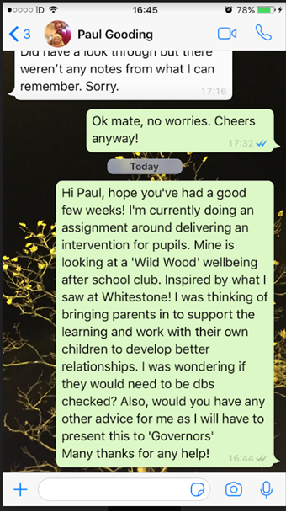
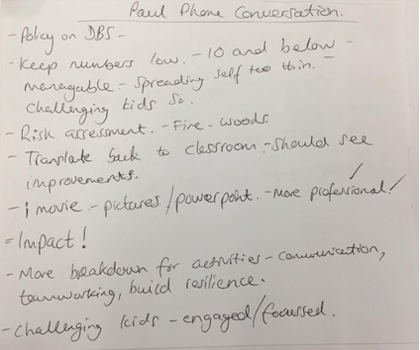
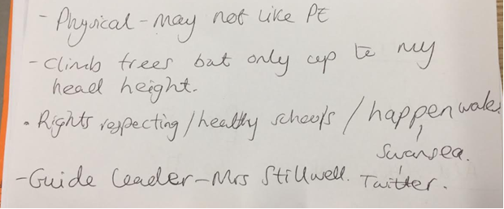
Appendix 2.
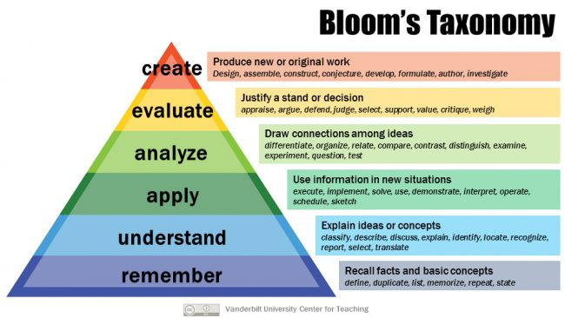

Appendix 3. 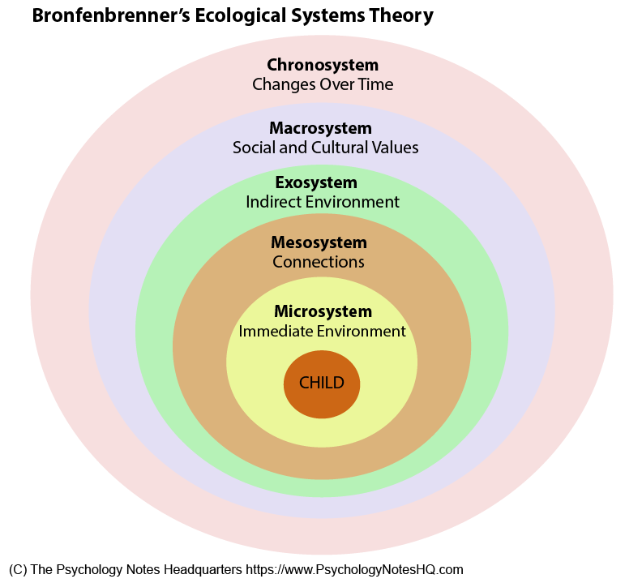

Appendix 4. (Cost Sheet)

Summary of costs for Wild Wood Intervention Group

Resource/materials | Cost per session (total)
Snacks | £2
Additional clothing/footwear | £1.62 (£20 for spare clothes + £40 for spare wellies divided over the whole academic year)
DBS checks | £40 per adult (£120 total for three adults)

Appendix 5. (Letter to Parents)

After School Wild-Woods Club

The After-School Club is for children attending School A.
We provide exciting and stimulating activities for children alongside free play. Wild-Woods After School Club is open until 6.00pm every day.
Afternoon Plan
- Collection: At 3.10pm, staff collect KS2 children from the Upper Road site and escort them safely to our woodland site. At 3.20pm, staff collect the Reception and KS1 children from their classrooms and escort them safely to the woodland area.
- Talk Time: As soon as the children arrive at Wild-Woods After School Club, they have a talk time in their key groups where they share their news and learn about the activities for the day.
- Snack: There are two snacks during After School Club: a fruit and biscuit snack during circle time and a fruit break at 5pm. Water is always available.
- Activities: We provide a variety of activities each day in each area of After School Club and always include ideas from the children.
- Free Play: A fundamental part of the Wild-Woods Club is child-led play. The children have the opportunity for free play throughout their entire time with us. We provide various accessible resources for the children to use as they please in a safe environment.

After School Club Sites
- Reception and KS1: Woodland site
- KS2: Woodland site

Wet Weather Plan
At School A, we encourage the children to play outdoors in all weathers as long as they have appropriate clothing and it is safe for them to do so. In circumstances where we feel this is not the case, extra staff members will be in the Infant Hall to ensure the children can play indoors.
School Clubs
If your child is attending Wild-Woods Club, please inform us and we will ensure they are collected from school and escorted to After School Club via the safest route. They will then be signed in by staff and provided with water, fruit and a biscuit.
Key Communication
Each child attending Wild-Woods Club is encouraged to talk to the member of staff about any concerns they have. The staff are responsible for monitoring the progress and meeting the individual needs of the children they support and building a relationship with their parents/carers.

Script

SHOW ME IN INTRODUCTION

Prynhawn da and thank you all for joining me today. I’m Mr. Jones, School A’s Social, Emotional and Behavioural Liaison and Forest School leader.

I really appreciate your time during this busy period, as we plan for spring term 2020. I am excited to talk to you about an idea I have been working on and the research that has gone into it.
I welcome any questions you may have as I run through this presentation.

SHOW STATS SLIDE

Why
The National Assembly for Wales points out that in the UK, it is thought that one in four children will display some signs of mental ill-health, and around three pupils in every classroom will have a mental health problem. Further to this, it is estimated that around half of all mental health issues have started by the age of 14. I’m sure you’ll all agree that these are shocking statistics and ones we need to do something about.

SHOW ESTYN RECOMMENDATIONS

Our ESTYN report last year was acknowledgement of the wonderful work that goes on in School A. However, the school needs to put significant focus on the wellbeing of pupils.
Following school council meetings, one issue that was raised was the need for more outdoor learning opportunities.
Also, our consortia, ERW, have stated that more needs to be done to identify and support children who need emotional support to bolster their wellbeing.
We are looking to build on our previous years ‘Green Flag’ award, by empowering our children to be more environmentally aware and improve the school environment. Through this we hope to engage the wider community and deliver on even more ESTYN requirements.
There has also been concern from a few of our parents that their children are feeling left out and aren’t allowed to mix with children from other years. The club will provide the opportunity for pupils of all ages to mix in a less formal setting.

SHOW RIGHTS OF CHILD SLIDE

One aspect we cannot ignore are the Rights of the Child, our children should be provided with groups to join to help them be healthy and provide a place to relax and play. They also need to include their parents in their lives, wherever possible. This also ties into the Wellbeing of Future Generations Act by developing resilient, healthier and globally responsible children.

What?

I met with most of you over the summer and we discussed then that I would get some ideas of interest into an intervention. The response has been great so far, with at least one parent of a pupil in each year saying they would be interested in an after-school club with a focus on wellbeing.

SHOW WILD-WOODS CLUB BANNER

After research into the matter, I am proposing an outdoor after-school club, based on some of the principles of the Scandinavian model of forest schools. I want to call this the Wild-Woods Club. The club will be available for pupils of all ages and abilities within our school, I really want to make this a warm, welcoming and fully inclusive environment for all.
The overall aim of this intervention is to nurture through nature. To give pupils the skills to deal with school and their future lives, from a physical and emotional perspective. The access to outdoor learning and the range of opportunities it provides children will help to develop the child’s well-being as well as a range of other skills, vital in giving our pupils the best start in life.

SHOW MONTESSORI WITH WORDS

I’d just like to take this opportunity to thank our parent-governor Catherine Smith, who has been a wonderful advisor to me when working on this, due to her background in Montesorri schools she has been invaluable. Thank you, Catherine. Together we decided that the club would provide hands-on learning through collaborative play and self-directed activities.

SHOW PARENTS WITH CHILDREN OUTDOORS

What I hope is that once the children are secure in their outdoor environment, we would then welcome parents of pupils to the woodland area to learn alongside their children. By inviting parents to join the Wild-Woods Club, the parents build their own set of skills and the aim is that they will connect socially and emotionally with their child. This will bring further benefits to the child through a feeling of safety, collaboration and consistency.

SHOW SHARING BEST PRACTICE SLIDE

The hope is that if this club proves a success, we will share best practice with other schools and aim to develop stronger links with them as a result, this will help us to fulfil the recommendations ESTYN gave us following our last inspection. Further to this, I am currently in talks with a local secondary school about the possibility of running a forest school club there. This would provide a more seamless transition for our pupils when heading up to year 7, a time when, I'm sure you can appreciate, they will be feeling nervous. My thoughts are that with fellow Wild-Woods Club members already in the secondary school, they will have familiar faces to talk to and to support them on their learning journey.

SHOW WOODLAND SETTING

How?

We are blessed to have a great woodland in the school grounds, this will be the base for our Wild-Woods Club. All children involved in the club will meet up together in the school hall before we head out into the woods.
One of the first aims of the group is to develop a Wild-Woods Charter, like a class charter, this will have rules where communication, respect and safety are prioritised. This will be referred back to, further enhancing the consistency and therefore security the pupils feel throughout the sessions.

SHOW SWANSEA PICTURES

Once we have used the woods to develop a secure and safe environment, we are planning to further explore the natural environment and go on some small visits around the local area in the spring term.

Who?

I will be overseeing the club every week, as part of my after-school responsibilities. I am first aid trained and have plenty of experience working in an outdoor setting from my previous school.
Our Governor, Paula Lawrenson, through her work with the Brownies, has agreed to help me during the trial period and has helped shape the ideas we have for the club. I just wanted to thank her for this, thank you Paula.
In addition, we are lucky to have some great parents involved with the school and after sending out letters asking for ideas and volunteers they have responded positively to the idea of the club. I have had 3 parents who live locally already agree to be adult helpers, we will rotate these helpers, so we have a ratio of at least one adult to eight children. The adults will need to be DBS checked; we will come on to covering these costs soon.

SHOW ADULTS IN WELLIES

Of course, all of you governors are welcome to pull your wellies on and come along to see the wonderful work we will be doing, whenever you are free.
The chances are that some children won’t have their own parent there and I don’t want them to feel left out if other children are working one-to-one with their own parents. Therefore, the idea is to have activities where the group works as a whole or can go off in small groups to work in rotation, this will provide an inclusive approach where no one feels left out.

When?

With your backing, I will start a trial period for the club. I will talk to class teachers and parents to identify one or two pupils from each year who they feel may need some additional emotional support. Ideally, I will try to get a few older pupils who I feel could support new members when they start in the Wild-Woods Club.
I'm aiming to offer around 8 places for the trial period and if there are many more who need the support, these will be on a list for when the club starts up fully.
With these initial members, the club will run every week for two months, if successful, we will open the club up to the whole school.

SHOW COST BREAKDOWN (Appendix 4.)

How much?

I have emailed you all a simple cost breakdown which I'm sure you’ll agree is reasonable for such a worthwhile intervention.
Now, as mentioned, adult helpers will need to be DBS checked, there have been small reductions in these costs from the government recently, but we will still need to cover these before adults are allowed on site as helpers.
There may be some small costs to families, but these will be miniscule as most parents will already have old clothes and footwear.
I want to have some spare clothes and wellies the children can use if they have forgotten their own. As well as some funds available for local visits to the beach and other local areas.

SHOW PICTURE ON PP

Therefore, I decided on a fundraising activity and am delighted to say that two of our governors, James Lusted and Councillor Donald Milne will use their experience in acting and stage production to work on a small school production of A Teddy Bear’s Picnic! Thank you both for your involvement in this.
Money raised from this production will provide the funds needed for the Wild-Woods Club. Any money left over will be put into the PTA fund for future use.

Impact?
The school has gone from strength to strength since our last ESTYN inspection and I feel this intervention will be a wonderful way to build on the amazing environment we have around the school already. This will help children who may feel a little left out and those who struggle to talk about their feelings. This will also give an opportunity for those parents that don’t get a lot of quality time with their children to connect with them more fully; not just hearing about what they got up to in school but by being involved in their school day.
Our pupils are why we are all here and getting the parents more involved in the life of the school can only benefit the support we can give our little learners.
The National Assembly for Wales have already highlighted that educational settings are key to developing good mental health and emotional well-being. Further to this they state that a whole- school approach is needed in order to embed well-being into the mindset of the whole school. Utilising a range of external professionals to understand the nature of the problem and deal with it in the best way possible.
ESTYN support this, stating there should be a coherent whole-school approach that benefits all pupils and that the pupils voice is always key when making decisions that affect them. Through developing this intervention I envisage staff within our school will become more aware of the difficulties children are facing in relation to mental health and it is this awareness which will provide a platform for adults in the school to learn and develop themselves in yet another area.
The Wild-Woods Club is not purely about protecting children's emotional well-being. In fact, good mental health will almost be a by-product of the activities we will undertake when learning in the outdoors. The activities themselves will develop a range of benefits to our children.

SHOW PIC OF CLIMBING/BUILDING

It will build children's physical strength through climbing trees, working with tools and being active. It will develop their ability to self-assess risk and awareness of their environment when they balance on logs, leap across streams and fall over in the mud.

SHOW ART IN WOODS PIC

My aim is that the club not only supports, but also extends the new curriculum. This will be achieved when we complete problem-solving tasks individually and in groups, working collaboratively to solve problems and overcome setbacks. This will harness children’s creative side and expand on it to produce creative learners. It will also produce more resilient learners who see setbacks not as a failing but an opportunity to learn and build from.

SHOW SDP

Through all of this, my aim is to meet the targets of inspection area 2 of our School Development Plan, I also want to develop key competencies alongside the current curriculum and establish a sound base to work towards the new curriculum, once implemented.

SHOW ANY Qs SLIDE

I’d like to thank you all for attending today and listening to my ideas about this intervention.
Are there any questions?
Diolch, Thank you.

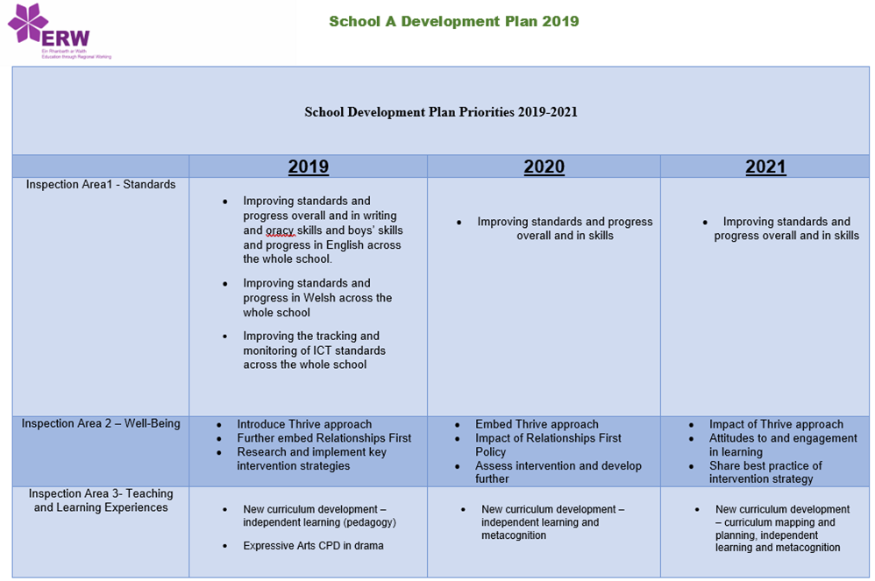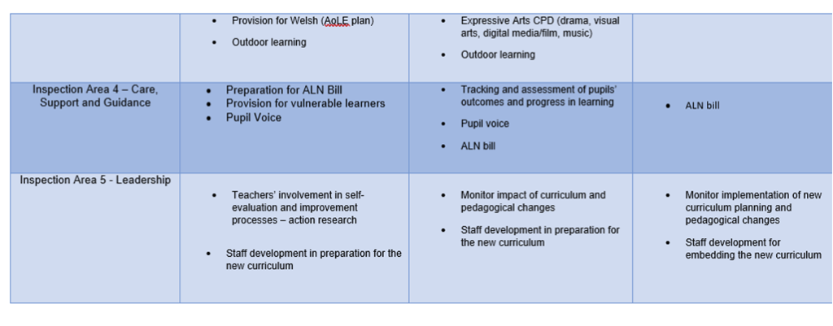

School Context

School A is situated on the outskirts of Swansea in a seaside locality. There are 170 pupils on roll between the ages of 3 and 11 in seven mixed-age classes. In addition, there is a part-time nursery and two specialist teaching facilities for pupils with moderate to severe learning difficulties. The school identifies around 38% of pupils as having additional learning needs, which is well above the national average. Around 16% of pupils, mainly in the specialist teaching facilities, have a statement of special educational needs. Approximately 23% of pupils are eligible for free school meals, which is slightly above the national average. Most pupils come from a white British background, where the predominant language is English. The school’s last inspection was in September 2009. The headteacher took up her post in September 2010. The individual school budget per pupil for School A in 2016-2017 means that the budget is £4,955 per pupil. The maximum per pupil in the primary schools in Swansea is £5,232 and the minimum is £2,703. School A is 4th out of the 79 primary schools in Swansea in terms of its school budget per pupil.
(ESTYN, 2017)

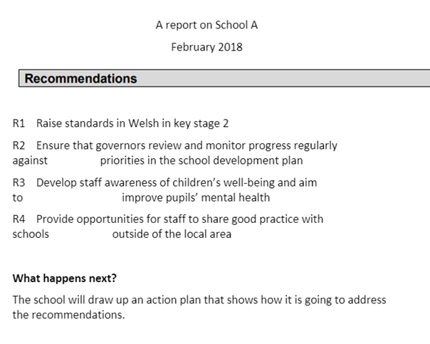

Bibliography

Forest Research. (2019) Do Forest Schools increase young people’s self-confidence and self-esteem?
https://www.forestresearch.gov.uk/research/forest-schools-impact-on-young-children-in-england-and-wales/
(Accessed: 06/11/2019).

Gov.uk. (2019) Fee changes for DBS checks.
Available at: https://www.gov.uk/government/news/fee-changes-for-dbs-checks
(Accessed: 08/11/2019).

Loughborough University. (2017) Study reveals how Forest Schools can benefit children’s development.
https://www.lboro.ac.uk/media-centre/press-releases/2017/october/study-reveals-forest-school-benefits/
(Accessed: 06/11/2019).

Michek, S. Novakova, Z. and Menclova, L. (2014) Advantages and disadvantages of forest kindergarten in Czech Republic. Department of Social Pedagogy: University Hradec Králové, Hradecká.
file:///C:/Users/1600699/Downloads/advantages-and-disadvantages-of-forest-kindergarten-in-czech-republic.pdf
(Accessed: 06/11/2019).

Millfield Pre-Prep School. (2019)
Available at: https://millfieldschool.com/pre-prep
(Accessed: 10/11/2019).

Muddy Puddles. (2017) What are the Pros and Cons of Forest School?
Available at:
https://www.muddypuddles.com/blog/pros-cons-forest-school/
(Accessed: 06/11/2019).

National Assembly for Wales. (2018) Mind over matter A report on the step change needed in emotional and mental health support for children and young people in Wales. National Assembly for Wales. Cardiff.
Available at: https://www.assembly.wales/laid%20documents/cr-ld11522/cr-ld11522-e.pdf
(Accessed: 11/11/2019).

NFER. (2019) The Benefits of a Forest School Experience for Children in their Early Years.
Available at: https://www.nfer.ac.uk/nfer/pre_pdf_files/05_33_06.pdf
(Accessed; 06/11/2019).

Outdoor Tribe. (2017). Experiencing woodland wellbeing.
Available at: https://www.outdoortribe.co.uk/experiencing-woodland-wellbeing/
(Accessed: 30/10/2019).

St. Helens Preschool. (date unknown) The Benefits of Forest School to the Emotional Well-being of Children.
https://www.sthelenspreschool.co.uk/files/forestschoolcompintro.pdf
(Accessed: 30/10/2019).

The Guardian. (2019) Forest schools: is yours more a marketing gimmick than an outdoors education?
Available at: https://www.theguardian.com/education/2019/jun/25/forest-schools-more-marketing-than-outdoor-education
(Accessed: 06/11/2019).

Woodland Adventures. (2019) The Outdoor Kindergarten.
Available at: https://www.outdoorkindergarten.org/managing-transitions-from-kindergarten.html#
(Accessed: 09/11/2019).

Young Minds. (2019). Impact Report How we made a difference to children and young people in 2016-2017.
Available at: https://youngminds.org.uk/media/1578/impact-report-final-web.pdf
(Accessed: 09/11/2019).

Young Minds. (2019). Wise Up to Wellbeing in Schools.
Available at: https://youngminds.org.uk/media/1428/wise-up-prioritising-wellbeing-in-schools.pdf
(Accessed: 14/11/2019).

