Master’s Degrees by Examination and Dissertation
Declaration Form.
1. This work has not previously been accepted in substance for any degree and is not being concurrently submitted in candidature for any degree.
Signed : Mandeep Kaur
Date : 09-02-2024

2. This dissertation is being submitted in partial fulfilment of the requirements for the degree of Master in Business Administration.
Signed : Mandeep Kaur
Date : 09-02-2024
3. This dissertation is the result of my own independent work/investigation, except where otherwise stated.
Other sources are acknowledged by footnotes giving explicit references.
A bibliography is appended.
Signed candidate : Mandeep Kaur
Date: 09-02-2024

4. I hereby give consent for my dissertation, if accepted, to be available for photocopying, inter- library loan, and for deposit in the University’s digital repository
Signed (candidate) : Mandeep Kaur
Date : 09-02-2024

Supervisor’s Declaration.
I am satisfied that this work is the result of the student’s own efforts.
Signed : Dr. Jaya Gopalkrishnan
Date: 09-02-2024

University of Wales: Trinity Saint David
E-Thesis Deposit Agreement

Details of the Work
I would like to deposit the following item in the digital repository maintained by the University, and/or in any other repository authorized for use by the University:

Title: The impact of computer-Aided designing (CAD) software on digital marketing of garment

This item is a product of my own research endeavours and is covered by the agreement below in which the item is referred to as “the Work”. It is identical in content to that deposited in the Learning Resources Centre, subject to point 4 below.
I agree that the University of Wales: Trinity Saint David may electronically store, copy or translate the Work to any approved medium or format for the purpose of future preservation and accessibility. The University is not under any obligation to reproduce or display the Work in the same formats or resolutions in which it was originally deposited.
UW: TSD Digital Repository
I understand that work deposited in the digital repository will be accessible to a wide variety of people and institutions, including automated agents and search engines via the World Wide Web.
I understand that once the Work is deposited, the item and its metadata may be incorporated into public access catalogues or services, such as national databases of electronic theses.
I agree as follows:
1. That I am the author or have the authority of the author/s to make this agreement and do hereby give the University of Wales: Trinity Saint David the right to make available the Work in the way described above.
2. That the electronic copy of the Work deposited in the digital repository and covered by this agreement, is identical in content to the paper copy of the Work.
3. That I have exercised reasonable care to ensure that the Work is original, and to the best of my knowledge, does not breach any laws including those relating to defamation, libel and copyright.
4. That I have, in instances where the intellectual property of other authors or copyright holders is included in the Work, gained explicit permission for the inclusion of that material in the Work, and in the electronic form of the Work as accessed through the open access digital repository, or that I have identified and removed that material for which adequate permission has not been obtained and which will be inaccessible via the digital repository
5. That University of Wales: Trinity Saint David does not hold any obligation to take legal action on behalf of the Depositor, or other rights holders, in the event of a breach of intellectual property rights, or any other right, in the material deposited.
6. That I undertake to indemnify the University of Wales: Trinity Saint David against all actions, suits, proceedings, claims, demands and costs occasioned by the University in consequence of any breach of this agreement

Signature: Mandeep Kaur
Date: 09-02-2024

Abstract
Computer-Aided-Design (CAD) has become the most popular manufacturing process nowadays that allows digitally creating 2D or 3D drawings of the products before manufacturing them actually. The benefit of CAD has been widely accepted in different spheres. This study has delved deep into investigating the impact of CAD application on the social media marketing campaign of the garments and fashion brands. In this particular context of the chosen topic the first chapter of the study has established the rationale and background of the study in terms of why the study is important. Apart from that the first chapter has developed aims, objectives and research questions of the study along with highlighting its significance.
The second chapter literature review has gone through exploring a range of literary sources to develop a critical view of the topic. On the other hand, it has developed a seamless theoretical ground along with developing a conceptual framework as well.
The third chapter of the study has been based on developing and explaining the methodological stance of the research paper. It has provided a brief overview regarding what types of research methodology the research has used and giving appropriate justification against each of the choices made.
The fourth and most crucial chapter of this research study is data analysis and discussion. This chapter has covered the qualitative and quantitative data analysis to meet research aim and objectives. Representing the data analysis plan helps to get the road map of qualitative and quantitative data analysis. The IBM SPSS Software analysed the quantitative data through descriptive test, correlation, regression and reliability test to detect the impact of CAD software on digital marketing of garments brand. This dissertation is has also used NVivo software for analysing primary qualitative data. With the help of this software, word cloud interpretation, chart view of the keywords, 3D clusters analysis and text search query have been done.
After this, the findings have been analysed in form of several themes. From the research work, it can be concluded that CAD Software affects the efficacy of social media marketing, as it encourages participation of the consumers, their loyalty and trust on the brand. This is why marketers of garment brands incorporate real-world user experiences with online advertising.
Acknowledgement
I like to convey my deepest appreciation to my supervisor Dr Jaya Gopalkrishnan for guiding and providing feedback throughout this study.
I am indebted to my colleagues and friends who supported me and assist me in gathering prerequisites for my study. Finally, I am grateful to my family for helping me complete my education and supporting me throughout the journey.
Your Signature: Mandeep Kaur
Date: 09-02-2024

THE IMPACT OF COMPUTER-AIDED DESIGNING (CAD) SOFTWARE ON DIGITAL MARKETING OF GARMENT BRANDS

Table of Contents
CHAPTER 1: INTRODUCTION 7
1.1 Introduction 7
1.2 Research Background 7
1.3 Research Rationale 8
1.4 Research significance 9
1.5 Research Gap 10
1.6 Research Aim and Objectives 10
1.6.1 Research Aim 10
1.6.2 Research Objectives 10
1.7 Research Questions 11
1.8 Chapter overview 11
1.9 Summary 11
CHAPTER 2: LITERATURE REVIEW 12
2.1 Chapter introduction 12
2.2 The concept of CAD 12
2.3 The concept of digital marketing 13
2.4 The benefits and disadvantages of CAD 15
2.5 The benefits and drawbacks of digital media and digital marketing 18
2.6 The impact of CAD on social media marketing campaign 21
2.7 Theories and models 22
2.8 Gap in the Literature 23
2.9 Theoretical framework 24
2.10 Chapter Summary 24
CHAPTER 3: METHODOLOGY 26
3.1 Chapter introduction 26
3.2 Research philosophy 26
3.3 Research design 27
3.4 Research approach 27
3.5 Data collection method 28
3.6 Data analysis method 29
3.7 Sample size and sampling technique 30
3.8 Ethical considerations 30
3.9 Reliability and Validity 30
3.10 Chapter Summary 31
CHAPTER 4: DATA ANALYSIS AND DISCUSSION 32
4.1 Introduction 32
4.2 Data analysis plan 32
4.3 Quantitative data analysis 33
4.3.1 Descriptive data analysis 33
4.3.2 Inferential analysis 34
4.4 Qualitative data analysis 45
4.4.1 Sample overview 45
4.4.2 Word cloud interpretation 45
4.4.3 Chart view of the keywords 46
4.4.4 Literature analysis from 3D cluster analysis and text search 47
4.4.5 Literature analysis from text search query 48
4.5 Discussion 49
4.5.1 Theme 1: CAD Software can improve the effectiveness of social media marketing for garment brands 49
4.5.2 Theme 2: CAD Software inspires consumers to participate in interactive marketing approach, which improves their loyalty and trust 50
4.5.3 Theme 3: Marketers of large garment brands incorporate real-world user experiences of consumers with their online advertising strategies 51
4.5.4 Theme 4: CAD Software has many utilisations to improve brand presence on social media platforms 52
4.6 Summary 53
CHAPTER 5: CONCLUSIONS AND RECOMMENDATIONS 55
5.1 Chapter Introduction 55
5.2 Conclusion 55
5.3 Recommendations 57
5.4 Research Limitations 59
5.5 Future research suggestions 59
References 61
Appendices 66
Survey Questionnaire 66
Interview Schedule 67

List of Figures
Figure 1.1: Different mediums of a marketing 7
Figure 2.1: flexibility of digital marketing 19
Figure 2.2: Theory of social selling and interaction 22
Figure 2.3 Technology Acceptance Model 23
Figure 2.4: Conceptual Framework 24
Figure 3.1: Inductive and Deductive Research 28
Figure 4.3.1.1: Descriptive statistics 33
Figure 4.3.2.1: Correlation 34
Figure 4.3.2.2: CAD software enhances visual representation 36
Figure 4.3.2.3: Model Summary 36
Figure 4.3.2.4: ANOVA 37
Figure 4.3.2.5: Coefficient 38
Figure 4.3.2.6: CAD software promotes digital marketing 39
Figure 4.3.2.7: CAD software integrates online advertising 40
Figure 4.3.2.8: Reliability statistics 41
Figure 4.3.2.9: CAD software in digital marketing 41
Figure 4.3.2.10: CAD software builds trust between consumers and garments brands 42
Figure 4.3.2.11: CAD Software helps in social media marketing 43
Figure 4.3.2.12: CAD software enhances visual appearance 44
Figure 4.4.1: Word cloud 46
Figure 4.4.2: Chart view of keywords 46
Figure 4.4.3: Text search query 48
Figure 4.5.1: Process of User module design 50
Figure 4.5.1: Manual Design solution 51
Figure 4.5.2: 3D Design solution by CLO software 51
Figure 4.5.1: Designs of function modelling of clothes 53

CHAPTER 1: INTRODUCTION

1.1 Introduction
Social media marketing refers to the use of different social media platforms or websites for promoting a product or service. The computer aided design (CAD) is such a software that helps in lowering production cost while accelerating the growth of production. In this context, this chapter has set the background of the research in order to find out the impact of CAD on the social media marketing, in order to so, the chapter has developed the aims and objectives along with setting the background and rationale of the study in terms of highlighting the need to investigate on the research topic.

1.2 Research Background
Different organisational brands nowadays majorly rely on social media marketing in order to promote their brands and services. The use of digital marketing has experienced random growth (Cardosoet al. 2020).
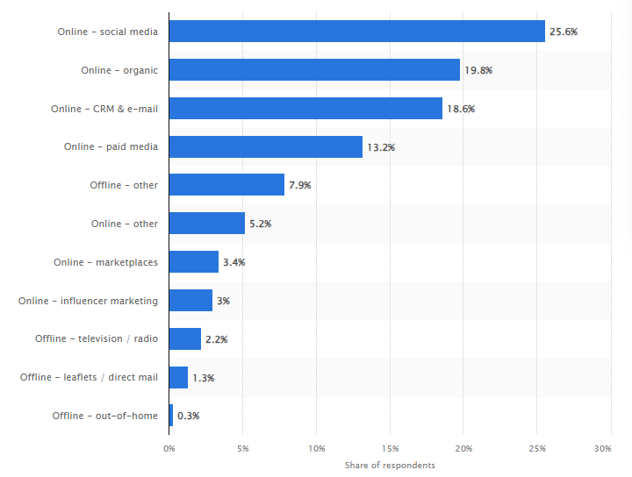

Figure 1.1: Different mediums of a marketing
(Source: Statista.com, 2024)
It has been noticed from the above graph that social media marketing has ranked on the top in surveying the most successful marketing channels in 2020 revealing that 25.6% industry professionals have relied on social media marketing (Statista.com, 2024). The global context has set statistics to be 44% for digital marketing which are majorly used by the professionals across the countries such as Australia, United Kingdom, United States, Japan, Germany and France. Apart from that, it has been noticed from a survey conducted that 19.35% marketers are planning to increase their investment on social media marketing (Statista.com, 2024). The luxury garment brands are majorly focused and relied on social media marketing. The luxury retail brands like Gucci have over 78 million followers on Instagram, Facebook, Twitter and Youtube (Statista.com, 2024).
On the other hand, CAD or Computer Aided Design refers to the use of computer-based programs and software for aiding in design procedures. CAD designs are mostly used by different types of designers and engineers (Cardosoet al. 2020). The context of social media marketing always depends on developing several posts and visual contents to attract the customers and potential audiences. CAD majorly helps in precise technical drawings while requiring a different combination of tools and mathematical calculation for getting started. The incorporation of CAD in social media marketing has the possibilities of improving the social media posts and visual imagery used in digital marketing (Lolaicoet al. 2023). This can make the outcome more precise and professional. Hence, in this context, it is highly required to note the impact of CAD incorporation in social media marketing in the garment or apparel sector.

1.3 Research Rationale
The revenue in the design and construction software market has been projected to reach 0.44 bn GBP in the year 2024. This particular revenue is expected to catch the growth of (CAGR 2024-2028) 2.99% by the year 2028 (statista.com, 2024). Hence, it is evident that the use of CAD is growing with time since many of the organisations are making use of the software to develop certain professional designs. The major benefits of the CAD are that it saves time, is easy to edit, decreases design effort, easy in sharing, improves accuracy, decreases error percentage along with having the scope of code reusing. Hence, CAD in designing the garments along with the social media posts can be highly impactful in the context of making the outcome more effective, influencing and professional (Cardosoet al. 2020). There are different positive attributes of social media marketing in today’s world that range from improving brand awareness, brand loyalty, the conversion rate along with audience engagement while on the other hand enhancing customer loyalty, brand visibility, boosting sales, monitoring analytics and promoting customer service. H4ence, both CAD and social media marketing have different advantages contributing individually to all its users.
However, in case of get them merged can develop a better system through which business industry can be improved in many ways within marketing aspect. In This is the foremost issue the research is focusing on. In this context, since the use of CAD is increasing day by day, it is high time to investigate and understand how this can have a positive impact on the social media marketing of the garment industry (Tuten, 2023). This is majorly important to know how the use of CAD can further benefit the social media marketing of the garments industry in the UK. Hence, in this context, this particular research is going to investigate the impact of Computer Aided Designs on the social media marketing of the garments industry. The garments companies generally use social media platforms to share posts, visuals aids or conduct any kind of campaigns. The development of such creative posts goes through a prolonged procedure of using a software that ensures an error free and more engaging content attracting the potential customers (Liet al. 2021). Hence, the incorporation of the CAD can make the process a lot easier while ensuring a fair better outcome than ever. In this context, the research is going to investigate exactly in which ways, the alignment or incorporation of CAD in social media marketing can help the brands dealing in apparel and garment sector to improve the organisational growth through a robust digital marketing system (Lolaicoet al. 2023).

1.4 Research significance
The significance of the research lies in the fact that it is going to work on two most important technology areas used by the business organisations which include digital marketing and CAD or computer aided design. With the development of the research, the focused garments or apparel industry players will be highly benefited who have started their digital marketing journey. It can help the targeted industry players in terms of knowing the ways and procedure of incorporating the CAD in the digital marketing scenario and how that can benefit the companies with social media marketing. The research has been proven highly beneficial in terms of providing a brief and in-depth overview of CAD along with how this can impact the growth of garment companies through getting aligned with social media marketing strategies. This can further help the organisations to improve their performance and marketing productivity through developing more attractive visual images and social media posts that can provide realistic effects towards the customers.

1.5 Research Gap
This research is going to understand the impact of incorporating and merging the use of CAD with social media marketing strategies of garment companies. There is a range of major research focused on social media marketing along with computer aided designs individually. However, there is not specific research done on the particular area of how CAD can help in improving social media marketing for the garments industry in the UK. Neither, there is any instance of how this CAD can be merged with the social media marketing portfolio for the organisation. Hence, in this context, this gap has been addressed based on which the research is going to be developed further.

1.6 Research Aim and Objectives

1.6.1 Research Aim
This investigation aims to decipher the impact of CAD Software in modern social media digital marketing.

1.6.2 Research Objectives
- To determine how CAD Software affects the efficacy of social media marketing
- To determine how CAD Software encourages participation, loyalty, and trust
- To determine methods for incorporating real-world user experiences with online advertising
- To determine how CAD Software is being used in trends to improve brand presence on social media.

1.7 Research Questions
- In what ways does CAD Software affect social media digital marketing campaigns' efficacy?
- What processes underpin CAD Software’s role in building customer trust, loyalty, and engagement in interactions between brands and consumers?
- What tactics can companies use to strategically incorporate real user voices and experiences into digital marketing initiatives to maximize CAD Software?
- Which new developments and industry standards best describe the use of CAD Software to increase brand awareness and resonance on social media platforms?

1.8 Chapter overview
This chapter has set the background about establishing the relationship between CAD and social media marketing along with identifying the primary aim to figure out the impact of CAD in social media marketing of the garments industry in the UK. This chapter has developed the rationale. It has identified that there is no specific research done on the particular topic of CAD getting merged into social media marketing campaigns. Hence, identifying this gap in the market, this chapter has set the stage for the research to get developed.

1.9 Summary
This particular chapter has set the background of the entire research in terms of exploring a range of information about CAD and social media marketing along with how these can impact the garment industry. Apart from that, this research has developed a series of research questions, research objectives and aim based on which the research is getting developed. The rationale of the research is developed in terms of finding out the basic requirement of the research. Alongside, this chapter has provided a range of data and information that has helped in setting the base of the entire research further.

CHAPTER 2: LITERATURE REVIEW

2.1 Chapter introduction
This chapter contains the literature review section, and it deals with reviewing all the existing literature related to both the variables of the study. Literature review refers to the careful exploration of a range of related literary resources which are relevant to a certain topic. Apart from that, with the help of theoretical backgrounds, this chapter has developed a conceptual framework along with finding out the literature gap based on what the entire research has been built up.

2.2 The concept of CAD
CAD or computer aided design is a specific way for digitally creating 2D drawings along with 3D models of the real-life products before they are actually manufactured or produced. With the help of 3D CAD, one can share, simulate, modify or review any design within a fraction of seconds, opening doors for differentiated and innovative product lines getting to the market fast. On the other hand, in different words, it can be said that computer aided design or CAD refers to the typical process of digitally developing simulations of real-world goods and products to be completed with precision, scale along with physical properties for optimising and perfecting the design (Cardoso et al. 2020). It is generally developed in a collaborative approach before getting finally manufactured. CAD is the use of computer-based software within designing processes. This software is often used by different types of designers and engineers helping them to create either 2 dimensional or 3 dimensional models. The primary purpose of the CAD has been to streamline and optimise the workflow of the designers while increasing the productivity along with improving quality as well as the parameters of design. Further it ensures improving communication and documentation while often contributing towards a manufacturing design database. The output of the CAD software often comes in the form of electronic files that are often used as per the manufacturing processes (Nazir et al. 2021).
CAD has been often used in tandem with the digitalised manufacturing processes. It is the software developed for being used in designing products such as clothing, circuit boards and some other devices in the computer. The CAD is generally used in a wide range of professions. For example, it is heavily used within arts, architecture along with engineering projects. CAD can be employed in designing the tunnels, bridges, automotive parts, aerospace designing along with space vehicles designing. The use cases of the software have been majorly specific to the industry and the job functions. The CAD software has been used by architects, city planners, engineers, graphic designers, animation illustrators, interior designers, exterior designers, product designers, game designers and manufacturers. It allows its users to manipulate designs in three dimensions while analysing them from different angles and identifying errors or interferences. Like its name has implied, CAD majorly involves the use of computers for the development, modification and optimisation of several designs (Hu et al. 2022). This particular method has replaced the manual designs used in the drafting process in the traditional way. Nowadays, the manufacturers tend to utilise computer aided design for creating more detailed, efficient and accurate representations of the products. Eventually this has led the entire process to enhance the quality of manufacturing goods while streamlining the planning process.
Manufacturing has been a highly essential component of different industries including the fashion, attire and garments industry. Hence, as a result, CAD has majorly played a highly significant role in advancing and improving each of the sectors. The computer aided design is a more advanced and high-tech software application which is needed for the people to avail highly aspiring manufacturing professionals (Oyindoubra, 2022). No matter which sector, computer aided design tends to offer everything to be innovative and exciting which is far different from usual expectation of a manufacturing job role. It helps the designers along with drafters to develop a range of goods or products such as washing machines, complexes, apartments or airplanes.

2.3 The concept of digital marketing
Digital marketing is the use of different digital channels for marketing the products. Commonly called as online marketing, it promotes different brands while connecting them with potential customers through the medium of internet. Digital marketing may take different forms including websites, search engines along with social media platforms (Saura, 2021). Apart from that it can include marketing through email, mobile applications, web-based advertising and text messaging.
Digital marketing tends to use the similar principles as traditional or offline marketing but in the digital platforms. The major difference that it has is its reliance on consumer data for finding the target audience of a business while delivering the most relevant messaging possible. Though digital marketing has been highly effective and popular nowadays, using it can be one of the biggest challenges to learn how to stand out from the crowd (Saura et al. 2021). The dedicated digital marketing strategy entirely depends on the business model. Business to business companies which deal with other businesses need a more strategic approach which is larger than the usual one. On the contrary, business to consumer companies tend to sell directly to the end customers that require the shorter sale cycles while having the access to larger audience. There are different types of digital marketing ways available in the market. However, amongst them four are predominant in the field which include content marketing, social media marketing, search engine marketing and search engine optimization.
Content marketing has been the art of utilising a short storyline containing a set of valuable information translating to brand building along with awareness within the target audience. The effect of “content marketing” is long term along with making the audience primed with data and information for taking a profitable action (Kingsnorth, 2022). The most impactful way of developing an effective content has been to build proper relationship with the target market rather than only posting. As a partner rather than an advertiser, its general goal is to establish trusting connections with potential clients. This explains that, by emphasising value provision to the target audience, content marketing is primarily appropriate for inbound marketing tactics.
On the other hand SEO or “search engine optimization” is the unique procedure of use organic strategy for ranking on the search engines. It has been a quite normal way of developing traffic to the company site from the result page of “search engine”. It does not just drive the traffic to the page but also plays a significant role in converting this traffic into appropriate and quality leads. SEO has been categorised under three major divisions including ‘on page SEO’, ‘off page SEO’ and ‘technical SEO’. On page SEO refers to the process of optimising a web page to target a particular search query while ranking high on the search engines (Veleva and Tsvetanova, 2020). This can be achieved through conducting various activities such keywords search, keywords optimisation along with content creation. Off page SEO has often be carried out for building the reputation of a web page through linking it with the greater quality websites. Through making the use of this, one can make the search engines in trusting the content of the website. It can further increase the reliability and popularity of the website on the search engines. The specific procedure of generating back links through connecting the webpage content with the other quality websites is generally called “link building”. “Technical SEO” is often carried out for providing a greater experience for the users. This is determined generally through focusing on the site speed, crawlability, indexation, user friendliness and structure of the site. It has been an assumption that SEO has become highly challenging in the market space of b2b model. However, in reality more that 70% of the b2b purchase decisions tend to begin the buying procedure with a general search. In this context, the SEO strategy should always be directedtowardsdeveloping quality content while generating improved back links for reaching a wider audience. Though this has been highly challenging with each passing day, it has been still one of the best modes for the b2b (Krishenet al. 221).
Search engine marketing has been a paid way of gaining attention for the brand through appearing high on the search engine results. This is also called paid search or the “pay per click” marketing. It can involve several activities which include setting a budget, setting up ads, optimising ads along with placement of ads. It can be the most effective marketing strategy and impactful immediately after the launch of the campaign. Lastly, social media marketing has been the procedure of achieving the traffic from social media platforms through posting relevant content related to the target audience. Some of the most popular and accepted social media sites include“Instagram, Facebook, LinkedIn, Twitter and YouTube”. Each social media platform has its own set of regulations, services and products and hence needs a unique approach or strategy. Hence, the approach or strategy might differ from platform to platform (Peter and Dalla Vecchia, 2021). There are platforms where only the video contents work. Hence, the users should be knowledgeable enough to target the audience along with strategising appropriately.The success of social media marketing has been attributed to its rise, which serves as evidence that B2B companies have switched from traditional to social media marketing techniques for their marketing campaigns.

2.4 The benefits and disadvantages of CAD
The random increase in the use of software like CAD has ensured that the software has a range of benefits that have made the companies using it highly benefited in many ways. The primary benefits of using CAD are as follows
Higher quality design
In ancient times, when a design did not function as expected, the responsible individuals had to go back and start the drawing from scratch.Nonetheless, in the present era, the design teams may now regulate the final product's quality thanks to the usage of CAD. It has been very easy to investigate the drawback and error while diagnosing the problem to finally solve the problem with the software prototype. Apart from that, it has not only saved time but also saved money. This has enabled the design to be right at the first attempt rather than having to modify it multiple times (Oyindoubra, 2022).
Increased productivity
CAD software and its usage have made the production cost half while accelerating the pace of the work much ahead of its time. This has ultimately made it possible to make the project complete faster than expected. Since the designers can work more effectively and efficiently, companies are able to keep the team small with efficient workers (Cardoso et al. 2020). This can further allow the organisations to produce high quality products which are manufactured in a cost effective way. This has been a major benefit for the company to compete in the global market.
Editable designing option
Fashion and garments design has been such an industry that tends to use CAD very often. It has allowed the designers in creating clothing design while seeing how they can fit on the virtual models without spending much on the manufacturing (Hu et al. 2022). In case they need to make any modifications in the design, they can easily make it with the help of CAD. Once they have finalized their design, it can be used multiple times to produce different versions of the same design without wasting the effort to draw it multiple times.
Easy to read
One of the major issues that the designers tend to face has been to communicate their ideas and vision through the medium of drawings. Paper and pencil drawings are more or less very untidy. In such cases, team members working in the fashion designing and engineering department face a hard time to understand them without an industrial designed background (Nazir et al. 2021). However, the application of CAD drawing has made it very easy to read since the drawings made through this software are organised and standardised. This software tends to produce models which can be used by other departments as well including sales and marketing. It can be an interesting way of demonstrating the work to the investors.
Design documentation and simplified sharing
Sharing design has been one of the most valuable and significant aspects of drawing. CAD software has made it very easy to collaborate with each other while sharing the designs and drawings with each other. One individual can work on the design while sending it to another where they can check the design history along with understanding the further requirements of the design. For remote teams even, CAD has made the collaboration easy. Not only sharing, documentation has been one of the most important and crucial factors of a design. The measurements in terms of dimensions, angles and size of the product design should always be recorded conveniently for the future use. CAD has perfectly made it possible for the designers to keep the track on documentation of the design (Olson et al. 2021). CAD software does not only have a range of benefits but also has few disadvantages as well. The challenges or the limitations of the software have been mentioned below:
Complex system and learning curve
One of the primary challenges of the CAD software has been its system complexity along with the steel learning curve. Having a good amount of knowledge along with mastering the software can be highly time consuming and demanding especially for the beginners. It needs rigorous training and educational resources to make it functional (Oyindoubra, 2022).
Licensing cost
CAD software is always accompanied by a heavy amount of licensing fees making it a highly considerable investment for smaller and individual businesses. Not only the cost of licensing fees but also the cost of software update should be considered. The maintenance cost rises over a certain period of time. In this particular context, for many of the organisations it can be highly difficult to avail the CAD tools for designing and manufacturing (Olson et al. 2021).
Requirements of hardware
CAD applications have been highly resource intensive in nature that demands high performance hardware to run perfectly. This can be considered as a potential challenge for those with limited resources and budgets.
Human touch and creativity
For the purpose of accurate and precise design, CAD has been an excellent tool. However they can severely lack in the sphere of artistic manifestation and organic creativity which generally comes from traditional design had drawn in hand (Hu et al. 2022). The prospects of human creativity and innovative flair are compromised heavily when the designers solely rely on CAD. In this context, it can be said that the CAD can lead to monotonous and standardised design.
Real world constraints
CAD has enabled intricate design, however it cannot always account for real life design flaws. The over reliance on the virtual simulations can inadvertently reject or avoid the practical considerations while leading to costly revisions that can be a potential challenge for the software users (Olson et al. 2021).

2.5 The benefitsand drawbacksof digital media and digital marketing
Digital marketing has become the leading marketing strategy in the 21st century. In this context, failing to understand the positive attributes of digital marketing can negatively impact businesses. The leading advantages of the digital marketing have been discussed below
Cost efficiency
Marketers are appreciated and rewarded when they appear good on spending their budgets wisely. However, investing in digital marketing can easily make the marketers succeed since it asks for a modest budget. For example, social media marketing costs lower than the traditional print media marketing while providing even the chance of tracking the exact numbers of sales generated through this. Digital marketing strategies tend to have a low start-up cost while some of them can be accessed freely at the initial stage (Veleva and Tsvetanova, 2020).
Global reach
Digital media along with social media has been the production of globalisation. Traditional marketing strategies such as television ads, billboards are constrained by geography. However, the application of digital marketing solutions has enabled the businesses to have an access to the global market and global audiences going beyond time zones and locations. Instead of having a limitation of the reach to the targeted community or people, one can potentially target the customers in the state, country or even globally with the help of digital marketing strategies (Krishenet al. 2021). Digital media tactics such as content marketing, email marketing, social media marketing can make it highly easy for the businesses to reach the customers across the world. It has led the businesses to scale up the efforts for building the brand and increasing the sales with the help of a larger pool of customers.
Effective targeting
Traditional marketing has never been able to track who is seeing the advertisements. It has been next to impossible to know whether the advertisements are hitting the right set of customers or not. However, in contrast to that, digital marketing always allows one to pinpoint the best set of audience and targeting information. It can allow one to collect necessary data regarding the potential customers of the products (Peter and Dalla Vecchia, 2021).
Increased customer engagement
The digital marketing strategies are highly able to increase the customer engagement since unlike traditional marketing it allows two-way interactions with the customers instead of one-way interaction opportunity (Krishenet al. 2021). The option to connect with the customers in real time has been one of the most unique features of the digital marketing strategies. This can make the customers highly engaged with the brands than ever before.
Flexibility
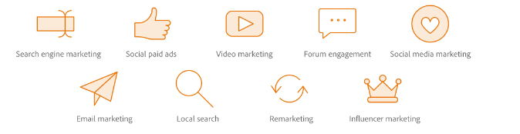

Figure 2.1: flexibility of digital marketing
(Source: Kingsnorth, 2022)
Digital Marketing often gives one the flexibility to make the choices from different channels and strategies. Alongside, it provides with the opportunities and flexibility to get the approach adjusted with one’s strategy and convenience (Kingsnorth, 2022).
Measurable results
With being much more affordable, digital marketing has more trackable marketing opportunities that the business can implement. Traditional marketing approaches such as print media advertisement, TV and radio advertisements can be considerably effective but it can be highly challenging to track the responses against those. On the other hand, digital marketing strategies implemented, the businesses can track the responses in every touch point that the potential customers have with the brand. It has provided the option of tracking each and every parameter of an advertisement such as page views, clicks, organic page views, social media views and conversion rate (Veleva and Tsvetanova, 2020).
However, there are certain disadvantages of implementing digital marketing as well. These are mentioned below:
Crowded market place
One of the most potent disadvantages of digital marketing has been the crowded market place since businesses irrespective of any size are vying for attention through digital platforms. This can pose high threats and challenges especially for the small and medium sized businesses making it intensely difficult for the organisations to stand out amongst the large pool of organisations.
Highly competitive market
Since more and more businesses are turning into having online presence along with having the option of digital marketing tools and strategy, the market has filled up with intense and increased competition (Saura, 2021). This can potentially lead the organizations to have major difficulties in converting the leads to the final sales. In order to become successful in this situation, the organisations should become more innovative in devising strategies that can attract the customers while turning them into sales figure.
Rapid changes
The market is changing rapidly. This nature of ever-changing market can be highly challenging to the organisations in case anyone of them is failing to address the demands of the customers. In this context, a continuous up gradation is highly required for the organisation which can make them work on the potential use of the digital marketing strategies. Being proactive and staying updated is highly necessary to get survived in the market (Veleva and Tsvetanova, 2020).
Over reliance on technology
Using digital media always directs to rely on the cutting-edge gadgets, internet technology and equipment. Without these devices, marketing through digital media has never been possible. There are several examples when the links don’t work along with landing on pages that do not load after repetitive tries (Saura, 2021).. Hence, technology-based marketing has only been possible with the availability of the technology. In this context, any technical glitch might impact on the consumers’ decision making and perception about the organisation.
Security and privacy concerns
Security and privacy concerns have been one of the most significant drawbacks of implementing the digital marketing strategies in the garments industry. It has plenty of examples of privacy issues and security breaches (Saura, 2021). This can be potential customers concerns since many a times; the personal data collected from customers has been exposed. Hence, the organisations making use of digital marketing tools should be highly attentive in using it.

2.6 The impact of CAD on social media marketing campaign
The use of CAD has been quite regularised in the field of engineering and designing. However, this can be equally impactful in the social media marketing campaigns as well of the companies.
Increased customer engagement
The application and implementation of CAD software within the social media marketing can be majorly lucrative for the customers targeted. Undoubtedly, the incorporation of the CAD software can enable the marketing designers to go pro in developing the designs that will be detailed, professional along with visually appealing to the customers. Without any second thought, customers are bound to feel attracted towards the marketing campaigns which can further ensure higher level of customer engagement and customer responses than ever (Cartwright and Raddats, 2021).
Generating authentic connections
The perfect integration of the CAD into social media marketing campaign can foster the authentic connections between the customers and the brands. Since CAD generates authentic expressions and experience in the customers, it should definitely develop the bond stronger than ever. The development of these emotional ties between customers is brands are not at all possible in the traditional marketing approaches. Since the users are more and precisely inclined with the systems that recognise them, CAD supported social media marketing can be highly effective in strengthening the brand loyalty of the organisations (Itaniet al. 2020).
Enhanced appeal
Along with being able to generate more and more responses, the digital marketing strategies aided with CAD have the ability to make the posts even more appealing to the customers which can further increases the chance of getting the percentage of conversion higher than ever. In this context, it can be noticed that, the incorporation of CAD into social media marketing campaigns has the possibility to increase the overall growth of the company (Cardoso et al. 2020). Hence, it can be said that the implementation of CAD can bring positive aspects in the social media marketing campaigns.

2.7 Theories and models
Social selling along with interaction theory

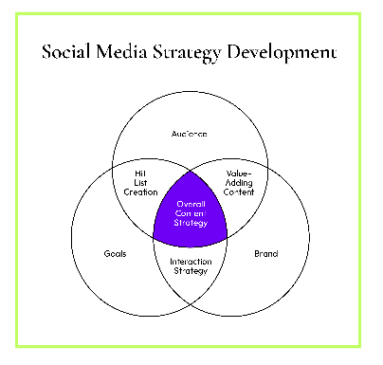

Figure 2.2: Theory of social selling and interaction
(Source: Cartwright et al. 2021)
Social media has become one of the most effective marketing channels because of its unique features. These unique features include transparency, two ways of interaction possibility along with prompt and immediate resolutions of the raised issue (Cartwright et al. 2021). Rather than having broadcasted corporate message, with the help of the unique features of social media marketing strategies brand can easily avail the opportunity to engage the customers individually as well as can generate more effective set of leads. Using the social listening strategy this can help one to locate the potential customers in online platforms. Apart from the concept of listening, social media platforms such as “Facebook, X (Twitter) and Instagram” provide people with the opportunities to sell quickly the products to the customers more quickly (Itaniet al. 2020). Moreover, social platforms such as LinkedIn provide the option of powerful lead generation for the B2B businesses. This has been very much useful in making sales through social media platforms.
“Technology acceptance model”
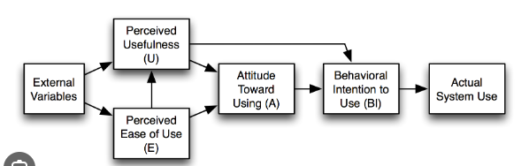

Figure 2.3 Technology Acceptance Model
(Source: Rafique et al. 2020)
“The technology acceptance model” has been an information system theory which has drafted how the users have come to the stage of using a technology. This particular model has suggested that when the users are presented with a new technology initiative there are different numbers of factors that generally influence their decisions regarding when and how the technology should be used. “Perceived usefulness” refers to the extent to which an individual agrees that the use of new technology can enhance their technology use experience in many folds (Sagnieret al. 2020). There is the “perceived ease of use” has been referred to the exact extent to which an individual believes that the particular system or technology will be free from the providing effort. In case the technology has been easy to use, the barriers are conquered. However, in case the interface has been highly complicated, no one will be having a positive attitude towards the technology. Hence, the technology will not be accepted. The exact opposite situation leads towards the acceptance of the technology.

2.8 Gap in the Literature
This chapter has underscored all the possible literary sources that are related to digital media and its impact on today's business world. Apart from that another range of literary sources has been also explored in terms of understanding the basic concept of computer aided design, its impact and the benefits it serves. However, there is no close match in papers that have already worked on the impact of CAD on digital marketing campaigns and approaches. In this context the current chapter has established a research gap which has paved the way for the further development of the entire research study to figure out the specific impacts that the use of CAD can make on the part of digital marketing campaigns in the sphere of UK garments industry.

2.9 Theoretical framework
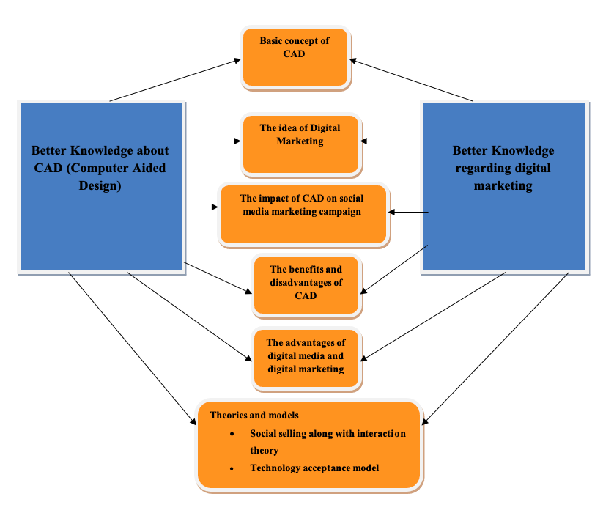

Figure 2.4: Conceptual Framework
(Source: Cartwright et al. 2021)

2.10 Chapter Summary
In a nutshell, this chapter has discussed a huge range of literature resources which are in any way related to either digital marketing or computer aided design. Apart from that, this particular chapter has documented the necessary information from the previously published research articles in a contrasting manner to understand different views of the authors on the same topic. It has not only outlined the views of the authors in a contrasting order but also has tried to address the literature gap which has not been considered or covered by the previous research. Based on the specific and identified gap, this entire study is going to get developed further.

CHAPTER 3: METHODOLOGY

3.1 Chapter introduction
Methodology is one of the most integral parts of developing the blueprint of a research study. This chapter has developed the methodological approach of the current research for identifying and deciding the methods and techniques. It has not only identified the research technique but also has delved deep into understanding the reasons why the chosen techniques are best for the research. It has provided an in-depth justification against each of the methods chosen for this research paper. It has provided a brief overview of how the data has been collected along with in which way they have been analysed in order to fetch the accurate results.

3.2 Research philosophy
Research philosophy has been closely associated with the knowledge, the nature of the study along with assumptions. It generally deals with a specific way of generating and creating knowledge. A research philosophy refers to a belief about the specific way in which the data regarding a phenomenon should be analysed, gathered as used. This particular research has followed interpretivism research philosophy. In this context, the adoption of interpretivism as the research philosophy has signified a commitment to understand the subjective meanings along with evaluations that different individuals assign to the events (Dubey and Kothari, 2022).. Interpretivism has allowed the researcher to conduct a more concrete and thorough investigation of how the people have perceived and engaged with CAD (Computer Aided Design) while analysing in which ways this can impact the efforts of social media and digital marketing. Through accepting the range of contexts and perspectives within which the CAD is present, this strategy has advanced the knowledge of the cultural and social componentsimpacting the dimensions of the digital marketing. The perfect application of interpretivism research philosophy has been beneficial for the study since it has produced high quality data since it majorly focuses on the part of personal motivations and meanings. It helps any complex and cross-cultural studies to be conducted in a lot of detail (Pandey and Pandey, 2021).

3.3 Research design
Research design is an integral part of deciding the methodology of a research. It has been noticed that research design tends to determine the nature of the study in terms of considering it to be either qualitative or quantitative (Mishra and Alok, 2022). Qualitative research generally focuses on gaining insight while understanding the perceptions of circumstances and events of an individual. This particular research study has followed a “qualitative research design”. The perfect application of qualitative research method has allowed the researcher for an in depth questioning of the chosen respondents who h is based on their responses. The implementation of the research design has enabled the researcher to understand the feelings and motivation if the respondents. Further, this can help in understanding how the audience can make decisions while identifying how they can help in deriving conclusions (Dubey and Kothari, 2022).. Apart from that, qualitative design has been highly beneficial for the study since it has the ability to generate results in a descriptive manner which is easy to understand for everyone. Further, it has helped the study to uncover the societal trend, beliefs, attitudes, motivations and opinions while revealing the root cause of problems and generating latest hypotheses for the further testing.

3.4 Research approach
The method of selecting, gathering, evaluating, and interpreting the data is called a research approach. Inductive research and deductive research are two distinct categories of research methodologies(Zawacki-Richter et al. 2022). They are two different types of research involving different goals, starting point, methods and particular ways of looking at the data. Inductive research tends to use specific patterns and observations to bring in new theories whereas deductive research approaches start with a new hypothesis or theory while testing it through observations. This specific research study has followed a deductive research approach for the study to get developed. It has helped the study to start with a theory and hypothesis, while generalising and testing it through observations and as well as data collection (Dubey and Kothari, 2022).
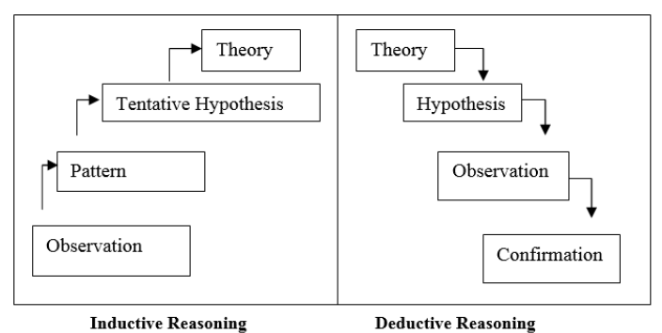

Figure 3.1: Inductive and Deductive Research
(Source: Dubey and Kothari, 2022)
The chosen approach employs a top-down method, where the researcher initiates the investigation with a broad concept or idea, subsequently validating it through specific observations. This method is particularly useful for confirming established theories or testing well-known hypotheses. The meticulous application of this research approach empowers the study to either substantiate or challenge existing theories concerning Computer-Aided Design (CAD) and its effectiveness in the realm of digital or social media marketing within the UK garments industry. By starting with overarching concepts and then scrutinizing them through focused observations, the research method enhances its capacity to either affirm or disprove prevailing theories, contributing to a more nuanced understanding of CAD's role in the dynamic landscape of digital marketing for the UK garment sector.

3.5 Data collection method
In a research work, the way data is collected and analysed is crucial for obtaining authentic results. The majority of the research outcome and its credibility depend on this aspect of the study. There are two different types of data collection methods which include primary data collection method and secondary data collection method. The former one involves choosing participants and engaging them either in a survey or an interview session to gather the real-life experience. The obtained data is then further analysed to reach the result. This can be either qualitative or quantitative in nature. Survey can lead to quantitative data whereas an interview is all about qualitative data (Ocaña-Fernández and Fuster-Guillén, 2021).
On the other hand, collecting secondary data involves obtaining the data to be collected from the previously published research articles and research reports or online articles. In this particular context, this study has chosen a primary qualitative data collection method through the conduction of a semi structured interview. It has chosen the participants carefully whose responses can cater a positive outlook to the study and add values to the entire research. Hence, in this context, the research has conducted a semi structured interview with the digital marketing executives who use CAD in their campaign designing (Mishra and Alok, 2022). A set of interview questions has been developed to gather the response from them. The interview has been conducted over telephonic conversation and the responses are recorded. This can further help the data to be preserved and analysed later when required.(Refer to appendix)

3.6 Data analysis method
Data analysis method is the second most important aspect research relies on. This is just because unless and until the gathered data is properly analysed, the research cannot get to its desired level of conduction. Data analysis in this context has been a procedure of obtaining raw data while subsequently converting it into the data and information useful for the decision-making purpose (Pandey and Pandey, 2021). Data tends to be collected, analysed and segregated for answering research questions and testing hypotheses or disprove theories. This particular research has analysed the data through NVivo software which has been a qualitative data analysis computer software majorly used for managing, analysing along with visualising qualitative data individually and in a systematic manner (Kothari, 2004). The semi structured interview has different advantages that include the ability to gather detailed, rich and real-life data while establishing a rapport and trust with the participants. This can help the research to study any sensitive topic based on the latest data collected from the relevant people who can hugely add values to the research. It has the ability to conduct detailed assessment of the responses gathered on a certain topic. A semi structured interview can help in providing the scope for modifying the questions as well as per the answers given by the respondents. Hence, this can be highly helpful for the research.

3.7 Sample size and sampling technique
The researcher has conducted a semi structured interview with five different individuals who are currently working in the marketing department of some reputed fashion brands within the UK. The sample size has been defined as the number of the observation which is used for determining the estimation of the chosen population (Ellis and Levy, 2009). The size of the sample is majorly drawn from the population. It is the basic process of selecting the subset of individuals from the population for estimating the characteristics of the entire population. This research has chosen the purposive sampling technique to select the samples. Purposive sampling in this context refers to the set of non-probability sampling methods within which the respondents are selected because they have the characteristics that are required in research. Hence, in this context and the same manner, this research has followed purposive sampling technique since the respondents should have specific characteristics of working in marketing department while having the experience of designing marketing documents (Thomson and Gunter, 2007). The major benefit of selecting purposive sampling has been that it has enabled the researcher to make choice of the participants based on the particular need and criteria that are related to the research. It can allow the researcher for more productive and profound investigation.

3.8 Ethical considerations
Research ethics refers to the concept of how the righteousness of a research is established, maintained or followed. This particular research has appropriately followed the ethical approaches in order to maintain the research ethics. No act of enforcement has been executed in order to collect the data. No act of data manipulation is considered. The collected personal data has been protected through following all the rules and regulations come under the Data Protection Act 1998. The data and responses are securely kept in digital devices having only the access to the researcher. This research has not considered any child or vulnerable group of people to get involved in the research procedure. No monetary transactions have been made for collecting the data. Neither any act of plagiarism has been executed in writing up the thesis.

3.9 Reliability and Validity
Reliability and validity are two parameters and they tell how well a particular method can measure something, and how suitable it is in measuring that. Reliability generally refers to the consistency of a measure in terms of whether the results can be reproduced within the same conditions. On the other hand, validity refers to the accuracy of the measures in terms of understanding whether the results really represent the aspects that they are supposed to measure. In this particular context of the current research study, the research has carefully assessed the trustworthiness of the data sources for granting the validity and reliability of the methods to analyse the data. In order to determine the correctness of the data, the research has already gone through the process of cross verification to check whether the information is drawn from reliable sources or not. This particular technique has ensured a strong basis for the data analysing method while strengthening the dependability of the analytical tool chosen along with validating the findings which are derived from the primary data on the impact of CAD or computer aided design on the digital marketing campaigns. Hence it can be said that, the research has practically followed all the measures to make the study result accurate, reliable and validated.

3.10 Chapter Summary
In summary, this chapter extensively delves into outlining the methodological approaches and techniques employed in the research study. A detailed justification is presented for each chosen methodological technique. The research has opted for a primary qualitative data collection method, complemented by analysis using NVivo. This combination is selected for its effectiveness in extracting genuine results from the collected data while organizing it in a manner that enhances the overall research value. Furthermore, the chapter offers a necessary overview of the ethical considerations observed throughout the research process. It identifies the specific rules and regulations adhered to in order to uphold the authenticity of the research. The strategic selection of qualitative data collection, coupled with advanced analysis tools, underscores the commitment to generating valuable and reliable insights for the research objectives. The emphasis on ethical practices ensures the integrity and credibility of the research findings, contributing to the overall robustness of the study.

CHAPTER 4: DATA ANALYSIS AND DISCUSSION

4.1 Introduction
The most important and valuable chapter of this research study is data analysis and discussion. Representing numerical and non-numerical data helps to develop a deep understanding of the research topic. This chapter will analyse the qualitative and quantitative data to detect the effectiveness of CAD software in modern social media marketing of garment brands. This chapter will analyse qualitative and quantitative data based on interviews and surveys. Executing this chapter is beneficial to conclude this research study. The researcher will summarize the qualitative and quantitative data on the research topic to meet the research aim of this study. This chapter will execute a data analysis plan, quantitative data analysis, qualitative data analysis and discussion to reach a conclusive position.

4.2 Data analysis plan
The Data analysis plan is a systematic way to analyse qualitative and quantitative data on the research topic. It is identified as the roadmap to organise and analyse surveyed and interviewed data. The data analysis chapter helps to reach the research goals. The data analysis chapter starts by questioning the respondents directly to the primary research question. The researcher will detect the respondent’s satisfaction level throughout the interview and survey method. It will help to continue the data analysis chapter (Syazaliet al. 2019). Organising questions helps to gain an understanding of the research topic. Organising research questions based on survey questions and interview questions is beneficial to detect the effectiveness of the CAD software in improving the quality of the digital marketing of the garments company.
Identifying a reliable source of information is essential for maintaining the quality of the research paper. Moreover, a better understanding of the research goals helps to enhance the quality of the research paper. The researcher is responsible for regular monitoring to maintain consistency in data analysis. Moreover, improving progress monitoring and team effectiveness helps to identify the trends of digital marketing on social media (Kawira et al. 2019). This chapter helps to analyse qualitative and quantitative data for a better understanding of the impact of CAD software in digital marketing on social media. The complex statistical data will be analysed through “Statistical Package for Social Sciences (SPSS)” software. This software will represent descriptive statistics, correlation, regression and reliability analysis of the research topic.
Creating Google Forms helps to collect qualitative and quantitative data through Interviews and surveys on the research topic. Visual representation of responses helps to detect the responsive value of the research topic. Analysis of qualitative data will help to accumulate deep theoretical learning on the research topic (Ratnasingamet al. 2021). The statistical analysis will help to detect the importance of CAD software for increasing customer engagement on social media. The creation of a data analysis plan helps to reduce the risk of bias for maintaining the quality of the research paper. Moreover, creating a systematic plan is significant for reducing the risk of drawbacks and limitations to meet research goals.

4.3 Quantitative data analysis

4.3.1 Descriptive data analysis
Descriptive
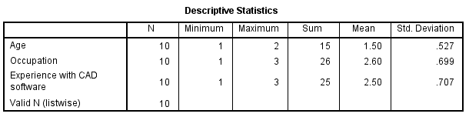

Figure 4.3.1.1: Descriptive statistics
The above figure represents the demographic profile and the respondents' sample size. Presenting Descriptive statistics computes the mean, Std. Deviation, minimum and maximum variables (Kawira et al. 2019). Descriptive statistics has focused on different variables, such as age, occupation and experience with CAD software. The above table shows that the N (Sample size) value is 10, which indicates that 10 participants were involved in the survey method. According to the descriptive test, the minimum value is 1 and the maximum value is 3, which represents the experience with CAD software. Std. The deviation value is .707, which is less than 1. According to this figure, it is revealed that among 10 respondents, 6 participants belonged to the intermediate and 3 participants were from the intermediate and 1 participant was from the advanced group. According to this figure, among 10 respondents, 5 respondents are from the 18-24 age groups of people and the rest of the 5 respondents are from the 25 to 34 age group. Another variable of this descriptive statistic is occupation. Among all respondents, six respondents were students, who are interested in the application of CAD software for enhancing the productivity and quality of the garment industry.

4.3.2 Inferential analysis
Correlation
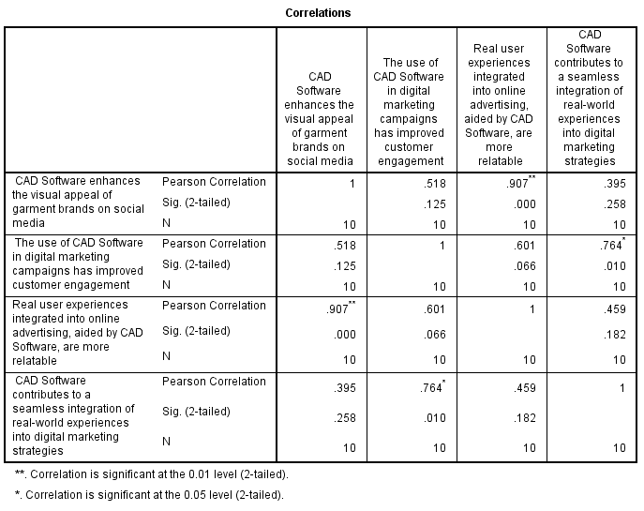

Figure 4.3.2.1: Correlation
The Pearson correlation statistical analysis is used to measure the strengths and limitations of individual variables. The correlation coefficient value provides information about the strength and nature of dependent and independent variables. The range of correlation is between -1.0 and 1.0 (Syazaliet al. 2019). The above figure displays the correlation between CAD software and the visual appearance of social media. The Correlation coefficient magnitude value lies between 0.9 and 1.0, which indicates the variables are “very highly correlated” (Purwanti, 2021). The values lie between 0.7 and 0.9, which indicates that variables are highly correlated. If the Correlation Magnitude value lies between 0.5 and 0.7, it indicates that the variables are moderately correlated and, whose value is magnitude between 0.3 and 0.5, which indicates the variables have low correlation (Ratnasingam, et al. 2021). According to this figure, CAD software and visual appearance value is 1, which indicates that these two variables are very highly correlated. Besides, Real users’ experiences are integrated into online advertising aided by CAD software, value is 0.9, which is also “very highly correlated”.
Besides this, the values between CAD software and digital marketing lie between 0.5, in this scenario, these two variables are moderately correlated. Moreover, the relationship between CAD software and seamless integration in digital marketing has a low correlation. Implication of the CAD software is beneficial for maintaining the designer's workflow in the garments industry. This technological innovation is essential for increasing the productivity of the garment industry. The application of CAD software is beneficial for improving the quality of garment products. This software allows the creation two dimensional (2D) and three-dimensional (3D) models increasing the level of products (Ratnasingam, et al. 2021). The implication of this software helps to promote security in managing automated databases in the garments industry. Implication of the digitalised manufacturing process promotes documentation communication promotes the acceptability of garments products.
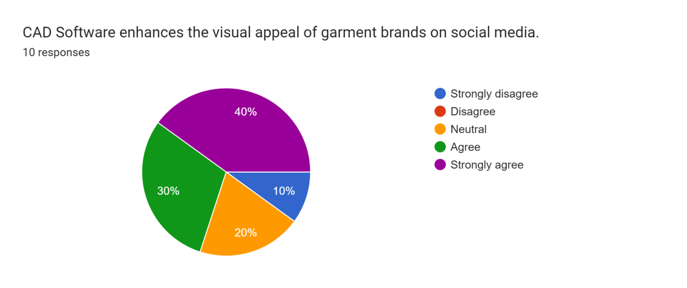

Figure 4.3.2.2: CAD software enhances visual representation
The above figure represents that CAD software enhances the visual appearances of garment brands on social media. Among 10 participants, 40% strongly believe that CAD software enhances visual appearances. 30% agreed with this statement. 20% of participants were neutral with this statement. However, 10% strongly disagreed with the statement as mentioned earlier. Hence proved, evaluation of the CAD software enhances the visual appearances of garment brands on social media. Using this software is beneficial for reshaping, dimension manipulation and design configurations of garments products on social media (Ratnasingam, et al. 2021). Integration of CAD into social media increases brand reputation in the garments company. The graphical representation of responses helps to identify the relation between visual representation and CAD software for increasing digital marketing on social media.
Regression
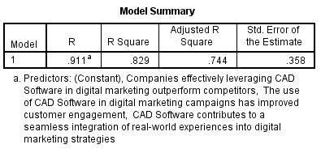

Figure 4.3.2.3: Model Summary
Regression is identified as the statistical tool for predicting the value of a continuous variable. The above figure displays the R-value, which indicates the value of variables. According to this figure, the R-value is .911ª . The R Square value is defined as the proportion of variances in DV, which is accounted for by the IV (Sawlani and Susilo, 2020). The RSquare value is .829. The “Adjusted R Square '' value is .744, which measures the model fit. This value determines the number of IVs in the model. This figure reveals the Std. deviation value is .358. This table reveals the relation between DV and IVs. Implication of the CAD software can create interactive and realistic virtual experiences to allow potential consumers to explore innovative products in the garments brand. Nowadays, the use of CAD software in digital marketing campaigns helps to promote customer engagement. Statistical analysis of the DV and IV helps to demonstrate the practical uses of CAD software in digital marketing.
Implication of the CAD software in the digital marketing campaign involves digital display advertising. Using audio, banners, images and banners in different social platforms helps to include different ads, such as social ads, Native ads, Responsive ads and Retargeting ads for promoting garments products in the company.

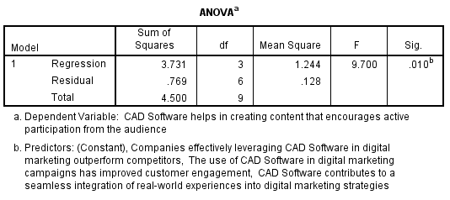

Figure 4.3.2.4: ANOVA
The above figure provides an F test to detect the relation between DV and IV. In this table, the F value is 9.7. There is a thumb rule regarding the F statistics, if the value is greater than 2.5, there is a positive relation between two individual variables (Dastane, 2020). According to this table, there is a positive relation between CAD software and active participation from audiences in creating content in digital marketing. This statistical analysis identifies the effectiveness of the CAD software for making significant effects on digital marketing. This software contributes to the seamless integration of the real-world experiences in the digital marketing strategies. The above-mentioned table helps to develop the relation between DV and IV. According to this table, using CAD software helps to conduct digital marketing campaigns to increase customer engagement in online marketing. This table highlights that the regression df value is 3, the residual value is 6 and the total value is 9, which indicates a positive relation between DV and IV of this research topic.
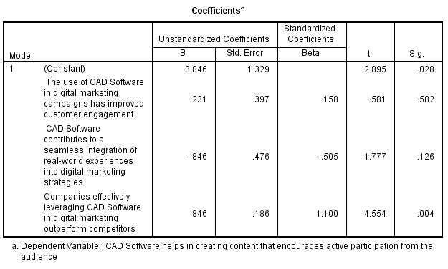

Figure 4.3.2.5: Coefficient
This figure represents the coefficient value of the individual variables. In this statistical analysis, the Beta contains the standardised regression coefficient to parameter the estimated value of independent variables. In the case of the "simple linear regression", the "standardised regression coefficient” value is equal to the DV and IV. According to the coefficient value, the square of the t statistics is equal to the F statistics of correlation statistics. According to this table, the companies leveraging CAD Software in digital marketing outperform competitors. Most of the respondents gave positive feedback on this statement. In the above table, the t value is 4.554, which indicates the positive relation between DV and IV. However, uses of the CAD software in the seamless integration of real-world experiences got positive responses to this statement. The t value of this statistical analysis is -1.777. This statement, 2 respondents strongly agreed and 8 respondents agreed with this statement. These statistics help to understand the effectiveness of using CAD software in creating 2D and 3D structures of products for creating consumer engagement on social platforms.

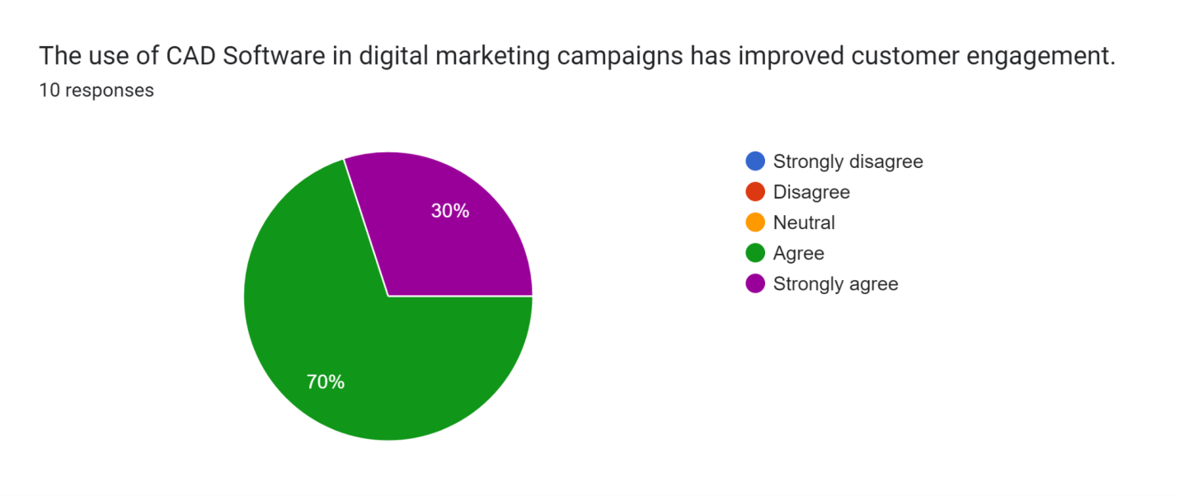

Figure 4.3.2.6: CAD software promotes digital marketing
The above figure shows that 70% agreed that using CAD software enhances customer engagement in the garment brands. The implication of this software helps in digital marketing to increase customer engagement in the garments company. According to this graph, 30% of participants strongly agreed with this statement. The above-mentioned graph shows that CAD software and digital marketing campaigns are positively related to improving customer engagement in the garments industry. Nowadays, designers and digital marketing authorities use this software to engage potential consumers on social media (Eze et al. 2020). The demand for online marketing is gradually increasing to traditional marketing.
The web-based advertising strategy involves several activities to improve marketing strategy. Uses of this software help to maintain high quality of design in the garments company. Using this software helps to identify the drawbacks or limitations of manufacturing and marketing products in the garments industry. This automation technology is beneficial to reduce manufacturing costs in the garments industry. The inclusion of the editable designing option helps clothing design for increasing the productivity of the garments industry. The inclusion of the editable design option is beneficial for increasing the production rate. The statistical analysis of the numeric values is significant for increasing the economic stability of the garment company.
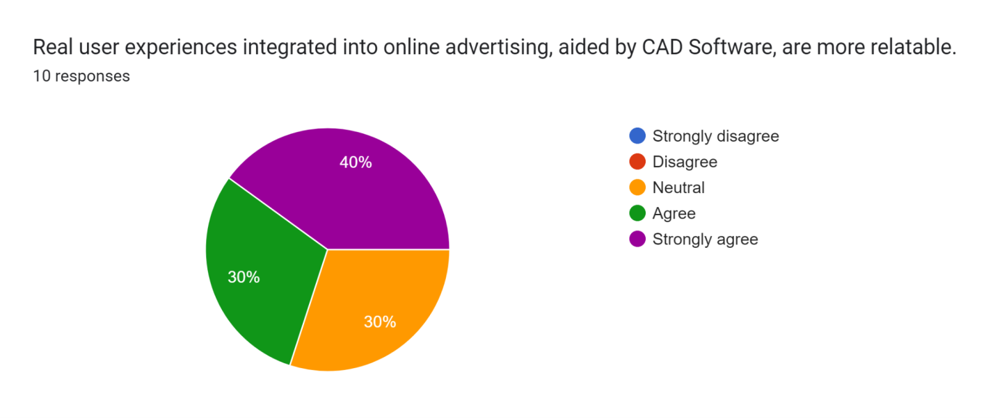

Figure 4.3.2.7: CAD software integrates online advertising
The above figure proves that, real user experiences in online servicing for increasing organization's value in the garments company. Among 10 participants, 40% strongly agreed with this statement and 30% agreed that real user experience integrates the online advertising, aided by CAD software. However, 30% or 3 people agreed with this earlier mentioned statement on the effectiveness of CAD software. According to this graph, most of the participants believe the positive relation between CAD and online advertising on social media. The implication of the CAD software is essential for the integration of online advertising on social media (Djakasaputraet al. 2021). Social media marketers use this software for creating visual content for advertising garments products on social media platforms. Integration of online advertising helps to promote customer engagement in the garments. It is beneficial for improving economic stability in the garments industry.
Reliability

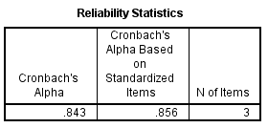

Figure 4.3.2.8: Reliability statistics
Reliability analysis encompasses the number of mathematical, graphical and textual information for identifying the reliability of that statistical information for further research. The above figure displays the “Cronbach’s Alpha Reliability”. The “Cronbach’s Alpha” value is > .70 is acceptable for further analysis. According to this statistical analysis, Cronbach’s Alpha is .843, suggesting 84% of reliability. Based on these statistical findings, 84% of reliability is suitable for further analysis. The reliable statistical value ensures the effectiveness of implementing CAD software for promoting garment brands on social media. This advanced technology is beneficial for improving the digital marketing campaign to increase customer engagement in the garments brand. The above figure shows that the N of items is 3, which indicates the reliability of the statistics for further research.
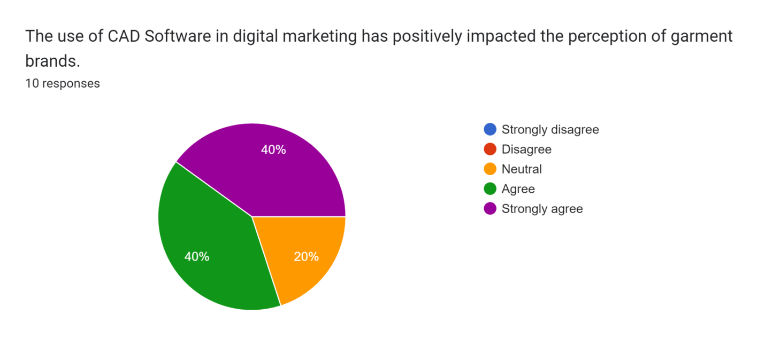

Figure 4.3.2.9: CAD software in digital marketing
The above graph shows that using CAD software in digital marketing has positively impacted the perception of garment brands. According to this graph, 40% strongly agreed and 40% agreed that using CAD software creates analyses and improves digital marketing for promoting garments products in the garments industry. However, 20% of participants agreed on the effectiveness of CAD software in digital marketing. Implication of this software is essential to reduce costs in digital marketing. The above figure shows that 4 respondents strongly agreed with this statement. Moreover, among 10 respondents, 4 participants agreed and 2 respondents were neutral about the impact of using CAD software in digital marketing in garment companies (Singh et al. 2023). According to the above graph, digital marketing has a positive impact on the perception of the garment industry.
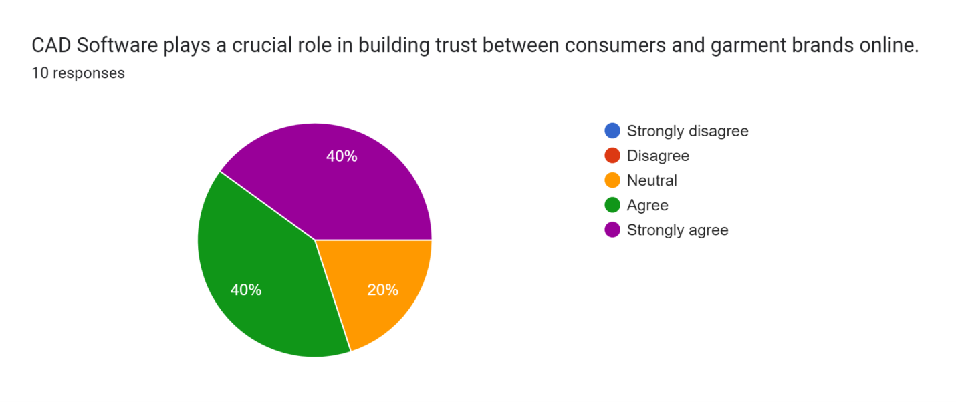

Figure 4.3.2.10: CAD software builds trust between consumers and garments brands
Implication of the CAD software plays a crucial role in building trust between consumers and garment brands. Among 10 respondents, 40% or 4 respondents strongly agreed with this earlier mentioned statement. Besides, 40% or 4 respondents agreed that the implication of the CAD software makes a positive impact on the garment company. However, 20% or 2 respondents are neutral about this statement. This software promotes printed surface design to attract consumers to explore innovative products in the garments brand. Advanced technology promotes the manufacturing quality of the products to increase product demand. In garment companies, using CAD software increases productivity by improving the quality of product design. The implication of CAD software promotes design quality in the garment industry. This software has better access to operate different software. Moreover, this software allows comprehensive technical analysis for promoting the quality of designed garments. Moreover, this software helps to design processes for increasing the productivity of the garment company.
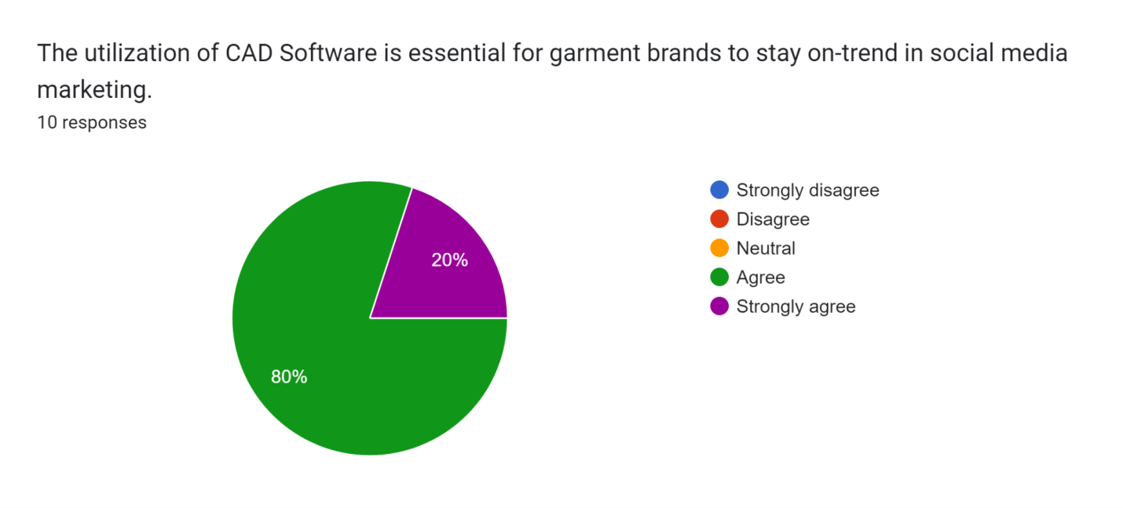

Figure 4.3.2.11: CAD Software helps in social media marketing
The above figure represents that, the inclusion of the CAD software helps to stay in social media marketing. The implication of this software improves the design standards by reducing the risk of drawing inaccuracies in the garment brand. According to the above graph, 80% or 8 respondents among 10 respondents strongly agreed with the earlier mentioned statements and 20% or 2 people strongly believe that CAD software is essential for garment brands to stay in social media marketing. According to the respondents, CAD software is beneficial for the structural design and surface design of the products. This software helps in planning the colour schemes, and intricate waves for producing an immense number of design variations for promoting the garments brands on social media platforms. This multi-utility software has had significant effects on creating market trends on social media.

Figure 4.3.2.12: CAD software enhances visual appearance
The above figure displays that the inclusion of CAD software enhances visual appearances for promoting garment brands on social media. Among 10 respondents, 40% or 4 people strongly agreed and 30% or 3 people agreed that CAD software enhances visual appearance on social media. Moreover, 20% of respondents were neutral about the statement. On the contrary, 10% of respondents strongly disagreed that CAD software enhances the visual appearances on social media. The creation of 2D and 3D pictures helps to visualise the products for attracting consumers on social media. Implication of the CAD software influences the latest and forecast-driven design for improving the quality of products in the garments brand. This digitized manufacturing process helps to optimise the workflow for increasing the productivity of the garment company.
The statistical analysis of the numeric data helps to detect the acceptance of CAD software in the garment company. According to statistical analysis, digital marketing or social marketing enables to connect audiences and build trust in brand value. Using this multi-use software is associated with the target audiences (Lee, 2021). Nowadays, designers and manufacturers intend to use this software to improve the visual representation of products on social media. This statistic helps to meet the research aims and objectives for increasing the quality of this paper for further research. The implication of CAD software enhances the visual appearances of the products in the garments industry. Digital marketing outperforms the competitors in the garments industry. This statistical analysis helps to detect the effectiveness of CAD software in improving the visual representation of the research topic. Inclusion of the descriptive statistics, correlation, and regression and reliability tests ensures the positive relation between DV and IV of this research paper.

4.4 Qualitative data analysis

4.4.1 Sample overview
In this phase of data analysis, NVivo software has been used, which helps to collect primary data, screen, extract and analyse. A wide range of research articles have been collected from several databases. These are helpful to address all the research objectives. At this stage, the samples introduce main purpose of data analysis and set for subsequent methodological and conceptual detail (Allsopet al. 2022). Sample overview also gives a brief explanation of different materials, which helps to redirect the attention of reader. Several keywords are defined, which are closely related to the immediate needs of this research. The sample semi structured interview questions and answers are related to CAD Software, social media marketing, user experiences, digital marketing campaigns, engagement of consumers, digital marketing initiatives, brand awareness and social media platforms. The respondents have answered on the basis of their knowledge and real-life experience.

4.4.2 Word cloud interpretation
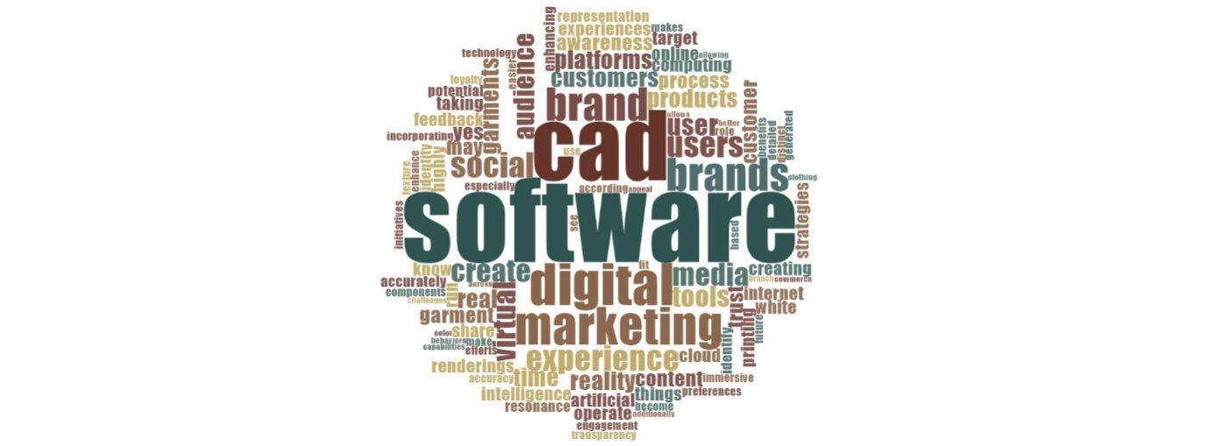

Figure 4.4.1: Word cloud
From the word cloud, it is clear that the word “software” is the largest word and hence, it occurred maximum times in the NVivo analysis. This word also has the highest frequency in the cloud (Dalkinet al. 2021). Many keywords can also be seen here, such as CAD, digital marketing, virtual, trust, internet, experience, social, brands and many others. From this, it can be found that creative design process can be done by utilising an efficient computer system. Word could also show a higher frequency of the words, media and virtual. CAD has a conventional design program, which is extensively used by various professionaldesignersto make technical drawingsprecisely. This drives social media marketing envelope, through giving users the competence to edit multifaceted 3D models online rapidly.This word cloud also depicts second highest frequency of CAD and digital marketing.

4.4.3Chart view of the keywords
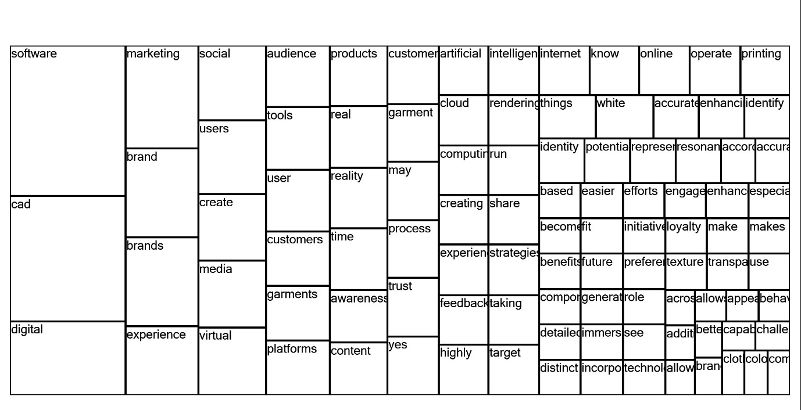

Figure 4.4.2: Chart view of keywords
At the time CAD designers make modifications or alterations of garment design, they can fix any error occurred or modify drawings effortlessly. This is significant for digital media and improve virtual interaction with consumers. The words with less frequency are awareness, platform, customers, create and social (Alam, 2021). With advent of modern technology, consumers can identify information via social media platforms and configure parts without sales representatives. These configurations of fashionable garmentsare preparedfor the manufacturer. After this, the sales team of manufacturers can use these CAD models to demonstrate the customer in real time. This also includes variations of different design, such as colour, design or pattern. This helps to improve the conversation betweenmanufactures, sales team and customer to be more productive. Customer also can visualize all the component in a better way within their design.

4.4.4Literature analysis from 3D cluster analysis and text search
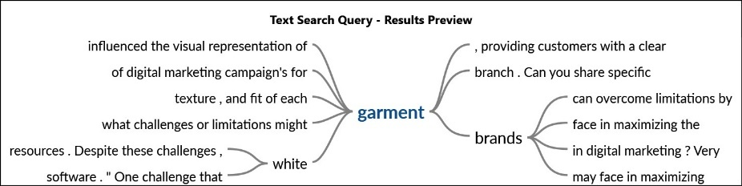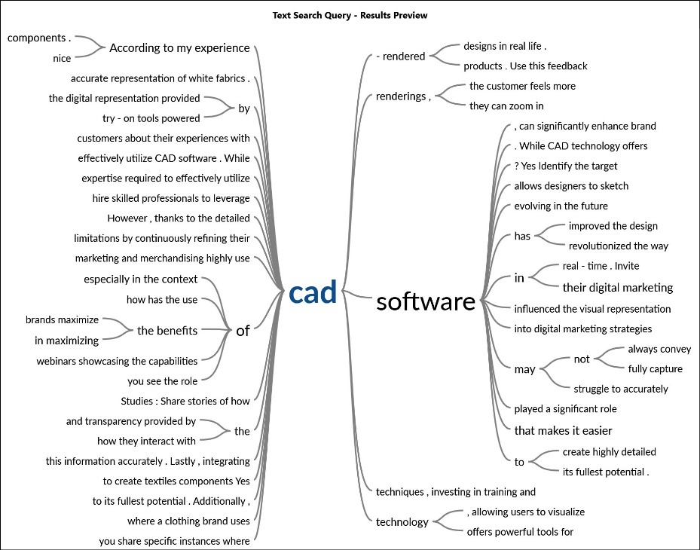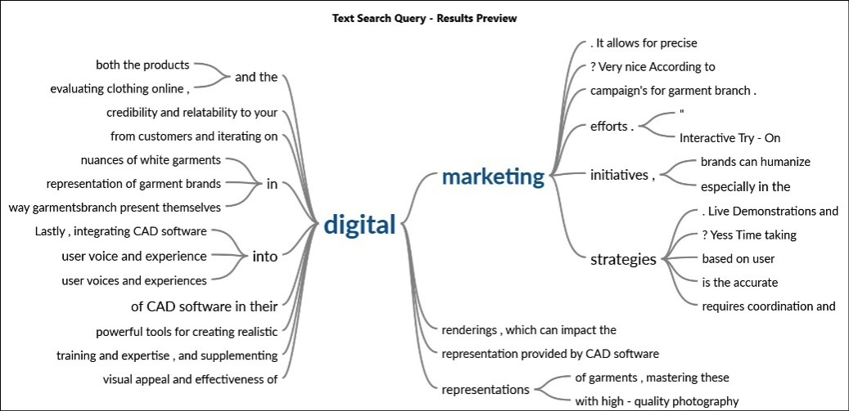

Figure 4.4.3: Text search query
This is an exploratory method, which is used to visualize the patterns in primary data, by grouping nodes or sources, which mainly share alike words or attribute values. These are also similarly coded by nodes. The following diagram of cluster analysis depicts a clear graphical representation of nodes. This makes it easier to see all similarities and differences. These nodes in cluster diagram appear closely, are more alike compared to the nodes that are not together (Salahudinet al. 2020). The following table can be helpful to measure similarities and differences of words.
Table rows | Clustered by | Table column
Sources | Similarity of words | Differentwords, appear within text
Sources | Similarity of coding | Nodescode entire file content
Sources | Similarity of attribute value | Attribute value in different files
Nodes | Similarity of words | Differentwordsappear in nodes
Nodes | Similarity of coding | Files with codes of row’s node
Nodes | Similarity of attribute value | Different attribute values of node

Table 4.4.1: Similarity index
It is clear that the words marketing and brand are closer to the word software. The word, CAD is also closer to brand and the word digital is closer to brand and experience. However, software is far apart from experience, social, users, create, media and virtual. Hence, these two words have higher degree of similarities, on the basis of their frequency and occurrence, as they are shown to be clustered together. Nevertheless, the word software has lower degree of similarity with the words experience, social, users, create, media and virtual. Hence, these are demonstrated to be further apart. Marketing is closely related to social and users and brand is close to media, create and virtual. From this, it is clear that large brands prioritize CAD software to design garments and check their fitting, colour, style and patterns.

4.4.5Literature analysis from text search query
This analysis shows results of text search. The word digital is related to marketing. The tree also shows that digital marketing is helpful to design and evaluate clothing via CAD software. It also ensures reliability and credibility of design, which is also convenient for customers. Manufacturers can also be advantageous to represent garment brands. Marketing is also closer to campaign, initiatives, strategies and efforts. Hence, marketers of garment industry take many initiatives to display an interactive try-on method to humanise the marketing process. This process is not so time-taking and produce accurate outcome of garment design. The word is also connected to precise, effort, require coordination and lice demonstrations. Hence, this initiative is influential in garment industry.
Hence, while the marketers use computer-aided design for making creating designs of garment for advertisement, they can save much time and make better plan efficiently. Reason behind this is, it offers many features, such as prototypes, mock-ups of garments, 3D models and sketches of fashionable clothing. Digital marketing and brand also have significantly high frequency in the cloud. In this regard, CAD models are downloadable in form of any file. For this, designers are able to provide product info designers and engineers, while instantaneously converting CAD models into digital marketing content. This also drives strategic sales. If this is delivered appropriately, CAD models can be deliverable content to take the marketing campaigns to its next level.

4.5 Discussion
For discussing the output obtained from NVivo analysis, several themes can be created, as follows.

4.5.1 Theme 1: CAD Software can improve the effectiveness of social media marketing for garment brands
Social media marketing is important to provide marketers with essential tools and knowledge to contribute to running effective and successful “social media marketing campaigns” for garment brands. They can gain a compact understanding of digital techniques and tools to promote their brand visibility (Hu, 2020). This also helps to increase flow of traffic through pay-per-click advertising, business analytics, search engine optimization (SEO) and content marketing. The best practices of CAD can ensure that the products can make this market faster. Present technology also facilitates production of low-cost and high-quality products.
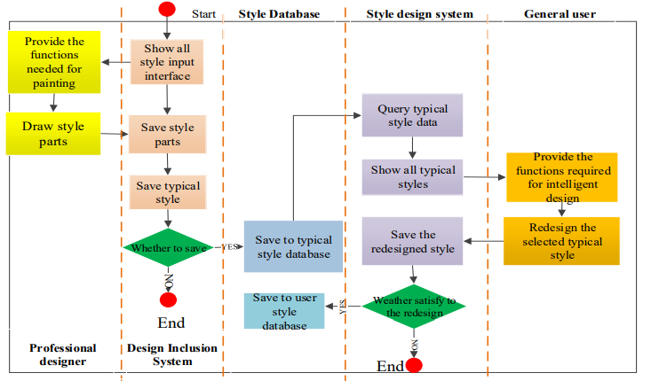

Figure 4.5.1: Process of User module design
(Source: Hu, 2020)
This also takes less amount of time to get those inthe market. Apart from this, CAD design allows garment brands to save their time and diminish the level of waste. Beforehand, it was essential to do drafting and after that perform designing by the hand. The process also consumed huge amount of time as well as effort andled to much waste.Designing garments by hand often means drawing board in case of mistake (Zhaoet al. 2021). However, CAD process of garment designmakes use of superior software to simplify this process. Marketers of large brands, such as Burberry, Prada, Hermes, Gucci and Louis Vuitton use this strategy to heighten productivity.

4.5.2 Theme 2: CAD Software inspires consumers to participate in interactive marketing approach, which improves their loyalty and trust
The utilisation of CAD tools leads to producing design of greater quality. Marketers will have greater control over the looks of garment items. They analyse and assess3D models and send to the consumers for review. Moreover, this is much easier to interact ideas, while using CAD tools. To make or draft clothing design, use of pen and paper can make confusion, as maximum consumers are not able to decipher those designs (Chaudharyet al. 2020). Understanding designs is simplified with CAD tools, aiding in implementing interactive marketing in the garment industry. CAD enables clearer visualization, facilitating communication of design concepts. This fosters interactive marketing strategies, allowing for engaging presentations of garment designs to potential customers. Consequently, CAD contributes to more effective marketing campaigns, enhancing customer engagement and ultimately driving sales in the garment sector.
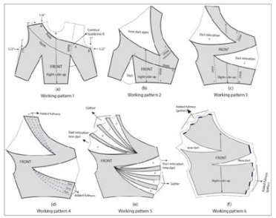

Figure 4.5.1: Manual Design solution
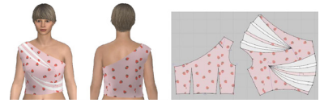

Figure 4.5.2: 3D Design solution by CLO software
(Source: Moniruzzaman and Oishe, 2022)
Prior to invention of CAD software, garment companies used to design manually, which was a sluggish process. Once a design was made physically, a sample product required for trial. On the other hand, CAD fulfil all the necessities of physical prototyping. This allows designers and social media marketers to simulate necessary testing follow-ups virtually in program (Moniruzzamanand Oishe, 2022). It is also reliable for customers and subsequently, it helps to improve their loyalty and trust. Garment designers can also make some adjustments during production. Applying manual changes naturally produces several human errors, as product variable needs independent input. By use of CAD, customers can review the overall process.

4.5.3 Theme 3: Marketers of large garment brandsincorporate real-world user experiences of consumers with their online advertising strategies
Cloud-based CAD systems are convenient for themarketers of large garment brands. It is worth mentioning that virtual designs of garments can facilitate marketing, since the promotional team of brands can visualize the overall design together with its useable functions (Ranjanet al. 2020). This enables advertising departments to display product features to their customers in abetter way. Furthermore, 3D models’ visualizations help to improve customer experience. As the marketers showcase garment design more excellently, it creates real-world user experiences of consumers. At the very first stage, designs of clothes are visualized and verified before manufacturing. After this, team members are allotted every small detail regarding design features, such as colours, lines, texture or emphasis. In this context, 3D modelling helps to accelerate development and reduce assembly errors (Quanet al. 2020). In this manner, consumers can get an earlier idea of garments, about what they suit the best, by seeing it on social media.

4.5.4 Theme 4: CAD Software has many utilisations to improve brand presence on social media platforms
CAD technology continuously evolves to meet the garment industry's changing demands. Graphic designers utilize 3D CAD software to visualize mock-ups effortlessly, toggling backgrounds, shapes, effects, and typography (Fujita, 2020). Previously, achieving flawless meshing required significant time. However, modern design software advancements now enable quick access to numerous simulations, simplifying the process. This evolution facilitates quicker and more efficient design iterations, ensuring designers can create high-quality garments in a shorter time limit. As a result, designers can experiment more freely, leading to innovative and innovative designs that meet consumer demands effectively.
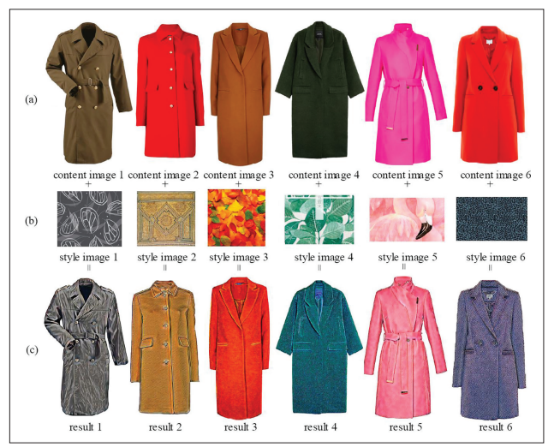

Figure 4.5.1: Designs of function modelling of clothes
(Source: Zhaoet al. 2021)
CAD enables fast design iterations, as it creates simulations without any meshing. Present strategy also reduces the time needs to execute simulations by eliminating requirement. Social media and digital marketing team use this approach to employ more accurate design. On CAD software, 3D models are made based on combination of multiple function modelling. For this, social media marketers of garment designers use “object model for function and geometry (OMFG)” (Mülleret al. 2020). This helps to relate design concept of the clothes to design automation or DA. This ensures a better presence of brand worldwide.

4.6 Summary
From the primary data analysis, it can be summarised that digital marketing makes use of technological advancement, which brings the world to newest level. Numerous software capabilities have improved the efficiency and process of work of marketing in different multinational garment brands. From the above data analysis, it can be found that 3D CAD systems are significant for garment visualisation, which are usually commercially available. This software also facilitates virtual try-on, which is mainly categorised into several groups, on the basis of their fundamental working procedure for making 3D designs. TPC and Virtualfashion® both allow the garment designers to represent their stylish clothes in 3D environment. This is beneficial for the social media marketers to attract a large pool of customers. This not only provides high quality design, but also increases productivity, presents editable designing option, design documentation and simplifies sharing.

CHAPTER 5: CONCLUSIONS AND RECOMMENDATIONS

5.1 Chapter Introduction
Garment companies take advantage of digital marketing, which includes email marketing, use of mobile applications,web-based advertising as well as text messaging. The success of digital marketing strategy of these brands depends on the incorporation of best business model. CAD software offers many facilities to the garment designers to reduce human-made error and time consumption for design process. This also makes perfect design for social media digital marketing. In particular, B2C or business to consumer companies want to sell directly to the end customers, by removing the interference of intermediate. Regarding this matter, content marketing on various social media platforms is an effective manner to foster the reach of advertisement. Hence, the advertisers of garment industry create some short storylines to attract their potential clients. This not only helps to develop traffic in company’s site. They also advertise on search engines through various approaches, such as pay per click, social media marketing and so forth. They also make use of different social platforms, such as Instagram, Facebook, LinkedIn, Twitter and YouTube. B2B companies are therefore more intended to adopt many social media marketing techniques to foster garment sells. This chapter is going to summarise the overall dissertation and evaluate the findings of primary quantitative and qualitative data analysis.

5.2 Conclusion
From the overall dissertation, it can be concluded that CAD Software has an impact on modern social media digital marketing. Leveraging the supremacy of CAD software, virtual garment demonstrations have renovated the traditional marketing approaches. With CAD technology, garment brands across the world can create interactive and realistic virtual experiences. This further enables potential customers to sightsee and interact with products in 3D environment. There are manybenefits of product demonstrations virtually on marketing approaches. This highlights how clothing businesses can harness advent of CAD to stand out of the crowded marketplace. Digital marketers utilize virtual product demonstrations, through which these companies can improve marketing approaches by offering potential customers with more informative and engaging experience.
Social media marketers know that rather than depending on static images, CAD demonstrations enablesconsumers to interact with product, manipulate features and see real-time. This improves the degree of interactivity in marketing approach. Through digital marketing,clothing companies can augment consumers’ understanding of the garmentand create animpactful and memorable experience. Virtual garment demonstrations eradicate geographical barriers, permitting brands to reach a broader target audience of each company. Instead of trusting onphysical samples or in-person demonstrations, marketers can now displaydesigns to customers across the world with a click of button. For these companies, it saves valuableresources and time. In this manner, companies can also to scale target and marketing efforts effectively.
Use of CAD software by the garment designers and marketersis fruitful to develop sketches, varieties and patternsaccuratelymore quickly. With evolutionary application of CAD software, they can create countless modifications of single style or design. They can also adapt those as per requirement of the brands.It is worth mentioning that all colours do not work for all types of designs. Regarding this matter, CAD comes for relief for them. CAD is also useful in exploring colours or patterns among garment designs, through which they can get perfect colour or style that can bring out the design independently.In the process of fabric designing, this software allows designers to try different fabric textures and patterns. Ultimately, this will reduce cost and save time consumed to deal patterns by hand.
The entire process is performed on a virtual version and quite a less part of entire process is done physically. Hence, the cost for raw materials and collection development of fashion designing is reduced to minimum.CAD allows garment designer to explore multiple colour ways of single print. By using this software, rectifications and modifications are faster and more accurate, which therefore decreases rooms for errors.In this dissertation, it has been proved that CAD Software positively impacts on the efficacy of social media marketing. CAD software is vital for the designers to visualize finished garment product, components together with assembly process. This also acts as one-stop tool for analysis, synthesis,and certification of design. As the marketers develop designs and advertise on social media, it can encourage participation, loyalty and trust. Many strategies have been documented in this dissertation, which are used by marketers to incorporate real-world user experiences with online advertising.

5.3 Recommendations
Recommendation 1: Social media digital marketers should consider designing software on CAD system
Morgan Tecnica is a CAD system, which offers cutting-edge machinery, order planning, automatic cutters, spreading tables, automatic spreaders and PDM as well as virtual fitting. This software is compatible with both“Windows 10 operating systems” and Windows XP. Social media marketers can leverage the power of CAD software for pattern modification, measurement checks, technical sheet, adjustment and size grading. All of these can be performed through a single software platform. “The Pattern Design” module of this software system also has import/export facility. This is available for all files of standard format, such as DXF, ISO, AAMA and HPGL. Marketers can also use standard ‘converters’ for importing models or other virtual contents from other systems. Another advantage of this software is that reading native files from prevalent CAD programsdirectly. Marketers should incorporatenesting system with well-organized nesting algorithm along with“nesting queue management”. There is a variety of software packages available for designers. All of these arehighly customizable and perfectly integrated for optimization of apparel production. The management of functionalities of every mechanism is easier for automatic markers. They can easily design, make cutting and fit to the model. Marketers of garment industry should incorporate this software throughout life cycle of the apparel, from creation to clothing production and sales to the end users. They can get customizable and explicit e-commerce solutions.
Recommendation 2: Marketers of garment brands should use social media platforms for enhancing the reach to target audience
Building a brand awareness is the most vital step for this process, as consumers are not likely to purchase products that is not known to them. Getting help from the influencers is vital and effective way for the brands. It is necessary to consider workable strategic partnerships. This strategy helps to increaserevenue and web trafficand a recurrent customer base. Havinga sound strategy ofsocial media marketing is the success to drive cost-effective traffic. Driving traffic is crucial for the younger brand. For this reason, marketers should climb through various social media channels. Choosing a right platform is also crucial for these brands. Facebook can be an appropriate platform for creating brand loyalty. Instagram is another place to explore fashion products. Brands should prepare a particular strategy for fashion social media, which focuses on countless Instagram users. Luxuryfashion brand also dominates a large space by creating many organic contents through YouTube channels, rather than using paid ads. Garment designers also have option to create story-selling through Story Ads and Snap Ads. TikTok will be another platform for attracting new generation customers towards the brand.
Recommendation 3: Marketers and garment designers should have adequate training for achieving success
The garment brands should put remarkable effort for being a successful marketer, fashion designer, or fashion entrepreneur.For this, it is necessary to use specific tools in hand that are capable of improving creative renderings. The brands should have proper access to diverse software pieces of fashion design. These must be developed to make ideas and fashionable sketches in a noticeable reality. For this reason,marketers and designers should be trained in this domain, so that they can make use of CAD software, by enhancing their creativity and skills. There is a wide range of “Fashion Design — Art Certificate” programs. These are developed to fulfil the needs of garment industryfor training talent about advanced “Fashion Design computer skills”. By attending this program, designers and marketers of garment brands can get opportunity to elevate their skills of digital fashion design to their industry standards. Main purpose of such training program is to empower them to design and produce various presentation products of fashion design. The training and development programs include digital trends, concept boards, digital specification sheets for portfolio and textile colour developments. Employeesattending this program can be able to improve their rudimentary garment designing skills and succeed.
Recommendation 4: Garment marketers should have many social media marketing ideas to increase customers’ loyalty and trust
Garment marketers should optimize company’s website, so that it will “pop up” higher in users’ “search engine results” pages. This helps to grabattention of target audiences, who arelooking for fashionable clothing. SEO marketing involves use ofphrases, keywords along with other tools, through which Google can find them. For ecommerce garment businesses, digital marketers should add product descriptions for adding keywords. Marketing approaches for garment brand comprise of fashion blogging, videos or reelson social media, generating posts and conducting unique campaigns to promote new releases. They should post contents on social media to promote designs. This will be helpful to improveperformance in the search result pageand makes this brand discoverable online. To optimize the garment brand for local searches, marketers should create “Google Business Profile”. This tool helps to update the entire profileand notify on social media. Marketers can further handle customer reviews of brand byapplying this tool. “Facebook led ads”can grow email list and call to action (CTA) should be designed for driving consumers to sign-up on email. This helps toincrease customers’ loyalty and trust.

5.4 Research Limitations
Although this research paper has explored many influences of CAD Software in modern social media digital marketing, it has several limitations. Only use of primary research has limited the scope of this research. Due to the understandable procedures related to carrying out this primary research, qualitative and quantitative data engages huge amount oftime and costs. This took a lot of time and money to conduct this work. At the same time, the researchers could not collect any secondary resources and analyse those. This limited the use of information about subject matter. Moreover, time of completing this research was short. This was problematic to complete primary qualitative data collection, choose the participants carefully and conduct semi structured interview. In this stage, telephonic conversation was also not easy to do, as there were some network issues. The researcher also depended on NVivo software. This cannot be used in different types of research and it is sometimes ineffective. The researcher faced many issues with installation and machine error. Although this minimises bias from research, it does not support measurability and observability.

5.5 Future research suggestions
CAD allows predicting designer's output and enhances quality of garment design. Future research will be focused on how garment designers utilize CAD Technology to virtually simulate their designs and fit garments. Forthcoming researchers will also highlight components of garment design, which can be transformed into “3D CAD model” with the help of various instruments such as“CMM (coordinate measuring machine)”, white light scanner, laser scanner and so forth. The use of CMM machines to decode or measure the shape of real model, virtual model for modification purpose,documented and shared. Many benefits of using CAD software for garment industry has been described in this section. However, it is required to put emphasis on various factors to consider beforehand installing CAD system.
Before buying the subscription for design, it is necessary to know brand value and extra features of the software. Determining allotted budget for marketing and initial hardware available is also a significant factor to do research on. Henceforth, upcoming scholars will focus on evaluating the future of CAD in garment industry and broaden the scope in textile and fashion. On-demand Manufacturing has opened many ways of garment production. For this, CAD has influenced this industry with 3D visual interpretation of garments on human figures. Use of this software in diverse industries will be explored in future research. This will be helpful to push forward the garment boundaries.

References
Alam, M.K., 2021. A systematic qualitative case study: questions, data collection, NVivo analysis and saturation. Qualitative Research in Organizations and Management: An International Journal, 16(1), pp.1-31.
Allsop, D.B., Chelladurai, J.M., Kimball, E.R., Marks, L.D. and Hendricks, J.J., 2022. Qualitative methods with Nvivo software: A practical guide for analyzing qualitative data. Psych, 4(2), pp.142-159.
Cardoso, M.H., Orozco, R.Q., Rezende, S.B., Rodrigues, G., Oshiro, K.G., Cândido, E.S. and Franco, O.L., 2020. Computer-aided design of antimicrobial peptides: are we generating effective drug candidates?. Frontiers in microbiology, 10, p.3097.
Cartwright, S., Liu, H. and Raddats, C., 2021. Strategic use of social media within business-to-business (B2B) marketing: A systematic literature review. Industrial Marketing Management, 97, pp.35-58.
Chaudhary, S., Kumar, P. and Johri, P., 2020. Maximizing performance of apparel manufacturing industry through CAD adoption. International Journal of Engineering Business Management, 12, p.1847979020975528.
Dalkin, S., Forster, N., Hodgson, P., Lhussier, M. and Carr, S.M., 2021. Using computer assisted qualitative data analysis software (CAQDAS; NVivo) to assist in the complex process of realist theory generation, refinement and testing. International Journal of Social Research Methodology, 24(1), pp.123-134.
Dastane, D.O., 2020. Impact of digital marketing on online purchase intention: Mediation effect of customer relationship management. Journal of Asian Business Strategy, DOI, 10, pp.142-158.
Djakasaputra, A., Wijaya, O., Utama, A., Yohana, C., Romadhoni, B. and Fahlevi, M., 2021. Empirical study of Indonesian SMEs sales performance in digital era: The role of quality service and digital marketing. International Journal of Data and Network Science, 5(3), pp.303-310.
Dubey, U.K.B. and Kothari, D.P., 2022. Research methodology: Techniques and trends. CRC Press.
Ellis, T.J. and Levy, Y., 2009. Towards a Guide for Novice Researchers on Research Methodology: Review and Proposed Methods. Issues in Informing Science & Information Technology, 6.
Eze, S.C., Chinedu-Eze, V.C., Okike, C.K. and Bello, A.O., 2020. Critical factors influencing the adoption of digital marketing devices by service-oriented micro-businesses in Nigeria: A thematic analysis approach. Humanities and Social Sciences Communications, 7(1), pp.1-14.
Fujita, H., 2020. AI-based computer-aided diagnosis (AI-CAD): the latest review to read first. Radiological physics and technology, 13(1), pp.6-19.
Hu, L., 2020. Design and implementation of a component-based intelligent clothing style cad system. Computer-Aided Design and Applications, 18(S1), pp.22-32.
Hu, X., Chen, Y., Cai, W., Cheng, M., Yan, W. and Huang, W., 2022. Computer-aided design and 3D printing of hemipelvic endoprosthesis for personalized limb-salvage reconstruction after periacetabular tumor resection. Bioengineering, 9(8), p.400.
Itani, O.S., Krush, M.T., Agnihotri, R. and Trainor, K.J., 2020. Social media and customer relationship management technologies: Influencing buyer-seller information exchanges. Industrial Marketing Management, 90, pp.264-275.
Kawira, K.D., Mukulu, E. and Odhiambo, R., 2019. Effect of Digital Marketing on the Performance of MSMES in Kenya. Journal of Marketing and Communication, 2(1), pp.1-23.
Kingsnorth, S., 2022. Digital marketing strategy: an integrated approach to online marketing. Kogan Page Publishers.
Kothari, C.R., 2004. Research methodology. new Age.
Krishen, A.S., Dwivedi, Y.K., Bindu, N. and Kumar, K.S., 2021. A broad overview of interactive digital marketing: A bibliometric network analysis. Journal of Business Research, 131, pp.183-195.
Lee, Y.K., 2021. Impacts of digital technostress and digital technology self-efficacy on Fintech usage intention of Chinese Gen Z consumers. Sustainability, 13(9), p.5077.
Li, F., Larimo, J. and Leonidou, L.C., 2021. Social media marketing strategy: definition, conceptualization, taxonomy, validation, and future agenda. Journal of the Academy of Marketing Science, 49, pp.51-70.
Lolaico, M., Blokhuizen, S., Shen, B., Wang, Y. and Högberg, B., 2023. Computer-Aided Design of A-Trail Routed Wireframe DNA Nanostructures with Square Lattice Edges. ACS nano, 17(7), pp.6565-6574.
Mishra, S.B. and Alok, S., 2022. Handbook of research methodology.
Moniruzzaman, R.A. and Oishe, S.H., 2022. An approach to design solutions for garments using a CAD system. J Textile Eng Fashion Technol, 8(4), pp.145-148.
Müller, J.R., Panarotto, M. and Isaksson, O., 2020. Function model based generation of cad model variants. Comput. Aided Des. Appl.
Nazir, A., Azhar, A., Nazir, U., Liu, Y.F., Qureshi, W.S., Chen, J.E. and Alanazi, E., 2021. The rise of 3D Printing entangled with smart computer aided design during COVID-19 era. Journal of Manufacturing Systems, 60, pp.774-786.
Ocaña-Fernández, Y. and Fuster-Guillén, D., 2021. The bibliographical review as a research methodology. Revista Tempos E EspaçosEmEducação, 14(33), pp.e15614-e15614.
Olson, E.M., Olson, K.M., Czaplewski, A.J. and Key, T.M., 2021. Business strategy and the management of digital marketing. Business horizons, 64(2), pp.285-293.
Oyindoubra, D., 2022. Computer Aided Design (CAD) Skills Needed by Building Technologist in Polytechnics for Job Placement in Rivers State. International Journal of Contemporary Academic Research, 3(2).
Pandey, P. and Pandey, M.M., 2021. Research methodology tools and techniques. Bridge Center.
Peter, M.K. and Dalla Vecchia, M., 2021. The digital marketing toolkit: a literature review for the identification of digital marketing channels and platforms. New trends in business information systems and technology: Digital innovation and digital business transformation, pp.251-265.
Purwanti, Y., 2021. The influence of digital marketing &innovasion on the school performance. Turkish Journal of Computer and Mathematics Education (TURCOMAT), 12(7), pp.118-127.
Quan, H., Zhang, T., Xu, H., Luo, S., Nie, J. and Zhu, X., 2020. Photo-curing 3D printing technique and its challenges. Bioactive materials, 5(1), pp.110-115.
Rafique, H., Almagrabi, A.O., Shamim, A., Anwar, F. and Bashir, A.K., 2020. Investigating the acceptance of mobile library applications with an extended technology acceptance model (TAM). Computers & Education, 145, p.103732.
Ranjan, R., Pandey, R. and Kumar, V., 2020. Integration of CAD Technology for Fast and Customized Production of Apparels. Psychology and Education, 57(9), pp.4639-4645.
Ratnasingam, J., Ioras, F. and Lim, C.L., 2021. Digital technology application among malaysian value-added wood products manufacturers. BioResources, 16(2), pp.2876-2890.
Sagnier, C., Loup-Escande, E., Lourdeaux, D., Thouvenin, I. and Valléry, G., 2020. User acceptance of virtual reality: an extended technology acceptance model. International Journal of Human–Computer Interaction, 36(11), pp.993-1007.
Salahudin, S., Nurmandi, A. and Loilatu, M.J., 2020. How to Design Qualitative Research with NVivo 12 Plus for Local Government Corruption Issue in Indonesia?. JURNAL STUDI PEMERINTAHAN (JOURNAL OF GOVERNMENT & POLITICS), 11(3).
Saura, J.R., 2021. Using data sciences in digital marketing: Framework, methods, and performance metrics. Journal of Innovation & Knowledge, 6(2), pp.92-102.
Sawlani, D.K. and Susilo, D., 2020. How digital marketing helps higher education institution branding. Int J Multidis Edu Res, 5(3), pp.45-55.
Singh, V., Nanavati, B., Kar, A.K. and Gupta, A., 2023. How to maximize clicks for display advertisement in digital marketing? A reinforcement learning approach. Information Systems Frontiers, 25(4), pp.1621-1638.
statista.com (2024), Leading digital marketing channels according to marketers worldwide as of July 2022, Available at: https://www.statista.com/statistics/235668/interactive-marketing-adoption-worldwide/ [Accessed on: 15.01.2024]
statista.com (2024), Most popular luxury brands on social media worldwide as of May 2022, by social media audience size, Available at: https://www.statista.com/statistics/1256796/luxury-brands-with-most-followers-on-social-media/ [Accessed on: 15.01.2024]
statista.com (2024), Most successful marketing channels according to marketers in the United Kingdom in 2020, Available at: https://www.statista.com/statistics/1231767/successful-marketing-channels-uk/ [Accessed on: 15.01.2024]
Syazali, M., Putra, F., Rinaldi, A., Utami, L., Widayanti, W., Umam, R. and Jermsittiparsert, K., 2019. Retracted: Partial correlation analysis using multiple linear regression: Impact on business environment of digital marketing interest in the era of industrial revolution 4.0. Management Science Letters, 9(11), pp.1875-1886.
Thomson, P. and Gunter, H., 2007. The methodology of students-as-researchers: Valuing and using experience and expertise to develop methods. Discourse: studies in the cultural politics of education, 28(3), pp.327-342.
Tuten, T.L., 2023. Social media marketing. Sage Publications Limited.
Veleva, S.S. and Tsvetanova, A.I., 2020, September. Characteristics of the digital marketing advantages and disadvantages. In IOP Conference Series: Materials Science and Engineering (Vol. 940, No. 1, p. 012065). IOP Publishing.
Zawacki-Richter, O., Kerres, M., Bedenlier, S., Bond, M. and Buntins, K., 2020. Systematic reviews in educational research: Methodology, perspectives and application (p. 161). Springer Nature.
Zhao, L., Liu, S. and Zhao, X., 2021. Big data and digital design models for fashion design. Journal of Engineered Fibers and Fabrics, 16, p.15589250211019023.

Appendices

Survey Questionnaire
Demographic Questions:
- Age:
  - 18-24
  - 25-34
  - 35-44
  - 45 and above
- Occupation:
  - Student
  - Employed (Full-time)
  - Employed (Part-time)
  - Self-employed
  - Other (please specify)
- Experience with CAD Software:
  - Novice
  - Intermediate
  - Advanced
Likert-Scale Based Statements:
Please indicate your level of agreement with the following statements using a scale from 1 to 5, where 1 represents "Strongly Disagree" and 5 represents "Strongly Agree."
- CAD Software enhances the visual appeal of garment brands on social media.
- The use of CAD Software in digital marketing campaigns has improved customer engagement.
- CAD Software plays a crucial role in building trust between consumers and garment brands online.
- Incorporating CAD designs in digital marketing materials increases brand loyalty.
- Real user experiences integrated into online advertising, aided by CAD Software, are more relatable.
- CAD Software helps in creating content that encourages active participation from the audience.
- The use of CAD Software in digital marketing has positively impacted the perception of garment brands.
- Companies effectively leveraging CAD Software in digital marketing outperform competitors.
- CAD Software contributes to a seamless integration of real-world experiences into digital marketing strategies.
- The utilization of CAD Software is essential for garment brands to stay on-trend in social media marketing.

Interview Schedule
- In your experience, how has the use of CAD software influenced the visual representation of garment brands in digital marketing?
- Can you share specific instances where CAD software played a significant role in fostering customer trust and loyalty in the online interactions between brands and consumers?
- From your perspective, what are some effective tactics for incorporating real user voices and experiences into digital marketing initiatives, especially in the context of CAD software?
- How do you see the role of CAD software evolving in the future to further enhance brand awareness and resonance on social media platforms?
- In your opinion, what challenges or limitations might garment brands face in maximizing the benefits of CAD software in their digital marketing strategies?

