Module BMPL50
Reflective Portfolio 2Wish
Alicia May Jones (2201136)





This Reflective Portfolio explores the experiences and learnings that I encountered during a 80 hour voluntary placement with an organisation known as 2Wish. 2Wish is a bereavement charity that offers practical and emotional support for those affected by sudden death in young people, created following the tragic death of the founder, Rhian Mannings, son and husband and the lack of grief support she found to be available (2Wish, 2023). The support provided is not limited to friends and family but also extends to healthcare workers and emergency services who may be impacted through their work (2Wish, 2025). I decided to take on this role as I felt a strong need to understand vulnerability, empathy and compassion to the highest degree possible. My role during this placement encompassed supporting fundraising events and community activities such as a netball tournament, raising awareness of their services through stands, general admin such as contacting news outlets for charity week recognition, preparing event materials and setting/packing up as well as providing support for those suffering. This voluntary experience allowed me to further understand vulnerability and sensitivity, which I believe can lend vast knowledge to my role within policing, during this reflective portfolio I will touch on three experiences that have allowed me to grow as an individual and taught me lessons I will carry with me, simultaneously linking them with Gibbs’ 1988 and Kolbs’ 1984 Reflecting Cycles, subsequently relating the chosen scenarios to the National Decision Model and the College of Policing Code of Ethics to demonstrate how the voluntary work developed my skills needed in my degree and future career in response policing.

Reflective Evidence
Courage


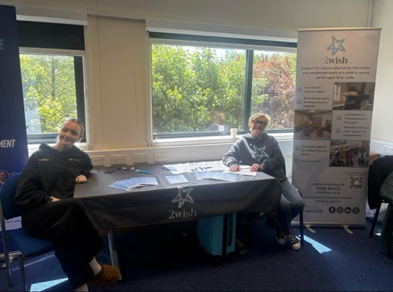

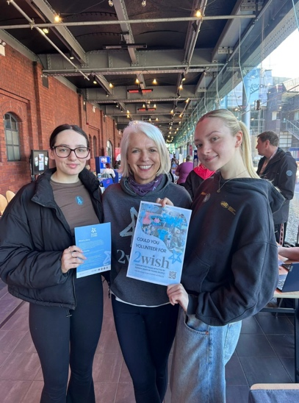
Whilst discussing a specific incident that occurred during my voluntary work, I will be following the structure of Graham Gibbs’ 1988 Reflective Cycle, following the six stage framework, infamously used to reflect on experiences, with the hopes to improve future practice (Gibbs, 2013). The six stage framework begins with a description of what exactly happened, following with how the situation made someone feel, thirdly, an evaluation of the chosen response and next with an analysis and conclusion, ending with an action plan to improve if ever to find one's self in a similar situation (University of Hull, 2024). A specific incident that comes to mind when I reflect on my experience with 2Wish takes place at an awareness stand, of which I accompanied many, however, this specific stand was held at South Wales Police Headquarters, with the idea to inform the working forces of the 2Wish charity for signposting as well as support for those affected by the job, the event held not only trained officers but emergency call handlers, nurses, detectives and so on. During this event, I was approached by a lady who informed me that she was the lead nurse at her occupation for bereavement, she expressed that there was a woman that she had contact with, who she believed would benefit from a signpost to 2Wish but was unable to do so as she was retreating, following the death of her 2 month old son, through more discussion it was clear to see that the lady she had mentioned was not the only person in this circumstance that needed our support, the nurse was extremely emotional and tired and expressed the pressure she was under due to her position, feeling like she had nowhere to turn. Although it was crucial for this lady to feel heard and understood, it was also important that I understood my capabilities and respond professionally whilst also understanding my limitations. I remained compassionate throughout the encounter, informing her of our services and what she was entitled to, shortly after gathering the courage and following with a referral to an appropriate member of staff that was able to assign her counselling, which I believe was the most responsible reaction. As a future police officer, dealing with vulnerable people, in specific those experiencing mental health, whilst also remaining a professional distance is extremely important, in fact it has been stated that the crises consumes an estimated 30% of frontline time (HMICFRS,2023), following up with a direct signpost to further support that is more suitable for the divergent needs at hand (College of Policing, 2016), mental health is an ever growing obstacle, effecting 1 in every 4 people and I am proud to say that I was able to positively effect a victim (Mind, 2019), this experience reinforced the importance of active listening and clear communication. I believe I responded appropriately, through empathy and accountability, however, moving forward, I recognise that I could have asked more open ended questions to better understand the immediate needs, rather than solely thinking of long term support.

Reflective Evidence
Respect and Empathy
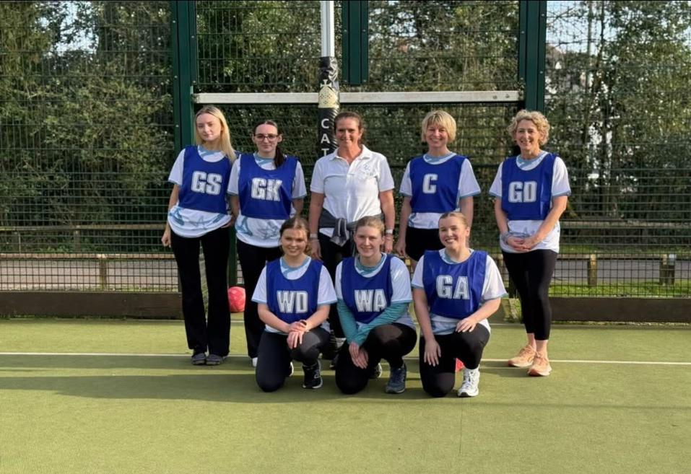
Another encounter I experienced during my 80 hour voluntary work occurred at a charity netball match we held in Cardiff, organised to raise both awareness and funds for the 2Wish cause. This reflection will use Kolbs’ 1984 4 stage Reflective Cycle to focus on how I demonstrated empathy and respect in the face of conflict. I will also explore how my response lends itself to the National Decision Model and the skills learnt that I can carry into my future career as a police officer.
Kolbs’ 4 stage framework was designed to allow people to learn from experience by reflecting on personal events and applying that learning to future events, to minimise making the same mistakes and optimise learning (NHS, 2022). During the netball games halftime, I was approached by a member of the public who happened to be interested in our 2Wish leaflets (2Wish, 2021), what seemed to be a fairly normal interaction, seemingly changed when the gentleman expressed concerns regarding the charity, stating that we only cover support regarding the sudden death of young people, he felt that there should not be an age limit and we should support the death of all ages. Instead of becoming frustrated with his lack of understanding, I quickly listened intently and acknowledged his perspective and thanked him for sharing his views, noting that I would pass it to the higher up entities. During this altercation, I was initially surprised at the lack of understanding of the charities scope. As a relatively small, self funded organisation, 2wish does not hold the resources to cover all age groups. 2Wish was created as grief support for those suffering from the sudden death of a young person as this is an area that previously lacked support, however, I was quick to understand that his viewpoint was most likely shaped by an experience that he had endured, highlighting the importance of empathy and not judgement, reacting with understanding and not defensiveness. Through reflection, it's clear to see my response aligning with the 2013 six step National Decision Model that has since been adopted by all forces and updated accordingly (College of Policing, 2014). Firstly, I gathered information via active listening, allowing me to understand the gentleman's perspective before forming a response. I then assessed the situation, recognising no immediate risk per say, however, responding dismissively or defensively could damage the reputation of 2Wish. After considering options I decided that the most appropriate response was to remain calm, respond respectfully and provide an accurate representation of the organisation and its limits, I believe this approach actively helped maintain a positive interaction (College of Policing, 2013). This particular experience reinforced to me the importance of active listening and making decisions based on the information available before responding, skills that are fundamental in my future career with policing (College of Policing, 2021).

Reflective Evidence
Public Service

Another memorable experience that taught me some valuable lessons occoured whilst myself and two other volunteers were assembling memory boxes that would later be sent out to the local hospitals in the area to support any families that may experience the sudden death of a young person. Throughout this reflection I will make links to Kolbs’ 1984 4 stage learning cycle and to the College of Policing Code of Ethics, particularly the principles of public service, acting lawfully, delivering a service to be proud of and improving myself and others (Northamptonshire Police, 2017). During a visit at the 2Wish headquarters, myself and two other volunteers were set the role of completing 250 memory boxes, within these memory boxes were immediate support leaflets, a small teddy bear, a finger print maker to remember the childs small print as well as a bag to place a lock of hair in and some other pieces (2Wish, 2023). All boxes had to contain the same items, however, as time passed, I realised that one volunteer had become somewhat tired and was accidentally missing some items in her boxes, I politely and respectfully pointed out the mistake and the boxes were therefore corrected before being sent out.
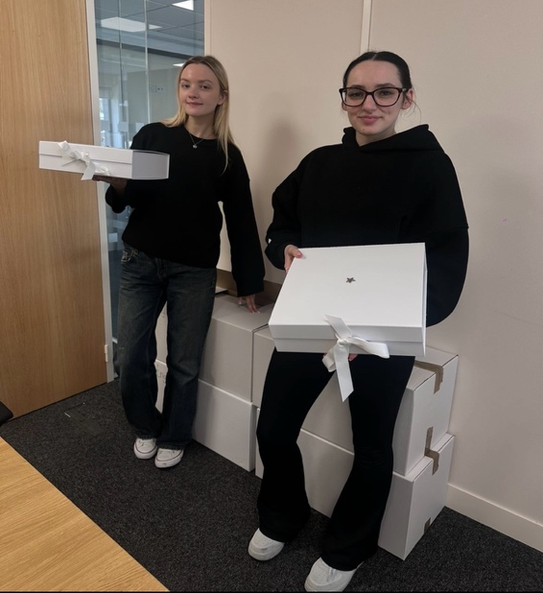
I initially felt unsure about speaking up as I worried that I would be undermining a fellow volunteer, however, it was important to recognise the emotional necessity of the boxes, and overlooking such incident could effect a bereaved family. This has direct links to the principles of the code of ethics, in particular, leadership, honesty, integrity, respect and public service (College of Policing, 2024). Whilst no laws were directly involved, I acted responsibly and followed the organisations procedures to maintain that the boxes were prepared accurately, this refers to the wider policing principle of carrying out a duty with integrity and in accordance with policies (HM Inspectorate of Constabulary, 1999). Rather than assuming someone else would correct the mistake, I understood that we had to maintain a service to be proud of, as well as by highlighting the omission I hope to have helped others improve and highlight the importance of improving outcomes (College of Policing, 2014). The Code of Ethics was created to establish consistent standards of behaviours, it is crucial that all public servants familiarise themselves with this code, the home office has stated that it will apply to more than 220,000 officers and volunteers (Home Office, 2014). This experience highlighted for me that small mistakes can have significant consequences, as an officer I will be dealing with a bundle of evidence and this scenario reinforced the importance to attention to detail. Moving forward, I believe I wouldn't change how I reacted as it was necessary for the moment.
When deciding on an organisation to choose for my 80 hours of voluntary work, I was torn on where to go, until I came across 2Wish and realised that if I was to ever understand vulnerability, starting with a bereavement organisation would help me a step up, I'm eternally grateful for the charity for trusting myself with such a sensitive yet rewarding experience and for the lessons I have learned along the way. Reflecting on the three scenarios mentioned above has demonstrated that effective volunteering extends beyond carrying out tasks but requires empathy, respect, professionalism, understanding, integrity, ethical decision making and the confidence to respond to challenging situations, impacting positively on many lives (Citizens Advice, 2015). These experiences have strengthened my understanding of reflective practice and has enabled me to critically evaluate the decisions that I make, recognising areas of strength and identifying opportunities for growth and development. Overall, this placement has enhanced my confidence and resilience and taught me many lessons I wish to take with me throughout my career with policing.

References
College of Policing, 2016. Mental Vulnerability and Illness. Available at: https://www.college.police.uk/app/mental-health/mental-vulnerability-and-illness (Accessed 10/7/26)
College of Policing, 2014. Latest changes- National Decision Model. Available at: https://www.college.police.uk/app/national-decision-model/changes (Accessed 10/7/26)
College of Policing, 2013. National Decision Model. Available at: https://www.college.police.uk/app/national-decision-model/national-decision-model (Accessed 10/7/26)
College of Policing, 2021. Communication. Available at: https://www.college.police.uk/guidance/vulnerability-related-risks/communication (Accessed 10/7/26)
College of Policing, 2024. Ethical policing principles. Available at: https://www.college.police.uk/ethics/code-of-ethics/principles (Accessed 10/7/26)
Citizens Advice, 2015. Importance of volunteers. Available at: https://www.citizensadvice.org.uk/about-us/information/understanding-the-benefits-of-volunteering/ (Accessed 10/7/26)
College of Policing, 2014. Code of Ethics: A Code of Practice for the Principles and Standards of Professional Behaviour for the Policing Profession of England and Wales. Available at: https://assets.publishing.service.gov.uk/media/5a7de6dfed915d74e33eec19/Code_of_Ethics_2014_FINAL_July14.pdf (Accessed 10/7/26)
Gibbs, 2013. Learning by doing: A guide to teaching and learning methods. Oxford centre for staff and Learning Development. Section 4.3.5 (Accessed 10/7/26)
HMICFRS, 2023. Policing and Mental Health: Picking up the pieces. Available at: https://hmicfrs.justiceinspectorates.gov.uk/publication-html/policing-and-mental-health-picking-up-the-pieces/ (Accessed 10/7/26)
Home Office, 2014. Code of Ethics Launched. Available at: https://www.gov.uk/government/news/code-of-ethics-launched (Accessed 10/7/26)
HM Inspectorate Of Constabulary, 1999. Police Integrity- Securing and maintaining public confidence. Available at: https://assets-hmicfrs.justiceinspectorates.gov.uk/uploads/police-integrity-19990601.pdf (Accessed 10/7/26)
Mind, 2019. Key facts and statistics about mental health. Available at: https://www.mind.org.uk/information-support/a-z-mental-health/mental-health-facts-and-statistics/ (Accessed 10/7/26)
NHS, 2022. Learning Cycle (Kolb, 1984) Available at: https://www.hee.nhs.uk/sites/default/files/documents/Kolb%20learning%20cycle.pdf (Accessed 10/7/26)
Northamptonshire Police, 2017. (PDF) Code of Ethics. Available at: https://www.northants.police.uk/SysSiteAssets/media/downloads/northamptonshire/about-us/code-of-ethics-booklet.pdf (Accessed 10/7/26)
University of Hull, 2024. Reflective writing: Gibbs. Available at: https://libguides.hull.ac.uk/reflectivewriting/gibbs (Accessed 10/7/26)
2Wish, 2021. (PDF) Mental Health Information Leaflet. Available at: https://2wish.org.uk/wp-content/uploads/2025/01/mental-health-information-leaflet-ENG-PRINT.pdf (Accessed 10/7/26)
2Wish, 2023. Memory Boxes. Available at: https://2wish.org.uk/get-support/memory-boxes/ (Accessed 10/7/26)
2Wish, 2023. Rhian’s Story. Available at: https://2wish.org.uk/about-us/rhians-story/# (Accessed 10/7/26)
2Wish, 2025. Our Services: What you need to know. Available at: https://2wish.org.uk/our-services/ (Accessed 10/7/26)

