Name: Jessica De schoolmeester

Student Number: 2503086

WORKSHEET 2 – TESTING (Carrots)

- Original code:

[Copy and paste your original code from Moodle into this box. Do not change it.]

print("Please enter the height of your garden bed:")
userHeight = int(input())
while userHeight <8:
print("You won't be able to grow any carrots")
print("try again?")
userHeight = int(input())
print("Please enter the width of your garden bed")
userWidth = int(input())
while userWidth <8:
print("You won't be able to grow any carrots")
print("Please enter a number above 8")
userWidth = int(input())
userHeight2 = userHeight // 8
userWidth2 = userWidth // 8
userCarrots = userHeight2 * userWidth2
print(f"You can grow {userCarrots} carrots")

- Code Testing

For each test below (i-vi, run your code and enter the values provided. Provide a screenshot of the programme output. Did the programme behave correctly or did it do something unexpected? Fill in a box for each test below.

Input – are the following dimensions in range?:

- Enter dimensions: Width 45 Length 85
- Enter dimensions: Width 7 Length 25
- Enter dimensions: Width -16 Length -20

Logic:
- Enter dimensions: Width 27 Length 30. The result should be 9 carrots.
- Enter dimensions: Width 32 Length 32. The result should be 16 carrots.
- Enter dimensions: Width 7 Length 16. The result should either be 0 carrots, or you may have accounted for this in your validation at the input phase.

Test i:
Input - Enter dimensions: width 45 length 85

Screenshot(s) of output:
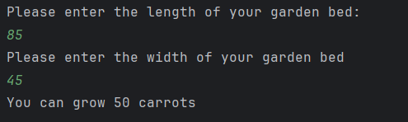
Result: Did the programme behave as expected ie syntactically and logically correct?
YES (delete as appropriate)
If YES, comment on what happened

The program produced an output of 50 carrots, which is both logically and syntactically correct. It correctly accounted for the fact that the user cannot grow half a carrot by only using full 8 × 8 grid spaces when calculating how many carrots can be planted.

Test ii:
Input - Enter dimensions: width 7 length 25

Screenshot(s) of output:
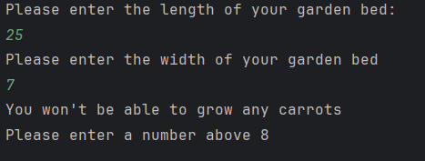
Result: Did the programme behave as expected ie syntactically and logically correct?
YES (delete as appropriate)
If YES, comment on what happened

The program correctly prevented the user from entering a value of 7, since the garden bed must be at least 8 × 8. As a result, the user was prompted to try again until a valid input (8 or greater) was entered.

Continue the rest of the tests below. (Copy and paste a box for each one)

Test:
Input - Enter dimensions: Width -16 Length -20

Screenshot(s) of output:
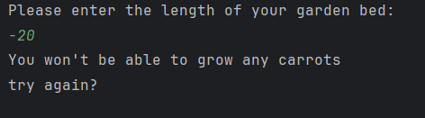
Result: Did the programme behave as expected ie syntactically and logically correct?
YES (delete as appropriate)
If YES, comment on what happened

The program correctly handled input validation by not allowing the user to enter a negative value and prompting the user to try again.

Test:
Input - Enter dimensions: Width 27 Length 30. The result should be 9 carrots.

Screenshot(s) of output:
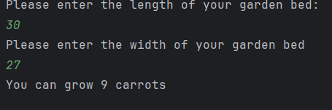
Result: Did the programme behave as expected ie syntactically and logically correct?
YES (delete as appropriate)
If YES, comment on what happened

The program output indicated that the user could grow 9 carrots, and the program functioned correctly both logically and in terms of syntax.

Test:
Input - Enter dimensions: Width 32 Length 32. The result should be 16 carrots.

Screenshot(s) of output:
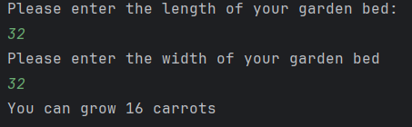
Result: Did the programme behave as expected ie syntactically and logically correct?
YES (delete as appropriate)
If YES, comment on what happened

The program produced an output of 16 carrots, and this result is both logically valid and syntactically correct.

Test:
- Input Enter dimensions: Width 7 Length 16. The result should either be 0 carrots, or you may have accounted for this in your validation at the input phase.

Screenshot(s) of output:
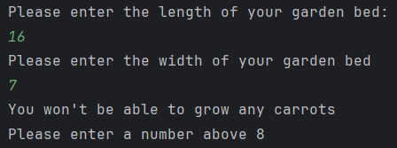
Result: Did the programme behave as expected ie syntactically and logically correct?
YES (delete as appropriate)
If YES, comment on what happened

The program’s syntax included validation to handle this case and prompted the user to enter a value above 8 when an invalid input was provided.

- Consider the results of the above tests and revisit your code in order to solve any problems discovered at the testing phase. (Note: you may not be able to solve all of them, but solve as many as you can.)

Paste your revised code here:

[Copy and paste your revised code here – note, do not use a screenshot]

print("Please enter the length of your garden bed:")
userLength = int(input())
while userLength <8:
print("You won't be able to grow any carrots")
print("try again?")
userLength = int(input())
print("Please enter the width of your garden bed")
userWidth = int(input())
while userWidth <8:
print("You won't be able to grow any carrots")
print("Please enter a number above 8")
userWidth = int(input())
userHeight2 = userLength // 8
userWidth2 = userWidth // 8
userCarrots = userHeight2 * userWidth2
print(f"You can grow {userCarrots} carrots")

