University of Wales Trinity Saint David
School of Engineering
Can FEA replace physical testing?
Christopher Hopkins
149588
24/04/2020
Advanced Stress Analysis & FEA M6X00420
Kelvin Lake
Contents
1 Introduction 1
1.1 Aims 1
3 Carrying Out both FEA and physical testing 2
4 How Physical testing may be correlated to an FE model 5
5 Can and should FEA replace physical testing. 9
6 Conclusion 10
7 References 11

Figure 3.1 (Bechtel, et al., 2009) Results 2
Figure 3.2 (Chajes, et al., 2010) Results 3
Figure 4.1 (Yucheng, 2013) Results 5
Figure 4.2 V&V plan (Abbey, 2015) 6
Figure 4.3 (Rawson, 1994) Results 7
Figure 4.4 (Rawson, 1994) Results 2 7
Figure 5.1 TML 10

Introduction
This report will undertake an investigation into the role that finite element analysis (FEA) plays during production and development when applied to destructive and non-destructive testing within the industry. The report will examine 3 areas of study, the first being the use finite element analysis coupled with real world physical testing and why companies typically carry out both when finite element analysis should remove the need for physical testing. Following this, a study will be carried out into the impact physical testing may have on a finite element model and the connection between the two forms of testing. Finally, an enquiry into the possibility of replacing physical testing completely in support of finite element analysis discussing the possibility and if so the practicality of the matter. Finally, the information gathered within the 3 sections will be correlated and concluded upon with justification based upon the research gathered.

Aims
- Using a case study investigate why companies tend to carryout both finite element analysis and physical testing during the design stage of a product determining the usefulness of this concept
- Investigate the relationship between physical testing and finite element analysis in hopes of determining how finite element analysis is affected by physical testing
- Discuss whether finite element analysis could be used to completely replace physical testing by exploring the pros and cons of this with the aim of making an educated judgement on the viability of removing physical testing.

Carrying Out both FEA and physical testing
Typically, when designing a product, a company will use both finite element analysis alongside physical testing. However, this means companies are spending time and resources on two different testing methods leaving the question why?
According to (Bechtel, et al., 2009) although advancements in FEA have allowed for more accurate system-level analyses, allowing for a more efficient design process some knowledge surrounding simulated solutions is still too sparse to make it perfectly accurate. (Bechtel, et al., 2009) used both destructive testing and FEA to determine the ultimate capacity of skewed steel I-Girder bridges. When preforming physical testing 2 of the 4 bridge girders exceeded yield with the application of 12 -13 scaled trucks with the ultimate capacity of the bridge being 22 scaled trucks. However, 3 FEA models were created 2 of which failed as they incorporated a static analysis, whereas the final model used an Explicit central difference operator was successful and predicted the load of 21 scaled trucks would achieve the ultimate capacity. This means that the FEA model was within 1 truck load of the physical test results showing high accuracy between the two methods. However, figure 3.1 shows the comparison of load to deflection between the 2 tests. Although at lower loads girders 2-3 show practically identical deflection the FEA model is not 100% accurate throughout the higher loads.
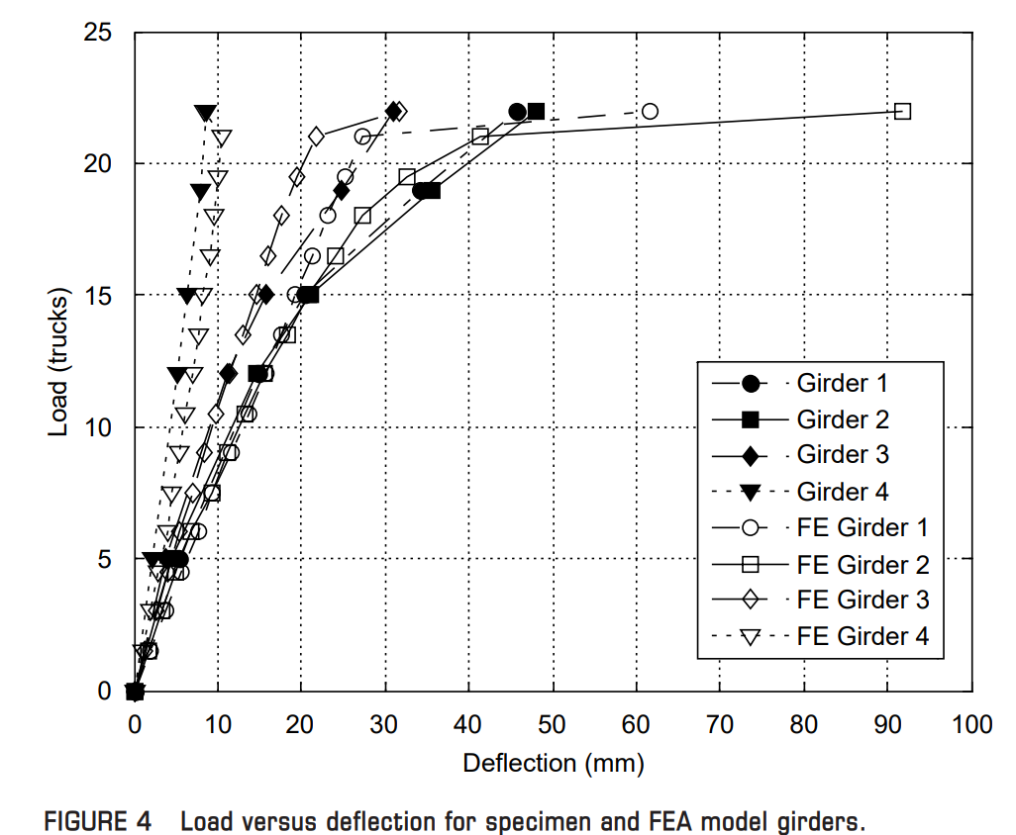
Figure 3.1 (Bechtel, et al., 2009) Results
The accuracy concerns of standalone FEA modelling are further backed up by a similar study also carried out on I-Girders by (Chajes, et al., 2010) where FEA predicts higher strain at almost every load increment.
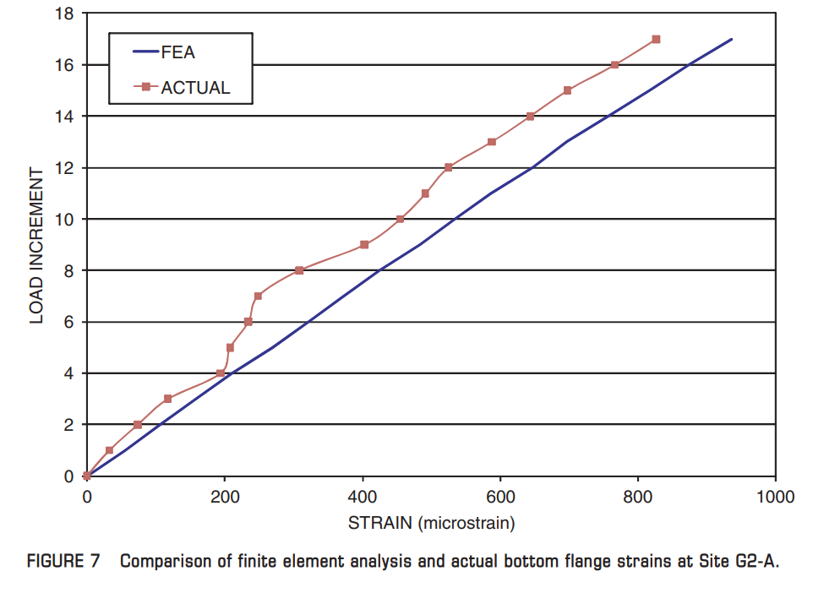
Figure 3.2 (Chajes, et al., 2010) Results
These studies demonstrate one reason companies use both FEA and physical testing as although FEA was close to the real word values there was a slight difference even if the simulation predicted a lower ultimate capacity in this instance, if the product wasn’t physically tested and the FEA model suggested a bridge that could support a load that it couldn’t it would cause major implications on the manufacturers. This suggests that companies are likely to use FEA models to achieve close values and then when happy with a design verifying the FEA model with physical testing resulting in fewer prototypes but verified and validated results. Finally, these studies are both backed up by (Design World Staff, 2007) who state that the method used by FEA is an approximation as the analysis is produced on a model rather than the structure itself meaning that for full trust within the results tests must be carried out on both the model and real structure. This does however allow for a reduced number of studies to be carried out on the real structure reducing the overall cost.
Additionally, (Penner, 2020) finds that linear FEA solvers have severe limitations in the case of stress concentrations like gussets or keyways. This is due to the large stress over a very small area causing the material to yield and no longer behave linearly. This can lead to parts failing unexpectedly when produced and resulted in the company running stress concentration tests alongside FEA to determine acceptable stress concentrations. Linear solvers, however, use drastically lower computer resources and time making them the only viable option at times. Both the above points are backed up by (Pre Technologies, 2020) claiming that linear solvers lead to significant computational and cost savings as the stiffness matrix is presumed to be unchanged throughout the simulation. However, when a ductile material has a load exerted upon it that surpasses the materials yield point more complex and expensive FEA is required which further supports the use of more accessible software with the addition of physical testing for verification.
Finally, According to (Kurowski, 2002), although FEA software is becoming easier to use it is not a simple programme that just anyone can use and therefore there is an aspect of possible human error defining objects. Poorly defined FEA objects are a wasted effort as they will not produce accurate results. This suggests that the use of physical testing is required to verify the results of FEA. However, also advise about human error with a focus on human error during manufacturing which could skew the results of FEA testing due to unforeseen tolerances. Without the use of physical testing in addition to FEA in this case produced ships could fail in the real world that would be deemed functional within FEA.

How Physical testing may be correlated to an FE model
Once a model structure has been formed the only way to verify the results accuracy is through physical testing of the actual structure and comparing the results to those of the FE model. This is because the FE model is only an approximation of the real structure and the simulation is not being ran on the real structure.
“All models are wrong, but some are useful “ (Box & Draper, 1987, p. 424)

With that being said, for the model to be useful the validity of the calculations must be proven through physical testing. This means that if the FE results do not match nor follow a strong correlation to the physical results then something within the FE model is incorrect. This may be down to a few things, such as the initial material parameters being set wrong/insufficient meshing which is demonstrated in (Yucheng, 2013) ran a range of simulations on a metal plate with the independent variable being the mesh density.
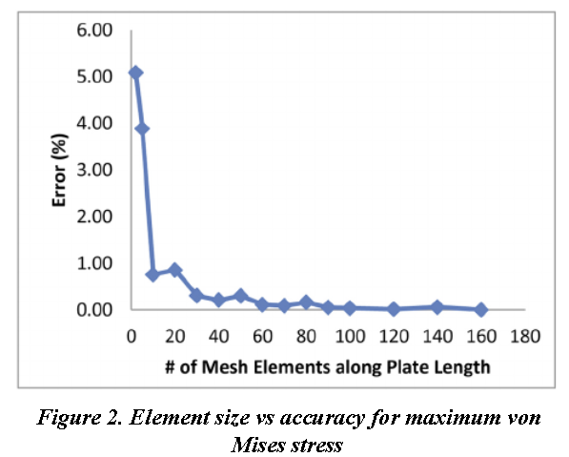
Figure 4.1 (Yucheng, 2013) Results
As seen in figure 4.1 the trend appeared to show that the higher the density the lower the error % with a few outliers towards the higher end. The study also showed the increase in computing time suggesting that using physical testing to gauge an appropriate mesh value that would provide accurate enough results without drastically increased run time. This could be done by investigating the error % and selecting an acceptable error % which could remove hours from the simulation for 0.1% of an error.
(Abbey, 2015) suggests that FEA and physical testing are correlated together through verification and validation. Verification is the checks carried out on the FE model to ensure that the model itself is working, the maths used within the simulation is correct and providing an accurate analysis. Validation is making sure that not only does it work but that it does what it is supposed to do, gets the physics correct and is checking the model against the physical test. From this it can be assumed that verification consists of typical checking process periodically as the model develops whereas validation is the process of comparing the model against available test data.
“Verification: The process of determining that a computational model accurately represents the underlying mathematical model and its solution.” (ASME, 2006)
“Validation: The process of determining the degree to which a model is an accurate representation of the real world from the perspective of the intended uses of the model.” (ASME, 2006)
Figure 4.2 demonstrates a combined verification and validation plan.
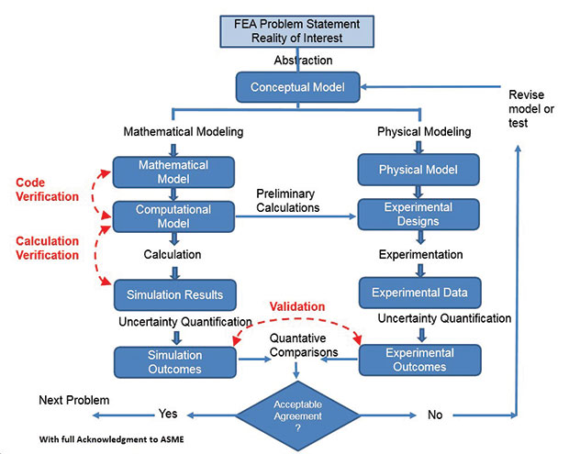
Figure 4.2 V&V plan (Abbey, 2015)
Comparing test and analysis based on metrics means that that single comparison such as ultimate failure in destructive testing is supplemented by numerous incremental metrics. This allows for a greater validation between physical testing and the FE model.
(Rawson, 1994) who conducted a study comparing FEA with actual physical test data of a thermoplastic bumper that would replace steel bumpers within the automotive industry. The results from the study show that the model was verified as shown in figure 4.3 by the FEA model following a similar trend to the physical test. However, the model isn’t validated as closely and could do with extra refinement so that the model closer fits the real-world data and therefore making the FEA results more reliable for future tests.
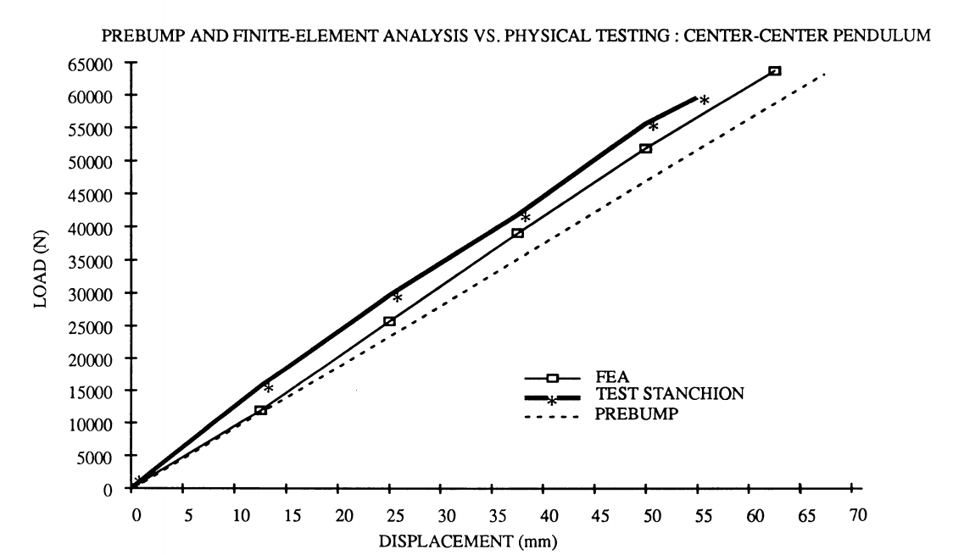
Figure 4.3 (Rawson, 1994) Results
Further tests also show similar trends where the model fits the general trend however doesn’t perfectly match the results of the physical testing as shown in figure 4.4
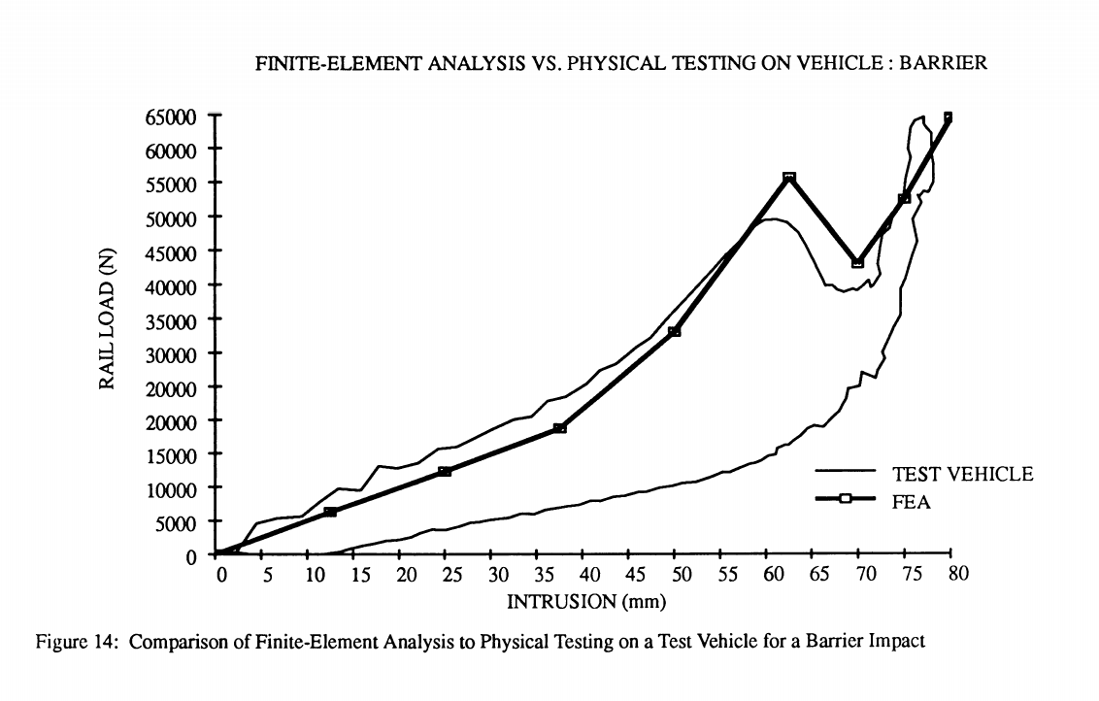
Figure 4.4 (Rawson, 1994) Results 2
A study carried out by (Cheng, et al., 2001) where a reverse engineered FE model of a 1997 Honda Accord is refined to improve the computational performance of the model, and validate the crash response with crash data of actual vehicles. Various issues with this were noted by the researchers such as missing parts that weren’t located in major load transmission paths, connection problems such as correct welding modelling and with over 200 parts assigning the correct material properties proved difficult. The model was then compared to physical data numerous times and refined each time until the FE model was a closer representation to the physical test data. The study concluded with a successful model that was validated as a suitable for use as a crash partner for other vehicles. Tests found that the model was computationally stable, reliable and repeatable. This means that without real manufacturers models accurate FE models can still be created through verification and validation means, retesting the FE model with refined parameters section by section allowed for an accurate representation of a physical model suggesting the influence from physical testing on FE models can help to obtain realistic FE models.

Can and should FEA replace physical testing.
FEA has became a very important product testing tool for manufacturers. Due to this it has become a very integral part within the design process for engineers. It has significantly assisted manufacturers in the reduction of product development time as well as the associated costs. As a tool capable of predicting flaws within designs as well as preforming ultimate capacity simulations with a good amount of accuracy, provided initial conditions are set up correctly. However, the question remains whether finite element analysis could replace physical testing now or in the future?
According to (Vyas, 2015) computer simulations provide results based on mathematical equations that are solved to define the physical system. As such, the results of the simulation are based upon the user’s inputs and therefore meaningful results are at the experience and expertise of the user itself. This creates arguments for both sides as valid inputs would allow for physical testing to be removed however, the risk of human error supports maintaining the relationship between physical testing and FEA.
Additionally, although there have been many phenomena that can be defined accurately through equations that can be applied to data to validate results, changes in design or parameters being input can produce different results that would need to be further validated. Furthermore, if the results obtained fail the study would need to be repeated in a physical nature. This would suggest that FEA wouldn’t be capable of replacing physical testing completely as there are too many uncertainties when creating new designs that could react differently to current designs making physical testing of some sort paramount when refining models and to improve their accuracy. This is backed up by (Thornton, 2011) & (Parnell, cited by Wong, 2010) who states that FEA does not remove the need for prototypes just reduces the amount needed and without physical testing to validate the FEA the results are not credible. Additionally, according to (Schmitz, 2016) concluded that the use of simulation does not replace the need for verification and validation. Although it does allow for testing with greater efficiency reducing results time from months down to mere hours. (Vyas, 2015) does however suggest that models that have been developed using several experimental validations may be able to eliminate physical tests completely.
Moreover, (Vyas, 2015) states that as new materials are being developed and tested to replace conventional ones such as carbon fibre, it is difficult to predict behaviour for them if there is no prior testing been conducted on this material suggesting that physical testing will always be required as technology and ideas develop.
(Parnell, cited by Wong, 2010) states that simulation by itself is not enough. However, the amount of physical testing required depends on the the value of the product even more so in products that involve life and saftey. This suggests that physical tests can be very important and irreplaceable for any product designed to protect an individual as a simulation is never 100% accutrate.
Finally, (Vyas, 2015) believes that although currently physical tests are a necessity with the development into 2 areas there might be a possibility of removing physical testing all together. This would require development of systematic maturity model. In 2013 a platform was established to evaluate simulation tools for composites. The purpose of the hub was to certify simulation tools. Tools are assessed using the Tool Maturity Level which is split into the 5 levels displayed in figure 5.1.
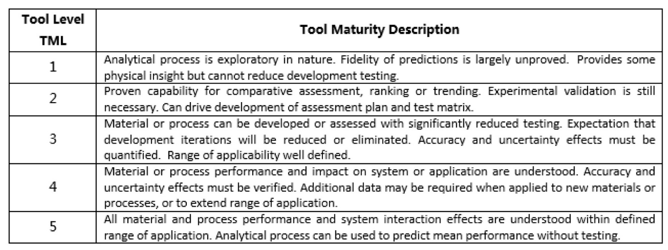
Figure 5.1 TML
At level 5 the model is considered to be mature enough to carry out stimulations without V&V Vyas believes that further development into this model would bring us closer to removing physical tests. The second area Vyas believes exascale computing or increasing computational power more specifically from peta to exa allowing for more sophisticated calculations. However, this would require huge expenditures but is a necessity for computational science to be fully predictive for real world systems. This suggests that although there is no way to replace physical testing currently there is a possibility that this could only be for a limited amount of time if developments allow for it.

Conclusion
To conclude companies, tend to use both FEA and physical tests for numerous reasons most tying into each other. The first being accuracy of the model, it is possible to receive results that do not represent the real-world model and even if the results do, they will never be perfect as the simulations is on a model not the real product. Accuracy can also be affected by human input errors which would lead to incorrect simulation. Inaccurate simulation could be dangerous if left untested physically holding companies accountable for any injuries caused by not testing thoroughly enough. Finally, some FE software’s only offer linear solvers meaning material properties are kept the same. This would mean that although simulations can be carried out if the material is to go into yield it won’t be modelled. For this reason, it is common for a company to run simulations on a design and then verify it on a prototype.
The main correlation between physical testing and FE models is verification and validation. A lonely FE model may be verified correctly acting in an expected was however without validation from physical testing to refine and improve the accuracy of the simulation the model is practically useless therefore the FE model and physical testing are used together throughout the process to provide an accurate representation of the real world within the simulation with as little money spent.
Finally, FEA cannot currently replace physical testing completely. The use of FE models has drastically reduced the number of physical tests that are required because using a verified and validated model removes the need for most physical tests used along the design process but not the need for a final test to validate the results throughout. This is most important with products that involve life or safety. There could, however, be a possible scope to make physical tests obsolete in future by hardware developments allowing for more complex simulations and development of models that are sophisticated enough to not need further V+V (TML)

References
Abbey, T., 2015. Verification vs. Validation in Relation to FEA. [Online]
Available at: https://www.digitalengineering247.com/article/verification-vs-validation/
[Accessed 22 01 2020].
ASME, 2006. Guide for Verification and Validation. [Online]
Available at: https://cstools.asme.org/csconnect/FileUpload.cfm?View=yes&ID=24816
[Accessed 21 04 2020].
Bechtel, A. J., McConnell, J. R. & Chajes, M. J., 2009. Destructive Testing and Finite Element Analysis to Determine Ultimate Capacity of Skewed Steel I-Girder Bridges. Transportation Research Record: Journal of the Transportation Research Board, 2131(1), pp. 49-56.
Box, G. E. P. & Draper, N. R., 1987. In: Empirical Model-Building and Response Surfaces. New York: John Wiley & Sons, Inc., p. 424.
Chajes, M. J. et al., 2010. Full-Scale Destructive Bridge Test Allows. Transportation Research Record, 2200(1), pp. 117-124.
Cheng, Z. Q. et al., 2001. Experiences in reverse-engineering of a finite element automobile crash model. Finite Elements in Analysis and Design, 37(11), pp. 843-860.
Dascotte, E. & Schönrock, A., 1999. Validation and updating of an aeroengine finite element model based on static stiffness testing.. s.l.:s.n.
Design World Staff, 2007. Using FEA to study a mechanical part. [Online]
Available at: https://www.designworldonline.com/using-fea-to-study-a-mechanical-part/
[Accessed 15 04 2020].
Kurowski, P., 2002. When Good Engineers Deliver Bad FEA. [Online]
Available at: https://www.machinedesign.com/3d-printing-cad/fea-and-simulation/article/21831586/when-good-engineers-deliver-bad-fea
[Accessed 15 04 2020].
Penner, R., 2020. The Limitations of Finite Element Analysis. [Online]
Available at: https://www.spartaengineering.com/the-limitations-of-finite-element-analysis/
[Accessed 15 04 2020].
Pre Technologies, 2020. Advantages of finite element analysis (FEA). [Online]
Available at: pretechnologies.com/services/finite-element-analysis/advantages
[Accessed 15 04 2020].
Rawson, J. M., 1994. Comparison of Analysis Results to Physical Testing for the Performance of Engineering. JOURNAL OF MATERIALS &MANUFACTURING, Volume 103, pp. 81-88.
Schmitz, B., 2016. Testing is inefficient: Material simulation’s advantage over the status quo. [Online]
Available at: https://www.compositesworld.com/articles/testing-is-inefficient-material-simulations-advantage-over-the-status-quo
[Accessed 24 04 2020].
Thornton, J., 2011. FEA and the Question of Credibility. [Online]
Available at: https://www.asme.org/topics-resources/content/fea-and-the-question-of-credibility
[Accessed 24 04 2020].
Vyas, K., 2015. Can Simulation Tools Replace Physical Tests Completely?. [Online]
Available at: https://www.designworldonline.com/can-simulation-tools-replace-physical-tests-completely/
[Accessed 24 04 2020].
Wong, K., 2010. Is Digital Simulation Good Enough to Replace Physical Tests?. [Online]
Available at: https://www.digitalengineering247.com/article/is-digital-simulation-good-enough-to-replace-physical-tests
[Accessed 24 04 2020].
Yucheng, L., 2013. Effects of Mesh Density on Finite Element Analysis. SAE Technical Papers, Volume 2.

