`
Introduction to Web and Database Concepts
Component 1- Coursework
11/6/2026

Module NaMe: Introduction to Wed and database concepts
Module Code: ACCA4023
Lecturer: Dr Anum paracha
Trinity saint david University of Wales (London Campus)

Mohamed Camara (2533434)
Student ID: 2533434
Group: 2


Contents
1. Introduction & scenario analysis 2
A. Introduction 2
B. Scenario Analysis 2
2. ERD section 4
3. Data Structure & Table Design 5
4. Normalization Compliance (Third Normal Form - 3NF) 7
5. Sample Data Population 8
6. Query Development 8
7. Forms & Reports 12
8. Validation & Testing 12
9. Reflection 13
10. Conclusion 13
References 14

1. Introduction & scenario analysis

A. Introduction
AutoPark Management System is a large company that manages multiple parking locations across the city. Based on their business scenario, I am going to develop a robust database solution using Microsoft Access to improve their operations.
Currently, the staff perform all their daily tasks manually by recording vehicle entries, parking slot allocations, customer details, and payments on paper. This manual system increases the risk of human error, data loss, and inefficient use of available parking spaces.[1] In addition, it is difficult for managers to produce accurate weekly and monthly reports from paper-based records. Database management systems enable organisations to store, retrieve, and analyse information efficiently, making report generation much easier.[2]
The main goal of this project is to address these challenges by designing and implementing a Microsoft Access database that automates the parking management process. The database will store and organise information relating to customers, vehicles, parking locations, bookings, and payments. By replacing the manual system with a database solution, the organisation will improve data accuracy, reduce data redundancy, and increase operational efficiency.[3] As a result, the new system will make day-to-day operations faster, more secure, and much easier for managers.

B. Scenario Analysis
The AutoPark Management System is designed to automate the management of multiple parking sites across the city. The current manual system causes data redundancy, errors, and inefficient parking space management. The proposed database system will centralize information about parking sites, parking slots, customers, vehicles, bookings, and payments, allowing real-time monitoring of parking operations and improving decision-making.
Main Entities:
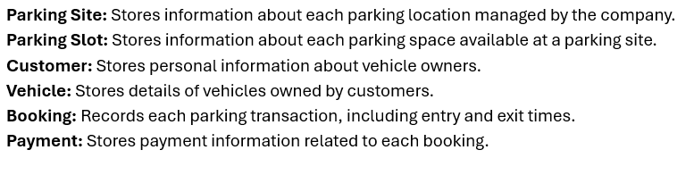

Entity Attributes:
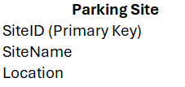
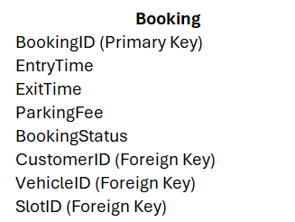
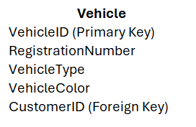
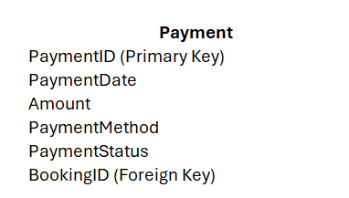
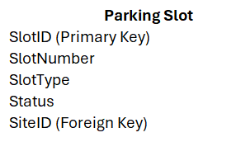
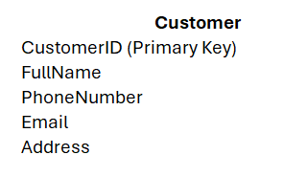

Relationships Between Entities:
The relationships identified in the database are as follows:
Parking Site – Parking Slot (1:N)
- One Parking Site can contain many Parking Slots (1:N).
- Each Parking Slot belongs to only one Parking Site.
Customer – Vehicle (1:N)
- One Customer can own multiple Vehicles (1:N).
- Each Vehicle is owned by only one Customer.
Customer – Booking (1:N)
- One Customer can make multiple Bookings (1:N).
- Each Booking is associated with only one Customer.
Vehicle – Booking (1:N)
- One Vehicle can be involved in multiple Bookings over time (1:N).
- Each Booking is linked to only one Vehicle.
Parking Slot – Booking (1:N)
- One Parking Slot can be allocated to multiple Bookings over time (1:N).
- Each Booking is assigned to only one Parking Slot.
Booking – Payment (1:1)
- One Booking generates exactly one Payment (1:1).
- Each Payment is associated with only one Booking.

2. ERD section
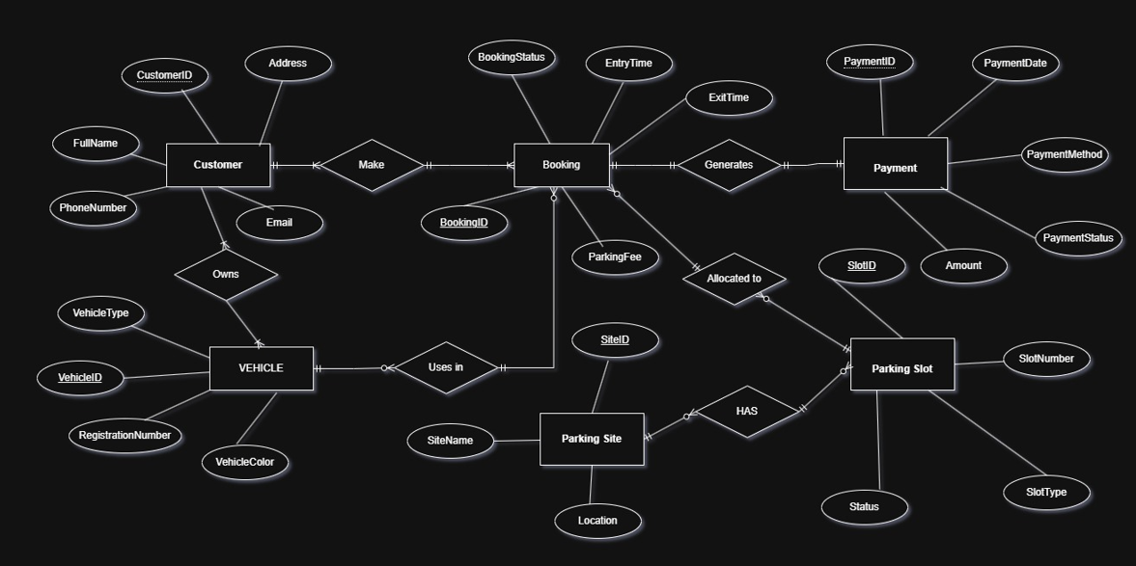 Untitled Diagram.drawio.html - draw.io

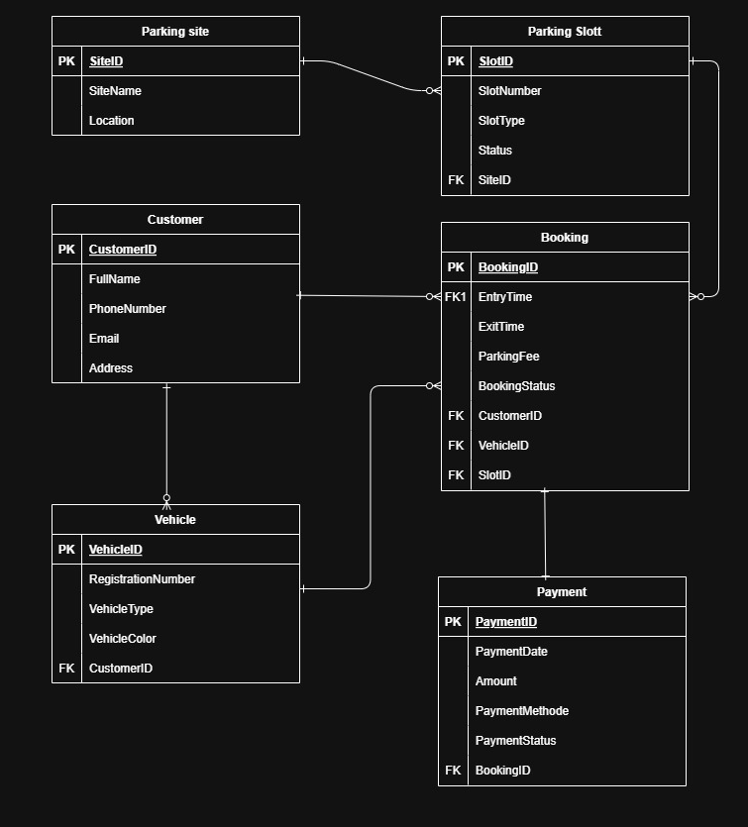 Diagram.drawio - draw.io

3. Data Structure & Table Design
The database structure is developed from the Entity Relationship Diagram (ERD). Each entity is implemented as a table, with Primary Keys (PK) uniquely identifying each record and Foreign Keys (FK) establishing relationships between tables, ensuring data integrity, consistency, and efficient relational database management throughout the system.

Entity Design
Entity | Main Attributes | Primary Key | Foreign Keys
Parking Site | SiteName, Location | SiteID | —
Parking Slot | SlotNumber, SlotType, Status | SlotID | SiteID
Customer | FullName, PhoneNumber, Email, Address | CustomerID | —
Vehicle | RegistrationNumber, VehicleType, VehicleColor | VehicleID | CustomerID
Booking | EntryTime, ExitTime, ParkingFee, BookingStatus | BookingID | CustomerID, VehicleID, SlotID
Payment | PaymentDate, Amount, PaymentMethod, PaymentStatus | PaymentID | BookingID

Relationship Implementation
The relationships identified in the ERD are implemented through foreign keys:
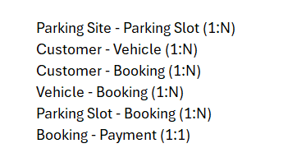
Data Integrity Constraints
To ensure data accuracy and consistency, the following constraints are applied:
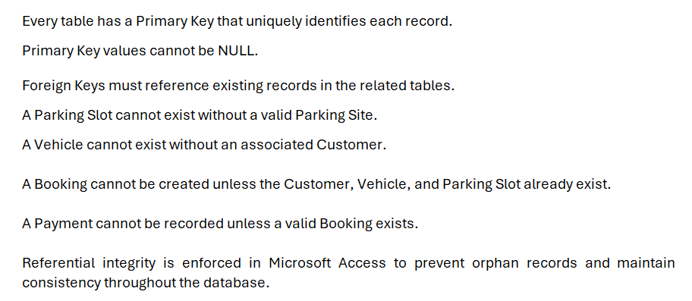
The proposed database structure provides a reliable and efficient foundation for the AutoPark Management System. By implementing primary keys, foreign keys, and referential integrity constraints, the system minimizes data redundancy, maintains data consistency, and supports accurate management of parking operations.
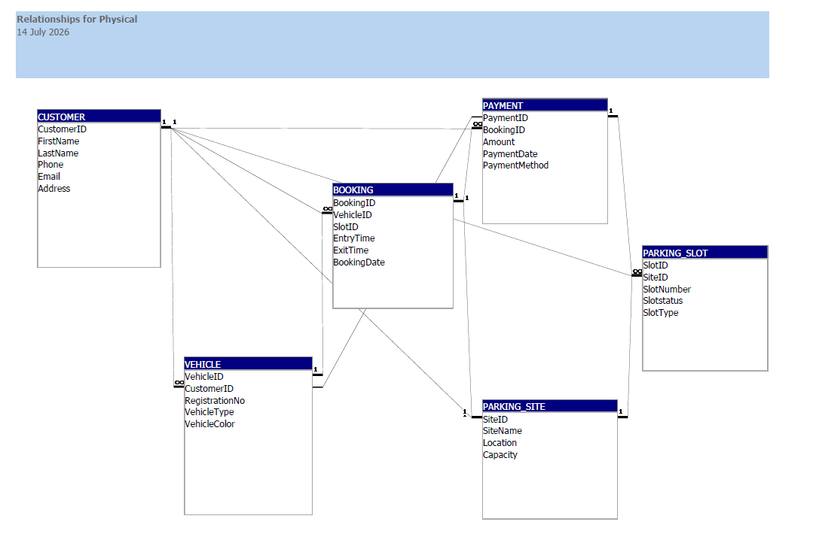 Relationships for physical

4. Normalization Compliance (Third Normal Form - 3NF)
The Management System database is designed in Third Normal Form (3NF) to reduce data redundancy and maintain data integrity. Each table stores information about a single entity, and every attribute depends on the table's primary key.
The database satisfies the normalization rules as follows:
- First Normal Form (1NF): Each table contains atomic values, with no repeating groups or multiple values in a single field. For example, the Customer table stores one phone number, one email address, and one address per customer record.
- Second Normal Form (2NF): All non-key attributes are fully dependent on the primary key. For example, in the Vehicle table, the attributes RegistrationNumber, VehicleType, and VehicleColor depend only on VehicleID, while customer details are stored separately in the Customer table.
- Third Normal Form (3NF): There are no transitive dependencies because non-key attributes do not depend on other non-key attributes. For example, customer information is stored only in the Customer table, vehicle details are stored only in the Vehicle table, and payment information is stored only in the Payment table. Relationships between these tables are maintained using foreign keys rather than duplicating data.
By applying 3NF, the database minimizes duplicate data, prevents update, insertion, and deletion anomalies, and improves data consistency. This structure also makes the AutoPark Management System easier to maintain, ensures accurate reporting, and supports efficient parking, booking, and payment management.

5. Sample Data Population
To test the functionality of the AutoPark Management System, each table was populated with realistic sample data. The sample records represent typical daily parking operations, including customers, vehicles, parking sites, bookings, and payments. This data allows the database to be tested for relationships, queries, forms, and reports. Figure 1 below shows an example of the sample data entered the Customer table in Microsoft Access.
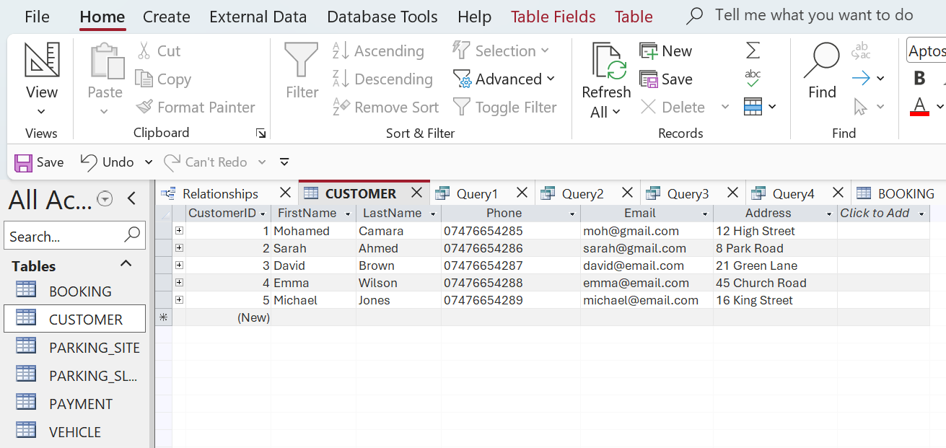 Screenshot of the Customer data in Microsoft Access.

6. Query Development
To demonstrate the functionality of the AutoPark Management System, several queries were created in Microsoft Access. These queries allow staff and managers to retrieve important information for managing parking operations efficiently.
Query 1: Customer Information
Purpose: Displays customer details stored in the system.
Criteria:
• No specific criteria (displays all registered customers).
Fields Displayed:
• CustomerID
• FirstName
• LastName
• Phone
• Email
• Address
Benefit:
This query helps staff quickly access customer information, manage customer records, and communicate with customers when required.
SQL Example: SELECT * FROM Customer;
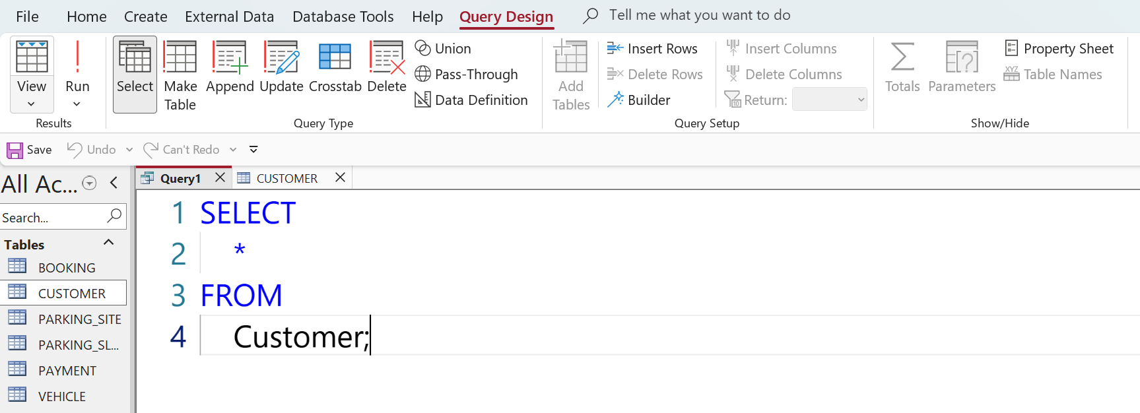
SQL SELECT query displaying all records stored in the Customer table. This confirms that customer information has been successfully saved and can be retrieved from the database.
Query 2: Add New Customer Information
Purpose: Adds a new customer record into the system.
Criteria:
• Adds a new customer with a unique CustomerID.
Fields Displayed:
• CustomerID
• FirstName
• LastName
• Phone
• Email
• Address
Benefit:
This query helps staff add new customers to the database, maintain accurate customer records, and ensure customer information is available for future services and communication.
SQL Example: INSERT INTO CUSTOMER (CustomerID, FirstName, LastName, Phone, Email, Address) SELECT 6, "Fanta", "Sylla", "07476654255", "fant@gmail.com", "25 High Street"

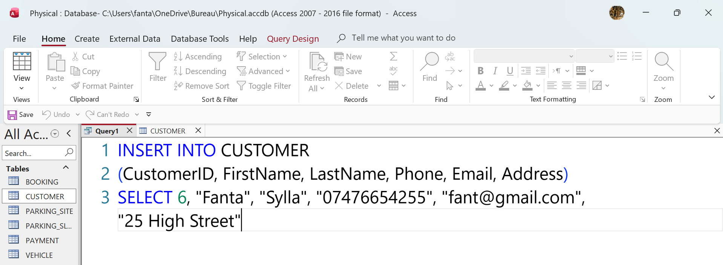
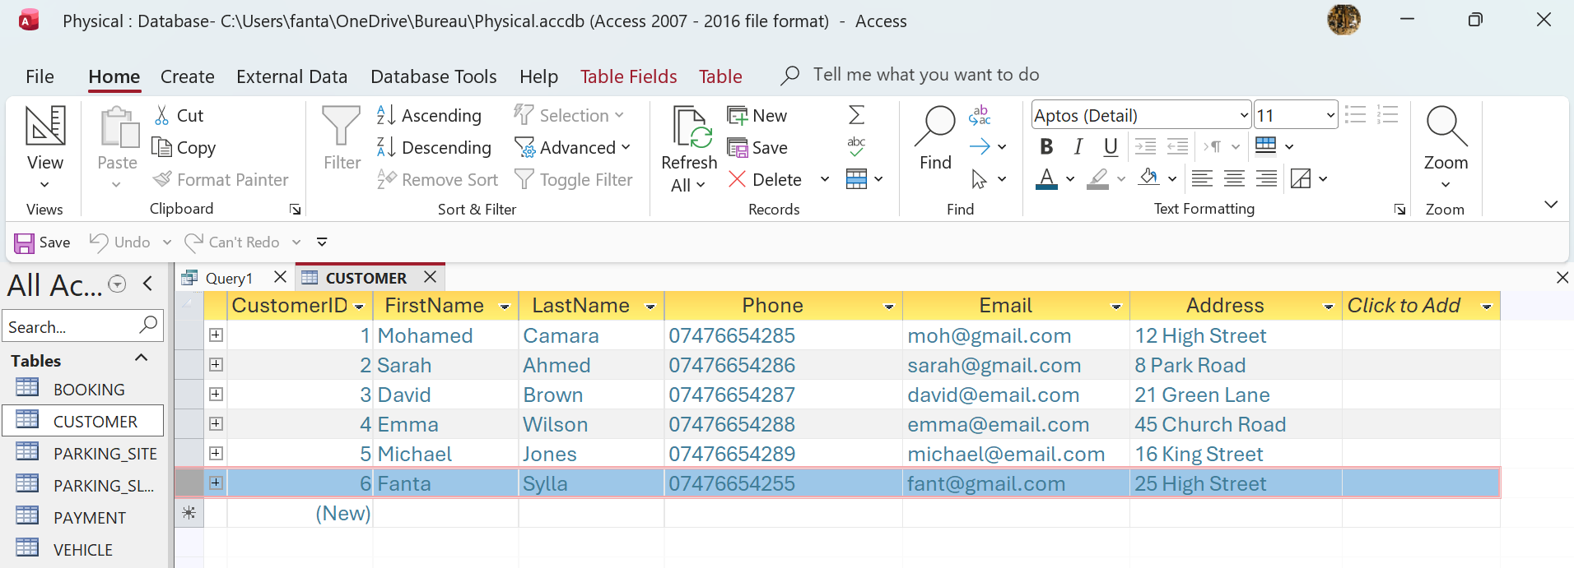 SQL INSERT statement demonstrating how a new customer is added to the AutoPark Management System database. The successful execution of this query confirms that new customer records can be stored correctly in the Customer table.

7. Forms & Reports
The Parking Site form provides a user-friendly interface for managing parking locations. It allows users to enter and update site information, including the site name, location, and capacity. The embedded subform displays all parking slots linked to the selected parking site, enabling efficient management of available parking spaces while maintaining referential integrity between the ParkingSite and ParkingSlot tables.
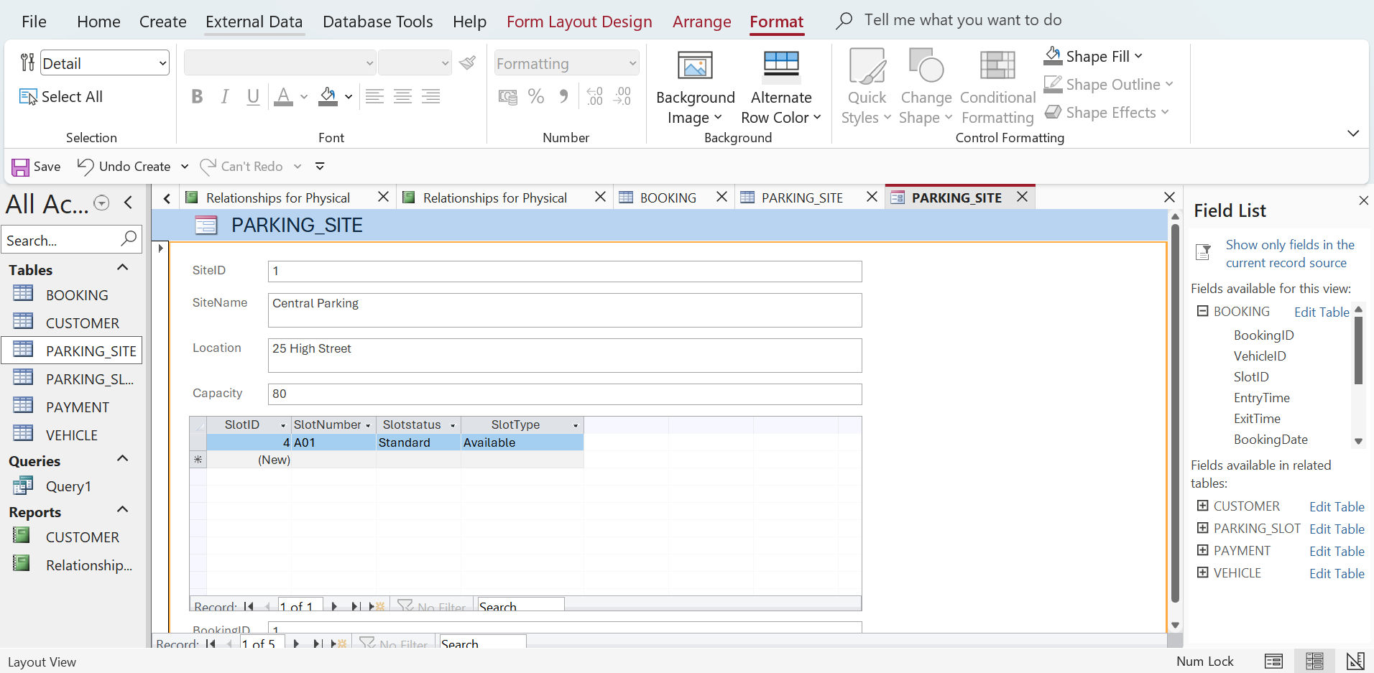 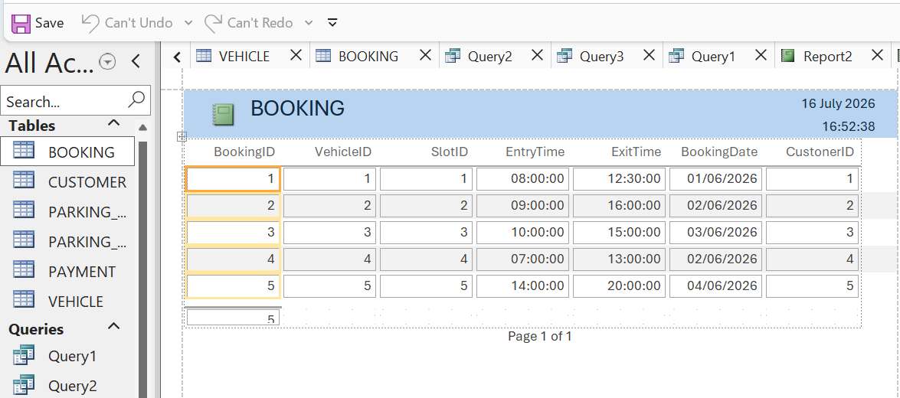 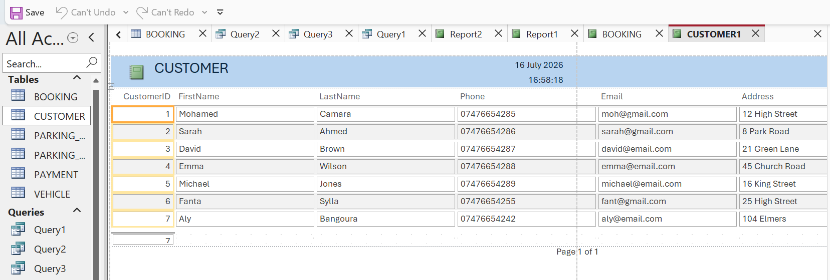Parking Site, Booking and customer form used to create, update, and view parking site details and their associated parking slots.

8. Validation & Testing
To ensure that the AutoPark Management System meets the functional requirements, a series of tests were carried out in Microsoft Access. The purpose of testing was to verify that the database stores data accurately, maintains relationships between tables, and allows users to perform common parking management tasks efficiently.
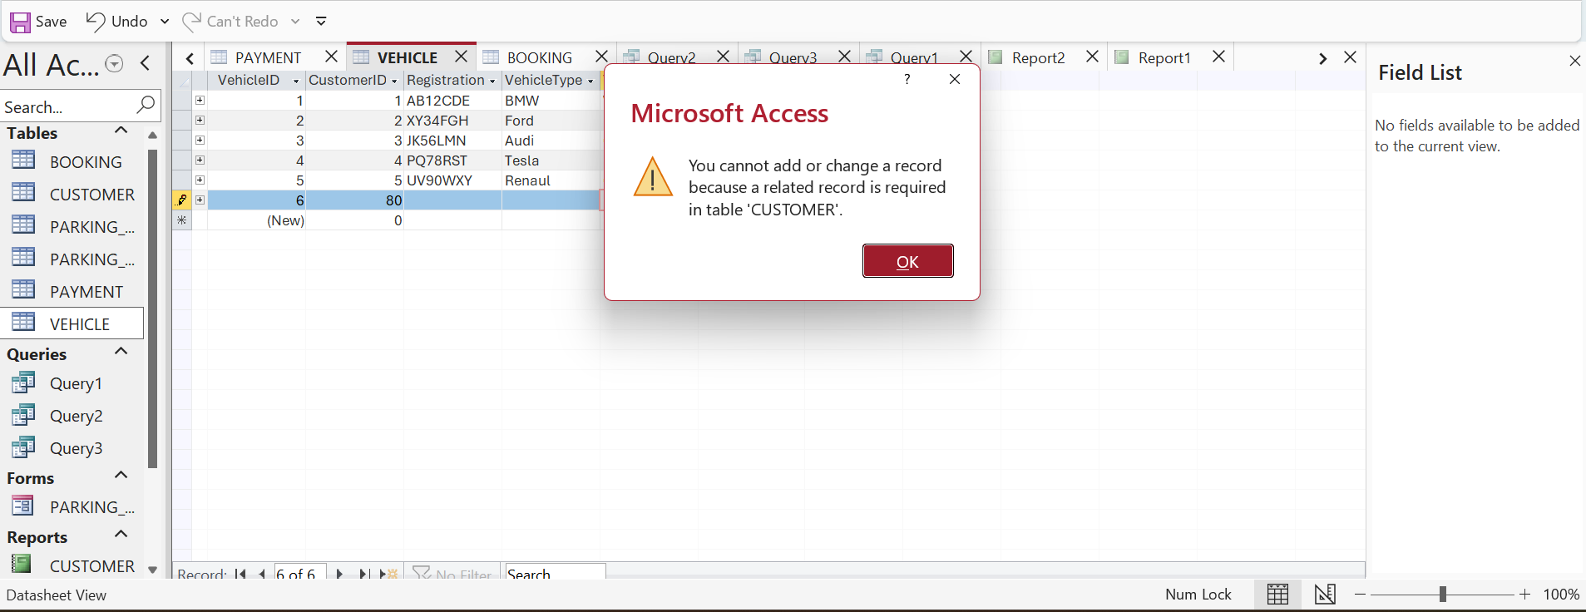 The screenshot confirms that every vehicle must be associated with an existing customer because CustomerID is a foreign key in the VEHICLE table and referential integrity is enforced. A vehicle cannot be inserted or updated unless the referenced customer already exists in the CUSTOMER table.
Testing Results
Test Case | Expected Result | Actual Result | Status
Add a new customer | Customer record is saved successfully. | Customer was added successfully. | Pass
Add a new vehicle linked to an existing customer | Vehicle is linked to the correct customer. | Vehicle record was linked correctly using the CustomerID foreign key. | Pass
Create a new booking | Booking is created only when a valid customer, vehicle, and parking slot exist. | Booking was created successfully with valid foreign keys. | Pass
Record a payment | Payment is linked to the correct booking. | Payment was recorded and linked correctly to the Booking table. | Pass
Display available parking slots | Query shows only parking slots with the status "Available". | Query returned only available parking slots. | Pass
Display active bookings | Query lists all bookings with the status "Active". | Active bookings were displayed correctly. | Pass
Search customer booking history | System displays all bookings for the selected customer. | Booking history was returned accurately. | Pass
Calculate total revenue | Query calculates the total of all paid parking fees. | Total revenue was calculated correctly. | Pass
Enforce referential integrity | Invalid foreign key records cannot be entered. | Microsoft Access prevented invalid records from being saved. | Pass
Prevent duplicate primary keys | Duplicate IDs cannot be inserted into tables. | Duplicate primary key values were rejected. | Pass

Evaluation Against Functional Requirements
The AutoPark Management System successfully meets the main functional requirements identified during the analysis stage.
- The system stores information about parking sites, parking slots, customers, vehicles, bookings, and payments in separate tables.
- Relationships between tables are enforced using primary keys and foreign keys, maintaining data consistency and referential integrity.
- Staff can efficiently create, update, and retrieve records without relying on manual paperwork.
- Queries provide useful information such as available parking spaces, active bookings, customer booking history, outstanding payments, and total parking revenue.
- The database structure reduces data redundancy by following Third Normal Form (3NF), improving accuracy and simplifying maintenance.

The testing confirmed that the AutoPark Management System meets the user requirements. All test cases passed successfully, showing that the database manages parking operations accurately, maintains data integrity, and improves efficiency compared to the previous manual system.

9. Reflection
During this project, I improved my understanding of database design and Microsoft Access. Creating the ERD, designing the tables, and implementing relationships helped me understand the importance of primary keys, foreign keys, and normalization. One of the main challenges was ensuring that the relationships between tables were correct and that referential integrity was maintained. If I were to continue this project, I would add features such as online booking, automated payments, and a management dashboard to further improve the system.

10. Conclusion
This project successfully developed a Microsoft Access database for the AutoPark Management System to replace the existing manual parking process. The database was designed using an ERD, primary and foreign keys, referential integrity, and Third Normal Form (3NF) to ensure data accuracy and reduce redundancy.
The system includes tables, sample data, queries, forms, and reports to support daily parking operations. Testing confirmed that the database meets the functional requirements by storing data accurately, maintaining relationships, and improving efficiency.
Overall, the AutoPark Management System provides a reliable and user-friendly database solution that reduces manual errors and supports effective parking management. Future improvements could include online booking, automated payments, and real-time parking space monitoring, ensuring future operational growth sustainability.

References

[1] T. M. Connolly and C. E. Begg,Database systems: a practical approach to design, implementation, and management, Pearson Education, 2005.
[2] C. Coronel, S. Morris and P. Rob,Database systems: design, implementation, and management, Cengage learning Boston, 2016.
[3] T. M. Connolly and C. E. Begg,Database systems: a practical approach to design, implementation, and management, Pearson Education, 2005.

