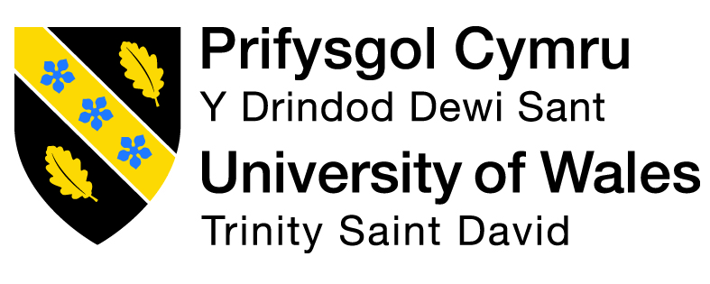
Stakeholder Management Plan for a New Public Park Development Project

Programme: BA (Hons) Business Management
Module: Stakeholder Engagement
Module code: LCBB4013
Lecturer: Nishi Ramsurrun
Marek Horvath – 2438124
Date: 2nd May, 2026

Executive Summary
The portfolio creates a stakeholder management strategy of a proposed community based park project that would not only enhance the community wellbeing but also increase environmental sustainability. It defines the important stakeholders, the local council, residents, businesses and the advocacy groups and evaluates their interest and power. The stakeholder mapping strategy and the communication planning and consultation strategies implemented in the report are effective in its engagement with the stakeholders. Ethical issues, e.g., transparency, fairness, diversity and inclusion, are also mentioned. The results showcase that a good stakeholder engagement will translate into improved decision making, less conflict and a successful project. All in all, the report shows that the key to community-oriented development and infrastructure development that is sustainable lies in the inclusion and systematic management of stakeholders.

Table of Contents

Element 1: Introduction 5
1.1 Project Overview 5
1.2 Relevance and Importance of the Project 5
1.3 Stakeholder Concept and Importance 5
1.4 Key Stakeholders and Benefits 5
Element 2: Application to Include Stakeholder Engagement Strategies 6
2.1 Stakeholder Identification 6
2.2 Power, Interest and Influence 6
2.3 Stakeholder Map and Justification 8
2.4 Communication Plan 9
2.5 Consultation Strategy 10
Element 3: Ethical Considerations 11
3.1 Consultation Methods 11
3.2 Ethical Considerations in Data Collection 11
3.3 Bias and Fairness 11
3.4 Diversity, Equity and Inclusion 12
3.5 Feedback Collection and Review 12
Element 4: Conclusion and Reflection 13
4.1 Conclusion 13
4.2 Reflection 14
Reference List 15

Element 1: Introduction

1.1 Project Overview
This is a portfolio that develops a stakeholder management strategy for a proposed new park within the residential community in the locale. The project application is a transformation of unutilized land into a secured, accessible and green area that necessitates walking paths, children's play areas, sitting areas, lighting, landscaped gardens and access roads. The park will serve the needs of a very large group of people, which includes families, elderly citizens and citizens with disabilities.

1.2 Relevance and Importance of the Project
The concept of the development of a new city park is particularly relevant in modern urban areas in which citizens are often denied access to vegetation (Halecki et al., 2023). Parks are significant to physical and mental health because parks encourage going outside, spending time with and sharing with others (Bustamante et al., 2022). They, as well, improve the environmental sustainability process through the improvement of the biodiversity and green infrastructure in the urban contexts (Wang et al., 2024). Therefore, it is a socially and environmentally topical project because it will complement the quality of life improvement, and will be in line with the goals of the sustainable city development (Brom et al., 2023).

1.3 Stakeholder Concept and Importance
Stakeholders are individuals or groups that may be different and can make a difference or are affected by project outcomes (Amin, Scheepers and Malik, 2022). It is brought to the fore in the stakeholder theory that the success of the project is dependent on the potential to address and recognise the needs of these groups (Kujala et al., 2023). Stakeholder participation is crucial in improving the decision-making process during the period of infrastructure development in order to reduce the level of conflict and the project is delivered as expected by the community. Therefore, the stakeholder identification and management form a major part of planning and implementation of the proposed community park.

1.4 Key Stakeholders and Benefits
The local council, local residents, families with children, local businesses, environmental, contractors and disability advocacy groups are the stakeholders in this project. The local council gets the advantage of the achievement of the community development objectives and improvement of services at the expense of people. There is a rise in the provision of better life and recreation facilities by the citizens. The families will be rewarded with safe play grounds in which the children can have fun and the businesses will be rewarded since more people will come to visit the premise. Greener green infrastructure and biodiversity are encouraged by environmental organizations.

Element 2: Application to Include Stakeholder Engagement Strategies

2.1 Stakeholder Identification
The other significant aspect of a formulation of good stakeholder management plan is the identification of the stakeholders. With the proposed public park decided, it is possible to reduce the stakeholders to general internal stakeholders and external stakeholders. Internal stakeholders in the area, such as the decision-making process, funding and regulatory approvals, are the responsibilities of the local council and planning department (Buhmann et al., 2024). The external stakeholders will include residents, families, businesses, environmental organisations, contractors and disability advocacy groups; they will either be directly or indirectly affected by the project.
The project involves all the stakeholders in a specific capacity. Local council is one of the stakeholders as it has the ability to establish the funding, approvals and general governance. It is land use regulations and development standards that are followed by the planning department. The immediate concern of the locals is that they will be the ones to use the park and may be impacted by the construction process. The most important stakeholders are families and youth, as the park will support their leisure activities (Prebanić and Vukomanović, 2023). The sustainability and biodiversity concerns the environmental individuals and the implementation of the project is executed by the contractors. The disability advocacy organisations play a vital role in the achievement of inclusive and accessible design. These stakeholders ought to be engaged with the view of achieving balanced and effective developmental outcomes.

2.2 Power, Interest and Influence
The stakeholders are ranked on the basis of power, interest and influence table which determines the level of concern and influence that the list of stakeholders has towards a project and their power level. High power, high interest and strong influence go to the local council, which will approve and finance the project. The planning department is also very strong due to the regulatory character it possesses; however, its interest could be tilted towards compliance rather than community use. Local residents demonstrate original interest because they are directly affected, but their formal power is moderate.
Higher interest but lower power of families that have children gives interest but relatively low power since they are not the decision-makers; it is an end user. The medium force and influence of local businesses is that they may get economic benefits from the more active arena. The environment and disability advocacy groups are less formal in their sources of power, yet they can be highly influential due to the ability to create the opinion of masses and exchange the concepts of sustainability and inclusiveness. There is medium power and influence that will be attached to the contractors because they take the project's delivery under set out agreement. The need for different kinds of engagement arises with this classification. Close control should be exercised on high-power stakeholders and active consultation of high-interest groups should be made. Information about such dynamics can be applied to make sure that all the expectations of stakeholders are fulfilled, reduce conflicts and increase the level of project success (Ebekozien et al., 2024).
Stakeholder | Power | Interest | Influence
Local Council | High | High | High
Planning Department | High | Medium | High
Local Residents | Medium | High | Medium
Families with Children | Low | High | Low
Local Businesses | Medium | Medium | Medium
Environmental Groups | Low | High | Medium
Contractors | Medium | Medium | Medium
Disability Advocacy Groups | Low | High | Medium
Table 1: Power, Interest and Influence Analysis
(Source: Self-Developed)

2.3 Stakeholder Map and Justification
The stakeholder map is based on the power-interest grid and helps to prioritise the engagement efforts. Stakeholder levels have four high power/high interest, high power/low interest, low power/high interest and low power/low interest. This framework will allow for effective allocation of communication and engagement resources. The reason why the local council is in the high power/ high interest quadrant is that the local council controls funding, approvals and strategic direction. The high-power but low-interest group includes the planning department that is interested not in using the community on a regular basis at all, but in compliance with regulations. The local residents, families, environmental groups and disability organisations fall in the high interest and low power quadrant as they have immediate interests in the outcomes of the project but with a small amount of formal power.
The medium category will involve local businesses and contractors because they are all medium-sized and interested. This stance is justified because these stakeholders can command certain elements of the project, such as the quality of the construction work and economic life but not the overall. Such a mapping method will ensure the strategies of engagement are suitable. Close integration between high-power stakeholders is required, and high-interest stakeholders have to be regularly informed and consulted. It is a structured process of ensuring the stakeholders' contentment and raising the likelihood of project success (Gonzalez-Urango et al., 2022).
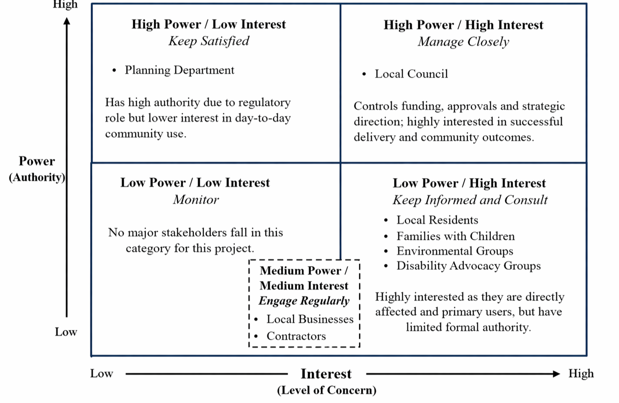
Figure 1: Stakeholder Map
(Source: Self-Developed)

2.4 Communication Plan
Communication plan implies that the stakeholders too will be to be communicated with. The frequency and mode of communication as well as the amount of information must have been different to the aspiring stakeholders too. Project activities, budget and risks are communicated with the local council on a regular basis, either through formal meetings, reports and emails. This involves responsibility and quality leadership.
The local people must be informed about the schedules, advantages and the possible inconvenience of the projects. The communication planning can be either a formal meeting or a letter format, which is intended to be an approach to a local notice board and online news. Involving families of children can be achieved by conducting surveys, mailing school newsletters and social media on what they would wish to see in designing of the parks. The local businesses should be notified through meetings and emails about the construction schedules and how they will affect their businesses in order to reduce the amount of disruption.
The workshops and consultations with environmental organisations and disability organisations should involve the organisation in the building and design of the workshop and ensure that the considerations concerning the sustainability and accessibility are included. The contractors in those constructions frequently face the need to communicate among themselves as in the form of construction meetings and telephone communication to control deadline and safety demands. The communication should be timely and effective and should also be stakeholder-specific. Trust is formulated in this plan, misunderstandings are minimized and collaborative decision making is established. Communication is another crucial element of the successful interaction with the stakeholders and execution of the project (Adhi and Muslim, 2023).

2.5 Consultation Strategy
The strategy of consultation that would be embraced in the public park venture would encompass the mixed application and the involvement. The stakeholders are varied and not everyone has the same preferences and availability hence not everyone needs all the methods of consultation. The surveys may be used to provide feedback regarding the characteristics of the park, safety and accessibility of most residents. Open meetings provide them with an opportunity to be open and ask questions and concerns. Particularly in situations where individual groups of people are involved, such as in cases where parents, old people and those living with disabilities are involved, focus groups would be beneficial since it can be dealt with in detail. The concerned authorities like the council officials as well as the owners of the businesses may be interviewed as to whether they are competent or not. The workshops will also conduct the discussions of the design and will allow the stakeholders to input into the decisions.
This will extend the concept of participating in the concept of meaningful engagement as a stakeholder that is grounded in participation and not communication (Buhmann et al., 2024). A good consultation plan will improve the quality of the information obtained and will also ensure that the various perspectives are taken into account. It further brings joy to the stakeholders and offers the projects better impacts as they consider the needs of the community when planning the projects (Samal and Dash, 2024).

Element 3: Ethical Considerations

3.1 Consultation Methods
The proposed public park should be consulted in various ways to facilitate effective involvement. Vast community opinions can be gained by means of surveys, but during open meetings, one can talk and communicate (Tepper et al., 2022). Focus groups are other pieces of information, depending on the contribution of single stakeholder groups such as families, elderly residents and people with disabilities. The interviews will be suitable in the case of addressing the larger stakeholders, including the council representatives and business proprietors (Lim et al., 2022). Moreover, online and written questionnaires enable the participation of individuals who will not be able to attend face-to-face sessions. All these will be combined to ensure that it becomes an inclusive approach and contribute to the quality of stakeholder engagement, which will contribute to a better decision-making process.

3.2 Ethical Considerations in Data Collection
Ethical considerations are the most important factor when collecting stakeholder data (Laryeafio and Ogbewe, 2023). The purpose of the consultation, the uses of their information and the anonymity of the information should be informed to the respondents. This is an example of informed consent because it makes the process voluntary. It should be kept secret, primarily at the occasions when stakeholders are discussing their highly sensitive ideas regarding the issues in the community, or the effects of their projects (Kujala et al., 2023). This information must be stored in a safe place and operate with it according to data safety guidelines. They also ought to be transparent since the stake holders ought to know what will be the effect of their input in the project decisions. They include ethical participation, which is founded on trust and helps participation, which creates more believable and valuable feedback. There is also the concern that there was not to coerce and to make the participants free to air their opinions. Ethical consultation is no longer a mere legal requirement but also a vital consideration to creating credibility and positive relationship with the stakeholders.

3.3 Bias and Fairness
The quality of stakeholder consultation can be affected majorly by discrimination. This may happen when it is assumed that the opinion of the powerful stakeholders takes precedence over that of the weak or when the syphrasing of the questions is manipulated to make the respondents answer. The needs of vulnerable populations can be disregarded as a guide when the views of the business and government are the only ones present in the business (Peskett et al., 2023). The heterogeneous people should be used in consultation process and neutral/bias-free questions should be used to minimize bias. Indiscreet analysis is required to make equal cogitations to the feedback. Prejudice is one of the key areas that need to be covered to approach decision-making in a balanced manner and realise that the project will meet the needs of the whole community.

3.4 Diversity, Equity and Inclusion
Diversity, equity and inclusion (DEI) is one of the most important aspects of a successful stakeholder engagement. It must be a community-based park and that means that the various groups of people should be consulted including those with disabilities, the aged, families and the minority communities and households with low incomes. One of the elements is equity which relates to fair opportunity to participate and possibly to do so by means of providing available spaces to conduct a meeting or by means of providing materials that have been translated or have been in a flexible consultative form. This sense of inclusion makes everyone feel an invited and heard-out part of the process (Zong et al., 2024). Lack of consideration of DEI might lead to absence of inclusion and lack of successful outcomes of projects. Inclusive participation leads to better decision-making since a myriad of various perspectives are incorporated. It also supports social sustainability in that it will ensure that the park is adjusted to the needs of every visitor. The DEI will therefore be integrated throughout the consultation with the stakeholders.

3.5 Feedback Collection and Review
The channels of stakeholder feedback should be obtained in many ways and this may incorporate: surveys, face-to-face meetings, interviews and a web form. Once the data has been collected, it will be required to systematically analyse these data to identify common themes, concerns and recommendations. The clarity of the feedback and decision-making process can be improved by dividing feedback into such categories as safety, accessibility and environmental design. It is crucial to notify the stakeholders about the outcomes of the consultation process. Attainability of transparency and accountability can be improved by providing a summary of the findings and explaining to the participants how the feedback has influenced the final decisions (Zhang et al., 2023). The measured approach assists in building a relationship of trust between the stakeholders through establishment of a feedback loop. Effective feedback management is beneficial in that it ensures that the input of the stakeholders is achievable and that their input is acceptable and factored into the project. This improves the participation and relates the quality of the development.

Element 4: Conclusion and Reflection

4.1 Conclusion
This portfolio has equipped a stakeholder management plan for a proposed park development project which is a public park. This project was seen as a socially and environmentally important project due to the way it can influence the quality of living of the community, promoting exercise and green cities. The local council, residents, families, businesses, environmental groups, contractors and disability organisations were identified as important stakeholders.
The discussion has provided insight into the importance of determining and creating classifications of the stakeholders in the power, interest and influence model. The stakeholder map also identified the need for a particular approach to the engagement, based on the stakeholders' characteristics. Comparison of communication plan and consultation strategy beckoned the commonality of efficient, timely and just communication, and to ensure that the stakeholders are not only aware but also involved in the final outcome of the decision-making process. There also existed the ethical aspects where emphasis was made on transparency, fairness, data protection, and inclusiveness. Clearing the bias and fostering diversity, equity and inclusion turned out to be the main factors of achieving effective stakeholder engagement.
The feedback, in general, however, points to the fact that the success of a project heavily depends on its stakeholder management. It enhances openness, reduces conflict and ensures the end development is informed by community needs. With the inclusion of the views of the stakeholders in the planning process we expect to have a greater likelihood of achieving the project with sustainability and positive attainment of social impact in the long term.

4.2 Reflection
This project was a very enlightening experience on the importance of stakeholder involvement in infrastructure development projects. The first impression of stakeholder management was straightforward- to identify and engage in contact with pertinent parties. However, this paper has enabled me to understand its complexity and significance better. I was aware that various stakeholders have different levels of power, interest and influence and handling dissimilarity requires strict planning and tact. Throughout the process, I understood that such theoretical concepts as stakeholder mapping and engagement strategies allowed me to understand how making decisions in the actual project takes place.
I also learnt that communication does not only concern the provision of information, but also the making sure that the information being provided is relevant, accessible and in time. This has made it necessary to differentiate between the various needs of the stakeholders in terms of communication approach used. Another one of the most valuable lessons that I learned is about the importance of ethics in stakeholder engagement. Some of the ethical considerations that require consideration are informed consent, confidentiality, and fairness to establish trust and offer meaningful participation (Lim et al., 2022). I got to understand more how bias affects decision-making and under what conditions it is necessary to possess a variety of views within the consultation process.
The concept of diversity, equity and inclusion was a strong concept. I realised the exclusion can happen when the needs of the vulnerable populations are not considered, and it reduces the effectiveness of a project. Making everybody speak is both fair and, on top of this, better results are achieved. Generally, the assignment has assisted me in enlarging my horizons in the field of understanding stakeholder management as a dynamic and crucial element of project success. I would make it more inclusive and open in the future by making sure the stakeholder input is, in fact, considered in the making of decisions. This has cemented the importance of having stakeholders in the project to deliver successful and sustainable infrastructure projects.

Reference List
Adhi, A. B., and Muslim, F. (2023). Development of stakeholder engagement strategies to improve sustainable construction implementation based on lean construction principles in Indonesia. Sustainability, 15(7), 6053. https://www.mdpi.com/2071-1050/15/7/6053
Amin, H., Scheepers, H. and Malik, M. (2022). Project monitoring and evaluation to engage stakeholders of international development projects for community impact. International Journal of Managing Projects in Business, 16(2). doi: https://doi.org/10.1108/ijmpb-02-2022-0043.
Bjørgen, A., and Ryghaug, M. (2022). Integration of urban freight transport in city planning: Lesson learned. Transportation research part d: transport and environment, 107, 103310. https://www.sciencedirect.com/science/article/pii/S1361920922001389
Brom, P., Engemann, K., Breed, C., Pasgaard, M., Onaolapo, T., and Svenning, J. C. (2023). A decision support tool for green infrastructure planning in the face of rapid urbanization. Land, 12(2), 415. https://www.mdpi.com/2073-445X/12/2/415
Buhmann, K., Fonseca, A., Andrews, N., and Amatulli, G. (2024). Meaningful stakeholder engagement: the concept, practice and governance. In The Routledge handbook on meaningful stakeholder engagement (pp. 3-39). Routledge. https://www.taylorfrancis.com/chapters/oa-edit/10.4324/9781003388227-2/meaningful-stakeholder-engagement-karin-buhmann-alberto-fonseca-nathan-andrews-giuseppe-amatulli
Bustamante, G., Guzman, V., Kobayashi, L.C. and Finlay, J. (2022). Mental health and well-being in times of COVID-19: A mixed-methods study of the role of neighborhood parks, outdoor spaces, and nature among US older adults. Health & Place, 76, p.102813. doi: https://doi.org/10.1016/j.healthplace.2022.102813.
Chase, L. C., Phillips, R. G., and Amsden, B. (2023). Stakeholder engagement in tourism planning and development. In Handbook of Tourism And Quality-Of-Life Research II: Enhancing the lives of tourists, residents of host communities and service providers (pp. 317-333). Cham: Springer International Publishing. https://link.springer.com/chapter/10.1007/978-3-031-31513-8_22
Ebekozien, A., Aigbavboa, C. O., and Ramotshela, M. (2024). A qualitative approach to investigate stakeholders' engagement in construction projects. Benchmarking: An International Journal, 31(3), pp.866-883. https://www.emerald.com/bij/article/31/3/866/1230341
Gonzalez-Urango, H., Mu, E., and García-Melón, M. (2022). Stakeholder engagement and ANP best research practices in sustainable territorial and urban strategic planning. In Multiple criteria decision making for sustainable development: Pursuing economic growth, environmental protection and social cohesion (pp. 93-130). Cham: Springer International Publishing. https://link.springer.com/chapter/10.1007/978-3-030-89277-7_5
Halecki, W., Stachura, T., Fudała, W., Stec, A. and Kuboń, S. (2023). Assessment and planning of green spaces in urban parks: A review. Sustainable Cities and Society, 88, p.104280. doi: https://doi.org/10.1016/j.scs.2022.104280.
Kujala, J., Heikkinen, A., and Blomberg, A. (2023). Stakeholder engagement in a sustainable circular economy: Theoretical and practical perspectives. Palgrave Macmillan. https://link.springer.com/content/pdf/10.1007/978-3-031-31937-2.pdf
Laryeafio, M.N. and Ogbewe, O.C. (2023). Ethical Consideration dilemma: Systematic Review of Ethics in Qualitative Data Collection through Interviews. Journal of Ethics in Entrepreneurship and Technology, [online] 3(2), pp.94–110. doi: https://doi.org/10.1108/JEET-09-2022-0014.
Lim, C. H., Wong, H. L., Elfithri, R., and Teo, F. Y. (2022). A review of stakeholder engagement in integrated river basin management. Water, 14(19), 2973. https://www.mdpi.com/2073-4441/14/19/2973
Park, K. (2026). CSR fit with CEO image: Unpacking its influence on stakeholder engagement and authenticity perception. Journal of Marketing Communications, 32(1), pp.40-64. https://www.tandfonline.com/doi/abs/10.1080/13527266.2024.2306906
Peskett, L., Metzger, M. J., and Blackstock, K. (2023). Regional scale integrated land use planning to meet multiple objectives: Good in theory but challenging in practice. Environmental Science & Policy, 147, pp.292-304. https://www.sciencedirect.com/science/article/pii/S146290112300179X
Prebanić, K. R., and Vukomanović, M. (2023). Exploring stakeholder engagement process as the success factor for infrastructure projects. Buildings, 13(7), 1785. https://www.mdpi.com/2075-5309/13/7/1785
Samal, R., and Dash, M. (2024). Stakeholder engagement in advancing sustainable ecotourism: an exploratory case study of Chilika Wetland. Discover sustainability, 5(1), 50. https://link.springer.com/article/10.1007/s43621-024-00233-2
Shehadeh, A., Alshboul, O., Taamneh, M. M., Jaradat, A. Q., Alomari, A. H., and Arar, M. (2025). Advanced integration of BIM and VR in the built environment: enhancing sustainability and resilience in urban development. Heliyon, 11(4). https://www.cell.com/heliyon/fulltext/S2405-8440(25)00938-7
Sobieraj, J., and Metelski, D. (2025). Innovative approaches to urban revitalization: lessons from the fort Bema park and residential complex project in Warsaw. Buildings, 15(4), 538. https://www.mdpi.com/2075-5309/15/4/538
Tepper, S.J., Spruill, M.K., Premachandra, B. and Lewis, N.A. (2022). Surveys as conversations between makers and takers: A conversational framework for assessing and responding to community needs. Analyses of Social Issues and Public Policy. doi: https://doi.org/10.1111/asap.12326.
Wang, D., Xu, P. Y., An, B. W., and Guo, Q. P. (2024). Urban green infrastructure: Bridging biodiversity conservation and sustainable urban development through adaptive management approach. Frontiers in Ecology and Evolution, 12, 1440477. https://www.frontiersin.org/journals/ecology-and-evolution/articles/10.3389/fevo.2024.1440477/full
Zhang, H. M., Chong, H. Y., Zeng, Y., and Zhang, W. (2023). The effective mediating role of stakeholder management in the relationship between BIM implementation and project performance. Engineering, Construction and Architectural Management, 30(6), pp.2503-2522. https://www.emerald.com/ecam/article/30/6/2503/44293
Zong, M., Xu, G., and Yanai, S. (2024). Building local partnership through community parks in Central Tokyo: perspectives from different participants. Frontiers in Sustainable Cities, 6, 1445754. https://www.frontiersin.org/journals/sustainable-cities/articles/10.3389/frsc.2024.1445754/full

