BSc Health and Social Care Introduction to Physiology (BMHP5003) Poster Presentation Human Digestive System
Student Name: Shilpi Begum Student Number: 1810998 Lecturer: Mumtaz Goolam

Functioning of Human Digestive System
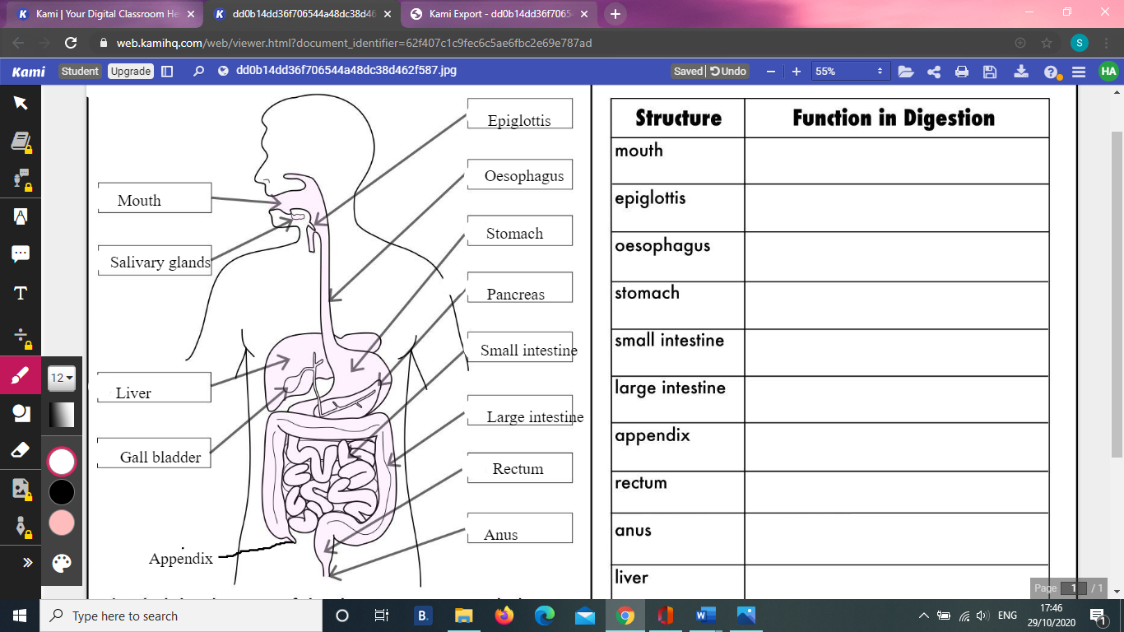
Source: ( Twinkl.co.uk, 2020)
The food we eat takes on an amazing journey through our body from the mouth all the way to the bottom (anus), beneficial parts of food is absorbed along this journey giving nutrients and energy that is needed to fuel the body to survive (Cleveland Clinic, 2018). Function of digestive system is to breakdown food so that it can be absorbed into the circulation and then used by body cells. System consists of the alimentary canal and accessary organ (Waugh and Grant, 2014).
Mouth: Is the start of digestive tract and it is also known as buccal cavity or oral cavity in human anatomy, orifice, through which food and air enters the body, boundaries defined by lips, cheeks, hard and soft palates, and glottis. This is split into 2 parts: the vestibule area between cheek and teeth, and the oral cavity proper. Tongue is the large muscles firmly clamed to floor of the mouth, its primary role is intake and initial digestion of food, teeth tears and grinds ingested food into small bits that are manageable for digestion. Tongue positions and blends the food and transfers sensory receptors for taste, and the palate which separates mouth from nasal cavity, allowing different entrance for food and air (Britannica, 2020).
Salivary Glands: Aids the chemical and mechanical process of digestion, saliva is 99% water, cleanness mouth and moistens food, dissolves food chemicals so it can be tasted and contains enzymes that start the chemical breakdown of starchy foods (Visible Body, 2020).
Epiglottis: Is a flap of tissues that sits underneath the tongue at the back of the throat, its main function is to prevent food from entering airways while eating (NHS, 2018).
Oesophagus: Swallowed food enters the oesophagus (gullet or windpipe). Muscles in the oesophagus contract to make the tube above the food thinner, and this pushes the food towards the stomach and that is how the food is moved through the entire gut (Levesley et al., 2014).
Stomach: Food is stored and further broken in the stomach with powerful enzymes and acid. From there, food moves to small intestine (Spectrum Health, 2020).
Pancreas: This produces pancreatic juices, which contains digestive enzymes and bicarbonate ions, and delivers it to duodenum through pancreatic duct (OpenStax, 2013).
Gall Bladder: Is responsible for storing and concentrating bile from liver, and then releasing this into the duodenum in the small intestine to assist absorb and digest fats (Cleveland Clinic, 2018).
Liver: Makes digestive juice called bile, which help digest fats and some vitamins. Bile ducts transfer bile from liver to gallbladder for storage , or to small intestine for use (National Institute of Health, 2020).
Small Intestine: Majority of nutrients are absorbed in small intestine; food is further broken down by enzymes released from the pancreas and bile from liver. Walls of small intestine absorb water and the digested nutrients into your bloodstream. Remaining bits are moved into the large intestines (Spectrum Health, 2020).
Large Intestine/ colon: Is the terminal part of the alimentary canal, and its primary function is to complete absorption of water and nutrients, synthesize certain vitamins, form feces, and remove feces from the body (OpenStax, 2013).
Rectum: Functions primarily as a temporary reservoir for feces storage, and it plays an integral role in controlling defecation and maintaining continence (Wang and Wiseman, 2020).
Anus: Is the terminal opening of the anal canal, the portion of the digestive tract through which excrement, solid bodily waste is excreted (Britannica, 2020). Around 2-inch long, upper anus lining can detect rectal contents, lets you know whether contents are gas, liquid or solid (Cleveland Clinic, 2018).
Disease of Digestive System: To maintain homeostasis balance internal environment must work in harmony, if balance is threatened or lost, this leads to serious risk to well-being of individual (Waugh and Grant, 2014). Various disease associated with digestive system such as Liver disease, Inflammatory bowel disease, includes Crohn’s disease, chronic constipation, chronic diarrhoea, cancers and many more (National Institute of Health, 2020). One of the diseases associated with digestive system is bowel cancer, which is also called colorectal cancer, it affects the large bowel, which is made up of the colon and rectum. According to Cancer Research UK (2020) and Bowel Cancer UK (2019) over 42,000 people are diagnosed with bowel cancer each year in UK and mortality rate is around 16,300 per year. And bowel cancer is the 4th most common cancer in the UK, accounting for 11% of all new cancer cases and it is the 2nd most common cause of cancer death in the UK, accounting for 10% of all cancer deaths. An estimate 268,000 people living in the UK today have been diagnosed with bowel cancer, and 94% of the cases are in the age bracket of 50 and over, 1 in 15 men and 1 in 18 women will be diagnosed with bowel cancer during their lifetime (Bowel cancer UK, 2019). Bowel cancer is treatable and curable due to both advances in technology and medicines, early detection, and treatment of colorectal cancer through better screening has reduced mortality (NHS England, 2015).

References:
Bowel Cancer UK. (2019). “Beating bowel cancer together”. Available at:
https://www.bowelcanceruk.org.uk/about-bowel-cancer/bowel-cancer/. Accessed on: (29/10/2020)

Britannica. (2020). Mouth Anatomy. Available at: https://www.britannica.com/science/mouth-anatomy. Accessed on: (27/10/2020)

Cancer Research UK. (2020). “Bowel Cancer Statistics”. Available at:
https://www.cancerresearchuk.org/health-professional/cancer-statistics/statistics-by-cancer-type/bowel-cancer#heading-Zero. Accessed on: (30/10/2020)

Cleveland Clinic. (2018). Structure and the Function on the Digestive System. Available at:
https://my.clevelandclinic.org/health/articles/7041-the-structure-and-function-of-the-digestive-system. Accessed on: (29/09/2020)

Exarchakou, A., Donaldson, L.J., Girardi, F. and Coleman, M.P., (2019). Colorectal cancer incidence among young adults in England: Trends by anatomical sub-site and deprivation. PloS one, 14(12), p.e0225547.

Healthline. (2015). “Human Body Maps: Epiglottis”. Available at:
https://www.healthline.com/human-body-maps/epiglottis#1
Accessed on: (23/10/2020)

Levesley, M. Johnson, P. Brand, I. Kearsey, S. (2014). “Exploring science: working Scientifically 8”. Essex: Pearson.

National Institute of Health (NIH). (2020). Your Digestive System and How it Works. Available at: https://www.niddk.nih.gov/health-information/digestive-diseases/digestive-system-how-it-works#whatis. Accessed on: (03/10/2020)

NHS England. (2015). “Quality of Life of Colorectal Cancer Survivors in England”. Available at:
https://www.england.nhs.uk/wp-content/uploads/2015/03/colorectal-cancer-proms-report-140314.pdf. Accessed on: (29/10/2020)

NHS. (2018). “Epiglottitis”. Available at:
https://www.nhs.uk/conditions/epiglottitis/#:~:text=The%20epiglottis%20is%20a%20flap,prevent%20food%20entering%20your%20airway.
Accessed on: (23/10/2020)

OpenStax. (2013). “Atomy and Physiology”. Available at:
https://opentextbc.ca/anatomyandphysiology/chapter/23-5-the-small-and-large-intestines/. Accessed on: (23/10/2020)

Spectrum Health. (2020). “Your Digestive System, from Beginning… to End”. Available at:
https://healthbeat.spectrumhealth.org/your-digestive-system-from-beginning-to-end/
Accessed on: (20/10/2020)

Twinkl. (2020). “Human digestive system labelling activity sheet”. Available at:
https://www.twinkl.co.uk/resource/us2-s-156-human-digestive-system-labeling-activity-sheet. Accessed on: (01/10/2020)

Visible Body. (2020). “Structures of Oral Cavity are Responsible for the First Step of digestion: Indigestion”. Available at:
https://www.visiblebody.com/learn/digestive/digestive-oral-cavity

Waugh, A. and Grant, A. (2014). Ross & Wilson Anatomy and physiology in health and illness E-book. Elsevier Health Sciences.

Wang, Yun Hwa W. and Wiseman, J. (2020). “Anatomy Abdomen and Pelvis, Rectum”. Available at:
https://www.ncbi.nlm.nih.gov/books/NBK537245/. Accessed on: (22/10/2020)

