Tia Thomas (1706468)
Marie Pitson (M4X02101)
Academic Skills
Review of industry skills

Executive Summary
This report will be exploring the different skills employers look for when hiring staff within the events industry. Research in to multiple event manager job roles will be carried out, and further discussion in to each individual skill found within a selection of job advertisements will be considered. They will be examined further and then discussed in contrast to the writers attached CV. It was found that there was a base set of skills that employers desired through out the samples, however there were some skills more specific to the company requirements.
Table of Contents
Executive Summary 2
Introduction 4
Content Analysis of Skills 5
1. General Skills 5
2. Role Specific Skills 6
3. Unspecified skills 6
4. The Writers CV 7
Conclusion 8
Bibliography 9
References 11
Appendix 12
Appendix A 12
Appendix B 13
Appendix C 16
Appendix D 17

Introduction
Employability skills are essential in order to expand the knowledge of a person who wants to develop and help further improve their existing skills, to assist in getting a better job (Ali, 2016). Within the events industry there is an extensive selection of job titles, thus leading to a wide selection of skills required for each one. However, to be considered for a job, a person must possess certain qualities that fit the role in correlation to the specific employer. The aim of this report is to explore the different skills requested by different employers and understand the importance of them in the role.

Content Analysis of Skills

For this section of the report research in to the Event Manager role has been carried out. Two job samples have been inserted in the appendices and will be referred to throughout the report. When researching the role, it was found that many job advertisements focus around requiring a similar list of skills. To further compare the adverts, a governmental website has been chosen to act as a general outline of the skills required. The National Career Service (2018) states that to be a manager within the events industry, one must possess these skills:
- organisation skills | - high level of attention to detail
- multi-tasking | - be able to work under pressure and meet deadlines
- communication and people skills | - negotiation, sales and marketing skills
- creative approach to problem-solving | - budget awareness

General Skills
  - As previously mentioned, many of the same skills are stated as a requirement in numerous job advertisements, many of which fall under the category of soft skills (Gibert, et al. 2017), otherwise known as interpersonal skills. Interpersonal skills are the general skills used to communicate with others on a daily basis and create relationships (Armstrong, 2014). These would include skills such as; verbal and non-verbal communication, problem solving and negotiation skills. These skills are incredibly important to most, if not all jobs as communicating with others is something of a daily task that is imperative to the production of relationships with co-workers and clients. The problem solving, and negotiation skills are helpful in relation to the events industry as events are sometimes completely unpredictable, disruptions such as the weather are things that one must be able to handle and provide a solution for.

Role Specific Skills
  - The other skills mentioned on the job articles are not specialist skills, however they are more useful to the event manager role. These skills are not a necessity to have, but some including the example employers require them. Skills such as multi-tasking, organisational skills and attention to detail are essential within a busy industry such as events, due to the large number of tasks and deadlines that have to be met.
  - When working within the operations of an event, a person may be required to perform multiple tasks at once such as set up the event itself and also dealing with clients. It would then be consequently beneficial to possess the ability to multi-task. Whilst not mentioned in Appendix C, it is a useful skill to have not only in the events field but in everyday tasks.
  - Working in the events industry means it is very likely that a person will be operating within a fast-paced environment. It is therefore crucial that one can work under pressure and meet specific deadlines. In doing so, candidates must keep attention to detail. It is said that an event is made great within the details, (Allen, 2010) thus having a good eye for detail is something that is quite important within the industry.
  - Two skills not specified on the National Careers webpage are Teamwork and IT Skills. However, both job specifications in the appendix mention the requirement for both of these abilities. Like most jobs, a lot of work within the events industry is based within teams. For example, employees will be assigned group projects that could last a significant amount of time. This would suggest that it is therefore crucial to be able to work with others to achieve the set goals of the company and reach the desired results. IT skills are becoming more of a requirement these days as it is now quite necessary to be computer literate in order to keep up with the ever-advancing technology. It is specified within Appendix C, that it is in fact crucial in these times to be familiar with numerous computer applications.
  - Appendix D states the requirement for a degree qualification. However, the National Careers Service states that it is not necessary to hold a qualification for events. This further proves that not all companies will require the same experience. However, if a person desired a qualification to maybe gain more knowledge, there are many ways of achieving this. By either attending university, or there are several other different options available online.

Unspecified skills
  - Interestingly, none of the provided job advertisements specify the desire for a person with creativity as a skill. According to a study carried out by London & Partners, only 39 per cent of event planners are creative thinkers (2015). This is quite a low figure when a study performed by Investors in People found that ‘creativity is integral to success’ and creates a work environment to which better results are achieved (2015). This could argue that creativity is an important skill to which people should consider developing in order to work more efficiently and produce interesting ideas.

The Writers CV
  - In regard to the attached CV within the appendix, the writer shows various examples of the skills discussed within this report, many of which are situated in a prominent section of the CV to indicate importance. It is apparent that the writer has experience performing interpersonal skills. However, to fit the Event Manager role the writer would need to gain more relevant experience within the leisure or events field and increase practice in a more fast-paced environment.

Conclusion
To conclude, this report has found that while many different skills are required within the events industry, many employers will require a general set of interpersonal skills. However, companies seem to also state that in order to consider a candidate, the person would be required to possess other role specific skills in order to fit well within the job and be able to perform the tasks to the company’s standards. These skills are not always the same and they can vary from business to business. Although qualifications are not essential, they are easily accessible and help to further knowledge and create an advantage over the candidates who do not possess them.

Bibliography

Allen, J. 2010. Event Planning Ethics and Etiquette: A Principled Approach to the Business of Special Event Management. [ONLINE] Available at: https://ebookcentral-proquest-com.ezproxy.uwtsd.ac.uk/lib/trinity/detail.action?docID=555000. [Accessed 22 April 2018].

Ali, F. A., 2016. Employability Skills among Students and Employers’ Perceptions: An Assessment of Levels of Employability Skills Acquired by Business Students at Ishik University. International Journal of Social Sciences & Educational Studies, [Online]. Vol. 2, Iss. 3, pg. 82. Available at: http://ijsses.org/wp-content/uploads/2017/03/81-93.pdf [Accessed 1 April 2018].

Armstrong, M., 2014. Armstrong`s Handbook of Human Resource Management Practice. 13th ed. London: Kogan Page.

Bowdin, G., Allen, J., O’Toole, W., Harris, R. & McDonnell, I. (2011) Events Management. 3rd ed. Oxford: Butterworth-Heinemann.

Fletcher, D, 2009. Entry level skills for the event management profession: Implications for curriculum development. The ICHPER-SD Journal of Research in Health, Physical Education, Recreation, Sport & Dance; Reston, [Online]. Vol. 4, Iss. 1, pg. 52-57. Available at: https://search-proquest-com.ezproxy.uwtsd.ac.uk/docview/816481361/fulltextPDF/1BAA0068533E4974PQ/1?accountid=130472 [Accessed 6 April 2018].

Gibert, A., Tozer, W.C. & Westoby, M. 2017. Teamwork, Soft Skills, and Research Training. Trends in Ecology & Evolution. [Online]. Vol. 32, Iss. 2, pg. 81-84. Available at: https://www-sciencedirect-com.ezproxy.uwtsd.ac.uk/science/article/pii/S0169534716302178 [Accessed 30 March 2018].

Investors in People. 2015. Creativity. [Online] Available at: https://www.investorsinpeople.com/creativity/ [Accessed 6 April 2018].

London and Partners. 2015. The events industry needs more creative thinkers according to new study of MICE professionals. [Online] Available at: http://www.londonandpartners.com/media-centre/press-releases/2015/150429-event-industry-creative-thinkers [Accessed 2 April 2018].

Monster. 2018. These 7 work skills can make you more marketable to employers in 2018. [Online] Available at: https://www.monster.com/career-advice/article/work-skills-2018-1217. [Accessed 3 April 2018].

National Careers Service. 2018. Events Manager. [Online] Available at: https://nationalcareersservice.direct.gov.uk/job-profiles/events-manager. [Accessed 28 March 2018].

Rockwood, K, 2018. 2018 JOBS REPORT. PM Network; Drexel Hill, [Online]. Vol. 32, Iss. 1, pg. 28-47. Available at: https://search-proquest-com.ezproxy.uwtsd.ac.uk/docview/1985533818/fulltextPDF/4A03C6FF8B2C40BDPQ/1?accountid=130472 [Accessed 2 April 2018].

References

Allen, J. 2010. Event Planning Ethics and Etiquette: A Principled Approach to the Business of Special Event Management. [ONLINE] Available at: https://ebookcentral-proquest-com.ezproxy.uwtsd.ac.uk/lib/trinity/detail.action?docID=555000. [Accessed 22 April 2018].

Ali, F. A., 2016. Employability Skills among Students and Employers’ Perceptions: An Assessment of Levels of Employability Skills Acquired by Business Students at Ishik University. International Journal of Social Sciences & Educational Studies, [Online]. Vol. 2, Iss. 3, pg. 82. Available at: http://ijsses.org/wp-content/uploads/2017/03/81-93.pdf [Accessed 1 April 2018].

Armstrong, M., 2014. Armstrong`s Handbook of Human Resource Management Practice. 13th ed. London: Kogan Page.

Investors in People. 2015. Creativity. [Online] Available at: https://www.investorsinpeople.com/creativity/ [Accessed 6 April 2018].

London and Partners. 2015. The events industry needs more creative thinkers according to new study of MICE professionals. [Online] Available at: http://www.londonandpartners.com/media-centre/press-releases/2015/150429-event-industry-creative-thinkers [Accessed 2 April 2018].

National Careers Service. 2018. Events Manager. [Online] Available at: https://nationalcareersservice.direct.gov.uk/job-profiles/events-manager [Accessed 28 March 2018].

Gibert, A., Tozer, W.C. & Westoby, M. 2017. Teamwork, Soft Skills, and Research Training. Trends in Ecology & Evolution. [Online]. Vol. 32, Iss. 2, pg. 81-84. Available at: https://www-sciencedirect-com.ezproxy.uwtsd.ac.uk/science/article/pii/S0169534716302178 [Accessed 30 March 2018].

Appendix

Appendix A
Tia Thomas
2 Tabernacle Terrace, Carmarthen, SA31 1DL.
07476586086
tiath0mas@hotmail.co.uk
08/03/2018
Mr. Joshua Pryer
Cardiff Business Technology Centre
Senghennydd Road, Cathays
Cardiff
CF24 4AY

Dear Mr. Pryer,
I am writing to you in regard to the Events Assistant vacancy you have listed as a placement with Arc Hospitality. Please find attached my CV.
I am interested in this placement because, I am looking for relevant experience within my chosen sector. I am currently studying Events Management in the University of Wales Trinity Saint David and I feel as if it would be beneficial for me to have experience with you to progress my understanding of the events industry.
I am an outgoing person with a positive attitude that enjoys working hard and achieving goals. I believe in good customer service and going above and beyond for the guest. I enjoy teamwork and I believe I would be a great asset to your team if I was to be successful with my application.

I would like to thank you for considering me for this placement and I am looking forward to hearing back from you.

Yours sincerely,
Tia Thomas

Appendix B
TIA THOMAS

2 Tabernacle Terrace
Carmarthen
Carmarthenshire
SA31 1DL
Mobile No 07476586086
tiath0mas@hotmail.co.uk
D.O.B. 06/12/1995

PROFILE

I am currently studying Events Management at UWTSD. I am seeking industry experience in order to gain a good understanding of what is required to succeed. I am a highly motivated, attentive person with experience within the retail and hospitality environment. I have worked in retail on shop floor and back of house in a warehouse and have also worked within a fast-paced pub/restaurant environment. In my previous role, I worked at a local pub, where I learned valuable skills for the hospitality industry. I am a keen person and I am very driven by achieving goals and by assuring excellent customer service whenever possible. In the future, I am aiming to work within the Festival Events sector, therefore experience in the industry would be very beneficial for me.

KEY SKILLS:

- Strong communication skills
- People skills
- Ability to work effectively in a team
- Cash handling

  - EMPLOYMENT HISTORY:

2017 – Present – The Castle Inn, Llansteffan

Barmaid/ Waitress

I decided I would test myself by applying for a completely new job role after being in retail for many years. Entering the role, I was initially quite nervous, however I adapted to the new working environment and became confident in a surprisingly short amount of time. I quickly gained the trust of the landlord and was given the responsibility of opening and locking up the pub on a frequent basis. I learned a lot of new skills during my time at The Castle such as preparing drinks, serving food and cellar work which helped boost my confidence phenomenally. Customer service being the main objective in the hospitality environment I believe I have now gained a new understanding of the importance of this to any business and its continued success.

2016 – 2017 – Flying Tiger, Northampton

Key Holder/Sales Assistant

During my employment in Flying Tiger, I was given extra responsibility in a new position as key holder which meant I was trusted with the opening, closing and cashing up of the shop. I shared a few supervisor responsibilities such as managing staff when the store manager was out of work and also issuing refunds and exchanges. I assisted in the setting up and merchandising the store which gave me and understanding of how other companies operate and was interesting to see from a different perspective. Unfortunately, this store was only a 'pop-up' shop and as a result the store closed, therefore terminating my employment. However, I really enjoyed my time with Flying Tiger and would like to find a job where I can continue in a similar role.
2014 - 2016: The Range, Carmarthen
Sales Assistant
Working in The Range gave me the opportunity to gain a good understanding of the retail sector and helped improve my customer service skills incredibly. I have been till trained also furniture trained. Being furniture trained means I am well trusted with ordering large stock items into store and taking customer details. I was given the opportunity to run two separate departments (Arts and Crafts & Gifts) with part time workers helping me. I have gained creative knowledge and communication skills from this department as it was based around helping individual customers with finding the things they wanted. I was then moved from the Arts and Crafts department to begin a change around on the Gifts department. I have since created multiple stock displays for promotional sales and in doing this I have also re-merchandised many aisles which made a huge sales improvement

  - Training and Qualifications

- Cellar Work via The Castle Inn
- 9 GCSE'S including Maths, English and Science. Awarded at Queen Elizabeth High School in 2012
- Various voluntary work roles with Carmarthen Youth Opera such as a photographer and an assistant to the director.
- Answers to any queries available on request.

Appendix C
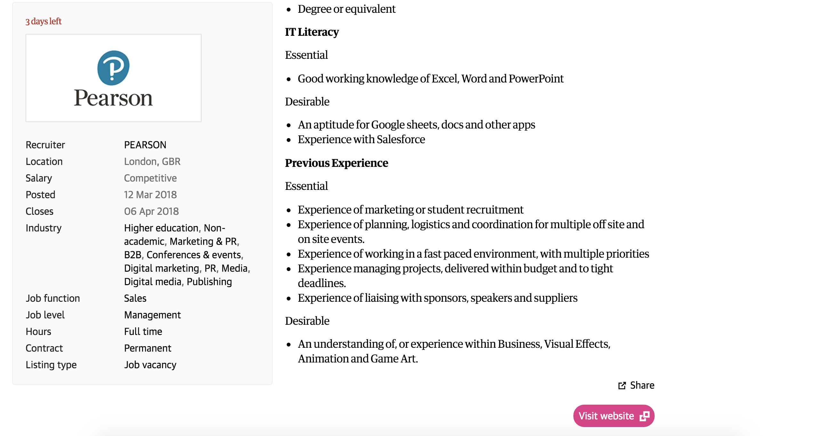
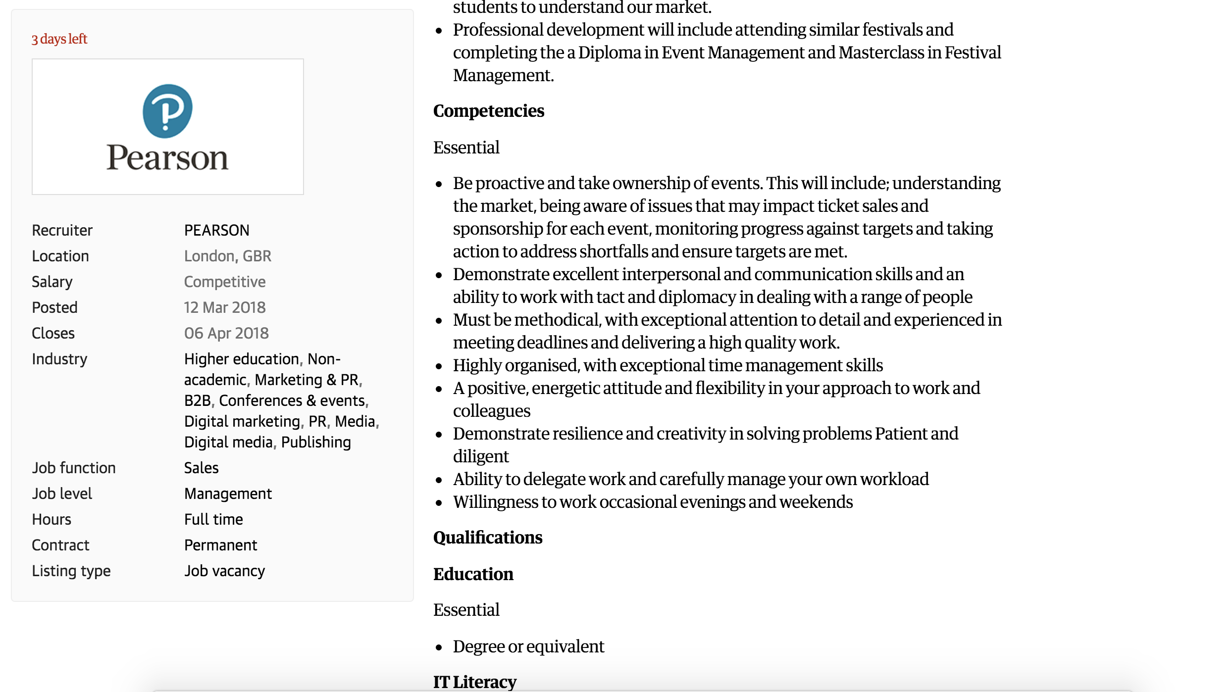
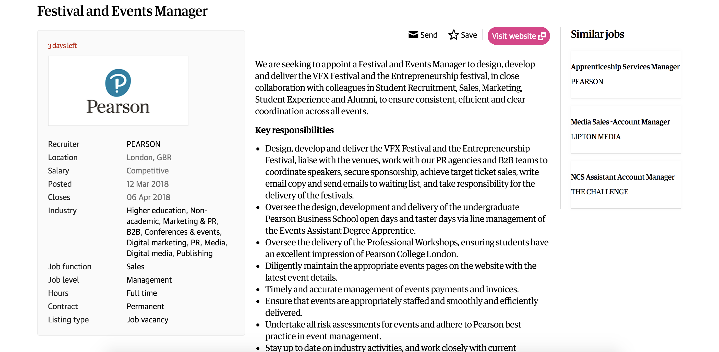
Appendix D

