Name: Ash Toner

Student Number: 2514500
__________________________________________________________

WORKSHEET 2 – TESTING (Tiles)

- Original code:

import math

def check_valid_number(value_entered):
# function checks value is not blank, is not 0 and is not less than 0
if value_entered == "":
print("You must enter a value, cannot leave this blank.") # FINISH
raise ValueError
elif value_entered == 0:
# custom error message for 0, more specific than "negative wall"
print("Wall cannot be 0cm, you have no wall to tile.")
raise ValueError
elif value_entered <= 0:
print("Cannot have a negative amount of wall.")
raise ValueError

tileLength = 20
tileWidth = 20

try:
customerWallLength = float(input("Please enter the length of the wall you wish to tile (in cm): "))
check_valid_number(customerWallLength)
customerWallWidth = float(input("Please enter the width of the wall you wish to tile (in cm): "))
check_valid_number(customerWallWidth)

# could have used // (divide floor) then added 1 if length / width % 20
# math.ceil (ceiling) works in the same way, is less code
tilesNeededLength = math.ceil(customerWallLength / tileLength)
tilesNeededWidth = math.ceil(customerWallWidth / tileWidth)

tilesNeededTotal = int(tilesNeededLength * tilesNeededWidth)

print(f"You need {tilesNeededTotal} tile(s) for your wall.")

except ValueError:
# error handling
print("ERROR: What you entered is invalid. Please enter a valid input.")

- Code Testing

For each test below (i – vii), run your code and enter the values provided. Present a screenshot of the of what happened when the programme ran. Did the programme behave correctly or did it do something unexpected, and if so, why?

Input:

- Enter dimensions of wall: Width 40 Length 45
- Enter dimensions of wall: Width 100000 Length 200000
- Enter dimensions of wall: Width -16 Length -20

Logic:
- Enter dimensions of wall: Width 80 Length 80. The result should be 16 tiles
- Enter dimension of wall: Width 40 Length 45. The result should be 6 tiles
- Enter dimensions of wall: Width 85 Length 90. The result should be 25 tiles.
- Enter dimensions of wall: Width 15 Length 15. The result should be 1 tile.

Note: If you decided to include logic within your program to allow a tile to be cut such that 2 pieces can be used from the same tile where possible (therefore reducing the total number of tiles required), your results may differ from the above. In this case, explain your logic as part of your answer. If you did not, consider adding this logic to your final code.

Fill in a box for each test above. You should present 7 separate boxes, 1 for each test. (Note: the first box is provided as a template)

Input
Test i: Input - Enter dimensions: Width 40 Length 45

Screenshot(s) of output:
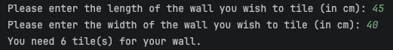
Result: Did the programme behave as expected ie syntactically and logically correct?
YES
Both 40 and 45 are valid integers / floating-point numbers and so the program should accept them, which it does. This passes the test.

Test ii: Input - Enter dimensions: Width 100000 Length 200000

Screenshot(s) of output:
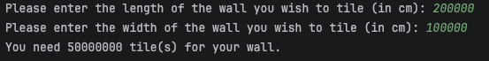

Result: Did the programme behave as expected ie syntactically and logically correct?
NO
Are these two inputs valid integers / floating-point numbers? Yes. Should they have been allowed? No probably not. When I was writing validation for this program I didn’t think to add a maximum value, I definitely should have. A wall that has a width of 10,000m is impractical and if this system was behind a real company then a request that large should ideally manually checked. For these reasons, this test fails.

Test iii: Input - Enter dimensions: Width -16 Length -20

Screenshot(s) of output:
Length:
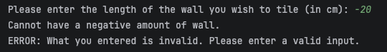

(Valid length) Width:
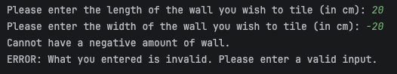
Result: Did the programme behave as expected ie syntactically and logically correct?
YES
Both my inputs, length and width get run through the same function that checks inputs are not null and a number above 0 so negative numbers get picked up and end the program. These errors get picked up and so pass the test.

Logic
Note – I did not implement functionality to split tiles, so these results are based on one tile being used for one 20cm by 20cm space. I am counting this result as “correct”.
Test iv: Logic - Enter dimensions of wall: Width 80 Length 80. The result should be 16 tiles
Screenshot(s) of output:
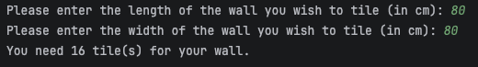
Result: Did the programme behave as expected ie syntactically and logically correct?
YES
80cm by 80cm accounts for 4 tiles by 4 tiles, meaning 16 tiles total. My program is correct.

Test v: Logic - Enter dimensions of wall: Width 40 Length 45. The result should be 6 tiles
Screenshot(s) of output:
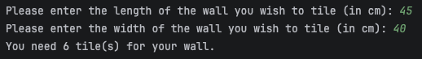
Result: Did the programme behave as expected ie syntactically and logically correct?
YES
45cm by 40cm accounts for 3 tiles by 2 tiles, meaning 6 tiles total. My program is correct.

Test vi: Logic - vi. Enter dimensions of wall: Width 85 Length 90. The result should be 25 tiles.
Screenshot(s) of output:
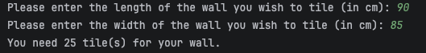
Result: Did the programme behave as expected ie syntactically and logically correct?
YES
90cm by 85cm accounts for 5 tiles by 5 tiles, meaning 25 tiles total. My program is correct.

Test vii: Logic - Enter dimensions of wall: Width 15 Length 15. The result should be 1 tile.
Screenshot(s) of output:
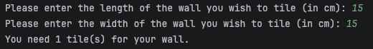

Result: Did the programme behave as expected ie syntactically and logically correct?
YES
15cm by 15cm accounts for just 1 tile total. My program is correct.
- Consider the results of the above tests and revisit your code in order to solve any problems discovered at the testing phase. (Note: you may not be able to solve all of them, but solve as many as you can.)

What I did:
- Allowed user to re-attempt length and width if invalid value is entered
- Added a maximum value validation for length / width
- Created split tile functionality (tiles can be re-used if >= half the tile is used)

Paste your revised code here:

import math
tileLength = 20
tileWidth = 20
def check_valid_number(value_entered):
try:
numbered_value = float(value_entered)
if numbered_value == "":
print("ERROR: You must enter a value, cannot leave this blank.") # FINISH
return False
elif numbered_value == 0:
# custom error message for 0, more specific than "negative wall"
print("ERROR: Wall cannot be 0cm, you have no wall to tile.")
return False
elif numbered_value <= 0:
print("ERROR: Cannot have a negative amount of wall.")
return False
elif numbered_value > 500:
print(f"We can not accommodate this size of wall through this service, you asked for {numbered_value}cm,"
f" the maximum you can enquire about through this service is 500cm.\n"
" NOTE: If the number you entered above is correct, "
"please exit this service and speak to a manager for assistance.\n"
" NOTE: If the number you entered above is incorrect, "
"you can try again below.")
return False
else:
return True
except ValueError:
print(f"ERROR: This must be a number, you entered {value_entered}.")
def calculate_tiles(length, width):
# Whole tiles needed
length_whole_tile = length // tileLength
width_whole_tile = width // tileWidth
# Remaining length (after whole tiles)
length_remaining = length % tileLength
width_remaining = width % tileWidth
# Calculate tile needed along each axis
if length_remaining == 0: # No extra length
length_tiles = length_whole_tile
elif length_remaining <= (tileLength / 2): # Under half tile's length
length_tiles = length_whole_tile + 0.5
else: # Over half tile's length
length_tiles = length_whole_tile + 1
if width_remaining == 0: # No extra width
width_tiles = width_whole_tile
elif width_remaining <= (tileWidth / 2): # Under half tile's width
width_tiles = width_whole_tile + 0.5
else: # Over half tile's length
width_tiles = width_whole_tile + 1
total_tiles = length_tiles * width_tiles # Work out area
return int(math.ceil(total_tiles)) # Round up to the nearest whole tile
lengthText = "Please enter the length of the wall you wish to tile (in cm): "
customerWallLength = input(lengthText)
while not check_valid_number(customerWallLength):
customerWallLength = input(lengthText)
widthText = "Please enter the width of the wall you wish to tile (in cm): "
customerWallWidth = input(widthText)
while not check_valid_number(customerWallWidth):
customerWallWidth = input(widthText)
print(f"You need {calculate_tiles(float(customerWallLength), float(customerWallWidth))} tile(s) for your wall.")

