Student name: | Joshua T. Omelis
ID number: | 2435410
Programme: | Certificate in Higher Education Business Skills for the Workplace
Module: | Enterprise and Entrepreneurship
Module code: | LCLM4006
Assignment Title: | Task 1:  Individual Written Business Plan

Business Plan for GreenBite -
A Sustainable Plant-Based Meal Startup for Health-Conscious Consumers
Executive Summary
GreenBite is a new sustainable food business idea, which offers healthy and affordable plant-based meals to health-concerned customers. The company will respond to emerging issues about environmental sustainability, healthy dieting, and food waste by sourcing them locally, providing biodegradable packaging, and giving out excess food to local charities. The company will be a limited liability company and will start with urban customers via online ordering and food delivery services.
According to the market analysis, there is a growing trend of healthy and environmentally friendly food as a result of changing preferences among consumers and the supportive government initiatives. To attract and retain customers, marketing activities will mainly employ digital marketing, social media, influencer partnerships, and customer loyalty programmes. GreenBite needs a start-up of about PS 50,000, which will be provided by investors and government support programmes. The investment will entail kitchen equipment, rental, marketing, licences, salaries of staff, and working capital. On the whole, GreenBite presents the investors with a lucrative business opportunity, as it is both commercially viable and has positive environmental and societal effects.

Table of Contents
Introduction 4
1. Overview of the Business Idea 5
Business Concept 6
Products and Services 6
Management Structure 6
Legal Structure 7
2. Market Research 8
PESTEL Analysis 8
Competitor Analysis 9
3. Marketing Communications 10
Target Market 10
Marketing Strategy 10
Sustainability Communication 11
4. Financial Plan 12
Funding Requirement 12
Funding Source 12
First-Month Operating Expenses 12
Conclusion 13
References 14

Introduction
Marketing communications are very crucial in creating brand awareness, attracting customers and establishing long term relationships within the competitive food industry. To successfully reach its target market and establish a stronger position in the market, GreenBite will implement an integrated marketing communications approach, which will integrate digital marketing, customer relationship management and sustainability-related messages. The goal of the business is to distinguish itself among the competitors and make its customers loyal by conveying its interests in healthy food and green environment.

1. Overview of the Business Idea
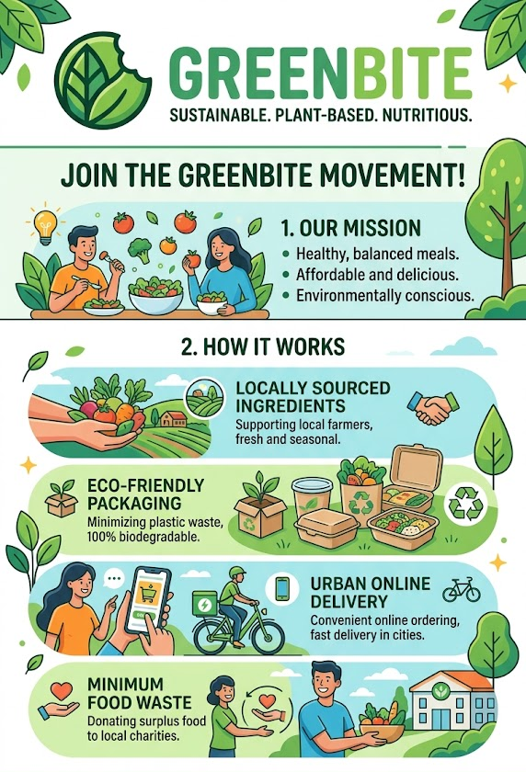
Source: Author

Business Concept
GreenBite is an eco-friendly food company that deals in freshly prepared plant-based meals to health-conscious people. The company will focus on ensuring the affordability of healthy food and minimizing the environmental effects of conventional food production. Plant-based diets are less resource-intensive and generate much less greenhouse gas emissions compared to meat-based ones, making them a promising solution to achieving sustainability (Poore and Nemecek, 2018).
The restaurant will serve wholesome breakfast, lunch, dinner, snacks, smoothies and meal subscriptions consisting of foods made of locally grown vegetables, grains, legumes, fruits and other natural foods. GreenBite will reduce food waste by ensuring the inventory is well managed and will donate excess meals to local community organisations, hence contributing to the environmental sustainability and social responsibility. These practices are indicative of the values of social entrepreneurship in that they generate economic and social value (Dees, 1998).

Products and Services
GreenBite will offer diverse healthy foods such as vegan bowls, salads, wraps, soups, protein oriented foods, fresh juices, smoothies, and tailor-made meal plans. The company will allow customers to make orders by utilizing the company webpage, mobile app, and food delivery service.
The company will also introduce weekly and monthly subscription plan which will foster customer loyalty and also make the business experience predictable revenue. GreenBite will also enhance its environmental responsibility with sustainable packaging made of biodegradable materials.

Management Structure
The business will be run with a functional organisational structure with the Founder and Managing Director heading four departments:
- Operations Manager
- Marketing Manager
- Finance Manager
- Kitchen Supervisor
This design allows specialisation of departments and enables effective decision-making. Daft (2020) states that functional organisational structures enhance the level of coordination and operational efficiency and are more effective at the initial stages of business development.

Legal Structure
GreenBite will be registered as a Private Limited Company (Ltd.). This legal form will provide limited liability to the shareholders, more business credibility, easy access to investments, and expansion in the future. Burns (2021) states that growth-oriented start-ups tend to choose limited companies due to their financial flexibility and investor confidence.

2. Market Research

PESTEL Analysis
Political Factors
Most governments are promoting healthier living and green businesses by granting it, through food safety regulations, and environmental policies. State programs that encourage sustainable food production provide good opportunities to plant-based food enterprises (Burns, 2021).
Economic Factors
Inflation and the rising cost of food will need to be considered in terms of the cost of operations, but consumers are increasingly willing to pay more and more to enjoy healthy food as an investment in long-term health. Plant-based food market in the world is currently showing a robust growth in spite of economic uncertainty (Kotler and Keller, 2016).
Social Factors
Consumers are more health-conscious, nutritionally conscious, animal welfare conscious and environmental sustainability conscious. The younger generations are especially more inclined to plant-based diets and ethical consumption. Kotler and Keller (2016) argue that the purchasing behaviour and market opportunities are greatly affected by the changing consumer lifestyles.
Technological Factors
Digital ordering systems, online payment systems, mobile apps, delivery systems, and customer relationship management systems enhance efficiency in operations and customer convenience. Businesses can also use social media to relate with customers directly and have long-term relationships (Chaffey and Ellis-Chadwick, 2022).
Environmental Factors
One of the most powerful forces behind the demand of plant-based foods is environmental issues. GreenBite is in line with sustainability goals in the world because of sustainable sourcing, biodegradable packaging, reduction of food waste, lowering carbon emissions, and other factors. The fact that plant-based food production requires significantly fewer adverse environmental effects as compared to animal-based food systems is demonstrated by Poore and Nemecek (2018).
Legal Factors
GreenBite should be able to meet the food safety laws, employment laws, health and safety laws, tax laws and consumer protection laws. Compliance minimizes legal risks and enhances customer trust and reputation of the business (Burns, 2021).

Competitor Analysis
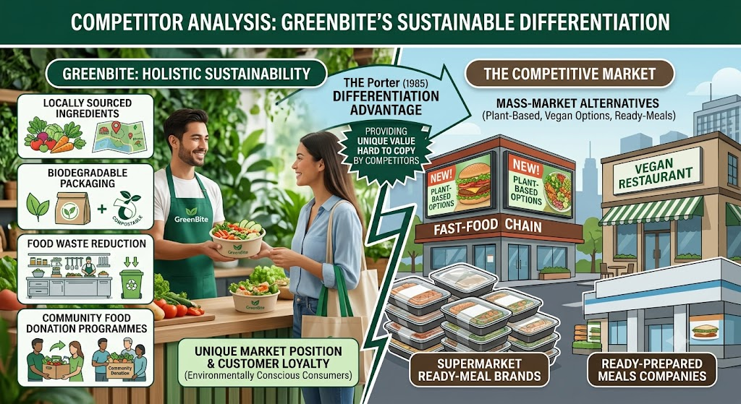
Source: Author
GreenBite is a company that is in a competitive market of healthy food. Large fast-food chains are also on the list of major competitors, as they are launching their own plant-based alternatives, vegan restaurants, ready-prepared meals companies, and even supermarket ready-meal brands.
Nonetheless, GreenBite sets itself apart with its holistic approach to sustainability. The business incorporates locally sourced ingredients, biodegradable packaging, food waste reduction, and community food donation programmes in one business model as opposed to many competitors that do not. According to Porter (1985), differentiation helps businesses to achieve competitive advantage by providing unique value that can hardly be copied by the competitors.
This focus on the environment and community by the company gives the company a unique market position and builds customer loyalty with the environmental conscious consumers.

3. Marketing Communications

Target Market
GreenBite is mostly focused on the health-conscious consumer segment of people aged 18-45 years and residing in urban centers and actively pursuing healthy, convenient, and sustainable food products. This market consists of working class, university students, fitness enthusiasts, vegetarians, vegans and flexitarians who seek to cut down on meat intake but still have a balanced diet. Such consumers are typically more educated about nutrition, sustainability, and ethical food production and are ready to pay a fair premium to products that are in accordance with their own values. Moreover, the increasing health awareness and the need to consume healthier living styles and environmentally friendly products offer great prospects of GreenBite to build a base of loyal customers. According to Kotler and Keller (2016), the market segmentation and customer needs are the key to designing effective marketing strategies that will generate customer value in the long term.

Marketing Strategy
GreenBite will be using an integrated marketing communications (IMC) approach which involves a blend of digital marketing and selective use of traditional promotional activities to create awareness of the brand and get customers to engage. Digital marketing will be used as the main mode of communication as it is cost effective and it can be used to reach the targeted audience. The visually pleasing content, i.e., video tutorials on how to prepare meals, customer reviews, nutrition, environment-friendly activities, and back-story about sourcing locally, will be shared on social media, including Instagram, Facebook, Tik Tok, and LinkedIn. Chaffey and Ellis-Chadwick (2022) explain that digital marketing helps companies provide personalised content, engage directly with customers and build better brand relationships.
The company will also provide the investment for search engine optimisation (SEO) as well as paid online advertisements to boost site visibility to encourage more customers to look for healthy meal options (Al-Mukhtar, Hamad and Kareem, 2021). Partnering with nutritionists, fitness trainers, food bloggers, and health influencers will lend credibility and reach to your brand. GreenBite will also attend local health fairs, fitness events, and community programmes, to increase their visibility in the community and promote samples for sale.
Customer Relationship Management
GreenBite understands that it's as crucial to have customers return once you've already got them as it is to gain new ones. In doing so, the business will devise a wider customer relationship management (CRM) approach, using a digital solution in the shape of a loyalty scheme which entitles customers to earn points towards their purchases. Customers will also receive discounts for their subscription, referral offers, a birthday deal, and personalized promotions, depending on their purchase habits. Healthy eating ideas, seasonal menus, special offers, and announcements of new products will be sent out via regular e-mail newsletters. Establishing a close bond with customers boosts customer satisfaction, helps customers to come back, and also enhances customer life value, which affords a sustainable competitive advantage (Kotler and Keller, 2016).

Sustainability Communication
GreenBite's marketing communications will be very focused on sustainability. The company's pledge to help promote sustainable business practices, such as the use of local ingredients, biodegradable packaging, curbing food waste and donating unsold food to community groups, will be highlighted in the promotional campaigns. These actions have visibly shown the company's environmental and social responsibility and distinguished GreenBite from other companies. Consumers have started to appreciate businesses that can actually prove the commitment of the business towards the society as it brings a good corporate image, trust in the business and finally purchasing decisions (Carroll, 1991). Through consistent messaging and communications on sustainability throughout all marketing channels, GreenBite seeks to establish a sustainable, value-driven premium reputation as a responsible and innovative provider of value for customers, communities and the environment in the plant-based food business.

4. Financial Plan

Funding Requirement
GreenBite requires approximately £50,000 to commence operations.
The investment will finance:
Expense | Estimated Cost (£)
Kitchen equipment | 15,000
Shop renovation | 8,000
Initial inventory | 6,000
Licences and permits | 2,000
Marketing campaign | 5,000
Staff salaries (Month 1) | 8,000
Technology and website | 3,000
Working capital | 3,000
Total Required Funding | 50,000

Funding Source
GreenBite would like to invest with angel investors, the venture capital firms that focus on sustainability (Ganti, 2024). The extra funds can be availed by the government grants to environmentally friendly businesses. The capital of investors allows entering the market quicker and decreases over-indebtedness. According to Burns (2021), equity financing is especially appropriate when it comes to innovative start-ups with high growth potential due to its ability to enhance financial flexibility in the initial business development.

First-Month Operating Expenses
In the initial month, the highest costs will be on the staff salary, raw materials, installation of kitchen equipment, facility rent, utilities, digital marketing, insurance, and transportation costs.
Financial planning is important in the adequate cash flow and stability in operations during the critical start-up stage. As pointed out by Barringer and Ireland (2019), proper financial management can considerably enhance the rates of survival of new ventures.
An online food delivery partnership, direct sales of meals, subscription services, and catering services will be considered as the sources of projected revenue. With the rising awareness of the customers due to the marketing activities, the revenues will steadily increase as the operational efficiencies will increase the profitability.

Conclusion
In general, the marketing communications strategy by GreenBite incorporates specific promotion, online interaction, customer relationship management, and sustainability communication to develop a solid and coherent brand image. The needs of the health-conscious consumers and emphasizing its environmental and social work will allow the business to gain customer trust, grow brand loyalty and become sustainable in the ever-growing market of the plant-based food.

References
Al-Mukhtar, F.H., Hamad, N. and Kareem, S. (2021). Search engine optimization: A review. [online] ResearchGate. Available at: https://www.researchgate.net/publication/350529991_SEARCH_ENGINE_OPTIMIZATION_A_REVIEW [Accessed 24 July 2026].
Barringer, B.R. and Ireland, R.D. (2019). Entrepreneurship: Successfully launching new ventures. [online] Pearson. Available at: https://digitallibrary.peninsulacollege.edu.my/handle/123456789/34 [Accessed 24 July 2026].
Burns, P. (2021). Entrepreneurship and small business. [online] Google Books. Available at: https://books.google.com/books/about/Entrepreneurship_and_Small_Business.html?id=QG1NEAAAQBAJ [Accessed 24 July 2026].
Carroll, A.B. (1991). The pyramid of corporate social responsibility: Toward the moral management of organizational stakeholders. Business Horizons, 34(4), pp.39–48. doi: https://doi.org/10.1016/0007-6813(91)90005-G.
Chaffey, D. and Ellis-Chadwick, F. (2022). Digital marketing. [online] Google Books. Available at: https://books.google.com/books/about/Digital_Marketing.html?id=AVmczgEACAAJ [Accessed 24 July 2026].
Daft, R.L. (2020). Organization theory & design. [online] Cengage Learning. Available at: https://books.google.com/books/about/Organization_Theory_Design.html?id=PQfFDwAAQBAJ [Accessed 24 July 2026].
Dees, J.G. (1998). The meaning of “Social entrepreneurship.” [online] Stanford University. Available at: https://web.stanford.edu/class/e145/2007_fall/materials/dees_SE.pdf [Accessed 24 July 2026].
Ganti, A. (2024). Angel investor definition and how it works. [online] Investopedia. Available at: https://www.investopedia.com/terms/a/angelinvestor.asp [Accessed 24 July 2026].
Kotler, P. and Keller, K.L. (2016). Marketing management. [online] Pearson. Available at: https://books.google.com/books/about/Marketing_Management.html?id=UbfwtwEACAAJ [Accessed 24 July 2026].
Poore, J. and Nemecek, T. (2018). Reducing food’s environmental impacts through producers and consumers. Science, 360(6392), pp.987–992. Available at: https://www.science.org/doi/10.1126/science.aaq0216 [Accessed 24 July 2026].
Porter, M.E. (1985). Competitive advantage: Creating and sustaining superior performance. [online] Harvard Business School. Available at: https://www.hbs.edu/faculty/Pages/item.aspx?num=193 [Accessed 24 July 2026].

