ACCA5026 – Database and Application Development
Dafydd Davies

Contents
Introduction 3
Database Design 3
Entity Relationship Diagram 3
Table Designs 3
Database Implementation 6
Creating the database and tables 6
Creating the constraints 9
Inserting data 12
Transactional Scenario 17
Processes and executions 18
Enhancing database 30
Indexing 30
Bibliography 31
Appendix 31

Introduction
I have been tasked with creating a database for the company AdventureWorks Cycle. This company primarily focuses on selling bikes and related accessories to people from different manufacturers. My task is to create a Robust database to help support their business. This database will support accounts for both manufacturers so they can upload new products and customers so they can place orders. It will also include a method to process an order and to give feedback on products received from orders. The database will be efficient, dependable and will be scalable for future use. It is also able to hold large volumes of data without any data repeating.

Database Design

Entity Relationship Diagram
This is the ERD I created before creating my database to help me when I create the links to the different tables and to help me gauge what different tables I would need in the database. As you can see these are the links that will be in the database to help group the data. I also added a word between each one to help explain the link between them.
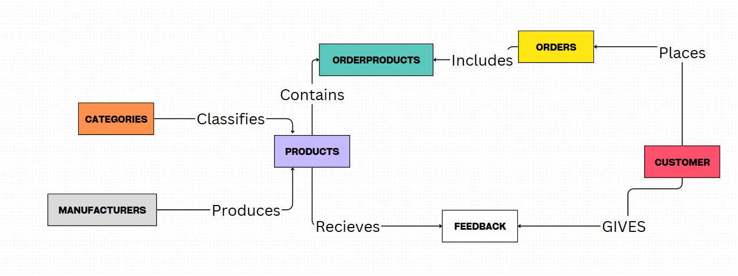

Table Designs
These are the tables I had created to help me decide what data would go inside of the tables and for what they would be used.
Categories | Datatype | Constraints | Description
CategoriesID | INT | Primary Key, Identity | The unique identifier to help identify the category
CategoriesName | VARCHAR(50) | Presence | The name of the category for a product

Manufacturer | Datatype | Constraints | Description
ManufacturerID | INT | Primary KEY, Identity | The unique identifier to help identify the manufacturer
ManufacturerName | VARCHAR(30) | Presence | The name of a manufacturer who created a product
ManufacturerEmail | VARCHAR(50) | Presence, Unique | The email address that belongs to the manufacturer
ManufacturerPassword | VARCHAR(50) | Presence | The password used to login to the manufacturer account
ManufacturerPhoneNumber | VARCHAR(15) | Presence | The phone number that belongs to the manufacturer

Products | Datatype | Constraints | Description
ProductID | INT, Identity | Primary Key | The unique identifier to help identify the product
ProductName | VARCHAR(50) | Presence | The name of the product
ProductDescription | VARCHAR(100) | Presence | The description to explain the item
Price | DECIMAL(10,2) | Presence | The price for the item
Stock | INT | Default(0) | A stock amount for the product
ManufacturerID | INT | Foreign Key | A link between manufacturers to give a product a manufacturer
CategoriesID | INT | Foreign Key | A link between categories to give a product a category

Customer | Datatype | Constraints | Description
CustomerID | INT | Primary KEY, Identity | The unique identifier to help identify the customer
CustomerName | VARCHAR(30) | Presence | The name of a customer who is going to buy a product
CustomerEmail | VARCHAR(50) | Presence, Unique | The email address that belongs to the customer
CustomerPassword | VARCHAR(50) | Presence | The password used to login to the customer account
CustomerPhoneNumber | VARCHAR(15) | Presence | The phone number that belongs to the customer

Orders | Datatype | Constraints | Description
OrderID | INT | Primary Key, Identity | The unique identifier to help identify the customer
OrderNumber | INT | Presence, Unique | The order number that belongs to the order
Address | VARCHAR(50) | Presence | The address the order is going to
PostCode | VARCHAR(7) | Presence | The postcode the order is going to
Country | VARCHAR(50) | Presence | The country the order is going to
CardNumber | VARCHAR(16) | Presence, Length | The card number to pay for the order
CVV | CHAR(3) | Presence, Length | The CVV to pay for the order
TotalCost | DECIMAL(10,2) | Presence | The total cost of the order
Status | VARCHAR(20) | Presence, Default(Pending) | The status of the order e.g., shipping, delivered, processed
CustomerID | INT | Foreign Key | A link between the customer for the order

Products | Datatype | Constraints | Description
OrderProductID | INT | Primary Key, Identity | The unique identifier to help identify the customer
Quantity | INT |  | The amount of the product that is being ordered
Cost | INT | Presence | The cost of the product
ProductID | INT | Foreign Key | A link between the products to display multiple
OrderID | INT | Foreign Key | A link to designate an order for the products

Feedback | Datatype | Constraints | Description
FeedbackID | INT | Primary Key, Identity | The unique identifier to help identify the customer
Feedback | VARCHAR(200) | Presence | The feedback for the product
Rating | INT | Presence, Range(1-5) | The rating the product received
ProductID | INT | INT | A link so the product receives the feedback
CustomerID | INT | Foreign Key | A link so the customer can post the feedback

Database Implementation
Refer to readmefile.txt to know the correct order to run the files to ensure there are no problems with the database when you are attempting to create it.

Creating the database and tables
This section is for creating the database and the tables alongside it and will show the queries I used to complete them.
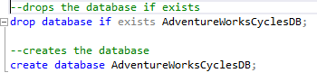

This creates the database while also dropping it beforehand in case something with the same name is already created.

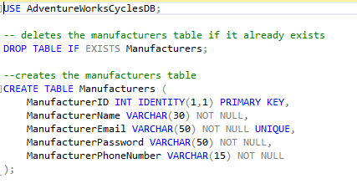

This query creates the manufacturers table while also deleting one beforehand in case it already existed it also adds the data types into it as well as you can see to help store the basic information that a manufacturer would have.
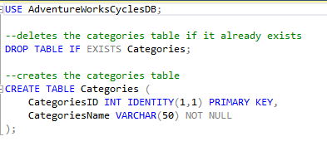
Again, a drop statement is used just in case and this query adds the categories table although it only has two data types its due to the fact no other data types are needed which makes it more efficient and robust.

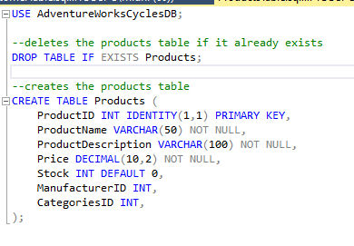
This is the products table which, as you can see, is where the products will be stored. The data types are the ones decided from earlier as explained.

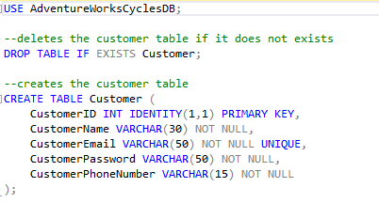
This is the customer table which, as explained earlier, is used for the customer’s account, and only requires the needed information from them.

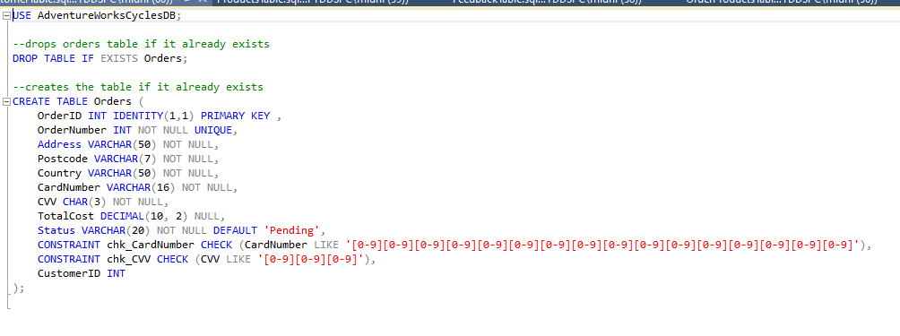
This is the Orders table which will contain all the data types for the orders for the customers.

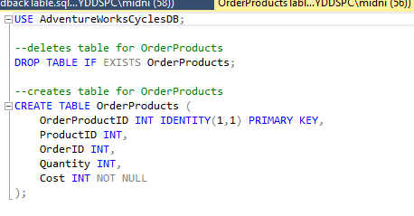
This is the Order Products table which will be used as a junction table between the Order and Products tables to help store multiple products per order.

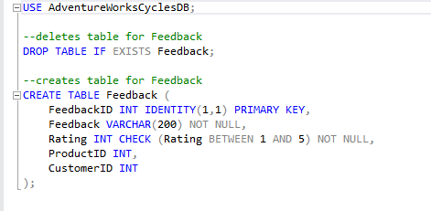
This is the feedback table which will be used for ratings and reviews on the products.

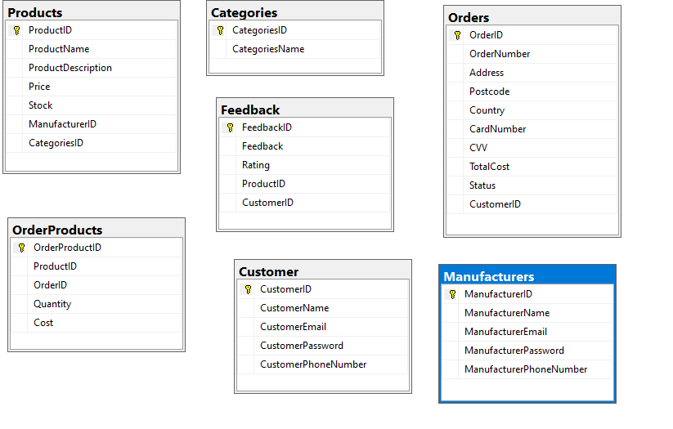
As you can see the queries worked fine and the seven tables have been implemented into the database.

Creating the constraints
This section will be showing the queries I used to make links between the different tables .
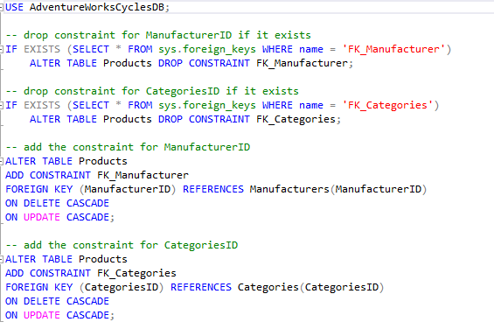
This is the product constraint which links the categories and manufacturers to the product table.

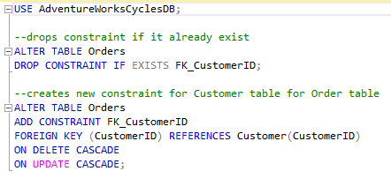
This is the order constraint which is used to link the customer table to the order table.

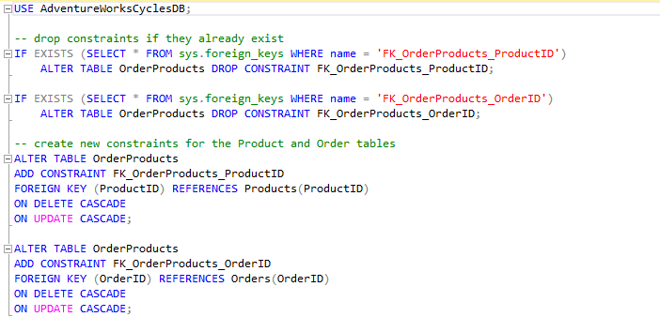
This is the orderproducts constraint which is used to link the products and order tables to the orderproducts junction table.
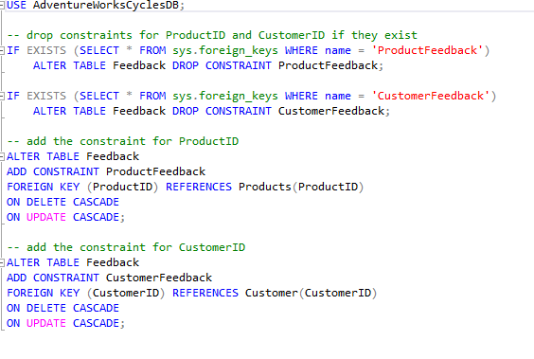
This is the feedback constraint which links the products and customer tables to the feedback table.

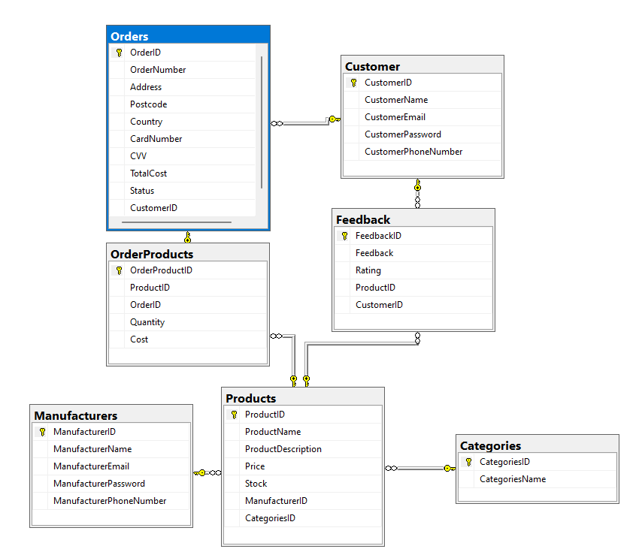
As you can see above the database diagram shows that the tables are linked properly and linked as wanted in the ERD.

Inserting data
This section will show the data that will be implemented into the database and how it will be structured.

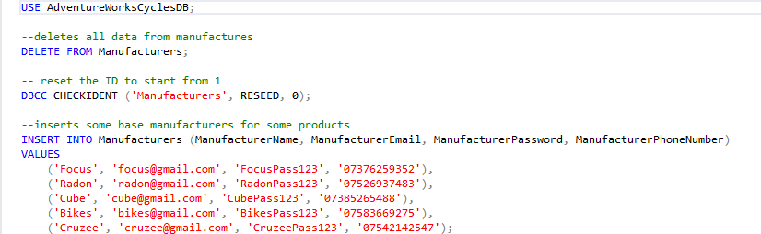
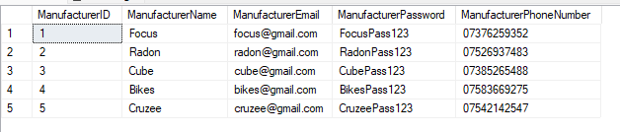
These are the base manufacturers that will be adding products for customers to choose from.

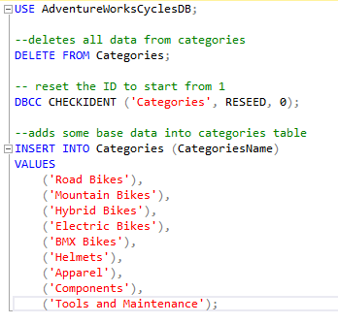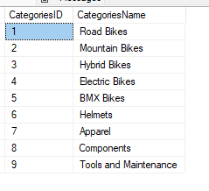
These are the types of categories that the manufacturers can use for their products that they will be selling.

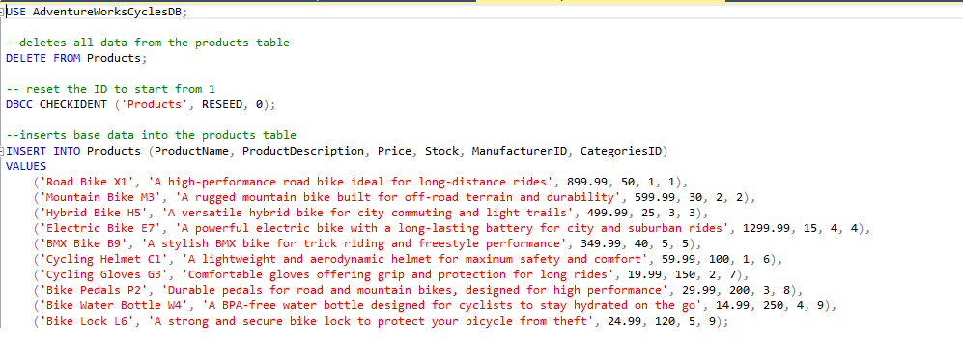
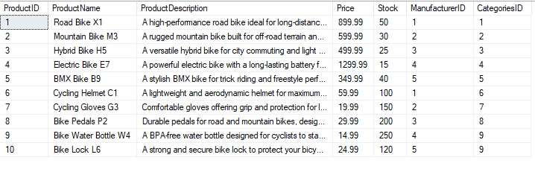
These are the base products that will be entered into the database for the customers to choose and purchase from.

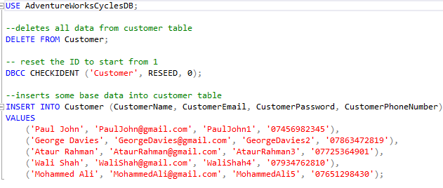
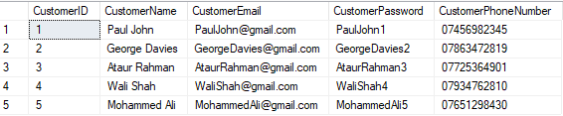
This is customer information for examples of how it would be structured.

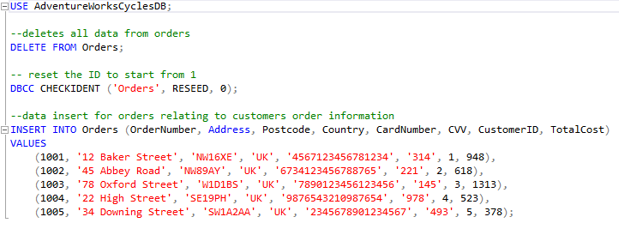
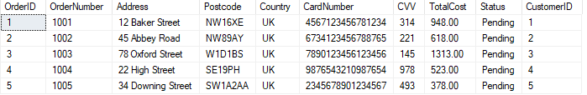
These again are examples of the order table data inserts for testing purposes and structuring.

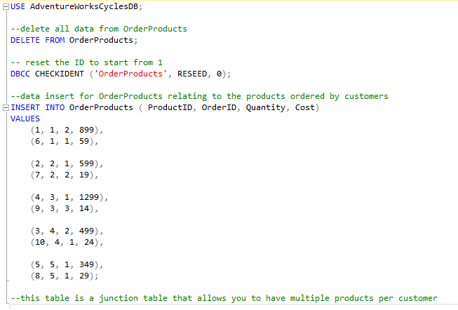
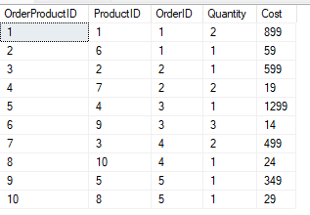
Again, another example for testing purposes to evaluate that the data works and is effectively added.

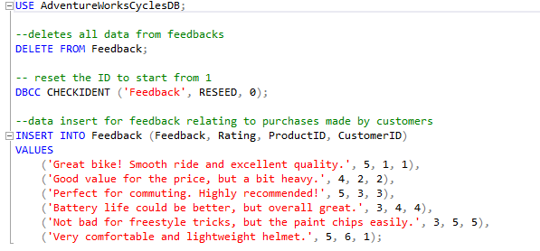
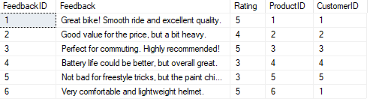
Finally, inputting reviews again for testing purposes to ensure data being added properly.

As you can see from all the above images all the data was properly inputted into the system and I had also added automatic assignment for the IDs with a reset so if the data insert is ran again it would start at 1 rather than just going to the next number available afterwards.

Transactional Scenario
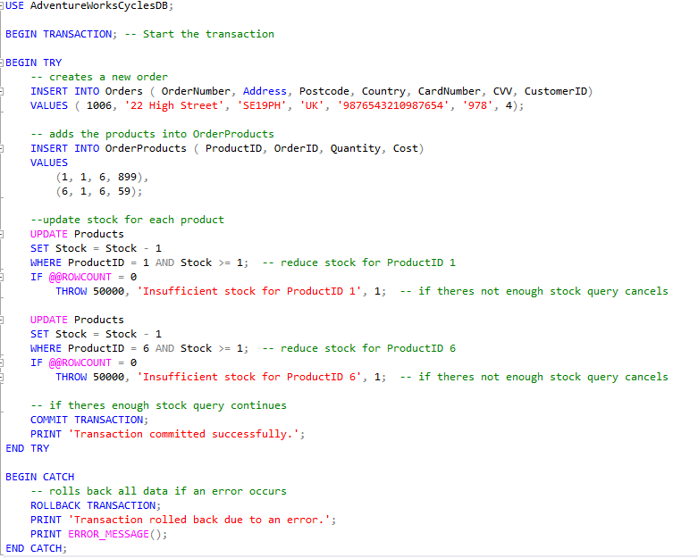
This is a transaction query. The point of this query is to attempt to make an order. This order will then be added to the system, and it will reduce the stock of that item by the amount selected. It will add different data to the Order and OrderProducts tables. The order table will get the OrderNumber the Address, Postcode, Country, CardNumber, CVV and CustomerID while the OrderProducts table will get the ProductID, OrderID, Quantity and Cost for the item. As you can see from the comments it helps explain what is going on in the query. I learned try catch from here [1] and I learned transactions from here [2].
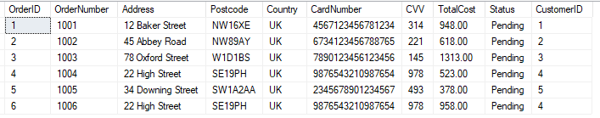
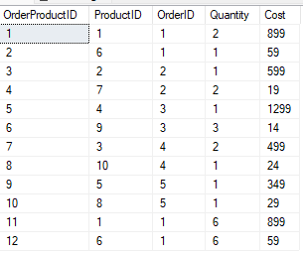
As you can see it successfully added the order to both the Order table and the OrderProducts table

Processes and executions
This section will feature some processes and executions to increase the efficiency of the database.
I learned how to do procedures from here [3] and executions from here [4]
Manufacturer Registration
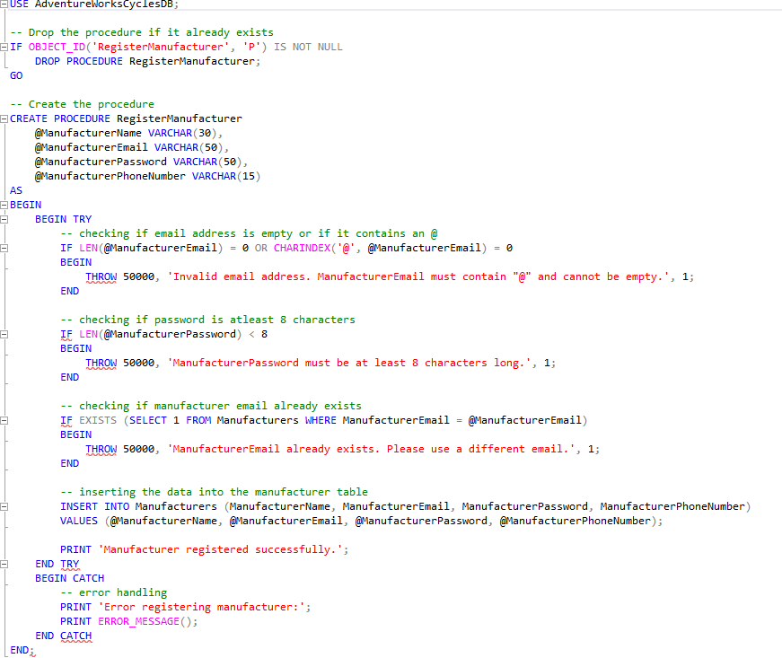
As you can see from this procedure there are multiple validation attempts to make sure that when a manufacturer account is created certain problems do not arise. The validation inside of this procedure are no duplicate emails, making sure an @ is present and making sure the password is over eight characters for some form of safety.
Validation Proof
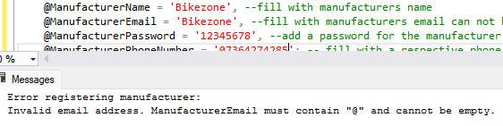
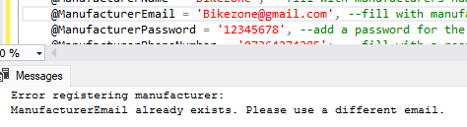
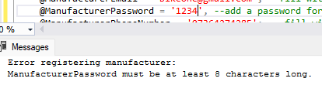
As you can see from the above three images that proves that the manufacturer validation techniques work to help ensure only correct data is entered.

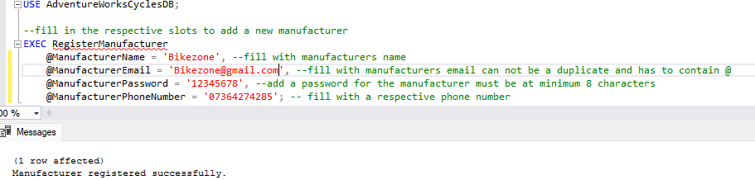
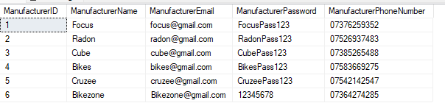
As you can see that shows that a manufacturer has successfully been added after making sure to meet the requirements. You can also see in the second image that it was added to the table properly in the correct format.

Product Listing
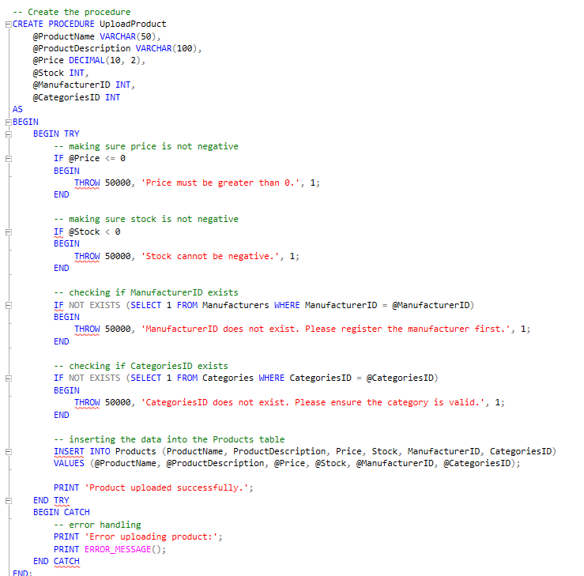
As you can see this is the procedure for uploading a product to the database it again features some form of validation in the form of making sure the manufacturerID and the CategoriesID exists as well as making sure there is at least stock of the item and the price is positive.
Validation Proof
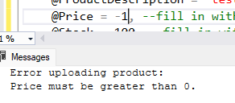
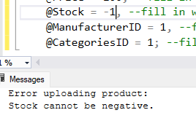
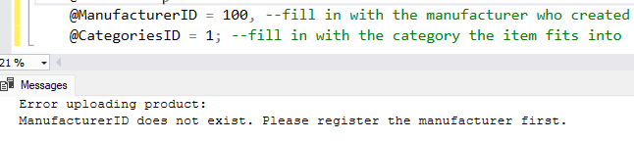
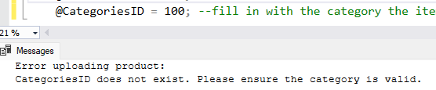
As you can see from those four methods,
If the requirements are not met the product will not be uploaded.
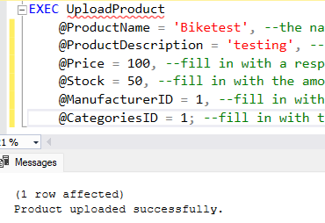
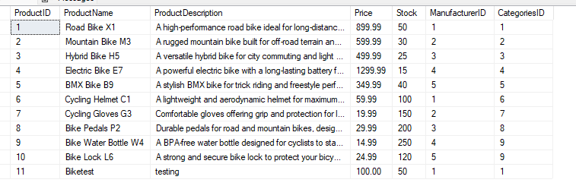
As shown in the images above, if the conditions are met the execution command will work and the data will be uploaded to the table as shown in the second image.

Customer Registration
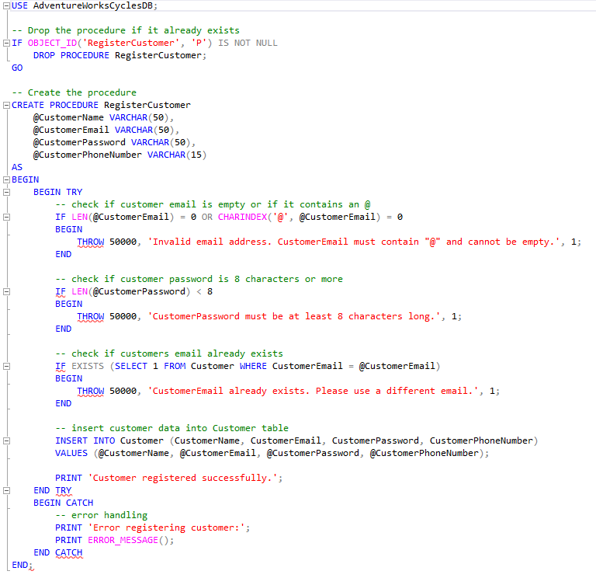
As you can see, just like manufacturer the customer has the exact same validation methods for the exact same reasons.
Validation Proof
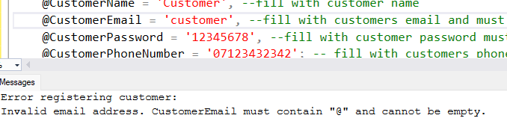
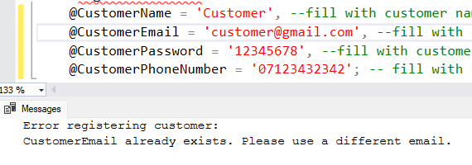
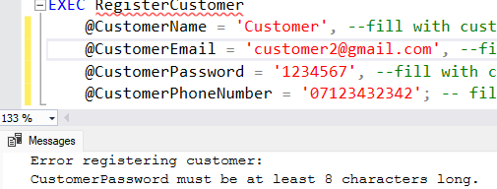
As you can see all the validation methods work which will ensure no duplication of emails and ensure passwords exist.
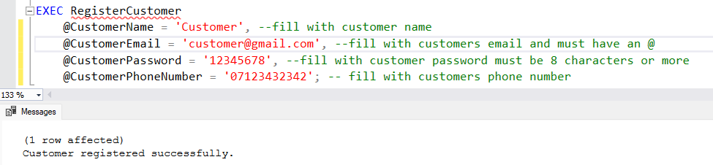
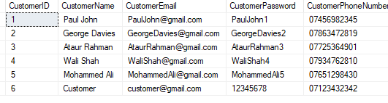
As you can see from the image above when the requirements were met the data was added to the table

Product Purchase
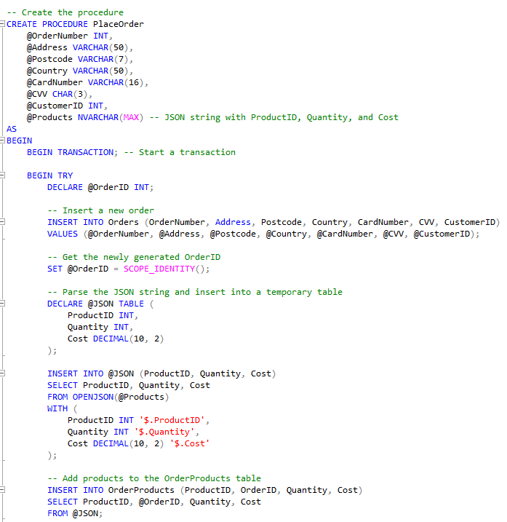
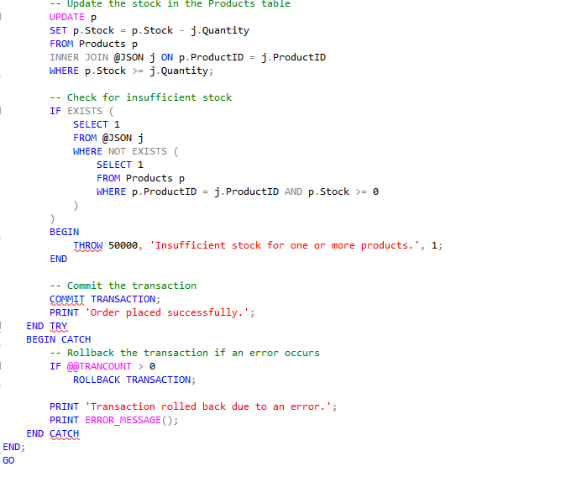
As you can see from the procedure it not only has validation checks but also changes data already existing. For example, even though it creates a new order it will still remove stock from the product that was selected for the order.

Validation Proof
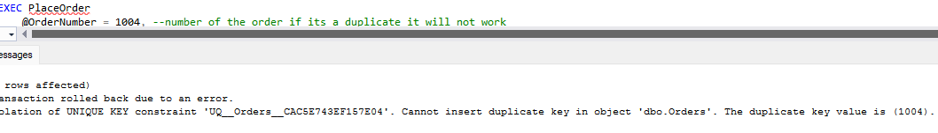
As you can see it does not let a duplicate of an order go through
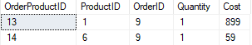
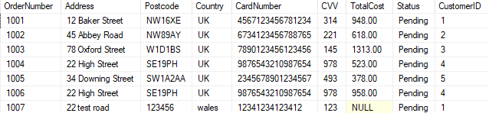
As you can see the total cost has not gone through but everything else has.

Order Processing
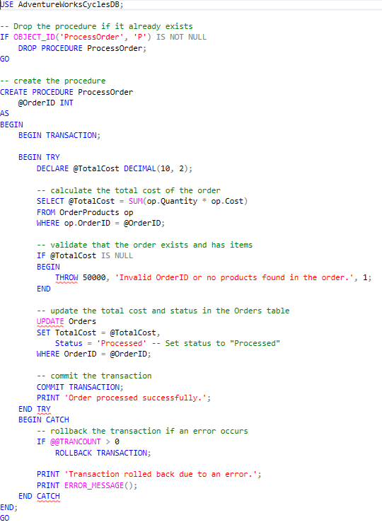
There is only one validation check for this part and the reason for that is since it only takes the OrderID, so the only validation check is checking if the order exists.
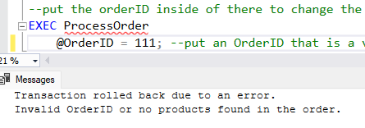
Since the order does not exist as you can see it says the Order does not exist.
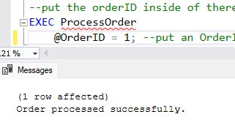
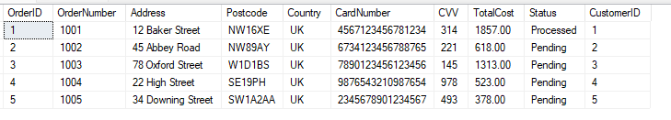
As you can see, clearly there is now a process on the status of the order to show that it has gone through.

Feedback and Reviews
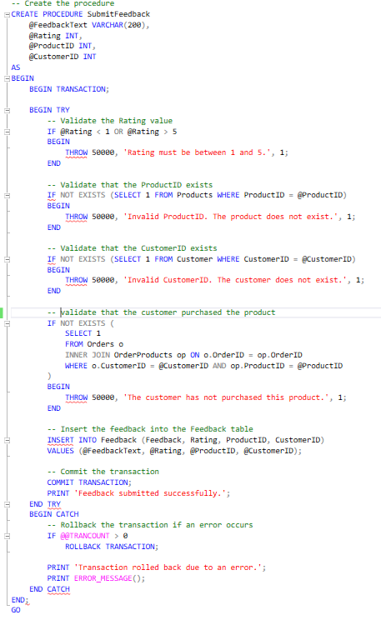
As you can see there is a good few validation checks in that including a check to make sure the rating value is between 1 and 5, a check to see if the product exists, a check to see if the customer exists and a check to see if the customer bought the product.
Validation Proof
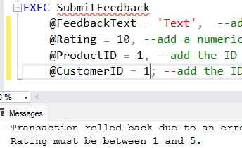
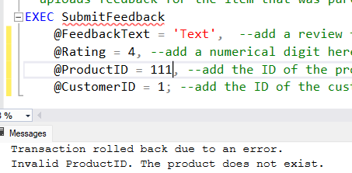
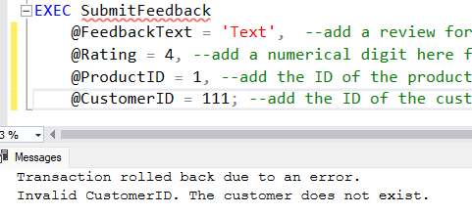
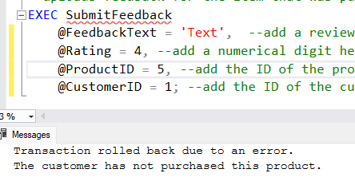
As you can see the validation methods all work, which means that the reviews will only come from the people who buy them, and reviews will match the scale for the review method we use.
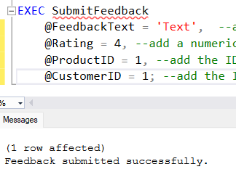
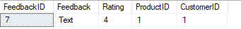
As you can see the feedback execution worked as here you can see all the information I entered and that it is all correct.

Enhancing database

Indexing
I learned indexing from here [5]

Order with ordered product, quantity and cost
Not indexed Version
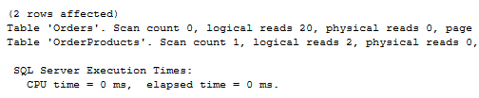

Indexed version
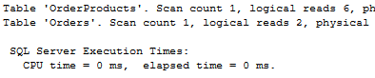
As you can see the indexed version used another scan but reduced the amount of logical ready by 14 which helps speed up the process.

Order, Order Products and Products
Not indexed version
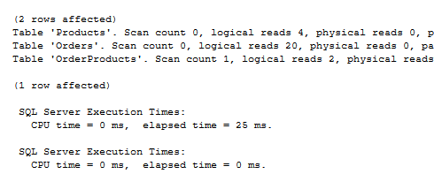
Below is the indexed version
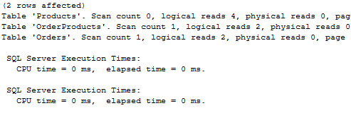
If you compare the 2 you can clearly see that order products did get another scan count, but it also lost 18 of its logical reads and the elapsed time for the execution went from 25ms to 0ms which proves that this has made it much faster.

Customer and Order
Not indexed version
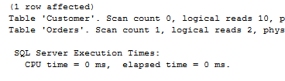
Indexed Version
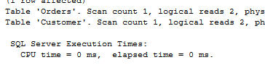
As you can see again, I have indexed it and again it has reduced the logical reads therefore making it use less power which increases its efficiency.

This shows that if I were to index every process, I would be able to increase the productivity and efficiency of the database itself. The reason I chose those specific indexes as well were due to them being high traffic ones. Joining a customer to an order would be done a lot as it would help when attempting to check a customer’s order. The order with the quantity, cost and product would be helpful as well as to check what someone’s order is how many they ordered and what they ordered as that would be something extremely important to the system due to it being a main part of it.

Bibliography

[1] | B. Petrovic, "How to implement error handling in SQL Server," 15 June 2018. [Online]. Available: https://www.sqlshack.com/how-to-implement-error-handling-in-sql-server/.
[2] | E. Erkec, "Transactions in SQL Server for beginners," 10 February 2021. [Online]. Available: https://www.sqlshack.com/transactions-in-sql-server-for-beginners/.
[3] | R. Babu, "SQL Server stored procedures for beginners," 29 July 2019. [Online]. Available: https://www.sqlshack.com/sql-server-stored-procedures-for-beginners/.
[4] | R. Babu, "EXEC SQL overview and examples," 18 June 2019. [Online]. Available: https://www.sqlshack.com/exec-sql-overview-and-examples/.
[5] | B. Richardson, "Using SQL CREATE INDEX to create clustered and non-clustered indexes," 10 January 2020. [Online]. Available: https://www.sqlshack.com/using-sql-create-index-to-create-clustered-and-non-clustered-indexes/.

