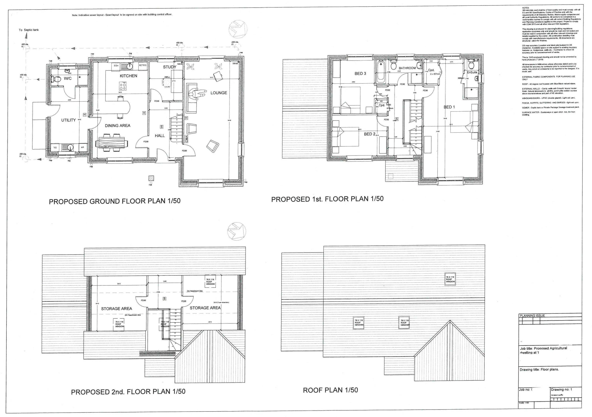

Construction Detailing
  - CONSTRUCTION PORTFOLIO
OWEN TOWELL | Fundamentals of Construction Technology | 28/04/2020

BRIEF
Please note this is an academic assessment that relates specifically to the module studied. It is a fictional proposal.

You are to assume that a major property developer has received planning consent for a single, two storey detached domestic building with a loft room. [See attached floor plans and elevations].
It is to be built on a level, greenfield site that has 450mm of topsoil above a firm subsoil with a low clay content that is above the water table.
The building is of standard cavity wall construction; block and block with partial fill cavity insulation and a smooth render externally. Plinths, soldier courses over all openings and porch pillars are to be natural sandstone.
There is a suspended timber ground floor and upper floors are to be traditional solid timber with tongue and groove softwood flooring.
Windows and external doors are to be light oak wood effect uPVC with sealed Double-glazed units.
Roof structure is to be trussed rafters at a 40⁰ pitch with a natural slate covering and closed eaves. The roof covering is to be natural slates.
You need to solve the following construction details:
  - The ground floor. Construction, detailing and junctions with external walls.
  - The first floor. Construction, detailing, junctions with external walls and restraints.
  - Openings. Solutions for lintels, sills and jambs.
  - Eaves detailing and roof covering – indicating appropriate weathering, fixing and laps.
  - The main roof structure. Construction, detailing and fixing.

You will produce neat, annotated sketches, where all elements will be identified. You will produce as many graphic details as needed so that you can illustrate the materials and methods used properly. You can use any CAD software or hand-drawing, for this last option you should present very clear drawings (you can help it with colour pens). Additionally, you will include a step-by-step description about how the element is built, and solutions adopted to avoid humidity because of rain, thermal bridging and condensation.
You will ensure that your construction method shows how the design will meet the current Building Regulations for a domestic new-build, and you specify it in your drawings and explanation (indicating what part of the Building Regulations).

GROUND FLOOR
Construction Process:
- Remove 450mm of topsoil to the footprint of the proposed building in accordance with Building Regulations Part C.
- Excavate the full perimeter of the proposed building to include all load bearing walls as highlighted in the drawings attached to the brief, and through the centre of each room as shown in APPENDIX 1 in readiness for cast in situ concrete foundations.
- Pour cast in situ concrete mix into the excavation to form new strip foundation. Ensure concrete is 225mm x 600mm in size and mix to conform to BS EN 206-1 and BS8500-2. NB: All foundations should be a minimum of 1000mm below ground level; however, exact depth to be agreed with the Building Control Officer to suit on-site conditions. (Part A Building Regulations, 2020)
- Once the concrete has cured, compact the remaining ground within the footprint and begin to construct external cavity walls using 7kN dense concrete blocks and single skin, load bearing walls for the internal walls. Where strip foundations have been installed through the centre of the rooms, buildup 3 courses of blockwork in readiness for sleepers walls to take suspended timber flooring. NB: Brick vents must be included to provide ventilation to the new ground floor system.
- When constructing the sleeper walls, ensure a honeycomb bond, as highlighted in APPENDIX 1 to ensure adequate airflow beneath the new flooring system.
- Once sleeper walls are in place, lay DPC over the top and install C24 grade softwood in readiness to take joists.
- Resin fix timber treated wall plates to the perimeter of each room, ensuring to keep the same level as the sleeper wall.
- Install C24 grade softwood joists at a maximum 400mm cts and lengths of 2.10m. Joists to be supported off galvanised joist hangers fixed to treated timber wall plates. Where joists overlap over sleeper walls, bolt through and ensure level.
- Once all is level, install herringbone strutting between floor joists and lay new insulation between joists.
- Finish with 20mm floorboards in readiness to take new floor finish. NB: Ensure the boards are moisture-resistant and comply with BS EN 312:2010.

FIRST FLOOR
Construction Process:
    - Construct walls as per APPENDIX 1 & 6.
    - Once walls have been constructed to ground floor ceiling height, install joist hangers at 400cts as per APPENDIX 2. NB: Ensure hangers comply with BS EN 6179 Part 1 1999. Ensure the backplate of the hangers in contact with the blockwork. Where spans are over 3m long, special restraint hangers must be used that comply with BS EN 5628: Part 1. Ensure that a minimum of 3no courses of blockwork has been constructed above the joists before applying any loads.
    - Cut C24 grade softwood joists to lengths and fix to joist hangers installed in the blockwork walls. Ensure the joist is accurately cut to length so that while it does not extend into the cavity, it is fully supported by the full width of the blockwork it is bearing into.
    - Once joists are in place, fix noggins between from the same grade of softwood to ensure stability and install high-density acoustic mineral wool insulation between joists in accordance with Part L of the Building Regulations.
    - Install tongue and groove chipboard to the joists to create a floor surface in readiness to take new floor finish.
    - Install perimeter edging strip around the perimeter of the room and install a three-ply, flexible rubber crumb matting using adhesive to comply with Part E of the Building Regulations.
    - Once adhesive has set, install softwood tongue and groove boarding through secret nailing through the tongues, ensuring to leave 10mm spacing from the walls to allow for expansion.

WINDOW APERTURES
Construction process:
1. When constructing external walls as per APPENDIX 1 & 6 – allowances must be made for window apertures.
2. Once the wall is at the desired height for the proposed windows (no more than 1100mm above the floor area as per Approved Document K) allowances must be made to close off the cavity in preparation to installing the window.
3. Continue to construct the external wall ensuring the aperture is the correct size for the new window.
4. Once the wall level has reached the desired height of the window, the installation of a suitable lintel is required. Install cavity lintel at the proposed head of window level as per detail within APPENDIX 3. NB: lintel design and installation must comply with BS EN 485-2 and BS 5997. It is recommended that to comply with thermal efficiency and performance listed in Approved Document L; an insulated lintel is used to ensure no thermal bridging is present.
5. Now that the lintel is installed, you must close the cavity at the window jambs. This prevents thermal loss from occurring and is required to comply with Building Regulations Part L as it aids with reducing the amount of energy used to keep the building warm.
6. Once the above has been completed in accordance with building regulations, lay a DPC across the foot of the aperture and install the sandstone cill on a bed of mortar as per APPENDIX 3.
7. Remove any packaging from the new uPVC frame and fix into aperture using packers to level, ensuring to maintain a 5mm expansion gap.
8. Once the frame is installed, fit the double glazed unit and bead in place, ensuring compliance with industry recognised bodies guidelines such as CERTASS or FENSA. This ensures full compliance with Building Regulations, namely; Part L.

EAVES DETAIL & Roof Covering
Construction Process:
1. Once the roof structure is in place as per APPENDIX 4, install suitable insulation to comply with Building Regulation Part L and as per APPENDIX 5.
2. Lay a suitable breathable membrane to the full roof area in readiness to install roofing batten. NB: Membrane selection must comply with BS EN 5534.
3. Once the membrane has been installed, gauge and install new technical roofing batten to take new slates. NB: Installation of battens must meet the grading requirements specified in BS 5534 and NFRC Technical Bulletin 33.
4. Install new slates in accordance with BS EN 5534, and ensuring a minimum of 80mm headlap due to the pitch of the roof.
5. Finish the slates with an overhang into the rainwater goods to ensure correct rainwater disposal as per Building Regulations Part H.
6. Finish the Eaves detail as per APPENDIX 4, providing adequate ventilation to comply with Approved Document F.

ROOF STRUCTURE
Construction Process:
1. Once the external walls have been constructed, wall plates must be installed as per APPENDIX 4 & 5 along the full length of the building in readiness to install new roof trusses. NB: Roof trusses are pre-formed off-site to ensure a smooth and safe installation and must comply with BS 5268.
2. Mark the centres of the trusses along the wall plate to comply with BS EN 14250 and as per APPENDIX 4.
2. Once the trusses have been manufactured and are delivered on-site, operatives will be at eaves level ready to take delivery of trusses via crane and fix in place where centres have been previously marked.
3. Once the first truss is lifted, it must be correctly plumbed and held in position with temporary raking braces which are nailed to the top chord of the truss and to the wallplate. While continuing to install roof trusses, ensure diagonal braces are running continuously along the roof.
4. Finally, apply longitudinal members at all nodes as per the purlins in APPENDIX 4.

NB: all of the above should be installed in accordance with Building Control Guidance Note 6.

Bibliography
Advice, B., 2020. Know About The BS 5534 Changes? | Roofinglines. [online] Roofing Materials & Roofing Supplies at Low Prices | Roofinglines. Available at: <https://www.roofinglines.co.uk/blog/what-do-roofers-need-to-know-about-the-bs5534-changes> [Accessed 28 April 2020].
Bpindex.co.uk. 2020. [online] Available at: <https://www.bpindex.co.uk/res/pdfs/b58e21ecaef298.pdf> [Accessed 28 April 2020].
Bregroup.com. 2020. BRE: Green Guide: Green Guide 2008 Ratings. [online] Available at: <https://www.bregroup.com/greenguide/ggelementtype.jsp?buildingType=Health&category=7> [Accessed 28 April 2020].
Bsigroup.com. 2020. Standards For Windows And Doors. [online] Available at: <https://www.bsigroup.com/en-GB/our-services/product-certification/industry-sector-schemes/construction/windows-and-doors/Standards-for-windows-and-doors/> [Accessed 28 April 2020].
Construction Studies Q1. 2020. Suspended Timber Floor. [online] Available at: <http://constructionstudiesq1.weebly.com/suspended-timber-floor.html> [Accessed 28 April 2020].
Diydoctor.org.uk. 2020. [online] Available at: <https://www.diydoctor.org.uk/projects/hollowfloor.htm> [Accessed 28 April 2020].
Houseofwindows.co.uk. 2020. Building Regulations For Windows And Doors. [online] Available at: <https://www.houseofwindows.co.uk/building-regulations.php> [Accessed 28 April 2020].
Ikoustic.co.uk. 2020. Mutemat® 3 | Ikoustic Soundproofing. [online] Available at: <https://www.ikoustic.co.uk/products/floor/mutemat-3> [Accessed 28 April 2020].
Minera Roof Trusses. 2020. Installation Guides | Minera Roof Trusses. [online] Available at: <https://www.minera-rooftrusses.com/installation_guides.html> [Accessed 28 April 2020].
Pistonheads.com. 2020. Installing New Windows To Brickwork - Page 1 - Homes, Gardens And DIY - Pistonheads. [online] Available at: <https://www.pistonheads.com/gassing/topic.asp?t=1504906> [Accessed 28 April 2020].
Portal, P., 2020. Building Regulations | Doors And Windows | Planning Portal. [online] Planningportal.co.uk. Available at: <https://www.planningportal.co.uk/info/200130/common_projects/14/doors_and_windows/2> [Accessed 28 April 2020].
Shop.bsigroup.com. 2020. BS 5268-3:2006 - Structural Use Of Timber. Code Of Practice For Trussed Rafter Roofs – BSI British Standards. [online] Available at: <https://shop.bsigroup.com/ProductDetail/?pid=000000000030163113> [Accessed 28 April 2020].

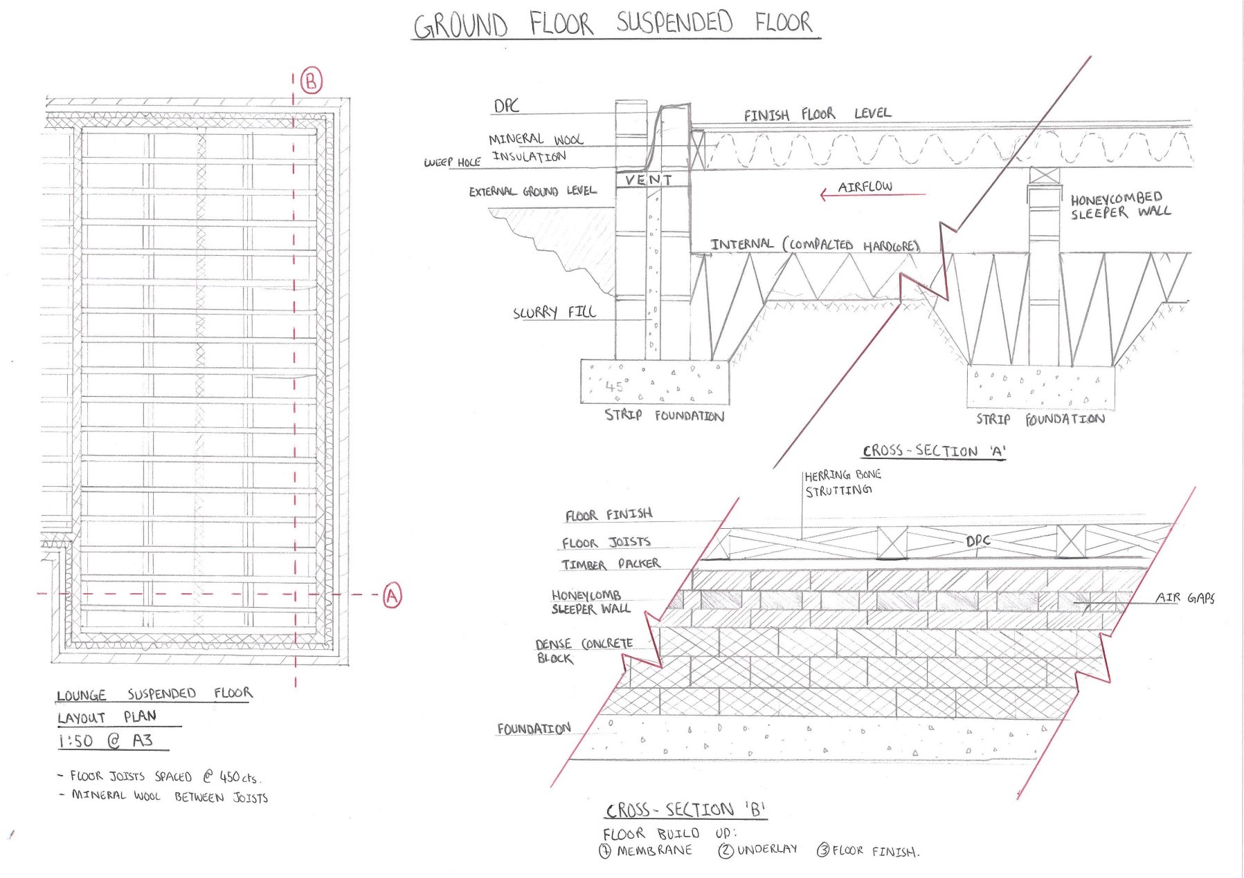
APPENDIX 1

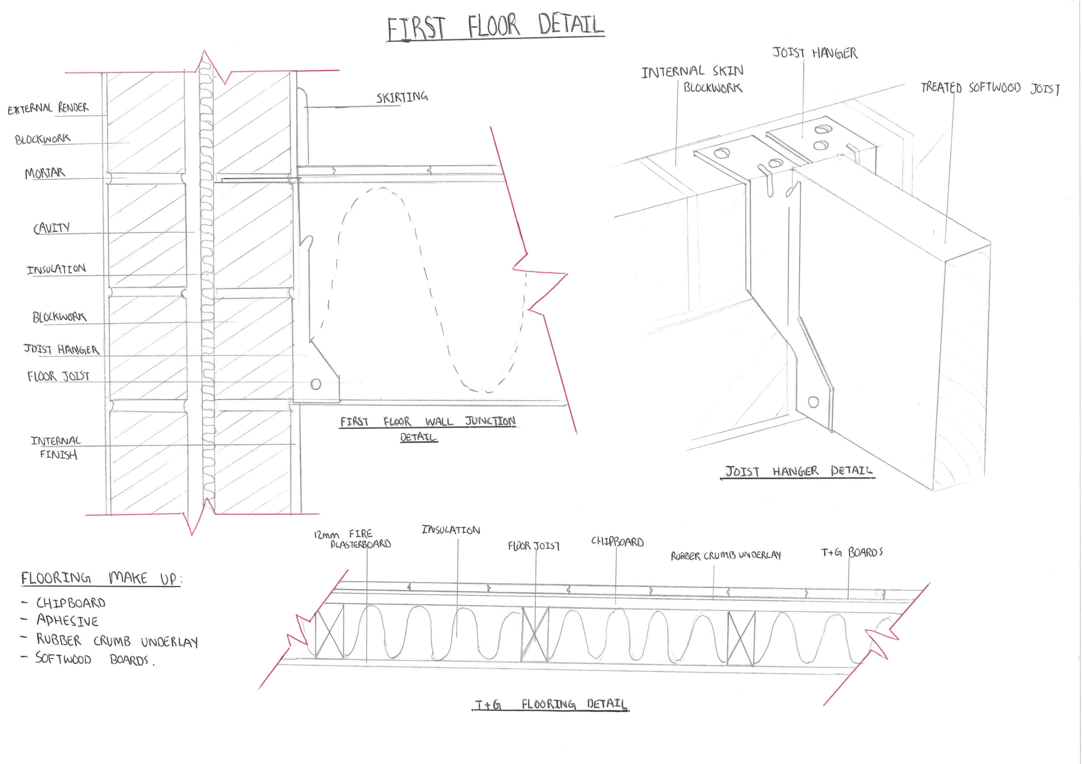APPENDIX 2

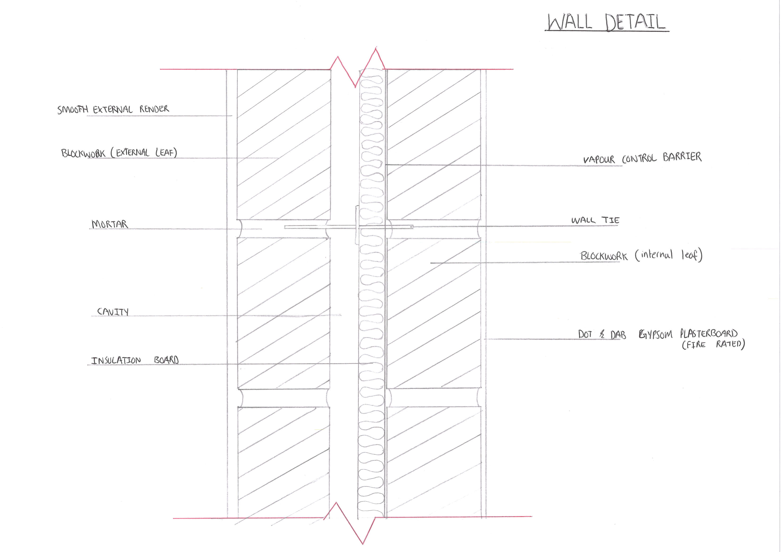APPENDIX 3
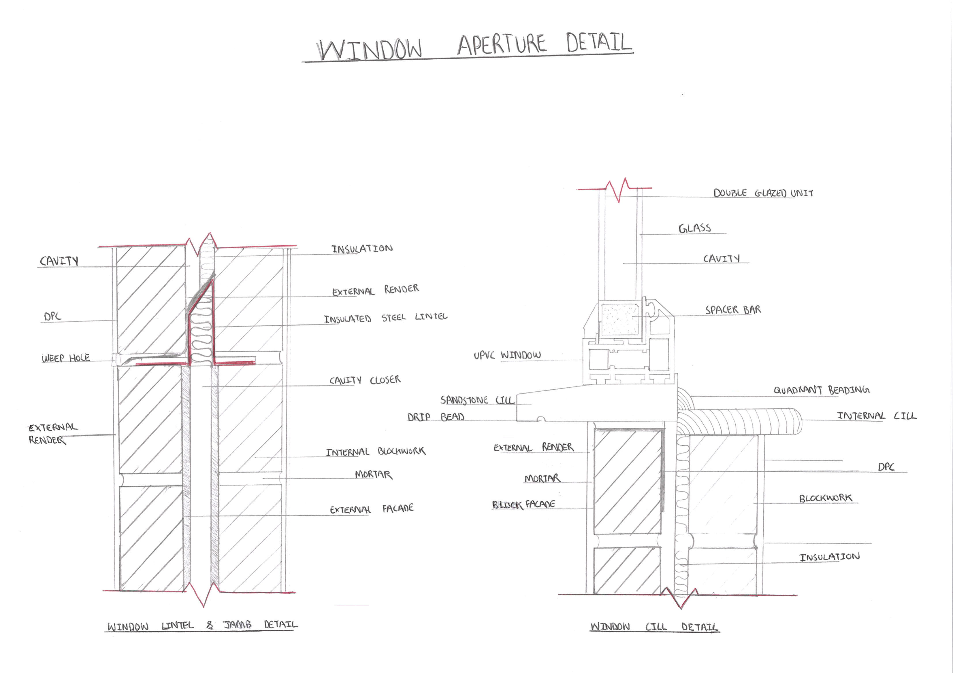

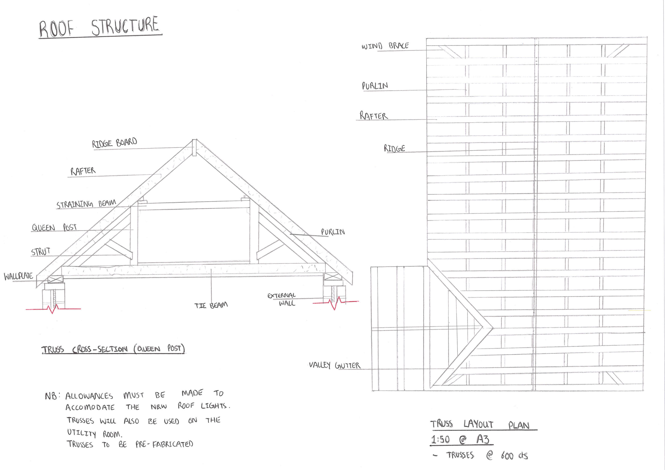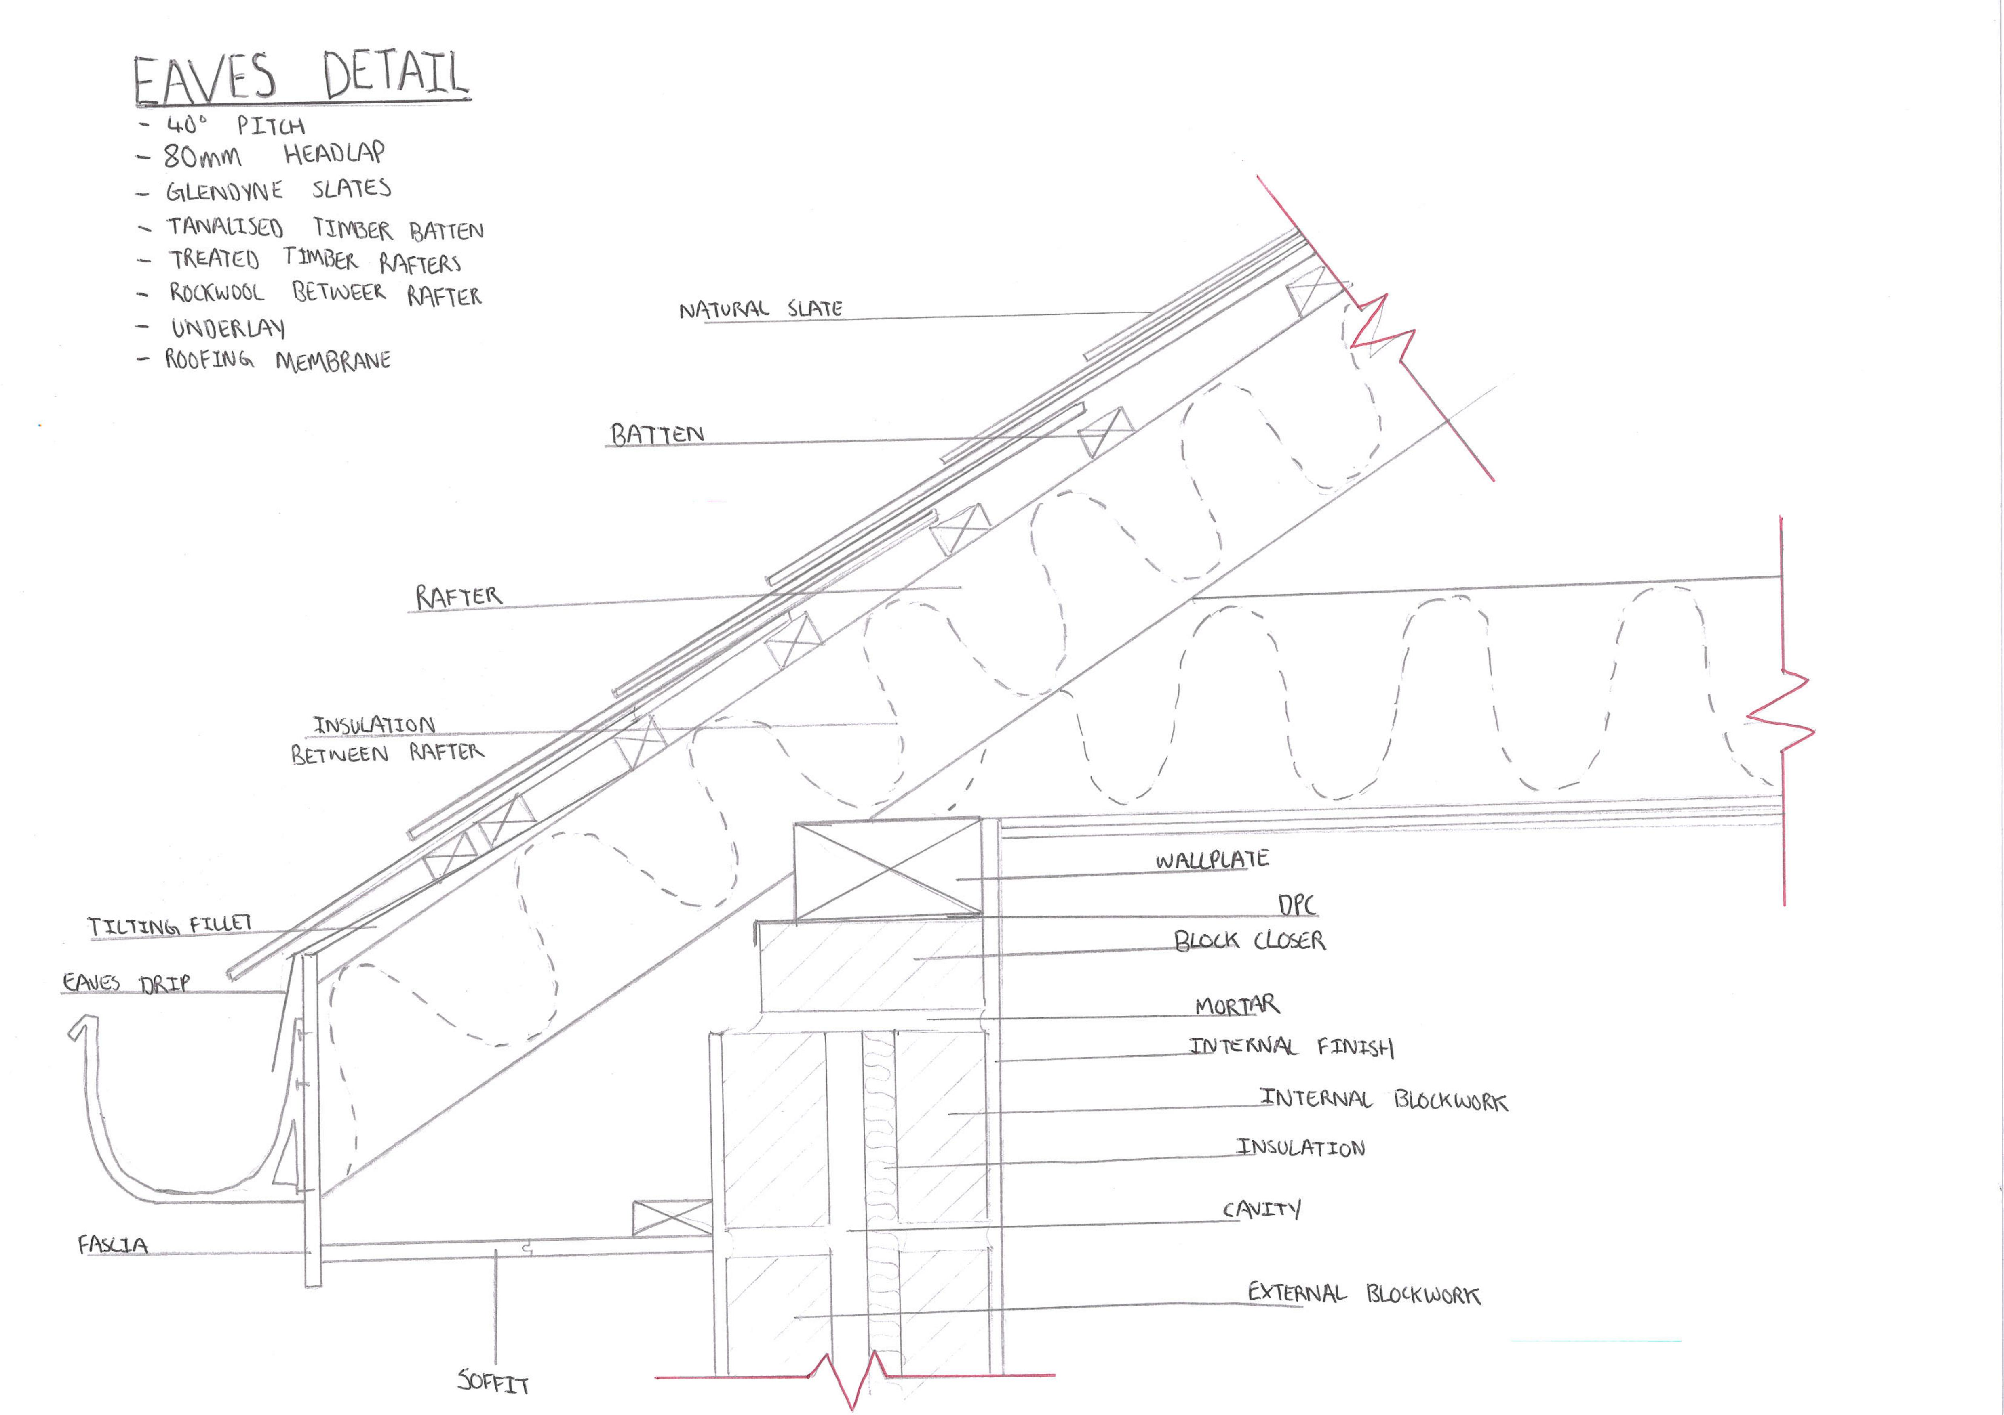APPENDIX 4

APPENDIX 5

APPENDIX 6

