Student name: Shaymaa Al Abbasi
Student ID no: 1817837
Lecturer name: Vajira Balasuriya
Module title: Managing project for the workplace BMSW 5104
Submission date: 23/7/2021

project plannig for Restaurant Extenssion

Contents
Introduction 2
The project outline. 2
The scope of the project 2
Mission breakdown 2
The scope of project deliverables 3
Stakeholder analysis 4
The Quad Chart 7
The project budget 8
Work Breakdown Structure WBS 9
The WBS approach 10
Network diagram in project management 11
Gantt chart 12
Risk management 12
Risk response 13
Conclusion 16
References 17
Appendences 18

Introduction
This report will be discussing project management plan for a restaurant extension, the report also will be highlighting the scope of the project, total cost of the plan, project deliverables. In addition, the study will dissect in the depth the most important stages of the project’s management plan which contains WBS and its approach, stakeholder analysis, quad chart, the project capital and the spare capital, Gantt chart to measure the milestone of the work within the set timeframe, risk management and the risk response to it. The following part will be dissecting the project outline in complete depth.

The project outline.
The restaurant is located in a busy area with its demands growing to have a bigger capacity to serve and accommodate more customer. The goal is promoting a conservatory extension with the current business. The way to proceed this is to build an extension to the terrace of the current business as there is a space to accommodate for the extended dining area, by setting up this extension the restaurant will be benefited by having a built-in bar and build W/C as well as disabled toilet.

The scope of the project
Project scope is a piece of the venture arranging measure that reports explicit objectives, expectations, highlights, and financial plans. The extension report subtleties the rundown of exercises for the effective fulfilment of the undertaking. The degree is characterized by understanding the venture necessities and the customer's expectation (Khan, 2006).
The goal:
17.5 weeks (123 days) restaurant extension plan: build an extension on the terrace of the restaurant to create outdoor dining in a warm, ambient with a high standard finish. The extended area will also require building a bar, W/C, and a disabled W/C to accommodate for all of the customers. The time frame to complete this project from start to finish is 17.5 weeks.
Total cost plan: within £30000 capital.
Spare budget to cover any unexpected expenses: £10000.

Mission breakdown
- Get the planning permission.
- Get an architect to design/draw the final plan of the extension.
- Inform all the relevant parties involved such as solicitor, directors, stakeholders, employee etc via emails, direct calls, and social media.

The scope of project deliverables
deliverables | Date
Planning permission | Apr 1^{st,} 2021
Acceptance of planning permission | Apr 21st 2021
Architect to finalise the design | Apr 10th 2021
Bring in builders for at least 3 different quotes | Apr 15th 2021
Decision on builders and pricing | Apr 24th 2021
Meeting with all directors and stakeholders to inform them of plans going ahead and deadline | Apr 26th 2021
Inform customers of the closure of the outdoor via social media, emails, and public announcement | Apr 27th 2021
From this date Builders and the relevant parties such as electrician, painters, plumbers in the place undertaking the work from the date…. | Apr 29th 2012
Reaching the deadline of completing the project | July 26th 2021
Setting up the outdoor/conservatory | July 27th 2021
Announcement of the reopening | July 28th 2021
Outdoor reopening | August 1st 2021
Table 1 project deliverable
The above table 1 presents that the planning application needs to be submitted. 21 days waiting time is needed to wait for a response from the local authority. In the meantime, the architect can proceed with the final designs and then assign the builders to get the best cost by inviting them to assess the project. Once the green light is given then the next step is to liaise directors and all stakeholders to discuss the project in a meeting breaking down the project. Afterwards, announce the refurbishment via social media and get the builders, all the relevant parties in as its mentioned in the table to start the work and keep monitoring the progress in phases till the whole project executed.

Stakeholder analysis
It is defined as a cycle of distinguishing these individuals before the venture starts; gathering them as per their degrees of cooperation, interest, and impact in the task; and deciding how best to include and convey every one of these partner bunches all through (Brugha and Varvasovszky, 2000).
Below is table 2 to present the stakeholder analysis each one of them in the table of the stakeholder analysis plays a very vital role in this project from the first who are the funders all the way to the surrounding areas are all key players in this project, looking at what their interests are, as well as their importance, from low to high and how influential they are to a certain level to the success of the project, this all breaks it all down into sections.
stakeholder | interest | Importance | influence | Communication
Directors.  / Internal | To fund the project | High | Master minds | Emails/direct calls
Suppliers such as energy. /External | To supply the company with energy for the extension | High | Supply gas/electricity to the premises | Emails/ direct calls
food, and beverage suppliers.  /External | and the food suppliers to supply produce on a day-to-day basis. | High | Food/Maintaining the standard of premises. | Emails/direct calls
The local community.  /External | to promote and support the business amongst the community. | Medium | Spreading the word | Emails/direct calls
Dining customers.  /External | To enjoy the experience of the new features of the place | High | The breadwinners of the business | Social media such as  Facebook/Instagram
Local authority.  /External | to ensure that the correct health and safety and building regulations are correct and up to date for the project to grant the planning permission | High | Grant or decline the building project. | Emails/direct calls
Marketing.  /Internal | Marketing, to advertise the new changes within the business. | High | Advertising the business | Emails/direct calls
Finance.  /Internal | ensure money is being spent correctly | High | To oversee finance for the business | Emails/direct calls
IT department.  /Internal | to create data to monitor any IT issue across the business such as broadband to cover the extended areas to run the CCTV cameras across | Low subject to review towards the end of the project | To ensure that all system run smoothly. | Emails/direct calls
The surrounding area.  / External | The surrounding area will be informed via the local authority when the announce it. | Low | To provide support to the business | Flyers and social media

Table 2 Stakeholder analysis
Also, the communication amongst the internal/external stakeholders is the most vital part in the project and can be done via direct calls or emails between funders with local authority, contractors, marketing, and IT departments, as well as using the social media platform to keep the public up to date with the set date of the start/finish of the project.

The Quad Chart
It is defined as a type of specialized documentation used to momentarily portray a creation or other advancement through composition, delineation as well as photos. Such reports are depicted as "quad" outlines since they are isolated into four quadrants spread out on a scene point of view (Stamey and Honeycutt, 2005).
Below table 3 presents the Quad chart for the restaurant extension. It is additionally to explain the main 4 judges’ categories to what is important about of the extension project such as the purpose of the project, who are the stakeholders, what is the desired final article of the project and finally the criteria of the success.

Title: Restaurant Extension
Purpose  (Aim/Objectives)  - To extend a restaurant  - To increase the dining capacity  - To accommodate larger number of customers and events | Customers  (stakeholders)  - The restaurant directors  - People who always like to eat out.  - All the employees in the restaurant.
Desired end result  (Critical success factors)  - Great worming atmosphere  - Perfect set up  - Perfect services | Measures of success  (standards/criteria)  - Customers express their satisfaction of the new changes and come back again.

Table 3 Restaurant Extension Quad chart
The project budget is an apparatus utilized by project directors to appraise the complete expense of an undertaking. An undertaking spending format incorporates an itemized gauge of all costs that are probably going to be caused before the venture is finished. It is constantly refreshed throughout the span of the task (Kwon and Kang, 2019)
Below is table 4 presents the estimated cost of the project expenditures based on the set capital of £30000 to complete the Extension project, start from the cost of the planning project all the way to more detailed work required. This budget to cover every single activity was stated in the table below including the labour and the raw materials such as any required equipment to set up the terrace ground, paint, wallpaper and its accessories, pipes for plumbing, electric work with its accessories and so forth the rest of the of activities each in the category column. Further, there is a spare capital of £10000 to cover any unexpected expenses such as labour, building materials, or any additional expenses.


Table 4 project budget

Work Breakdown Structure WBS
WBS is to make a huge task more reasonable, separating it into more modest lumps to make implying work more possible all the while by various colleagues, prompting better group efficiency and simpler task the executives (Brotherton et al.,2008).
The brainstorming of the restaurant extension WBS
A. Project Initiation (planning permission get applied for) 21 days.
A.1 stakeholder analysis
A.2 Contractor Selection
A.3 Raw Material Purchase
A.4 Project arranging
B. Internal Work/94 days in total, the breakdown below shows duration for the sub activities.
B.1 Setup the ground of the terrace, set up the conservatory/ 13 days.
B.2 Plumbing/ 8 days.
B.3 Electric work/ 15 days.
B.4 Plastering/ 10 days.
B.5 Toilet/disabled toilet installation/ 20 days.
B.6 Interiors/ bar fitting or building/ 15 days
B.7 Internal Decoration/ 10 days.
B.8 wooden floor fitting/ 3 days.
C. External Work/6 days in total, the breakdown below shows duration for the sub activities.
C.1 Roof Repair Work/ 3days.
C.2 landscape development/ 2 days.
C.3 Outside paint/ 1 day.
D. Project Closure/ 2 days
D.1 Closure documentation
D.2 Payments to contractors
D.3 Project sign-off
The above brainstorming of the Work Breakdown Structure spliced the restaurant extension work categories into main 4 level of activities, level 1 project initiation for the planning permission application needs no less than 21 days to get approved so the rest of the work can get started. However, within these 21 days the architect can finalise the design and the contractors selection get done, as well as the raw materials get purchased and then each of these activities level splits into sub activities to give the overall required work to be done for this project and the estimated duration to complete them.

The WBS approach
The approached which was used for this project is the mind mapping (appendix 1) which is defined as a method of connecting key ideas utilizing pictures, lines, and connections. A focal idea is connected by means of lines to different ideas which thus are connected with other related thoughts. Brain planning utilizes the idea of "brilliant reasoning" – that is, musings transmit out from a solitary thought, frequently communicated as a picture (Buzan, 2006). This approach was used for this project to identify all the 4 main level of activities and mind map it into their related sub activities.

Network diagram in project management
A venture network graph according to McCahon and Lee (1988), it is a visual portrayal of the work process of a task. Also, it is basically an outline that is populated with boxes taking note of errands and duties, and afterward bolts that map the timetable and the grouping that the work should be finished.
The graph below shows Network Graph of the dining extension.
21 days 6 days
D
C
AB
B

94 days 2 days
Project network graph

This graph presents the estimated days required within the timeframe which was set for the project for the main activities of Work Breakdown Structure for the completion of the extension project. Also, the table below of the project network breakdown each the activities A, B, C, D with their duration as well as dependencies
Activity | Duration | Dependencies
A | 21 days | None
B | 94 days | B
C | 6 days | C
D | 2 days | D

Table 5 the Project Network

Gantt chart
Gantt diagram was designed by Henry Gantt, an American mechanical designer. It's anything but a graphical portrayal of a task plan. It is anything but a kind of bar outline that shows the beginning and finish dates of a few components of a venture that incorporate assets, achievements, assignments, and conditions (Seymour and Hussein, 2014).
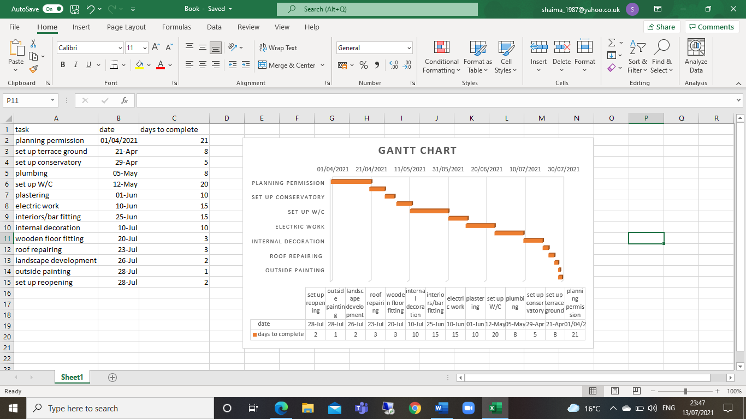
Figure 1: Gantt Chart of the extension project
above is figure 1 the Gantt Chart to clearly present the start and finish dates of the work activities of the restaurant extension project that includes milestones and tasks.

Risk management
In project management, hazard the executives is the act of distinguishing, assessing, and forestalling or relieving dangers to a venture that can possibly affect the ideal results. Venture chiefs are commonly answerable for supervising the danger the executive’s cycle all through the length of a given undertaking (Raz and Michael, 2001).
possible risks to impact the completion (appendix 2) of the restaurant extension project could be:
- Cost: The danger of occasions that sway the financial plan of the extension project is high and funders have to consider extra money to cover any unexpected cost and expenditures for purchasing raw materials etc, particularly those that cause the task to be finished over financial plan. Mistakes in cost assessment by the funders usually create hazard notwithstanding outside factors.
- Notwithstanding project chances, project deferral hazard is another significant danger. Task deferral hazard alludes to the dangers related with neglecting to do a venture. Like venture hazard, this danger can emerge from any of the danger sources. It can likewise happen if there is just a restricted open door for leading a task. Inability to lead the undertaking presently makes a danger that makes it difficult to adequately direct a task later. Therefore, extra time has to be considered and added to the deadline of the project to avoid any disappointment.
- Risk of communication is the danger that the communication conflict will neglect to create results steady with project determinations. Therefore, the regular monitor to the work progression in the restaurant is very important to rectify to any unexpected obstacles before it is too late.
The Matrix approach table below to present the likelihood of the above identified risks.
Risks | Importance/Impact | Likelihood/probability
Cost | High | Medium
Project deferral hazard | High | High
Risk of communication | High | High

Table 6 risk management
Risk response
It is the way toward creating vital choices, and deciding activities, to upgrade openings and lessen dangers to the undertaking's goals. A venture colleague is relegated to assume liability for each hazard reaction (Lyons and Skitmore, 2004).

Risk Category | Risk | Impact | Response
Cost | The genuine expense brought about in acquiring crude materials and finishing the remodel work can take a greater number of costs than at first arranged. | Medium | The project progress should be checked, and financial plan ought to be delivered in stages dependent on independently stage prerequisite to keep an authority over the expenses of the task. The financial plan ought to be allocated according to the necessities of every movement distinguished in the WBS.
Deferral risks | Postponements are caused in conveys of the venture errands, for example, provider delays in sending crude materials or deferrals in the pipes, electric or fix work by the doled-out laborers | High | The task should be checked by the timetable of the undertaking and at any trace of getting delays, appropriate moves ought to be made immediately to ensure that work gets completed on time.  If deferrals are at this point occurring, the undertaking chief may have to go through additional resources for keep with the work. For concedes that cannot be hindered and can make difficulties for distinct transport of the endeavour,  additional underwriting may be taken for extension of the endeavour plan from the owner and the additional time may be distributed to the assignment work
Risk of communication | Clashes between the laborers during the action of the project can prompt postponements or different issues at work making the usefulness of the venture group to endure | High | These contentions can be stayed away from with the task administrator taking endeavours to acclimate individuals in the group with one another and find ways to make a holding between them in the inception period of the venture, so they see each other's work and correspondence styles.

Table 7 risk response
The above table presents the risk response to all the expected risks in the project.

Conclusion
From the above study it has been concluded that to develop a good article of project plan, specially for a restaurant extension, then the following aspect should be included:
- hazard the board plan, and an examination of correspondence struggle on project.
- The undertaking the board plan introduced WBS, basic way, and a practicality investigation that legitimizes the choice of the venture.
- The danger the board distinguished dangers identified with cost, correspondence, timetable, and partners, broke down them and proposed reaction plans.

References
Brotherton, Shelly A., Robert T. Fried, and Eric S. Norman. "Applying the work breakdown structure to the project management lifecycle." In PMI Global Congress Proceedings, pp. 1-15. 2008.
Brugha, R. and Varvasovszky, Z., 2000. Stakeholder analysis: a review. Health policy and planning, 15(3), pp.239-246.
Buzan, T., 2006. Mind mapping. Pearson Education.
Kwon, H. and Kang, C.W., 2019. Improving project budget estimation accuracy and precision by analyzing reserves for both identified and unidentified risks. Project Management Journal, 50(1), pp.86-100.
Khan, A., 2006. Project scope management. Cost engineering, 48(6), pp.12-16.
Lyons, T. and Skitmore, M., 2004. Project risk management in the Queensland engineering construction industry: a survey. International journal of project management, 22(1), pp.51-61.
McCahon, C.S. and Lee, E.S., 1988. Project network analysis with fuzzy activity times. Computers & Mathematics with applications, 15(10), pp.829-838.
Raz, T. and Michael, E., 2001. Use and benefits of tools for project risk management. International journal of project management, 19(1), pp.9-17.
Seymour, T. and Hussein, S., 2014. The history of project management. International Journal of Management & Information Systems (IJMIS), 18(4), pp.233-240.
Stamey, J. and Honeycutt, T., 2005. Quad charts in software project management. Journal of Computing Sciences in Colleges, 21(2), pp.322-327.

Appendences

Appendix 1
Mind mapping diagram of the restaurant extension WBS
3.1 roof repair work
1.1 stakeholder analysis
3.2 landscape development
1.2 contractor Selection

1.0 project initiation
3.0 external work
3.3 outside paint
1.3 Raw Material Purchase
Restaurant extension project
1.4 Project arranging

4.0 project closure
2.0 Internal Work

4.1 closure documentation
2.2 Plumbing

2.1 Setup

4.2 payment to contractors
2.4 Plastering
2.3 Electric work

2.5 toilet/ disabled toilet
4.3 project sign-off
2.6 interiors/ bar fitting or building

2.7 internal decoration
2.8 wooden floor fitting

Appendix 2

Almost certain Deferral risk Risk of communication

Likelihood Cost

Rare

Insignificant severity catastrophic

