A handbook for key workers in early years settings during childhood transitions.

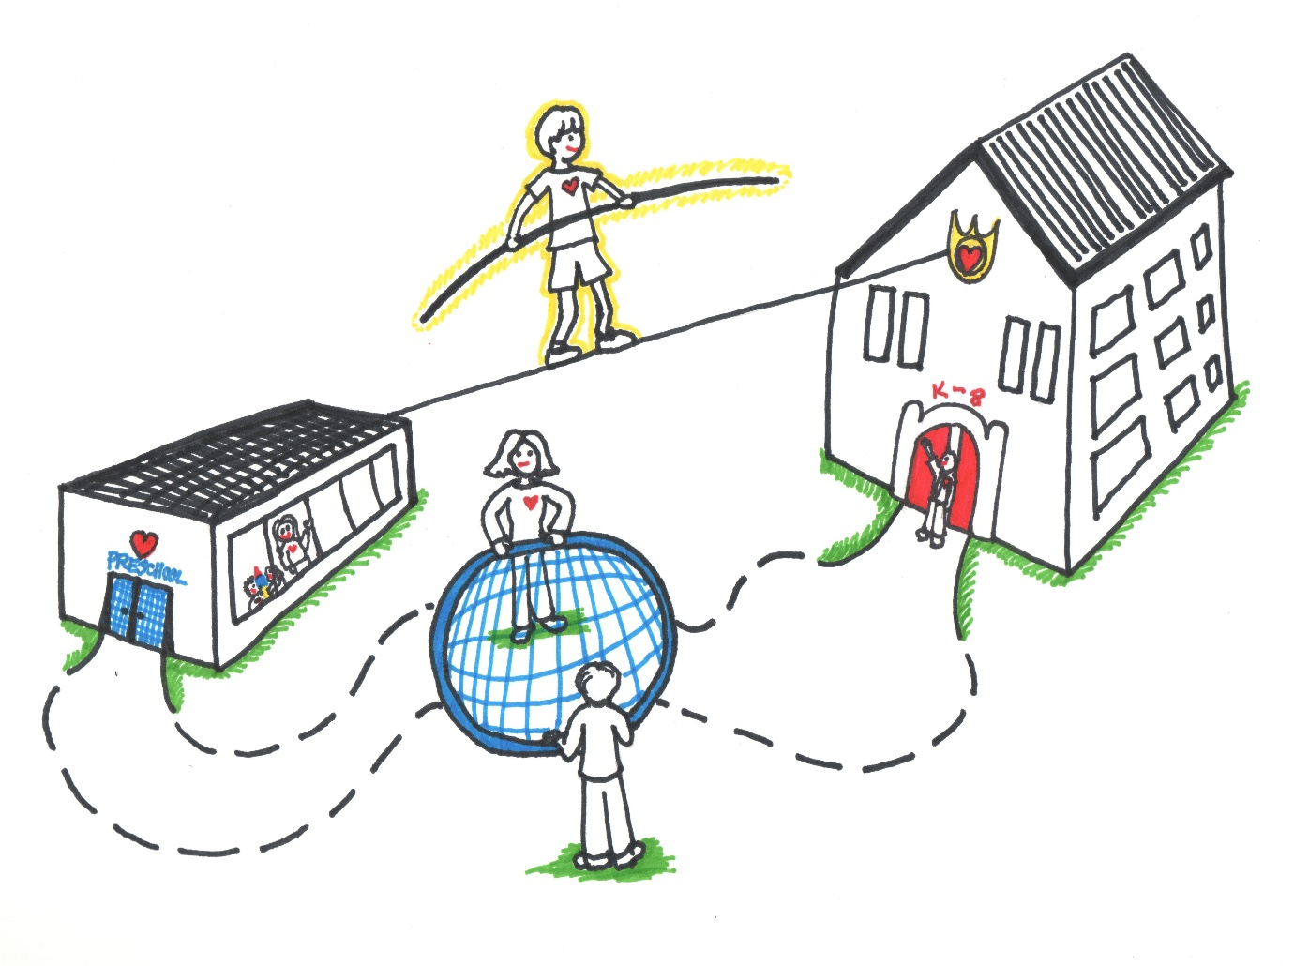
(Source: confident parents' confident kids, 2023)

Word count-
Contents
Reference list Page 15
Proprosed outcomes Page 14
Interventions Page 13
Partnerships Page 11
The role of the adult Page 9
The needs of the child Page 7
Transitions Page 4
Introduction Page 3

Introduction

This handbook’s objective is to support keyworkers as they assist children during developmental transitions. The handbook is intended for young children ages three to four, who are making a transition from home to school. The keyworker should utilise this guide to assist educate themselves on the value of excellent communication through the transitional time, in order to make sure it goes as smoothly as possible for the child. It will benefit children’s outcomes as keyworkers will become more aware of what is expected of them but also how they should deal with each individual child and their personal needs.
After reading this handbook, practitioners should have a deeper understanding of the significance of effective communication and how it impacts young children’s learning and development during transitions. The handbook was created to increase keyworkers awareness of this impact. Oxfordshire County Council (2019) state hoe cooperative planning, information exchange, and reciprocal visits between carers, parents and experts can facilitate children’s adjustment to their new routine. Working with one another such as cooperation between childminders, settings and schools is crucial to a successful transition because it allows everybody to clearly grasp each other’s goals, motives, and philosophies. This highlights and acknowledges the significance of keyworkers functioning well during childhood transitions.
This handbook covers a wide range of topics including the needs of the child, interventions, and partnerships. The handbook will also cover the role of the adult and proposed outcomes. These sections constitute necessary reading for keyworkers to comprehend the impact of communication upon how children learn and during transitions.
Keyworkers should be able to handle transitions well while realising the value of continuous, effective communication by following advice and applying best practises. Transitions should be thoughtfully planned while keeping in mind that every child is an individual.
Transitions

A transition is “a change from one form or type to another, or the process by which this happens.”
(Cambridge Dictionary, 2023)
Transitions are not an event but a process. They can also be known as change, and regardless of age or the individual, it is an unavoidable part of everyone’s life. Transitions can be small like altering a child’s daily schedule, or they can be bigger, like a child going from home to school. These transitions are well known as horizontal and vertical transitions. Vogler et al. (2008) was able to differentiate horizontal and vertical transitions by associating them with certain activities. Regular events that usually have to do with moving or a change in your daily routine are referred to as horizontal transitions. Activities such as children leaving the class to play on the playground is an example of a horizontal transition. Conversely, vertical transitions are linked to specific, sporadic events and are far more sustainable. It is important to remember that for children to adjust to this, we usually discuss how they move from nursery to primary education and then from primary to secondary education for them to adjust to this and realise what is going to be happening soon. The parent's role is vital in the vertical transition's children go through such as when they move “up” from one school to another, but so is the role of the teachers, teaching assistants and key workers. While transitions that are vertical and horizontal are the most discussed, there is another kind of transformation that is related to schooling called education associated transitions. This is a reference to the less formal modifications that take place outside of institutional settings in children’s lives and routines. These shifts could take place in a child’s daily life outside of school, but they still have the power to impact and mould their lives and general well-being. (Open Learn Create, 2023).

To guarantee that the children can learn and develop during these transitions, practitioners must work closely with the children and their microsystem. Journal of Family Theory & Review (2013) state that Bronfenbrenner first presented the biological theory of human development, which was first referred to as an ecological model or approach. The theory primarily focused on the influence of context. According to Bronfenbrenner’s theory, a child’s development is influenced by a variety of contexts throughout their life, such as biological, interpersonal, sociological, and cultural elements. The Psychology Notes HQ (2021) discusses how a child typically discover themself entangles in a variety of ecosystems, beginning with the most human-centred ecological system which include immediate contacts in a child’s life, then advancing to a new educational system, and arriving at the most comprehensive system that incorporates society and culture according to the ecological systems theory of Bronfenbrenner. Children will each react to change in separate ways, therefore it is critical that everybody in the child’s microsystem are aware of this to benefit the child. Given that Bronfenbrenner (1979) also mentions that a child’s surroundings affect their ability to learn, it is imperative that practitioners provide a pleasant, welcoming environment. According to him, a child’s capacity for successful learning will be impacted by the environment they are entering therefore it is vital that where children attend is suitable and welcoming.

Below is a schematic illustrating the ecological system theory proposed by Bronfenbrenner (2019).

(Source: Bronfenbrenner, Pinterest, no date)

Though many babies and children cannot prevent them, transitions/changes can be very frightening. Such as the first weeks in a new school can be difficult regardless of the situation. It can also be difficult on parents and families, however there are a numerous number of methods that can be put in place to support children and their families during the transitions. A smooth transition can be aided and supported by interacting with parents and having open and honest communication with them. Assist in positive transitions by informing families about the settling in procedures and cultivating strong ties with both them and the child. A child’s initial positive transition is crucial because an unpleasant experience could traumatise them and how they act and behave going forward.

The needs of the child

Any child’s transition to primary school is a significant one, and early childhood providers and schools must collaborate to support each child throughout this time. It is crucial that children get the chance to become accustomed to the school setting so they may begin forming bonds with the staff and keyworkers in the setting. Given the significance of a shift in routine this is for children, it’s critical to acknowledge and attend to the child’s needs. In the early years setting, every child deserves to be respected, involved, and given equal chances.
It should always be possible for children to interact and converse with the adults in the room. For children to feel safe and secure in the setting they need to feel at ease with their practitioner. If they can build good relationships within the transitional setting, they will have a favourable outlook on education.
Children’s learning and development are greatly impacted by play. According to Vygotsky (1966); play is crucial for a child’s cognitive development. Dolya (2010) emphasized that Vygotsky’s theory shows that through play, children can exercise their own judgement and make their own decisions in a safe supervised setting.
Miller and Pound (2011) stated that children pick up skills through imitation, therefore as their environment changes so do some of their demands. They believe that a child absorbs everything that occurs around them they take in and it becomes a part of the individual. MacBlain (2021) agrees with this and believe that children begin to pick up on the methods of communication employed when they connect with them as early as infancy and children learn to imitate verbal language through imitation, which is a foundational skill for improving their development in all aspects. Bandura (1960) developed a theory that supports this point, as he was able to discover that children copy behaviour whether it be positive or negative when show by a role model or someone older than them.

Here is an image that shows how children imitated the behaviours shown during Albert Banduras experiment.
(Source: Socialsciencespace, 2021)

The Welsh Government (2015) established seven areas of learning in the foundation phase, which are a need of the child because this handbook is intended for children ages three to four. These include:
- Personal and Social Development, Well-Being, and Cultural Diversity
- Language, Literacy and Communication Skills
- Mathematical Development
- Welsh Language Development
- Knowledge and Understanding of the World
- Creative Development
- Physical Development
To create a cross-curricular approach and a realistic pertinent curriculum, each area needs to support and enhance the others, they shouldn’t be dealt with separately.
During transitions, when children are entering a new setting and interacting with unfamiliar individuals, it is crucial that children feel at ease and accepted in their early years setting. It is important for children to build strong bonds with both teachers and friends. Having stable attachments can help to boost children’s confidence and self-worth which will help them through any upcoming changes.
The role of the adult

Early childhood educators are essential in making sure every kid has a seamless and comfortable transition. They have to be able to greet the new kids in the programme and make sure they know everything that needs to know about them. It is the practitioner's duty to make sure the kids are at ease and settled in their new environment as well as to get them ready for their next transfer. (Welsh Government, 2008).
Maslow (1943) constructed a hierarchy of needs; this comprises the demands that must be satisfied in order to promote the child's development. If practitioners aren't addressing the requirements of the children in their care, for example, they won't be able to advance in the hierarchy. Higher needs arise when people believe they have adequately met the preceding need.
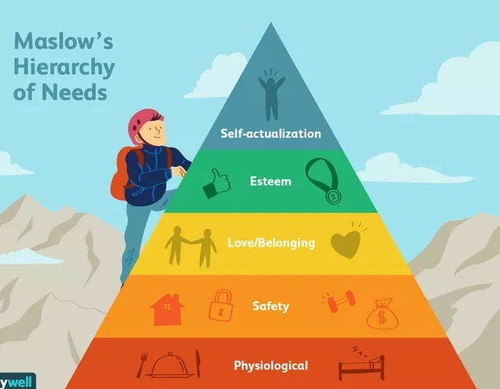
(Source: Verywellmind, 2022)

To make sure parents are able to form solid bonds, keyworker collaboration is essential. The keyworker may provide a settling in period during a transition to help the youngster get used to the new environment. In order to make sure they are adhering to both the government's and their own requirements, it is also crucial that keyworkers follow all regulations and procedures within the setting. A keyworker should be an excellent role model for the kids in their environment and possess strong communication abilities as well. A keyworker's documentation is crucial because they must fill out daily progress sheets and more detailed documents. This way, practitioners in the child's next setting will know exactly what the child can accomplish and what their next steps should be.
The keyworker should provide a warm and supportive environment for the kids in the setting. According to Montessori (1912), children's interests change as they grow older. For instance, between the ages of two and six, she predicts that children will naturally be interested in music and suggests that this could be included into the environment of the setting as the child grows more intrigued and interested.

Partnership

The most important partnership is with the child and working with the child can also help them learn more as if a parent knows what their child is interested in and learning in the classroom, they can connect that knowledge at home. Consequently, the learning and development of the children would benefit from this.
In order for children to reach their full potential in an early years environment, parents need to have a great deal of confidence in the educators and the setting they are putting their children into. According to the Early Years Foundation Phase Framework (2023), a partnership consists of parents, families and practitioners cooperating to support children’s successful learning and development. During transitions, trust is crucial since the practitioner needs to establish a connection with both the parents and the child.
Pacey (no date) state that The National Minimum Standards for Registers Childcare (NMS) in Wales and the Early Years Foundation Stage (EYFS) in England both place strong emphasis on collaborating with parents. It is crucial that carers as well as parents recognise you the key worker as the child’s key person. This means it’s your responsibility to inform the parents of their child’s day and the progress they are making. You must involve the parents and carers from the very beginning of the transition period, along the way from induction, settling in, and daily chats, to sharing of resources, social invents and information sessions. When strengthening the partnership, communication is crucial. For instance, regular talk, sheets such as all about me forms, and updates help ensure that all partners are completely aware of the child’s developmental progress.
According to earlyyearscareers (2016) the EYFS and NMS places a strong emphasis on collaborating with other experts and multiagency since it is everyone’s responsibility to satisfy the needs of the child and family. Regular sessions to review children’s development enable all experts to come together and offer guidance and support. Building a connection with other professionals can be a significant asset in assisting children in getting early assistance they require. Relationships are still able to be developed in preparation for the day when you need to contact them, even if you aren’t receiving assistance from many agencies. This can occur, for instance if a child is not reaching developmental milestones. In this case, the practitioner might want to speak to the health visitor to have a more comprehensive picture if the child’s circumstances. The settings policies and procedures will determine how this information is shared.

Interventions

Interventions are implemented at transitional times to help the children to have a more positive and seamless experience. Child Mind Institute (no date) believe that there are many different strategies that can be put in place to make this period much smoother for children. Establishing a routine for daily transitions is a fundamental tactic. Children of all ages can benefit from routines for things like getting ready for school, doing their homework, and going to bed. Nonetheless, this can be particularly helpful for children aged 3 to 4, as the transition from staying at home to attending school five days a week may cause them to feel overwhelmed and exhausted during the first few weeks. The child will then get acquainted and establish the connection with school resulting in a more positive, stress-free environment before.
‘All about me’ sheets which contain information about the child are frequently used in early years settings. According to Vygotsky (1934), a practitioner must have a thorough understanding of the child in order to assign activities and lessons that are appropriate for the child’s skill level and areas of interest. These are useful as they provide background information about the child, which may facilitate the development of a relationship between the child and the practitioner as they will have a better understanding of the child. Other settings may use ‘my daily sheet’ or more often now is done via an app online in many settings, which will show parents what their child did today, eat, nappy changes and more. Notifying the practitioner of any changes is equally vital. For instance, if your child had a restless nigh, the parent should let the practitioner know as it could impact their behaviour throughout the day. This guarantees that all relevant information about the child is kept current for both the parents and practitioners. Verbal communication is also vital, for example when collecting your child handover should happen between the parent and teacher to share the child’s information or any concerns and worries. This is why it’s vital they build positive partnerships so they can have open conversations.
Proprosed outcomes

The people participating in the transition will benefit if interventions are carried out well. A contented and at ease youngster will indicate that they have been accustomed to the early years setting. They will also form ties with the teacher and other kids, which will further prove that they have settled in. Additionally, a well-adjusted child should continue to grow during their time in the setting; this can be tracked with the use of learning journeys or developmental sheets. It's crucial to remember that everyone is different, and that parental and educational support are essential in ensuring that this transition goes well. If the interventions are implemented well, the child's behaviour should show improvements that the practitioners can identify. This is the primary result because it will benefit the child both now and down the road, easing their adjustment.

Reference list

Cambridge Dictionary (2023) Transitions. Available at: https://dictionary.cambridge.org/dictionary/english/transition (Accessed: 18th November 2023).

Child Mind Institute (No date) How can we help kids with transitions?. Available at: https://childmind.org/article/how-can-we-help-kids-with-transitions/ (Accessed: 21st November 2023).

Confident parents' confident kids (2023) New early childhood transition support. Available at: https://confidentparentsconfidentkids.org/2014/03/06/new-early-childhood-transitions-support/ (Accessed: 18th November 2023).

Department for Education (2023) Statutory framework for the early years' foundation stage. Available at: https://assets.publishing.service.gov.uk/government/uploads/system/uploads/attachment_data/file/1170108/EYFS_framework_from_September_2023.pdf. (Accessed: 20th November).

Dolya, G. (2010) Vygotsky in action in the early years: The ‘Key to learning’ Curriculum. London: Routledge.

Earlyyearscareers (2016) Childcare providers working in partnership with Multi agencies. Available at: https://www.earlyyearscareers.com/eyc/latest-news/childcare-providers-working-in-partnership-with-multi-agencies/ (Accessed: 20th November 2023).

MacBlain, S. (2021) Children’s learning in early childhood: learning theories in practice 0-7 years. Los Angeles: SAGE Publications.

Miller, L., Pound, L. (2011). Theories and approaches to learning in the early years. London: SAGE Publications.

Open Learn Create (2023) 3 Children’s transitions. Available at: https://www.open.edu/openlearncreate/mod/oucontent/view.php?id=79794&section=3 (Accessed: 19th November 2023).

Oxfordshire County Council (2019) Smooth Transitions in the Early Years. Available at: https://www.oxfordshire.gov.uk/sites/default/files/file/early-years-childcare/smoothtransitionsintheearlyyearsagoodpracticeguide.pdf (Accessed: 18th November 2023).

Pacey (no date) Working in partnership with parents. Available at: https://www.pacey.org.uk/working-in-childcare/spotlight-on/partnerships-with-parents/ ( Accessed 20th November 2023).

Rosa, E. M., & Tudge, J. (2013). ‘Urie Bronfenbrenner’s Theory of Human Development: Its Evolution from Ecology to Bioecology’. Journal of Family Theory & Review, 5(4), 243–258, Available at: https://onlinelibrary-wiley-com.ezproxy.uwtsd.ac.uk/doi/full/10.1111/jftr.12022 (Accessed: 19th November 2023).

Social Science Space (2021) Albert Bandura, 1925-2021: The Social Psychologist Who Transformed How We Think of Learning and Mortality. Available at: https://www.socialsciencespace.com/2021/08/albert-bandura-1925-2021-the-social-psychologist-who-transformed-how-we-think-of-learning-and-morality/ (Accessed: 18th November 2023).

Verywellmind (2022) Maslows Hierarchy of Needs. Available at: https://www.verywellmind.com/what-is-maslows-hierarchy-of-needs-4136760 (Accessed: 27th November 2023)

Vogler. P, Crivello. G, Woodhead. M (2008) ‘Early childhood transitions research: A review of concepts theory, and practice’, Early Childhood Development, 48, pp. 5-47.

Welsh Government (2015) Foundation Phase Framework. Available at: https://www.gov.wales/sites/default/files/publications/2018-02/foundation-phase-framework-revised-2015.pdf#:~:text=The%20statutory%20Areas%20of%20Learning%20in%20the%20Foundation,the%20World%20%E2%80%A2%20Physical%20Development%20%E2%80%A2%20Creative%20Development. (Accessed: 20th November 2023).

