
ex
Applied Computing

Wales Institute of Science and Art (WISA)

Networks and Cybersecurity Essentials (ACCA4024)

Lab 8: Let’s play Hide and Seek
(Steganography)



n.kaliyamurthy@uwtsd.ac.uk 1

Objectives
Using open source steganography program to hide a document within an image file.
Tasks
1. Use Steghide to hide a data file within an image file
Required Resources
- PC with Ubuntu 16.0.4 LTS installed in a VirtualBox or VMware virtual machine. (Alternatively, Any Linux Platform)
- Internet Connection to refer the outcomes
- References: http://steghide.sourceforge.net/

Task 1
- Login as User Cisco.
- Go to Terminal and Type the following commands and examine
- Run Steghide program
    - cisco@ubuntu:~$ cd Downloads/ o Enter libreoffice secret.odt & at the prompt to view the document.
    - cisco@ubuntu:~/Downloads$ libreoffice secret.odt & Here, & is used to append the operation to run in background What is the message in the secret.odt?
The secret document
  - Enter gimp keyboard.jpg & at the prompt to view the image.
    - cisco@ubuntu:~/Downloads$ gimp keyboard.jpg &
o Enter the command to embed using steghide. The jpg file keyboard.jpg is used to embed the document secret.odt.
    - cisco@ubuntu:~/Downloads$ steghide embed -cf keyboard.jpg ef secret.odt
    - It will ask for a passphrase, use Cisco.
    - Re-enter the passphrase when prompted.
You have embedded the document, secret.odt, into the image file, keyboard.jpg.
  - Open the files, secret.odt and keyboard.jpg. Did these files change?
NO

- Extract the hidden file.
  - To verify the hidden file.
    - cisco@ubuntu:~/Downloads$ steghide info keyboard.jpg ▪ Type y at the prompt. (Do not press Enter).
    - Enter the passphrase Cisco and press Enter.
    - The results below shows that the file, secret.odt, is encrypted and compressed.
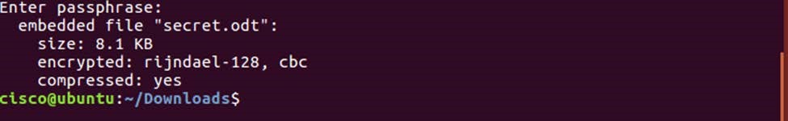
- Extract the hidden file.
  - To extract the hidden file.
    - cisco@ubuntu:~/Downloads$ steghide extract -sf keyboard.jpg ▪ Enter the passphrase, Cisco, and press Enter.
    - Enter y when prompted to overwrite the existing secret.odt file with the new extracted secret.odt file.
You have extracted the file. Open the extracted secret.odt file with LibreOffice. Could you open the file? Is the secret message the same as before?
Yes

- Task 1 to complete. I have shared an image file class1.jpg with you in Teams Channel. That file has a hidden message. What is that?
- You need a passphrase to extract the information. Find out the passphrase. Hint: (6,6) (2,3) (5,4) (3,5) (10,3) (9,5) (8,2) (5,4)
1 | 2 | 3 | 4 | 5 | 6 | 7 | 8 | 9 | 10
2 | a | e | e | r | ; | j | o | h | j
3 | p | a | r | r | r | t | r | t | d
4 | c | r | a | s | l | a | r | m | g
5 | v | a | d | k | k | e | r | r | f
6 | h | u | g | a | w | a | m | n | d
7 | k | l | a | h | q | q | w | a | s

Enter the text in the document here…… HIYA!!! Great work-You deserve a PIZZA!!!
Task 2 to complete. Create your own file, hide it in an image and challenge your friends to find out the hidden text. Challenge at least one of your classmate via team’s channel (one notebook platform) and accept one challenge.
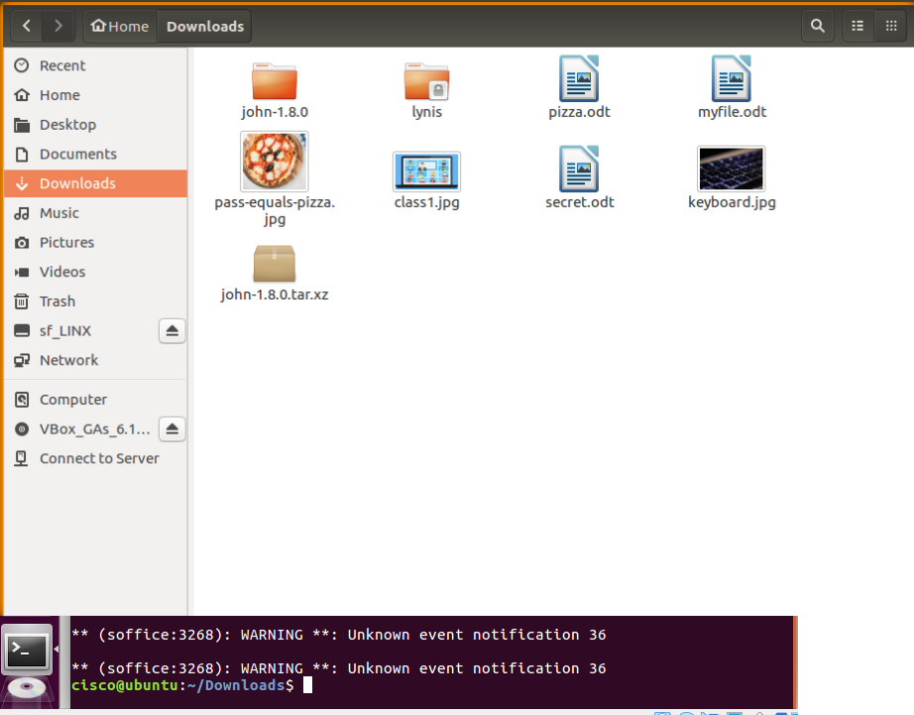

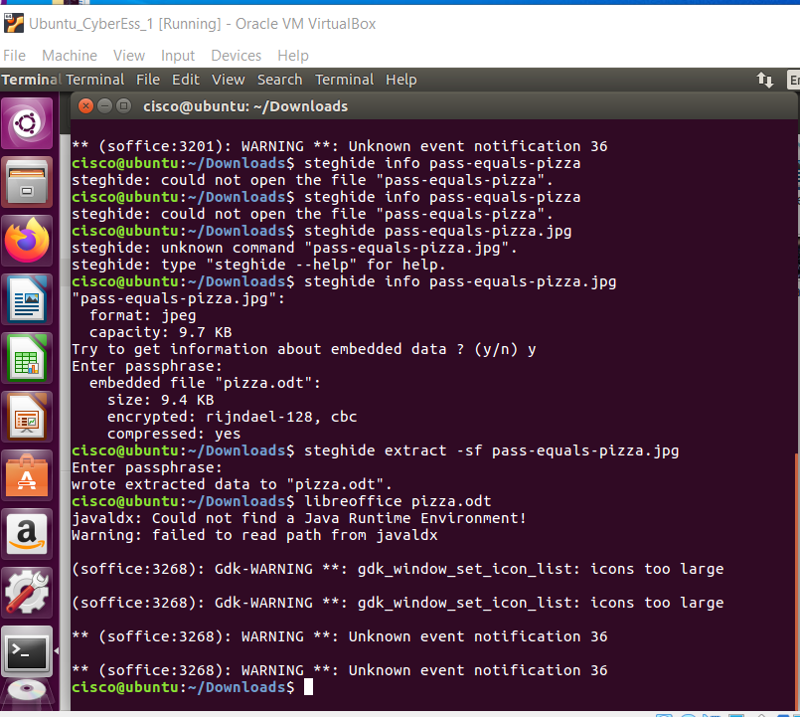
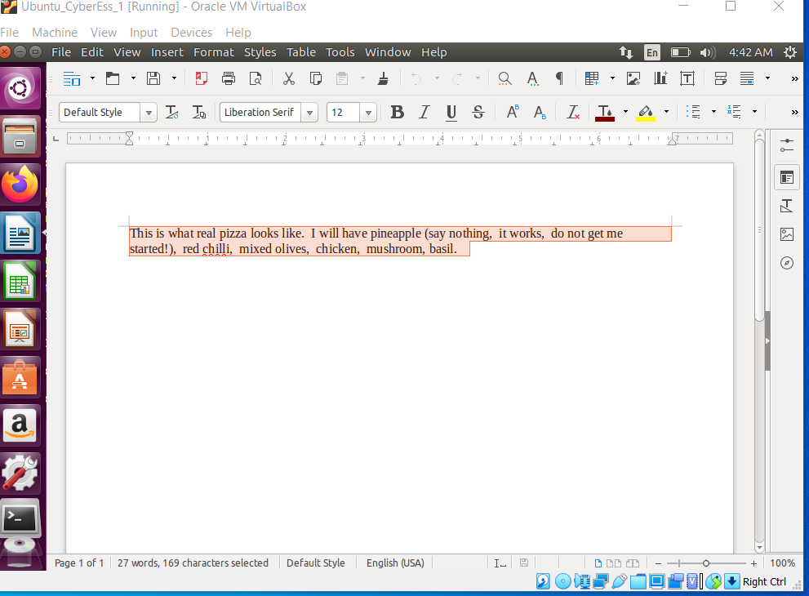

Learnings from tutorials so far:
Part 1 (Packet Tracer, Host Machines)
- Build a home Network
- Understand and configure IP Address
- Use Ping/ Trace route Utility to check the connection status
- Use ipconfig /all command to determine the MAC address of a Windows computer on an Ethernet network.
- Analyze a MAC address to determine the manufacturer.
- Analyze the Wired and Wireless Network connection.
- Analyze Address Resolution Protocol (ARP).
- Connect to a Wireless Router and configure the basic settings in a wireless router and add security features.
- Use nslookup command to understand the url to ip conversion.
- Configure basic connectivity settings in Intermediate devices (Switch/ Router).
- Work with SBA Packet Tracer Files/ environment
- Configure ftp, web, email, dns, ntp and aaa Servers Part 2
- Set up a virtual lab environment
- Troubleshooting the virtual lab environment
- Working with virtual machines
- Authentication, Authorization and Accounting
- Threats and Vulnerabilities – Using NMAP
- Hide and Seek – Use Steghide to hide a data file within an image file

