
Preparing for RESEARCH within Policing

(BMPL5017)

Seren Thomas
(2305811)

Contents Page
Task 1: Mind Map of Ideas 2
Task 2: Research Proposal 3
Task 3: Ethics Form 10
Task 4: Justification of the Chosen Research Method 11
Task 5: Draft Research Questions 13
Task 6: Evaluation of the Chosen Data Analysis Method 15
Reference List 17

Task 1: Mind Map of Ideas
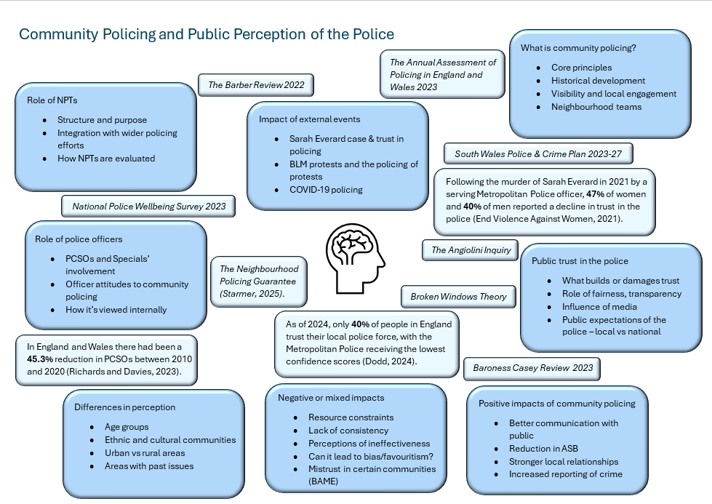

Task 2: Research Proposal


UNDERGRADUATE DISSERTATION
RESEARCH PROPOSAL FORM

NAME:  Seren Thomas | Student number:  2305811
DRAFT RESEARCH TITLE QUESTION:
A critical analysis of the role of community policing in shaping public perceptions of the police in the UK.

The topic of community policing and its role in shaping public perceptions of the police in the UK is highly relevant to contemporary discussions surrounding public trust and the effectiveness of policing strategies. The relationship between the police and the communities they serve is a crucial factor in ensuring both public safety and the legitimacy of policing. In recent years, issues such as public distrust, perceptions of bias, and concerns about police-community relations have come to the forefront, making the role of community policing even more significant.

Community policing, which emphasises building positive relationships between the police and local communities, is widely seen as a means of improving public trust and cooperation in the justice system. However, while there is a growing body of research exploring community policing, there is still much to be understood about its true impact on public perceptions of the police. This dissertation seeks to address this gap by critically analysing how community policing influences public trust and perceptions of policing in the UK, while also exploring potential challenges or negative aspects that may hinder its effectiveness.

This topic is especially important considering the increasing complexity of modern policing, with pressures such as public scrutiny, high-profile cases of police misconduct, and the need for more community-based approaches to prevent crime. Understanding the role community policing plays in shaping perceptions will contribute to the broader conversation about effective policing strategies, highlighting both the positive and negative impacts that community policing can have on public trust.

Furthermore, this topic is timely and relevant to the UK context, where recent reforms and initiatives have aimed to strengthen community policing practices. Given the focus on improving relationships between police forces and diverse communities, the dissertation will explore how community policing can be a key driver in transforming public attitudes towards the police, while also considering any challenges and limitations that may arise.

By exploring the nuanced relationship between community policing and public perceptions, this research will provide valuable insights into the potential of community policing to improve police legitimacy, foster safer communities, and help identify areas for improvement. It will also contribute to the wider academic literature on policing, offering critical perspectives on the implementation and effectiveness of community policing strategies.

SUMMARY OF RESEARCH AIM & OBJECTIVES:
The key aim of this dissertation is to critically analyse the role that community policing plays in shaping public perceptions of the police in the UK. This research seeks to explore whether, and to what extent, community policing contributes to building trust and confidence in the police, while also considering the challenges that may limit its effectiveness. By evaluating both the strengths and limitations of community policing, the dissertation aims to provide a balanced understanding of its impact on public attitudes.

Objective 1 - To examine how community policing strategies are implemented within selected UK police forces and the extent to which they prioritise public engagement. This will involve exploring how different police forces approach community policing in practice, including the structures, initiatives, and priorities in place to foster police-community relationships.

Objective 2 - To explore the impact of community policing on public perceptions of trust, confidence, and legitimacy in policing. This objective will focus on public responses to community policing efforts, investigating whether these strategies improve how individuals view and engage with the police.

Objective 3 - To critically assess the limitations and challenges of community policing in influencing public perceptions, including any barriers to its effectiveness. This will involve identifying potential obstacles, such as inconsistent implementation, resource limitations, or misaligned public expectations, that may undermine the intended outcomes of community policing.

THEORETICAL CONTEXT:
As of 2024, only 40% of people in England trust their local police force, with the Metropolitan Police receiving the lowest confidence scores (Dodd, 2024). This concerning figure underscores the importance of understanding how public trust in policing is formed, maintained, or lost. My study seeks to explore how community policing influences public perceptions of legitimacy and confidence in policing across the UK.

Following the murder of Sarah Everard in 2021 by a serving Metropolitan Police officer, public confidence suffered a significant blow, with 47% of women and 40% of men reporting a decline in trust in the police (End Violence Against Women, 2021). These figures reflect wider concerns about police accountability, culture, and responsiveness, particularly in high-profile metropolitan forces. However, trust is not solely shaped by critical incidents — day-to-day interactions, visibility, and community presence also play key roles. This is where community policing, particularly neighbourhood-focused models, becomes central to improving legitimacy.

Community policing strategies often reference the "Broken Windows Theory," which suggests that maintaining order and addressing minor offences can prevent more serious crimes and improve perceptions of safety and control in local areas (Ruhl, 2024). While this theory has been criticised for contributing to over-policing in marginalised communities, it has also shaped many neighbourhood policing frameworks aimed at building visible and proactive local patrols.

Several official documents provide the strategic context for evaluating these policing models. The Annual Assessment of Policing in England and Wales (Cooke, 2024) highlights both progress and inconsistencies in the delivery of neighbourhood policing. It reports that while many forces claim to prioritise community engagement, austerity-driven resourcing issues have often limited their ability to do so effectively.

In Wales, the South Wales Police & Crime Plan 2023–27 (Michael, 2023) and South Wales Listens — the force’s neighbourhood alert system both illustrate the region’s emphasis on local accountability and two-way communication. These mechanisms allow residents to report issues, receive alerts, and participate in shaping local policing priorities. The Neighbourhood Policing Guarantee, introduced by Starmer (2025), reinforces a national commitment to putting more “bobbies on the beat,” returning to visible, local policing as a means of building confidence.

The Angiolini Inquiry (2024) further adds weight to the discussion by identifying systemic failures in vetting, misconduct reporting, and internal cultures, raising questions about whether community-facing officers can truly build trust without institutional reform.

Organisational capacity also plays a role. The National Police Wellbeing Survey (Graham et al., 2023) identified that workforce morale and wellbeing have a direct impact on officers’ ability to deliver effective community policing. Performance data supports this view: Richards and Davies (2023) found that forces struggling with workforce shortages, backlogs, and underinvestment are least likely to sustain meaningful public engagement.

Finally, the theoretical framing for my study draws from Muir et al. (2022), who propose a “new mode of protection” a model of policing that balances public reassurance, social justice, and evidence-based practice. Their work supports the idea that community policing should not only be local but also values-driven and responsive.

By engaging with up-to-date literature, official policing guidance, and current statistical reports, the study will develop a nuanced picture of how community policing affects public attitudes in the UK. This will include evaluating both promising practices and areas of concern, particularly in terms of public trust, legitimacy, and inclusivity.
SUMMARY OF RESEARCH –SURVEY METHOD:
For my research into the role of community policing in shaping public perceptions of the police in the UK, I have chosen a mixed-methods approach, incorporating both quantitative and qualitative research methods. The primary data collection techniques I plan to use are a questionnaire and semi-structured interviews.

The questionnaire will be the primary tool for collecting quantitative data. I plan to send this out to a wide range of participants, including members of the public, as well as friends, family, and colleagues, who can provide varied perspectives on community policing. The use of a questionnaire allows me to gather standardised responses from a larger sample, which will enable me to identify trends and general patterns in public perceptions of community policing. I will include a combination of Likert scale questions, which will help me quantify respondents' attitudes toward the police and community policing initiatives, and multiple-choice questions to capture the demographic variables that might influence perceptions (e.g., age, gender, ethnicity, and prior experiences with the police). This method will allow for statistical analysis and give me the ability to compare responses across different groups within the public.

I chose the questionnaire method because it offers the ability to collect a large amount of data relatively quickly and efficiently, providing a broad overview of public opinion on the subject. By collecting data from a diverse range of participants, I can identify patterns and trends that will form the basis of my analysis and conclusions about the public’s trust in the police and the effectiveness of community policing.

Alongside the questionnaire, I will conduct semi-structured interviews with individuals currently working within the police force. This will provide a qualitative dimension to my research, allowing for a deeper exploration of the perspectives and experiences of those directly involved in the implementation of community policing strategies. Semi-structured interviews offer the flexibility to explore topics in more depth, giving interviewees the opportunity to discuss specific challenges, successes, and the impact of community policing from their professional standpoint. This method allows for more open-ended questions and the possibility of adapting the conversation based on responses, which will provide richer insights compared to more rigid survey formats.

I plan to target a range of police officers, from community officers to senior staff, to gain multiple perspectives on how community policing strategies are perceived and implemented within different units. This will enable me to understand the internal challenges and benefits of community policing initiatives, offering a nuanced view of their effectiveness and the role they play in shaping public trust.

The use of both quantitative (questionnaire) and qualitative (semi-structured interviews) methods allows me to approach my research from two complementary angles. The quantitative data from the questionnaire will provide measurable insights into how community policing is perceived by the public on a larger scale. By analysing these responses, I will be able to identify key patterns, such as differences in perception based on demographics or prior interactions with the police.

On the other hand, the qualitative data from the semi-structured interviews will allow me to gather more contextual and detailed insights into the lived experiences of police officers. This combination will provide a more holistic understanding of the topic, as it will allow me to not only understand the public's views but also delve into the internal mechanisms of community policing strategies.

Using both methods will enable me to triangulate the data, increasing the validity of my findings. By comparing and contrasting the quantitative results with the qualitative insights, I can identify any disparities or agreements between public perception and the experiences of those working within the police force. This will enrich my analysis and allow me to present a more comprehensive view of how community policing impacts public trust in the police.
SUMMARY OF SAMPLING FRAMEWORK:
For my study on the role of community policing in shaping public perceptions of the police in the UK, I plan to use two distinct sampling groups to provide a balanced and comprehensive view. The first group will be the general public, who will participate in the questionnaire. The questionnaire will also include responses from my colleagues in the police service, ensuring that I capture perspectives from both members of the public and those who are directly involved in policing. The participants will be aged 18 and above, and I aim to gather at least 100 responses. The sample will include a mix of friends, family, colleagues, and others to create a diverse set of responses, reflecting a broad range of demographic backgrounds. This will allow me to obtain quantitative data that can help identify trends and patterns in how different groups perceive community policing and its impact on public trust.

The second group will be police officers, and I plan to conduct semi-structured interviews with between five and ten individuals. These will include a range of personnel, from PCSOs and PCs to Specials, and, if possible, I will also include some higher-ranking officers. This diverse mix of participants will provide both frontline and managerial perspectives on the implementation of community policing strategies. The interviews will provide qualitative data that will allow for a deeper understanding of the challenges, successes, and internal dynamics of community policing from those directly involved.

By combining both the quantitative data from the questionnaire and the qualitative data from the interviews, I will be able to triangulate my findings. The public sample will allow me to explore the general perception of community policing, while the police sample will offer insights into the practicalities and internal views of the police force. Together, these groups will enable me to present a well-rounded and nuanced analysis of the role of community policing in shaping public perceptions of the police.

INITIAL REFERENCE LIST:
- Angiolini, E. (2024) The Angiolini Inquiry: Part 1 Report. London: Home Office.
- Cooke, A. (2024) State of Policing: The Annual Assessment of Policing in England and Wales 2023, HMICFRS. Available at: https://hmicfrs.justiceinspectorates.gov.uk/publication-html/state-of-policing-the-annual-assessment-of-policing-in-england-and-wales-2023/ (Accessed: 11th April 2025).
- Dodd, V. (2024) ‘Only 40% of people in England trust their police force, research reveals’, The Guardian. Available at: https://www.theguardian.com/uk-news/2024/apr/18/only-40-of-people-in-england-trust-their-police-force-research-reveals (Accessed: 9th April 2025).
- End Violence Against Women (2021) Almost half of women have less trust in police following Sarah Everard murder Available at: https://www.endviolenceagainstwomen.org.uk/almost-half-of-women-have-less-trust-in-police-following-sarah-everard-murder/ (Accessed: 9th April 2025).
- Graham, L, Plater, M and Brown, N. (2023) National Police Wellbeing Survey 2023. Durham: Durham University.
- Michael, A. (2023) South Wales Police & Crime Plan 2023-27. Bridgend: South Wales Police and Crime Commissioner.
- Muir, R, Higgins, A, Halkon, R and Walcott, S. (2022) A New Mode Of Protection. London: The Police Foundation.
- Richards, G and Davies, N. (2023) Performance Tracker 2023: Police, Institute For Government. Available at: https://www.instituteforgovernment.org.uk/publication/performance-tracker-2023/police (Accessed: 11th April 2025).
- Ruhl, C. (2024) Broken Windows Theory of Criminology, SimplyPsychology. Available at: https://www.simplypsychology.org/broken-windows-theory.html (Accessed: 9th April 2025).
- South Wales Police (2022) South Wales Listens: Neighbourhood Alert System. Available at: https://www.southwaleslistens.co.uk/Content/Pages/About-Us (Accessed: 11th April 2025).
- Starmer, K. (2025) New measures to put neighbourhood bobbies back on beat, GOV.UK. Available at: https://www.gov.uk/government/news/new-measures-to-put-neighbourhood-bobbies-back-on-beat (Accessed: 11th April 2025).

Task 3: Ethics Form

Link to Ethics Form - PG2 Ethics Form.docx
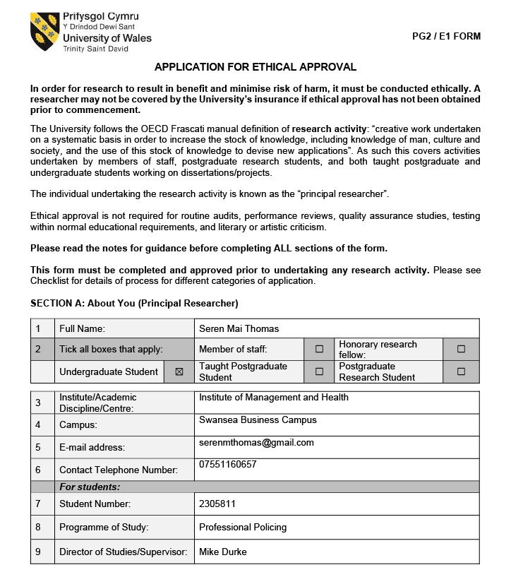

Task 4: Justification of the Chosen Research Method

For my study on neighbourhood policing, I have chosen a mixed-methods approach, using both questionnaires and semi-structured interviews. This design allows me to gather both broad trends and in-depth insights, offering a more holistic understanding of perceptions around neighbourhood policing from both the public and policing professionals.

I chose questionnaires because they allow me to collect data from a wider sample, including members of the public, friends, family, and colleagues in policing roles. Given the sample size of 100, this method provides efficiency while still offering meaningful findings. The questionnaire includes both closed-ended and open-ended questions. The closed questions help identify patterns across the group, such as perceived visibility of neighbourhood officers or levels of public trust. Meanwhile, the open-ended questions give participants a chance to express their opinions in their own words, offering more depth than numerical responses alone (Greetham, 2019). Questionnaires also preserve anonymity, which I believe increases the honesty of responses, especially regarding potentially critical views of policing (Walliman, 2022).

In contrast, I am also conducting semi-structured interviews with 5–10 officers, PCSOs, and specials working in Neighbourhood Policing Teams. This method allows me to explore individual experiences and views in much greater depth than a questionnaire would. The semi-structured format provides a balance between structure and flexibility — I have a list of core questions, but I can adapt and probe further depending on the participants’ responses (King, Horrocks and Brooks, 2019). Interviews will help uncover how officers perceive their role in communities, the pressures they face, and the practical realities of delivering neighbourhood policing.

The rationale for combining these two methods is based on triangulation, which strengthens the validity of my research by allowing findings from one method to complement or challenge the other (Creswell & Plano Clark, 2018). For example, I can compare whether public perceptions of visibility align with officers' accounts of their deployment and priorities. This mixed-methods approach also reflects recent academic work suggesting that policing research benefits from the integration of both quantitative and qualitative perspectives (Crow, 2021).

My sample selection reflects both accessibility and ethical considerations. By focusing on adults aged 18 and above, I ensure all participants can legally give informed consent. Including both public participants and police colleagues offers a balanced view from both ends of the policing relationship (Rowe, 2020). While the interview sample is smaller, it is diverse in rank and role, which supports the depth and range of insight.

In summary, I believe this mixed-methods approach is the most appropriate for answering my research questions. It allows me to explore what people think about neighbourhood policing and also why they think it — something that would be difficult to achieve with just one method alone.

Task 5: Draft Research Questions
Questionnaire -
- Q1. What is your age group?
- Q2. What is your connection to the police?
- Q3. On a scale of 1–5, how confident are you in your local police’s ability to deal with issues in your community?
- Q4. How likely are you to report a crime or suspicious behaviour to the police?
- Q5. How visible are police officers and PCSOs in your local area?
- Q6. Do you feel that the police understand the specific needs of your community? Please explain your answer.
- Q7. Have you had any direct contact with a Neighbourhood Policing Team (e.g., PCSOs or local officers) in the last 12 months?
- Q8. If yes to Q2, how would you describe that experience?
- Q9. To what extent do you agree with the following statement: “Community policing improves trust between the public and the police.”
- Q10. Are you aware of what your local neighbourhood policing team does in your community?
- Q11. Rank the following in order of importance when it comes to building public trust in the police (1 = most important):
Police visibility, Police fairness and impartiality, Community engagement activities, Quick response to incidents, Clear communication and updates.
- Q12. In your opinion, what are the strengths of community policing?

Interview –
- Q1. Can you describe your current role within the neighbourhood policing team and the community you serve?
- Q2. In your experience, how does community policing influence public trust in the police?
- Q3. How visible would you say your team is in the community and how does visibility affect local engagement?
- Q4. Have you noticed any shifts in public attitudes towards the police recently? What do you think has influenced those shifts?
- Q5. What methods or initiatives have you found most effective in building trust and relationships with the public?
- Q6. What are the biggest challenges you face when trying to engage with the community and how do you manage them?
- Q7. If you could make one change to improve the impact of neighbourhood policing on public trust, what would it be and why?

Task 6: Evaluation of the Chosen Data Analysis Method

Given that my research combines both qualitative and quantitative data, I have chosen two complementary data analysis methods: descriptive statistics for the questionnaire responses and thematic analysis for the interview data and open-ended questionnaire responses. These methods match the nature of the data and the goals of my study.

For the questionnaire’s closed-ended responses, I will use descriptive statistical analysis. This involves summarising data using frequencies, percentages, and averages to identify trends and patterns. For instance, I can quantify how many participants feel that police visibility in their area is sufficient or whether they believe neighbourhood policing is effective. This method allows me to present the data clearly and concisely, especially with a sample of around 100 people (Bottomley, Pryjmachuk and Wright, 2020). Since I am not aiming to generalise to the entire population but rather to explore trends in perceptions, descriptive statistics are more appropriate than complex inferential techniques (Denzin et al, (2023).

This approach also supports data transparency, as findings can be easily understood by non-academic readers, including those within the police service or community groups. Visual representations such as charts or graphs may also enhance the accessibility of the data, a factor often highlighted in applied policing research (Spooner et al, 2022).

For the qualitative data from interviews and open-ended questionnaire responses, I will use thematic analysis, following Braun and Clarke’s six-phase model. This method involves familiarising myself using the data, creating preliminary codes, looking for themes, evaluating them, characterising and labelling them and finally writing up the findings. Thematic analysis is flexible and allows me to explore not just what participants say, but also the meanings and patterns behind their words (Braun and Clarke, 2022).

It is particularly well-suited to my interview data, where participants may reflect on organisational pressures, community engagement, or perceptions of legitimacy. This method enables me to draw out themes such as trust, visibility, or police-community relationships — all of which are central to neighbourhood policing. Additionally, it allows for a comparison between public and officer perspectives, offering a richer narrative than numbers alone (Wood, 2022).

While thematic analysis does involve an element of subjectivity, I plan to mitigate this through transparency in my coding process, keeping detailed notes and audit trails to show how themes have developed. I am also aware of the importance of reflexivity, and I will reflect on my own role and potential biases throughout the analysis (Flick, 2018).

In conclusion, both analysis methods suit the specific types of data I am collecting. Descriptive statistics will help me identify and communicate broad trends, while thematic analysis will allow me to explore the deeper meanings behind those trends. This combination strengthens the overall validity and richness of my findings.

Reference List

- Angiolini, E. (2024) The Angiolini Inquiry: Part 1 Report. London: Home Office.
- Bottomley, J, Pryjmachuk, S and Wright, M. (2020) Academic writing and referencing for your policing degree. St Albans : Critical Publishing.
- Braun, V and Clarke, V. (2022) Thematic Analysis: A Practical Guide. London: SAGE Publications.
- Casey, L. (2023) The Baroness Casey Review: Final Report. London: UK Government.
- Cooke, A. (2024) State of Policing: The Annual Assessment of Policing in England and Wales 2023, HMICFRS. Available at: https://hmicfrs.justiceinspectorates.gov.uk/publication-html/state-of-policing-the-annual-assessment-of-policing-in-england-and-wales-2023/ (Accessed: 11th April 2025).
- Creswell, J and Clark, V. (2018) Designing and Conducting Mixed Methods Research. 3rd Edition. California: SAGE Publishing.
- Crow, G. (2021) Community studies: research methods. 1st Edition. London: Bloomsbury Academic.
- Denzin, N, Lincoln, Y, Giardina, M and Cannella, G. (2023) The SAGE Handbook of Qualitative Research. 6th Edition. California: SAGE Publications.
- Dodd, V. (2024) ‘Only 40% of people in England trust their police force, research reveals’, The Guardian. Available at: https://www.theguardian.com/uk-news/2024/apr/18/only-40-of-people-in-england-trust-their-police-force-research-reveals (Accessed: 9th April 2025).
- End Violence Against Women (2021) Almost half of women have less trust in police following Sarah Everard murder Available at: https://www.endviolenceagainstwomen.org.uk/almost-half-of-women-have-less-trust-in-police-following-sarah-everard-murder/ (Accessed: 9th April 2025).
- Flick, U. (2018) An Introduction to Qualitative Research. 6th Edition. London: SAGE Publications.
- Graham, L, Plater, M and Brown, N. (2023) National Police Wellbeing Survey 2023. Durham: Durham University.
- Greetham, B. (2019) How to write your undergraduate dissertation. Third edition. London: Red Globe Press.
- King, N, Horrocks, C and Brooks, J. (2019) Interviews in Qualitative Research. 2nd Edition. London: SAGE Publications.
- Michael, A. (2023) South Wales Police & Crime Plan 2023-27. Bridgend: South Wales Police and Crime Commissioner.
- Muir, R, Higgins, A, Halkon, R and Walcott, S. (2022) A New Mode Of Protection. London: The Police Foundation.
- Richards, G and Davies, N. (2023) Performance Tracker 2023: Police, Institute For Government. Available at: https://www.instituteforgovernment.org.uk/publication/performance-tracker-2023/police (Accessed: 11th April 2025).
- Rowe, M. (2020) Policing the Police: Challenges of Democracy and Accountability. Bristol: Policy Press.
- Ruhl, C. (2024) Broken Windows Theory of Criminology, SimplyPsychology. Available at: https://www.simplypsychology.org/broken-windows-theory.html (Accessed: 9th April 2025).
- South Wales Police (2022) South Wales Listens: Neighbourhood Alert System. Available at: https://www.southwaleslistens.co.uk/Content/Pages/About-Us (Accessed: 11th April 2025).
- Spooner, E et al. (2022) Police research and evidence-based policing. St Albans : Critical Publishing.
- Starmer, K. (2025) New measures to put neighbourhood bobbies back on beat, GOV.UK. Available at: https://www.gov.uk/government/news/new-measures-to-put-neighbourhood-bobbies-back-on-beat (Accessed: 11th April 2025).
- Walliman, N. (2022) Research methods: the basics. 3rd Edition. Oxfordshire: Routledge.
- Wood, D. (2022) Blackstone’s handbook for policing students. Seventeenth edition. Oxford: Oxford University Press.

