Student name: Ana Maria Dumitru
Student ID number: 2127610
Lecturer: Kathryn Flynn
Module: International Meetings Management for the Hotel Industry
Module code: BMIH6007
Assignment 2 Report

Table of Contents
1 Introduction 3
2 The Event Cycle 3
3 Event Concept 4
4 Aim and Objectives 5
5 Event Operations 7
6 Event Budget 9
7 Industry Trends 11
8 Cultural and Situational Consideration 13
9 Conclusion 14
10 References 16

Introduction
TechHospitality Innovate 2024, the second version of the global event focusing on the latest technical solutions and the roadmaps to upcoming organizational tendencies in the hospitality area. The event is considered to be staged in London's central area, with the intention to invite high-profile individuals working in the field, technological geniuses as well as organizers and prospective hosts from throughout the world. The selection of the host is done on the basis of the growing demand of technology in the sector which does not only allows the customers service to be more advanced, but make everything easy during the operation and also gives the advantage of being competitive. London is often called for its whole history, cultural valuor and a very common business centre and this special day was the perfect time and place to organize the event. For the city to act as a backbone that is well linked and able to host international mega events are the ingredients.

The Event Cycle
The Event Cycle, as the heart of the framework, is what allows to carry out the event planning process on the stage of strategy formation, the arena of event implementation and the backstage of event analysis. It implies that in every moment the most optimal manner to address the specified issues in each of the steps is the only way to reach the most productive results in terms (Araez-Risco et al., 2020). For TechHospitality Innovate 2024, the Event Cycle comprises four key phases: Stage I includes: concepts of the event, plans of the design and implementing it. Stage II includes: evaluation the event and winding-up.
Concept and Initiation: The first stage is aimed at how the event will be accomplished, what kind of audience will be attracted, and what the major aim is. One of the possibilities for TechHospitality Innovates 2024 is creating a platform that will integrate technology and hospitality together to prove it is a way to modernize whole industry in the end. Among those, it is planning a feasibility study, collecting founders capital, and building the working group for the event planners and the industry experts in this phase.
Planning and Design: This portion entails logistics planning and creative design types such as learning environment. It is mirrored by choosing a venue that is well positioned in London and reaching an agreement with primary suppliers; on top of that, the timeline should be planned and should include keynote speeches, interactive sessions, technology presentations, and networking talks. In the project the individuals are going to address two point of view: visual identities of event together with branding, interior design and technical facilities respectively that are in the innovative thematic. This stage will be manifested in the provision of facilities that include AV equipment, food stuff and security.
Implementation and Execution: The next step would be to implement & initiate the operation of the event plan. To do this, the individuals assign someone on-site to be the boss to take care of everything one by one like setting up the venue, handling the speakers and giving the allocated exhibition space. The individual also make sure to run the whole event smoothly in terms of technological matters. Workers and volunteers trained to operate specific jobs such as registration, accreditation and transfer of information (Işık et al., 2022). Outstanding handling of unexpected problems and crisis control are the essential operating fields and at the same time the risk prevention factor.
Evaluation and Closure: Monitoring of the result of implementing sustainable strategies and indicating which areas need to be improved in future events necessitates an evaluation of post-event. The second phase is about learning from participants, analysing the variety of sessions and taking into account the results as well as the event's impact as a result. The records of the budgets, the account activity and the comparative analysis of the actual expenditures will be performed by financial reconciliation and detailed reporting. Finally the accumulated expertise is converted into knowledge and utilized while replicating such projects in the future.

Event Concept
Tech Hospitality Innovate 2024 is an event that will demonstrate how the hospitality industry will have technological innovations. The mission is to function as a 360-degree platform, which allows people to test, to develop contact and to experience different cases of modern technologies conversion for the hospitality industry. The program TechHospitality Innovate 2024 will be characterized by professionalism and creativity. That is so because, the well-planned one day itinerary definitely will meet or even exceed the expectations of all participants of the conference. Then the panel discussion includes the real issues Artificial Intelligence in customer service and smart hotel innovations which are touched by experts’ and professionals’ speeches.
Attendees are going to make use of the varied live shows of the latest technological tools which will be ongoing all day. They want the prospects to understand the services that would be offered and therefore would be given a VR tour of yet to be built hotels, an artificially intelligent concierge and automations of check-in and check-out processes (Gonzalez et al., 2020). Through exhibition areas, the tech will display to the public their gadgets, giving the opportunity to the visitors to try out the countless solutions that make the lives easier. The networking of the event is complete since it encompasses at least 2 networking sessions to ensure a strong network. The structure is of several breaks, with the networking opportunities being in between sessions.
The closing ceremony consists of the panel discussion with speakers about the crucial event takeaways and the Q&A section where the guests can communicate directly with the speakers. Not only the award ceremony at the end of the event which will have the measurements of the progress in hotel technology impress but also memorable (Filimonau et al., 2024). In brief, the Technhospitality Innovate 2023 event is a quite participatory and educational occasion that will make a commentate to the attendants to become standard-bearers of the hospitality technology revolution. The developed agenda is tailor-made to ensure that the participants not only get practical but also helpful lessons, networking opportunities with their peers and also drive the implementation of innovation in the industry (Liberato et al., 2023).

Aim and Objectives
Aim:
The ultimate idea to follow with TechHospitality Innovate 2024 meeting is to be a platform for all hotel tech-related possibilities with an impact on productivity as well as a tool for assessments. The engine of the seminar is transfer of knowledge, it can be a template for technical innovations in the coming period and the participants have a chance to collaborate during the seminar for the betterment of the industry, technology suppliers, and the intellectuals.
Objectives:
- To influence 500 delegates.

- To Showcase 15 Innovative Technologies

Event Operations
Regardless, the event planners operations will capture this event’s entire planning and management aspects and consequently the smooth running of TechHospitality Innovate 2024 event. Therefore, it is the fact that all of this is done in such a way that will create comfort and amazing memories for the attendants in the most economical way using things like technology, logistics and human assets.
- Venue and Infrastructure: The choice of central London has become the priority and so the site must be large enough to provide a hospitable place for up to 500 delegates to participate and have state of art technology equipment. The process was incorporated as that which included the existence of accessibility, maximum capacity and the availability of appropriate technical capabilities of the venue (Camilleri, 2024).
- Technology Management: The most concerning aspect would be what topics are being focused on. After that it will deal with the issues of how a human can use such technology productively by making it a central one. The process includes the provision of demo stations, a live software and hardware setup (Kolobkova et al., 2021). Besides, the provision of an unlimited internet connection and technical support through the live showcase.
- Event Staffing: A human resource team of a working event shall have creative and adaptable skills that can be used to manage event processes without errors. The possible jobs ending in the event organizers, servers/hostesses, technical support staffs, people working with food & drinks, or security teams are a few examples (Dwivedi et al., 2024). Member of health team starts functioning as a sleep expert, who has all the relevant information for the patient and guides them properly.
- Logistics and Coordination: It is the question of logistics During the organization, if the events are to run according to the plan, then everything must be on the working schedule, which would give for the smooth run of the events. Logistics include corresponding the mobilizing of speakers and VIPs, transportation to the exhibition further to the right place, and guarantee that all machines and equipment are brought to the location appropriately (D’Souza and D’Souza, 2023). The event is all set to be performed with the necessary planning.
- Catering and Hospitality: Catering quality should be on par at the event to make the visitors connect the catering with a good overall experience as they will be part of the event for the whole day. The brunch for the mid-day and the morning breakfast to be included in the menu with several taste flavors. Members of the catering staff will have to communicate with the event host to avoid mistakes and provide the services at the right time (Lehto et al., 2024). Basically, staffing will be there for improving the attendance and keeping attendee satisfied and treated throughout the program.
- Safety and Security: On one hand being the security factor is the aspect that has awakened the curiosity (Ratna et al., 2024). Guards would be distributed in all following areas: gates would be guarded, personnel on duty would be vigilantly. This communication process will present an overview of what to do in every case and how to get help for employees as well.
- Evaluation and Feedback: The realisation after an incidence is known to be another way of assessing changes that the TechHospitality Innovate 2024 medical center has to go through alongside the constraints that it faces. Some information is directly taken from the visitors and speakers, whereas the conference organizers are indirectly responsible (Samuel, 2022).

Event Budget
The budget for TechHospitality Innovate 2024 has to come first, and the budget needs to factor in all kinds of expenses, and of course financing plans if necessary to achieve the goals that will make the project endure. Proceeds of events come from the ticket sales and renting the exhibition space with the costs that include the venue rental, equipment renting and setting up, advertising materials creation, speakers’ pay, catering, and long-term employment.
Category | Details | Amount (£)
Income
Ticket Sales | 500 tickets at £150 each | 75,000
Sponsorships | Corporate sponsors (5 x £10,000) | 50,000
Exhibition Fees | 20 exhibitors at £2,000 each | 40,000
Total Income |  | 165,000
Expenditure
Venue Rental | Full-day rental of central London venue | 30,000
Technology Setup | AV equipment, internet, tech support | 25,000
Marketing and Promotion | Advertising, social media, promotional materials | 20,000
Speaker Fees | Keynote and panel speakers (travel, accommodation) | 15,000
Catering | Lunch, refreshments, snacks for 500 attendees | 20,000
Staffing | Event planners, coordinators, security, volunteers | 25,000
Miscellaneous | Contingency fund, miscellaneous expenses | 10,000
Total Expenditure |  | 145,000
Net Income |  | 20,000

Income section includes the annual event's primary revenue generating sources. Tickets sales believed to bring £75,000 if there becomes the expected attendance of 500 delegates each at £150 ticket price. Sponsorships are expected to generate about £50,000 equal to the contribution that gives £10,000 done by five corporate sponsors. Besides this, £2,000 exhibitors' commission will raise the revenue through exhibitions up to £40,000. The section Expenditure deals with the greatest share of the operation-related expenses. The estimated figure is £30,000 for renting the central London venue. However, this cost is reasonable since what the individuals are buying is the premium location and services being offered. Technology setup for the successful audio-visual projection and technical support, £25,000 is the calculated budgeting allowance. Since marketing and advertising activities, which are directly related to the attendance rate and to sponsorship, are planned in this limit £20,000. The itemization of the speaker fee, the accommodations and the travel allowances for the main speakers will be £15,000. It is the job of the caterer to not only supply lunch but also refreshments for all guests, the cost of which will be £20,000. Consolidated of comprehensive all including security, coordinators, and planners, paying category is placed at £25,000.

Industry Trends
This excellent industry is rising fast at amazing speed because of the constant evolution of technology and changing visitors' expectations. Another crucially emerged current trend, is the virtual and hybrid events rising. To begin with, the existence of these layouts was brought about by the contagion and therefore they finally became permanent fixtures since they allowed more individuals coming in, decreased the costs and offered access (Hammoudet al., 2022). The hybrid events that are a joint of on-site and online interactions can be considered as a combined format for those who prefer it for different personal needs too. Sustainability is not a luxury any longer - it is one of the most important factors nowadays (Zsarnoczky¸ 2018). Event organizers who have started noticing the effects of climate change have come up with options like using eco-friendly venues and digital alternatives to paper in their future events. The fact that it contributes to the reduction of environmental impact and is in compliance with the growing client trend of corporate responsibility is also one of its crucial merits.

SWOT Analysis
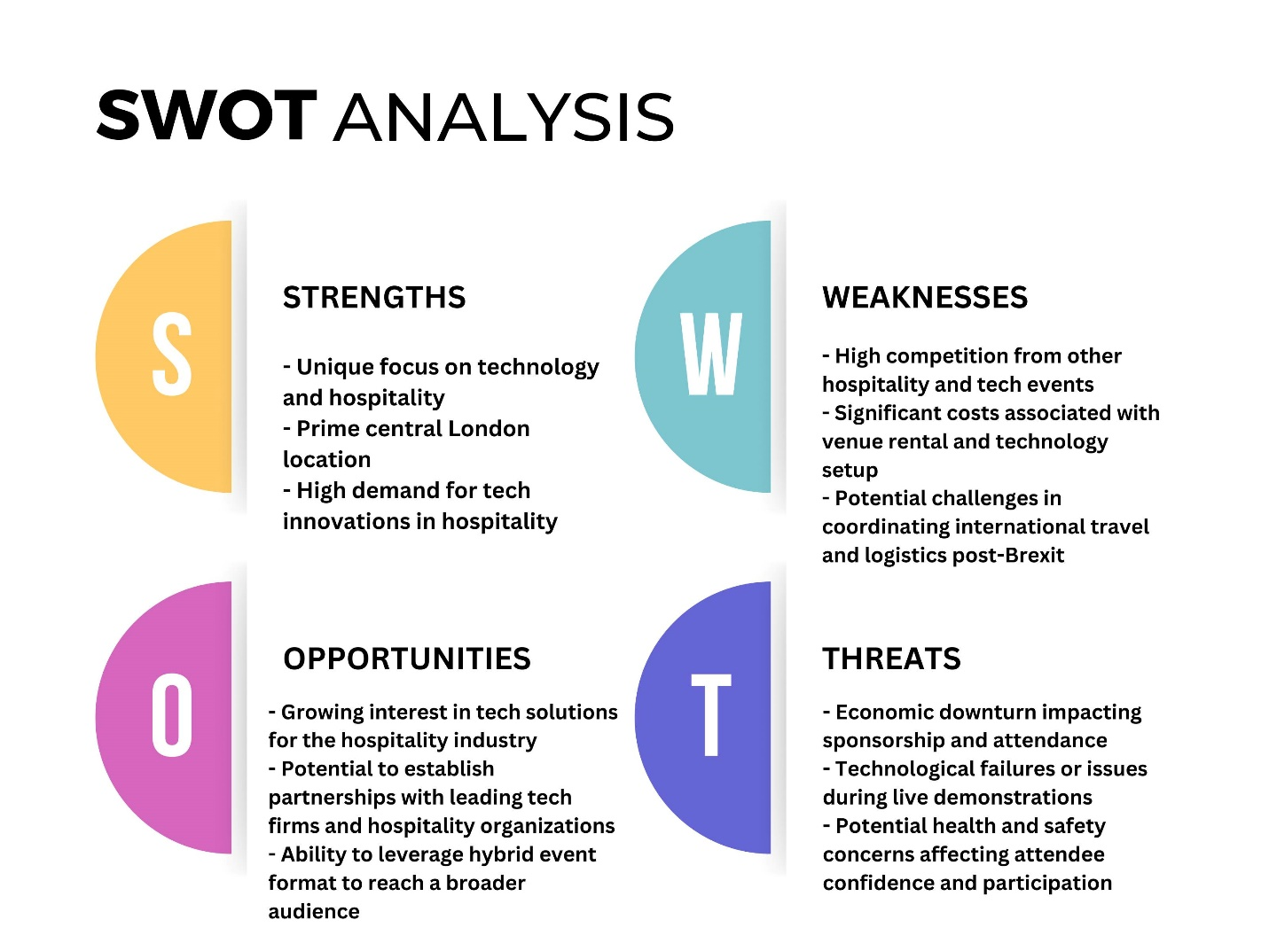

PESTEL Analysis
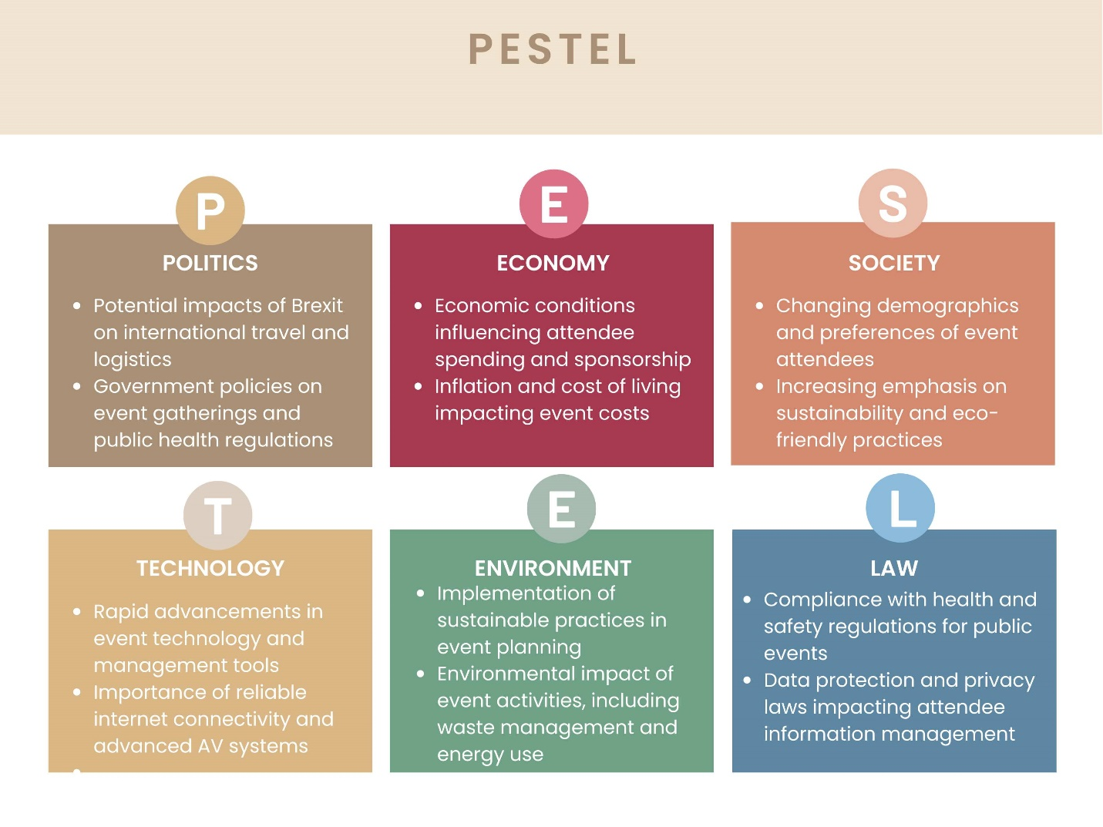

Cultural and Situational Consideration
- Cultural Considerations: From a wide, international viewpoint, cultural variety should be given a lot of attention, as well as the fact that they are different from each other. (Thus) One needs to pay due attention to such patterned words, eating habits that bring harm, and social customs. Likewise, the implementation of multilingual help and translation services can increase the ‘accessibility’ of the conference to the non-English speakers, who will now understand what is being said. The Catering must have special menus for Diet specifically for vegan, halal, and kosher diets in order to serve approximately 10,000 men. Furthermore, while developing the plan, one will take into account two practices, and put them apart from the broader religious ceremonies. Additionally, there should be cultural sensitivity in all the content and communication during digital event and nothing should be carried without any consideration towards stereotypes and rather inclusiveness will be maintained by having a respectful and diverse communication (Buhalis et al., 2019).
- Situational Considerations: While, that circumstances have changed much from past [technology, political, society, and heath ecosystem], must be factored in. The thing is that London is a hosting city that means that all the regulatory system of the city, and mainly post-Brexit, then it could be very a big problem for humans and goods transportation. Nevertheless, the matter of health and safety continues to dominate the public opinion, however; more recently the situation in the overall health standards of the world population has become even more daunting (Bladen et al., 2022). Of the utmost importance, being assured that their health and safety are in hand is what visitors will look for; hence, maintaining the policy of hygiene, such as sanitary facilities and emergency medical assistance, is essential (Wong et al., 2024). Moreover, the technology as one of the fastest changing brings the need of the company to up to the date with industry trends. Elevate the event’s reputation among this tech-savvy audience by employing the most recent technologies and solutions, systematized on AV equipment, virtual attendance options, and tools for in-time interactions (Buhalis and Moldavska, 2021).

Conclusion
The event TechHospitality Innovate 2024 is going to be trending and a connection between the world of technology and hospitality which will be a world of possibilities and solutions. The event will be planned and operationalized very meticulously considering the latest technological trends, creating opportunities for networking, and becoming a platform for exchanging the ideas. This goal is to be met by applying cultural, situational, and operational aspects as well as painting current trends in this area. Therefore, this event will make sure that students have an unforgettable and contributing experience.

References
Alvarez-Risco, A., Estrada-Merino, A. and Perez-Luyo, R., 2020. Sustainable development goals in hospitality management. In Sustainable hospitality management (Vol. 24, pp. 159-178). Emerald Publishing Limited.
Bladen, C., Kennell, J., Abson, E. and Wilde, N., 2022. Events management: An introduction. Routledge.
Buhalis, D. and Moldavska, I., 2021. In-room voice-based AI digital assistants transforming on-site hotel services and guests’ experiences. In Information and Communication Technologies in Tourism 2021: Proceedings of the ENTER 2021 eTourism Conference, January 19–22, 2021 (pp. 30-44). Springer International Publishing.
Buhalis, D., Harwood, T., Bogicevic, V., Viglia, G., Beldona, S. and Hofacker, C., 2019. Technological disruptions in services: lessons from tourism and hospitality. Journal of Service Management, 30(4), pp.484-506.
Camilleri, M.A. ed., 2024. Tourism planning and destination marketing. Emerald Publishing Limited.
D’Souza, E. and D’Souza, K., 2023. A study on the impact of innovative technologies in the hospitality industry. Journal of Tourism, Hospitality and Culinary Arts, 15(1), pp.1-23.
Dwivedi, Y.K., Pandey, N., Currie, W. and Micu, A., 2024. Leveraging ChatGPT and other generative artificial intelligence (AI)-based applications in the hospitality and tourism industry: practices, challenges and research agenda. International Journal of Contemporary Hospitality Management, 36(1), pp.1-12.
Filimonau, V., Ashton, M. and Stankov, U., 2024. Virtual spaces as the future of consumption in tourism, hospitality and events. Journal of Tourism Futures, 10(1), pp.110-115.
Gonzalez, R., Gasco, J. and Llopis, J., 2020. Information and communication technologies and human resources in hospitality and tourism. International Journal of Contemporary Hospitality Management, 32(11), pp.3545-3579.
Hammoud, G.A., Tawfik, H.F. and Rady Mohamed, S.S., 2022. Technological Innovation in Tourism and Events industry: A hybrid future of Events. International Journal for Tourism, Archeology & Hospitality (IJTAH), 2(3).
Işık, C., Aydın, E., Dogru, T., Rehman, A., Sirakaya-Turk, E. and Karagöz, D., 2022. Innovation research in tourism and hospitality field: A bibliometric and visualization analysis. Sustainability, 14(13), p.7889.
Kolobkova, V.A., Romanov, A.A. and Frolova, E.A., 2021. Digital technologies in the hotel industry: new prospects for sustainable development. Socio-economic Systems: Paradigms for the Future, pp.387-394.
Lehto, X.Y., Kirillova, K., Wang, D. and Fu, X., 2024. Convergence of boundaries in tourism, hospitality, events, and leisure: defining the core and knowledge structure. Journal of Hospitality & Tourism Research, 48(3), pp.407-419.
NHS Confed Expo, 2024. Available at https://www.nhsconfedexpo.org/about-the-event/book-your-pass?gclid=CjwKCAjwrcKxBhBMEiwAIVF8rH-6c5_Nt3L6WjYt9jfa1XdS_mCnobb-GhXHpxAlGcSrUtdgBcVR-RoC3twQAvD_BwE. [Accessed on 1st May 2024]
Ratna, S., Saide, S., Putri, A.M., Indrajit, R.E. and Muwardi, D., 2024. Digital transformation in tourism and hospitality industry: a literature review of blockchain, financial technology, and knowledge management. EuroMed Journal of Business, 19(1), pp.84-112.
Samuel, S., 2022. Immersive technologies in the healthcare space. In Augmented intelligence in healthcare: A pragmatic and integrated analysis (pp. 433-451). Singapore: Springer Nature Singapore.
Wong, L.W., Tan, G.W.H., Ooi, K.B. and Dwivedi, Y., 2024. The role of institutional and self in the formation of trust in artificial intelligence technologies. Internet Research, 34(2), pp.343-370.
Zsarnoczky, M., 2018. The digital future of the tourism & hospitality industry. Boston Hospitality Review, 6, pp.1-9.
Liberato, D., Costa, E., Barradas, I., Liberato, P. and Ribeiro, J., 2023, November. Events’ Tourism and Hospitality Marketing. In International Conference on Tourism, Technology and Systems (pp. 483-493). Singapore: Springer Nature Singapore.

