

BA Leadership and Management
Skills for the Workplace
Module Assignment Submission

Student Name: | Louise Puresevic
Student Number: | 2005324
Module No: | BMSK6003
Module Title: | Leading and Implementing Workplace Change

Statement of Confirmation of Authenticity

By the act of making this submission, the student declares that this is the work of the student named above. The work has not, in whole or in part, been knowingly presented elsewhere for assessment, or where assessment has been built on a previous assessment, this has been identified. Where materials have been used from other sources it has been properly acknowledged. If this statement is untrue, the student acknowledges that an assessment offence has been committed.
Attention is drawn to the plagiarism and unfair practice policies of both the University and of ILM.
Table of Contents
Abbreviations …2
1.0 Introduction 3
2.0 Critically analyse the current forces for change in the organisations micro and macro environment that can impact workplace culture and capability 5
2.1 Managing and leading to successful workplace change 7
2.2 Implementing and managing resistance to change 9
2.3 Examples of change models 10
2.4 Covid-19 and change in the workplace 12
2.5 Workplace scenario – Trauma & Orthopaedic workplace change 13
3.0 Evaluate how organisational stakeholders can be efficiently led through complex workplace change 14
3.1 What is stakeholder analysis? 15
3.2 The stakeholder engagement and influence on an organisation 16
4.0 Conclusion 17
References 19
Articles, Journals, Books 19
Websites & Videos 21
Appendices 22
Appendix A – Mind Map 22
Appendix B – PESTLE analysis 23
Appendix C – SWOT analysis 24
Appendix D – Tuckman’s process model 25
Appendix E – McKinsey’s 7 changes model 26
Appendix F – Lewin’s change model 27
Appendix G – Kotter’s 8 step change model 28
Appendix H – Lewin model vs. Kotter model 29
Appendix I – Kotter’s change in the Accident & Emergency follow up appointment booking process 30
Appendix J – Stakeholder analysis positive change model 31
Appendix K – Stakeholder analysis for Trauma & Orthopaedic change 32
Appendix L – PDCA model 33

List of abbreviations

NHS National Health Service
A&E Accident and Emergency
T&O Trauma and Orthopaedics

1.0 Introduction
In a fast-paced world, change is all around us. It is happening every minute of every day. As the world evolves, businesses and organisations must keep up and change too. They must develop, encourage, and move forward, connecting and build new leaderships, creating new skills to produce a service that will succeed above and beyond.

Focusing on the last 20 years or so there has been an incredible amount of change in the world.

The innovation and the progression of technology over the past two decades has dramatically transformed the world we live in today. Just before the millennium, we could only dream of owning a mobile phone, such a new item to the market and one that was only owned by the rich or famous. One of the world’s most famous brands of technology today, Apple, was just the name of a piece of fruit. The internet was also a new revelation. That long pause, the ‘screeching’ sound of the connection, regularly losing connection and having to share the limited online time with other household members is now a thing of the past. A small company back in the day, Google, is now one of the most widely used internet engines. Today we learn, work, shop, bank and communicate with the internet. Social media has made one of the greatest impacts on our lives, changing the way we live (Business Insider, 2018). Facebook, Twitter, Instagram and TikTok have all transformed the way we communicate and entertain ourselves, as well as the tv aspects such as Netflix and YouTube.

Some of the most radical changes to date would be that of global population. Dating back to 1998 just before the millennium the world population stood at 5.9 billion. Today, we stand at 7.97 billion (Worldometers.info, 2022). Alongside the increase of global population there is one of the greatest changes to the world today, and one that will continue to get worse if we do not try to change the way we deal with it. This is global climate change. A grim reality in the dramatic changes of the worlds surface. Changes in weather patterns, floods and wildfires are becoming increasingly more prevalent and pose a continuous threat to mankind, wildlife and the environment.
Following the tragic circumstances of the collapse of the Twin Towers following a terrorist attack in 2001, changes have been made to buildings and their structural format. Many countries compete to build the tallest and the most spectacular eye-catching structures. Now there is as much focus on the safety aspects of these buildings, such as fire precautions and criminal attacks. Similarly, would be the safety aspects of large ships such as cruise liners, which can date further back to the greatest shipping disaster of all time in the sinking of the Titanic. We have also had to change the way we work with other countries following the attack in 2001. Relationships between countries became conflicted, leading to wars. Changes in airport systems, higher security measures, which also fed into other areas such as sports stadiums and music venues (Meeker, 2022).

Social changes for LGBTQ and large groups such as #MeToo and Black Live Matter were introduced to support the changes and the legal matters of such growing aspects of life change to many. Many of these changes over the years affect us in our workplace and how we conduct our daily lives. Many aspects of the above-mentioned changes affect us all.

We need to change. Change should be welcome at any opportunity for any reason, to produce a better outcome. Charles Darwin, one of the world’s most famous naturalists, biologists and geologists, known for his passion and contribution to evolutionary biology once stated “It is not the strongest of the species that survives; nor the most intelligent that survives. It is the one that is the most adaptable to change” (O’Toole, n.d.). As the world becomes more connected, more transparent, and more diverse, businesses need a new type of leadership. This new leadership requires different skills to guide organizations into the future successfully.

In this assignment, I will study the forces surrounding the change process, in particular studying the implementation of change within a department of the NHS. I will look at resistance to the changes, particular models, managing successful change and stakeholder engagement. The aspects of these topics are structured within a Mind Map (Appendix A) (Farrand et. Al, 2002) at the end of this assignment.

2.0 Critically analyse the current forces for change in the organisations micro and macro environment that can impact workplace culture and capability

How do we feel about change and how do we cope when we are faced with the prospect of a change? Doubt, anxiety, frustration, fear or worry tend to be the most obvious first thoughts above the welcoming aspect of change. If you don’t like something, change it. Everyone’s different. Change is a way of everyday life, in business and in our personal life. We can all relate with ‘the easy way’ – the established routine. But that can become a way of life that will not encourage us to think about how we can be better, work in different ways to make changes for better results. You don’t have to think about it every time you need to do something. Changing your perception about how you see the world, personal life or your workplace can bring ideas to life. If you have an idea, put it forward. A famous quote by former President of the United States of America, Barack Obama states “Change will not come if we wait for some other person or some other time. We are the ones we’ve been waiting for. We are the change that we seek.” (Higgins, 2022).

All businesses work in different ways. Dependent on the category of the business, the way the business is run and its activities, is affected by the micro environment and the macro environment which in turn impacts the business.

Businesses can never really predict change. Life can be unpredictable and therefore businesses and organisations need to be ready and focused for any changes that could be relevant whenever possible. Changes can bring new opportunities, so by successfully managing a positive workplace culture and good workforce morale, this will influence the quality and performance of the workforce and therefore the business organisation will benefit from a successful workplace output.

One of the biggest and most obvious changes of recent years has been that of the COVID-19 pandemic. Undoubtedly COVID-19 continues to impact globally on all organisations. Change has become a vital option for us all, needing to adapt to survive throughout this pandemic. Change impacted everybody and the requirements for businesses to introduce restrictions came into play. Restrictions such as minimising contact between staff and their customers, meaning staff working from home for example, to avoid potential contamination and thus limiting the spread of the virus. Changes such as the wearing of PPE such as face masks and the use of antibacterial hand gel became a way of life for us all.

The two elements that are micro environment and macro environment are factors that can both have a huge effect of the influence of decision-making processes within an organisation.

Micro environment influences the routine activities that are associated with organisations on a smaller scale. Daily performances are influenced by factors such as suppliers, competitors, shareholders, employees, the media and of course the customers. Each factor can in turn hold the prospective outcome for an organisation, each in turn affecting the product of the business or the reputation that can take the organisation forward or determine a downfall. As an example, an organisation decides to employ its IT and HR department for a certain training module. The training materials, adequate training classes and the availability and reliability of the new IT programmes can have a huge effect on the organisation and its success or failure. The investment of finances and staff time should benefit by producing an up-to-date service and a more work inspired team to take the business forward.

The macro environment studies the forces externally that have factors that many organisations are unable to control, any changes made relating generally to the environment that are beyond the organisations decision making processes. These factors are those described in the PESTLE model (Kolios & Read, 2013) (Appendix B). The general forces such as political, economic, social, technological, legal and environmental, can have an impact that can often become out of the control of many. The Covid-19 pandemic is one of the most obvious forces of latter years that has become one of those such forces.

Micro and macro environments differences can be critically compared for workplace changes as follows:
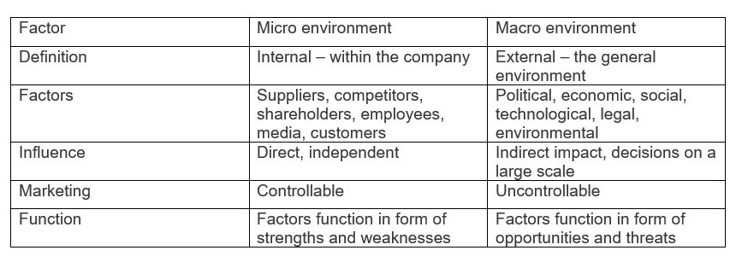
Table 1 – Micro and macro environment (Puresevic, 2022)

In conclusion, micro environment and macro environment can both have significant impact on organisations. They can both play an enormous part on growth and success in businesses. A SWOT analysis (Cottrell, 2015) (Appendix C) can be a useful tool to use to look at the organisation in-depth and to create a plan that can help to improve and change. The size of the organisation will determine whether micro or macro is the element that will be geared towards the benefit of the business. In the case of this assignment, the NHS are clearly governed by a macro environment. Many factors dictate the working pattern of the everyday function of the hospital.

2.1 Managing and leading to successful workplace change

Managing change in the workplace is essential in the outcome in any process that is to be considered. Implementing change & managing its potential and any resistance implications to the workplace can decide upon leading to the failure or success in workplace change. How do we define change? The implementation of progress, to undergo a transformation process. The values, attitudes and beliefs that we act upon along the way are vital in this process.

Table 2 – Values, attitudes and beliefs (Puresevic, 2022)

Values, attitudes and beliefs go a long way in performance (Ballon & Skinner, 2014). Changes must be considered, introduced and managed with detail to achieve the required outcome. They must be assessed throughout the process to oversee the implementation to give the best chance of success. In doing so, those at the centre of the change process can be guided and supported along the way.

Changes happen for many reasons, for example organisational redevelopment, IT network changes or departmental changes. There could possibly be a blame culture. As Patrick Lencioni states “When things start to look as if they are going wrong, then people start to pass judgement and blame each other” (Lencioni, 2003). This should not happen. However usually the most common change in a workplace would be departmental processes, such as a change in the delivery of a service to the customer. Therefore, by having the vital support of the management, the HR department and the workforce team in question, this should result in bringing the most successful outcome to the workplace change, thus creating a pattern of long-term sustainability to re-shape and perform more efficiently (McBride & Mustchin, 2007).

Change can fail however if there is a poor management process. Sometimes failure to deliver an effective change can lead to many complex problems such as removal of certain staff such as management, motivational impact, or poor performance results leading to stakeholder credibility. Organisations must continue to evolve, often to compete against other companies in similar professions (Unknown, n.d.).

The introduction of work-based models, usually in the form of team learning tutorials are introduced to implement the flexibility of the potential changes. The adaptation of willingness to want to change must be viewed as significant within the workforce team as well as the management. They must be willing to want to commit to change, to share the knowledge and experiences. The thought of any idea of change in any walk of life, at work or at home can lead us ‘out of the comfort zone’. In the workplace, individuals can steer away from their commitment to learning new ideas. They can become isolated and can appear to react with negativity. This is discussed further in 2.2.

2.2 Implementing and managing resistance to change

Organisations must be able to adapt when necessary. Successful management programmes offer companies the ability to strategically plan, incorporate effective communications, and look after its staff by offering suitable employee wellbeing programmes. On the flip side of this, poorly managed companies who cannot adjust to change effectively can produce poor results, leading to a downward spiral in customer satisfaction and poor employee relations and morale.

Changes can occur anywhere and at any time. Primarily, the most obvious changes occur because of financial status, technological updates, or perhaps from competition from rival organisations. There are also the unforeseen changes that must be made, situations that are very often out of our control.

Every workforce is different. Each branch of Tesco for example. They all have the same guidebook and systems to work by. But each store has its own manager, its own team members, and its own customers (Kim & Hallsworth, 2016). Similarly, large professional organisations such as the NHS have similar systems too.

The three phases of change – preparing, managing and reinforcing are all aspects to consider in producing a successful outcome. Preparation and strategy development, detailed planning, data gathering and corrective action are all vital in communicating the process. There will be those however who will be fearful of change and so the emphasis on reducing resistance to change must be considered. Concerns such as economical – will there be job losses or losses in opportunities to progress in the workplace, relationships – will there be new team members or managers, uncertainty – does this mean extra work, is there an office relocation, criticism – why do we have to change, what’s wrong with what we do now. Therefore, it is important that the management listen to their workforce, gathering feedback and constantly communicating and giving reassurance, which presents an outcome of a workforce that would be happy to be involved development and supporting the future of the organisation (Rothenberg, 2015). In summary, there are positive and negative characteristics that need to be addressed to produce the best outcome (Lencioni, 2010). Positive characteristics are the sense of comfort and control, satisfaction, possibility of a rewarding outcome such as salary or promotion, the realisation that “I’m ok, you’re ok”. Possibly more negative feelings and thoughts would come into play, such as hostility, frustration, mistrust, job security, fear of challenge and of the change, fear of resistance and the feeling of anxiety and self-doubt.

2.3 Examples of change models

A workforce must be open to change and have openness and willingness to take every opportunity to listen and learn to potentially move the organisation forward (Gavetti & Levinthal, 2000). Various theorist’s and their models are considered and used in many change processes. Often, change is good and will benefit the future working environment and its workforce (Tuckman, 1965). As detailed in Tuckman’s process of Sequence modelling (Appendix D), the values, attitudes and beliefs of Tuckman’s Theory and the sequence of movements from initial Forming of ideas (Values), into Storming and Norming (Attitudes), finally Performing and Adjourning (Beliefs), (McGrath and Bates, 2017, p.108-110). It’s approach to change and management can pay dividends to the workplace but could not work if there is negativity and resistance to the thought of having to change. Staff, usually those who have been in the workplace longer, can become ‘blinkered’ in their proposed change in routine.

Communicating clear aims, listening, learning, using sensitivity, collaborative leadership and exploring information and trusting your team should produce a successful outcome (Best & Holmes, 2010). There is often the issue of only seeing what is on the surface, such as an iceberg (Rick, 2015). Many fail to understand the full picture of what a potential change can bring forth. Many do not appreciate the full aspect of a change and the benefits of new ideas, when all they can see is ‘what is on top’, such as the structure and the strategy. Underneath lies all the benefits such as short-term goals, small steps, developing a broad vision and creating a coalition, as detailed in the Kotter 8 step in Appendix I.

Another model widely used is that of McKinsey (Kaplan, 2005) (Appendix E). However, despite producing successful outcomes from implementing useful and dynamic ideas and processes, this process is not always effective in the time scales of implementing the change, it focuses more on the simplifying and increased productivity of a change. As most changes usually require a timescale, it is not necessarily one of the most productive in time delivery.

Therefore, two models that could be considered for the changes in the delivery of NHS care, to be discussed in 1.5 of the assignment, would be Lewin’s model and Kotter’s model. Two very simple and effective models used for understanding change process in organisations.

Kurt Lewin (Levasseur, 2001), states that ‘Change is a journey’ and so as with any journey in life, it needs to be as straight forward and hassle-free as possible. In the Unfeeze/Freeze model (Appendix F), detail is given to show the three-step model of unfreeze, freeze and re-freeze which helps to assist managers and motivate the workforce team to contribute their ideas and processes to establish a way forward that can benefit the workplace as well as the team (Maund, 2018). As detailed in Lewin’s model, it can be used for the change process that is proposed for the Trust. The three stages of this process allow the managers to motivate their workforce, to include them in the processes of the change, before re-setting the decision to move forward.
Unlike Lewin, Kotter’s model, the 8-step process (Mohiuddin & Mohteshamuddin, 2020) (McGrath & Bates, 2013) (Appendix G), looks at a change process over an extended period. The 8 steps are creating the need for the change, the urgency and vision, through to making the adjustments and bringing in the change. To summarise, unlike Lewin, Kotter’s model even though proving effective, was deemed to be much more complex, as detailed to show the differences between the two models (Appendix H).

2.4 Covid-19 and change in the workplace

In 2019, the world changed. Faced with the Covid-19 pandemic, there became to urgency for a rapid change to everything about life. How we lived, how we worked, and how we looked to the future. The one most obvious change for the workforce, was that of working space, having to give many people the opportunity to continue to work from home.

There was a significant disruption to the world. How we travelled became particularly disruptive with restricted travel times and limited seating and there were cancelled flights, in many cases leading to access restrictions into many countries across the world.
The Covid-19 pandemic has also coincided with Brexit (Luque, 2022). When the UK made the decision to leave the EU, little did we know that a pandemic was around the corner. However, this historic change has so far proved a bit of a flop, resulting in soaring prices of food and everyday living and also the shortage of certain produce. There has also been a significant drop in workers available for many roles, particularly healthcare, catering and hospitality.

There is a greater need to take more care now when making financial decisions and achieving objectives within organisations. In addition to this, there is also now the increased pressure of the impact that is being caused due to the ongoing conflicts between Russia and the Ukraine, which is starting to create economic pressures around the world.

Disruption or introducing new ideas, creates the need for change. It can be slowly over a length of time, or it can be a rapid change, possibly due to requirements that need to be addressed as a priority. This could be for many reasons such as team operating and employment relationships, IT issues and how technology has evolved in the workplace, or perhaps the way in which customers or patients are looked after. The implementation of committed customer care must be in the forefront of every business or organisation. For it is the service we provide that produces the feedback that is needed to continue to move forward in positive steps, to manage and support, to give the best possible outcome. There must be a need to continuously update and enhance our advancing knowledge (Nickerson & Zenger, 2004). Above all else, organisations must ensure that they continue to offer their best service as usual.

Following the impacts of the Covid-19 pandemic a situation became clear within the hospital setting. This situation became an option to look at changing the process of a particular aspect of patient care. Keeping an open mind about change is vital (Wedell, n.d.). The changes were discussed and are now put into practice are currently being studied following the role out and will hopefully be a long-term fixture for the Trust.

2.5 Workplace scenario – Trauma & Orthopaedic workplace change

One of the most recent changes within the workplace, is that of clinic delivery. Similarly, to that of a service evaluation carried out on behalf of an NHS referral service from NHS 111 to a community pharmacy team (Nazar et. Al, 2020), with stakeholder involvement, a request came forward following the impact of Covid-19 and the subsequent ‘knock-on’ effect of shortage of clinic appointments and staff shortages. The NHS is constantly looking for ways in which it can introduce workforce improvements (Braithwaite, 2018). Team roles are often brought into the spotlight of discussion and how the workflow can be managed better, to work better together collaboratively as teams and to offer the best service possible in patient care.

It became apparent that there must be some way of delivering patient care where it was most needed. Upon discussion with other hospitals within the Trust, it was suggested that there should be a trial run of virtual clinic delivery for patients that had attended Accident & Emergency the previous day/previous days. As laid out in Appendix I, the Kotter model shows the performance analysis of this change. Initially looking to serve patients as quickly as possible following a visit to A&E, there also produced a question of whether every patient within the Trauma and Orthopaedic department did require a follow up appointment. Some could be discharged and have a telephone appointment with a Senior Nurse or a Registrar, instead of coming back into hospital for a face-to-face appointment. The idea of a virtual clinic facility initially came into play during the start of Covid-19, as patients were still coming through the doors of A&E, but there was a need to try and keep as many people away as possible. Therefore, it was trialled initially in GP practices and subsequently rolled out into hospitals. This new service, which is still in its early days for this hospital, has posed many questions which are being dealt with daily, specifically from members of the clinic reception team, but has provided many benefits to the service also. In conclusion looking at the model in Appendix I, this service is potentially very beneficial to the NHS and has proved very successful across other sites. If the barriers of the admin staff can be overcome, perhaps communication and levels of support from management and from the medical secretary, the change in the delivery of this service can be a change for the better. For want of a better suggestion – just try it, don’t complain and get onboard. “Attitude is a little thing that makes a big difference” (Ballon & Skinner, 2014). It may be welcomed as a change for good (Girdler, n.d.).

3.0 Evaluate how organisational stakeholders can be efficiently led through complex workplace change

There are many aspects to organisational change. Choosing the need for it, evidence for it and finding the right time to implement change. The micro environment and macro environment factors are also identifiable when deciding on organisational change. It must be driven by the right person or right team with participation from employees, key players, the right communication methods and perseverance and determination to reach the goal.

Without stakeholders, organisations suffer (Sarhadi, 2021). They rely on critical input and resource to survive. A stakeholder is anyone who is an individual, a few people or a whole group who all share interests in that organisation, definition being anyone that is affected by the organisation or the projects that it undertakes. Healthcare stakeholders include but not limited to, doctors, nurses and healthcare providers, unions, patients, local community, drug companies, equipment and food suppliers, as shown in the stakeholder analysis (anonymous, 2007) (Appendix J). Any of these sectors can become involved in any part of a project and can be beneficial to the outcome of that project.

A clear and defined relationship between the parties benefits the best potential outcome. The table (Appendix K) lays out an example of the impact on the workplace change as discussed in 1.5 scenario and how changes with the introduction to the virtual T&O clinic can be studied across various aspects of the Trust staff, from management through to admin and catering, also incorporating the findings from those outside of the Trust including patients, food suppliers and drug and resource companies.

In addition, perhaps it is also better to choose stakeholders that are not involved with other projects or organisations (Cassarino et. Al, 2020). This will benefit from maintaining the best outcome and not having the individual side-tracked into any other business concerns.

3.1 What is stakeholder analysis?

Stakeholder analysis is a specific technique involving anyone who is part of the concern of an organisation that is studying a prospective change. Any stakeholder having a vested interest in the subject matter can be involved with the project. Primary stakeholders are those directly involved in the matter, secondary are those indirectly involved. There are also tertiary stakeholders, who have the least involvement in a project or change, as they are least affected.

In order the get a perspective of the customer, or in this case a patient’s view, a stakeholder analysis is addressed before a project begins or a change is put into place. This preliminary analysis is carried out prior to approval. After approval and once the project is confirmed, a formal stakeholder analysis takes place. It is a source of being able to grasp the ideas and thoughts from everyone else concerned before a project or change is put forward (Maund, 2018). In summary;
- Prelaunch phase – Gathering information, establishing the requirement for change.
- Launch phase – Communicating, dealing with resistance to change.
- Further implementation – Consistency, perseverance, maintaining the action.
- Sustaining change – Look to launch new ventures, following new successors and team activities, learning from both positive and negative issues.

It can define the impact of change to the public, how it will affect investors, and how it would be welcomed by the team members, the suppliers and for the current clientele and the patients who will be a continuous cycle of footfall.

3.2 The stakeholder engagement and influence on an organisation

Stakeholders influence in the healthcare organisation is vital, as in any other organisation, to guarantee support and guidance in projects and to possibly assist in sourcing funding. It is beneficial to have the input of stakeholders particularly in the individual environment of the organisation, as they can provide specific information on issues relating to that environment having such close working relationships or involvement with that organisation.
Direction from a stakeholder perspective was critical in the process of the virtual clinic introduction. A project such as this, involving the public, was vital to get a response from many levels. A Plan-Do-Check-Act or PDCA (Appendix L) (Demming, 2012) (Malega et. Al, 2021) (Gupta, 2006), was put together to explore the various aspects of the potential change. The results derived from various factors such as staff morale, communication methods, patient hospital visits, auditing, training and PADR reviews. This PDCA model proves useful in exploring the explanations for each aspect of the change to introducing a virtual clinic. In summary, by building this model we can take each section and break down each aspect of the change process, add sub-sections to each to determine the aspects of the change and how it works, focusing on positives and negatives of each area.
It is also important to engage with the most effective and appropriate stakeholders, to benefit from the maximum outcome of the proposals of the projects in question (Spotswood, 2016).
A strong relationship and trust in identifying with the individual or individuals who will have the most impact on the performance of the organisation is the key to a successful outcome.

4.0 Conclusion

It is vital that any business or organisation considers change. By adapting work practices and effective communication, this can result in a better functioning workplace.

The Richard Beckhard Change Equation (V x D x F) > R model is useful for such resistance within the workforce (Beckhard & Pritchard, 1992). As seen with the T&O changes, there is resistance at the bottom of the scale, with the clinical administration team. The only factor resisting the change. Therefore, there needs to be sufficient energy across the team to implement these tasks and to encourage the administration team to focus on the realisation that the change will be a positive one (Covey & Covey, 2020). The questions that are likely to crop up are detailed in the “change equation”. Does a change need to happen? Should I be involved in this change? The equation (V x D x F) > R is shown below;

V – Shared vision and shared aim to produce a successful outcome – the option of change.
D = Dissatisfaction with current situation – lack of interest and participation from front desk administration staff.
F = First steps – processes are put into play, continuous support and communication at all levels.
R = Resistance to proposed change – Barriers are addressed in relation to administrative roles not wanting to play a role in change.

Change can only occur if there is a shared vision and everyone wants to see the change work. As written by Stephen Covey “People can’t live with change if there’s not a changeless core inside them. The key to the ability to change is a changeless sense of who you are, what you are about and what you value” (Covey & Collins, 2020). They will not change if they are not made aware of the potential benefits of change. They may not like the current situation; however, they are not prepared to change (Dowson, 2019). Usually, it is a minority that can potentially portray negativity and therefore spoil the outcome for the majority.

Change is unavoidable in any walk of life. This can be in personal or in the workplace. For organisations that face competition every day, change is all about staying on top, being competitive and therefore they must be adaptable to survive. Engaging with the workforce every day, such as regular meetings, staff communications, customer feedback, are all important aspects of staying one step ahead (Grieff et. Al, 2013). And similarly in the NHS, listening to patients and their concerns and grateful thanks, all benefits they way that the service operates.

References

Articles, Journals, Books
Anonymous, 2007. Project Management in the Real World: Shortcuts to Success. 109-114. Swindon: BCS Learning & Development Limited,
Ballon, B.C. and Skinner, W., 2014. “Attitude is a Little Thing That Makes a Big Difference”: Reflection Techniques for Addiction Psychiatry Training. Academic psychiatry; Acad Psychiatry, 32(3), pp. 218-224.
Beckhard, R., & Pritchard, W. (1992). Changing the Essence. Jossey-Bass.
Best, A. and Holmes, B., 2010. Systems thinking, knowledge and action: towards better models and methods. Evidence & policy, 6(2), pp. 145-159.
Braithwaite, J (2018). Changing how we think about healthcare improvement. BMJ: British Medical Journal (Online), 361.
Cassarino, M., Quinn, R., Boland, F., Ward, M.E., McNamara, R., O’Connor, M., McCarthy, G., Ryan, D., Galvin, R. and Robinson, K., 2020. Stakeholders’ perspectives on models of care in the emergency department and the introduction of health and social care professional teams: A qualitative analysis using World Cafés and interviews. Health expectations: an international journal of public participation in health care and health policy; Health Expect, 23(5), pp. 1065-1073.
Cottrell, S (2015). Skills for Success: Personal Development and Employability. 3rd edn. Basingstoke, Palgrave, Macmillan.
Covey, S.R. and Collins, J., 2020. The 7 habits of highly effective people: powerful lessons in personal change. New York: Simon & Schuster.
Covey, S. R., & Covey, S. (2020). The 7 Habits of Highly Effective People 30th Anniversary Guided Journal (3rd ed.). London, England: Franklin Covey.
Dowson, J., 2019. Transferring knowledge into practice? Exploring the feasibility of action learning for improving knowledge, skills and confidence in clinical communication skills. BMC medical education; BMC Med Educ, 19(1), pp. 37.
Farrand, P., Hussain, F. and Hennessy, E., 2002. The efficacy of the `mind map' study technique. Medical education; Med Educ, 36(5), pp. 426-431.
Gavetti, G. and Levinthal, D., 2000. Looking Forward and Looking Backward: Cognitive and Experiential Search. Administrative Science Quarterly, 45(1), pp. 113-137.
Grieff, S., Wustenberg, S., Molnar, G., Fischer, A., Funke, J. and Csapo, B., 2013. Complex problem solving in educational contexts - Something beyond g: Concept, assessment, measurement invariance, and construct validity. The journal of educational psychology, 105(2), pp. 364-379.
Gupta, P., 2006. Beyond PDCA-A New Process Management Model. Quality Progress, 39(7), pp. 45-52.
Kaplan, R.S., 2005. How the balanced scorecard complements the McKinsey 7-S model. Strategy & leadership, 33(3), pp. 41-46.
Kim, W. and Hallsworth, A.G., 2016. Tesco in Korea: Regulation and Retail Change. Tijdschrift voor economische en sociale geografie; Tijdschr Econ Soc Geogr, 107(3), pp. 270-281.
Kolios, A. and Read, G., 2013. A Political, Economic, Social, Technology, Legal and Environmental (PESTLE) Approach for Risk Identification of the Tidal Industry in the United Kingdom. Energies (Basel), 6(10).
Lencioni, P.M., 2003. The trouble with teamwork. Leader to leader; Leader to Leader, 2003(29), pp. 35-40.
Lencioni, P.M (2010). The Five Dysfunctions of a Team. John Wiley & Sons.
Levasseur, R.E., 2001. People skills: Change Management tools - Lewin's change model. Interfaces, 31(4), pp. 71-73.
Malega, P., Daneshjo, N., Rudy, V. and Drabik, P., 2021. PDCA Cycle – Tool for Improvement of the Business Processes – Case Study. TEM Journal, 10(3).
Maund, A. (2018). BA in Leadership and Management: Skills for the Workplace Student Yearbook, Final Year. London, England: Sage Publications Limited pp 216-217. (Maund, 2018)
Maund, A. (2018). BA in Leadership and Management: Skills for the Workplace Student Yearbook, Final Year. London, England: Sage Publications Limited pp 137. (Maund, 2018)
McBride, A. and Mustchin, S., 2007. Lifelong learning, partnership and modernization in the NHS. International journal of human resource management, 18(9).
McGrath, J. and Bates, B., (2013). The Little Book of Big Management Theories ... And How to Use Them. 1st ed. Harlow, U.K.: Pearson Education Limited, pp 108-110.
McGrath, J. and Bates, B., (2013). The Little Book of Big Management Theories ... And How to Use Them. 1st ed. Harlow, U.K.: Pearson Education Limited, pp 142-143.
Mohiuddin, S. and Mohteshamuddin, K., 2020. Combination model for sustainable change by utilizing the Kotter's change model and the Hersey & Blanchard's leadership model for improving medication errors reporting. Journal of Medical & Allied Sciences, 10(1), pp. 25-32.
Nazar, H., Evans, C., Kyei, N., Lindsey, L., Nazar, Z., Thomson, K., Yeung, A. and Todd, A., 2020. A service evaluation and stakeholder perspectives of an innovative digital minor illness referral service from NHS 111 to community pharmacy. PloS one; PLoS One, 15(3), pp. e0230343.
Nickerson, J.A. and Zenger, T.R., 2004. A Knowledge-Based Theory of the Firm—The Problem-Solving Perspective. Organization science (Providence, R.I.), 15(6), pp. 617-632.
Rick, T. (2015) ‘The iceberg that sinks organizational change’, Change management, corporate culture [blog]; 16 January. Available at
Rothenberg, N., 2015. Communication and Information Sharing in Teams. The Accounting Review, 90(2), pp. 761.
Sarhadi, M., Hasanzadeh, S. and Hoseini, S.H., 2021. Stakeholder Analysis in the Feasibility Process of Projects: A Structural Evaluation of the Power-Oriented Relationship. Project Management Journal, 52(4), pp. 323-339.
Spotswood, F., 2016. Beyond Behaviour Change Key Issues, Interdisciplinary Approaches and Future Directions. Policy Press.

Websites & Videos

Girdler, A. Change in the Workplace (Overcoming Resistance to Organisational. [Video file]. YouTube. Retrieved from https://www.youtube.com/watch?v=ibNMeXQwZp0 (Accessed 4 September 2022)
Higgins, S. (2022, March 14). 44 Inspirational Quotes About Change That Will Help You Think. from https://blog.hubspot.com/sales/quotes-about-change (Accessed 4 September 2022)
https://www.businessinsider.in/slideshows/miscellaneous/11-dramatic-ways-the-world-has-changed-in-the-last-20-years-alone/slidelist/63519144.cms#slideid=63519158 (Accessed 28 August 2022)
Luque, M. (2022, February 1). What-has-changed-since-Brexit-has-anyone-gained-anything., from http://www.theallineed.com/news/20220201/change in Brexit (Accessed 24 August 2022)
Meeker, J. (2022, September 28). Prophecy-in-the-news/world-has-changed-since-sept-11-2001/. from https://lifehopeandtruth.com/prophecy/prophecy-in-the-news/world-has-changed-since-sept-11-2001/ (Accessed 24 August 2022)
O’Toole, G. It Is Not the Strongest of the Species that Survives but the Most., from https://quoteinvestigator.com/2014/05/04/adapt/ (Accessed 4 September 2022)
The 7 Habits of Highly Effective People Summary - YouTube [Video file]. YouTube. Retrieved from https://www.youtube.com/watch?v=WFc08j9eorQ (Accessed 12 August 2022)
www.worldometers.info (Accessed 19 August 2022)
Wedell, G. How to Survive Change at Work - YouTube [Video file]. YouTube. Retrieved from https://www.youtube.com/watch?v=q1mbrcFSwsY (Accessed 4 September 2022)

Appendices

Appendix A – Mind Map

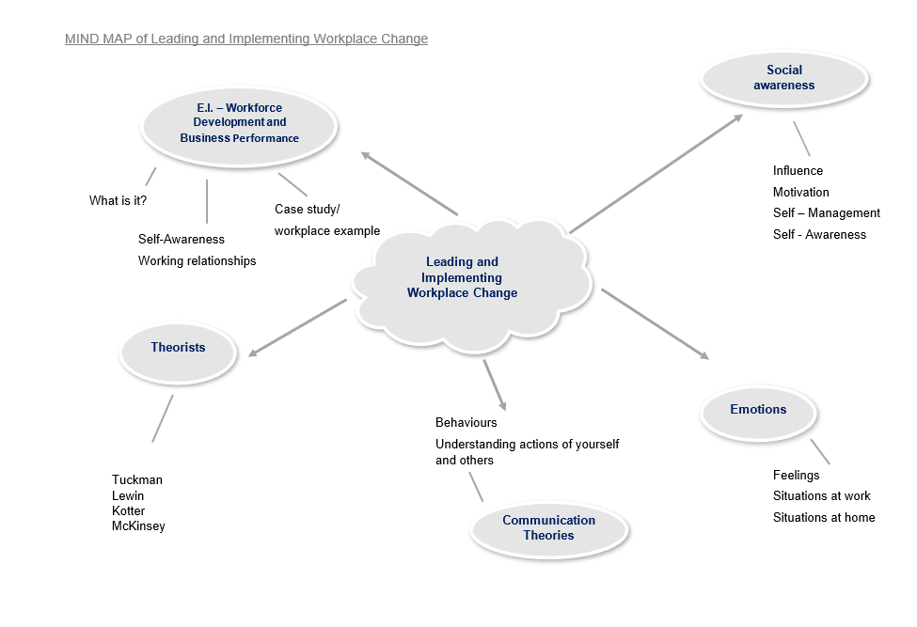

(Farrand et. Al, 2002) (Puresevic, 2022)

Appendix B – PESTLE analysis

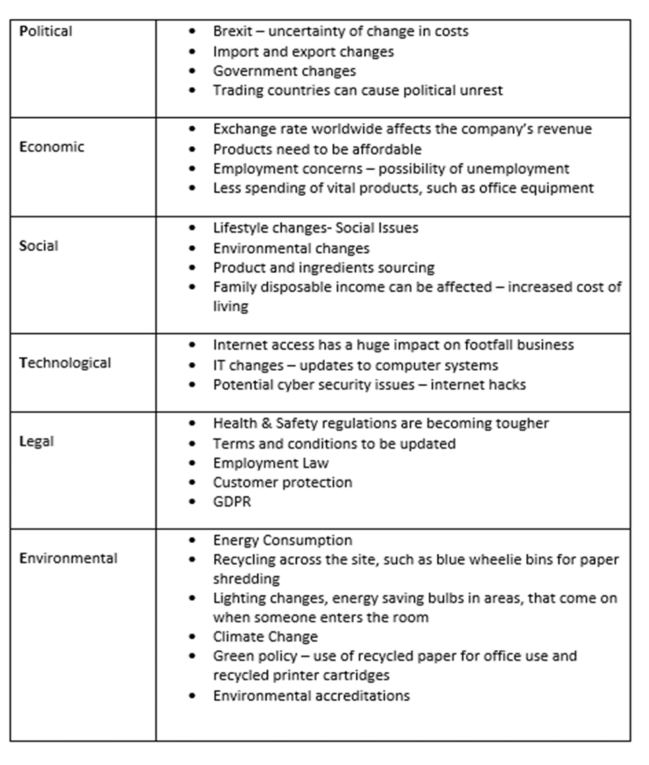

(Puresevic, 2022)

Appendix C – SWOT analysis

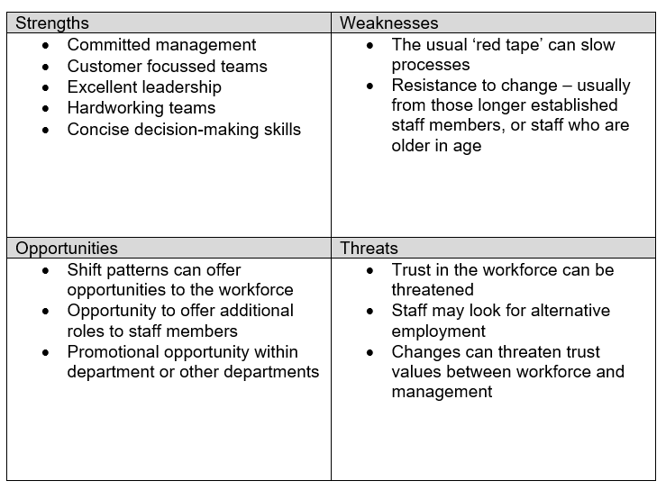

(Puresevic, 2022)

Appendix D – Tuckman’s process model

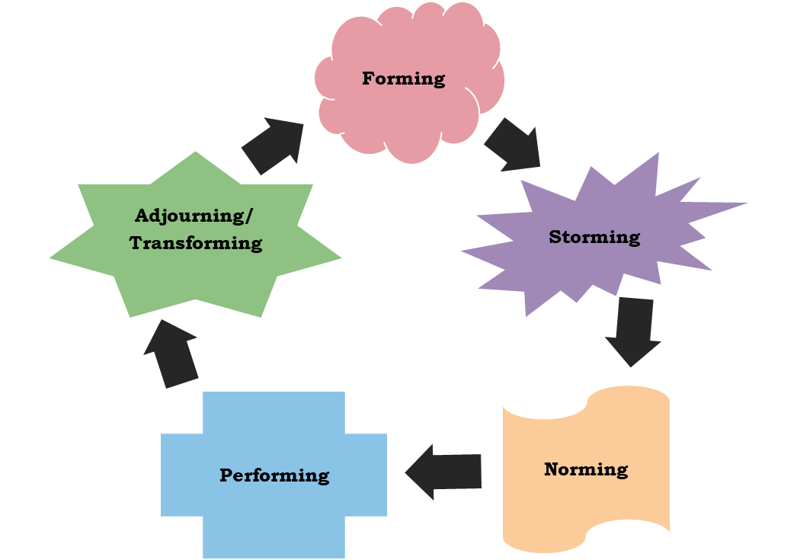

(Tuckman, 1965)

Appendix E – McKinsey’s 7 changes model

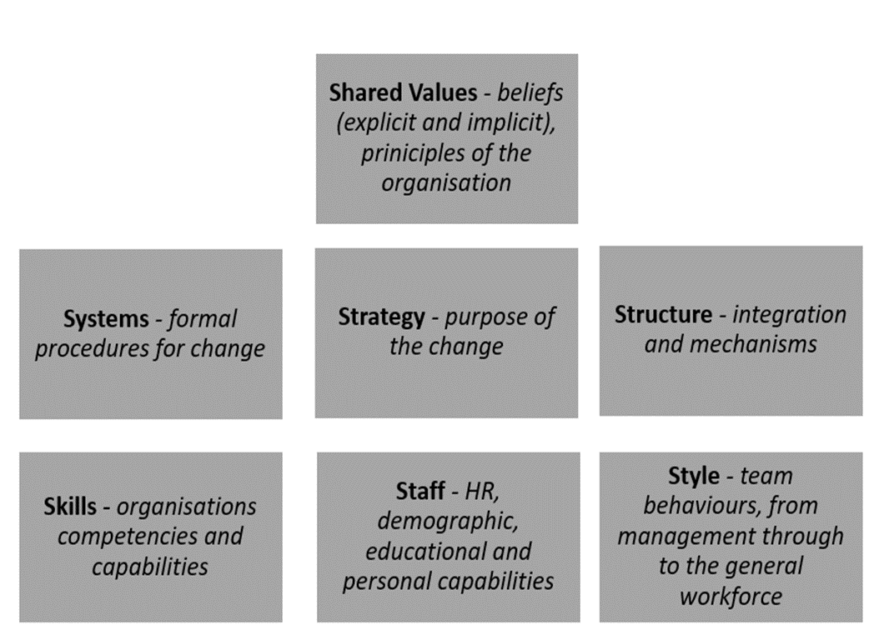

(Waterman & Peters, 1980’s)

Appendix F – Lewin’s change model

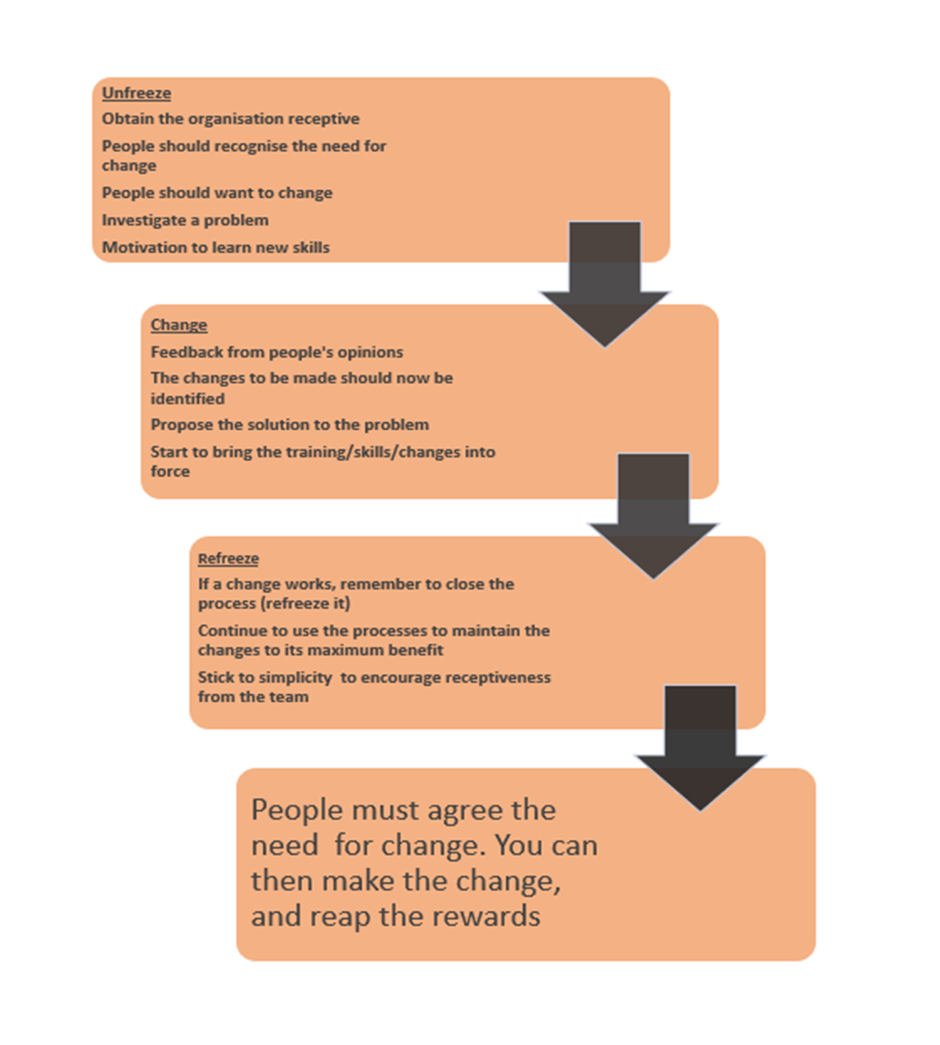

(Lewin, 1947)

Appendix G - Kotter’s 8 step change model

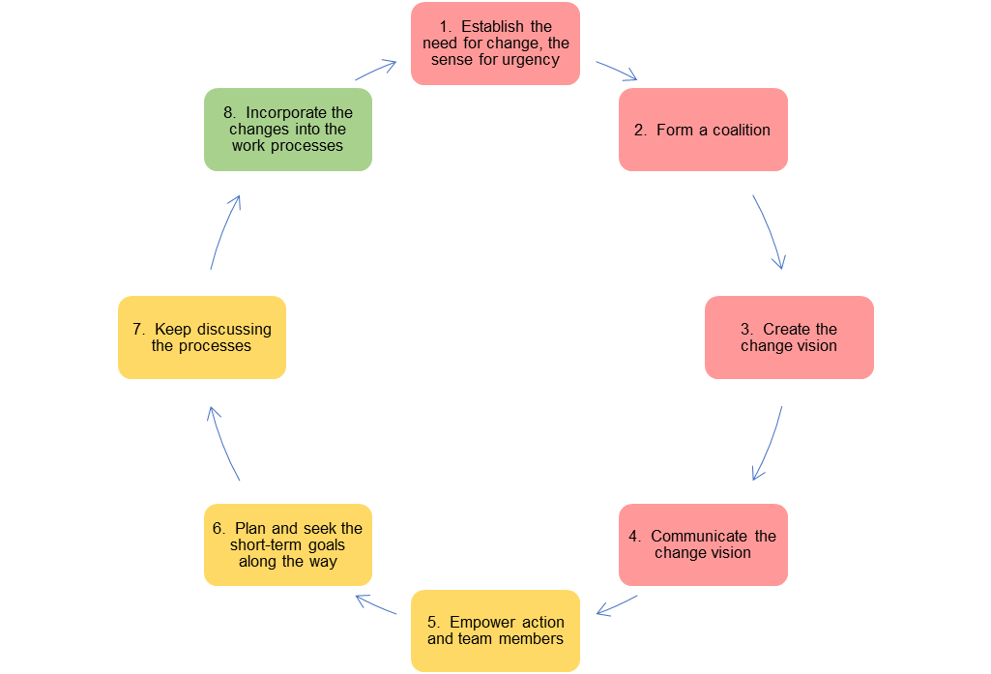

(Kotter, 2002)

Appendix H – Lewin model vs. Kotter model

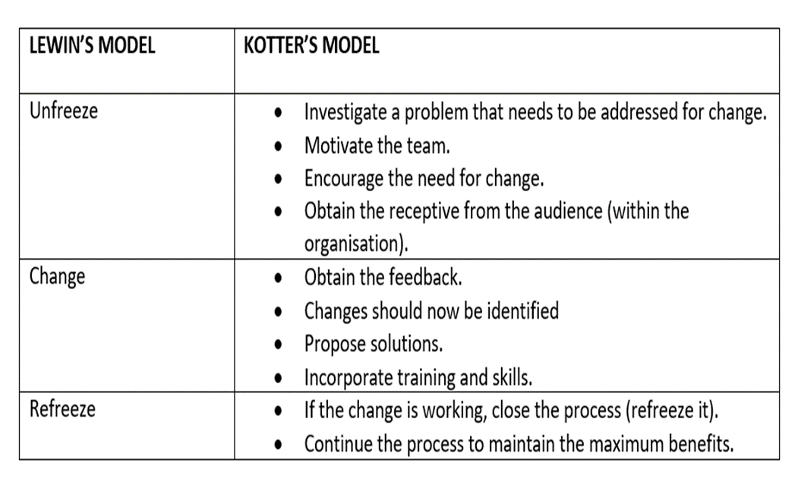

(Puresevic, 2022)

Appendix I – Kotter’s change in the Accident & Emergency follow up appointment booking process

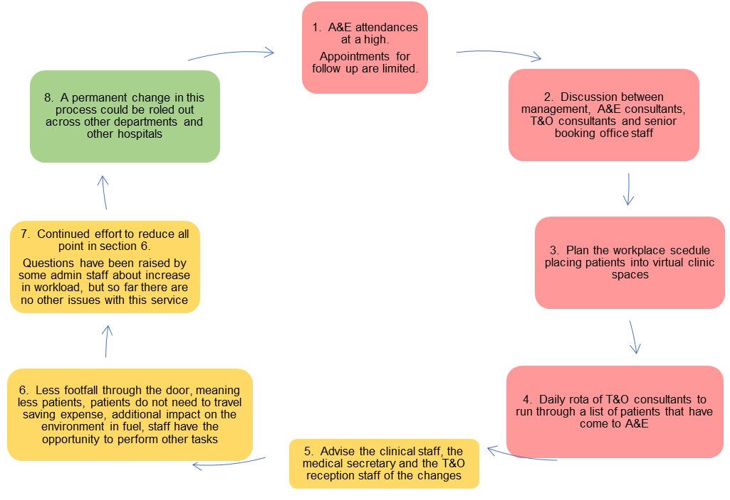

(Puresevic, 2022)

Appendix J – Stakeholder analysis positive change model
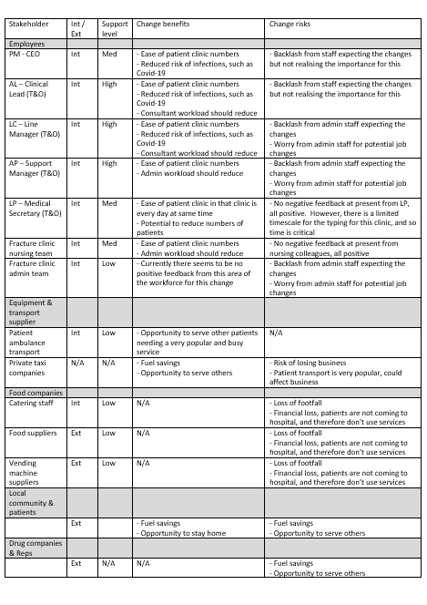
(Puresevic, 2022)
Appendix K – Stakeholder analysis for Trauma & Orthopaedic change

(Puresevic, 2022)

Appendix L – PDCA model

(Puresevic, 2022)

*****



