University of Wales Trinity Saint David
School of Engineering
Heat Exchanger Lab Report
Joshua Upson
P149438
05/04/19
Thermofluid Mechanics
M5X00406
Rob Goodson

Table of Contents
1. Introduction 1
1.1 Aims 1
1.2 Objectives 1
2. Background Research 2
2.1 HVAC system (Air Con) 2
2.2 Radiator 2
3. Experimental Procedure 3
3.1 Experiment 1 3
3.2 Experiment 2 4
3.3 Experiment 3 5
3.4 Formulas 6
3.4.1 Water/Air mass flow 6
3.4.2 Specific heat capacity 6
3.4.3 Density 6
3.4.4 Heat Energy 7
3.4.5 Energy balance coefficient 7
3.4.6 LMTD 7
3.4.7 Heat transfer coefficient 7
4. Results 8
4.1 Experiment 1 8
4.2 Experiment 2 10
4.3 Experiment 3 12
5. Conclusion 14
6. Evaluation 15
7. References 16

Figure 1 - Image of HVAC 2
Figure 2 - Image of Radiator 2
Figure 3 - Heat Exchanger 3
Figure 4 - Air flow Control 4
Figure 5 - Water Supply control 4
Figure 6 - Air Pressure 5
Figure 7 - Water Temperature 5
Figure 8 - Heat emitted/Heat absorbed (Experiment 1) 8
Figure 9 - Air/Water/Mean Density (Experiment 1) 9
Figure 10 - Heat transfer coefficient (Experiment 1) 9
Figure 11 - Heat emitted/Absorbed (Experiment 2) 10
Figure 12 - Air/Water/Mean Density (Experiment 2) 11
Figure 13 - Heat transfer coefficient (Experiment 2) 11
Figure 14 - Heat emitted/Absorbed (Experiment 3) 12
Figure 15 - Air/Water/Mean Density (Experiment 3) 13
Figure 16 - Heat transfer coefficient (Experiment 3) 13

Introduction

Aims
The aim of the laboratory session is to look at what variables effect heat exchanges and in particular we will be looking at the water flow rate, the air flow rate and the change in temperature of the water and this will give us a set of results showing which variables improve the performance on the heat exchanger.

Objectives

- Test different Water flows with a fixed air flow
- Test difference air flows at a fixed water flow
- Test different air flow at a lower fixed water flow of 45 degrees.

Background Research
Heat exchangers are used in many different thermodynamic application by using water and air to exchange heat. For example a heat exchanger is used in a HVAC installation by circulating water to heat or cool air. It is also used in the radiator of a combustion engine which allows the process of heating air by using the flow of water. Engineers can use the heat exchange and apply certain conditions to it so that they get the most efficient change in heat.

HVAC system (Air Con)
Figure 1 - Image of HVAC
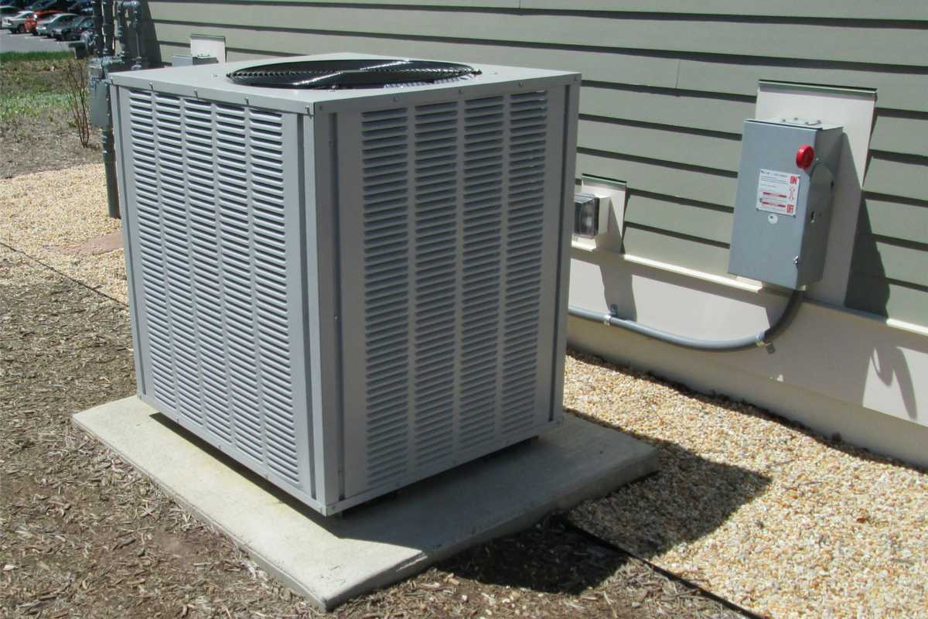
In this system it uses heat exchanger to transfer and exchange heat energy and provide a hot or cold fluid depending on the desired temperature. Within this system the thermal energy is transferred via convection or conduction by using fluids to heat or cool the air. In a HVAC system it typically uses water, steam and air transfer method which either heat or cool air. This is a perfect example of a heat exchanger by changing the temperature of the air.

Radiator
Figure 2 - Image of Radiator
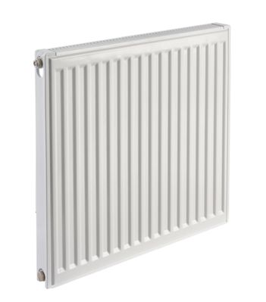
Another example of a heat exchanger is a radiator and is used in most homes around the world. This is a good heat exchanger as it allows water to flow round the coils and through the larger internal area of the radiator slowing down the velocity of the water allowing the heat to be transferred efficiently. The heat is transferred by conduction due to the metal walls of the radiator and when air hits the hot metal of the radiator it heats the air and expands allowing it to rise. The colder air then replaces the air rising creating a cycle of hear which warms the room up.
This therefore can be taken on board with the experiment and help to show different types of cross flow heat exchangers designs and to have an idea on what designs work best and therefore be able to compare the efficiency for different configurations, temperatures and flow rates for the experiments conducted.

Experimental Procedure

Experiment 1
The aim of this experiment is to look at how different water flow rates can affect the performance of the heat exchanger with a fixed air and water temperature.
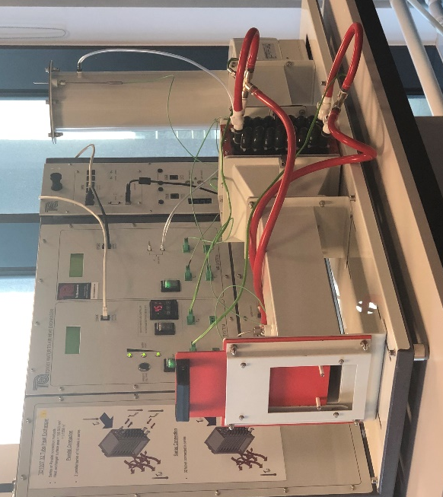
Figure 3 - Heat Exchanger
The first step of the experiment is to connect all the pieces of equipment together on the standard 32 tube heat exchanger for example setting up the heat sensors and making sure there all plugged into the correct places. It is important here that the correct equipment is used for parallel flow and to make sure the heater tank is set at a temperature of 60 degrees. This way the water will then enter at the bottom and exit at the top. At this point it is important to note down the ambient air pressure as well. The atmospheric pressure for the day of the experiment was 1003mBar. The orifice then needs to be inspected for any damage or an unusual problems with it. The diameter then needs to be noted down and this will be shown on the orifice. On the day of the experiment it was 0.10011m. The coefficient of discharge was also given and has a value of 0.6. Another value to note down is the heat exchanger surface area which is 0.1558m^2

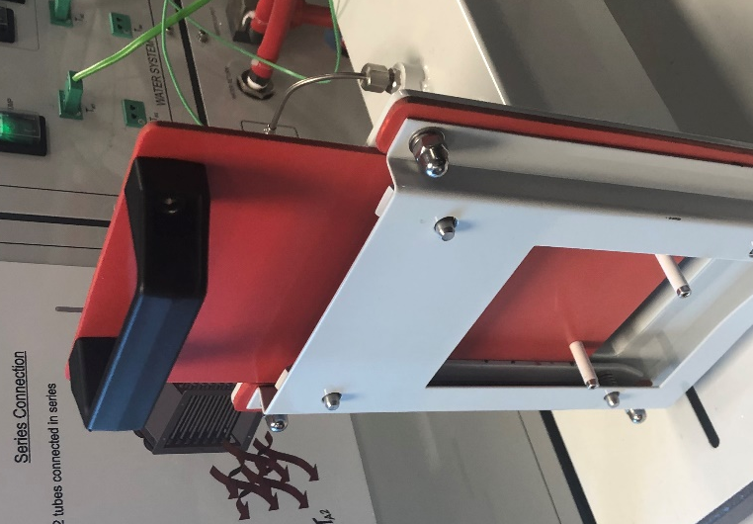
The next step of the experiment is to turn the fan on the heat exchanger on to start the process. The slide valve at the end on the heat exchanger can then be used to set the airflow in the exchanger and therefore can be tested at different pressures. To start the experiment set the airflow that the orifice pressure drops to 250 pa (+/- 5 pa Tolerance). This will therefore have the airflow in the heat exchanger set up ready to record results.

Figure 4 - Air flow Control
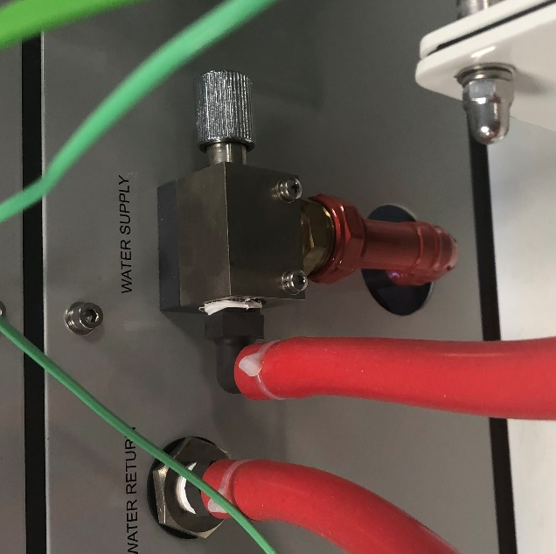
The water supply then needs to be set up. To do this the water pump needs to be switched on and the water supply valve set to have a water flow of 2.25 L/minute (+/- 0.01 L/minute). To do this it can be adjusted by the hand dial found at the water supply area of the heat exchanger and also shown in figure 3. Now that the experiment is set up the results can start to be taken. However you must allow for 5 minutes for the heat exchanger temperature to stabilise and then record all the readings. You will need to repeat this for each of the different water rates and therefore at 1.75, 1.25, 0.75 and 0.25 L/min.
Figure 5 - Water Supply control

Experiment 2

For this experiment it follows a very similar procedure as experiment 1 without to set up the heat exchanger however this time we are looking at the effect of air flow rate to the heat exchanger and will be looking at the different air flow rates and how it affects the performance of the heat exchanger for fixed water flow and temperature.
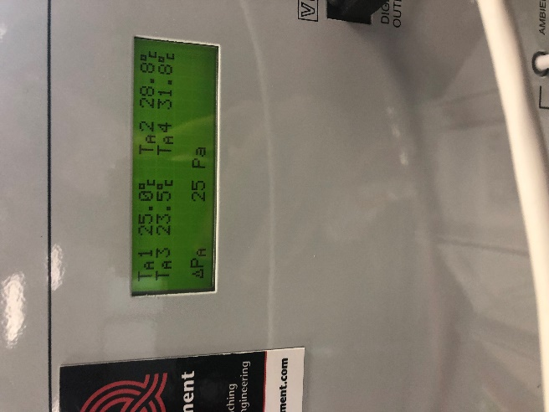
Instead of changing the water rate by the water supply valve we are now changing the pressure of the air supply and recording the information. We are changing the air pressure by adjusting the sliding door. However allow for 5 minutes allowing the heat exchanger temperature to stabilize and then the results can be taken. This process has to be repeated for 200,150,100.50 pa giving the set of results.

Figure 6 - Air Pressure

Experiment 3
For this experiment it follows the same procedure of the first experiment however this time we are changing the temperature to 45 degrees. This is to show how different temperatures of water affect the performance of the heat exchanger for a given fixed water flow.

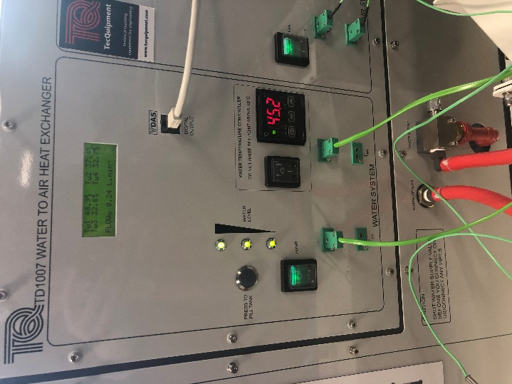
So therefore instead of changing the dial on the water supply were keeping it at a fixed level and then changing the temperature to 45 degrees. Then a repeat of experiment 2 is done to get a set of results.

Figure 7 - Water Temperature

Formulas

3.4.1 Water/Air mass flow

For the water mass flow the following formula was used to give the water flow in litres per minute and therefore help with future calculations:
Water mass flow = Volume Flow (L.min^-1)/6000*Water Density (Kg.^-3)
For the air mass flow this following formula was used. The Orifice discharge coefficient was given at a value of 0.6 and the area of the orifice was worked out by doing piR^2 and to work this out I used the diameter of the orifice which was a value of 0.10011m.
Air flow mass = Orifice discharge coefficient * Area of orifice*SQRT(Change in pressure * 2 * Air density)

3.4.2 Specific heat capacity
To work out the specific heat capacity of water the following formula is used so that it can be used for future calculations:
0.996185+0.0002874(Average temperature+100/100) ^5.26+0.011160*10(^-0.036*Average temp)*4185.5. This is worked out by using the heat capacity of water as well. Together this comes together to give the specific heat capacity of water.
The heat capacity of air is a constant at around 1005 J kg^1 k ^-1

3.4.3 Density
The density of water is worked out by the following formula T in this formula is your average water temperature at each change in flow rate and delta pressure.
Pw= (999.839+16.952T-7.990*10^-3T^2-46.241*10^-6T^3+105.846*10^-9T^4-281.030*10^-12T^5)/(1+16.887*10^-3T)
The next formula gives the air density and therefore can be used for further calculations:
Pa = P/RT

3.4.4 Heat Energy
The next formula that has been used is the heat power emitted and this is an important formula to use to get the graphs needed.
Qw=Mw*Cpw*Change in Tw
The heat power absorbed is worked out by using the following formula
Qa = Ma*Cpa*Change in Ta

3.4.5 Energy balance coefficient
The following formula is used to work out the energy balance coefficient and will be useful for future calculations:
Ceb = Qa/Qw

3.4.6 LMTD
The LMTD is then worked out by the following formula and can be used to work out the heat transfer coefficient (U):
LMTD = (Tw2 – Ta2)-(Tw1 – Ta1)/ln(Tw2-Ta2/Tw1-Ta1)

3.4.7 Heat transfer coefficient

Lastly the heat transfer coefficient is then worked out by using the following formula where A is the heat exchanger surface area:
U=Qw/A*LMTD

Results

Experiment 1
Heater Temp – 60 Degrees
Orifice change in pressure – 250pa
Ambient Pressure - 1003mBar
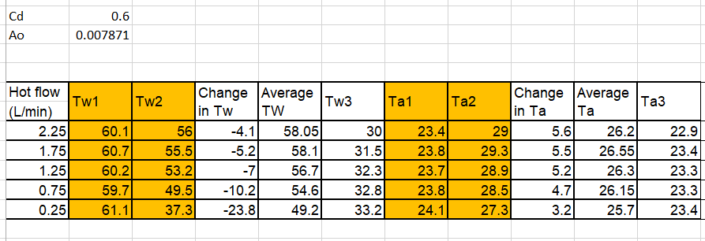
Orifice Diameter 100.011mm

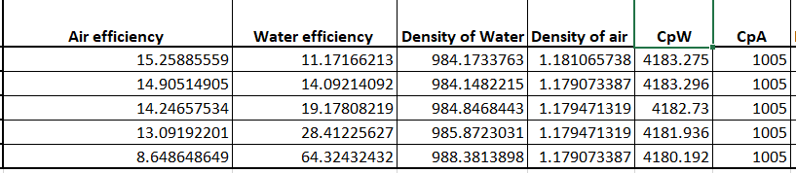

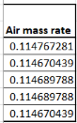
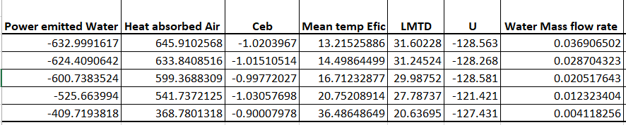

From the figure on the right we can see that it shows a general trend that as the water flow increases the power transfer improves. However the slope is not linear and levels out meaning that there will be a maximum power transfer at a water mass flow and this is shown at around 0.04 kg.s^-1 on the graph. The graph also shows that it has a good energy balance coefficient as the absorbed by the air gives similar values. This therefore shows that there is a reduction in power at lower flows.
Figure 8 - Heat emitted/Heat absorbed (Experiment 1)
Figure 9 - Air/Water/Mean Density (Experiment 1)
In the figure on the right it shows a graph of the water mass flow rate against air, water and then the mean density. It shows that the water efficiency decreases against water flow where as it increases for air. However the decrease in water efficiency is much greater than the air density but this is expected as temperature in water can change much quicker. Furthermore the mean temperature efficiency shows a steady decrease with increasing flow. At low water rates the heat exchanger gives higher drops in temperature for a given emitted power meaning that it gives a higher temperature efficiency for the water circuit. Therefore meaning that there is a reduced air efficiency at lower flows.

From the figure on the right it shows the water mass flow rate plotted against the heat transfer coefficient. And shows that the heat transfer coefficient generally increases with water flow and then levels out however the first result shows to be an outlier as it decreases first. The steady rise and then levelling out suggests that the increasing water flow above an optimum value gives no improvement to the performance.
Figure 10 - Heat transfer coefficient (Experiment 1)

4.2 Experiment 2
Heater Temp – 60 Degrees
Water Flow – 0.25
Ambient Pressure - 1003mBar
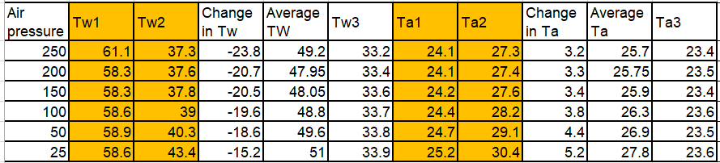
Orifice Diameter 100.011mm

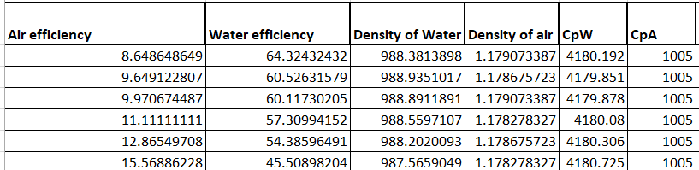

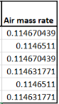
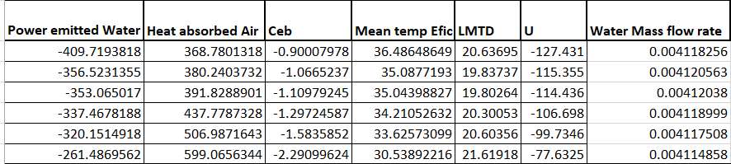

Figure 11 - Heat emitted/Absorbed (Experiment 2)
In the figure on the right it shows the heat emitted and absorbed against air flow. The graph shows that the power transfer generally improves with air flow and gives linear results. Air flows are lower levels show that the heat emitted is greater than the heat absorbed showing that there are increased loses at low air rates. The results then start to connect with each other meaning that the energy balance coefficient has been effected and decreases. However the graph shows them crossing over each other which could mean to be an outlier in the results. However they don’t level out meaning that the air flow can increase in the heat transfer.

Figure 12 - Air/Water/Mean Density (Experiment 2)
From the figure on the right it shows the air flow plotted against the air/water and the mean density. It therefore shows that water efficiency rises with air flow where as air efficiency decreases and shows similar results with air flow rates. The mean density gives a slow increase with increasing air flow.

The figure on the right shows the air flow rate against the heat transfer coefficient. And shows a linear increase with air flow therefore showing with increasing air flow the heat exchanger improvers in performance. Furthermore suggesting that increasing air flow rate gives increased heat transfer.
Figure 13 - Heat transfer coefficient (Experiment 2)

4.3 Experiment 3
Heater Temp – 45 Degrees
Water Flow – 0.25
Ambient Pressure - 1003mBar
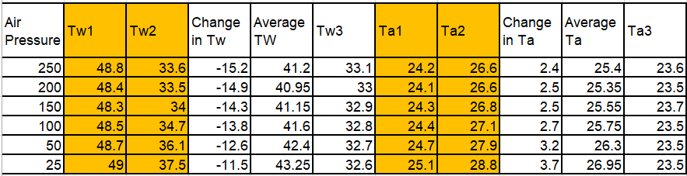
Orifice Diameter 100.011mm

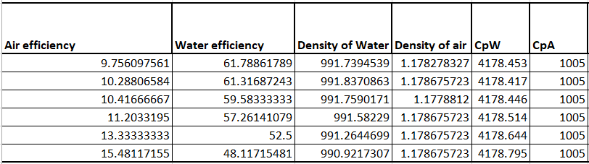

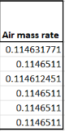
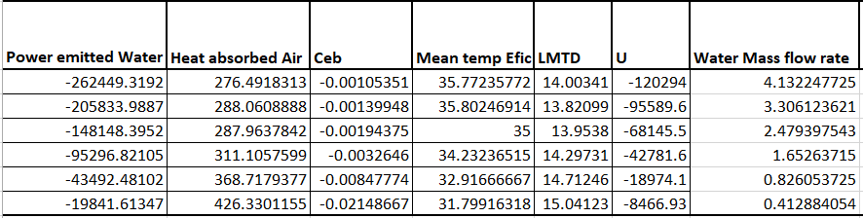

Figure 14 - Heat emitted/Absorbed (Experiment 3)
In the figure on the right it shows the heat emitted and heat absorbed again against the air flow however this time its for 45 degrees. This shows that the trend starts to trail off suggesting a reduced force at 45 degrees. The difference is also larger in the heat emitted with increasing air flow. However the results cross each other over which could be an outlier in the results. Therefore meaning that the change in temperature does not affect heat transfer coefficient as much as power as the results are quite similar.
Figure 15 - Air/Water/Mean Density (Experiment 3)
On the figure on the right it shows similar results to experiment 2 showing that the water efficiency increases where as the air efficiency decreases. The mean temperature shows a general decrease with air flow.

From the figure on the right it shows the heat transfer coefficient against the air mass flow rate and again shows an increase in air flow meaning that the air flow improves with a better heat transfer coefficient.

Figure 16 - Heat transfer coefficient (Experiment 3)

Conclusion
Overall looking at the results it shows that changing the water flow on the heat exchanger generally starts to initially improve the heat transfer however starts to level out meaning that the increasing water flow reaches an optimum value but makes no improvement to the performance of the heat exchanger. Where as for experiment 2 it shows that the increase in air flow improves the heat exchanger as the heat transfer coefficient rises meaning it benefits the heat exchanger. For experiment 3 it again shows that it rises meaning it does improve the performance of the heat exchanger but at a lower rate because of the temperature drop and shows it working better at high air mass flow rates. Overall air flow improves the heat exchanger where as water flow does not.

Evaluation

Overall the experiment was very efficient however there are some possible errors that could have occurred which could of effected the results and caused some outliers. For example the clips that hold the pipers could have been loose and therefore create a leakage of liquid and could affect the results. This could be improved for next time by making sure all the clips are securely on before the experiment starts. Another issue is that between the water heater tank and tw1 there will be a lag in temperature because of the pipe work that is different which could have affected the results of the experiment. During the experiment when calculating the air density we could of compared the results with published documents which would of given us a percentage error for each air density and could have been accounted for in the calculations. This could have possibly been the biggest error in the experiments. So this could be something to consider next time if thee experiment was done again. Another problem that could of effected the results is human error when taking down the results or changing the apparatus which could affect the results and therefore cause there to be outliers. Next time if the experiment was to be repeated is to take multiple results at each air flow and water flow so that the results become repeatable. There is also turbulent flow are the outtake of the air flow meaning that the readings could be a little off so to improve this a better pipe for the outflow of the air could be used to give better accurate results. On the day of the experiment the ambient temperature in the room was higher than a normal day (23.6 degrees) meaning that it was a struggle to bring the temperature down from 60 to 45 which wasted time in the experiment and this could be improved next time by picking a day when it was cooler. Overall the experiment went well giving fairly accurate results and giving the conclusions however could be made more accurate and repeatable by changing the small problems stated.

References
ATN, 2018. Residential HVAC system. [Online]
Available at: https://www.atnmechanicalsystems.com/blog/residential-hvac-system/
[Accessed 05 04 2019].
Evans, P., 2018. HVAC Heat Exchangers Explained. [Online]
Available at: https://theengineeringmindset.com/hvac-heat-exchangers-explained/
[Accessed 05 04 2019].
Joel, R., n.d. Basic Engineering Thermodynamics. s.l.:Longman.
Mayhew, G. R. a. Y., n.d. Engineering Thermodynamics. s.l.:Longman.
Plumbing, C., n.d. Halcyon K1 compact Radiator. [Online]
Available at: https://www.cityplumbing.co.uk/Halcyon-K1-Compact-Radiator---600mm-x-500mm/p/232953
[Accessed 05 04 2019].
TecQuipment, 2014. TD1007. s.l.:s.n.

