Effective Team Working and Communication
Student name :Lacramioara Voiasciuc
ID Student Number:1916152
Lecture Name :Timothy Hopkins
Date :04/05/2020

Table of Contents
Introduction 3
Main Body 4
Section 1 4
Section 2 6
Section 3 10
Conclusion 11
References 12

Introduction
Communication is a process that transfers ideas, opinions, facts, information from one person to another. Every communication consists of a sender and a receiver, which are essential parts of effective communication (Guerrero et al., 2017). An effective communication is based on five methods such as verbal, non-verbal, written, visual and listening. Workplace communication is important for organizations, as it enables them to maintain employees and work functions effectively for higher productivity and increases employee morale. Effective workplace communication enables management to recognize employee value, practices in the workplace, and manages employees systematically for better productivity and performance. This report will focus on the efficient communication in the organization and serve the purpose of communication between employees and management. Relevant theories of communication will be discussed including diagrams. The necessity of effective communication in the work environment will be discussed in this report.

Main Body

Section 1
How communication can be made effective in a business organization
Communication is an important aspect in the organizational function and benefits organizations in several different ways (Thompson, 2018). Effective communication ensures product improvement, customer relation and employee’s relations and management. Employees are an important audience in the workplace where management would need to engage with appropriate ways to increase their performance and productivity. However, there are many ways to make communication effective in the organization.
Office meetings are an effective approach that can assist management to approach the employees in an office open meeting. Furthermore, it would resolve confusions and complications of the employees in the organization and allow management to implement a new business plan and educate employees about the new business procedures. This would increase employee participation in the meetings and establish a healthy relation between employees and management. Emailing is modern approach of communication and creates an effective communication in the organizational functions. It allows managers to transfer messages to the employees about new changes and equally enables employees to send feedback and concerns to the management that simplifies work functions in the organization. Face to face, approaches are also beneficial for the organizations, as it enables employees to reach out to management and expresses concerns and reports, which ensures health relation between employee and management. Responsive atmospheres are needed for employees in the organization to avoid intense and unhealthy manners in the workplace and establish healthier relationships among employees that increase team building and motivation and contribute profitability for the organization.
How communication works between Management and Employees and to what purpose
Effective communication builds clear assumptions for employees and for the customers. A consistent tone while communicating with manager and customers would certainly increase effectiveness of messages that provide right indications to the management and enable management to resolve those issues for employees in the workplace, stated by Vine, (2020). Choice of language allows employees and care assistants to communicate with other employees and management more freely, which also helps employees build strong relationships as language plays an important factor in the organizational function. Furthermore, it helps employees to be more constructive and positive in the workplace and enhances their performance and productivity. Choice of language enables employees and care assistants to discuss new possibilities in the workplace in a simple term. It allows employees to speak out new ideas for business, which ensures healthier relationships among employees and management. Employees are much more encouraging and proactive in the workplace when they have been given the opportunity to communicate in their preferred language, suggested by Yanaprasart, (2016). It directly affects team building, encourages care assistants and team members to chase team objectives and organization goals, and enhances their performance.
Active listening is an important communication skill that enables an individual to listen with all senses, paying attention to details and makes communication effective for both speaker and listener, stated by Sola, (2019). Active listening establishes better relationships among employees and employers in the organization as it enables employees to pay attention to the details and information offered by the employer and enhances employee’s active listening skills and concentration. American anthropologist Ray Birdwhistell has first introduced the kinesis communication method. Kinesis communication is a technical term for body language. Kinesis is considered a non-verbal way of communication; it focuses mainly on the body language while communicating (IASMINA et al., 2017). Disabled employees in the organization use this communication method to express concern using body language with employers and colleagues in the organization and maintain healthy relationships. This enhances performances of the employee in the workplace. Personal awareness is an ability that allows a person to see itself clearly and objectively via mirroring and self-analysis (Caldwell and Hayes, 2016). Personal awareness enables employees to identify the areas they are lacking and develop their skills accordingly. Motivate employees to align their ideas to their objectives for better outcomes and increases happiness and willingness. Personal awareness helps managers to become a better leader and enables them to understand the employees' needs and issues. Most importantly, it manages emotions, which helps employees to build up work and personal relationships. Furthermore, it encourages employees to seek out their true passion and which is beneficial for their career development.

Section 2
Relevant Theories (Shannon and Weaver, Schramm and Berlo) discuss different aspects
The transmitting or exchanging of information via writing, speaking, using body languages, by listening and by mediums is called communication. American mathematician Shannon and American scientist Weaver first introduced the Shannon-weaver model of communication. This communication model is designed to make effective communication between receiver and sender. An important factor in this communication mode is noise and mainly focuses on technical communication. Furthermore, this communication model works with various concepts like source, transmitter, noise, channel, receiver, information destination, encoder, and decoder (Baecker, 2017).
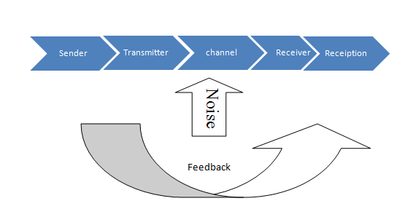
Figure 1: Shannon-weaver model of communication
(Source: learner)
This communication model has sender, encoder, channel and noise. Sender is the source of information in this model and starts to process by selecting a message and sending it to someone via channel. Similar to the case study, Maria was the sender and Pedro was the receiver, the communication medium was telephone. Encoder is a mechanism that converts the idea into a signal allowing the sender to transfer messages to the receiver. Channel is considered as the medium of communication, where senders transmit information to decoder and receiver. During Maria and Pedro’s communication, telephone is worked as medium. Noise is the important factor in the communication; it disrupts the messages from sender to receiver. Noises are two types such as, internal and external. When the sender makes wrong encoding of a message and the decoder makes wrong decoding internal noise happens and disrupts the message. Maria made a mistake while encoding the message and Pedro made a mistake by wrongly decoding the message. External noise refers to something, which is not in the control for sender and receiver. While conversing Pedro and Maria might have felt disruption in the channel and thus it could be the reason Pedro could not decode Maria’s message. Decoder is the opposite of the encoder where the receiver gets the encoded message from the sender. Receiver receives the messages from sender.
Schramm model of communication
The osgood-schramm model of communication is circular instead of linear; this communication model consists of the sender encoding the message and the recipient decoding the message (Rubtcova and Pavenkov, 2018). Sender and receiver play an important role in this model. Interpreter mainly interprets the messages by understanding it. It is not a traditional model of communication but instead does communication in a practical way. Semantic noise is introduced in this model when the sender and receiver interpret messages; technical language changes the phrase and changes the entire meaning of the communication. Based on the case study, Maria and Pedro have been conversing in using telephone during their conversion Maria has expressed something that has misinterpreted due to technical involvement resulting Pedro to receive wrong interpreted messages.
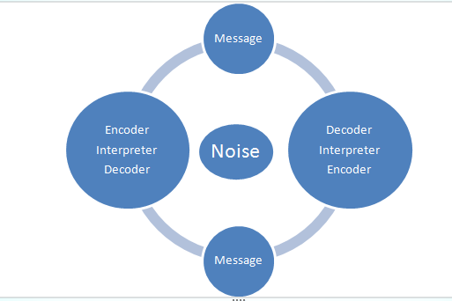
Figure 2: Schramm model of communication
(Source: learner)
Berlo’s SMCR model of communication
Berlo’s SMCR communication model represents the procedure of communication, which is also the simplest form of communication. The term SMCR indicates to the sender, message, channel and receiver. Berlo’s SMCR model of communication describes different forms of procedures in communication. Coding and decoding of the message is the purpose of this tool (Turaga, 2016). The sender is the source of information that sends information to the receiver. Sender first interprets the message by reading, listening and speaking and then sends the message. Receiver in this scenario is considered as an audience. Pedro is the receiver and audience, receiving messages from Maria who is the sender. Loss of distortion is another important part in this communication model, where the encoder needs to interpret the message clearly, for the receiver to attain it but additional channel distorts the message and receiver gets the un-interpreted message from sender. Pedro has been in the workplace while communicating with Maria, the environment around Pedro has distorted the actual message, which has been sent by Maria and changed the meaning of the conversation. Noise also disrupts the source of the message and the receiver partially receives half of the message from the sender. Internal problems from the receiver disrupts the source of the message, Pedro has not been focused during the conversation and could have been the reason for not listening to the actual message. External problems could also be a reason for distorted messages, sounds from the environment could have distorted Maria's actual message and transmitted the wrong message to Pedro.
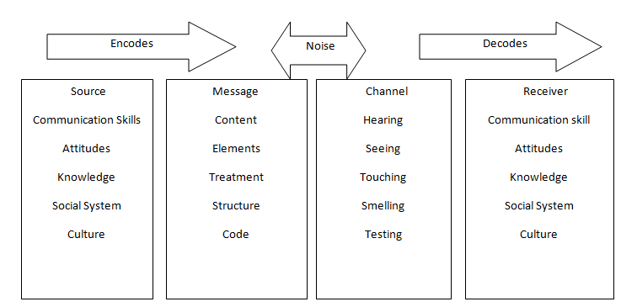
Figure 3: Berlos’s SMCR model of communication
(Source: learner)
Importance of feedback between encoder and decoder
Feedback allows the decoder to respond to the sender's message. The receiver provides feedback to the sender via words, symbols, gestures, which is also considered as the reversal method of communication where receiver also acts as a sender (Best et al., 2019). Above communication, theories have explained the process of communication via channel, where feedback allows the sender to transform messages and clear doubts of the receiver and completes the communication. Pedro has listened to Maria's messages and responded to it accordingly. Sender has thought that the Pedro who was the receiver thus has decided the message; sender did not transform the message later and complete the communication. Due to external noises, the message has not been decoded properly and resulted in inaccurate feedback to the sender, where Maria and Pedro’s communication has remained incomplete.
The concept of high low context
Cultural differences also bring differentiations in communication. High context culture focuses on the indirect communication and non-verbal procedures. The high context culture requires background information in the communication to understand the message properly. The low context culture mainly focuses on straightforward communication. The low context communication does not require background information and the message is spelled out in most cases. For instance, high context cultures are found in Asian, African, Arab, Europe and Latin America. The low context culture is found in Western Europe, United states, Australia.

Section 3
The Importance of effective communication can be seen in my own
Working environment
Communication is an important function in the workplace and being, a care assistant at a renowned care home; it is my utmost responsibility to communicate with colleagues and patients to maintain a healthy relationship. Shannon-weaver communication model communication serves a purpose in every conversation and its applications are more beneficial in the practical phase. I do believe that effective communication has helped me to communicate with the team members of this care home and established strong team building. This has increased my productivity and performance. The utilization of Shannon weaver communication model has enabled me to transfer messages to patients and helped me to understand feedback from them, which also enhances the standard of the communication. Berlo’s SMCR model of communication has allowed me to interpret messages of the employees in this care home and the circular nature of this model enabled me to voice my opinion in the management including innovative ideas that have helped this organization to improve the business functions. Berlo’s communication model also indicates that communication is dependent on internal and external factors. Internal factors have assisted me to create strong lines while communicating with patients and external factors maintain the consistency that has enabled the receiver to decode the actual message. Care projects required communication at every level thus, continuous practices in the care home, it has increased my communication skill. Berlo’s communication model has enabled me to communicate effectively with the patients, during the conversation external factors such as, sounds from other patients have sometimes distorted the actual message, which has led patients to misunderstand my advice. Feedback has allowed me to listen to managers' advice, which has improved my active listening skills and allowed me to transfer encoded messages with important information as a feedback to colleagues and managers to complete the entire conversion.

Conclusion
From the above analysis, the report has concluded the importance of communication in the workplace. The practice of effective communication and function in the organization has improved the communication skill of employees. Enabled them to enhance overall work performance. Furthermore, the impact of communication in the management has been discussed, which has benefited management to maintain a healthy relationship with the employees and increased overall productivity of the organization. The purpose of communication between employees and management has been explained. Important communications theories have been discussed in this report along with the feedback and importance of decoder and encoder in the simplified message. Theories have been added to the reflective section to discuss the importance of communication in the workplace.

References
Baecker, D., 2017. Systemic Theories of Communication. Revista mad-revista del magister en analisis sistemico aplicado a la sociedad, (37), pp.1-20.
Best, S.C., Abhyankar, A.M., Chang, K.Y. and Lambrecht, F., Rambus Inc, 2019. Drift tracking feedback for communication channels. U.S. Patent 10,503,201.
Caldwell, C. and Hayes, L.A., 2016. Self-efficacy and self-awareness: moral insights to increased leader effectiveness. Journal of Management Development.
Guerrero, L.K., Anderson, P.L. and Afifi, W.A., 2017. Conceptualizing relational communication: Definitions and principles. Close encounters: Communication in relationships, pp.1-24.
IASMINA, I., ALEXANDRA, V., GABRIELA, P. and DIANA, M., 2017. The importance of classification and interpretation of most common gestures in nonverbal communication. Agricultural Management/Lucrari Stiintifice Seria I, Management Agricol, 19(1).
Rubtcova, M. and Pavenkov, O., 2018, September. Transformation of the Classical Model of Mass Communication in the Modern Society. In RF-269th International Conference on Management, Economics & Social Science-ICMESS (pp. 22-23).
Sola, A., 2019. Active Listening Strategies to Boost Language Acquisition.
Thompson, N., 2018. Effective communication: A guide for the people professions. Macmillan International Higher Education.
Turaga, R., 2016. Organizational models of effective communication. IUP Journal of Soft Skills, 10(2), p.56.
Vine, B., 2020. Introducing language in the workplace. Cambridge University Press.
Yanaprasart, P., 2016. Managing language diversity in the workplace: between ‘one language fits all’and ‘multilingual model in action’. Universal Journal of Management, 4(3), pp.91-107.

Appendix
Appendix 1
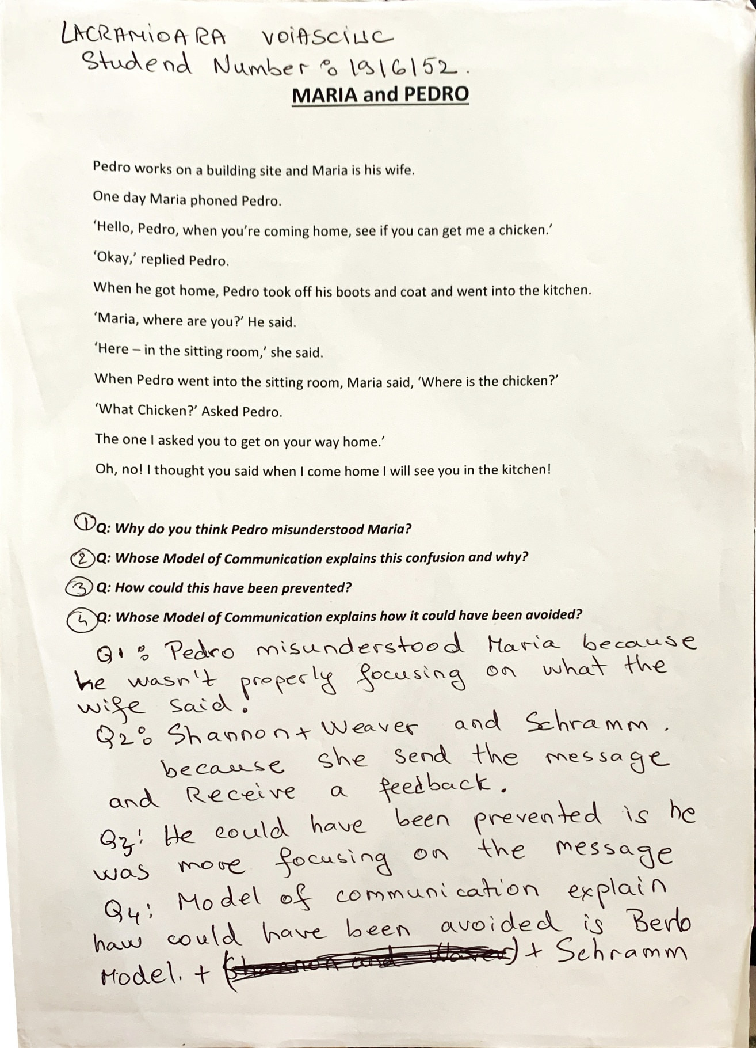
Appendix 2
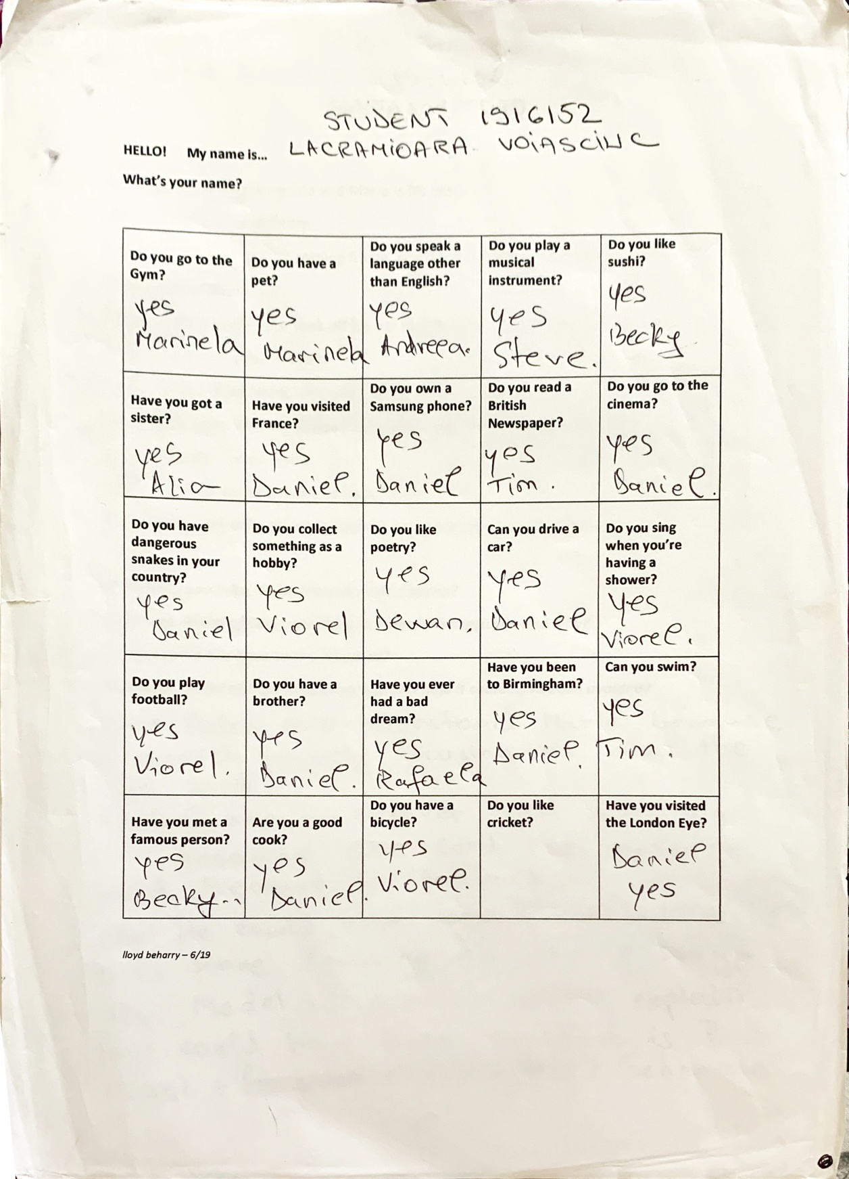


Appendix3

