EAEE4005/C

The Young Mathematician: Exploration and Problem Solving

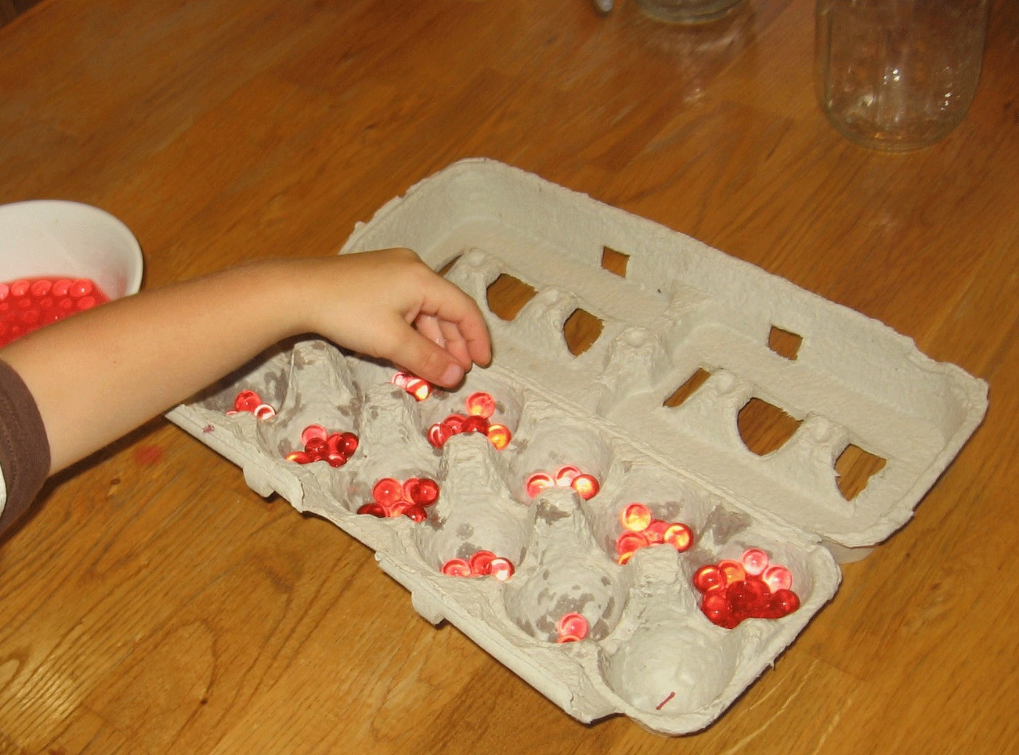

Contents page

- Activity plan
- Evaluation
- Discussion
- Explanation
- Reference list

Cynllun Gweithgaredd
Activity Plan
Gweithgaredd:

Activity: Water play; counting water beads and placing in to an egg carton.

Nifer o blant:  Number of children: 5/6 | Oed y plant:  Age of children: 4 and 5 | Nifer o oedolion:  Number of adults: ½
Lleoliad:  Location: Primary School | Amser paratoi:  Preparation time: 15 minutes | Amser gweithgaredd:  Activity time: 20 minutes
Adnoddau:

Resources: Empty egg cartons/boxes, marker pen, water beads, water, towel, bowl or plastic box.

Amcan/ion y weithgaredd:

Aim/s of activity: The aim of the activity is to place the correct amount of beads in to the correct box, they will all have a different number on them. This will improve their mathematical skills, by adding, subtracting, counting, recognizing numbers.

Cysylltiadau â deilliannau:

Links to outcomes: Improve literacy and numeracy skills. As seen in the National literacy and numeracy framework. www.learning.gov.wales

Gwahaniaethu:

Differentiation: Some children will need more assistance than others, therefore the practitioner should be there to assist rather than just observing. Especially perhaps children who have any additional learning or development needs.

Iechyd a diogelwch:

Health and safety: The adult must make sure the child does not place any water beads in their mouth.

Rôl yr oedolyn/oedolion:

Role of adult/adults: To assist the child when needed, explain what they must do and help them with counting if they are unsure. Although the task is not a difficult one therefore the practitioner will be able to observe the children but help when needed.

Y weithgaredd:
The activity:

There will be an empty egg box which will be open. The adult will write a different number between 1-10 in each section of the egg box. The child must take the water beads and put the correct amount of water beads into each section.

Evaluation

I’m satisfied with the activity plan I wrote. I believe it enabled me to plan for the activity well and set aside a realistic amount of time for the activity according to the ages of the children.
If I were to change anything it would be to allow less time for the activity itself as I think for the age group 4-5, 20-25 minutes is quite a long time to concentrate fully. I think 15-20 minutes would be long enough. However some would say that 10-15 minutes is long enough for this age group. (Neville, 2007).

It was a well organised activity, the adult to child ratio was sufficient.
The ratio worked well as the children were happy to carry out the activity themselves with the adult assisting when needed.
Jean Piaget (1936) was quoted in his later years as saying “Our real problem is – what is the goal of education? Are we forming children that are only capable of learning what is already known? Or should we try developing creative and innovative minds, capable of discovery from the preschool age on, throughout life?”. He believed that children learn more independently, through experiences.

In Wales the current adult to child ratio is 1 adult to every 6 children aged between 4-8. Although it is always recommended that there are at least two adults present even in small groups. (Gov.uk, 2018)
Preparation took around 5 minutes, I simply opened all of the egg boxes and wrote a number in each section. They had to be different numbers and the children had to count the correct amount of water bead to correlate with the number on the box. For the children that found this easy I asked them to add both numbers together. In that instance, a separate box would have been good to have with simple sum, i.e. 2 + 3 = 5, so they must put 5 beads in the box. Therfeore in hindsight I should have had more empty egg boxes.
The children could familiarise themselves with numbers, count and add.
In a recent study conducted with Primary School Children of low to mid socio-economic status in the UK, they discovered that fine motor skills were a more reliable predictor of early maths ability than of early raeding ability. Fine motor integration was a large predictor of maths ability, even when non-verbal IQ was taken into account.
This suggests fine motor skills must have a pivotal role in educational interventions to support early mathematical skills, and how an early intervention approach to maths education is beneficial. (Pitchford et al., 2016).

The children enjoyed the feel of the water beads, which would count as both sensory play and water play. One child who has additional learning needs did not want to put his hands in the water to collect the beads, so we adapted the activity to make him feel more comfortable. We simply took the beads out one by one and counted with him out loud, he enjoyed this.
Children with SEN should be offered full access to a broad, balanced and relevant education.
Within the current legal framework in Wales, there is a code of practice. The Code is founded on five general principles. (Snapcymru.org,2018, p10)
Children with SEN should be offered full access to a broad, balanced and relevant education.
A child with SEN should have their needs met;
The SEN of children will normally be met in mainstream schools or settings;
The views of the child should be sought and considered;
Parents have a vital role to play in supporting the child’s education;

During the activity I witnessed some peer learning. Some of the children would look at each other and copy or imitate each other. This is a type of teaching that Lev Vygotsky (1934) advocated, (Montessorimuddle.org,2018). He believed that by allowing students of a similar but differing abilities work in groups, they could help one another, and perhaps even often more effectively than a teacher would be able to.
I did not carry out a risk assessment on this activity as it was carried out inside the classroom. There were no dangerous objects involved, no sharp objects were used by the children i.e. scissors. The only risk was the child putting the beads inside their mouth, they are tiny beads and not something a child could choke on but nevertheless the practitioner should be aware of this and be vigilant always, as young children do sometimes put objects in their mouths.

Discussion

The resources used in the activity were the water beads, that cost £5 for several hundred water beads. The egg boxes which were recycled material and came from the staff so no cost. The water and container which were also free, and the marker pens which were already at the school but cost around £3 for a packet.
I think this was a very low-cost activity therefore, and after the initial outlay of the water beads these materials will be used again, as they were bought in bulk so good value for money. No plastic materials were used as the school is trying to always use natural materials that are recyclable as it is better for the environment.
Generally, there are many resources in settings that promote children’s maths development. Some of these include;
Sand and Water
Using sand can develop mathematical concepts and language, e.g. heavy, light, empty, full, big, little • Conservation – how much will it hold • Make shapes and patterns • Provide boxes and materials of different shapes and sizes to compare weight and quantity • Look at the differences between wet and dry as a means of looking at weights
Dough
The use of dough can help to develop a mathematical understanding.
Develops mathematical language – short, long, fat, thin. Make shapes of different dimensions, 3-d shapes. Creates opportunities to compare things that ﬂoat with things that do not
Books and Rhymes
Stories and rhymes that has a mathematical element, e.g. “One-two, Buckle my Shoe”,
This can also help to develop literacy skills by showing your child that the print reads from left to right.
Counting out items in the books – how many animals are on the page; how many items are blue.
Using rhymes can also help develop a child’s awareness of sequencing
Physical Play
Develop ﬁne motor skills through physical activity, e.g. Sorting out a jigsaw, Threading beads
Block play or playing with toy cars can help to develop sequencing by encouraging your child to sequence according to size, colour, use (e.g. bike, car, lorry). Playing with different sized blocks can help to develop an understanding of weight and dimensions. Tidying toys away allows children to sort into different sizes and colours. It can also develop mathematical language – ﬁrst, second, third, how many are blue, which is largest / smallest.
Nature
By planting seeds, you can help to develop your child’s understanding of time and the life cycle of plants.
Watch as the plants grow and even measure your plant – develop language such as taller.
Teaching the children about the different seasons and plant different items at different times of the year to compare colours, ﬂowers, smells.

Child development scientists at Purdue University in West Lafayette, Ind. Found that playing with simple building blocks can help children learn the basic principles of maths and science.
“When children are figuring out how to put blocks together they really have to estimate and calculate the relative size of things and the number of things they need, and so it’s a very concrete math experience” said Jim Elicker, a child development scientist at Purdue. While playing with the blocks, children use their imaginations to design and build their projects while getting hands-on experience with measuring, counting, organizing, and problem solving. (Insidescience, 2018).
Therefore, blocks are just one example of how every day materials which are normally found in most settings can be used to teach mathematics in the early years and the many ways in which they can be used.
In our setting, due to the age of the children they can play freely amongst the different areas most of the time. This type of play has been proved to be very beneficial for young children.
The Welsh Assembly Government believes that:
- play is the elemental learning process by which humankind has developed. Children exhibit a behavioural imperative and instinctive desire to play. It has contributed significantly to the evolutionary and developmental survival of our species. Children use play in the natural environment to learn of the world they inhabit with others. It is the very process of learning and growth, and as such all that is learnt through it is of benefit to the child.
- play encompasses children’s behaviour which is freely chosen, personally directed and intrinsically motivated. It is performed for no external goal or reward, and is a fundamental and integral part of healthy development - not only for individual children, but also for the society in which they live.
- play is so critically important to all children in the development of their physical, social, mental, emotional and creative skills that society should seek every opportunity to support it and create an environment that fosters it. Decision making at all levels of government should include a consideration of the impact of those decisions, on children’s opportunities to play.
- play is first and foremost the process of a child’s own, self-directed learning and as such is a process that has a validity for all ages of children. It is a such a vital component of a child’s life that the child’s capacity for positive development will be inhibited or constrained if denied free access to the broadest range of environments and play opportunities. (Gov.wales, 2018).

According to (Howe, 2014), Wooden and natural resources encourage creativity and imagination in young children. Plastic toys can often only be used for their purpose and can restrict children’s thinking skills.
Children must be allowed access to natural materials if they are to learn about and from them. Natural materials are not uniform. They cannot be guaranteed germ free, smooth edged and non-toxic. A few basic rules minimise risk, always check materials for obvious hazards before giving them to children. Always wash hands after handling the materials. Make risk assessment of any outside area to be used.

Explanation

When working with young children in an Early Years setting the adult has many roles. According to (McGillivray,2013) the practitioner must be the critical reflector, the carer, the communicator, the facilitator, the observer, the assessor and the creator.
Often adults admit to not being very good at mathematics or putting a wall up when they are faced with an equation. Such behaviour and negative feelings can inhibit a child’s future learning and continue the cycle of mathematically disaffected children who become mathematically disaffected adults. (Montague-Smith and Price, 2013, p221).

Planning is essential when teaching children mathematics, whether that play is independent or organized.
Practitioners need to assess where children are in terms of their own mathematical development, determined by observation and formative assessment and where they need to go next.
A planning checklist can be useful, as seen in (Tucker, 2014, p110), this could include points such as:
- What resources are needed
- What provision needs to be made to encourage the children to become self-regulated learners.
- Does the activity encourage cooperation and talk, and promote sustained share thinking?
- What mathematical opportunities does this offer.

According to the foundation phase framework in Wales (Anon, n.d. p4), There must be a balance between structured learning through child-initiated activities and those directed by practitioners. A well-planned curriculum gives children opportunities to be creatively involved in their own learning which must build on what they already know and can do, their interests and what they understand. Active learning enhances and extends children’s development.

In Wales, children’s work is monitored and assessed using the foundation phase child development assessment profile. They are normally assessed within six weeks of their entry to the foundation phase to provide a ‘baseline’ assessment. This will cover the six developmental areas that make up the profile:
Two of the developmental areas that are relevant to mathematics are;
Sort, order and number.
Approach to learning, thinking and reasoning.
The Programme for International Student Assessment (PISA) is a triennial International survey which aims to evaluate education systems worldwide by testing the skills and knowledge of 15 year old stdents.
In 2015 over half a million students, representing 28 million 15- year olds in 72 countries and economies, took the internationally agreed two-hour test. Students were assessed in science, maths, reading, collaborative problem solving and financial literacy. Wales, despite improvements underperformed compared to the rest of the uk in maths, ranking in at 36, whilst the uk came in at number 27. (Oecd.org,2018).
Singapore came 1st and interestingly the top seven spots were occupied by Asian countries.

Although there are improvements to be made, Kirsty Williams, Wales’ education secretary said that “Pisa may divide opinion but it is the recognised international benchmark for skills. It has never been more important to demonstrate to ourselves, and to the world, that our young people can compete with the best”. (Adams et al., 2018).

Reference list

Department for Children, Education, Lifelong Learning and Skills (2015) Foundation Phase Framework for Children’s Learning for 3-7-year-olds in Wales. Cardiff: Welsh Government.
Haylock, D. (2012) Understanding Mathematics for Young Children (4th Ed). London: Sage Publications Ltd.
Howe, A. (2014). Play using Natural Materials. David Fulton Publishers.
McGrath, C. (2010) Supporting Early Mathematical Development: Practical Approaches to Play-Based Learning. London: Routledge.
Montague-Smith, A. and Price, A. (2013). Mathematics in Early Years Education. Florence: Taylor and Francis.
Neville, H. (2007). Is this a phase?. Seattle, Washington. Parenting Press.
Pugh, G. & Duffy, B. (eds) (2014) Contemporary Issues in the Early Years. (6th Ed) London: Sage.
Smidt, S. (2015) Observing Young Children: The role of observation and assessment in early childhood settings (2nd Ed). London: Routledge.
Taylor, H. and Harris, A. (Eds) (2014) Learning and Teaching Mathematics 0-8. London: Sage Publications Ltd.
Tucker, K. (2014). Mathematics through play in the early years. Thousand Oaks, CA: SAGE Publications.
Waller, T. and Davis, G. (Eds) (2014) An Introduction to Early Childhood. London: Sage.

Journals

Bruininks, R. H., and Bruininks, B. D. (2005). Bruininks-Oseretsky Test of Motor Proficiency, 2nd Edn. Minneapolis, MN: NCS Pearson.
Hargreaves, D. H. (2014). A self-improving school system and its potential for reducing inequality. Oxford Rev.
McGillivray, G. (2013). The role of the adult in early years settings. International Journal of Early Years Education, 23(2), pp222-223.
Pitchford, N., Papini, C., Outhwaite, L. and Gulliford, A. (2016). Fine Motor Skills Predict Maths Ability Better than They Predict Reading Ability in the Early Primary School Years. Frontiers in Psychology, 7.
Primary Maths Journal - Mathematical Association

Websites

Care Council for Wales (2013) The Children’s Care Learning and Development (CCLD) National Occupational Standards (NOS) http://www.ccwales.org.uk/qualifications-and-nos-finder/n/childrens-care-learning-and-development

Anon, (n.d.). Foundation Phase Framework – Welsh Government. [online] Available at: http://gov.wales/topics/educationandskills/foundation-phase/?lang=en [Accessed 20 Feb. 2018].
Anon, (n.d.). Welsh Government / Foundation Phase profile. [online] Available at: http://gov.wales/topics/educationandskills/foundation-phase/fpundationphase-profile/?lang=en. [Accessed 21 Feb. 2018].
Adams, R., Weale, S., Carrell, S. and Bengtsson, H. (2018). UK schools fail to climb international league table. [online] the Guardian. Available at: https:// www.theguardian.com/education/2016/dec/06/english-schools-core-subject-test-results-international-oecd-pisa [Accessed 1 March. 2018].
Inside Science. (2018). Simple Building Blocks Can Teach Math And Science. [online] Available at: https://www.insidescience.org/video/simple-building-blocks-can-teach-math-and-science [Accessed 19 Feb. 2018].

Gov.wales. (2018). Welsh Government/Play Policy. [online] Available at: http://gov.wales/topics/educationandskills/publications/guidance/3291781/?lang=en [Accessed 1 Mar. 2018].

Montessorimuddle.org.(2018). Scaffolding and Peer-learning: Thinking about Vygotsky’s “Zone of Proximal Development” / Montessori Muddle. [online] Available at: http://montessorimuddle.org/2011/07/12/scaffolding-and-peer-learning-thinking-about-vygotskys-zone-of-proximal-development/ [Accessed 25 Feb. 2018].

Oecd.org. (2018). [online] Available at: http://www.oecd.org/pisa/[Accessed 1 Mar. 2018].

