Database Design

University of Wales Trinity St David

Module: Information Technology

Web Development

Shamuel Hashan

Beverly Holland

6 May 2018

1803153

Contents

Task 1

ERD

This is the ERD
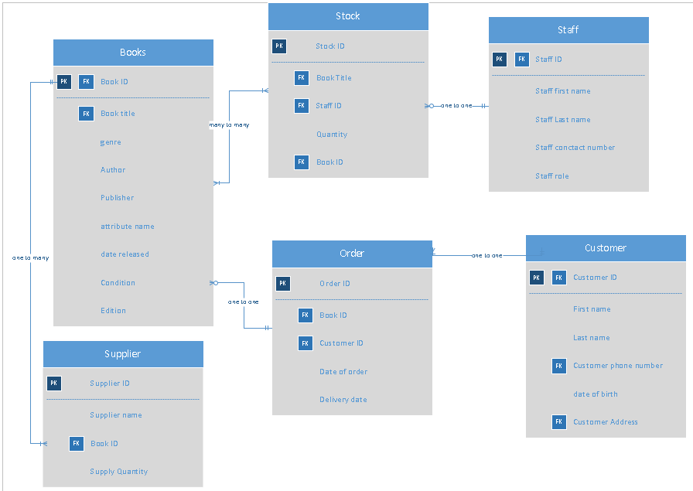

Database

  - Tables
Book Table
This table holds the details for the books in the book store. It has Book ID as the primary key. The book ID is a also a foreign key in the order table, stock table and the supplier table. The data is entered into this table using the book form. The Book ID is an auto number data type, the book publisher is a lookup field. It gets the data from the supplier field. The Book Author, genre, edition and condition fields are short text data types. The date released field is a date data type.
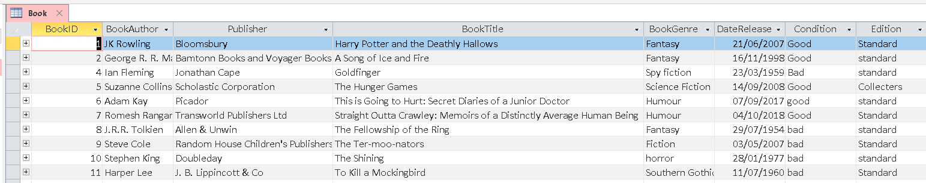
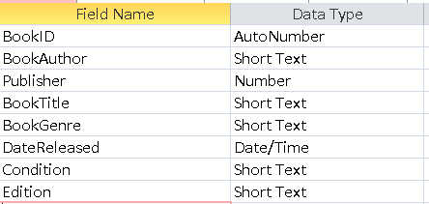

Customer Table
This table holds the details of the customer. For example, it has the fields for the customers, first name, last name, address, phone number and email address. The customerID field is a number data type. Its field size is integer. CustomerFistName, CustomerLastName, CustomerEmail, CustomerAddress. CustomerNumber field will only allow 11 characters.
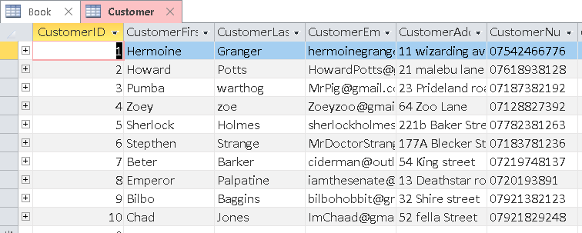
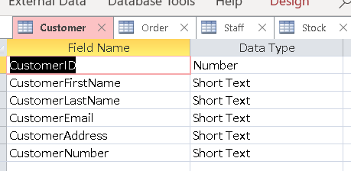

Order table
The OrderID field is the primary key in this table. It is an audtonumber datatype The DateofOrder field and Deliverydate fields are Date/Time data types. The BookID field is a short text data type and CustomerID is a number data type. They are both lookup fields.
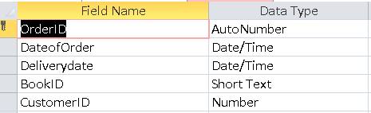
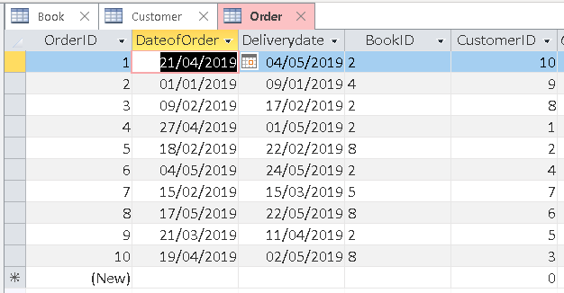

Stock Table
The StockID field is an autonumber data type. It is also the primary key for the stock table. The quantity field is a number data type.. The Book ID and Staff ID are lookup fields.
Book ID and Staff ID are foreign keys here.
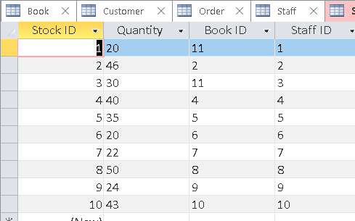
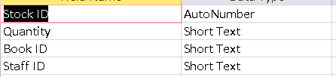

Supplier Table
The Supplier table uses the Supplier ID as the primary field. The Supplier ID field is an AutoNumber data type. The supplier name is a short text field. It has a field size of 100. The supplier quantity is a short text data type. and the Book ID field is a lookup data type.
The Book ID is a foreign key in this table
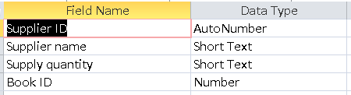
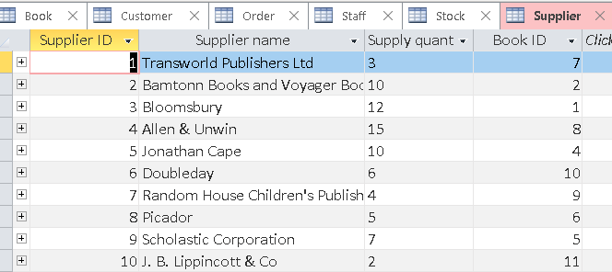

Staff Table
The Staff ID field is the primary key for the Staff table. It uses an autonumber data type. The staff first name field is a short text data type. It has a field size of 25. The Staff last name field is also a short text data type. This has a field size of 25. The staff phone number field is a short text data type with a field size of 11. The staff role field is also short text data type. This has a field size of 50.
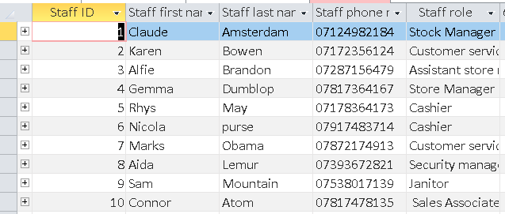
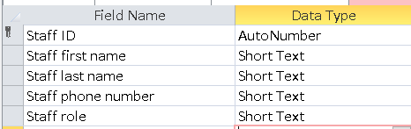

All the tables do relate to what was shown on the ERD.

  - Relationships
  - Forms
The database used various forms
Book Form
This form is used to input data into the book table.
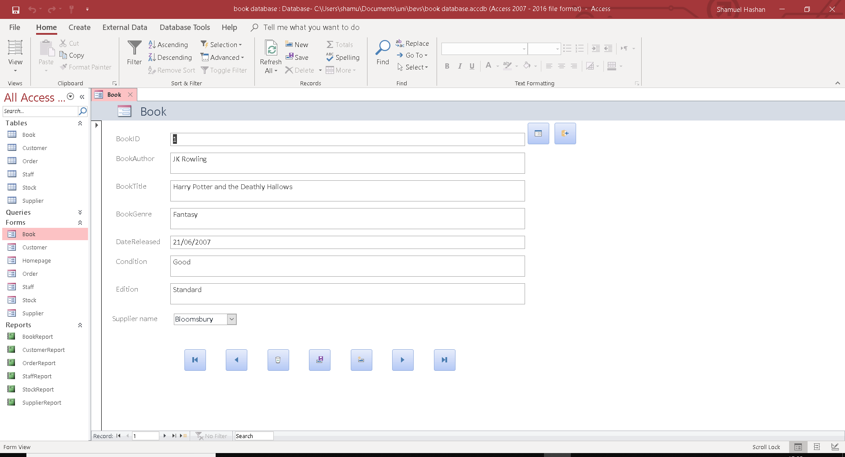

Customer Form
This form will add all the inputs in this page to the customer.
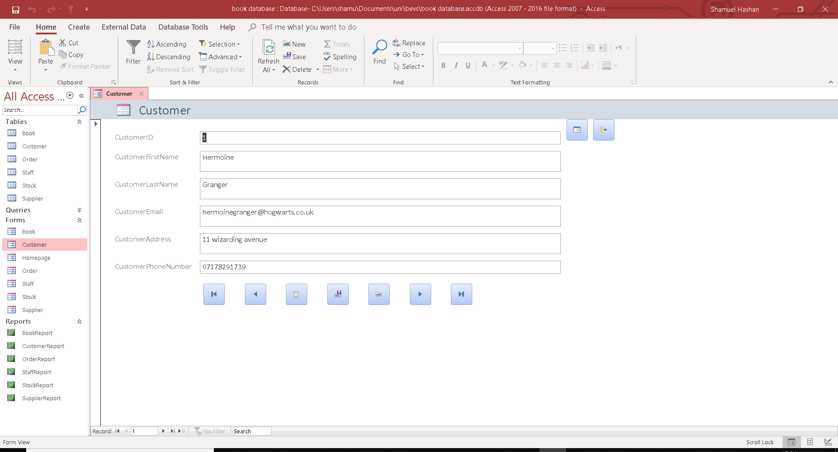
Order Form
All of the data input into this form will then be added to the form table.
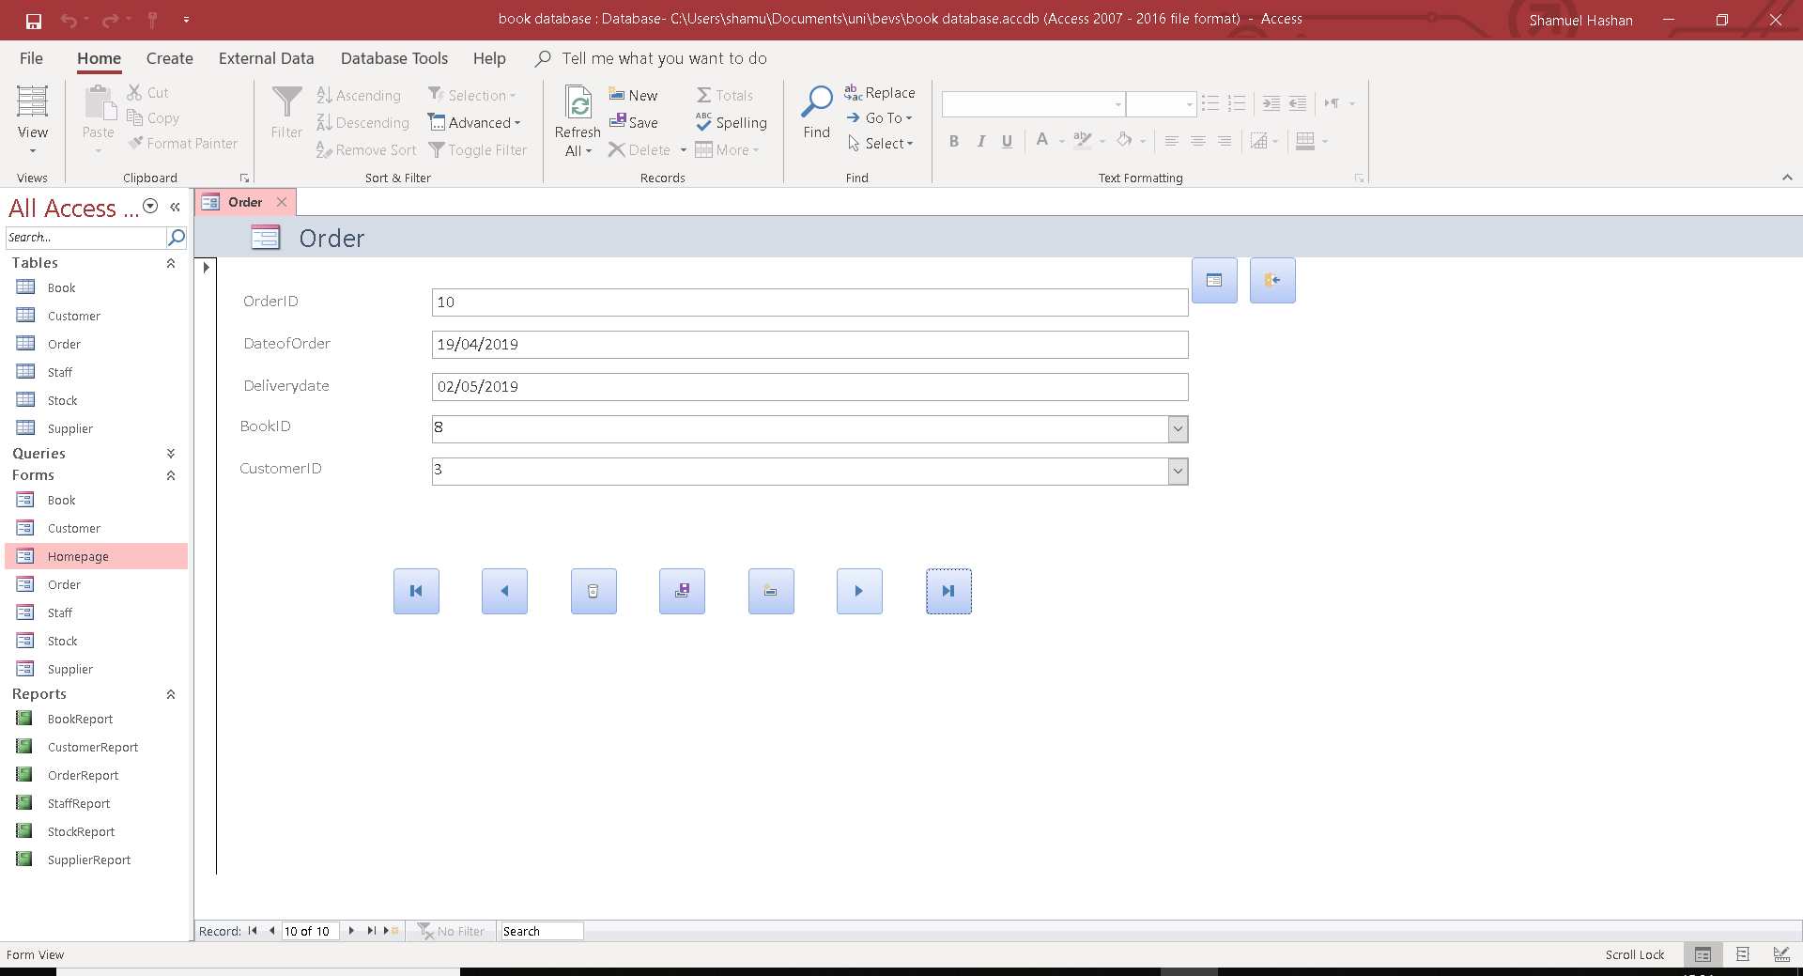

Staff form
This form will add all the data input here into the staff tables.
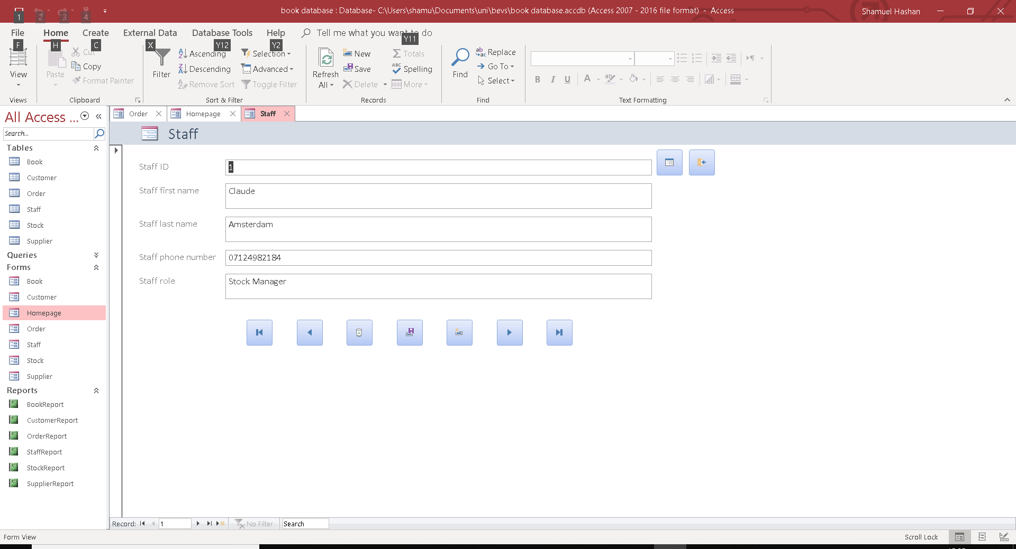

Stock Form
This form will add all the Stock input here into the Stock table.
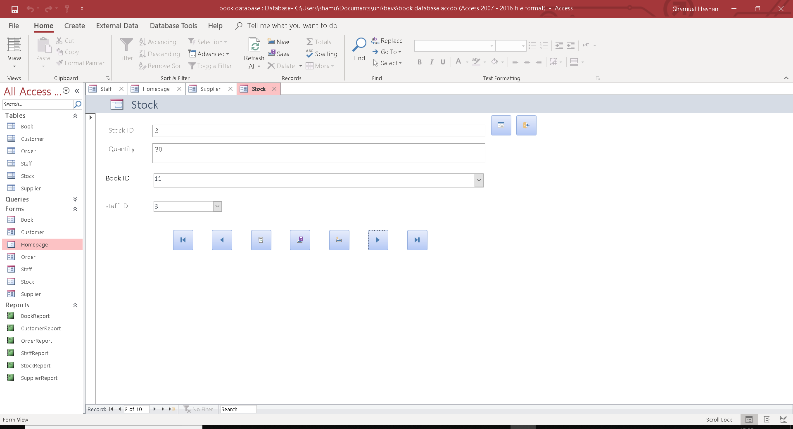

Supplier
This form will add all the supplier input here into the supplier table.
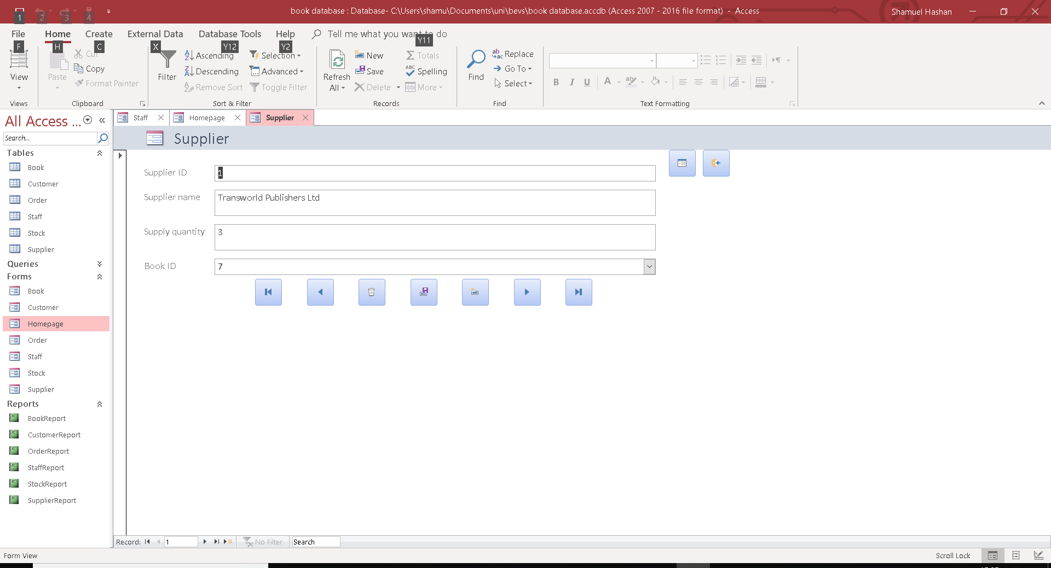

Homepage form
This form will be the homepage. It has links to the other forms.
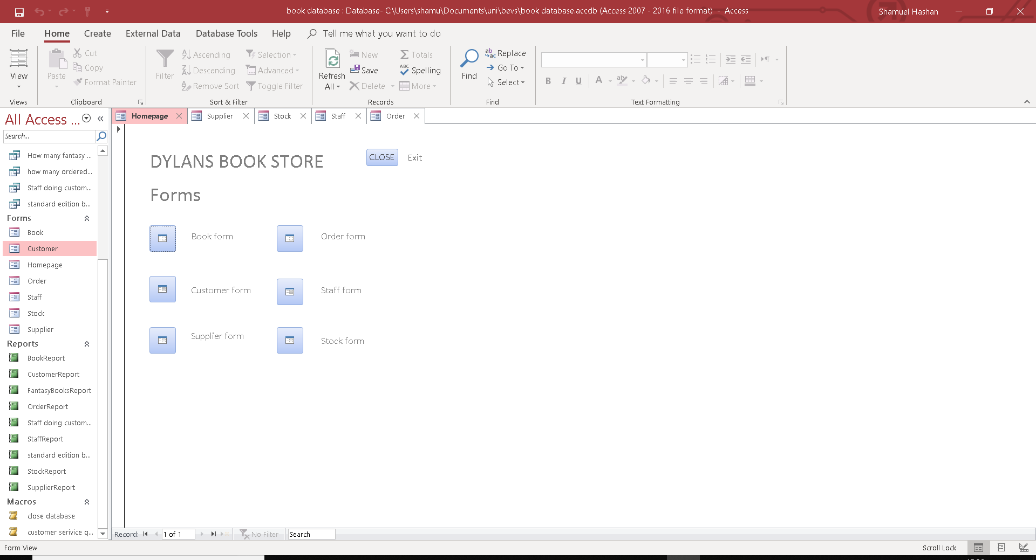

  - Queries
Query showing amount of supplies with a quantity of over 5 ordered.
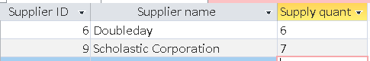
This is a query showing the amount of supplies that has supplies with a quantity of over 5 ordered.
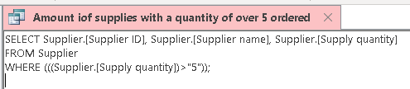
This is the SQL for the query.
Fantasy books query
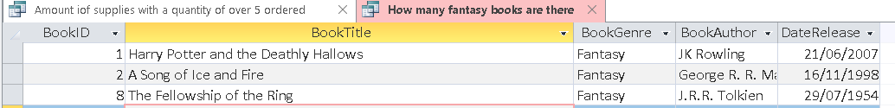
This is a query showing the amount of fantasy books there are.
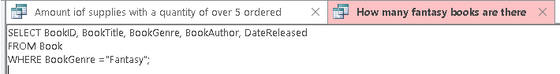
This is the SQL for the query.

Query showing books with a quantity over 40
This query shows the number of books there are with a quantity of more than 40 in stock.
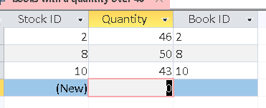
This is the SQL for the query
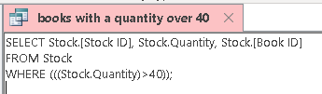

Query showing how many ordered a song of ice and fire
This is a query showing how many customers ordered the book called song of ice and fire.
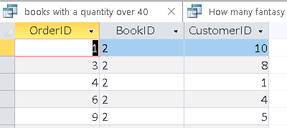
This is the SQL.
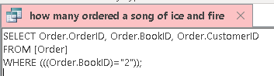

Query showing staff doing customer service
This query shows the amount of staff that has the role of customer service.
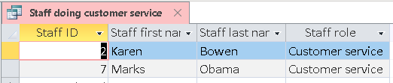
This is the SQL for the query.
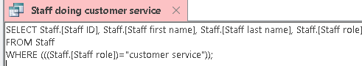

Query showing the amount of standard edition of books
This query shows the amount of standard edition books there are on the database.
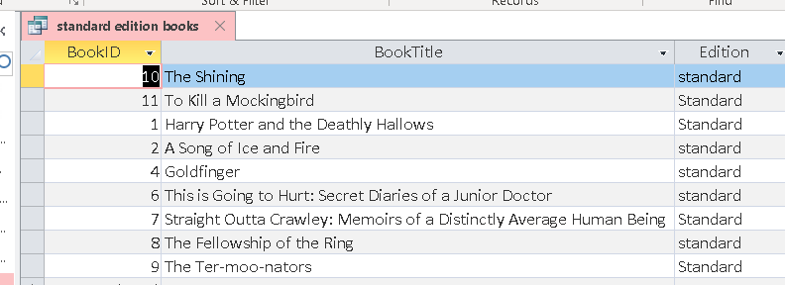
This is the SQL
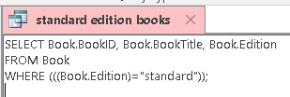

  - Relationships
This shows the relationships in the database
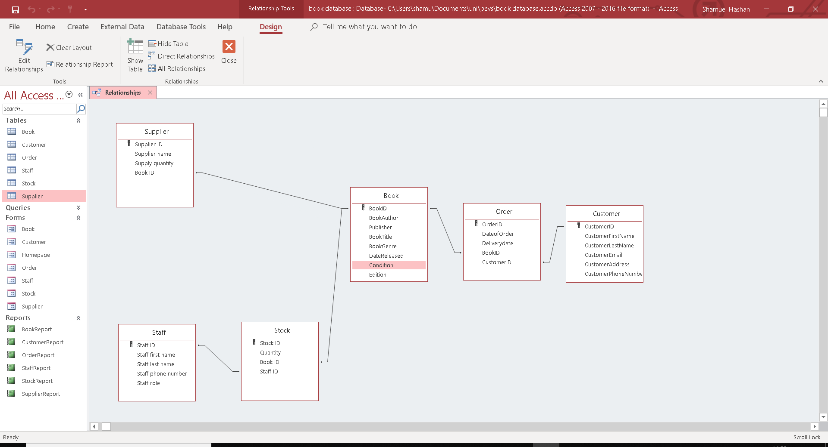

  - Reports

Book Report
This is a report showing the details of the books.
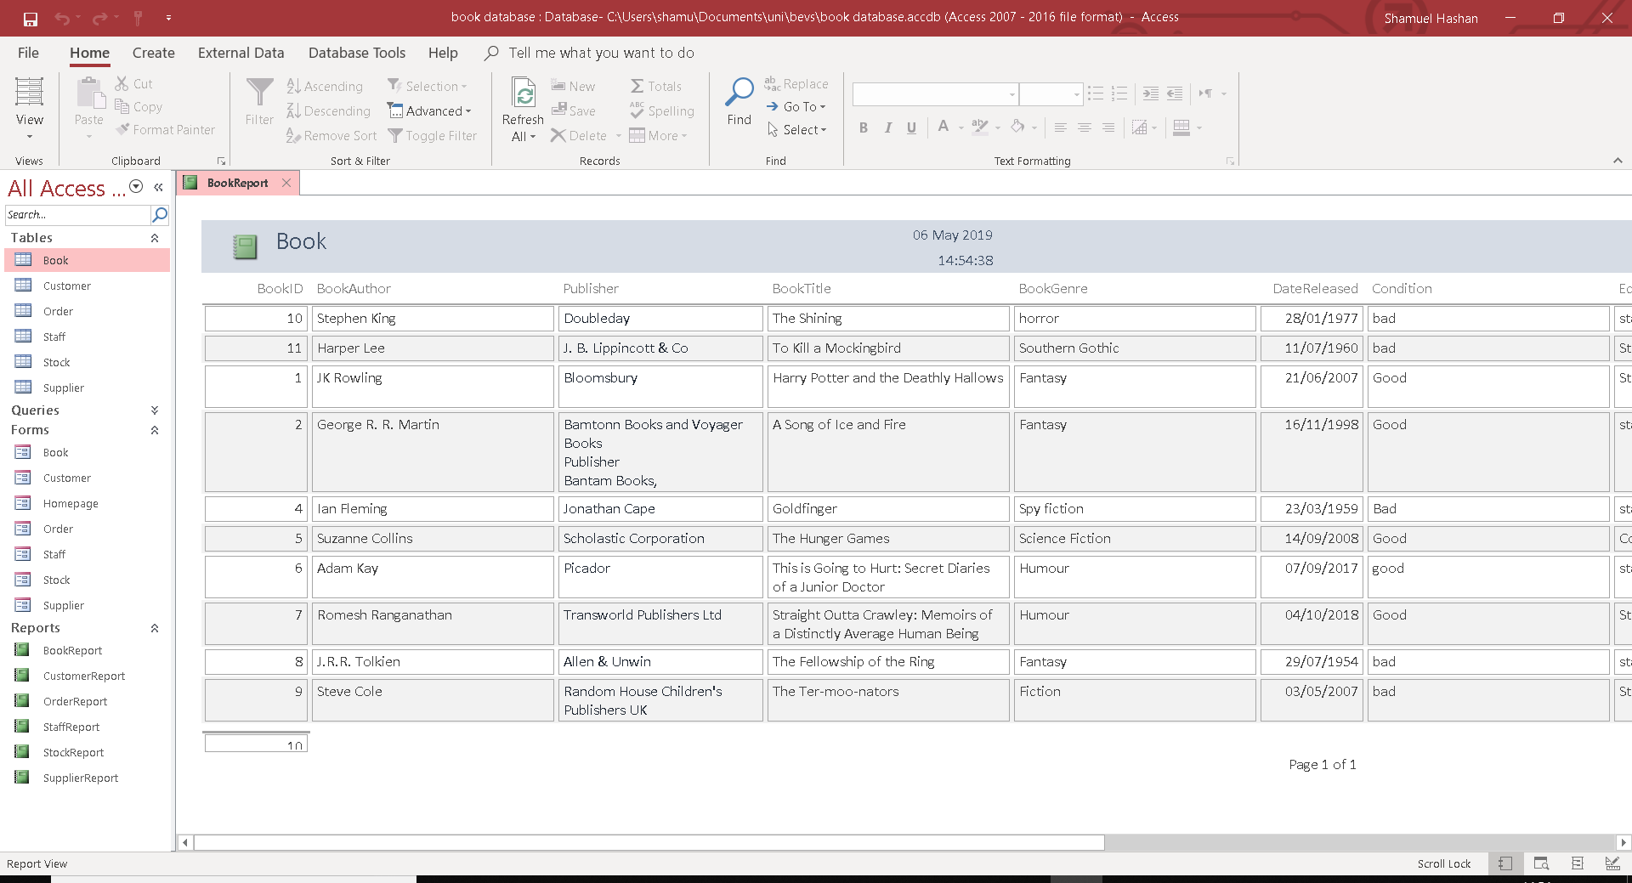

Customer Report
This is a report showing the customer details
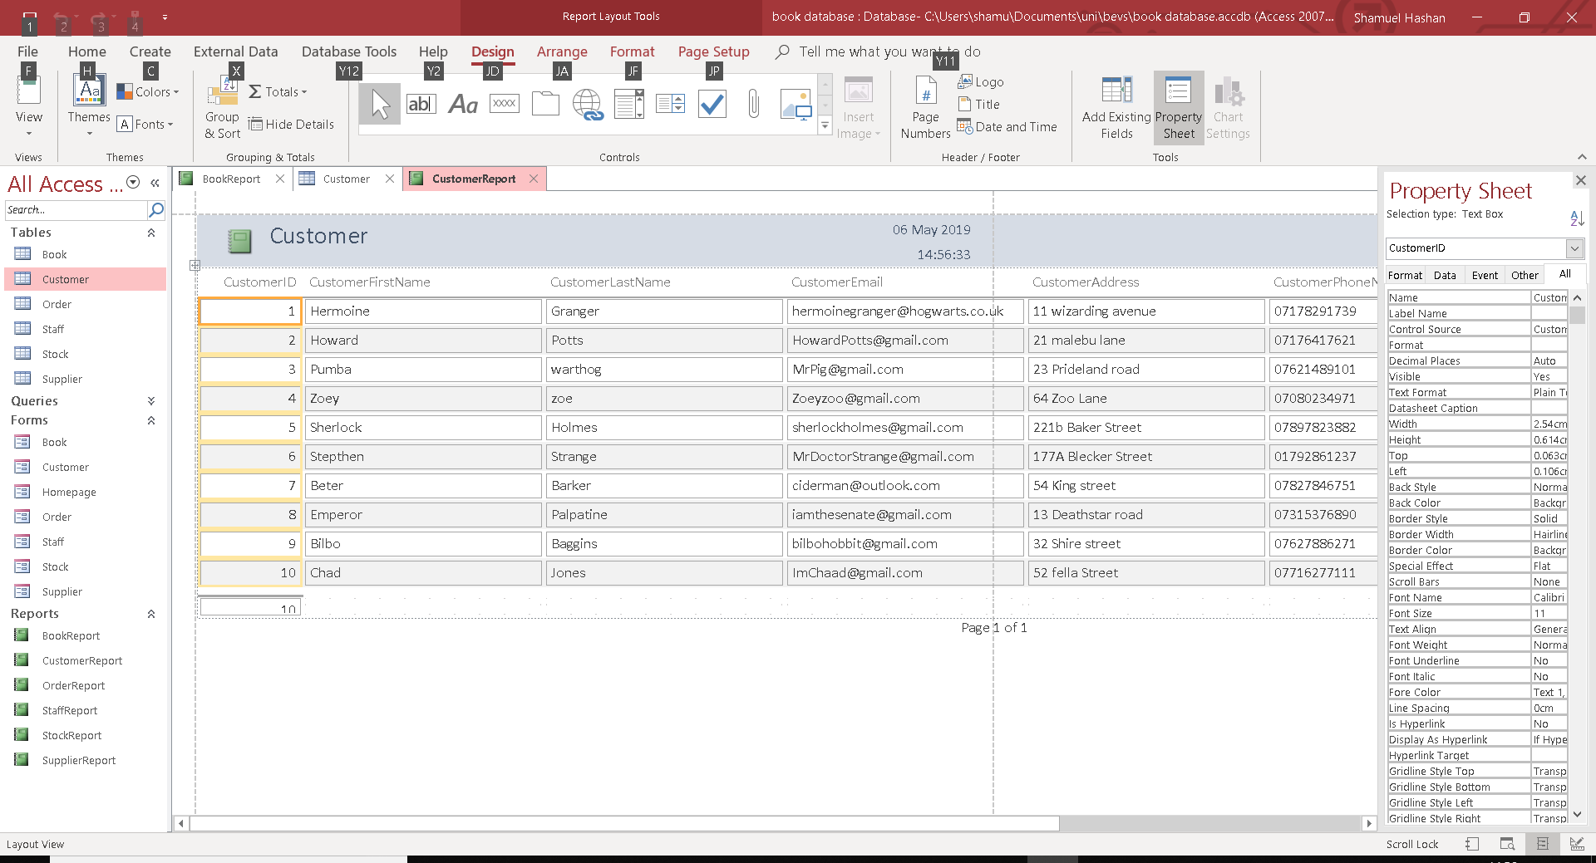

OrderReport
This is a report showing the Order details
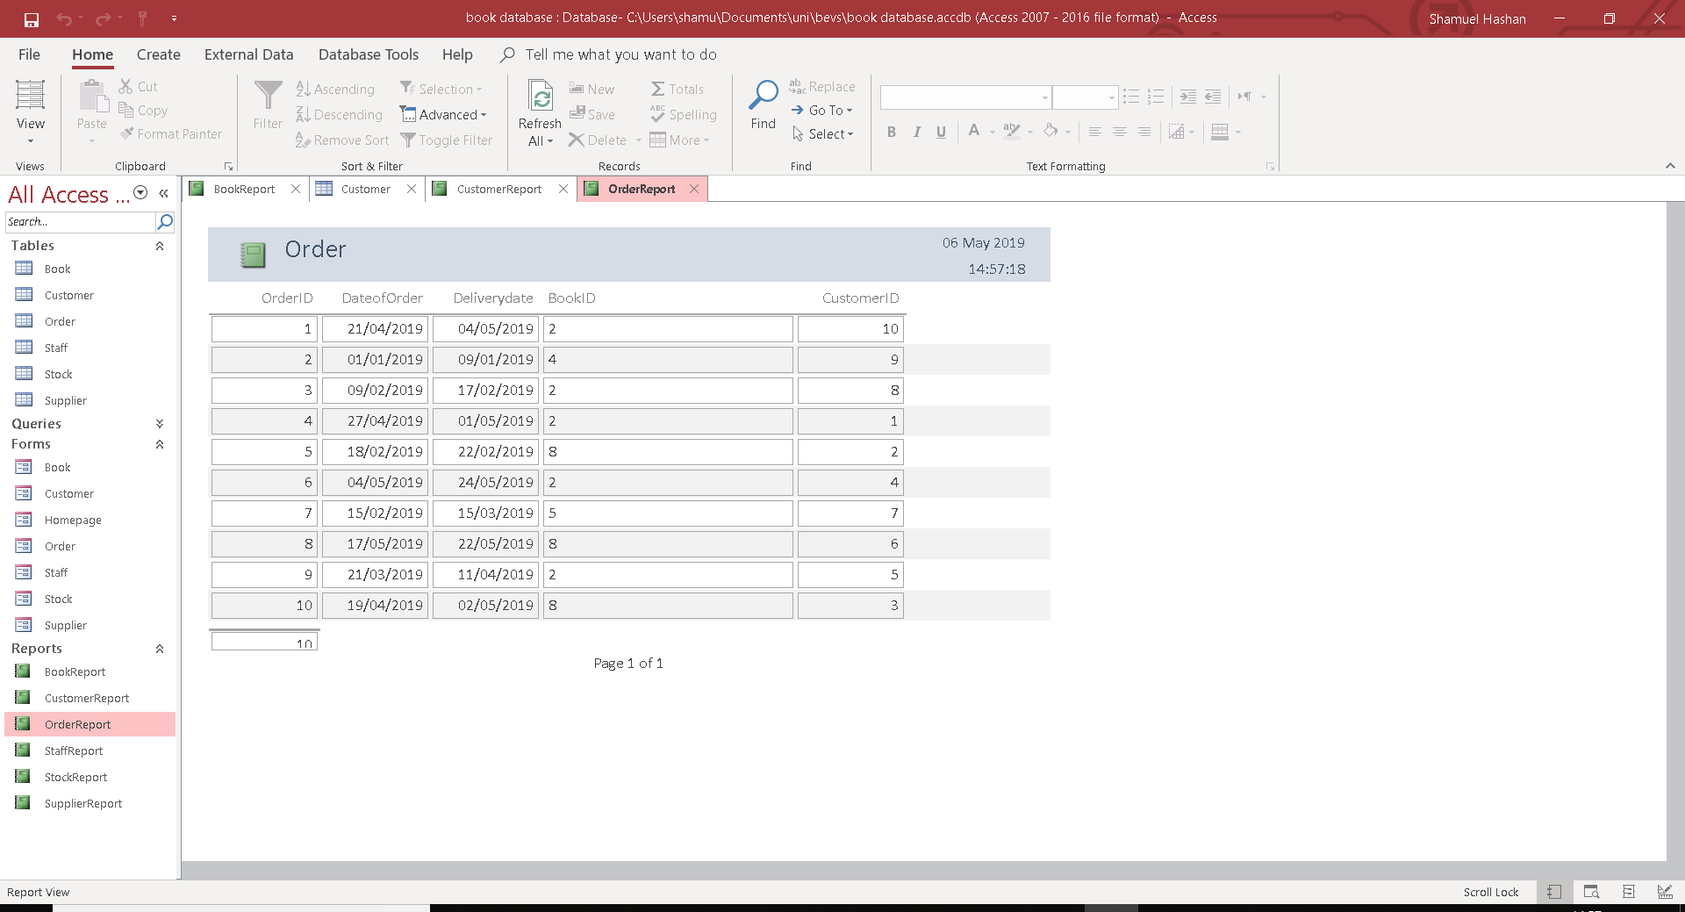

Staff Report
This is the report showing the details of the staff.
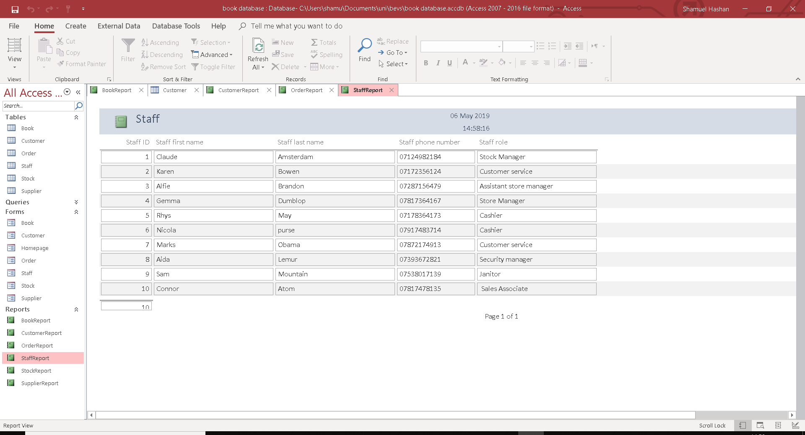

Stock report
This is a report showing the stock details
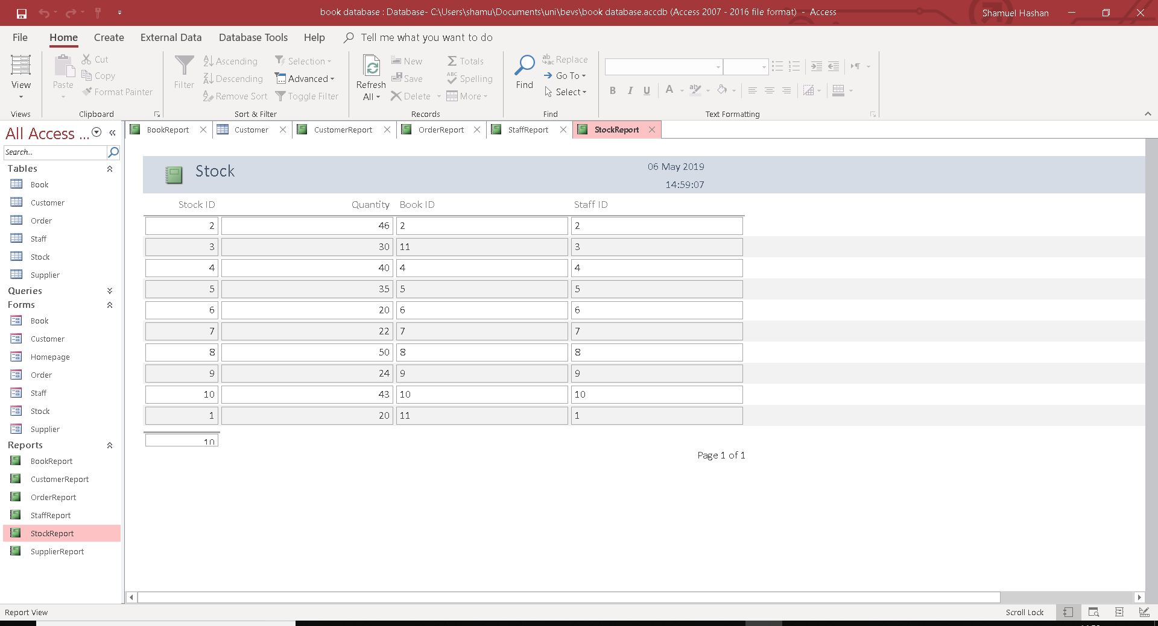

Supplier report
This is a report showing the details of the supplier
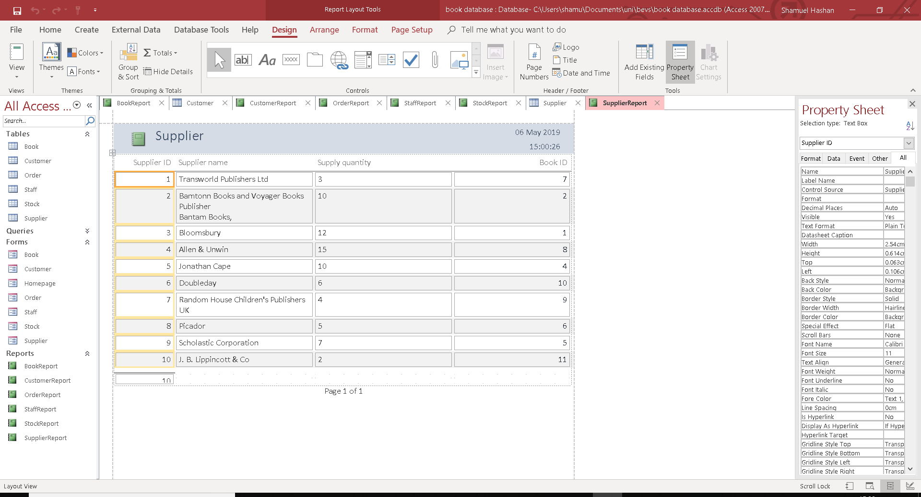

Fantasy book query
This is a report on the query where it shows the amount of different fantasy books in the store
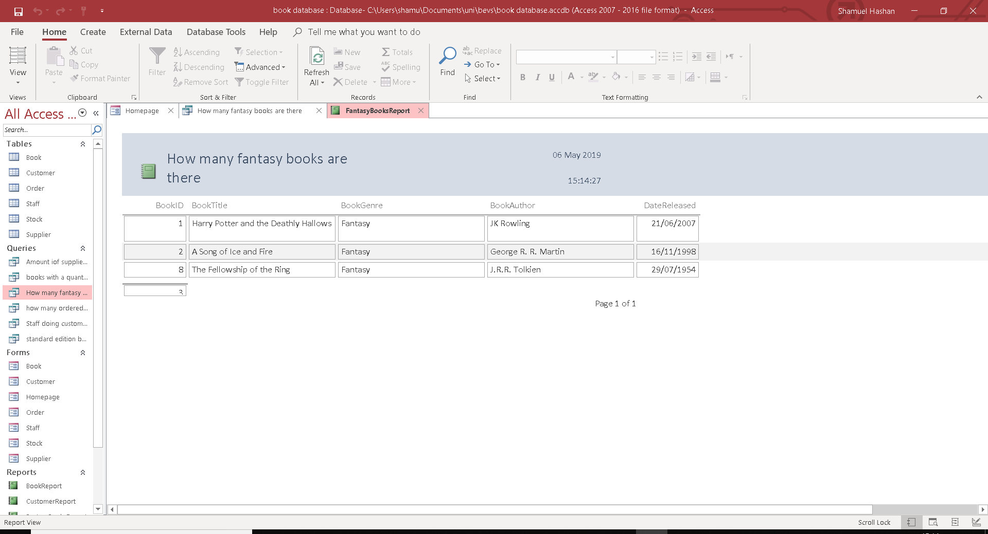

Staff doing customer service Report
This is a report on the query where it shows the amount of staff working in customer service.
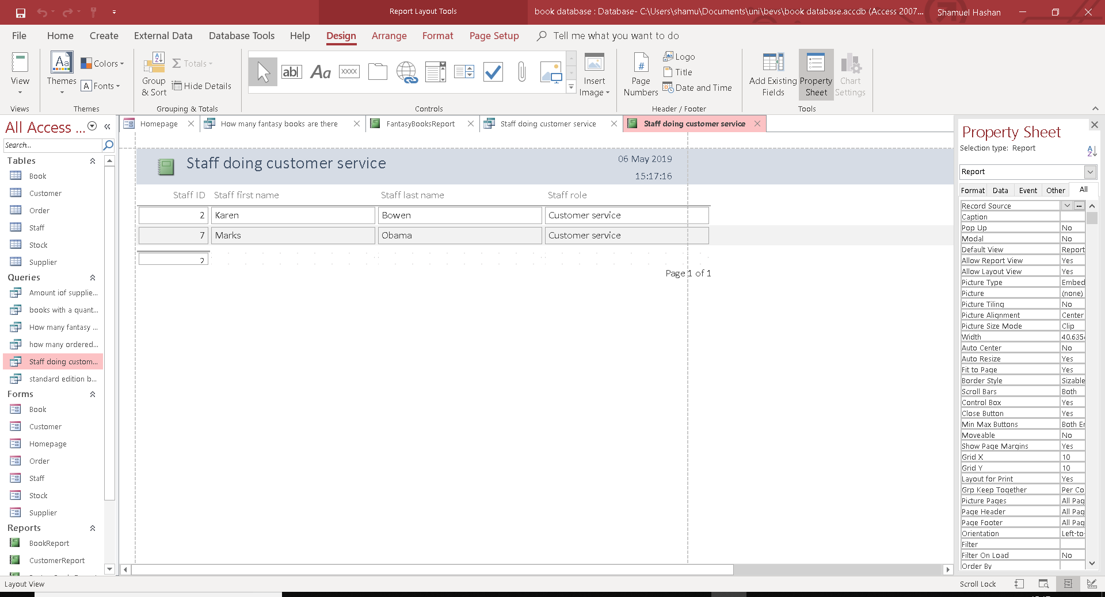

Standard edition books report
This is a report on the query where it shows the standard edition books in the store.
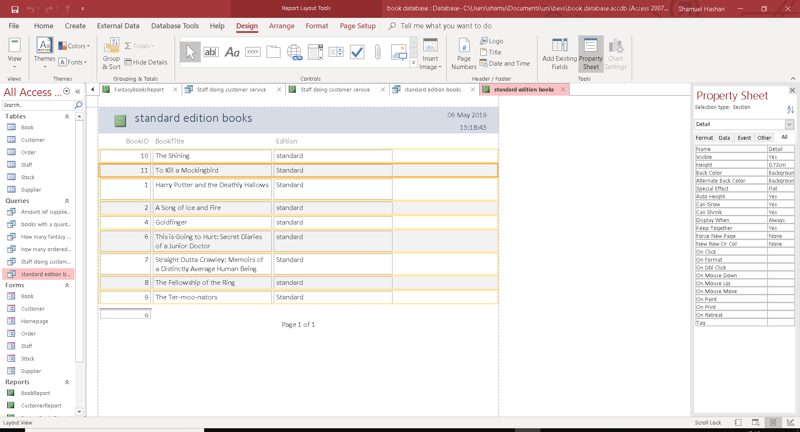

  - Marco
I used a macro too create a button to close the database and I put it on the homepage. The macro is used where it says close.
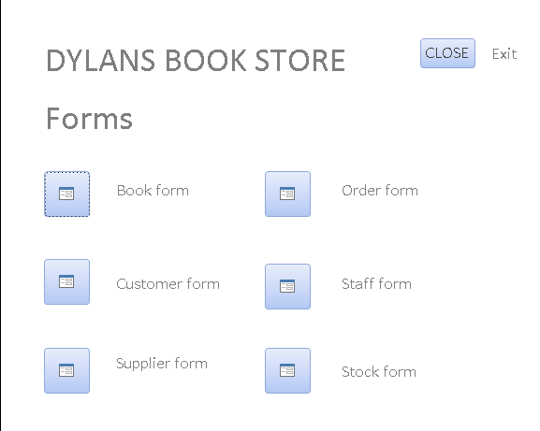

  - User guide
Tables
The database has 6 tables. There is a customer table, book table, order table, staff table and a supplier table.
The customer table has 6 tables. The Customer ID is the primary key field for that table.
The Book table has 8 fields. The book ID field is the primary key field for the book table.
The order table has 5 table. The Order ID field is they primary key field for the order table.
The Staff table has 5 tables. The primary key field is the staff ID.
The supplier table has 4 fields. The supplier ID the primary key

Query
There are 6 queries in the database
There is a query showing the amount of supplies with a quantity of 5 ordered. This has 3 fields. These are Supplier ID, Supplier name, Supplier quantity. This query is called “Supplies with over 5 ordered.”
There is also a query for the number of books with a quantity of over 40 in the stock. There are 3 fields used in this query. These are stock ID, Quantity and Book ID. This query is titled “Books with over 40 ordered.”
There is also a query showing the amount of fantasy books. There are 5 fields used in this query. These are DateReleased, BookAuthor, BookGenre, BookTitle and BookID. This query is called “fantasy books.”
There is also a query showing how many people ordered the book called “a song of ice and fire.” This query uses 3 fields. These are OrderID, BookID and CustomerID. The query is called “a song of ice and fire orders.”
Another query that’s used is the query showing which members of staff are working in customer service. This has 4 fields. These are Staff ID, Staff first name. Staff last name and Staff role. The Query is called “Staff in customer service.”
The database also has a query showing the amount of standard edition books the store has. This table has 3 fields. These are BookID, BookTitle and Edition. This query is called “standard edition books.”

Reports
The database has a fair amount of reports. There are 10 repots. There are 9 reports.
The book report is a report on the book table.
The customer report is a report on the customer table.
The order report is a report on the order table.
The Staff report is a report on the staff table.
The stock report is a report on the stock table.
The standard edition books report is a report on the query showing the amount of standard edition books the bookstore sells.
The staff doing customer service reports is a report on the staff in customer service query.
The fantasy book report is a report on the fantasy books query where it shows the amount of fantasy books the store sells.

Form
The homepage form holds links to all the other forms. The buttons on the form will send you to another form. The form it sends you to will be labelled on the right side. There is also a macro button on the top right where it says close. This will close the database.

The book form is used to add data to the book table. The bookID is done automatically here. The date released textbox has to be a date. The supplier name is a selection of the names the store gets the suppliers from. Fir the other fields, enter your own data.
The first button on the left takes the user to the first page. The button after that takes the user to the previous page. The button with the bin icon will delete one of the pages. The button in the middle saves the data. The button after that creates a new page where the user can add more inputs. The button after that sends the user to the next page while the button on the right sends it to the last page on the supplier form. The button with a form icon leads to the homepage and the button with the door icon exits the form.

The customer form is used to add data to the customer table. The CustomerID is done automatically but the user will have to enter the other fields accordingly.
The first button on the left takes the user to the first page. The button after that takes the user to the previous page. The button with the bin icon will delete one of the pages. The button in the middle saves the data. The button after that creates a new page where the user can add more inputs. The button after that sends the user to the next page while the button on the right sends it to the last page on the supplier form. The button with a form icon leads to the homepage and the button with the door icon exits the form.

The staff form is used to add data to the staff table. The Staff ID is done automatically but the user will have to enter the other fields accordingly.
The first button on the left takes the user to the first page. The button after that takes the user to the previous page. The button with the bin icon will delete one of the pages. The button in the middle saves the data. The button after that creates a new page where the user can add more inputs. The button after that sends the user to the next page while the button on the right sends it to the last page on the supplier form. The button with a form icon leads to the homepage and the button with the door icon exits the form.

The order form is used to add data to the order table. The OrderID is done automatically but the user will have to enter the other fields accordingly.
The first button on the left takes the user to the first page. The button after that takes the user to the previous page. The button with the bin icon will delete one of the pages. The button in the middle saves the data. The button after that creates a new page where the user can add more inputs. The button after that sends the user to the next page while the button on the right sends it to the last page on the supplier form. The button with a form icon leads to the homepage and the button with the door icon exits the form.

The supplier form is used to add data to the supplier table. The Supplier ID is done automatically but the user will have to enter the other fields accordingly. The book ID is a dropdown box.
The first button on the left takes the user to the first page. The button after that takes the user to the previous page. The button with the bin icon will delete one of the pages. The button in the middle saves the data. The button after that creates a new page where the user can add more inputs. The button after that sends the user to the next page while the button on the right sends it to the last page on the supplier form. The button with a form icon leads to the homepage and the button with the door icon exits the form.

The stock form is used to add data to the stock table. The Stock ID is done automatically but the user will have to enter the other fields accordingly. The Staff ID will be able to be selected. The user will have to select one of the staff ID in the database.
The first button on the left takes the user to the first page. The button after that takes the user to the previous page. The button with the bin icon will delete one of the pages. The button in the middle saves the data. The button after that creates a new page where the user can add more inputs. The button after that sends the user to the next page while the button on the right sends it to the last page on the supplier form. The button with a form icon leads to the homepage and the button with the door icon exits the form.

  - Evaluation
The goal of this project was to create a database for Dylan’s Book Store. The database will have to suit the needs for the book store. I believe I have achieved the goal and created a database that suits the needs. It is not complicated, and the database is easy to navigate. It has a menu for the forms. It has all the databases they will need and reports they need. If I was to do anything differently then I might add more colour to the forms. I might also add more databases and queries.

References

Bibliography
Abraham Silberschatz Professor, H. F. (2010). Database System Concepts. McGraw-Hill Education.
Ramez Elmasri, S. B. (2010). Fundamentals of Datbase Systems. Pearson.
Sikha Bagui, R. E. (2011). Database Design Using Entity-Relationship Diagrams (Foundations of Database Design). Auerbach Publications.
Wenzel, K. (n.d.). What is a Database Table? Retrieved from essentialSQL: https://www.essentialsql.com/what-is-a-database-table/
What is Entity Relationship Diagram (ERD)? (n.d.). https://www.visual-paradigm.com/guide/data-modeling/what-is-entity-relationship-diagram/.

