

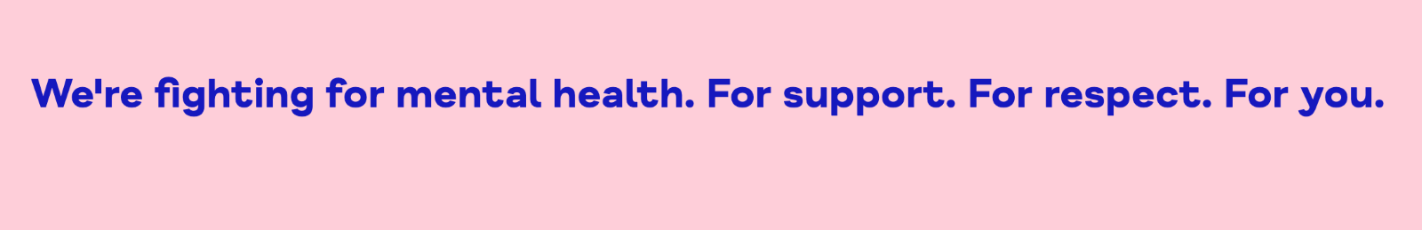
Mind (18 Jan 2022) Our Achievements.Mind.org.uk

Befriending Placement Portfolio

Programme: BSc Psychology and Counselling
Module: Counselling Skills & Approaches
Module Code: ECPS5008
January 2022

Table of Contents

Reflection…………………………………………………………………………..3
References…………………………………………………………….7
About Mind………………………………………………………………………..8
Vision statement……………………………………………………….…….…9
Mission Statement…………………………………………………….……….9
Goals……………...…………………………………………………………..…10
Values……………………………………………………………………….…..11
Evidence…………………………………………………………………………..12
Certificate of Training……………………………………………………..…12
Placement Log……………………………………………………………..….13
Data Log……………………………………………………………………..…14
Collection of Admin Examples….……………………………...…………..15
References.………….…....................……………………………………….16

Reflection
Finding a placement I wanted was my first challenge in this aspect of my degree. Truthfully, this placement was not my first choice. Unfortunately, the organisation I wanted to be involved with does not support student placements. This only became apparent quite late into the process. This left me with little time and less preferred choices to apply to. From those, I was drawn to Mind for several reasons. Its reputation, its longevity, its range of services and its proximity to my home. My initial disappointment at not being at my preferred choice was quickly forgotten. I have been in awe of Mind from my first point of contact and now feel that maybe it was where I was meant to be after all. Their support, encouragement and friendly nature has been nothing but a pleasure to be involved in. Their whole ethos is inspiring.
Training was thorough and I have been offered extra courses through the organisation. For example, this month I have a course on cannabis screening and another on transgender awareness. These are online courses provided at no cost to me, through the local government authority. I have included a certificate for a Safeguarding course I have already completed, in the evidence section below. The in-house training by staff at my local Mind office was excellent. It was as much an opportunity to meet the staff and other volunteers as it was about learning. The welcoming and informal atmosphere made the whole experience positive and fun.
Soon enough it was time for my first befriending phone call. My first service user and I were matched and we hit it off. Deutsch (1984) states that many therapists place stress upon themselves by setting such high standards for their work. This was certainly applicable to my own experience as prior to my first interaction with the service user I was extremely apprehensive. This was completely unnecessary as the session went extremely well! However, after some text message exchanges, it seemed she didn’t require a further call. Perhaps that initial outpouring was enough for her. As per training, I informed my supervisor and we are currently arranging for another service user to match up with. Albeit a one off phone call, I found myself feeling incredibly relieved that I’d had such high quality training at university through triad practice sessions. I realised that I had in fact learnt far more than I’d initially thought. The frequency with which I was visiting those core conditions and other key points during the session was countless. Along with the expertise of my tutors, I was grateful for the teachings of McLeod (2013) and Midwinter and Dickson (2015).
Covid-19 has impacted slightly upon my befriending placement in that we aren’t meeting in person as and when the government suggests. Though restrictions have been lifted currently and we are able to meet in person, thus far I have only carried out sessions over the phone. This obviously creates some restriction to the skills we can use. SOLER (Egan, 1975) is obviously not applicable to phone calls, however, several other counselling skills have been used. Carl Rogers’ (1957) core conditions are the base skills I rely upon the most. They are versatile across so many types of interactions. To be empathetic, congruent and maintain a continual unconditional positive regard are my main focus points. I strive to reach a high quality of service by relying on these skills along with active listening, using positive encouragers, paraphrasing and the use of open questions. Many of which I refer back to in McLeod and McLeod (2011) Counselling Skills, another influential resource.
I have learnt that putting skills into practice is easier said than done. Sometimes, not knowing the correct response due to the sheer gravity of what I was told was unnerving. Therefore, I know that I must continue to learn and improve my skills. Maintenance through continual and frequent use is imperative. People are all so vastly different with incredibly varied histories, backgrounds and experiences but your skills unify your ability to react accordingly with the broad range of information that is entrusted to you.
The presentation that was required as part of the degree did in fact act as a further reflection for me. Having to collate my experiences and tie them into my counselling skills and explain the impact it has had upon me was cathartic in a sense. It clarified the process whilst showing me how far I have to go and how much I have already achieved. Reflecting is a skill in itself and has proven to be vital in accessing the ability to identify your weak and strong points. This allows you to create a plan to address those points. It removes the vagueness of moving forward and helps to focus progress making it far more efficient.
What I have enjoyed the most is the training and the feeling of helping someone free themselves of troubles and burden. Using my learnt skills to help someone on their journey to feeling better. The satisfaction is the main driving force behind my continuation on this journey of learning and helping others.
I have learnt that people are vulnerable and this service is an answer to their call for help. I have a responsibility and it is not something to take lightly. That learnt skills are vital in this role. That a better level of help for service users is only provided through the volunteer’s dedication to their duties.

References

Deutsch. (1984). Self-reported sources of stress among psychotherapists. Professional Psychology, Research and Practice, 15(6), 833-845. https://doi.org/10.1037/0735-7028.15.6.833

Egan, G. (1975). The skilled helper: A model for systematic helping and interpersonal relating. Monterey, Calif: Brooks/Cole Pub.
McLeod, J. (2013). An introduction to counselling (5th ed.). Open University Press.
McLeod, J., & McLeod, J. (2011). Counselling skills: A practical guide for counsellors and helping professionals (2nd ed.). McGraw-Hill.
Midwinter, R., & Dickson, J. (2015). Embedding Counselling and Communication Skills: A relational skills model. Routledge.

Rogers, C. R. (1957) The necessary and sufficient conditions of therapeutic personality change. Journal of Consulting Psychology, 21(2), 95-103.
https://doi.org/10.1037/h0045357

Mind (18 Jan 2022) Our Achievements.Mind.org.uk

Founded in 1946 as the National Association for Mental Health. Their motto is simply: For Better Mental Health


Mind (18 Jan 2022) Our Achievements.Mind.org.uk

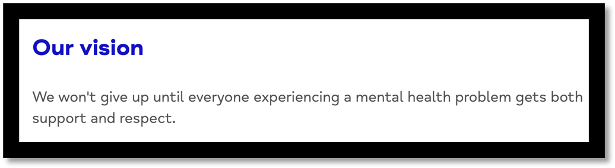
Mind (18 Jan 2022) Our Achievements.Mind.org.uk

Commitment! Mind is not afraid to set itself massive goals and has achieved so much in doing so. For example, assisting in getting the Mental Health Units (Use of Force) Act passed in 2018 (Mind, 2022).

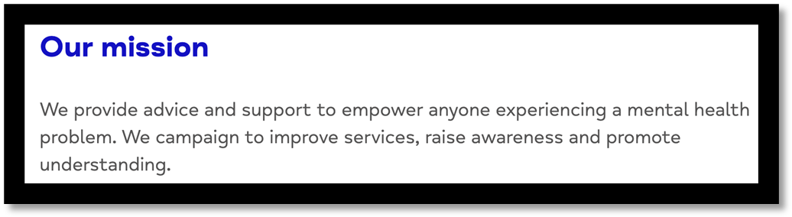
Mind (18 Jan 2022) Our Achievements.Mind.org.uk

Not just a service to help but an organisation actively pushing for more. More awareness, more services, more understanding. Not an easy task when you have limited funds and resources. In 2017, Mind successfully lobbied the government to release better data on mental health and benefits sanctions; leading to changes to help people suffering with mental health gain access to disability badges.

Mind encourage equality for their service users, to provide them with the same experiences as others in society. In doing so, they provide on going support at any point in a service user’s mental health state, not just until they feel better.

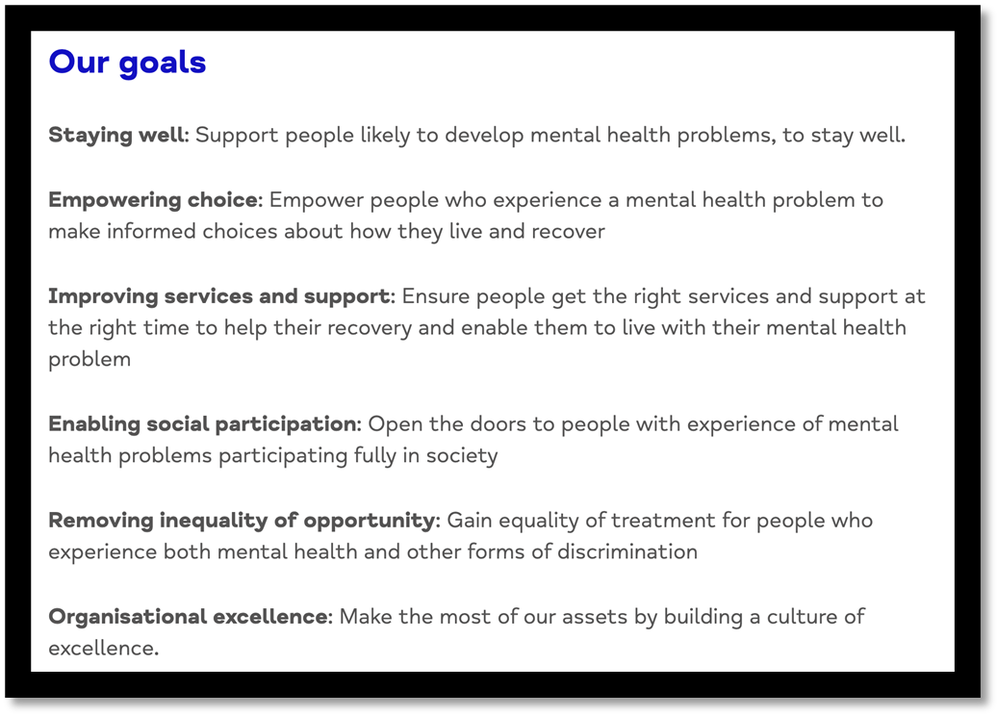
Mind (18 Jan 2022) Our Achievements.Mind.org.uk

Six simple ways of keeping focussed and on track. Six points to follow and keep striving for. This set of goals acts as a reminder to all Mind staff and volunteers that there is an essential goal orientated way of carrying out your work and that it is a continual mind set.

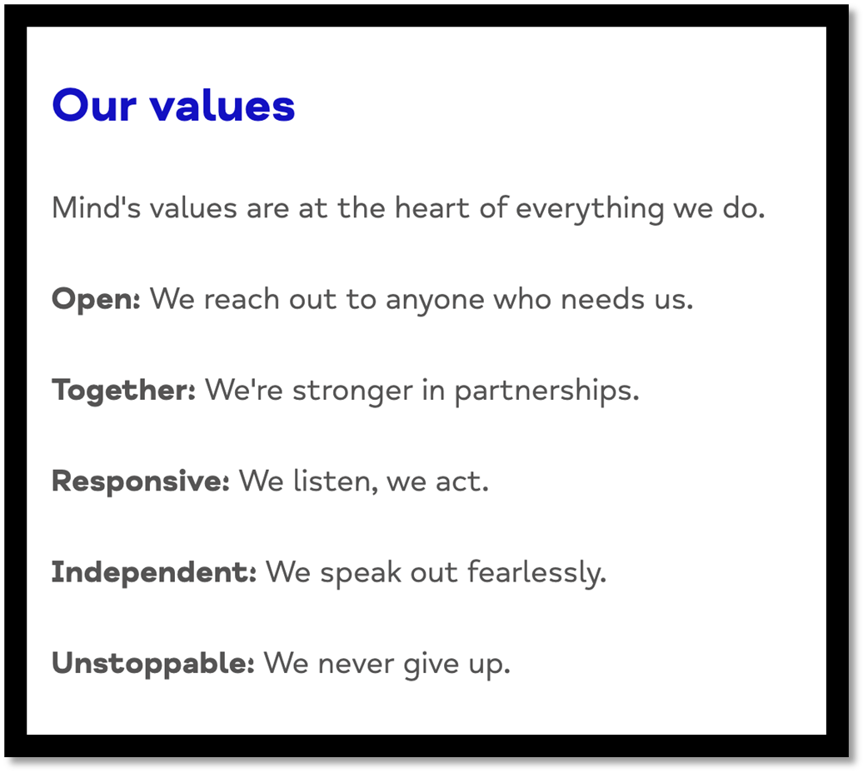
Regardless of stigma
They will always help
Inclusive
Mind (18 Jan 2022) Our Achievements.Mind.org.uk

Having a set of values to follow and guide you through your placement as a volunteer is an excellent way of reminding us why we are there. We are needed and we must maintain these values at the core of our thoughts and behaviours as a member of Mind.

Evidence

Certificate of completed Safeguarding training
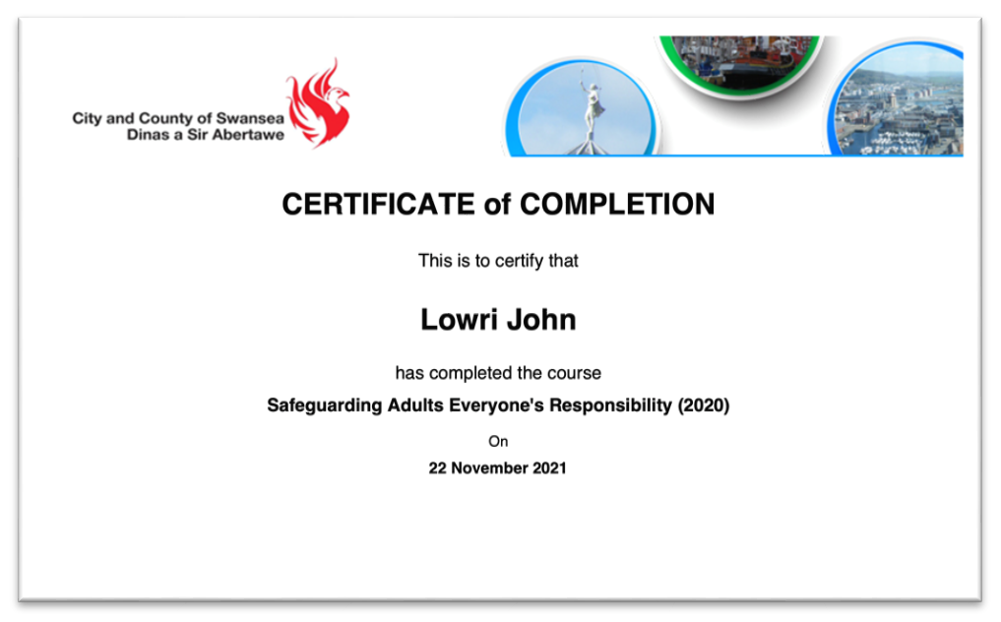Safeguarding ensures that everyone involved in the organisation is protected by ensuring everyone knows what signs to look for regarding the wellbeing of their colleagues, friends and service users.

Entry in placement log book

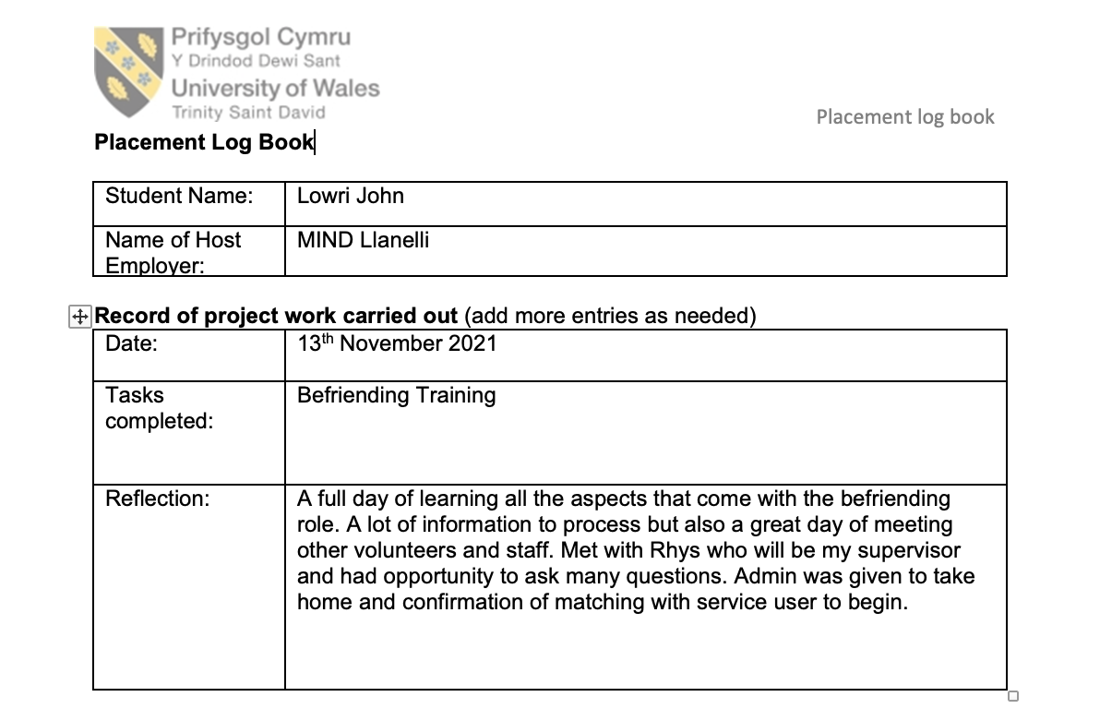

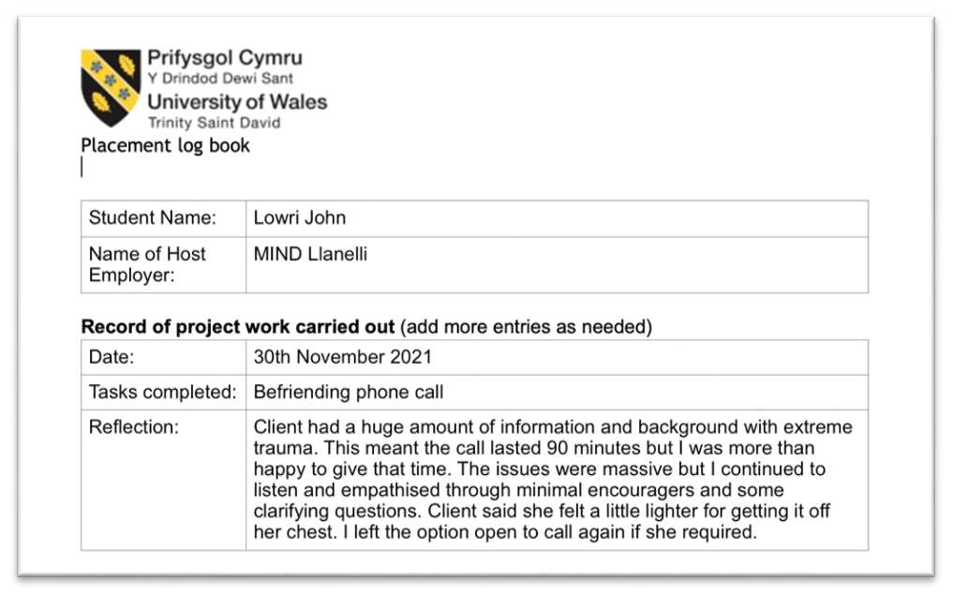These logs provide a quick method of getting thoughts and feelings down after any session or experience. They are useful for bringing awareness to the positives and negatives you experienced and may therefore need to address.

Entry in volunteer placement log.
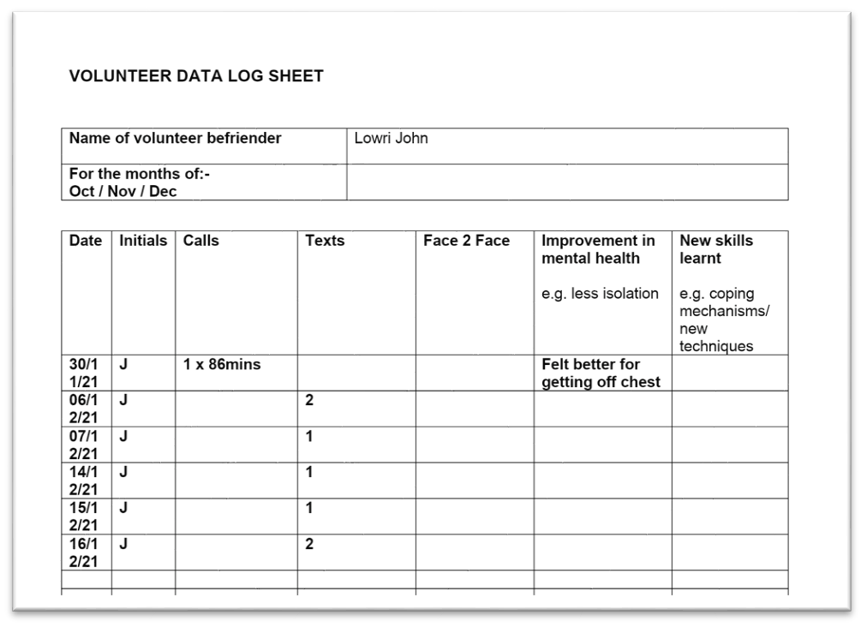
This is purely a record of time spent engaging with service user for my supervisor to monitor.

Example of supplied admin from Mind

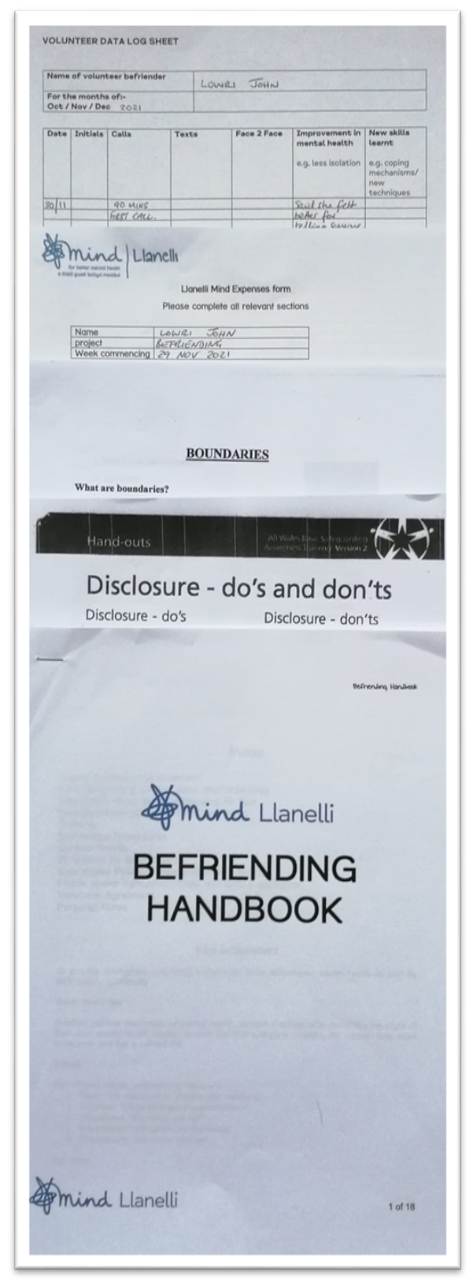
This is just an example of some of the admin a volunteer will take home to use as records or to refer to in case of any queries.

References

Mind. (2022, January 18) Home.
https://www.mind.org.uk/

Mind. (2022, January 18) About Us/Our Achievements.
https://www.mind.org.uk/about-us/our-achievements

