Student name / ID - Kian Sheppard / 2519334
Module title – Materials Engineering – RESIT ASSIGNMENT
Academic year – 2025/2026
Unit tutor - Alan Nantel
Assignment title – Plastics in Concrete
Submission date – 10th April 2026

Contents
Plastics in construction 4
Introduction 4
methods and approaches for Mortar reinforcement 4
common plastics used 4
How can plastics in mortar mixes be used in the construction industry. ? 5
Newcastle University findings 5
Bamako findings (Global) 6
Methods and approaches for waste plastics implemented into a prefabricated road decking material. 7
Netherlands Plastic road construction 8
United kingdom (MacRebur) 8
assess the material’s practicality, functionality, and future efficiency potential in these applications 9
Material assessment. 9
Conclusion 11

Plastics in construction.

Introduction
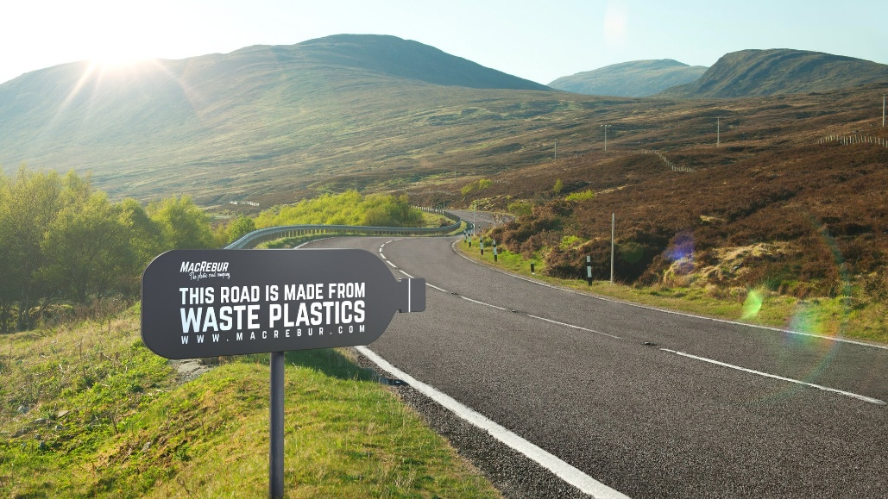 (www.bbc.co.uk, n.d.)
Over the past 8 years, there has been a rise in plastic waste along with a push for a greener construction industry. This has lead to leading industry figures to explore ways on how we could potentially use waste plastics in building materials. In this document, I have researched some of the methods being undertaken from the past 8 years that look into introducing waste plastics into the industry. One method is by adding waste plastics into mortar mixes, the research undertaken will give me a better understanding on weather it effects strength capabilities, heat loss and binding. I have also reviewed the use of plastics in road construction, from research I have found methods globally on implementing this approach which include pre-fabricated plastic road construction along with plastic used as an aggregate in asphalt.

methods and approaches for Mortar reinforcement

common plastics used

A serious environmental issue has arisen as a result of the accumulation of plastic waste over time and the absence of appropriate disposal methods. Plastic waste is clogging our water resources and waterways, overflowing landfills, contaminating important natural resources in our environment. Because this is a serious concern,, plastics are now being used in the construction industry. One common use is in mortar mixes:
(pmc.ncbi.nlm.nih.gov, n.d.)

Researchers have tested a range of waste plastics in mortar mixes. From the research I have undertaken, some of the most common plastics being used include polypropylene , HDPE and LDPE from containers and films , PET from bottles, and PVC from pipes. Expanded polystyrene (EPS) foam, shredded mixed plastics, thermoset scraps, glass reinforced plastic (GRP), polycarbonate, and polyurethane.
(www.sciencedirect.com, n.d.)
Recent studies suggest that these plastics could potentially be the replacement material for some fine aggregates in the construction industry. For this to be achievable we need to have a solid understanding on how these plastics behave when applied into these mixtures. Some of the key information will be to understand the positive side of implementing plastics along with the negative effects.

How can plastics in mortar mixes be used in the construction industry. ?

From a recent document dated February 2025, Newcastle university researchers have created a Mortar mix that uses silica aerogel and plastic waste material to potentially reduce heat loss by up to 55 percent compared to standard mortar mixes used in the industry. Because plastic waste is a major challenge globally along with a constant worry with energy costs rising, This implementation may be key to addressing these issues, while having working towards a greener environment.

The University personnel were able to achieve this mortar mix by replacing sand with a specific mixture of silica aerogel particles and shredded PET (polyethylene terephthalate) plastic. Silica aerogel is already known for its good standard of thermal insulation, used in sectors ranging from construction to aerospace.

Newcastle University findings

The study found a particularly effective blend that comprised 3% shredded PET and 7% untreated silica aerogel in place of sand when comparing seven mortar formulations with a traditional control. While adhering to major construction regulations (BS-EN 413-1:2011, ASTM C270-10, and AS 1012/AS 3700), this formulation greatly improved insulating performance by reducing the mortar's thermal conductivity by up to percent . In addition to the thermal advantages, the authors noted that important mechanical characteristics satisfied the requirements for common mortar applications and that workability and setting behaviour continued to be acceptable. These findings could back the theory that recycled PET may be added to mortar mixes without effecting the overall performance, which could offer a solution to reduce the waste being sent to landfill sites leading to a greener environment.

(interestingengineering.com, 2025)

Bamako findings (Global)

There was a study undertaken in the city of Bamako to evaluate whether the use of mortar with melted plastic waste was an acceptable material for the construction of interlocking paving blocks for use on residential construction projects. In this study there was two curing conditions used. One was to air dry and the other was a water curing technique.
The test used various granular sizes to get a better understanding on the impact of different ratios used including different plastic densities (high density polyethylene) and low density polyethylene). This was key to learning critical behaviours of mixes, due to the significant impacts on mechanical strengths from ratio changes.
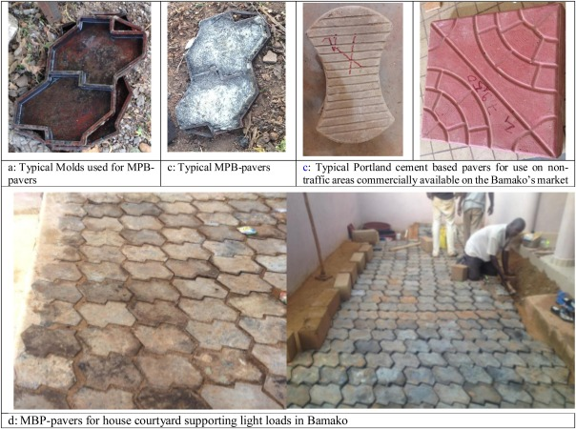

The test was produced by melting a blend of (HDPE and LDPE) and mixing it with sand to create a well balanced mix. There was two different aggregate combinations used for the test. One including finer sands to test the plastic wastes strength and workability as a major aggregate in the compound, along with a mix containing larger sand granules. This would create an important understanding on how far we can push the use of plastic waste in mortar mixes, as the overall goal from an environmental aspect would be to completely remove sand from mixes.

Three (HDPE and LDPE) blends were mixed with a 50% plastic content and was poured into cylindrical moulds . After the plastic was melted at 250 degrees for 20 to 45 minutes they were then combined with sand or gravel. After 30 minutes of hand compacting to minimize sagging, the mixture was allowed to cure between 1 day ,3 days, 7 days and 28 days. Guided by the time frames the tests were then undertaken to examine the strengths and weaknesses.

Test results

Plastic based mortar cured in air is much stronger than water cured samples as the water cooling results became more pourus and can cut strength by up to about 45%.
Using larger sand granules as aggregate has advantages to packing and density, so those mixes show much higher compressive and tensile strength than all fine sand mixes.
Plastic waste mortar mixes for interlocking paving behave more ductile than standard paving and can still carry some load after failure, and should be cheaper since they don’t use cement.
Plastic based mortar looks like it is suited to low load paving where ductility and cost matters, but it may be less appropriate for structural applications without further development and long term testing.
(www.sciencedirect.com, 2021)

Further research on structural behaviours

Another document I reviewed with similar testing from April 2024, conclude their results with the findings that replacing sand with waste plastics, alters behaviours in concrete. It implies that small replacements at around 5 percent can keep strength capabilities and improve workability.
When you are adding 15 to 20 percent in plastics the results show that density and compressive strength capabilities are drastically reduced due to the plastics poor binding properties.
There was an 80 percent loss in compressive strength even when plastics were distributed evenly through mixes due to the tensile split strength and freeze resistant characteristics.
Overall, the authors stated that although low plastic content may be helpful for non-structural uses, a greater plastic content raises concerns about strength and durability unless bonding and thermal compatibility are taken into account.

(https://pmc.ncbi.nlm.nih.gov/articles/PMC11051361/, 2024)

Methods and approaches for waste plastics implemented into a prefabricated road decking material.

Waste plastics in road construction is fairly recent development with multiple countries around the world provided test results in case studies. Some studies find that on average small additions around 5 to 10 percent by weight to bitumous mixes can make improvements to stability and strength while being more durable. There have been case studies produced from countries such as India , United kingdom , Netherlands and from countries in the African continent. These countries have produced promising results which show signs that this implementation into the industry can produce environmental benefits.
(assets.publishing.service.gov.uk, 2019)

Netherlands Plastic road construction
On September 11th 2018, the worlds first plastic road opened in Zwolle, Netherlands. The plastic road project was a collaborative effort between KWS, Wavin and Total. The project was conceived by inventors Anne Koudstaal and Simon Orritsma of KWS. Over 218,000 plastic cups were broken down and used along the 30 meter plastic road.This was a major advancement in the industry while offering strength and sustainability
.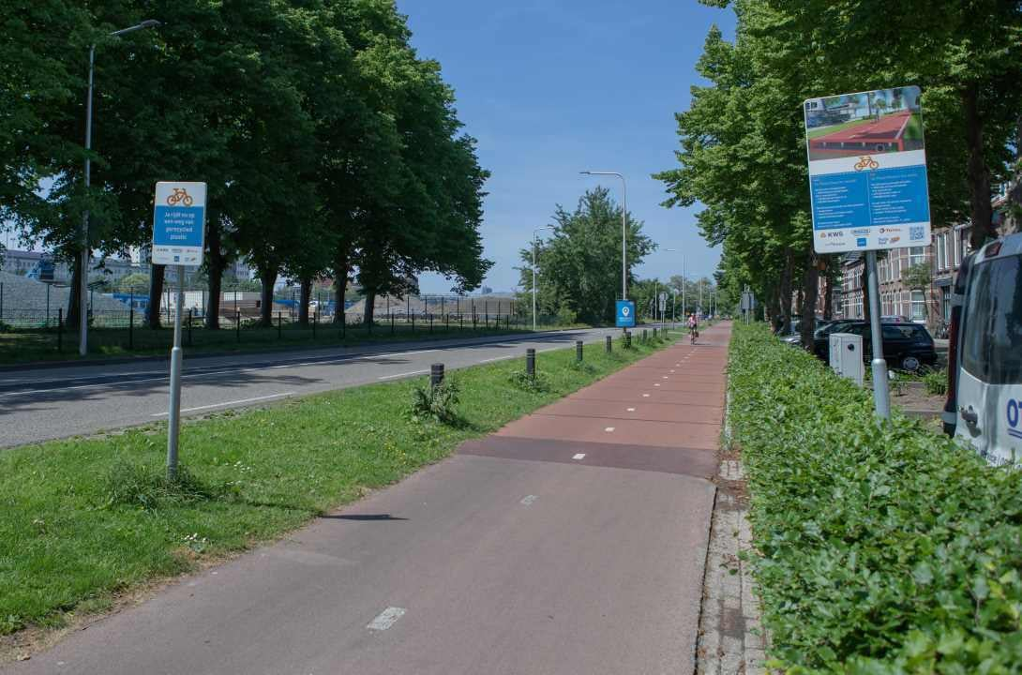

The construction business KWS first proposed the idea in 2016, and Wavin and Total collaborated with them to turn it into a product that included a plastic road bike route in Zwolle, the location of Wavin's main headquarters and is now being implemented through the Netherlands which is further discussed towards the end of this report.
(blog.wavin.com, n.d.)

United kingdom (MacRebur)

Another major step in the industry is MacRebur’s approach to plastic waste use. MacRebur aims to cut down on the reliance of virgin oil based materials and lower carbon emission by turning waste plastics into high performance aggregates. At their facility in Scotland , they convert mixed plastic waste into products called MR6 and MR8 that can replace bitumen contents in asphalt mixes. Their approach combines lab driven formulation, industrial scale production, and quality control including published EPDs and carbon accounting to produce more affordable, low carbon asphalt that supports net zero objectives.
(innovationweek.campaign.gov.scot, n.d.)
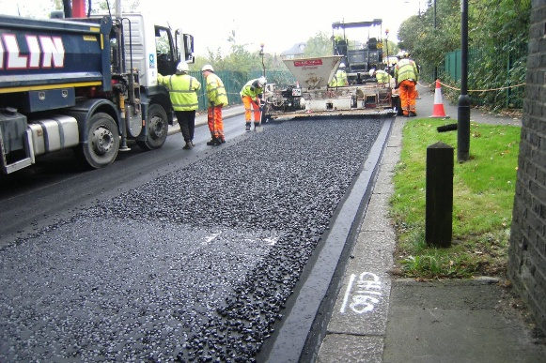

(www.dailyrecord.co.uk, n.d.)

MacRebur’s products are used in road projects across the UK, USA, Spain, Moldova, Bahrain and Malaysia and over 1 million tonnes of asphalt per year are treated with their polymers which saves 5,000 tonnes of CO2 each year.
As a company they continue to engage with international clients to create manufacturing facilities across the globe. As stated in the document their aim is to continue to work closely with local councils in Scotland and across the UK, supporting their ambitions to reduce emissions in line with Net Zero targets, while aiming for performance and cost improvements on asphalt roads.
(https://innovationweek.campaign.gov.scots, n.d.)

assess the material’s practicality, functionality, and future efficiency potential in these applications

Material assessment.

Waste plastic in mortar mixes.

From the research I have undertaken through multiple case studies, it is clear that the implementation of plastics into the construction industry is still a new technology that is being further researched. Some of the major stand out benefits would be the heat loss capabilities which show signs of efficiency. This is key because it cuts energy use and keeps indoor spaces more comfortable in living circumstances while lowering carbon emission leading to a greener environment.

When it comes to performance properties for plastics being used for mortar mixes, it comes down solely on the purpose of use. From the Bamako case study , we can see that when using plastics in mortar mixes for public paving blocks, the plastic showed promising strengths, The paving became more ductile with the corrected mixture of aggregates and became more cost effective which is very promising, but was limited on its capabilities.
The purpose of this report was to investigate the plastic wastes reinforcement capabilities when added to mortar.
After reviewing multiple case studies there is strong sense that the mortar is not suitable for heavy load activity, continuously showing signs of weakening the overall mix compared to a traditional mix. There is a lack in evidence on the topic of reinforcement capabilities and acquires some further research by professionals.

Waste plastic in road construction
From looking at case studies UK based and globally, The implementation of waste plastics in pre-fabricated road construction does show very positive signs with the advantages outweighing the disadvantages. The benefits that The Zwolle road construction and major companies like MacRebur have made to the industry are very promising.
The implementation of a pre-fabricated, full plastic road concept is a substantial step forward in the construction industry. It offers several practical advantages from helping manage both flooding and drought by integrating storage and improved drainage to lightweight but robust design which is a major positive for road construction Another positive outcome when fitting a plastic road is the reduced labour costs and project timeline due to the off site fabrication,
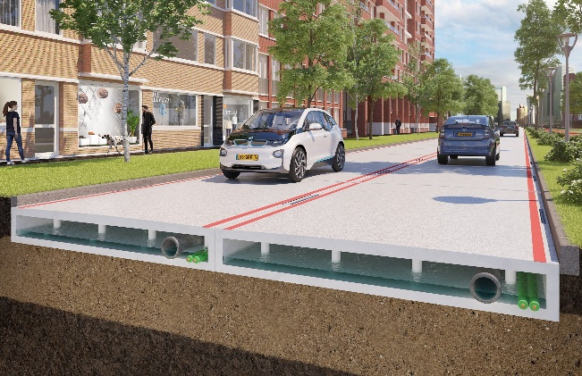
(www.orbia.com, n.d.)
The aspect of serving as a road system while housing water storage, drainage, cables and smart sensors for traffic monitoring is a huge step in the industry. management and upkeep are also easy to maintain due to the panelling system. Another positive outcome when fitting a plastic road is the reduced labour costs and project timeline due to the off -site fabrication, this allows for quicker turnover times which leads too less disruption to communities which long projects create.
(www.volkerwessels.com, n.d.)
Macrebur also bring substantial benefits to the construction industry by implementing waste plastics into asphalt. reducing the carbon footprint from bitumen reduction is a major environmental benefit. Also the approach acts on the plastic waste problem globally, diverting mixed plastic waste from landfill sites and implementing it into a useful industry product.
According to the MacRebur website, utilizing MR6 has the following more environmentally friendly advantages: it is composed entirely of recycled materials, requires less fossil fuel, can be used to make warm asphalts, lowers carbon emissions, uses plastics that would otherwise end up in landfills, and promotes a circular economy. Additionally, MR6 is a more economical method of extending the asphalt's lifespan, strength, and durability.

According to the MacRebur website, Their product MR6 has substantial environmental benefits. It is produces as 100 percent recycled materials and lowers carbon emissions, The mixture uses plastics that would end up in landfills. MR6 is also stated to extend the asphalt's lifespan along with better strength and durability, which is hopefully a major step forward in the industry.
(www.ideassonline.org, n.d.)

Conclusion
To conclude this document, I believe that the industry has taken major steps forward into adopting waste plastic’s into the construction industry. There is substantial environmental benefits being created due to companies like MacRebur and KWS etc, who are not just creating a greener environment but products that bring improved industry standards with durability and sustainability factors.
While looking at waste plastics in mortar and concrete, it has been heavily backed on performing for low load purposes but lacks in substantial evidence and testing for reinforcement use.

References
assets.publishing.service.gov.uk, 2019. https://assets.publishing.service.gov.uk/media/5d41b34040f0b60a86a5e5dc/595_Use_of_Waste_Plastics_in_Road_Construction.pdf. s.l.:https://assets.publishing.service.gov.uk/media/5d41b34040f0b60a86a5e5dc/595_Use_of_Waste_Plastics_in_Road_Construction.pdf.
blog.wavin.com, n.d. https://blog.wavin.com/en-gb/plastic-road-launch. s.l.:https://blog.wavin.com/en-gb/plastic-road-launch.
https://innovationweek.campaign.gov.scots, n.d. https://innovationweek.campaign.gov.scot/case-study/case-study-macrebur-ltd/#:~:text=Using%20patented%20technology%20and%20bespoke,national%20and%20international%20sustainability%20goals.. s.l.:https://innovationweek.campaign.gov.scot/case-study/case-study-macrebur-ltd/#:~:text=Using%20patented%20technology%20and%20bespoke,national%20and%20international%20sustainability%20goals..
https://pmc.ncbi.nlm.nih.gov/articles/PMC11051361/, 2024. https://pmc.ncbi.nlm.nih.gov/articles/PMC11051361/. s.l.:https://pmc.ncbi.nlm.nih.gov/articles/PMC11051361/.
interestingengineering.com, 2025. https://interestingengineering.com/innovation/recycled-plastic-and-aerogel-mortar-mix. s.l.:https://interestingengineering.com/innovation/recycled-plastic-and-aerogel-mortar-mix.
pmc.ncbi.nlm.nih.gov, n.d. https://pmc.ncbi.nlm.nih.gov/articles/PMC8520077/. s.l.:https://pmc.ncbi.nlm.nih.gov/articles/PMC8520077/.
www.bbc.co.uk, n.d. https://www.bbc.co.uk/news/uk-scotland-south-scotland-47454719. s.l.:https://www.bbc.co.uk/news/uk-scotland-south-scotland-47454719.
www.dailyrecord.co.uk, n.d. https://www.dailyrecord.co.uk/lifestyle/motoring/macrebur-lay-down-plastic-take-12550652. s.l.:https://www.dailyrecord.co.uk/lifestyle/motoring/macrebur-lay-down-plastic-take-12550652.
www.ideassonline.org, n.d. https://www.ideassonline.org/public/pdf/PlasticRoadsUK-ENG.pdf. s.l.:https://www.ideassonline.org/public/pdf/PlasticRoadsUK-ENG.pdf.
www.orbia.com, n.d. https://www.orbia.com/this-is-orbia/news-and-stories/plastic-road/. s.l.:https://www.orbia.com/this-is-orbia/news-and-stories/plastic-road/.
www.sciencedirect.com, 2021. https://www.sciencedirect.com/science/article/pii/S2214509521001492. s.l.:https://www.sciencedirect.com/science/article/pii/S2214509521001492.
www.sciencedirect.com, n.d. https://www.sciencedirect.com/science/article/abs/pii/S0950061812001432. s.l.:https://www.sciencedirect.com/science/article/abs/pii/S0950061812001432.
www.volkerwessels.com, n.d. https://www.volkerwessels.com/en/nieuws/plasticroad-offers-circular-infrastructure-made-plastic-waste-large-scale. s.l.:https://www.volkerwessels.com/en/nieuws/plasticroad-offers-circular-infrastructure-made-plastic-waste-large-scale.

