Developing relationship and workplace achievement; using the development vehicles.

PREPARED FOR:
ISAIAH OINO

MODULE CODE: BMSW5102
MODULE TILTLE: DEVELOPING RELATIONSHIP AND WORKPLACE ACHIEVEMENT.

PREPARED BY:
MOHAMMED ABDUS SALAM STUDENT ID: 1709396
LEARNER GROUP 1

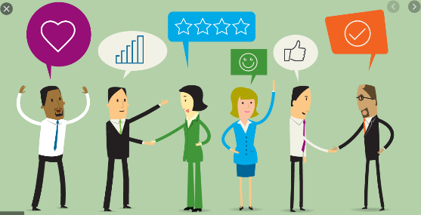

Contents

Introduction: page 3
Task 1- Critical evaluation of three development vehicles: page 3
- Employee engagement: page 4
- Feedback and Reward: page 7
- Leadership and Management development: page 9
Task 2- Assessing the potential benefits to the organisation: page 10
Task 3- Plan to meet the development needs and expectation: page 11
Conclusion: page 14
References: page 15

Introduction:

An organisation’s success mostly depends on its employees that’s why the employees are called as organisation’s most valuable resource. That’s why it is essential for an organisation to plan a development process for its employees to maintain the good relationship and motivate them to maximise the working efficiency. The employee’s development can be referred to the process of increasing the skills, knowledge, capabilities through training, seminar, coaching session and motivating them financially and non-financially. According to Norton, M.S. (2008) ‘Staff development is defined as the process of providing opportunities for employees to increase their knowledge, skills, and performance in line with the goal and values of the organisation and in relation to the interest and needs of employee.’ There are various employee’s development vehicles available for an organisation like; motivation, employee engagement, learning and development, appraisal, rewards, leadership and management development etc. but this should be selected by considering the needs of organisation and employees. However, to meet the requirement of this assignment this report will be produced based on the three given task such as: Task 1, critically evaluating the three development vehicles; employee engagement, feedback and reward, leadership and management development. Task 2, critically assessing the potential benefits to the organisation in using these vehicles. Task 3, developing a plan using six examples to meet the identified development needs and expectation of an individual.

Task 1- Critical evaluation of three development vehicles:

Development vehicle can be defined as method for using to develop the employees. Any organisation uses various kind of development vehicles. Using the development vehicles by an organisation depends on the situation, organisation size, type, nature and requirement for the job role etc. like for whom development vehicles needed and for what kind of development needed. That’s why, using those development vehicles may vary by organisations, also same vehicle may be used in various organisation. However, following are the critical evaluation of three developments vehicles.

Employee engagement:
The concept employee engagement involves in ensuring the employee go extra mile for the organisation or beyond the expectation. According to Cook, S (2008) employee engagement can be summed up by how positively the employee:
- Thinks about the organisation.
- Feels about the organisation.
- Is proactive in relation to achieving organisational goals for customers, colleagues and other stake holders.

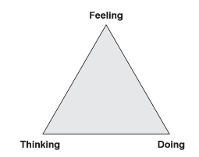

Graph 1: Three aspects of engagements (source: Cook, S 2008)

Now the question arise why an employee goes or should go extra mile or does something extra for the organisation. The elements of employee engagement answer the question. According to Armstrong, M, Brown, D, and Reilly, P (2010), there are three elements for employee engagement which can are presented by below Graph 2.

Engagement
Commitment
Organizational
Citizenship
Motivation

Graph 2: Employee Engagement’s Model. (Source; Armstrong, M, Brown, D, and Reilly, P 2010).
Commitment: In general, when we make promise, we try our hard to keep it. Similarly, employee’s commitment with the organisation for their obligatory duty they will perform beyond the expectation for the benefits of the organisation.
Organisational citizenship: When an employee gat deeply involves with the organisation and he/she realise the involvement will go extra mile for the organisation. Some time employee gets involve in decision making process and to make a plan. In this case the employee will do every possible thing to make this plan successful as he/she is involved in it.
Motivation: Is the most powerful tool to make the employees engaged with the organisation. As human nature to do something we look for our demands to be satisfied. In term of employee motivation Maslow’s hierarchy of needs can be bought forward. Which is presented in below Graph 3.
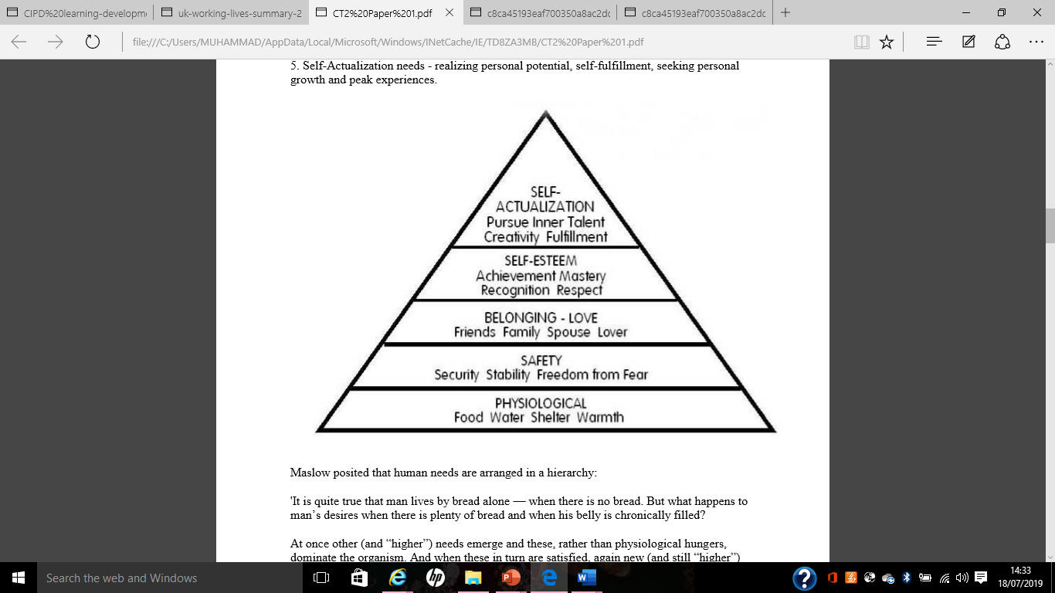

Graph 3: Hierarchy of needs described by Maslow (Source; McLeod, S. A. 2007).
So, the employees will go be engaged with the organisation if they see there is benefits or rewards for doing these. If we look at Maslow’s hierarchy needs, it is clear that a person will firstly demand the basic needs to be satisfied and then will go for further stages. That’s why the degree of engagement differs by individuals and depends on their needs and how well it is satisfied. Also, an employee who is well engaged with the organisation will find a batter way to gat the task done. According to CIPD (2010) there are a range of positive results of employee engagement such as: batter performance, innovative or creative idea, higher score in performance review, stay with organisation and pleased with personal wellbeing.
However, the main criticism of the employee engagement is only the permanent or regular employees will be engaged with the organisation where they see their wellbeing within organisational wellbeing. But what about temporary or seasonal workers. Employee engagement program will be failed here as those employees are after fulfilling the basic needs and do not look for promotion or self-establishment within the organisation. For example; as taxi driver in Uber I have personal experience the employee engagement does not work for this type of company as the people working just to get fair rate, where the employees have no time to think about the company. Because, the Uber drivers are only connected with the company for picking up and dropping off a customer and get the payment. Also, employee will not be engaged with organisation only by commitment rather they will look for other benefits like rewards or bonus to go extra miles. Furthermore, not every employee will behave as the organisation as their own rather will look forward how to maximise the income and rewards. That why trying to make those employee organisational citizens will be failed there for the idea of employee engagement program. Also, engaging employee through Maslow’s hierarchy needs model can not be applied always and every where, as persons demand varies country and areas. For example; in some Asian countries people can get love and sex even before getting the food and shelter, also some people gained self actualized before their other demands are fulfilled like writer, philosophers, and scientist etc.
Feedback and Reward:
To attain the organisational goal, it is vital to ensure the productivity or high performance from the employees. That’s why the performance must be measured, and feedback should be given to employees regarding the performance. Also, it is essential to put a reward system in place to motivate the employees. The term feedback can be defined as a process of telling or letting the employees about their performance. The reviewer should be neutral as close relationship with the recipient will affect the feedback. According to Leanne, E, A, David A, W (2008) ‘As a feedback provider consider the relationship you have with the recipient. If this is a relationship characterised by mutual trust and respect, there will be more likely to receive negative feedback as constructive.’ Providing feedback is beneficial for an organisation like feedback system remind the employees their commitment and job role and make them accountable for any gap, it make the employees aware that some-one is watching their performance so can not avoid the given task, its motivate the employees thorough reward systems and the employees have the opportunities to fill the gap which can increase the productivity. For example: Uber driver get instant feedback from the customers through their app and it create the drive credibility to the company and continuous low rating drivers will loose access to the app (Uber 2020). Which determined that the drivers are customer focused.
Again, the reward system can be defined as a set of process to motivate or engage the employee to meet the given target in line with organisational goal. According to Armstrong, M and Brown, D (2006) ‘Strategic reward management is about the development and implementation of the reward strategies and philosophies and guiding principles that underpin them.’ The aims of the reward strategy can be outlined as below.
- Drive all the employee’s positive behaviours towards organisation.
- Reward the right things to convey right massage about what is important in terms of expected behaviours and out comes. (Armstrong, M and Brown, D 2006)
- Increase the employees accountability there for productivity.
- Building employee relationship.
- Reward the employees for the value they create.
- Increase the employee’s commitment to an organization, including productivity, work quality, competitiveness and facilitate employee engagement and involvement (LinkedIn 2019).
Furthermore, it is also essential to make the reward system effective and attractive to the employees. Where the reward can be provided in various aspects and which is presented by below graph 4.
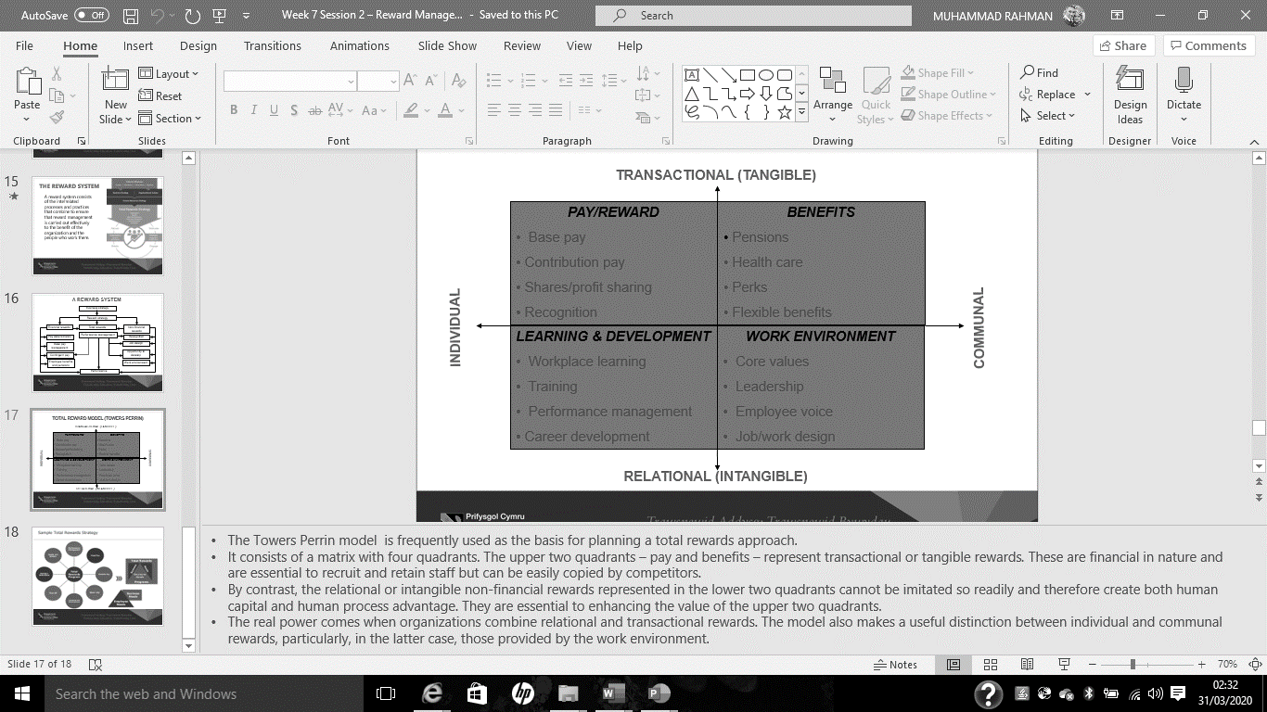

Graph 4: Towers Perrin total reward model (source UWTSD 2020).
However, Feedback and reward system also have some limitation like good and bad relationship with subordinates will affect the feedback process through performance evaluation as the reviewer may take any personal revenge on any subordinates that he/she doesn’t go along. Also, the rewards system may fail to ensure the productivity if the expectation or targets are set too high to get the rewards, where the employees will be demotivated.
Leadership and Management development:
It is crucial for an organisation to have enough qualified managers to achieve the organisation’s goal. Where a manager must need to have the both managerial and leadership skills to manage and lead the team towards achieving the goal. That why it is important for an organisation to put in place the leadership and management development program. Where this program can help not only developing new managers but also increasing the skills and knowledge of existing managers too. However, the meaning and function of a manger and a leader are not same. That why both term leadership and management need to be discussed individually.
The term leadership can be referred to leading a team to achieve the organisation’s success or goal through motivation and inspiring the team. Where a leader casts shadow on the team member to motivate them to follow the instruction and complete given task efficiently and effectively. According to David I, B. (2009) ‘leadership is the combination of characteristics or personality traits in an individual that compels that person to inspire other to achieve goals that, without the leader’s motivation, would not normally be accomplished.’ That why a leader must have certain qualities and skills. According to Morgan, P (2017) a leader should have the skills and qualities such as Vision, Influence/persuasion, Directing, Challenging, and Communicating. In addition, leaders should also have the skills of:
- Innovation or creativity to develop ideas that are beneficial for the organisation.
- Honesty/integrity, a leader must act honestly and make it clear to subordinates what need to be done and showing the results to the team.
- Awareness, a leader must be aware of what’s happening in surrounding and should be able to provide up to date information.
- Cast shadow of a leader, where the leader must be able to influence the team and put team in action to accomplish the given task.
Again, the term management can be defined as a process of planning, organising, coordination, leading and controlling the team and other resources to achieve the organisation’s goal. For the purpose of achieving the organisational goal effectively and efficiently, the process of planning, organising, leading and controlling the organisational resources is known as management (Daft, R, L, Kendrick, M, Vershinina, N 2010). As the managerial task is critical for the organisation success the managers must have certain skills, knowledge, and qualification to be a manager. Where the qualification can be pre established from formal institution and the required knowledge and skills can be gained through working and getting training. According to Bagad V.S. (2009) Managers must be able to develop business plan or carry out numerous functions of the managerial task, that’s why they need sound knowledge base and key management skills such as Technical skills, Human skills, and conceptual skills. In addition, a manger should also have following key skills:
- Skill of managing the people and increase the productivity by observing subordinate’s performance.
- Ability to plan and implement it to bring benefit to the organisation.
- Ability to coordinate the people and other resources to achieve the organisation goal.
- Build good relationship with steak holders like; colleagues, customers, suppliers and share holders etc.
However, despite the leadership and management look similar and both must be present within a manager, still the both terms differ form each other. Leadership is the process persuading and influencing other to get the job done, where management is the process of controlling the human behaviour to get the job done. Leadership involve in casting the shadow on others to accomplish the task, on the other hand management involve in organising a group of people to get the job completed. A leader lead by example by doing the task him/her self to influence other to follow, but a manager provides instructions and guidance to subordinates.
Furthermore, an organisation must choose the right person for the management to attain the organisational goal and it can be done through various test and examination, where the individual must understand and bale to perform the job role. According to Bruce, J, A. (2011) ‘A significant aspects of developing leadership potential require knowing the expectations one should have of others and stretching them when an individual or group of individuals is prepared to be stretched.’ To develop managers the organisation can approach to either formal or informal management development. Where formal management development involves in training, gaining experience as planned, coaching, mentoring, learning within the organisation and other institution, self-development structured. Informal management development involves in unplanned experienced where the employee gained the experience by working which was not pre planned and able to demonstrate the primary experience and skills needed to perform the manger task. In here informal management development is cost effective than formal management development as the employee already gained primary knowledge and skills by working every day. But, approaching to informal management development also can be risky for the organisation. Because if none of the employees bother to or failed to gain required experience the organisation will face the shortage of managers. Also, formal development is not the 100% right approach as well as. Because after providing all the planned trainings and courses the employee may fail to obtain required knowledge and skills. That why an organisation may approach to semi-formal development as it involves in performance evaluation, discussing issues and opportunities and have a personal development plan.

Task 2- Assessing the potential benefits to the organisation:

Using those three development vehicles for employee development program is beneficial for both employees and for the organisation.
For the organisations, employee development program can ensure an organisation using the available resources effectively and efficiently. Also, employee engagement ensures the employees go beyond expectation or extra miles as they think, feels and does every possible things for the organisation (Cook, S 2008). For example, providing essential information to the Uber drivers by the company keep the drivers connected with the company there for more efficiency and productivity. These development program makes the organisation more competitive in the industry as the organisation is able to make the employee highly motivated and attractive rewards draw the rivals employees’ attention too. There for the organisation can take competitive advantage on the rivals to retain the employees and reduce the labour turnover too. Also, those development vehicles help to build better reputation in the industry which will attract more customers there for the organisation can maximise its profits.
For employees, Using those vehicles can ensure the employees are getting what they deserve like financial benefits, rewards for going beyond the target, gaining the right skills and experience to get potential promotion that’s why it will build good relationship between the organisation and employees. For example: from my own experience working for Uber, the rewards system for driving extra miles or waiting extra time for pick up make the drivers happy to be more professional with customers there for goodwill of the organisation. These development program also help the employees to be productive and get pay rise, make them feel valued at work there for happy at work.

Task 3- Plan to meet the development needs and expectation:
The personal development plan is a process of identifying an individual training needs, make plan and implement the plan. According to online portal MindTools (2020) following six steps should be taken to plan an individual development need.
1. Analyse the job role.
2. Observe the performance.
3. Analyse the gap between the role and performance.
4. Meeting with individual.
5. Identify the training needed.
6. Plan and implement the training.
However, using the PDP is beneficial for an individual as it help the individual to focus on specific identified developments needs According to Cottrell, S. (2010) ‘PDP bring together three concepts of personal development improving learning, performance, and forward planning to achieve goal whether academic, personal, professional.’ as individuals’ developments needs differ by persons, that’s why it is essential to create personal development plan separately for each individual. But first of all, an individual development needs must be identified. This can be done through analysing the feedback, performance appraisal etc. In here as working with Uber following six example of development needs can be identified in myself by using feedback given from customers and the manager.
1. Time keeping.
2. Communication through the app.
3. Adaptability.
4. Goal setting.
5. More customer focussed.
6. Productivity.

By using above six example following table 1 can be created as my PDP.
Development needs | Description | How and when to gain | Status/Rating and completion by date
1. Time keeping. | Time keeping need to be improved, where the target to reach at work at least 15mintues before. | Need to set alarm on appropriate time and need to analyse the rush hour and calculate average time needed to reach at taxi base and this need to be done straight way | Need to put a date when it achieved or the status if not achieved or how confident to follow the time keeping.
2.Communication through the app | Need to fully understand how to communicate with the base through the app instead of calling and waiting long for the call to be answered. | Need to navigate through the app and play the training videos and manual guide for using the app. And this need to be done within one week | Need to put the completion date and status as fully understand the app or not.
3. Adaptability. | Must accept the upcoming changes like update in the app, only communicate through the app. | Need to update the app and go through the usual manual guide again to learn any new changed. And need to be completed in 2 days. | Need to put completion status and date once completed or record what left.
4. Goal setting | Need to able to set a goal like working 8 hours a day and 5 days a week to earn the suitable money. | Bring up the calendar and find any upcoming events and appointments and schedule my working hours. 1st of every month and review every week in advance for any amendment. | It can be ongoing as need to plan every month and review weekly
5. More customer focused | Need to be more customer focused and give full attention. | Can be done through taking online courses or sort time courses from any institution. Need to admit in the course within 2 weeks. | Put the status when take admission for the course and record completion date once the course is completed.
6, Productivity | Need to be more productive like, ensuring accepting the job on the app in a timely manner and picking up the customer in a timely manner too | Check the app tone if it sufficient for me to listen, watch the training video for accepting the job and how to pick customer in a timely manner. Need to eb done in 2 days | Record the completion date and rate how confident.

Table 1: PDP of Mr. A.

Conclusion:
The loyal and highly motivated employees will not hesitate to go extra miles for the organisation. And the employees become loyal and motivated when they are happy with the employer, which also mean the good relationship between employees and employer. Ensuring the using of development vehicles are essentials for an organisation to develop it employees which bring benefits to both organisation and employees and build a strong bond between both employees and employer. Also, using a PDP for any individual is a useful tool to focus on developing the identified needs.

References:
Armstrong, M, Brown, D, and Reilly,P (2010), Evidence-Based Reward Management: Creating Measurable Business Impact from Your Pay and Reward Practices. Kogan Page Publishers.
Armstrong, M and Brown, D (2006), Strategic Reward: Making it Happen, Kogan Page Publishers.
Bruce, J, A. (2011), Full Range Leadership Development, SAGE publications.
Bagad V.S. (2009), Principles of Management, Technical Publications, 2009.
CIPD (2010), Creating an engaged workforce, https://engageforsuccess.org/creating-an-engaged-workforce-cipd-report-2010 updated 8th January 2013. Last access on 28/03/2020.
Cook, S (2008), The Essential Guide to Employee Engagement: Better Business Performance Through Staff Satisfaction, Kogan Page Publishers.
Cottrell, S. (2010), Skills for Success: Personal Development and Employability, Macmillan International Higher Education.
David I, B. (2009), Leadership in organisation: There is a difference between leaders and managers. University press of America, 2009.
Daft, R, L, Kendrick, M, Vershinina, N (2010), Management, Cengage Learning EMEA, 2010.
Leanne, E, A, David A, W (2008), Leadership, Feedback, and the Open Communication Gap, Psychology Press.
LinkedIn (2019), Aims & Objectives of Reward Management, https://www.linkedin.com/pulse/aims-objectives-reward-management-basel-iskandar, last access on 28/03/2020.
Morgan, P (2017), The business students guide to study and employability, SAGE publications Ltd, London.
MindTools (2020), Career and Personal Developmental Needs, https://www.mindtools.com/pages/article/newLDR_06.htm. Last access on 29/03/2020
McLeod, S. A. (2007), Maslow's Hierarchy of Needs, http://www.simplypsychology.org/maslow.html, published 2007, updated 2013, accessed 27/03/2020.
Norton, M.S. (2008), Human Resources Administration for Educational Leaders, SAGE publications.
Uber (2020), Rating a driver, https://help.uber.com/riders/article/rating-a-driver?nodeId=478d7463-99cb-48ff-a81f-0ab227a1e267. Last access on 29/03/2020.
UWTSD (2020), Lecture slide 7, Reward management, BMSW5002
Developing Relationships and Workplace Achievement.

