

Urbanisation of the Countryside in West Wales. Should we be using the countryside for developments?

School of Architecture, Built and Natural Environment:
University of Wales Trinity St David

Course:
BSc (Hons) Architecture

Name: Steffan James Phillips
Student Number: 1900856
Module code: M6X01986
Word count: 9,949
Date: 11/04/2022



Author’s Declaration
I declare that the work in this dissertation was carried out in accordance with the regulations of the University of Wales, Trinity Saint David. The work is original except where indicated by special references in the text and no part of the dissertation has been submitted for any other degree.
Any views expressed in the dissertation are those of the author and in no way represent those of the University of Wales, Trinity Saint David.
The dissertation has not been presented to any other University for examination either in the United Kingdom or overseas.
I hereby give permission for my work, if accepted, to be available for photocopying and inter-library loan, and for the title and summary to be made available to outside organisations.

Signed: SPhillips | Student name: Steffan James Phillips
Date: 11/04/2022 | Insert date: 11/04/2022

Copyright statement

The copyright of this dissertation rests with the University of Wales, Trinity Saint David. No information derived from this dissertation shall be published without the prior written consent of the University.

Signed: SPhillips | Student name: Steffan James Phillips
Date: 11/04/2022 | Insert date: 11/04/2022

Abstract

Sustainable developments are essential for future generations for the greater wellbeing and greener environment. With an increasing population, negative commuting figures within Carmarthenshire and the need for new housing and developments is required. There are focused documents on LDPs and policies for future developments, but the issue is raised with updated regulatory. Most policies are outdated and require to be updated more regularly to satisfy any recent changes within our communities. New developments need to provide guidance and improvements with applications of policies, such as The One Planet Living policy. Regular assessments throughout the development would be greatly relevant to ensure that nothing is incorrect during the construction process. This would help to maintain the standards of the developments to ensure that it is following the right direction to achieve its ambitions.
Questionnaires were sent out via email, to understand different views on the concept, and see how other individuals approach the process. With their knowledge, they allowed to understand the local area more, which made it more relevant for this study.
Research into different policies and revised several times to understand what the current standard and regulations are for proposals. This helped to understand what was needed and had room to target and improve. Additionally, to be able to acknowledge whether they could be more applicable for certain areas of the LDPs. It is acknowledged that these documents need to be re-considered, and whether more focus on funding can be put behind developments to ensure that the best source of energy efficiency can be applied in future developments. Focus on the goals set by The Wellbeing of Future Generations (2015) can be introduced with clear demonstration of how they aim to achieve this.

Acknowledgements

Firstly, I would like to thank my supervisor, Ryan Stuckey, who provided me with guidance, encouragement and support that has been very valuable throughout my dissertation. I would like to thank Dr Elizabeth Walder for supporting me with my academic writing and encouragement, along with some useful resources. Her extra time and tutorials have been invaluable to help improve future writing. Additionally, I would like to thank the rest of the staff on my course at UWTSD, for their advice and knowledge that is very much appreciated.
Secondly, I would like to thank the participants who took their time to respond to my questionnaire. Their views and responses have helped guide the research used for this study.
Finally, I would like to thank my family who have supported me throughout the whole academic year by pushing me forward with words of encouragement and reassurance. Along with the students on my course, we have ensured we keep positive, supporting each other with workloads, coming along into university to put in additional hours of work.

Table of Contents

Author’s Declaration | 2
Copyright statement | 3
Abstract | 4
Acknowledgements | 5
List of Illustrations | 7
List of Tables | 8
Introduction  Why is West Wales the chosen focus?  Aims and Objectives  Definition of Urbanisation  Literature Review  Chosen Case Studies  Legislation  Key Players and Talks | 9  9  9  10  10  11  11  14
Methodology | 15
Chapter 1: Population and densities with reference to LDP  Wales population and densities  Population in rural areas in Carmarthenshire  Statistics for housing in urban and rural areas  Employment level rates in Carmarthenshire  A clear demonstration for new proposals  Needs of an expanding population  Chapter conclusion | 17  17  18  19  20  22  22  23
Chapter 2: Case Studies  Lammas Eco-Village  BedZED  The Solar Settlement | 24  24  26  28
Chapter 3 Comparison of case studies  Tir y Bont  Parc Mawr | 31  32  33
Chapter 4: Survey Analysis  Tan 6 and PPW supporting One Planet Development  An issue of funding for energy efficiency strategies | 38  40  41
Conclusion | 42
Bibliography Published Work  Bibliography Unpublished Work | 45  49
Appendix A: Survey | 50

List of Illustrations

Figure 1: Diagram of the seven goals set by The Wellbeing of Future Generations Act 2015 | 12
Figure 2: Diagram of the density population in West Wales | 19
Figure 3: Exterior of living accommodation within Lammas  Figure 4: Interior of living accommodation within Lammas  Figure 5: Exterior of BedZED development  Figure 6: Interior diagram of M&E system within the development  Figure 7: Exterior of the Solar Settlement development  Figure 8: Cycle parks situated within the development  Figure 9: Progress diagram for improvement of public transportation  Figure 10: Screenshot from Persimmon Homes website providing their inspiration sources  Figure 11: Concept sketch of Parc Mawr development | 24  24  26  27  28  28  29  32  33

List of Tables

Figure A: Table Comparison of Case Studies | 31

Introduction

Why is West Wales the chosen focus?
For this dissertation, the chosen location of research was Carmarthenshire, West Wales. 60% of Carmarthenshire’s population live in rural areas, which is nearly double the Welsh average (Youle, 2020). The most important target post covid-19 is to enhance the local economy with providing increased jobs and opportunities for those communities within rural areas (Youle, 2020). After an annual report at Carmarthenshire Council’s general meeting on June 10, 2020, Cllr Dole said:

“in light of Covid-19 we realise more than ever that we need to look locally, and in supporting and developing that economy we will become an even more resilient and robust county” (Youle, 2020).

He also added that the authority would spend £150 million into building council dwellings over the next five years and hope to invest a further £255 million on other projects. In conjunction with support from Plaid leader also stated that they would invest £86 million into upgrading or building new schools (Youle, 2020).
This information suggests that Carmarthenshire need economic development and proposals to help provide the areas with more jobs and communal opportunities.

Aims and Objectives
An aim of the dissertation is to create a more accurate strategic policy for the Local Development Plan in the chosen region. In order to achieve this, web research, interviews and questionnaires to understand the current policies in place to gather information to understand what could be included or changed. Recommendations can be made into whether these policies are up to date enough to keep up with current situations. Are these defined enough to allow for a strict sustainable design with the least environmental impacts.
Another aim is to use examples of European / local case studies that show great exemplar work towards a sustainable design that gives back to the community with the lowest possible effect to the environment. These case studies then can be compared with other developments that show a weaker approach to sustainability and wellbeing. Along with research of policies and applications, these can be recommended to the examples of developments.
To showcase several possible solutions for a more sustainable development in West Wales for the wellbeing of future generations. Web research methods will be used to discover ideas that could improve urbanisation and to make best use of the land. This is to satisfy housing needs for population and to improve our environment.

Definition of Urbanisation
“Urbanisation, the process by which large numbers of people become permanently concentrated in relatively small areas, forming cities” (Britannica, 2021).
“Urbanisation is the process through which cities grow, and higher and higher percentages of the population comes to live in the city” (Geographic, 2021).
“Urbanisation is the process of creating towns in country areas” (HarperCollins, 2022).

Literature Review
At the beginning of this dissertation, a literature review was administered with the use of search terms to find the most updated articles and documentations that were most relevant to the study. This study defined the definition of Urbanisation, along with several issues with over population and over developments for Carmarthenshire rural areas. A conference attended by the researcher, for example, Wood Knowledge Wales, an RSAW Conference 02/12/2021, hosted by Gary Newman to acknowledge the importance of community and lower carbon emissions in housing. Furthermore, to understand statistics of environmental impacts and initiatives to improve housing towards a net zero development. Additionally, research into government documentation and policies to understand what each policy is designed and written for. These are found on Carmarthenshire County Council web page and are easily accessible.

Key Bodies
The key bodies that the researcher will be using for the dissertation are:
- Carmarthenshire County Council
- Welsh Assembly Government
- The Planning Inspectorate

These key bodies will help provide the researcher with government approved documents with current guidelines and policies. These documents can be regularly referred to throughout the dissertation and provide the facts and statistics needed for the purpose of this research.

The Chosen Case Studies researched into for the Purpose of the Dissertation
- Lammas Eco Village, Pembrokeshire
- BedZED Factory, Beddington, South London
- Solar Settlement, Freiburg, Germany
- Tir y Bont, Coity, Bridgend

These case studies were selected carefully to gather information on projects that included relevant concepts and policies. For example, policies that support sustainable rural developments, such as One Planet Living, the Future Generations Acts and Local Development Plans. Similarly, the case studies were chosen to compare and contrast and share best practice to inspire the planners of Carmarthenshire for future developments. These examples can aid the thoughts of future developments to create a more sustainable and healthier living conditions that abide with the Future Generations Act 2015. Both examples of different approaches to design and developments are used to digest how various designs can be used for customer benefits or environmental benefits. Research into exemplar work of sustainable living along with examples of eco-living and live / work units help the researcher and future investors understand speculative designs into creating better developments

Legislation
The Well-Being of Future Generations Act gives us the “ambition, permission and legal obligations to improve our social, cultural, environmental and economic wellbeing” (Wales, 2015). This unique Act for Wales has attracted global interest, as it will create opportunity future generations. This legislation demonstrates the importance of healthier living conditions for future generations and references the question of urbanisation the benefits of living in rural areas.
This legislation is appropriate as it showcases the importance of a healthier living conditions for future generations and upcoming decades. This refers to the question of urbanisation and how we can improve the benefits of living in rural areas and what ambitions are heavily focused on in the design process and initiatives for Wales.

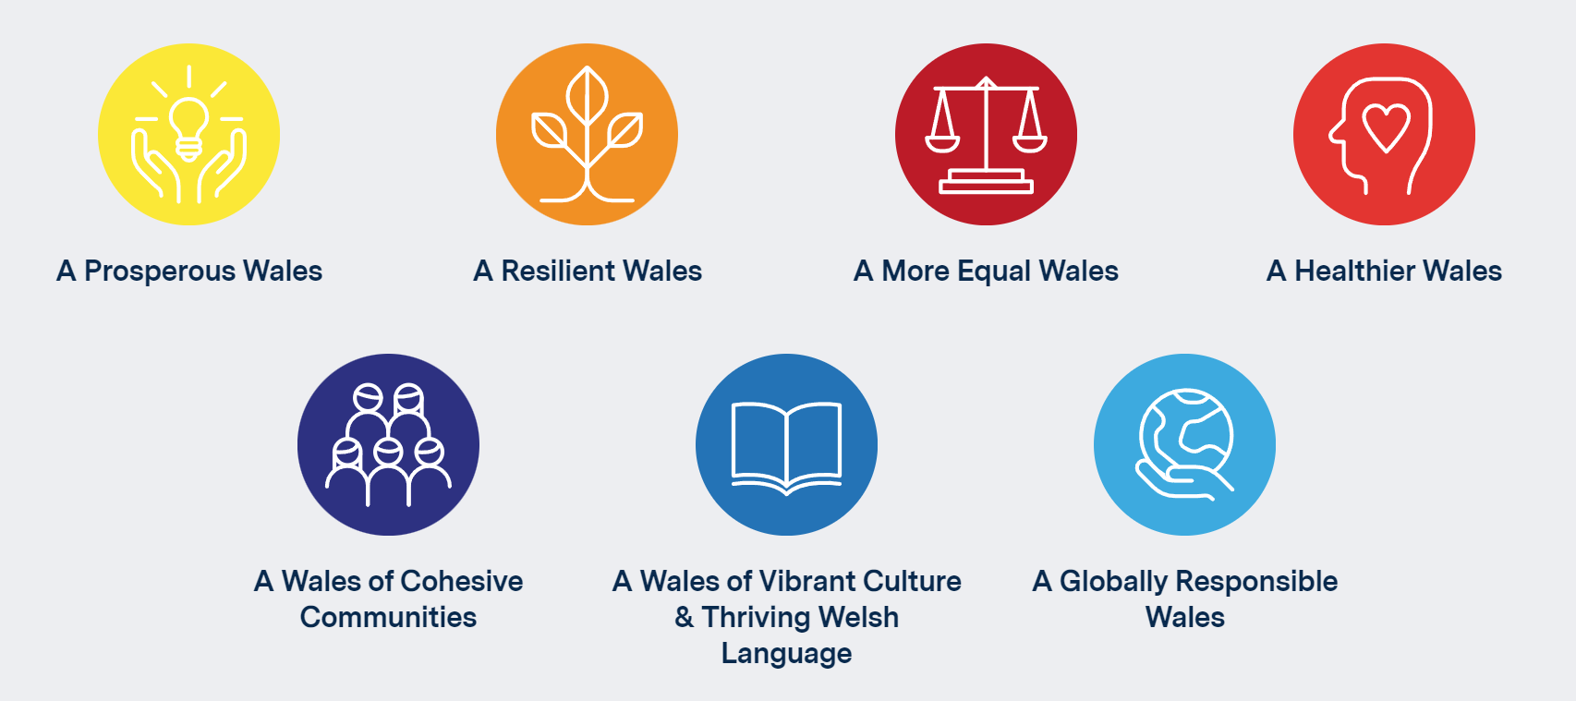
Figure 1: Diagram of the seven goals set by The Wellbeing of Future Generations Act 2015
Credit: (Wales, 2015)

The One Planet Living development as it aims to set out land use planning to encourage sustainable communities in a rural context. Aims to apply low impact development principles and being great examples of sustainable developments. The guidance of One Planet Developments addresses this in rural communities away from existing settlements.
Open countryside’s include areas of sparse small villages and hamlets and land on edge of establishments which would not be considered for development. They explain how the countryside should be located to adjoin settlements that new buildings there should be strictly controlled. This advises future developments in the countryside to fulfil requirements and planning authorities need to strictly revise the planning proposals in rural areas. Essential characteristics should be met to improve the symbiotic relationship between people and land to provide a much greater sustainable future with huge reduction to environmental impact as possible. This policy ties in with the Future Generations Act 2015 with its approach to these issues with community living and the integration of eco living.
This policy is very useful to refer to in this academic research as it applies certain principles for sustainable designs to improve the impact it has on environmental and social wellbeing. Due to this policy being aided by the Welsh Government and the Technical Advice Note 6 (Tan 6), it includes valid information due to being backed by approved bodies. The information on planning to encourage sustainable communities can be often referred to throughout the dissertation as it has great relevance to the question of “Should we be building in the countryside?”.

Planning Policy Wales Edition 11 (2021) is the national policy outlining guidance for making planning decisions, and: - will help to ensure that the planning decisions taken in Wales, no matter how big, or how small, are going to improve the lives of both our current and future generations” (Welsh Government, 2021).
This policy delivers a vision of Wales that they want to set out in the Future Generations Act, along with their seven goals (Government, 2018). It focuses on improving wellbeing in all aspects of its goals. They aim in the direction of a low carbon, resilient society, improving and creating more well-paid jobs and building with a grater connection to the environments for all in Wales. Furthermore, they look to prepare for a more divergent population, by encouraging the integration of services, embedding social cohesion, and establishing better examples of new housing developments and sense of belonging to the sites (Government, 2018). Additionally, these policies show clear views for future urban and rural areas and communities, emphasizing innovation and new technologies to anticipate that Wales have the leading edge of planning (Government, 2018).
Planning Policy Wales is a very advantageous document as it focuses on the planning decisions taken to ensure that every step is proven to be able to improve each goal of the Future Generations Act 2015. With ambitious aims like this, it allows opportunity to create a better economy for the social aspects of living with providing more jobs for local residents.
The Carmarthenshire Local Development Plan (2018-2033) sets out policies for proposals for future use of land in the main development in Wales. This plan aims to cover the periods of every fifteen years to echo the national policy in Wales. The policy gets revised for Carmarthenshire with Delivery Agreements which is rectified by the Welsh Government. This is used for planning applications to sustain future investment programmes within certain areas. This includes infrastructure as well as plans and strategies.
This deposit plan helps focus on certain locations with more accurate figures and statements. Due to its fifteen-year periods, future plans and developments are put into consideration with aims to improve future proposals. These are very important to the researcher as it greatens knowledge on what policies and restrictions are in place to achieve its goals such as, significant improvement to its infrastructure and strategies to building in rural areas.

Due to the increase in population and density in Wales, does this mean we will eventually start running out of space? Are Local Development Plans updated regularly enough to satisfy housing and development requirements? After acknowledging that the Local Development Plan 2018 and the Future Generations Act 2015 is still not yet to be updated to a more recent time, could this be the beginning of a problem with planning and approaches to future developments in Wales

Key Players and Talks
The key player contacted for this dissertation was David Thorpe (Director of the One Planet Centre), Jon James (Architect from Jon James Studio Architecture), and David Darkin (Architect from Darkin Architects). These key players shared their knowledge and experience around architecture and developments, to provide their views for this dissertation. A talk that was attended for the purpose of this dissertation was Wood Knowledge Wales, hosted by the RSAW and spoke by Gary Newman (Executive Chair of the Alliance for Sustainable Building Products) attended on the 02/12/2021.

Methodology
The chosen research materials used for this academic dissertation are:
- Web research and documentary sources
- Government and legislative data
- Interviews and questionnaires
- Fieldwork surveys with informative data of selected case studies

Methods (1) and (2) are accessible via the internet. Any communicative information, such as for (3) and (4) is completed by email, phone calls and video calls.

- Web research and documentary sources
A web study at the beginning of the dissertation research period into rural development initiatives discovered a number of varying approaches from stakeholders and government bodies. Throughout the literature review, the researcher used government published documentary sources which include a wealth of information that evaluates the issues surrounding and the opportunities available for improving rural developments.

The researcher also attended online talks and seminars to gather important material and talks with professionals in their chosen fields.

- Government and legislative data
The researcher investigated several key government and legislative documents, including the Carmarthenshire Local Development Plan, Planning Policy Wales and additional approved policies and documents for rural developments. These documents are explained in further detail in the literature review of this dissertation. Statistics for population and housing growth, available from the Office of National Statistics, also reveal significant changes of overpopulation.

- Talks and questionnaires
Questionnaires were sent via email to individuals as part of the research to ascertain a range of opinions and approaches to rural developments. Recipients included local architects and professionals in the field of architecture, planning and housing. A key individual, David Thorpe who specializes in the One Planet Development Policy, was able to share insight into the importance of this policy for future developments and residents.

The complete questionnaire is included in Appendix A of this dissertation.

- Case studies
A series of four residential case studies were selected that showed exemplar work of sustainable design, including live / work projects. The significance of each case study has been researched allowing information on best practice to be collected and compared.

Chapter Discussion 1: Population and densities with reference to Local Development Plan

“The focus on regeneration and growth reflects the Council’s core strategic ambitions with development distributed in a sustainable manner consistent with the spatial strategy and settlement framework” (Stephens, 2020).
The spatial approach to land representation, provides a balanced community and sustainable growth strategy. The spatial hierarchy will explore to characterise areas across the County, expressed through the settlement framework as collected clusters (Stephens, 2020).

Wales Population and Densities
According to the Office for National Statistics, the population in Wales for 2020 is estimated to be 3,170,000. This is an increase of 263,100 since 2010 (WelshGovernment, 2021). Population figures suggest that it will increase further, by 2.6% to 3.25 million between 2020 and 2030. Future projections suggestion an increase to a further 4.2% to 3.30 million (Projection, 2022). The population density in Wales is set to be an estimated 148 people per square metre (WelshGovernment, 2022). Welsh land is used for agriculture, forestry or is common land which makes up for approximately 85% of the land (WelshAssemblyGovernment, 2008).
These statistics suggest that the population projection is set to increase over a number of decades. Such a forecast will raise the issue of, is there enough housing capacity to satisfy the needs of an expanding population? Alongside these projections, one should question whether planning policies and development plans consider this growth, while creating strategies for developments into the countryside. Is there enough focus on creating work / live space and units in rural areas? The Carmarthenshire Local Development Plan 2018-2033 (LDP) plays a key role in decision making to ensure that it is prepared to operate within the national framework set through the Welsh Government legislation and by Planning Policy Wales and accompanying the various Technical Advice Notes (CarmarthenshireCountyCouncil, 2021). According to the LDP, it identifies a number of key areas that influence the plan facing working within rural communities.
The list of influences follows as:
- Economic development
- Planning and housing
- Education and skills
- Broadband and digital skills
- Tourism
- Transport and highways
- Agriculture and food
- Community resilience, access to services and third sector
- Renewable energy
- Environment and waste
- The way forward
Along with all these factors focused within the LDP, the evidence is revised and proved integral to form both critically through Preferred Strategy but also detailed proposal for the Deposited Plan. A demonstration of sufficient capacity in the existing infrastructure exists to help supply and aid any proposed development. This comes within the strategic policy within the LDP, where the plan provides a number of sustainable factors for developing into the countryside and British standard to follow and achieve. If this is not fulfilled, proposals will need to demonstrate that applicable preparatory measures are in place to present appropriate infrastructure capability to deliver and assist the development.

Population in rural areas in Carmarthenshire
Carmarthenshire is the third largest county in Wales which in 2005, had a population of 178,000 people. This population lived within 2394 sq/km which comprised 11.5% of Welsh land (Willis, 2010). According to the migration report, approximately 64% of the population occupy 20% of the land’s mass, centred in the towns of Llanelli and Aman and Gwendraeth Valleys (Willis, 2010). With scattered communities and urban developments, Carmarthenshire is seen to be abundant yet with pockets of severe deprivation.

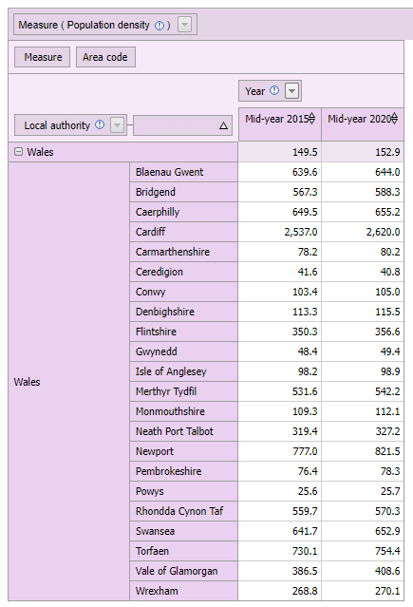
Figure 2: Diagram of the density population in West Wales
Credit: Stats Wales (WelshGovernment, 2020)

Statistics for housing in urban and rural areas
Around 20% of Wales population is classified as broadly rural using the National Statistics classification of settlement type and context. That is, outside the large or small towns in the less sparse context (WelshAssemblyGovernment, 2008).

According to the commuting patterns by Welsh local authority and measure (2020), there are 62,600 people living and working within the same area in Carmarthenshire (WelshGovernment, 2021). From these 62,600, some 16,200 people commute away from the area whilst 14,900 people commute in. This negative figure of -1,300 people suggests that there could be a lack of sufficient work / live developments in Carmarthenshire to keep residents from moving away to look for work.

Employment levels Rates in Carmarthenshire
According to Welsh local area (WelshGovernment, 2021), 69.2% of inhabitants of Carmarthenshire were employed in the year ending in September 2021. To compare with the 72.1% of people working in the year ending in September 2019, these two figures show that the decrease in employment rate in Carmarthenshire in the last two years suggests that there is not enough work to satisfy residents. One questions where or not this issue is addressed sufficiently within development plans for the county? The LDP do indeed consider this within their deposited plan. Carmarthenshire state that employment land is allocated in sustainable locations which conforms with the sustainability fundamentals of the plan (CarmarthenshireCountyCouncil, 2021). Along with supporting small sustainable employment settlements, Carmarthenshire recognise that they have support entrepreneurship as a part of the creation of a diverse and growing economy. The aspirations of the Future Generations Act (2015) to have a ‘More Equal Wales’, as top of their agenda suggesting that equal opportunities and rural enterprises in the countryside should benefit rural communities and deliver a diverse and sustainable rural economy. The future developments of employment and future economic developments is viewed in a wider context. A deal signed in 2017, secured a £1.3 billion investment for Swansea, Carmarthenshire, Neath Port Talbot and Pembrokeshire councils and is set to transform the economic landscape and improve the local economy by £1.8 billion, providing almost 10,000 new jobs within the next 15 years. This very much applies to the issues of outflows from Carmarthenshire to help preserve keep within the area and offer more workspaces and jobs. Further examination of ‘A Wales of Cohesive Communities’ (Future Generations Act, 2015) reveals that people can remain active in their own community and “give back”: to the area and doing things that matter to them. By providing active communities, it allows others to have a more connected community between each other and access to key well-being services.
Whilst the strategic focus is based towards the deal, the LDP aims to present a variety of sites and opportunities for potential future investments and relocations. In doing so, future larger employers can accommodate smaller scale developments within the policy framework and providing scope into the future generations and proposals (CarmarthenshireCountyCouncil, 2021).
The LDP includes a format and structure which mirrors core elements of sustainability in developments. It provides four objectives that are established by the Carmarthenshire Well-Being Plan. This enables strategical policies to interlink with the Well-Being Plans objectives to cross reference each other throughout the document (Stephens, 2020).
These set goals are:
- Early Intervention
- Prosperous people and places
- Healthy habits
- Strong connections
These goals connect all approaches across every theme within the LDP to establish long term solutions for sustainability and maintain and enhance well-being. It allows a balance including environmentally friendly, economically vibrant, and socially inclusive characteristics that target prosperity of future generations (Stephens, 2020).
As a part of the corporate policy, Carmarthenshire County Council’s primary objective is regeneration of the county. All this is achieved via:
- Swansea Bay City Deal
- Moving Forward in Carmarthenshire – Corporate Strategy 2018-2033
- Moving Rural Carmarthenshire 2019

By establishing that housing requirements are cross referenced along with economic ambitions, it provides an integrated strategy for economic growth, rather than in isolation with housing needs. With its connection to Welsh Government projections and statistics, ambitions and strategies are allowed to work in conjunction with each other (Stephens, 2020).
This strategy explores to administer growth within a hierarchy settlement that has been derived from the preferred spatial option. Appreciation of the diversity across the county, along with its rich environment, biodiversity, natural and built landscape credentials, and its relationship to both the rural and urban area will aid delivery of the vision of ‘One Carmarthenshire’ (Stephens, 2020).
A clear demonstration for new proposals
Every development proposal requires the ability to demonstrate and deliver an effective strategy for specific design and sustainability objectives. Developments will need to deliver a solution for appropriate specifications for the local area and nature of the development (Stephens, 2020). Proposals will need to deliver a positive understanding of sustainability and high-quality design within local characteristics and consideration of landscape for a built environment.

Needs of an expanding population
The number of households projected to increase in Carmarthenshire by 2033, is by 6,780, an increase of 8.7% (Bullock, 2019).
With the need of an expanding population, housing is key and is allocated within the Local Development Plan. Within the plan, housing and land requirements are focused to achieve a structured hierarchy and distribution of growth. Instead, of setting a basic standard for every site, requirements are considered on a site-by-site, due to a range of locations density and need. Carmarthenshire’s ‘The rural housing of Carmarthenshire’ shows a need, illustrated in surveys supported by Welsh Government research (Bullock, 2019) which offers compulsory justification for investment within rural areas of Carmarthenshire.
The ‘Moving Forward Carmarthenshire – The Council’s Corporate Strategy 2018-2033’ (Jenkins, 2021) looks at a direct need in Carmarthenshire.

“Life is for living, let’s start, live and age well in a healthy, safe and prosperous environment” (Jenkins, 2021)

This ‘Moving Forward Carmarthenshire’ document focuses on key objectives and recognises the need to develop Carmarthenshire, and one of the key issues identified within this strategy is transport infrastructure. Working alongside the Future Generations Act 2015, in achieving ‘A Prosperous Wales’ as one of the Future Generations Act’s goals, they focus on the importance of transport is important, and how existing provision can be improved. A key role for sustaining a community and delivering the goals of a prosperous Wales, is transportation and highways: as these links, provide an integrated and affordable access network for business and residents. This is to ensure that they can stimulate economic development, reductions and deprivation and increase in well-being. Transport is a concern for Carmarthenshire with its highway network being the second largest in Wales, covering 3,545 kilometres, more than double the Welsh average of 1,566 kilometres. The road condition in Carmarthenshire was also ranked 17th out of 22 across Wales in 2017/18 (Stephens, 2021). In response, improved connectivity, and support to access to services is most certainly required. As an authority, any development of the transportation system by Carmarthenshire County Council will allow business to help grow and flourish in line with economic ambitions (Evans, 2021). Certainly, investment into infrastructure will support sustainable travel and active travel. For example, through improved cycle ways, footpaths, and public transport are, priorities of the Regeneration Plan and Swansea City Bay deal. It continues also to support community and rural transport (Evans, 2021).

In conclusion
With a large focus on all these supporting documents and investments, Carmarthenshire will benefit significantly while moving rural for developments to satisfy an increasing population. Specific priorities for each of these factors such as the employment rate and outflows of residents from Carmarthenshire, infrastructure and transportation and housing requirements, will give future developers and investors a reference point for future proposals. There are sufficient documents and policies to understand how to appropriately improve our rural development and ensure that we are making the most of the countryside.

Chapter Discussion 2: Case Studies
Case Study 1: Lammas Eco-Village
Lammas Eco-Village, located in the Preseli Hills in North Pembrokeshire was designed and built by local residents, and completed in 2009. £40,000 for the seven-acre plot. Homes cost anywhere between £5,000 and £70,000.

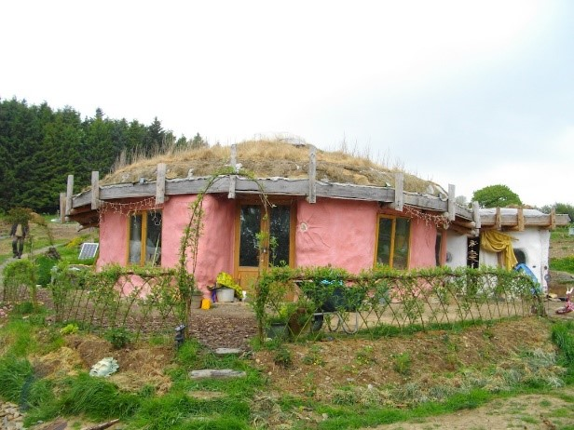 | 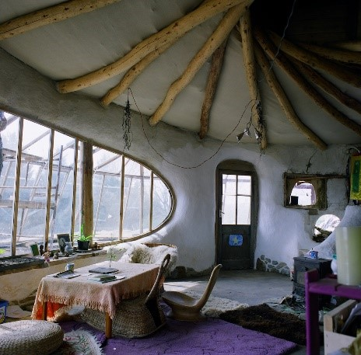
Figure 3: Exterior of living accommodation within Lammas  Credit: (Lammas, 2022) | Figure 4: Interior of living accommodation within Lammas  Credit: (Lammas, 2022)

The concept of the project was sustainable living while using natural building techniques in order to achieve a zero carbon in construction and use. The Lammas website describes how residents explore alternatives methods of living, acting in accordance with Welsh Governments ‘One Planet Living’ policy (2022). The residents create this collection of smallholdings and eco-dwellings combining traditional farming and building techniques, along with the current innovations with permaculture, green technology, and environmental designs (Lammas, 2022). This policy gives guidance to make it achievable to evolve new homes in the countryside as long as there is a clear promise to sustainable living, natural building techniques and land-based livelihood. Low impact developments are highly perceived by the Welsh Planning System as playing a key role of a low carbon society future. Planning legislation support both new and existing projects, though the majority of applications deliberate around the ‘One Planet Living’ policy (TAN-6, 2010). Another policy guidance that they adhere to is Planning Policy Wales Chapter 4, regarding the local and national developments with special designations, National Parks for example.
Lammas Eco-village is a great example of following a strict policy and guidance of the One Planet Living (2022). This source has great relevance to the dissertation topic as it heavily encourages bodies and firms to reconsider sustainability and zero carbon construction proposals for future developments. This aims to improve the quality of our environment and upcoming generations and wellbeing. Promoting the use of policies and acts can encourage other and future developments to improve the use of land and the quality of living for residents.

Case Study 2: Beddington Zero Energy Development (BedZED)
Designed and built by Bill Dunster and ZedFactory Architects in 2002, BedZED was supported by The Peabody Trust as the UK’s first large scale, mixed use sustainable community (Schoon, 2016). The site contains 100 homes, office spaces, a college, and communal facilities. The main office is also situated in this proposal (Schoon, 2016).

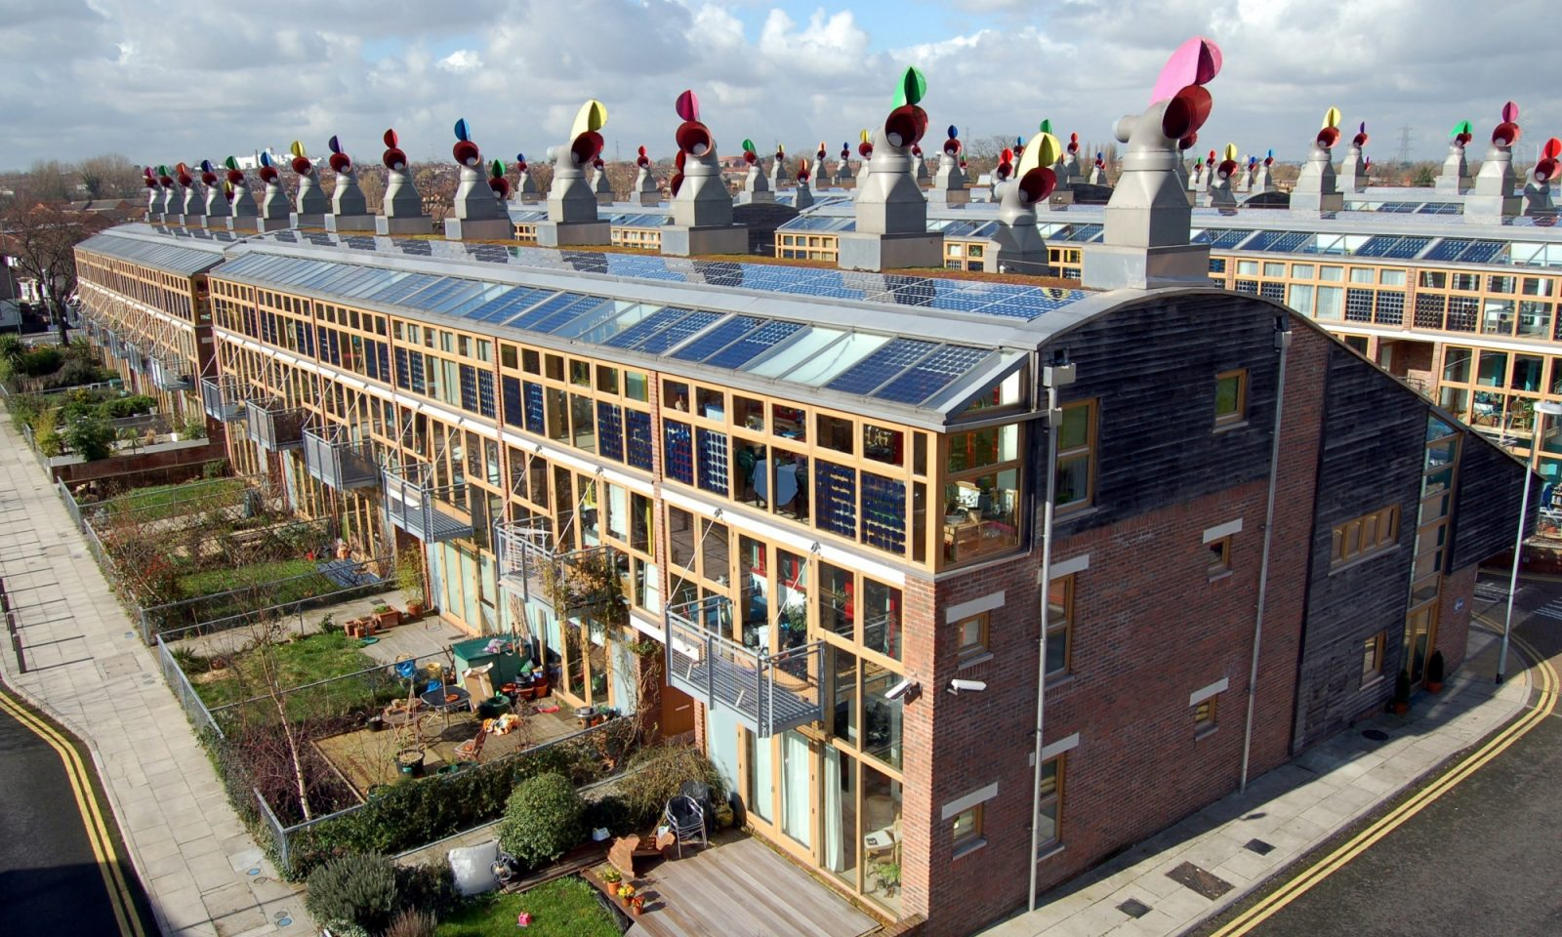
Figure 5: Exterior of BedZED development
Credit: Nicholas Schoon (Schoon, 2016)

The concept of the project was to construct a zero carbon eco village, aiming to achieve greater reductions in climate changing greenhouse gas emission and water use. Their uses of reclaimed materials and products for construction give it a greener approach with just 52% of the construction materials are sourced within 35 miles (Schoon, 2016). Most of the steel used in the development is reused, where it mostly came from refurbishment work at Brighton Railway Station (Schoon, 2016). Their decision of giving unused land new life, gives it the sustainable development, creating a new and greener community, which is a great outcome for a plot of recycled undeveloped land (OpenHouse, 2022). Objective of the proposal was to create an easier way for people living there to have a greener, lower impact lifestyle, where they would have to rely less on using unsustainable forms of transport (Schoon, 2016). BedZED won a reward too for its ambition. They won the Housing Design Award for sustainability from the Royal Institutes of British Architects in 2001. Along with being shortlisted for the prestigious Stirling Prize in 2003 (Schoon, 2016). To this day it still arguably remains the most ambitious attempt to create a healthier and more sustainable housing development which has fascinated thousands around the world (OpenHouse, 2022) They achieved this ambition by also involving the residents with ‘Green Lifestyle’ programmes, business in transport, local food and composting initiatives (Schoon, 2016).

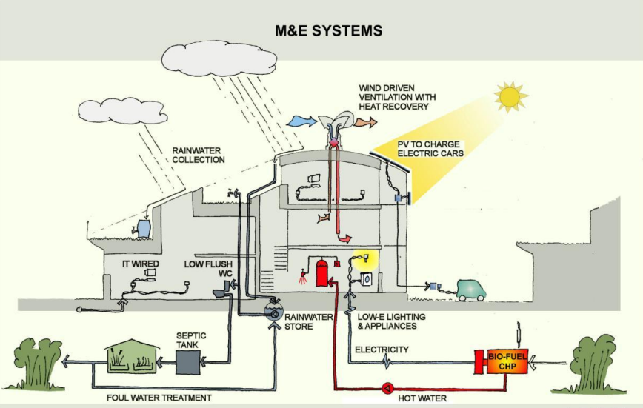
Figure 6: Interior diagram of M&E system within the development
Credit: John Widdowson (Widdowson, 2014)

BedZED showcases several great techniques and strategies by using reclaimed materials within a local distance. Their choice of using unused land shows that these locations can be transformed into good use. They manage to create spaces rather than places which can be used as a great encouragement for future developments to target unclaimed land and transform it into a true green and sustainable place to live that attract and intrigue people globally. An idea of creating this mixed-use facility and eco village has some relation to Lammas with its focus on creating a community within the development.

Case Study 3: The Solar Settlement
The Solar Settlement Development located in the Vauban Quarter in Freiburg, Germany. This is possibly one of the best examples of sustainable urban living proposed with its cooperative decision making and a model for environmental planning and eco-friendly living (Thorpe, 2017). This settlement aims to assemble six buildings that include 90 mixed use units for five thousand inhabitants. These units made up from eighty percent housing and twenty percent workspace (Powell, 2017). Each building would provide a four-storey building with a basement. The aspiration of this proposal is to provide a development that uses the minimum amount of energy use with the highest quality of living for the infrastructure (Powell, 2017).

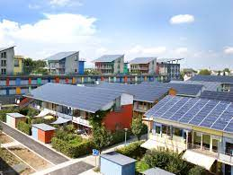
Figure 7: Exterior of the Solar Settlement development  Credit: David Thorpe (Thorpe, 2017) | Figure 8: Cycle parks situated within the development  Credit: David Thorpe (Thorpe, 2017)

Throughout the project they have significant application of specialist professional working towards sustainability involving the Local Government for Sustainability (ICLEI), the International Solar Energy Society (ISES) and the City Mayors Foundation (Thorpe, 2017). Solar Settlement also took views into the future with a profound cost analysis which helped support the initiative of carbon reduction. This included measuring the payback time of less than twenty years (Thorpe, 2017). The projects concept is to have an ultra-low energy Passivhaus consumption standard, PlusEnergy concepts with renewable energy techniques (Coates, 2013). PlusEnergy is a concept developed by Rolf Disch that expresses a structure’s extreme energy efficiency so it maintains a positive energy balance where it can produce more energy than it uses (Disch, 2021).

Various targets were placed in order to achieve carbon reduction for the development:
- Innovative Heating System: they chose air conditioning with heat re-coverage of eighty percent, arrangement of the remaining heat demand with a decentralised CHP device of natural gas (Powell, 2017).
- Very Detailed Planning: Programmes were placed to measure reduction in heat leakage, extra insulation of tubes to reduce heat allocation losses (Powell, 2017).
- Active Use of Solar Energy: the building integrated PV devices linking shading, shelter and electricity production. Solar thermal plants allocated for hot water (Powell, 2017).
To achieve these targets, spatial planning was established along with a planning framework. These included:
- Local Climate Conditions Analysis
- Town Planning Explicitly: reducing amount of traffic and unsustainable travel
- Initial intervention of preservation: for the nature of the site’s ventilation and conservation (Powell, 2017)

Figure 9: Progress diagram for improvement of public transportation
Credit: David Thorpe (Thorpe, 2017)
With focus on these ambitious aims, they managed to integrate a well thought infrastructure, cycle parks for example. This green plan was arranged around the district as a global beacon of green urban planning as aside from consumption, transportation is the hardest factor of ecological impact to diminish (Coates, 2013). Green transportation is very important to this district. Automobile, pedestrian, and bike paths also run through the centre of the site and owned by local businesses (Coates, 2013)
The Solar Settlement present new ways of creating community and sustainable design with their green infrastructure. It displays that there’s more techniques and strategies to sustainable developments, other than just using natural building techniques and focus on materiality. They consider carbon emission in the location, and target this to attempt to improve and lighten the effects of private transportation as much as possible. Setting targets to achieve carbon reductions are set, which gives the developers a criterion to manage the design and chose certain techniques. These features to the development give it a uniqueness to it that attracts visitors and residents. In 2001, it was said that they inhabited 2,000 residents. Since the completion of the development, they now have 5,000 inhabitants with over 600 jobs (Thorpe, 2017). This city gives theses that constitute a holistic and comprehensive framework that are used for the succession of Vauban, Freiburg. It promotes new ways to create a green community and sustainable design and improvement of wellbeing.

CHAPTER 3: Comparison of case studies
Figure A:
Development | Year | Size | Cost | Dwellings
Lammas Eco-Village | 2009 | 307,561 square metres  (76 acres Community hub) | £5,000 - £70,000  Per household | 9 Households
BedZED | 2002 | 1,405 square metres | £15.8 million | 100 – including homes, office spaces, a college, and communal facilities
The Solar Settlement | 2006 | 11,000 metre square | £11,150 | 59 households

After reviewing and collating data from the selected case studies, the researcher can examine and understand how each case study they can achieves sustainable development. Such a comparison will help to establish what innovative ideas and concepts from these developments can be applied for to future rural proposals and developments in West Wales. Not only ideas and concepts can be taken from these examples, but consideration of relevant key policies and guidelines which plays a vital role in their success and ambition of any future developments.
The case studies discussed in Chapter 2 of this dissertation (Lammas Eco-Village, Pembrokeshire; BedZED Factory, Beddington, South London; and The Solar Settlement, Freiburg, Germany) will now be discussed with the following sites:
Built: Tir y Bont, Coity, Bridgend, 2021, designed by Persimmon Homes.
Conceptual: The Parc Mawr Development, Penllergaer, Swansea, designed by Asbri Planning.

Tir y Bont, Coity, Bridgend
Completed in 2021, these homes created by the developer Persimmon Homes, have different approach to the other case studies listed in this dissertation.


Figure 10: Screenshot from Persimmon Homes website providing their inspiration sources
Credit: (PersimmonHomes, 2021)

The concept for these developments is to provide style and serenity and big focus on interior aesthetics over sustainability (PersimmonHomes, 2021). With pandemic being around, they’ve also adapted their design to also implement home offices, as they state, “Creating your ideal home office” (PersimmonHomes, 2021). Another feature of their builds is that they keep up with the latest trends for interior design focusing heavily on creating a show home inspiration (PersimmonHomes, 2021). This has an obvious difference to the different approaches for developments. The case studies discussed above have a visible procedure to green sustainable design that benefit the environment and community, rather than focusing on individual families and the comfort of their homes.
Tir y Bont provides a contrast to the other case studies as they have a diverse approach to design. This aims attention to the comfort of the homes for residents, which is also a very important factor when it comes to developing these projects. They fade away from using sustainable methods and servicing and rely on comfort and aesthetics of the building to gain attraction from users and residents. Having this contrasting case studies to the other examples allow the researcher to compare each one with each other, to analyse the pros and cons of each approach

Parc Mawr, Penllergaer, Swansea
Built by residential property developer and housebuilder Bellway Homes, the Parc Mawr development will comprise 850 houses at a cost of £130 million. Bellway’s approach is to focus on the aesthetics and quality of the designs to satisfy residents’ needs and comforts of living there. Bellway Homes also aim to meet with lifestyles demand with meticulous craftsmanship and architectural flair, to create homes that customers can be proud to live in (Bellway, 2022). The Artisan Collection provides, “the best in contemporary home design, developing feedback from our very own customers to create a new generation of properties” (Bellway, 2022).
Bellway Homes believe that in the design phase, they take into consideration the different characteristics of each local environment. Furthermore, Bellway Homes create a range of design features which complement the local climate of each location.
The development will provide the location:
- New link road – New accesses to be created onto the A483
- Help deliver 20% affordable housing
- New School
- Sports pitches
- Play areas
- Allotments and walking and cycling routes

Revising this proposal, it shows that its ambition is to provide new education and skills, planning and housing, improved infrastructure and transport and economic development. All these are listed within the local development that influence planning.
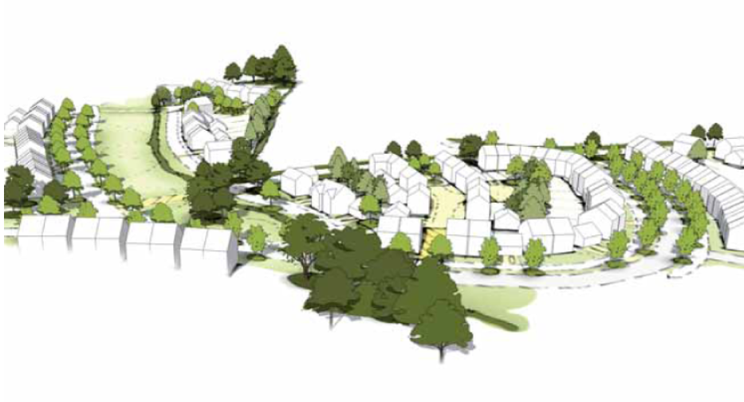
Figure 11: Concept sketch of Parc Mawr development
Credit: (AsbriPlanning, 2021)

The Parc Mawr Development in Penllergaer is a proposal set to be built after Welsh Ministers decided not to call in the scheme for consideration of approval (Youle, 2020).
Unlike Persimmon Homes, Tir y Bont development does not highlight anything about local climates, customer relation and communication, external design features to benefit the local climate. This could be something that is focused on each development and proposals.
This suggests that the Parc Mawr Development didn’t have this connection and relationship with the local residents, which may explain how they had over 700 objections to the proposal. One objections letter was made by one of the residents, explaining how the development is too close to the boundaries of their property, resulting in overshadowing of their home (Council, 2018). Another objection mentioned this, stating that the new dwellings garden view would overlook into the gardens of the existing dwelling. This invades the existing residents’ privacy, which could be the reason for the objections. The fact that the land for the proposed development is prime agricultural land, raises concerns for some residents as they thought that this land would’ve been protected from any proposals (Council, 2018). This happened previously from another planning enquiry, which the council managed to protect the land (Youle, 2020).

This may have been resolved within the design process if local residential feedback forms had been collected at beginning of the process. Completed forms would help the developer to understand the views of local residents, which, in turn, may have influenced the application into the planning portal.
Following this, the Future Generations Act (2015) should have been taken into consideration, specifically its goal of:

“A Wales of cohesive communities: Attractive, safe and well-connected”

What’s interesting and controversial about this scheme is that City & County of Swansea had voted in favour of the proposal, but the approval was held at the time, meaning it could not be formally accepted. Since then, the project was decided not to be called in for approval consideration, with back up from the planning directorate and behalf of ministers (Youle, 2020). It is understood that the ministers were satisfied for the proposal to go ahead, overruling the hundreds of objections. The Parc Mawr Development must have demonstrated enough from the Local Development Plan to provide the location future economic development with improved infrastructure. Their allotments and walking and cycle routes are very similar to The Solar Settlement Development. They focus on improving the infrastructure of the location and a greener form of transport which lowers the impact on private transport on the environment. With a new link road to the site off the A483, they targeted relieving the congestion at the junction 4 of the M4 to decrease the amount of traffic and improve the accessibility to the location (AsbriPlanning, 2021). Asbri Planning analysed the characteristics of the site in terms of landscape, ecology, transport, drainage, and master planning. This led to the strategic release in the Local Development Plan of their areas along with the preferred strategy on the Deposited Plan (AsbriPlanning, 2021).
Comparing the listed case studies to Tir y Bont, the other case studies all show a strict schedule following policies to help improve community, sustainability, and economic development for future generations. The policies followed are as stated previously in the dissertation. For the Tir y Bont, it rather contrasts to the ambition made for residents. Without much focus to economic strategy and well-being plan, it may play a part of the problem for sustaining the best possible outcome for living. Even though there is focus on the comfort of living and their customer feedback on personalising their home, this could shy away from the ambition to improve the environment and lower the effect of carbon emissions in construction. Can there be a document / policy that focuses on the goals each development needs to achieve with suggested technologies and strategies for each home? Following analysis of their website, there was no specific mention of their approaches to the design process or construction uses. Did they aim to use local materials and reuse local materials? Similarly, to how BedZED in Beddington did when they managed to use construction materials within 35 miles of the location. This benefits the local area with recycling and reusing the regions materials and help support businesses and the local economy.
The decision to not call the scheme in caused a lot of controversy with Councillor Wendy Fitzgerald describing the incident as:

“very disappointing and upsetting news for residents.” (Youle, 2020).

Regional MS Suzy Davies also added:

“We are extremely disappointed in my ward with this outcome.” (Youle, 2020).

Due to new homes being built in recent years, such as Bellway’s Parc Penderri caused a lot of negativities from the residents and caused a lot of widespread opposition. The Welsh Conservative MS added:

“Allowing up to another 850 houses to go on this top-class farmland adds to the cumulative impact of all these new homes.” (Youle, 2020).

With having such a reaction to the previous development of houses, this may have already destroyed the relationship between planners and local residents. So, any future proposals would have caused a mirrored effect to how the residents responded with obligations. Welsh planning directorate did consider calling in the scheme for several reasons, but after the councillor officers judging the assessment, they deemed that the planning application of relevant policies and given reasons for the proposal was enough to not make this decision. Bellway Homes were made to sign a legal agreement with the council, to secure its ambition to guarantee that they’d fulfil their objections and obligations. The decision letter stated:

“The application does not raise novel planning issues and there are no other relevant issues raised.” (Youle, 2020).

This was enough for the Parc Mawr development to justify their planning approval.

CHAPTER 4: Survey Analysis
As part of this dissertation, a survey was distributed to key individuals, as referenced in the Introduction of this work. This chapter will discuss the responses to these questions with particular reference to sustainability and technology.

When considering the cost of any new housing development, local authorities such as Carmarthenshire County Council (CarmarthenshireCountyCouncil, 2022) are mindful of budgetary requirements. Any design team in the 21st century will, naturally, want to introduce a sustainable element to their work. Therefore, a key question which was asked in the survey was whether sustainable development can be economically viable in the design process.

Architect and Passivehaus Designer Jon James from Jon James Architecture, replied: “It is incumbent on designers to lead and not be led by the market. The market will follow us if we set the tone and benchmark”.

By doing this, architects can specify products that help sustainability in the design process. Where there have not been enough options in recent years, in specifying products, other practices demand more technologies. Therefore, the issues of expense for technologies can be reduced because of the higher supply and demand for such products.

Architect David Darkin from Darkin Architects agrees with James’ reply, by adding: “Most client both private and commercial are driven by the market i.e. price”.

These responses suggest that one of the main issues of energy efficiency is cost.
How can this issue be resolved? If public bodies and designers can work alongside each other, this offers an opportunity to lower the cost of sustainable element as James stated. The more demand for products, and therefore a higher supply, results in a cost decrease which makes it more viably economic for future developments to include and specify a range of technologies.

However, Thorpe comments:
“There is a role for public procurement in particular: farms need to diversify in order to become more sustainable, but with an economic stimulus to do so. A commercial reason, hospitals and schools and other public bodies are in the position to source food and products of all kinds more locally”.

Thorpe goes on to say: “If these are long term contracts, it will give confidence and incentivise the setting up of new businesses and supply chains”.

Thorpe’s view suggests that the onus is on public bodies and sectors to take responsibility. Indeed, this ambition can be spread across all sectors and can transfer current and future developments to near zero carbon construction.

Thorpe also commented:
“The problem now is not the level of population but the skewed demographic. Services like school and hospitals have been ‘centralised’, meaning that ‘people have to travel a long way‘ from rural areas. This process is continuing and should be stopped”.

Thorpe is referring to the poor connection between planning and local areas. This effects local rural areas with towns that have lost their education and wellbeing centres due to residents moving away to look for work, which lead to a lack of employment in areas. Creating and providing more jobs within the area is vital so they residents don’t need to travel to look for work. Thorpe also suggests that we should promote the “six minute rule” whereby “every home should be within six minutes walk of each other of shops, greenspace, employment, schools, entertainment, and good public transport”. This would resolve any employment issues and reduce private travel carbon emissions, where it proposals can focus on a green infrastructure strategy as well as to provide back to the community. One asks, can this lead to a stricter application of policies for developments within LDPs to help support the ambition of improving current and future proposals? Should a local authority focus on creating new developments, or establish and maintain a renovation programme for current developments?
Thorpe and James both agree that we should be re-using buildings rather than demolishing existing. This is the most sustainable way to building into the countryside, while continuing to protect farmland and current food sources. Thorpe expanded on the fact that:
“15 years ago, Labour deputy Prime Minister John Prescott challenged the building industry to design affordable zero carbon homes. They showed they can do it”. A handful of developer’s challenge took up this challenge and succeeded.
But the Conservative-led UK Treasury axed the Zero Carbon Homes policy and Thorpe believes that the time is right for the government to now re-introduce this policy.

TAN 6 and PPW supporting One Planet Development
The One Planet Living document in Wales works alongside Planning Policy Wales and the Technical Advice Note 6 to apply low impact development principles in the Welsh Context and be exemplars of sustainable development (Thorpe, 2016).

Some of the characteristics in the One Planet Living document are:
- Affordable housing in various scale.
- Buildings following a minimum zero carbon throughout their life cycle.
- Reducing the current ecological footprint of 2.4 global hectares per person to 1.88 global hectares.
- 100% renewable energy.
- Low or zero carbon transport plan.
- Assessment of impact on the local community.
- Land based enterprises to satisfy around 65% of the minimum necessities of the dwellers.

The One Planet Council also works with The Well Being of Future Generations Act (2015), to help support and promote sustainable developments, publish national indicators to measure progress towards the ambitions of wellbeing goals and provide a UK assessment of risks of current and predicted impact of climate change (Thorpe, 2016). One Planet Development should be offered for skills and technologies, as current training Government bodies may not be sufficient to express the benefits of such practice for rural developments. To improve future proposals and developments, planning assessments and progressions can be applied to all future and new developments to encourage developers into line with the long-term ambitions and aims of the current legislations. With the application of the One Planet Living policy, developers can help focus on the Welsh agriculture which can offer more mixed farming, market gardening, woodland and other land-based value-added production and more job opportunities.

An issue of funding for energy efficiency strategies
Action on energy efficiency is instrumental across our wellbeing goals. It is a crucial factor in green growth, jobs, skills, and supply chains that lead to the most cost-effective means of meeting the needs of communities and reduce carbon emissions (Sargeant, 2016). The Energy Efficiency Strategy by the Government has a vital contribution to tackle fuel poverty and global threat of climate change. This allows the building of resilience for communities and support for greener developments in the economy and addressing health inequalities caused by insufficient energy efficiency (Sargeant, 2016). The aim of the energy efficient document and its ambition is to take action to enhance the energy efficiency of developments to protect the long-term wellbeing of the residents. Energy systems in Wales need considerable change with new strategies, energies, technologies, and opportunities for low carbon transitions. Investments can play an important role in this to tackle this issue and provide energy efficiency improvements to thousands of developments (Sargeant, 2016). With this said, there are barriers to investments in energy efficiency, making it harder to access funding, which, in turn, makes it harder for Wales to achieve their goals and vision of a greener and healthier Wales. The UK Parliament state that a coherent strategy for a renewable energy sector is absent in Wales (Parliment, 2021). A clearer plan for investment into energy efficiency strategy would benefit the communities, as well as overcoming infrastructure issues, which could also offer greater opportunities for Wales to shift to a net zero environment.

Conclusion
In conclusion, many factors influence the need to move into rural areas and what is required to satisfy policies and LDPs. Whether or not, using the countryside can be split into two arguments. After the research collected for this dissertation, the decision to use the countryside is vital that local government focus on following a strict regime and criteria provided through policies and LDPs. Moving rural for developments could be a viable way of improving sustainability in future developments, if there is an updated policy that provides updated requirements which are relevant to modern living standards. This naturally leads into a discussion as to whether the policy should be to create new developments or re-creating current developments. Will this affect the farmlands and food supply chains? The answer to this is whether developments are required to provide a future farming system where organic and local food can still be supplied for local communities. Can LDPs provide a greener infrastructure and improved highways and transport systems? This will suggest greener infrastructures and different modes of transport ensures less dependence on private transport and focus more on cycle lanes, footpaths and public transport. A clear demonstration of what should be required in future proposals is vital. This could be stricter within policies and LDPs, and if these requirements are not accommodated within government approval, then developers will need to reconsider their designs to ensure that the ambitions and goals of a sustainable developments are met.
As previously stated, maybe Governments and public bodies need to tackle funding opportunities for developers to ensure that there is enough back up to be able to satisfy the needs for new technologies and systems. This would help greatly, and with a higher supply and demand for these strategies, the overall cost will drop, resulting in a much more viably economic application of sustainability. Following on what Thorpe stated in his interview with the author of this work, the idea of introducing challenges, such as the “affordable zero carbon homes”, should be re-applied, so that it gives developers a target to reach. The researcher is in agreement with Thorpe in saying that now is the time for the government need to re-introduce the zero carbon homes policy. Could this be a major factor in how some developments In Wales are lacking in technologies and sustainability? Could this be why Carmarthenshire is struggling with keeping residents from travelling out of the area for work, as the commuting from Carmarthenshire figures suggest.
The One Planet Living policy require regular assessments throughout developments and proposals to ensure that developers and designers are designing accurately to demonstrate correct protocol. This may include a clear presentation of, green infrastructure, energy efficiency strategies and renewable energies and materials. This further ensure that progress is being made towards The Well Being of Future Generations Act (2015) goals.
A further argument is whether LDPs and polices are regularly updated enough to satisfy changes within the environment. Moreover, these standards and regulations are outdated, and if developments are built to the current guidance, then the need for more re-developing and renovation is needed. These changes include climate change, levels of employment, an aging population and housing requirements. With Carmarthenshire LDP being created for 2018-2033, a lot can change within those 15 years, Covid-19 being a great example of this. This has been a big change in the way residents live and develop and prepare for future generations. The need of housing to provide a work from home space has increased greatly, which influences the design process. Like the Tir y Bont case study on how the design process was heavily influenced by the comfort and aesthetics of homes with the addition of creating a work from home space. Could policies have integrated this in conjunction with sustainability policies? Of course, applying both together would improve every development and providing a greener environment globally. For better or for worse, there are positives and negatives to this change. Are these policies designed to cover possible changes that may occur? Can the application of One Planet Living policy be introduced in all policies and demonstrations? There is not a reason why it could not be, due to the goals and ambitions being very achievable, and gives future developers and developments an objective to reach. Its integration with The Wellbeing of Future Generations Act (2015), Planning Policy Wales (2021), and the TAN-6 documents, which supply it with enough supporting documents and policies to allow and provide enough guidance and ambition. In some cases, it may not be achievable, but for the foremost of proposals, it is easily achievable and applicable. For example

Could there be another approach, rather than using the countryside for developments? Of course, there are other strategies that could be taken, such as re-using current developments, renovation and retrofitting. One solution for this is to target existing urban areas, rather than moving rural for new developments. With the re-use of existing buildings, a start to the process of renovation avoids having to get demolition approval. This would result in less carbon emissions from demolishing buildings and from the re-construction of a new build. Also, by renovation and refurbishment, developments are able to re-use materials on site to reduce labour. Without demolition of buildings, any air and noise pollution of the local area can be avoided. This seems to be a very viable process for future proposals and developments, as long as there is not a definite need and reason to demolish a development.
A clearer blueprint for everything that has been discussed within this dissertation should be integrated into one revised document. This would allow developers to access the document and follow a stricter guideline that is updated more regularly to satisfy any changes that could occur. This would require Government bodies to allocate departments to overlook current situations and environments to keep up with recent news and changes. Preparation is key for future proposals, and with great preparation, comes greater success and less issues faced. Along with the opportunity to challenge funding barriers, the higher demand for new technologies to be introduced and provided could make the sustainable design process easier to achieve. Analysis of the Planning Policy Wales and LDPs need to ensure revision to understand any areas for special designations, for future proposals to understand the boundaries of which locations are viably acceptable to develop into.

Bibliography: Published Works

AsbriPlanning, 2021. Parc Mawr, Penllergaer. [Online]
Available at: https://www.asbriplanning.co.uk/projects/parc-mawr-penllergaer/
[Accessed 18 March 2022].
Bellway, 2022. Bellway - The Artisan Collection. [Online]
Available at: https://www.bellway.co.uk/the-artisan-collection
[Accessed 17 March 2022].
Britannica, 2021. Britannica. [Online]
Available at: https://www.britannica.com/topic/urbanization
[Accessed 20 November 2021].
Bullock, M., 2019. Carmarthenshire Rural Needs Study. [Online]
Available at: https://www.carmarthenshire.gov.wales/media/1221664/carmarthenshire-rural-needs-study-2019.pdf
[Accessed 01 February 2022].
CarmarthenshireCountyCouncil, 2021. Deposit Plan. [Online]
Available at: https://democratiaeth.sirgar.llyw.cymru/documents/s36544/Draft%20Revised%20Deposit%20LDP.pdf?LLL=1
[Accessed 10 March 2022].
CarmarthenshireCountyCouncil, 2022. Evidence Base. [Online]
Available at: https://www.carmarthenshire.gov.wales/home/council-services/planning/local-development-plan-2018-2033/development-of-an-evidence-base/#.YkGpwXrMJPY
[Accessed 04 March 2022].
Coates, G. J., 2013. The Sustainable Urban District of Vauban in Freinurg. [Online]
Available at: https://www.witpress.com/Secure/ejournals/papers/D&NE080401f.pdf
[Accessed 22 December 2021].
Council, S., 2018. Planning Application Documents. [Online]
Available at: https://property.swansea.gov.uk/online-applications/applicationDetails.do?activeTab=documents&keyVal=PK1DL6EVLZO00
[Accessed 17 March 2022].
Disch, R., 2021. Plusenergyhaus. [Online]
Available at: http://www.plusenergiehaus.de/index.php?p=home&pid=8&L=1&host=1#a490
[Accessed 22 December 2021].
Evans, H., 2021. Moving Forward in Carmarthenshire. [Online]
Available at: https://www.carmarthenshire.gov.wales/media/1225816/corporate-strategy-21-22.pdf
[Accessed 15 March 2022].
Future Generations Commissioner for Wales, 2022. Well-being of Future Generations (Wales) Act 2015. [Online] Available at: https://www.futuregenerations.wales/about-us/future-generations-act/
[Accessed 19 November 2021].

Geographic, N., 2021. National Geographic. [Online]
Available at: https://www.nationalgeographic.org/encyclopedia/urbanization/
[Accessed 20 November 2022].
Government, W., 2018. Planning Policy Wales. [Online]
Available at: https://gov.wales/sites/default/files/publications/2018-12/planning-policy-wales-edition-10.pdf
[Accessed 28 December 2018].
HarperCollins, 2022. Definition of 'urbanization'. [Online]
Available at: https://www.collinsdictionary.com/dictionary/english/urbanization
[Accessed 27 March 2022].
Jenkins, D., 2021. Moving Forward in Carmarthenshire. [Online]
Available at: https://www.carmarthenshire.gov.wales/media/1225816/corporate-strategy-21-22.pdf
[Accessed 02 February 2022].
Lammas, 2022. Lammas Eco Village. [Online]
Available at: https://lammas.org.uk/en/welcome-to-lammas/
[Accessed 8 March 2022].
OpenHouse, 2022. BedZED. [Online]
Available at: https://openhouselondon.open-city.org.uk/listings/1594
[Accessed 28 December 2021].
Parliment, U., 2021. Barriers holding back renewable energy in Wales must be urgently overcome. [Online]
Available at: https://committees.parliament.uk/committee/162/welsh-affairs-committee/news/156971/barriers-holding-back-renewable-energy-in-wales-must-be-urgently-overcome/
[Accessed 24 March 2022].
Persimmon Homes, 2021. Be Inspired. [Online]
Available at: https://www.persimmonhomes.com/be-inspired
[Accessed 13 December 2021].
Powell, M. B., 2017. Solar Settlement. [Online]
Available at: https://silo.tips/download/solar-settlement-freiburg-germany#
[Accessed 25 February 2022].
Projection, N. P., 2022. National Population Projection. [Online]
Available at: https://gov.wales/national-population-projections-interim-data-2020-based
[Accessed 12 January 2020].
Sargeant, C., 2016. Energy Efficiency in Wales. [Online]
Available at: https://gov.wales/sites/default/files/publications/2019-06/energy-efficiency-strategy.pdf
[Accessed 24 March 2022].

Schoon, N., 2016. Bioregional. [Online]
Available at: https://www.bioregional.com/projects-and-services/case-studies/bedzed-the-uks-first-large-scale-eco-village
[Accessed 8 March 2022].
Stephens, M., 2020. Deposited Revised Carmarthenshire Local Dvelopment Plan 2018-2033. [Online]
Available at: https://www.carmarthenshire.gov.wales/media/1223344/deposit-written-statement.pdf
[Accessed 14 March 2022].
Stephens, M., 2021. Moving Forward in Carmartheshire. [Online]
Available at: https://www.carmarthenshire.gov.wales/media/1225816/corporate-strategy-21-22.pdf
[Accessed 15 March 2022].
Thorpe, D., 2016. What is One Planet Development in Wales. [Online]
Available at: https://theoneplanetlife.com/what-is-one-planet-development-in-wales/
[Accessed 24 March 2022].
Thorpe, D., 2017. SmartCitiesDive. [Online]
Available at: https://www.smartcitiesdive.com/ex/sustainablecitiescollective/words-most-successful-model-sustainable-urban-development/229316/
[Accessed 8 March 2022].
Wales, T. w. o. F. G. A., 2015. The wellbeong of future generations act. [Online]
Available at: https://www.futuregenerations.wales/about-us/future-generations-act/
[Accessed 19 November 2021].
Welsh Assembly Government, 2008. A statistical Focus on Rural Wales. [Online]
Available at: https://gov.wales/sites/default/files/statistics-and-research/2018-12/080515-statistical-focus-rural-wales-08-en.pdf
[Accessed 12 December 2021].
Welsh Government, 2020. Population density (person per square kilometre) by local authority and year. [Online]
Available at: https://statswales.gov.wales/Catalogue/Population-and-Migration/Population/Density/populationdensity-by-localauthority-year
[Accessed 24 December 2021].
Welsh Government, 2021. Commuting patterns by Welsh local authority. [Online]
Available at: https://statswales.gov.wales/Catalogue/Business-Economy-and-Labour-Market/People-and-Work/Employment/Commuting/commutingpatterns-by-welshlocalauthority-measure
[Accessed 10 March 2022].
Welsh Government, 2021. Employment rate by Welsh local area, year and gender. [Online]
Available at: https://statswales.gov.wales/Catalogue/Business-Economy-and-Labour-Market/People-and-Work/Employment/Persons-Employed/employmentrate-by-welshlocalarea-year-gender
[Accessed 04 January 2022].
Welsh Government, 2021. Population estimates by local authority and year. [Online]
Available at: https://www.populationu.com/uk/wales-population
[Accessed 25 November 2021].
Welsh Government, 2022. Population Density of Wales. [Online]
Available at: https://www.ukpopulation.org/wales-population/#:~:text=The%20population%20density%20of%20Wales%20is%20approximately%20148%20people%20per%20square%20kilometer.
[Accessed 11 December 2021].
Widdowson, J., 2014. A sustainable neighbourhood: BedZED (Beddington Zero Energy Development). [Online]
Available at: https://lewebpedagogique.com/eurostjo/files/2014/01/3-bedzed.pdf
[Accessed 24 January 2022].
Willis, R., 2010. Measuring the Social Impact of Migration at a Local Authority Level. [Online]
Available at: https://gov.wales/sites/default/files/statistics-and-research/2019-09/100610migrationreporten_0.pdf
[Accessed 27 November 2021].
Youle, R., 2020. Bellway set to build up to 850 houses in Penllergaer after Welsh ministers decide not to call in the scheme. [Online]
Available at: https://www.walesonline.co.uk/news/wales-news/bellway-penllergaer-housing-parc-mawr-18941868
[Accessed 17 March 2022].
Youle, R., 2020. How rural towns could be key to Carmarthenshire bouncing back from coronavirus. [Online]
Available at: https://www.walesonline.co.uk/news/wales-news/carmarthenshire-rural-economy-news-council-18401833
[Accessed 22 March 2022].

Bibliography: Unpublished Work

Carmarthenshire County Council (Forward Planning Section). 2019. Deposit - Revised Carmarthenshire Local Development Plan 2018 – 2033: Draft for Reporting to Council Members. Available from: https://democratiaeth.sirgar.llyw.cymru/documents/s36544/Draft%20Revised%20Deposit%20LDP.pdf
Accessed: 10 March 2022

Swansea Council (Planning Portal). 2018. Hybrid planning application for Land South Of The A4240 Parc Mawr Penllergaer Swansea. Available from: https://property.swansea.gov.uk/online-applications/applicationDetails.do?activeTab=documents&keyVal=PK1DL6EVLZO00
Accessed: 17 March 2022

Appendix A: Survey

The following questionnaire was sent, by email, to a targeted list of named, Chartered Architects.
The questionnaire was created in 02/12/2021.

The questions were devised by the author of this dissertation.

- How do you think the increasing population is affecting the rural areas of West Wales?

- Does West Wales have sufficient housing to satisfy population growth and how does policy play a part in controlling that expansion?

- Do you think that the building regulations can be adapted to a more sustainable development process and if so, how?

- Do you ever get the opportunity to work with a. sustainable materials, b. recycled materials? please expand.

- Are the incentives to use sustainable materials sufficient and is there enough information to assist with the implementation of these new products to the market?

- How do you think we can make sustainable development an economically viable process?

- In your use and application of strategic planning policy within Local Development plans, do you think that they are current and applicable to a sustainable future? Please expand.

Responses were received via email and analysed as part of the dissertation.

1 supported by Welsh Government alongside Technical Advice Note 6 (TAN 6) and Planning Policy Wales
See Appendix A
Jon James response to author survey, received 02/12/2021
David Darkin response to author survey, received 02/12/2021
David Thorpe response to author survey, received 02/12/2021
David Thorpe response to author survey, received 02/12/2021
David Thorpe response to author survey, received 02/12/2021
David Thorpe response to author survey, received 02/12/2021
David Thorpe response to author survey, received 02/12/2021
Figures stated in Chapter 1: Population and densities with reference to LDP, p18

