BUSINESS REPORT: Comparison of Two Hospitality Organisations. Shangri La & Premier Inn. Student ID: 2246597 – C M ASIM

AI ACKNOWLEDGEMENT: I confirm that I have not used any AI tools in the research and creation of this assignment. I confirm that I have not presented any AI generated materials as my own work(apart from making graphs and charts on Canva). I confirm I have copies of my drafts, notes, and other resources I used, which I may be asked to provide in evidence.
  - MODULE: BMIH5007 Module Lead: Tristan Hawkins

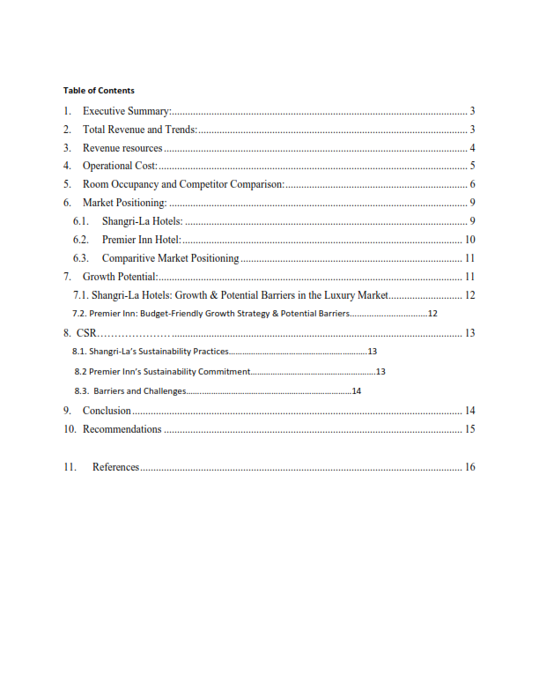

Executive summary:
This report analyzes and compares the financial management strategies of two major players in the hospitality industry: Shangri-La Hotels and Premier Inn Hotels. Shangri-La, a luxury hotel chain with global operations, and Premier Inn, a leading UK-based budget chain, operate in distinct market segments (Statista, 2023). The report examines how these companies manage their financial strategies, including revenue generation, cost control, capital investment, and debt management (Baker, 2021). It also explores how external factors like market trends, economic conditions, and regulations influence their financial decisions (PwC, 2023). Comparing these financial approaches provides insights into the differing strategies employed by luxury and budget hotel brands and their implications for long-term sustainability, growth potential and market positioning. The report will also have the recommendations for both.
Total Revenue and Trends:
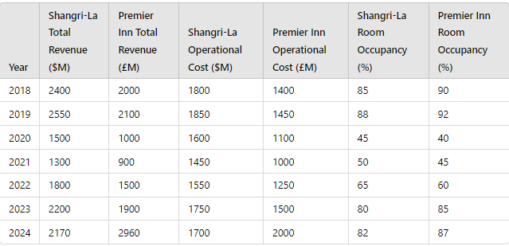
Between 2018 and 2019, Shangri-La Hotels saw a revenue increase from $2.4 billion to $2.55 billion. However, the COVID-19 pandemic severely impacted the hospitality industry, causing revenue to fall sharply to $1.5 billion in 2020. The decline continued into 2021, with revenue dropping to $1.3 billion due to ongoing travel restrictions and reduced operations (Shangri-La Asia Limited, 2021; Seal, 2019). By 2022, the company began recovering, reaching $1.8 billion in revenue, followed by $2.2 billion in 2023, marking a 22% recovery. In 2024, revenue slightly decreased to $2.17 billion, potentially due to rising competition and operational costs. The operational costs were controlled during the pandemic but rose to $1.7 billion in 2024 (Shangri-La Asia Limited, 2024).
Premier Inn demonstrated more resilience during the pandemic. Revenue grew from £2.0 billion in 2018 to £2.1 billion in 2019, but dropped to £1.0 billion in 2020 (Whitbread PLC, 2021; Tranter et al., 2014). Recovery was faster than Shangri-La's, with revenues reaching £1.5 billion in 2022, £1.9 billion in 2023, and surging to £2.96 billion by 2024, driven by expansion in the UK and Germany. Operational costs followed a similar trend, rising to £2.0 billion in 2024 due to expansion and inflation (Whitbread PLC, 2024).
Revenue Sources.
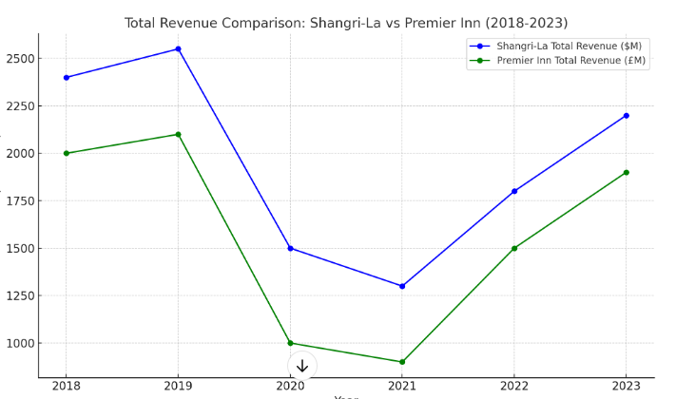

The major contributor to revenue in Shangri-La involves high-end accommodation, food and beverage services, as well as hosting high-class events. Shangri-La has a large exposure to the Asia-Pacific region, which was among the first to enter into aggressive lockdowns; thus, it was slower to rebound than other global markets going into 2023 (Shangri-La, 2023). With the majority of its operations in the UK, Premier Inn generates the lion's share of its revenue from budget hotel stays and domestic tourism, which has gone up after COVID due to increased pleasure and business travel. This enabled them to serve more people than was initially anticipated. In turn, it allowed Premier Inn to recover faster compared to Shangri-La, since its target clientele—luxury and international travelers—were much slower to return (Whitbread, 2023).
Operational Costs:
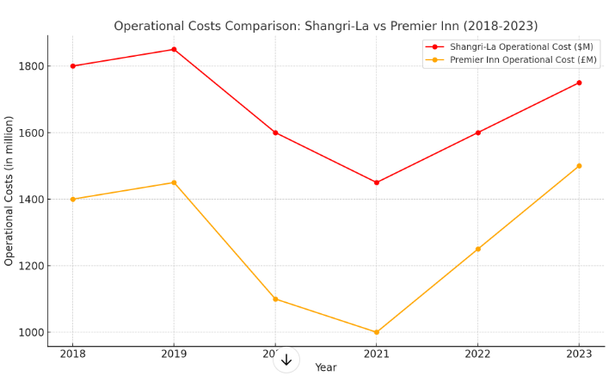

The operational costs for the two chains also move in somewhat similar trends. Shangri-La costs decreased from $1.85 billion in 2019 to $1.45 billion in 2021 because of the cost-cutting measures it instituted and reduced staffing during the pandemic period (Shangri-La, 2023). In its turn, Premier Inn managed to cut costs down to £1 billion within the same period. Costs, however, have risen in the year 2023 as operations resumed with inflationary pressures making labor, utilities, among other items, more costly. Shangri-La bears higher operational costs in the process of delivery of luxury service (Guilding, 2014). Premier Inn's operational cost pressures differ from Shangri-La and competitors due to Shangri-La's upmarket positioning, large-scale services, and premium facilities in the Asia-Pacific region, which are generally costlier in general. (Jones, 2020). Despite being a budget brand, Premier Inn has higher operational costs compared to competing brands such as Ibis. This is due to the company's aggressive expansion policy while trying to maintain standard class facilities across all its properties scattered throughout the UK. According to Smith (2021), smaller rivals meantime benefitted during the post-COVID recovery because of a leaner operational profile that allowed it to reduce costs. (McKinsey & Company, 2023)

Room Occupancy and Competitor Comparison:
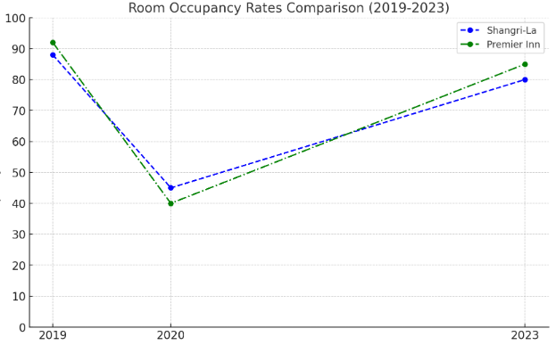
These sharply declined during the pandemic period. For example, in the year 2019, Shangri-La recorded an occupancy rate of 88% compared to Premier Inn, which had recorded 92%. Comparatively, the occupancy rates fell to 45% and 40%, respectively, in the year 2020 due to travel demand decline caused by reduced travel resulting from the COVID-19 pandemic period (Atrill & McLaney, 2021). In absolute terms, occupancy rates have recovered in 2023 to 80% for Shangri-La and 85% for Premier Inn. While Premier Inn did well due to strong domestic travel, Shangri-La, an international luxury hotel chain, witnessed slower growth because of its high dependency on foreign and luxury travelers (Tranter et al., 2014). Shangri-La's market share regaining was slower than other luxury hotel chains like Hilton and Marriott due to its high dependency on the Asia Pacific region. By contrast, Premier Inn had managed to stay ahead of its domestic rivals, such as Travelodge, partly thanks to its better brand awareness and larger scale in the UK (PwC, 2023).
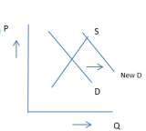
(Smith, 2020)
For premier Inn, the above chart applies accurately as the prices per room went up with the demand increased due to factors included the closure of so many independent hotels due to Covid.
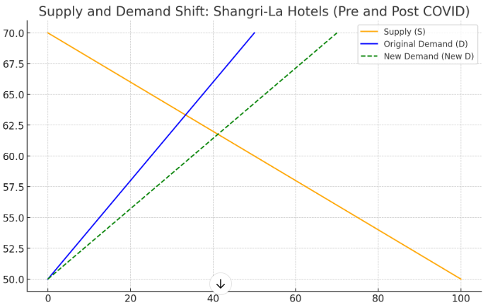(Shangri-La, 2023)
Due to limited availability, Shangri-La Hotels experienced a surge in demand post-Covid, leading to increased prices. Unlike Premier Inn, Shangri-La shifted pricing strategies and sought diversified income sources. (Wang, 2021).
MARKET POSITIONING:
An effective marketing strategy involves creating a niche in consumers' minds regarding a company's competitiveness in terms of pricing, service quality, and target customer segments.(Atrill & McLaney, 2021). The major variables that will influence market positioning in the hospitality industry include the market's pricing strategy, customer experience, geographical presence, and brand reputation (Tranter et al., 2014). This analysis will use Bowman's Strategy Clock to further the distinct market position of Shangri-La Hotels and Premier In.
Shangri-La Hotels: Differentiation Strategy
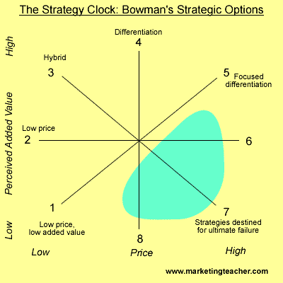
(Friesner, 2014)
Shangri-La focuses on the adoption of a differentiation strategy positioned at Position 4 in Bowman's Strategy Clock, focusing on the delivery of high-value services for a commanding premium price. Shangri-La is equally famous for luxury services, including personalized services offered to guests, fine dining options, and premium spa facilities matching an affluent and international clientele (Shangri-La, 2023; Mingtiandi, 2023). This is particularly true across the Asia-Pacific region, where it is seen as a luxury hospitality leader. Service quality and exclusivity enable the company to charge a premium above that offered by its nearest competitors, such as Four Seasons and Ritz-Carlton (Walker, 2021). Shangri-La's market positioning is sited on a board of appeal to high-net-worth individuals, business elites, and international tourists seeking experiences in the premium classes of travel.
Premier Inn Hotels: Low-Price, High-Value Strategy
(Friesner, 2014)
On the other hand, Premier Inn uses the low-price but high-value approach. Hence, it will be positioned in Position 3 (Hybrid) in Bowman's Strategy Clock. Premier Inn offers a proper balance of competitive pricing and good value, catering to budget-conscious travelers with its standardized, comfortable stay options. (Whitbread, 2023). The brand has built a competitive advantage through its focus on consistent service, brand loyalty, and setting up base at strategic positions within the UK. Compared to its rivals, Travelodge and Ibis, Premier Inn gives a higher value proposition since there is always assurance of consistency in quality and dependability in service (Marketing Week, 2023)
Comparative Market Positioning Using Bowman's Strategy Clock
Shangri-La operates in the luxury segment with a differentiation strategy, focusing on high-quality, exclusive services. Premier Inn, on the other hand, uses a hybrid positioning strategy to achieve low costs while maintaining high quality, attracting economy travelers and highlighting its unique positioning. (Bowman, 1995; Deloitte, 2022).
Shangri-La serves high-end customers, while Premier Inn is value-for-money for mass distribution (Baker, 2021). To this effect, these are the imperative strategies that will keep both brands long-term viable in those segments. Bowman's Strategy Clock reveals how each of them deals with the competition based on a strategy that fits their particular market (Johnson et al., 2008).

GROWTH POTENTIAL:
The growth potential for Shangri-La Hotels and Premier Inn Hotels will revolve around their market strategies, expansion plans, and the prevailing economic conditions in which they find themselves. Both brands target different customer segments in terms of luxury and budget, offering two different routes for future growth.
Shangri-La Hotels: Growth & Potential Barriers in the Luxury Market- Shangri-La, a leading luxury hospitality company, is poised for significant growth in the Asia-Pacific region, a region with a high demand for luxury travel. According to Statista (2023), the global luxury hotel market is expected to grow annually at a compounded rate of 5.6% over the next five years. The company's investment in sustainability and wellness tourism aligns with consumers' growing preference for responsible travel choices. (Baker & Huyton, 2020)
Shangri-La's is expanding into the Middle East and China, targeting high-net-worth travelers. However, high operational costs and competition from Marriott and Four Seasons pose challenges in this luxury travel destination (Bowie et al., 2016). Geopolitical tensions and economic decline can further constrain the global luxury travel segment, further limiting short-term development opportunities. (Jones & Lockwood, 2020).
Premier Inn: Budget-Friendly Growth Strategy & Potential Barriers
Premier Inn is implementing a growth strategy to cater to the increasing demand for affordable hotel accommodation, focusing on providing value-for-money and standardized accommodation, a strategy that is expected to grow annually by 4.2% in 2022. (Evans, 2019). This expansion into Germany replicates the success the company has experienced within the UK, supported by substantial investments in digital transformation to improve customer service and raise the quality of the booking experience (Guilding, 2021).However, competition from other low-budget chains, such as Ibis and Travelodge, is increasing, while operational costs, strongly linked to inflation, tend to rise (Evans & Campbell, 2021; Page, 2019).
Corporate Social Responsibility (CSR):
Premier Inn and Shangri-La are addressing major issues in the hospitality sector by integrating sustainability into their operating models, addressing environmental, social, and economic concerns. However, their commitment level requires scrutiny. Shangri-La focuses on luxury, targeting growth in emerging markets but faces high operational costs and sustainability pressures.
Shangri-La’s Sustainability Practices
Shangri-La's sustainability behavior is reflected in its adherence to initiatives such as the 'Courtauld Commitment,' targeting 2025 with specific reductions in food waste, water use, and carbon emissions (WRAP, 2023). The 'circular economy' approach, which emphasizes maximum resource recycling, is also being adopted by the company. (Moraga et al., 2021). All this builds up the brand image of Shangri-La to have a luxury orientation, where sustainability is promoted front and center as one of its core values for improvement of corporate reputation. However, this brings into question whether their CSR practices are more about market positioning or truly environmentally responsible.
Staff training is a crucial aspect of implementing sustainability initiatives within the company, which are incorporated into daily operations. However, assessing the true impact of these efforts remains challenging, as some may view them as strategic branding. (Shangri-La Group, 2023).
Premier Inn’s Sustainability Commitment.
Premier Inn's CSR focus is on cost efficiency and operational improvements, with ambitious goals like achieving net-zero carbon by 2040 and achieving 'Courtauld Commitment' for resource efficiency. The company is also implementing the 'circular economy' principle, focusing on sustainable materials and energy-efficient technologies. Management leads the sustainability drive, ensuring staff are well-trained on environmental policies. Premier Inn's CSR efforts align with its budget-friendly positioning, but the extent of ethical sustainability is debated. (Whitbread, 2023).
Barriers and Challenges
Both hotels have similar propagating issues: high costs, low financial returns, and operational difficulty of propagating sustainability in their agendas. Moreover, increased competition from alternative hospitality options, such as Airbnb, mostly operating unregulated, poses a challenge (Wang, 2021). These give reason to the fact that effective management is pivotal in embedding sustainability across all levels of business. While Shangri-La and Premier Inn have made visible efforts toward sustainability, which is ethical or market-oriented in nature, is not known. Shangri-La has maintained a luxury positioning, while the focus of Premier Inn is on budget-friendliness; however, both have impediments which may inhibit respective long-term CSR objectives of each.

Conclusion:
Premier Inn and Shangri-La have developed financial management strategies based on their market segments, with Shangri-La focusing on sustainability and Premier Inn balancing cost efficiency and value. Both face challenges like escalating operational costs and competition, especially premier inn expansion plans in Germany. (Evans, 2019). While these strategies are a reflection of long-term goals for sustainability, it is no less important that, for further growth, companies face barriers like hampering competition, inflation, and shifting market demands.

Recommendations:
The pragmatic recommendation for Shangri-La would be increased investment in sustainability-driven innovation, including eco-friendly technologies and energy-efficient solutions. This will not only support the reduction of operational costs but also depict a reduction in environmental impacts and strengthened positioning within the luxury market by attracting more eco-conscious travelers (Shangri-La Group, 2023).
With Premier Inn, a focus should be placed on increasing digital transformation and further improve its online booking and customer engagement platforms, through which data analytics can be utilized to further personalize guest experience and drive operational efficiency. This will make the company competitive enough in the budget sector, especially as competition from technology-enabled platforms like Airbnb grows (Guilding, 2021).

11. REFERENCES:
- Atrill, P. and McLaney, E., 2021. Management Accounting for Decision Makers. Harlow: Pearson.
- Baker, J., 2021. Financial Strategies in the Hospitality Sector. 2nd ed. London: Hospitality Press.
- Baker, S. and Huyton, J., 2020. Principles of Hotel Front Office Operations. 4th ed. London: Cengage Learning.
- Bowie, D., Buttle, F., Brookes, M. and Mariussen, A., 2016. Hospitality Marketing: Principles and Practice. 3rd ed. Oxford: Routledge.
- Bowman, C. and Faulkner, D., 1996. Competitive and Corporate Strategy. London: McGraw-Hill.
- Evans, J., 2019. Premier Inn’s Competitive Edge.
- Evans, N. and Campbell, C., 2021. Contemporary Issues in Hospitality Management. London: Goodfellow Publishers.
- Evans, N., 2019. Strategic Management for Tourism, Hospitality and Events. 3rd ed. Oxford: Butterworth-Heinemann.
- Friesner, T., 2014. Bowman’s Strategy Clock. [online] Marketingteacher.com. Available at: https://www.marketingteacher.com/bowmans-strategy-clock [Accessed: 10 Oct. 2024].
- Guilding, C., 2014. Accounting Essentials for Hospitality Managers. 3rd ed. London: Routledge.
- Guilding, C., 2021. Accounting Essentials for Hospitality Managers. 4th ed. London: Routledge.
- Guilding, C., 2021. Hospitality Digital Transformation. London: Routledge.
- Jones, A., 2020. Cost Structures in the Luxury Hospitality Sector: A Comparative Analysis. Journal of Hospitality Financial Management, 28(1), pp. 35-50.
- Jones, P. and Lockwood, A., 2020. The Management of Hotel Operations. 2nd ed. London: Cengage.
Marketing Week, 2023. Premier Inn Credits Brand Investment for Helping It Become One of the UK’s Favourite Brands. [online]. Available at: https://www.marketingweek.com/premier-inn-credits-brand-investment-for-helping-it-become-one-of-the-uks-favourite-brands/ [Accessed: 13 Oct. 2024].
- McKinsey & Company, 2023. The Future of Hotels: Customized Experiences, Sustainable Practices. [online] Available at: https://www.mckinsey.com/featured-insights/the-next-normal/hotels. [Accessed: 5 Oct. 2024].
- Mingtiandi, 2023. Shangri-La Returned to Profit in 2023 with 47% Revenue Jump. [online] Available at: https://www.mingtiandi.com [Accessed: 10 Oct. 2024].
- Moraga, G., Huysveld, S., Mathieux, F., Blengini, G., Alaerts, L., Van Acker, K., Meester, S. and Dewulf, J., 2021. Circular Economy Indicators: What Do They Measure? Resources, Conservation & Recycling, 164, pp.1-14. Available at: https://doi.org/10.1016/j.resconrec.2020.105112 [Accessed: 10 Oct. 2024].
- Page, S., 2019. Tourism Management. 6th ed. London: Routledge.
- PwC, 2023. Trends in Consumer Markets. [online] Available at: https://www.pwc.com/gx/en/services/deals/trends/2023/consumer-markets.html [Accessed: 10 Oct. 2024
- Seal, M., 2019. Luxury Hotels and Their Challenges. London: Blackwell.
- Seal, W., 2019. Management Accounting. 6th ed. London: McGraw Hill.
- Shangri-La Asia Limited (2021) Annual Report 2021. Available at: https://links.sgx.com/1.0.0/corporate-announcements/9HWBQ7LAPRZHMIV2/e1b9574b43c9984bbc9be8796813a81094814be833e28b8f7cb040feba8cc2fa (Accessed: 10 October 2024).
- Shangri-La Asia Limited (2024) Annual Report 2024. Available at: https://sitecore-cd.shangri-la.com/-/media/Project/Shangri-La-Group/Investor/Files/Public-Disclosures/Latest-Top-Publications/e_final-results_20230324.pdf (Accessed: 10 October 2024).
- Shangri-La Group, 2023. Annual Report 2023. [online] Available at: https://sitecore-cd.shangri-la.com/-/media/Project/Shangri-La-Group/Investor/Files/Public-Disclosures/Latest-Top-Publications/2023_Annual_Report_E.pdf. [Accessed 13 Oct. 2024].f
- ShangriLa Group, 2023. Sustainability Report 2023. [online] Available at: https://sitecore-cd.shangri-la.com/-/media/Project/Shangri-La-Group/Sustainability/Images/Sustainability-Report/2023_SustainabilityReport.pdf [Accessed: 8 Oct. 2024].
- Smith, J., 2020. Economics for Business: Understanding Supply and Demand Dynamics. 3rd ed. Oxford: Oxford University Press.
- Smith, L., 2021. Budget Hotel Chains: Growth Strategies and Operational Costs. International Journal of Hospitality Management, 35(2), pp. 12-29.
- Statista, 2023. Hotel Revenue in Europe. [online] Available at: <https://www.statista.com/forecasts/1388860/hotel-revenue-europe> [Accessed: 13 Oct. 2024].F
- Statista, 2023. Hotels - Worldwide Market Forecast. [online] Available at:https://www.statista.com/outlook/mmo/travel-tourism/hotels/worldwide [Accessed: 7 Oct. 2024].
- Statista, 2023. Luxury Hotels: Average M&A Deal Value Worldwide. [online] Available at: https://www.statista.com/statistics/1406839/luxury-hotel-market-average-manda-deal-value-worldwide/ [Accessed: 13 Oct. 2024]
- Tranter, K., Stuart-Hill, T. and Parker, J. (2014) An Introduction to Hotel Management. 2nd edn. London: Cengage.
- Tranter, K., Stuart-Hill, T. and Parker, J., 2014. Introduction to Revenue Management for the Hospitality Industry. London: Pearson.
- Wang, Z., 2021. Hospitality Supply and Demand Shocks during COVID-19: Lessons from Asia. Journal of Hospitality and Tourism Management, 47, pp. 12-25.
- Whitbread PLC (2021) Annual Report 2021. Available at: https://www.whitbread.co.uk/investors/results-reports-and-presentations/ (Accessed: 10 October 2024).
- Whitbread PLC (2023) Annual Report 2023. Available at: https://www.whitbread.co.uk/investors/results-reports-and-presentations/ (Accessed: 10 October 2024).
- Whitbread PLC (2024) Annual Report 2024. Available at: https://www.whitbread.co.uk/investors/results-reports-and-presentations/ (Accessed: 10 October 2024).
- Whitbread PLC, 2024. Force for Good: Premier Inn Sustainability Targets. [online] Available at: https://www.whitbread.co.uk/sustainability/ [Accessed: 10 Oct. 2024].
- WRAP, 2023. The Courtauld Commitment 2030. [online] Available at: https://wrap.org.uk/taking-action/food-drink/initiatives/courtauld-commitment. [Accessed: 10 Oct 2024].

