

Student ID:2119456
Assignment Title: Written Report
Module Title: Management and Organisational Behaviour BMIH5004
Lecturers name: Dale Clarke

Word Count: 2000

Introduction
In this report, the organizational structure, culture, and overall strategic leadership and directions followed by the Hilton Hotel Group have been analyzed and evaluated with a detailed analysis of relevant theories and models. The report also includes a detailed analysis of the change management approach followed in the company. Based on a detailed analysis of the business performance of Hilton Group, the contributions of effective organizational structure, culture, and leadership in the organizational growth performance have been evaluated in the report. In brief, the report presents detailed assessments of different aspects of organizational behaviour and organizational management of Hilton Group and how they contribute to the organizational overall performance.

Company Overview – Hilton Hotel Group
Hilton Hotel Group is a well-known global hospitality company that offers luxurious accommodations and excellent service (Reidhead, 2020). Hilton has more than 7399 properties throughout 12 countries around the world. Conrad Hilton created the company in 1919, and it now offers a variety of brands to suit various travel demands, ranging from the more expensive Waldorf Astoria to the more affordable Hampton Inn.
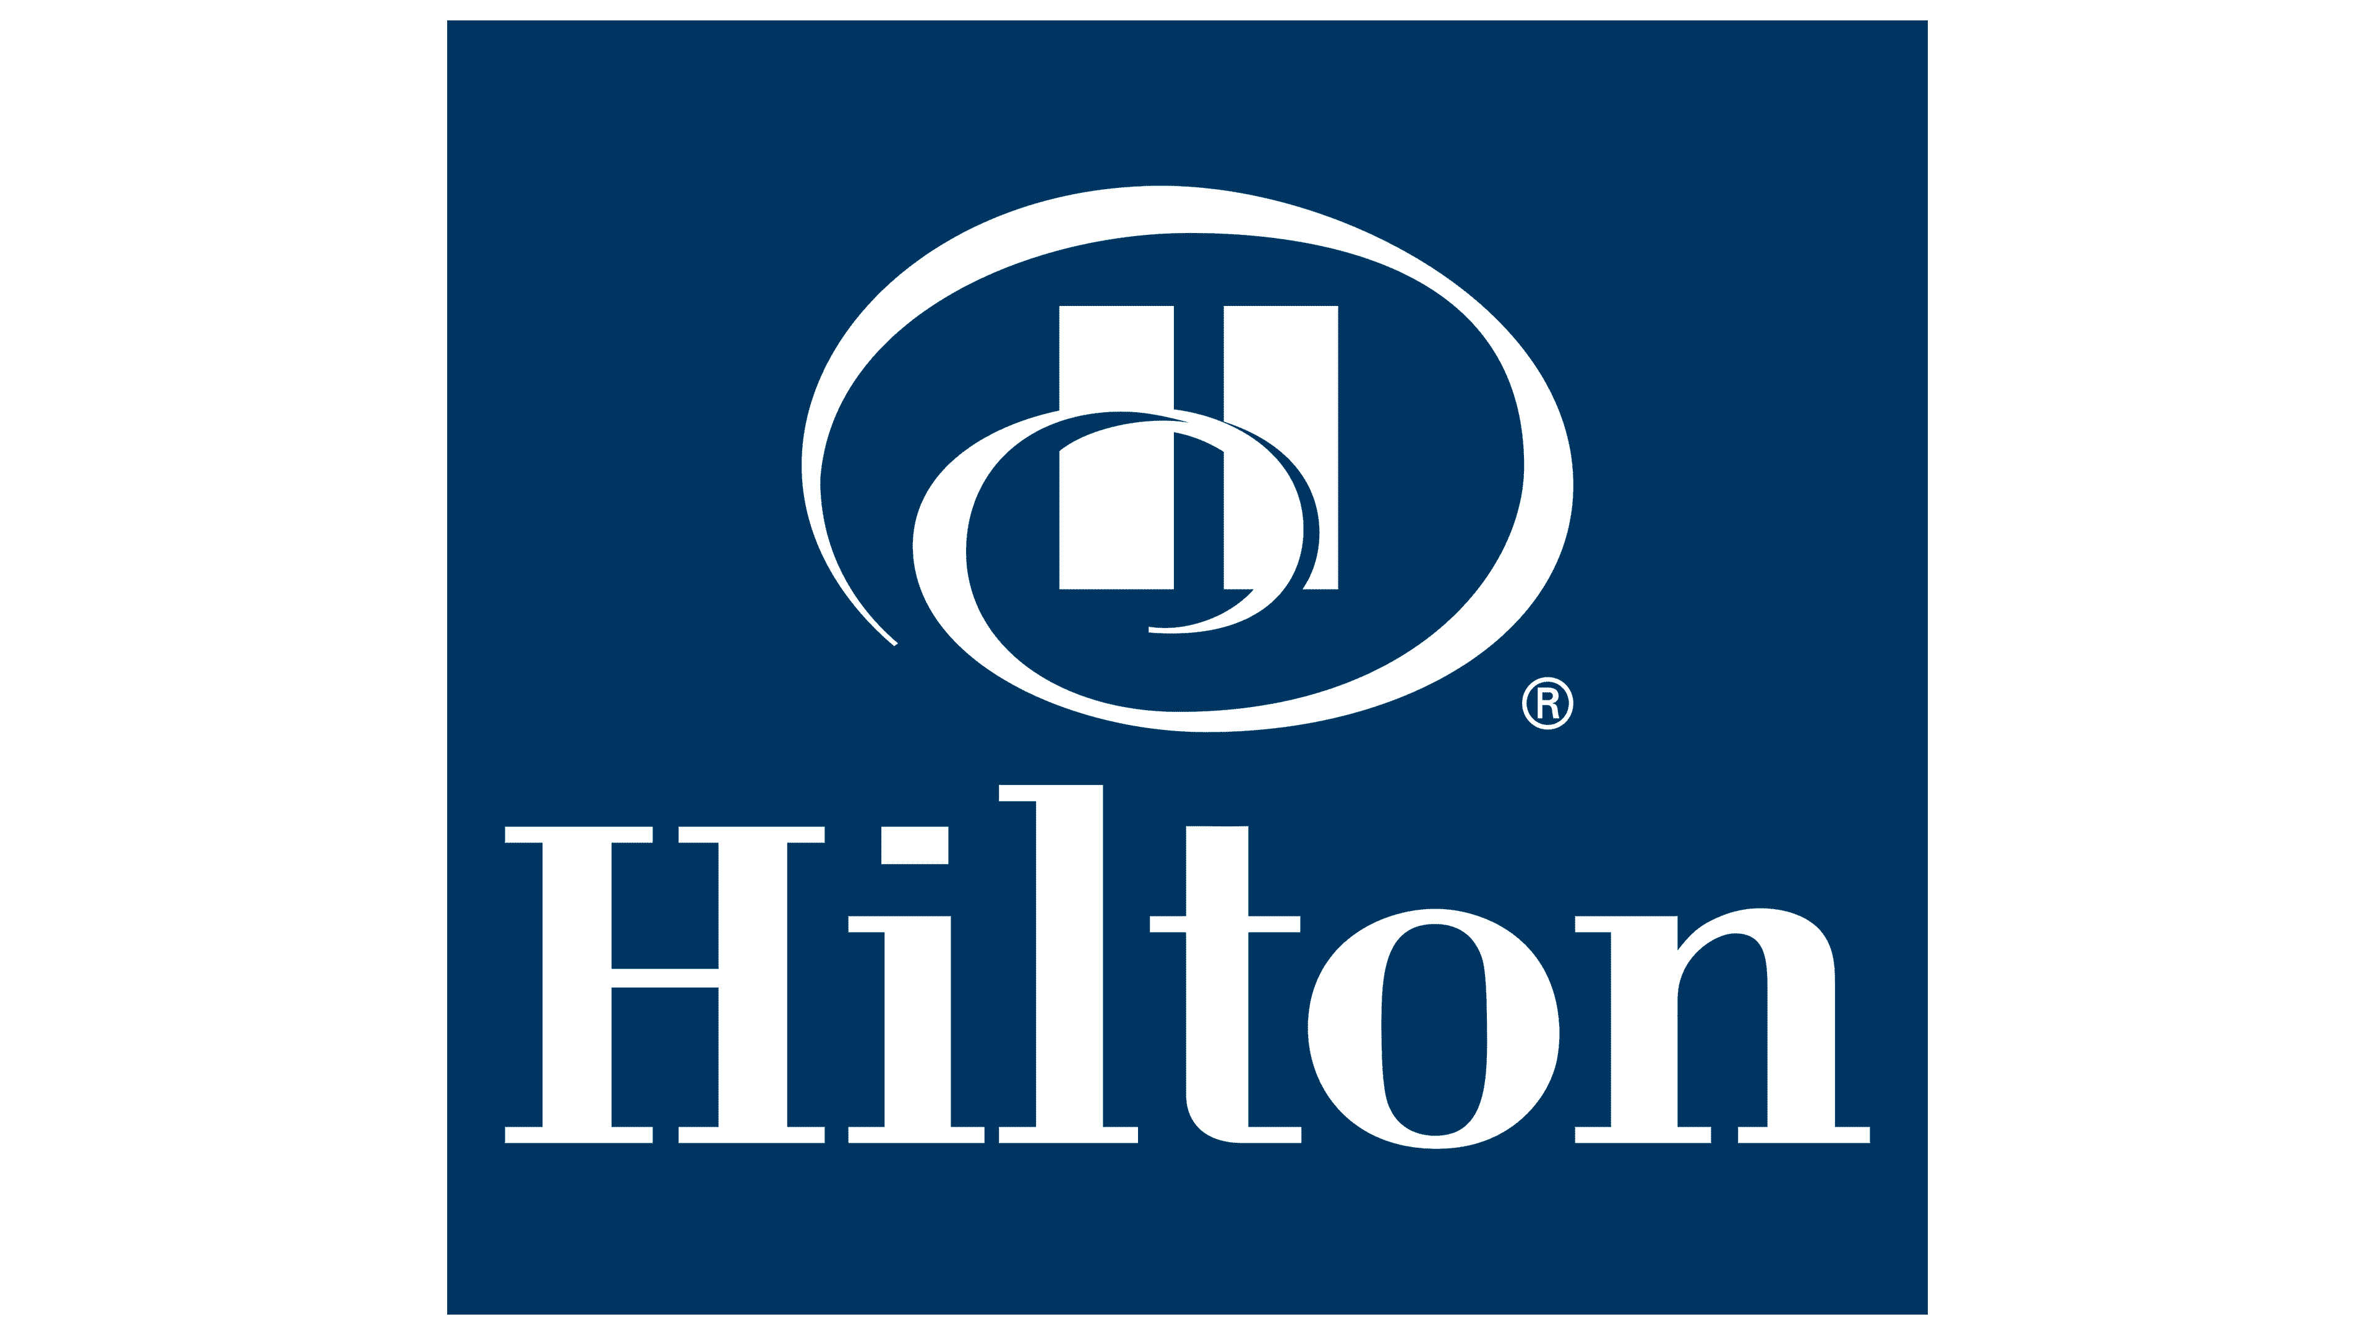
Figure 1: Hilton Group of Hotels Logo
Source: (Jia et al., 2022)
Hilton is well-known for its dedication to guest happiness and has won multiple industry accolades for excellence. With millions of members, Hilton Honors is the brand's loyalty program. Hilton maintains its position as a leader in the hospitality industry by emphasizing sustainability and creativity and by regularly changing to satisfy the changing needs of contemporary tourists. In 2023, the market share of Hilton Group is 8.81% which reflects that a significant portion of the market is captured by the company. In 2022, the net profit of the company was $1.255 billion which was 26.1% higher than the profit of 2021 (Langer, 2022). This reflects the strong financial position and financial stability of the company in the global hospitality industry.

Organizational Structure of Hilton Group
The division, coordination, and control of work inside a firm are defined by the organizational structure. It delineates roles, duties, and interrelationships to promote effective workflow. A well-thought-out structure facilitates effective resource allocation, improves communication, and defines reporting lines (Griffin et al., 2020). Crucially, it promotes organizational clarity, which makes it possible for staff members to comprehend their responsibilities and participate successfully, improving output and success in general.
Hilton Hotels Group follows a matrix organizational structure. The matrix organizational structure blends components of divisional and functional organizations. This structure encourages flexibility and cross-functional cooperation by having employees report to both functional managers and project or product managers.
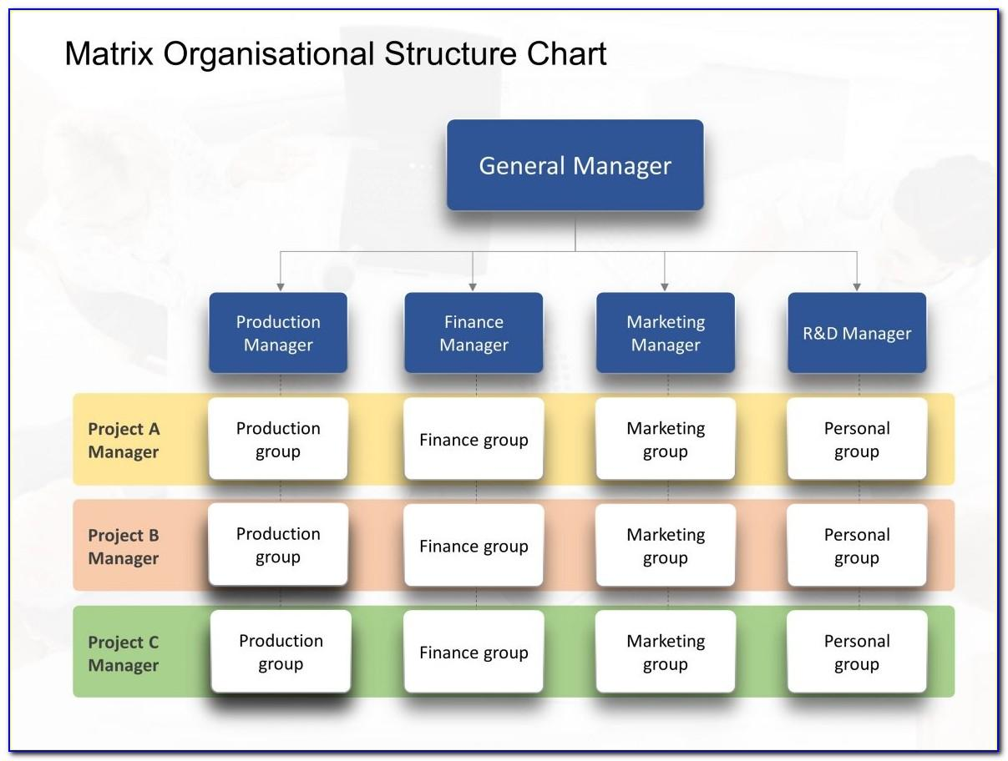
Figure 2: Matrix Organizational Structure
Source: (Jia et al., 2022)
This organizational style allows Hilton to gain flexibility in managing several hotel brands and international operations by combining elements of divisional and functional setups. While pooling resources centrally, divisions like full-service and luxury brands operate with a certain amount of autonomy. Specialization and responsiveness to market demands are improved in the Hilton Group by following this structure. Moreover, clear reporting lines promote efficient collaboration by facilitating effective communication in the organization (Zeng, L., 2021). The dynamic hospitality sector requires innovation and flexibility, which is why Hilton's matrix structure fosters these qualities and eventually contributes to the group's long-term success and global market leadership.

Organizational Culture of Hilton Group
A company's common values, beliefs, and practices are all part of its organizational culture. It shapes interactions, decision-making, and behaviour among employees, which in turn shapes the workplace culture as a whole (Luthans et al., 2021). Employee involvement, flexibility, and teamwork are all encouraged by a supportive and cohesive culture. It has a major impact on performance and creativity, attracts people, strengthens organizational identity, and ultimately influences the success of the business. In this section of the report, the organizational culture of Hilton Group has been discussed by analyzing its organizational values and the style of organizational culture followed in the organization.

Organizational Values of Hilton Group
Hilton Group practices a distinct set of values that collectively play a significant role in shaping the overall organizational culture of the company. The organizational values of Hilton Group have been presented below.

Figure 3: Organizational values of Hilton Group
Source: Author
Hilton's daily activities are deeply rooted in its core values. Personalized visitor experiences demonstrate hospitality, whereas moral judgment is informed by integrity. Teamwork encourages collaboration within varied teams, and the value of leadership cultivates empowerment. Responsiveness is a value that highlights timely service and flexibility to meet clients' urgent requirements (Jia et al., 2022). By defining employee conduct and influencing the guest experience, these principles collectively form Hilton's corporate culture and help to establish the company's well-known image for excellence in the industry of hospitality.

Handy’s Typology Model
The Topology Model by Charles Handy proposes four organizational cultures which are,
- Task Culture (adaptable teams focusing on particular tasks)
- Person Culture (individuals prioritize their interests)
- Power Culture (centralized authority),
- Role Culture (bureaucratic cultural structure with clearly defined roles).
Handy's model offers a framework for understanding and handling organizational dynamics (Jeong et al., 2023). It delivers insights into how businesses function and how various cultures might affect decision-making and employee behaviour.
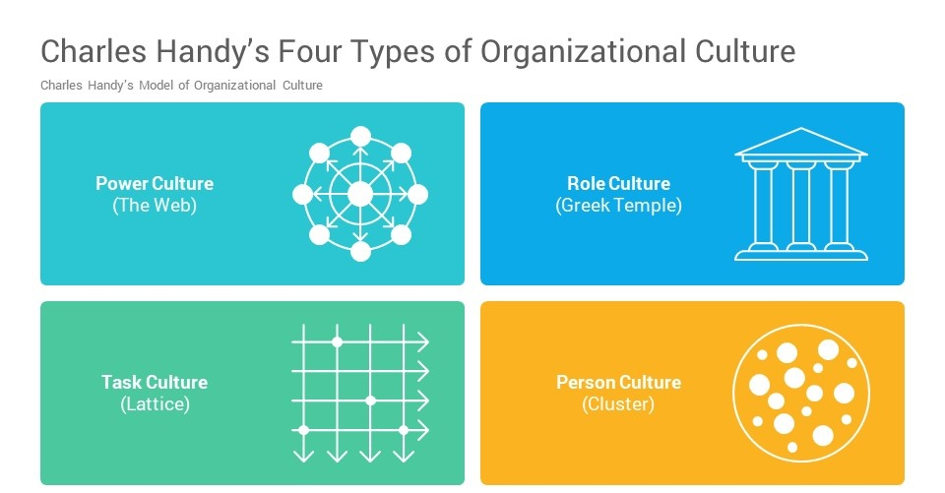
Figure 4: Handy’s model of organizational culture
Source: (Wagner et al., 2020)
Among the four types of cultures defined in Handy's model, Task culture is predominantly followed at Hilton. This is demonstrated by its dynamic approach, which encourages adaptable teamwork to meet the various demands of visitors. The focus on flexibility and teamwork in the Hilton Group makes it possible to react quickly to the constantly shifting needs of the hospitality sector (Black, 2019). While elements of Person Culture, which values individual contributions, and Role Culture, which ensures clear roles and responsibilities, may also be present, Task Culture predominates, in line with Hilton's dedication to innovation, customer satisfaction, and effective service delivery in a cutthroat global market.

Goals of Hilton Group – Mission and Vision Analysis

Mission of Hilton Group
The mission of Hilton Group is to be the most hospitable organization in the world by offering outstanding experiences that go beyond accommodation. Hilton is dedicated to meeting the changing demands of international travellers and strives to be the number one option for visitors, employees, and owners. Their goal, which is based on a tradition of hospitality, places a strong emphasis on innovation, individualized service, and beneficial societal impact (Wu et al., 2021). Hilton aspires to be a leader in the hospitality sector by delivering exceptional experiences, continuously going above and beyond customers' expectations, and improving the communities in which they operate.

Vision of Hilton Group
Hilton's vision is to spread hospitality's warmth and light throughout the planet. This ambitious objective highlights the brand's dedication to fostering inclusive and friendly environments throughout its varied worldwide hotel portfolio. Hilton hopes to provide more than just lodging—it wants to create experiences that customers will remember and find meaningful. This vision demonstrates a commitment to building relationships, providing outstanding service, and making a good impact on the communities they serve.

Recent Change Initiatives in the Hilton Group
Environmental responsibility and sustainability are at the heart of Hilton's latest change initiatives. The company has followed a deliberate move toward renewable energy and increased energy efficiency as shown in its target to reduce Scope 1 and 2 carbon emissions by 61% by 2030 (Abardeh, 2022). Simultaneously, the emphasis on a 50% decrease in waste indicates a proactive approach to waste management. These programs demonstrate Hilton's flexibility and reactivity to today's environmental issues, highlighting a dedication to constructive change within its operations and harmonizing with international sustainability goals.

Change Management in Hilton Group
Hilton Group follows the ADKAR change management model for effectively adapting to organizational changes. Five stages comprise the ADKAR model of change management which are,
- Awareness
- Desire
- Knowledge
- Ability
- Reinforcement.
It facilitates organizational change management by attending to the practical and psychological aspects of people's transformations during the change phase.
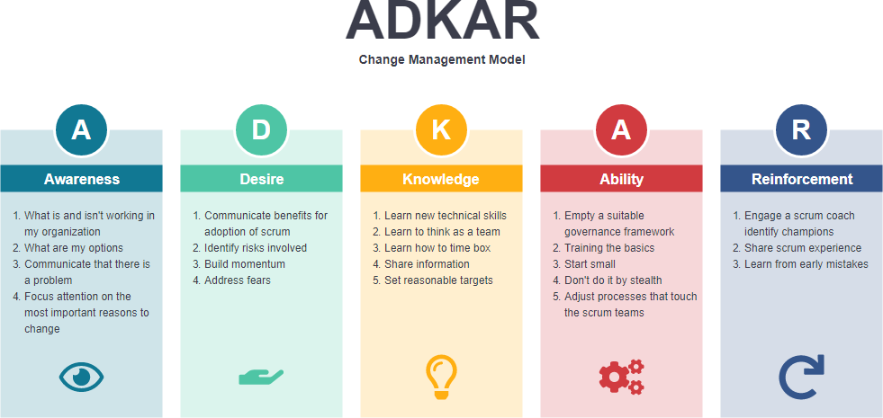
Figure 5: ADKAR model
Source: (Wu et al., 2021)
Hilton incorporates the ADKAR approach to manage change effectively. In the Awareness stage, the necessity for change is communicated, and participation cultivates a Desire for it. Employees receive knowledge that increases their capacity to make improvements. By praising accomplishments, reinforcement guarantee that the changes will remain sustainable (Wagner et al., 2020). Hilton's implementation of the ADKAR model demonstrates a deliberate and comprehensive approach to change, guaranteeing that staff members are not only aware of the changes but also inspired and prepared to support and participate in the organization's changing activities.

Strategic Direction in Hilton Group
Setting clear strategic direction requires effective leadership. Teams need leaders to help them create objectives, make choices, and adjust to change. They guarantee corporate concentration, encourage alignment, and cultivate a common vision (Sarhan et al., 2020). Moreover, good leadership helps teams overcome obstacles, fosters creativity, and increases agility, all of which help the organization succeed in the long run. To analyze the strategic direction of Hilton Group, the leadership style followed by the company has been discussed below.

Leadership Style in Hilton Group
The current CEO of Hilton Group, Christopher J. Nassetta emphasizes following the transformational leadership style to provide effective strategic direction to the company. Followers of transformational leadership are inspired and motivated to realize their greatest potential and go above and beyond expectations (Hoang et al., 2021). These leaders create a healthy company culture that extends beyond daily activities and supports long-term development and achievement by promoting creativity, stimulating the intellect, and forging strong relationships.
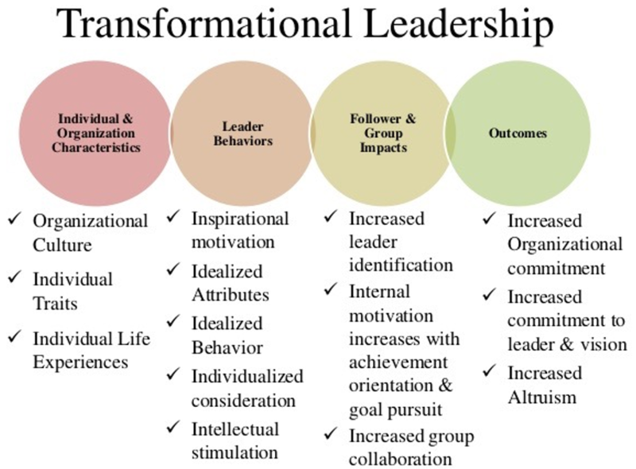
Figure 6: Transformational leadership
Source: (Hoang et al., 2021)
Hilton places a strong focus on inspiring and encouraging staff members beyond regular tasks, which is a reflection of transformational leadership. The business makes investments in training staff members and cultivates an environment that values creativity. This is consistent with the values of transformational leadership, which place a high value on personal development and intellectual stimulation (Uhl-Bien et al., 2020). Hilton's organizational dedication to customer satisfaction and continual improvement highlights the transformational influence, even though particular data on the company's leadership techniques may not be openly shared. Hilton positions itself to manage industry challenges and create excellent guest experiences by fostering an environment that values innovation, adaptability, and employee empowerment. This aligns with the fundamental principles of transformational leadership.

Business Performance Analysis
Hilton has continuously shown good business performance, which it attributes to a strong corporate culture, efficient leadership, and a well-structured organization.
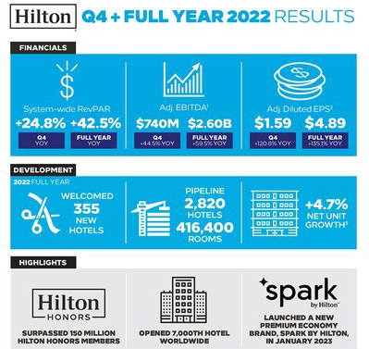
Figure 7: Hilton Performance Analysis
Source: (Rockett, 2023)
As the above figure demonstrates, in 2022, the yearly EBITDA of the company increased by 50.5% from the previous year and the diluted EPS increased from $1.59 to $4.89. the figure also highlights that in 2022, the company launched 355 new hotels and achieved a net unit growth of 4.7% (Rockett, 2023). In 2023, the overall market share of the company is 8.81%. Such growth and advancement in the overall business performance can be aligned with the effective organizational structure, culture, and strategic leadership of the company. Agility and adaptation are made possible by the matrix organizational structure, which is essential in the fast-paced hotel industry. Hilton's dedication to a task culture encourages adaptability and complies with industry standards. Its culture places a strong focus on principles like hospitality and now, which improves visitor satisfaction as well as responsiveness to market demands. Long-term success is fueled by innovation, which is encouraged by transformational leadership principles. Excellent structure, culture, and leadership all work together to support Hilton's steady expansion, sound financial standing, and capacity to overcome obstacles, which helps the company establish itself as a leader in the world's hospitality sector.

Conclusion
In conclusion, Hilton's long-term success is a result of its skilful combination of transformational leadership, an adaptable culture, and an efficient organizational structure. This collaboration not only supports the company's impressive financial results but also establishes it as a leader in its field. Hilton's dedication to innovation, guest experience, and organizational excellence is a reflection of a strategic alignment that encourages growth and resilience in the dynamic hospitality industry.

References
Abardeh, H.C., 2022. Finding a Path to Success for the Hilton Atlanta Downtown Hotel. SAGE Publications: SAGE Business Cases Originals.
Black, J.S., 2019. Organizational behavior. OpenStax College.
Griffin, R.W., Phillips, J.M. and Gully, S.M., 2020. Organizational behavior: Managing people and organizations. CENGAGE learning.
Hoang, G., Wilson-Evered, E., Lockstone-Binney, L. and Luu, T.T., 2021. Empowering leadership in hospitality and tourism management: a systematic literature review. International Journal of Contemporary Hospitality Management, 3(1), pp.41-67.
Jeong, M., Shin, H.H., Lee, M. and Lee, J., 2023. Assessing brand performance consistency from consumer-generated media: the US hotel industry. International Journal of Contemporary Hospitality Management, 3(1), pp. 56-83.
Jia, Y., Curpad, S., Diller, C. and Gentry, R., 2022. Serving Hotel Customers in a Postpandemic World: How Can Hilton Worldwide Recover and Change?. SAGE Publications: SAGE Business Cases Originals.
Langer, A., 2022. The Hotel on the Hill: Hilton Hotel’s Unofficial Embassy in Rome. Diplomatic History, 1(2), pp.37-39.
Luthans, F., Luthans, B.C. and Luthans, K.W., 2021. Organizational behavior: An evidence-based approach fourteenth edition. IAP.
Reidhead, C., 2020. Impact of organizational culture on employee satisfaction: A case of Hilton hotel, United Kingdom. Journal of Economics and Business, 2(1), pp.40-56.
Rockett, G., 2023. History/overview of Hilton. The Routledge Handbook of Diversity, Equity, and Inclusion Management in the Hospitality Industry.
Sarhan, N., Harb, A., Shrafat, F. and Alhusban, M., 2020. The effect of organizational culture on the organizational commitment: Evidence from the hotel industry. Management Science Letters, 2(1), pp.83-96.
Uhl-Bien, M., Piccolo, R.F. and Schermerhorn Jr, J.R., 2020. Organizational behavior. John Wiley & Sons.
Wagner III, J.A. and Hollenbeck, J.R., 2020. Organizational behavior: Securing competitive advantage. Routledge.
Wu, X., Wang, J. and Ling, Q., 2021. Managing internal service quality in hotels: Determinants and implications. Tourism Management, 3, p.79.
Zeng, L., 2021. Analysis of Hilton Worldwide Hotel Group’s Transnational Operation Strategy. Academic Journal of Business & Management, 1(3), pp.20-27.

