How can the archaeology of conflict contribute positively to the process of bereavement, commemoration and reconciliation?

Conflict, whether encountered as a scuffle, a skirmish, or full-blown warfare, begets emotions, and, likewise, emotions cause conflict. These emotions often have the same root, being founded on hatred and fear, and can be reinforced and energized by the experiences endured by the participants in the conflict arena. These experiences become embedded in memories which are then imparted to contemporaries and the next generation, thus ensuring their survival and promulgation, leading to a perpetual cycle of conflict. The archaeology of conflict helps to disrupt this repetitive loop by presenting an objective perspective of the hostilities (Schofield 2005), offering corroboration and truth, but also providing opportunities to ease the processes of bereavement, commemoration and reconciliation. These processes are needed to try to break the cycle and lead to a resolution of the conflict; they are complex topics requiring sensitive and diplomatic management to ensure success, and they are important constituents of the negotiation of peace. An added complication of this topic is the different procedures employed by governments and other official bodies to achieve this outcome.

To illustrate contrasting approaches in achieving such a resolution, I will be considering the accounts of two case studies: the Osobowice cemetery in Wrocław, Poland, and the Russian Front. These are different profiles, the former being post-war and the latter wartime, but they both demonstrate how the archaeology of conflict can be used to provide closure and to help effect a positive conclusion.

Archaeology of Conflict

The term ‘battlefield archaeology’ implies a narrow site-specific focus, whereas the ‘archaeology of conflict’ encompasses a much broader range. The archaeological practice and tools applied in this specialism are still familiar, using geophysical techniques for surveying sites, excavation, recording and processing evidence, identification of artefacts, and interpretation, all done using systematic, consistent and methodical principles. These techniques and principles are used whether it is a site-specific battlefield, a diffused site, or a conflict event covering a lengthy timeframe, but the result should be the same: the preservation of archaeological evidence which aids in the accurate understanding of a conflict (Sutherland & Holst 2005). An additional consequence of this is that the evidence can be used to corroborate, or to disprove, historical literary narratives (Schofield 2005). This is why the archaeology of conflict is important – it discourages partisan propaganda and glorification of the past, and encourages rational debate.

Osobowice cemetery, Wrocław, Poland

The work done at Osobowice cemetery was the first exhumation performed in Poland on such a large scale (Szleszkowski et al 2014a). It commenced in October 2011 and is an example of an interdisciplinary research project, incorporating archaeologists, anthropologists, forensic pathologists, and historians, and supported by national authorities, particularly The Institute of National Remembrance (INR) (Wrocław University 2012). The principal aim of the project was to locate and identify the buried remains of victims of the post-war pro-Soviet regime, and to bury them appropriately (Wrocław University 2012).

These victims are the “Accursed Soldiers”, members of a pro-independence underground movement who were active in the period 1944-1963. They were originally the Polish Resistance which splintered into various entities and then reincorporated as the Home Army, continuing the struggle for Polish independence which had started in 1939 with the invasion of Poland first by Germany, then by Russia, acting at the time as Germany’s ally (INR 2020). The territory of Poland was divided between these allies, with Russia taking overall control in 1944, with a Polish-Soviet Friendship Treaty being signed in 1945. Poland was promised free and unfettered elections by the participants of the Yalta Conference in 1945, but members of the Polish Underground State were arrested and taken to Moscow in 1945, and Poland remained under the authority of Russia (INR 2020). The Accursed Soldiers were fighting against the Polish communists and the Soviet apparatus, disrupting the communist administration and the Soviet power structure, which resulted in the authorities’ determination to destroy the independence movement using tactics of repression and propaganda (INR 2020). Elections were held in 1947, viewed by most as NOT free and unfettered (Enc. Brit. 2020, INR 2020), with the pro-Soviet communist incumbents being ‘elected’, and this event, combined with the general regime of manhunts, arrests, and capital punishment, meant the resistance gradually dwindled. Many of the independence fighters took refuge from the post-war security apparatus in Silesia in the south-western corner of Poland, whose capital is Wrocław, but, as the new regime embedded itself within Poland, they were captured, tried, and sentenced (Szleszkowski et al 2014a). And it is these prisoners whose graves were the focus of the Osobowice project.
Structure of the Polish Underground State (from INR 2020).

The existence of unidentified graves in the cemetery became apparent in 1989, on the opening up of state archives and other official sources after the transformation of the Eastern Bloc and the unravelling of the communist states (Cox 2011). The burials were of victims from the prison at Kleczkowska Street who died or were executed between 1945-1956 (Wrocław University 2012). 840 prisoners were buried in Osobowice in 22 plots, with the majority of the plots being reutilized, eliminated, or otherwise hidden today (Szleszkowski et al 2014a). However, plots 81A and 120 were identified and excavated, with 223 individuals found, although approximately 400 prisoners were recorded as buried there. The location of the burials was noted in cemetery records which were kept secret and confidential (Wrocław University 2012). The initial exhumations were ordered by the INR, with the team searching for specific individuals who were independence fighters. However, difficulties were encountered, with problems identifying individuals, individuals being in the wrong position, and, on examination of the skeletal remains, it becoming obvious there was disorder in the date sequence of burials. This has been interpreted as a deliberate attempt by the authorities to conduct an intentional policy of confusion, secret burials, and disinformation (Szleszkowski et al 2014a). This is a good example of the archaeology process disproving official records.

Szleszkowski et al (2014a) describes how each exhumation was conducted using strict archaeological criterion with a specific systematic approach devised for this project. Metal detectors were used at different stages of the stratigraphy, to ensure no loss of material. Skeletal remains were plotted carefully, photographed, and collected in their entirety, before being examined by anthropologists and forensic pathologists. Standard protocols were used to draw up a detailed morphology of each skeleton. Close examination of the remains gave information about cause of death, ante-mortem injuries, and structural changes caused by diseases. Dental details were noted to help identification and long bones kept from each skeleton for genetic analysis (Szleszkowski et al 2014a). One of the research objectives was to perform a detailed analysis of the gunshot wounds found for forensic ballistics assessments to try and identify the type of execution performed. By combining the information from all of these strands of data, the chances of positive identification of the remains were heightened, in spite of the chaotic nature of the burials and the disinformation contained in the records. In 2012, the Polish Genetic Database of Victims of Totalitarianism was set up to construct a database of reference material to aid the identification of individuals from future exhumations (Ossowski et al 2017). The researchers working on the Osobowice cemetery exhumations had assumed easy identification of the individuals but, in practice, this was not the case, and this project has formulated procedures to follow in future exhumations to aid identification (Szleszkowski et al 2014a), which will assist projects where the archaeological context is more complex, such as multiple burials.
Mass grave from grounds of Detention Centre, Białystok (from Ossowski et al 2017).
Example of typical skull injuries encountered (from Szleszkowski et al 2014a)

In 2012, plot 83B was excavated and a further 76 individuals were exhumed. These individuals were studied to analyse the methods of execution used, as a means of assessing whether the rules relating to firing squad practice were followed. The conclusion was that there was partial accordance with the regulations in some instances, but, in the majority of cases, the evidence showed the regulations were not followed (Szleszkowski 2014b).

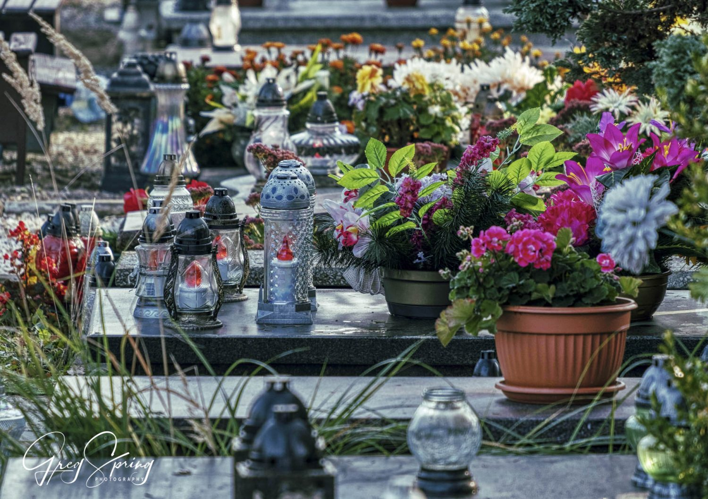
And what happens after the excavation process is complete? At Osobowice, the remains were reinterred in individual marked graves, giving relatives a location for commemoration. In Poland, November 1st is a national holiday – All Saints’ Day – and November 2nd is All Soul’s Day. These two days form a cultural tradition known as Zaduszki in Polish, which is an important occasion when families come together to visit the graves of their loved ones to honour the dead (culture.pl 2014). By providing a location for relatives, the Osobowice project has helped the families with the process of bereavement and commemoration. This fact has added significance when one realises many of the buried individuals had simply disappeared, with the families never having certainty as to what had occurred to them (Szleszkowski 2014a).
Osobowice Cemetery (photographer Gregory Spring, from Nagiecka 2018).

On a statelier level, a formal ceremony of handing out identification notes to family members was held in June 2019 at the Presidential Palace in Warsaw, under the aegis of the Office of Search and Identification of the Institute of National Remembrance, during which the names were read out of 24 victims of state repression. This is seen as the culmination ceremony of an ongoing process of identification of individuals, where the Office seeks to find and identify nameless graves to allow them to “find and restore memory” of the individuals, to whom they owe a “debt of gratitude and duty” (INR 2019). In this particular handing out ceremony, a note was presented to the niece of Roman Czczur, whose remains were identified from Osobowice Cemetery. Roman was a Home Army soldier and recipient of the Cross of Valour and was murdered by the communists in 1950 (INR 2019). It is an emotive, solemn and imposing occasion, but the ceremony available online is marred by the concluding section showing a video displaying the skeletal remains of the individuals in situ in the excavations with their photographs superimposed (INR 2019), which I feel was an uncomfortable, insensitive and sensationalist ending.
Photograph of Roman Szczur (from INR 2019).

Russian Front

The exhumation of the World War II war-dead from the many battlefield sites of the Eastern Front is illustrative of unregulated and unofficial searching. 4 million Soviet soldiers are still Missing in Action out of 30 million soldiers who died on the Russian Front (BBC 2014). In Russia, there is a growing movement of volunteers, coming from every part of Russia, who band together as groups of diggers, to search for the dead.

One of these diggers is Olga Ivishina, a journalist for BBC News and the BBC Russia Service interviewed by the BBC World Service Assignment programme Digging up the Dead (2014). Olga belongs to the Diggers Movement, a grass-roots group searching for bodies, exhuming them, and handing them to the authorities for burial. One volunteer described his initial experience of coming across a soldier lying in a swamp and realising there must be many more waiting to be exhumed and identified, an experience which he felt changed his life. They characterize themselves as an Army of Volunteers looking for an Army of the Forgotten and Unrecognised (BBC 2014). There are different motivations for their activities - some are members of the “transitional generation” (BBC 2014) where their primary schooling was communist and their secondary schooling was free market, and they feel that digging gives them a moral compass, a connection to the past, and they are doing a job that is worthwhile. Some believe the “soldiers bring you to the forest”, with talk of ghosts hovering in peripheral vision and lights appearing over sites of multiple graves. Others feel a closeness to the soldiers, and hence to family members, and others consider the bodies of the soldiers indicate a reality that highlights the triviality and insignificance of modern life (BBC 2014).

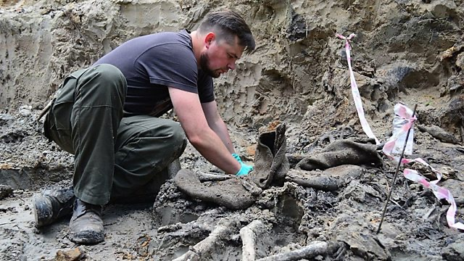
As an example of a battlefield site, in 1941 Hitler launched Operation Barbarossa, during which Leningrad (St Petersburg) was surrounded, besieged, and starved. The Red Army fought bitterly to try and break through the German lines, and, near the town of Luban, 19,000 soldiers were killed over two days (BBC 2014). Olga’s group of diggers dug at this site, using spades, metal detectors and metal probes on the battlefield zone, and, so far, have found up to 200 bodies (BBC 2014). Russian soldiers had ID capsules containing a roll of paper on which they were to write their details. Unfortunately, many are damaged and illegible, or simply had nothing written on them because of the superstition that to write on the paper would encourage death. However, personal artefacts, such as cutlery and bowls, often do have initials marked on them, aiding identification. These groups of volunteers camp overnight, working communally together at the campsite and at the battle site, exhuming bodies and the associated artefacts. Their skills vary but their intentions are the same – to bring the bodies back and give them a name. Although these are laudable intentions, the exhumations are lacking in skill, with little recording or context other than identifying marks, which is regrettable. However, this situation seems inevitable because of the scale of the problem.
Volunteer working at Luban (from BBC 2014).

After the war, the Soviet Government’s priority was to rebuild their shattered country. No effort was made to clear the battlefields, to identify or to bury the dead, either then or subsequently. Indeed, there is a belief that the battle sites were deliberately concealed, with sites ploughed and forests of trees being planted to destroy any traces of war and the huge losses that might be used to undermine the official narrative (BBC 2014). One BBC (2014) interviewee’s opinion was that the new forest plantations and newly constructed buildings were deliberately sited to coincide with the Russian front line. In contrast to the Polish effort, there seems no political will to find these men.

The importance to the families is obvious from the BBC (2014) programme’s narrative – for instance, an ID tag was found containing details and the family was traced. The soldier was killed in 1943 and his son and daughter remembered the village rumours that the father had collaborated with the Germans. Finding their father’s remains not only allowed them closure, but it provided them with the proof their father was not a traitor. For the family, the discovery was a means to restore historical truth and to honour their father’s memory. Another individual interviewed in the programme (BBC 2014) stated their mother heard their father’s name on the evening news – she was able to prove he was dead and not missing in action, which has legal significance (Petrig 2009), meaning she was eligible to receive a widow’s pension. Perhaps it is not just the scale of the problem that deters the Russian government; maybe it is also the thought of the finances involved in having to pay out pensions and other amounts to those survivors of the officially identified.

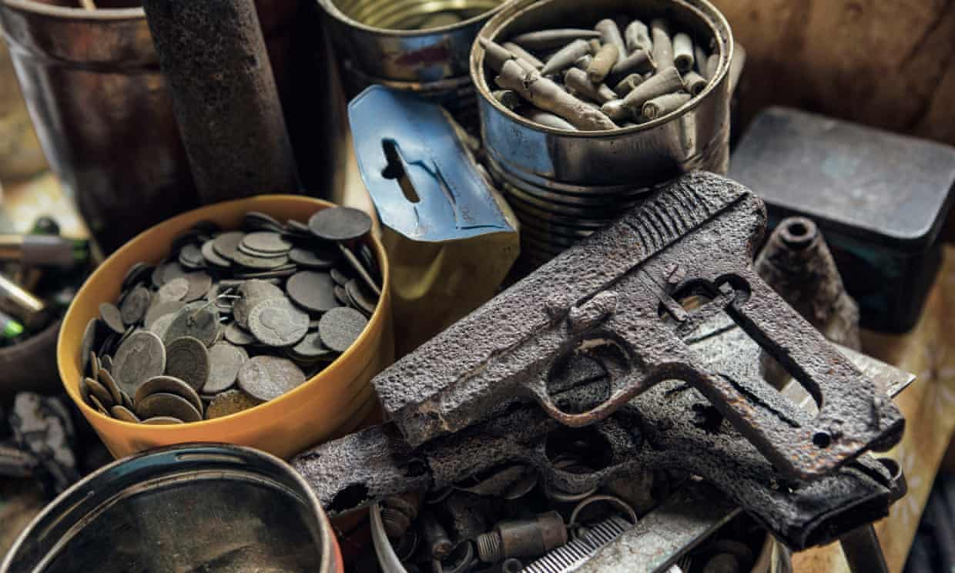
Once the bodies have been successfully identified, they are reinterred, in individual coffins but in a communal grave, following a Russian Orthodox service with full military honours in a special ceremony to which the families are invited, thus providing the families with a locus of commemoration (BBC 2013). German soldiers have also been identified, and these men have been buried in individual graves in German military cemeteries in Russia run by the German War Graves Commission, with ceremonies attended by German officials to show a spirit of reconciliation (BBC 2013). More than 2,000 soldiers have been identified, and Putin has now recognised the work done by the volunteer diggers, with some aid being given in terms of laboratory analysis of remains to aid identification (BBC 2013). However, the excavation is still done by volunteers and is unregulated, which has led to abuses by the ‘Black Diggers’, diggers who care more for the military memorabilia they can disinter and sell than for the soldiers’ remains and their identification (Vice International 2013). In fact, the abuses committed by the ‘Black Diggers’ prompted new legislation, with a federal law being passed in 2013, Bill N245-FZ, prohibiting metal detecting for items over 100 years old and regulating digging (BBC 2014). However, this legislation has not deterred the bounty hunters, who have expanded their operations to cover eastern Europe (Losh 2017). In Poland, there is animosity between the metal detectorists and the archaeologists, with no sign of a resolution of the problem (Losh 2017). Amongst the ‘good’ diggers, there is anger that the authorities are not disinterring the soldiers, instead holding a ceremony at the Tomb of the Unknown Soldier annually on 9 May, which is seen as hypocritical (BBC 2014, Polouektova-Krimer 2016).
1Metal detecting finds (photograph: Antonio Olmos/The Observer, from Losh 2017).

The excavation at Osobowice could be viewed as an example of good practice, with a multi-disciplinary approach and new directions in forensic medicine arising from the experience. It provides the relatives of the deceased with an opportunity for bereavement and therefore closure, in that they now know where their relatives died, for commemoration, in that they have a site to visit on Zaduszki, and, to a certain extent, for reconciliation, in the form of acceptance. Compare this with the work done in Russia, where the approach is haphazard and unregulated, albeit with good intentions, but with no official expertise and with little professional involvement. The Russians have achieved closure for the families of the identified, and provided a focus of commemoration, but it seems there is little reconciliation and acceptance because of the reluctance to commit to finding, identifying and burying the remaining missing soldiers.

Poland has the attitude that it wants to honour the fallen: Russia seems to imply there are just too many soldiers to bury, and official involvement seems minimal. However, does the Polish official involvement hide a deeper political agenda, perhaps of consolidating nationalism, or is it just a desire to ensure its soldiers are recognised? The INR was established in 1998 to research and document the losses suffered by the Polish nation in WWII and the post-war years. A controversial function of the INR is lustration, which is to reveal the secret agents and collaborators of the Polish communist security apparatus (Horne 2009). The INR has been criticised because of the size of its budget, its ‘martyrology’ approach (Mink 2017), and its perceived politicization after the electoral victory of the Law and Justice party. It is now felt the IRN’s approach has changed from objective historical research to historical revisionism (Ambrosewicz-Jacobs 2019).

It is evident from the above that the archaeology of conflict performs an important role in the processes of bereavement, commemoration and reconciliation for the descendants of those who have died whilst fighting for their country, but it is also apparent that an official or semi-official apparatus is needed to manage the disinterment. It is essential this apparatus is autonomous and independent and not subject to political influence. These processes are sensitive topics, needing empathetic administration, and can lead to controversy if mishandled. Done properly, objective historical research will prevail and will aid the process of acceptance and reconciliation.

Reference List

Ambrosewicz-Jacobs, J. 2019. The uses and the abuses of education about the Holocaust in Poland after 1989. Holocaust Studies 25(3): 329-350.

BBC. 2013. Burying the Past. BBC World TV. 4 & 5 January 2013. https://www.youtube.com/watch?v=p-Pt5K_PoDY [accessed 26 February 2020].

BBC. 2014. Assignment: Digging up the Dead in Russia. BBC World Service. 13 February 2014. https://www.bbc.co.uk/programmes/p01rsrj3 [accessed 1 March 2020].

Cox, T. 2011. 1989 and the Transformations in Eastern Europe. Europe-Asia Studies 63(9): 1529-1534.

culture.pl. 2014. All Souls’ Day: The Tradition of Zaduszki in Poland. https://culture.pl/en/article/all-souls-day-the-tradition-of-zaduszki-in-poland [accessed 1 March 2020].

Encyclopaedia Britannica. 2020. Communist Poland by P. S. Wandycz. https://www.britannica.com/place/Poland/Communist-Poland [accessed 29 February 2020].

Horne, C. M. 2009. Late lustration programmes in Romania and Poland: supporting or undermining democratic transitions? Democratization 16(2): 344-376.

INR (Institute of National Remembrance). 2019. The ceremony of handing out identification notes to family members of 24 victims of totalitarian regimes is to be held at the Presidential Palace - Warsaw, 17 June 2019. https://ipn.gov.pl/en/news/1966,The-ceremony-of-handing-out-identification-notes-to-family-members-of-24-victims.html [accessed 28 February 2020]

INR (Institute of National Remembrance). 2020. Accursed Soldiers Pro-Independence Underground 1944-1963. https://ipn.gov.pl/en/exhibitions/3771,Exhibition-Accursed-Soldiers-Pro-Independence-Underground-19441963-available-for.html [accessed 28 February 2020].

Losh, J. 2017. Battlefield Bounty Hunters: the detectorists of eastern Europe. The Observer. 17 September 2017. https://www.theguardian.com/global/2017/sep/17/battlefield-bounty-hunters-in-polish-ww2-battlefields [accessed 1 March 2020].

Mink, G. 2017. Is there a new institutional response to the crimes of Communism? National memory agencies in post-Communist countries: the Polish case (1998-2014), with references to East Germany. Nationalities Papers 45(6): 1013-1027.

Nagiecka, G. 2018. A night with the family – living and not. https://whypoland.net/archives/1881 [accessed 27 February 2020].

Ossowski, A., Diepenbroek, M., Zwolski, M., Falis, A., Wróbel, M., Bykowska-Witowska, M., Zielińska, G., Szargut, M., & Kupiec, T. 2017. A case study of an unknown mass grave – Hostages killed 70 years ago by a Nazi firing squad identified thanks to genetics. Forensic Science International 278: 173-176.

Petrig, A. 2009. The war dead and their gravesites. International Review of the Red Cross 91(874): 341-369.

Polouektova-Krimer, K. 2016. Unearthing Russia’s war dead, over and over again. openDemocracy. 22 June 2016. https://www.opendemocracy.net/en/odr/unearthing-russia-s-dead-over-and-over-again/ [accessed 1 March 2020].

Schofield, J. 2005. Combat Archaeology. Material Culture and Modern Conflict. London: Duckworth.

Sutherland, T. & Holst, M. 2005. BAJR Practical Guide 8 - Battlefield Archaeology: A Guide to the Archaeology of Conflict. http://www.bajr.org/BAJRGuides/8.%20Battlefield%20Archaeology%20%20A%20Guide%20to%20the%20Archaeology%20of%20Conflict/BAJRBattleGuide.pdf [accessed 22 February 2020].

Szleszkowski, Ł., Szwagrzyk, K., Konczewski, P., Kawecki, J., Swiątek, B. 2014a. Exhumation research concerning the victims of political repressions in 1945 – 1956 in Poland: A new direction in forensic medicine. Forensic Science International 235: 103.e1-103.e6.

Szleszkowski, Ł., Thannhäuser, A., Szwagrzyk, K., Kawecki, J., Jurek, T. 2014b. Gunshot wounds (resulting from execution) of exhumed victims of the communist regime in Poland. Legal Medicine 16: 201-207.

Vice International. 2013. Meet the “Black Diggers”: The Russians robbing WW2 Graves. https://www.youtube.com/watch?v=wglJxY6i77E [accessed 26 February 2020].

Wrocław University of Environmental and Life Sciences. 2012. History lesson taken from anthropologists. https://www.upwr.edu.pl/news/15649/history_lesson_taken_from_anthropologists.html [accessed 28 February 2020].

