University of Wales Trinity Saint David
School of Engineering

Engine Cycle Simulation Report
Alexander Penny
1706431
Motorcycle Engineering
17/12/2018
M5X00404

Contents
Introduction 4
Wheels base 5
Rake & Trail 6
Centre of Gravity 7
Gearing and top speed calculations 8
Ducati Panigalle 1199s Geometry analysis 10
Aprilia RS250 Geometry 12
BMW S1000RR 2019 14
Triumph Street Triple 765RS 2018 16

Introduction
We have been tasked with analyzing performance data from a Ford Sigma 1.6L petrol engine. Armed with this information we then were to build a simulation capable of predicting thermodynamic characteristics of an engine cycle. Comparing the results of the simulations allowed for study of there accuracy and limitations. This task was divided into two stages. Task 1 Annalise the internal parameters of the engine detailed in the data provided. Task 2 Using the geometry of a real engine and first principals create an engine simulation and test the simulation against the information gathered in Task 1.

Task 1
The key information provided for the Ford Sigma engine in the data was;
- Cylinder dimensions
- Cylinder Pressures
- Volumes at each degree of crank angle
- Each reading was repeated every 500rpm for a cycle, covering 1000rpm to 6500rpm
Analysis was focused on 1000, 3500 and 6000 rpm as an even spread covering the majority of the range would provide the most valuable comparisons.

Volume
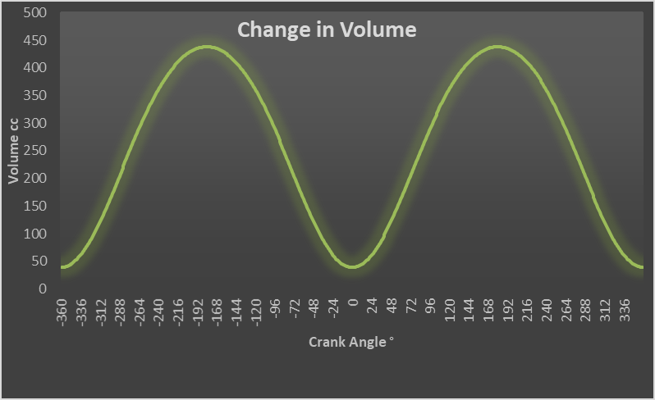
Figure 1
Comparing Volume and Cylinder pressure as the engine moved through its cycle can produce a lot of insights into the inner workings of an engine. Looking at TDC the volume has not been compressed completely there is a clearance volume of approximately 39 cc.
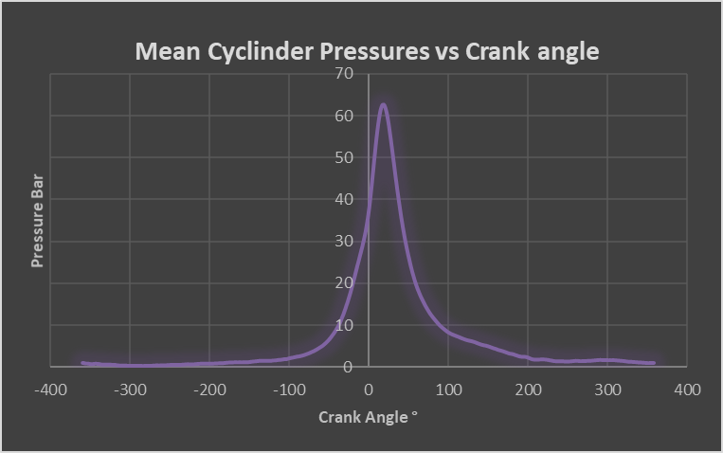
Figure 2
Looking at the previous two figures we can see that the pressure only rises and falls once in 720° of engine rotation. Figure 1 depicts the increase in volume occurring as the piston completes 4 strokes in 720°.
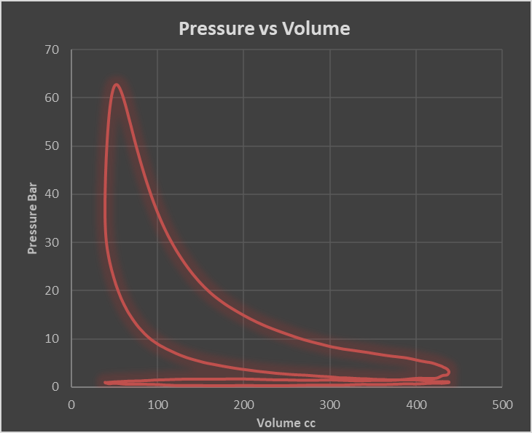
Figure 3
Comparing pressure and volume we can see the Otto cycle taking place
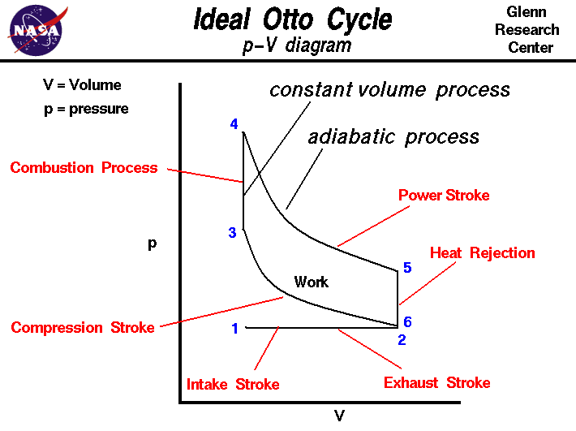
Figure 4
The heat rejection stage is much less significant in the pressure volume comparison performed and illustrated in figure 3.

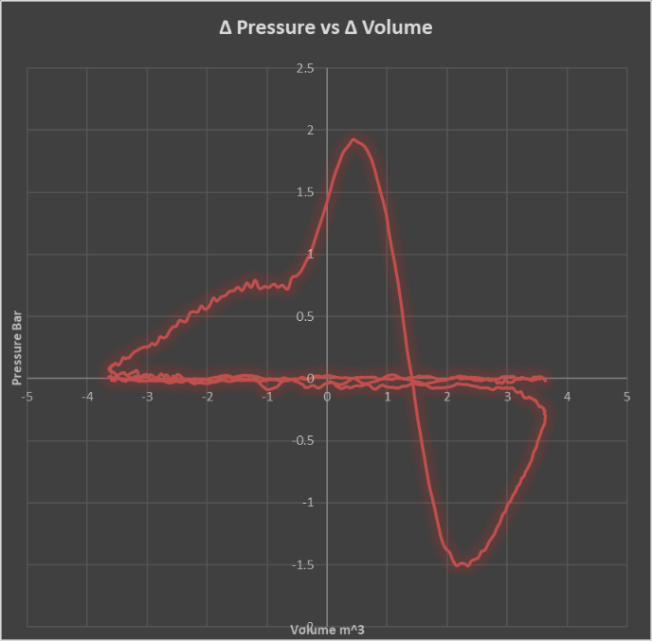
Figure 5

Poly tropic index
Identifying the polytropic index is fundamental for any analysis of gas behavior. The individual polytropic can be found using the following knowledge.
$$PV^{n}=constant$$
Comparing p1,v1 and p1,p2 the polytropic index for the reaction can be calculated.
$$n=\frac{Log(\frac{P1}{P2})}{Log(\frac{V2}{V1})}$$
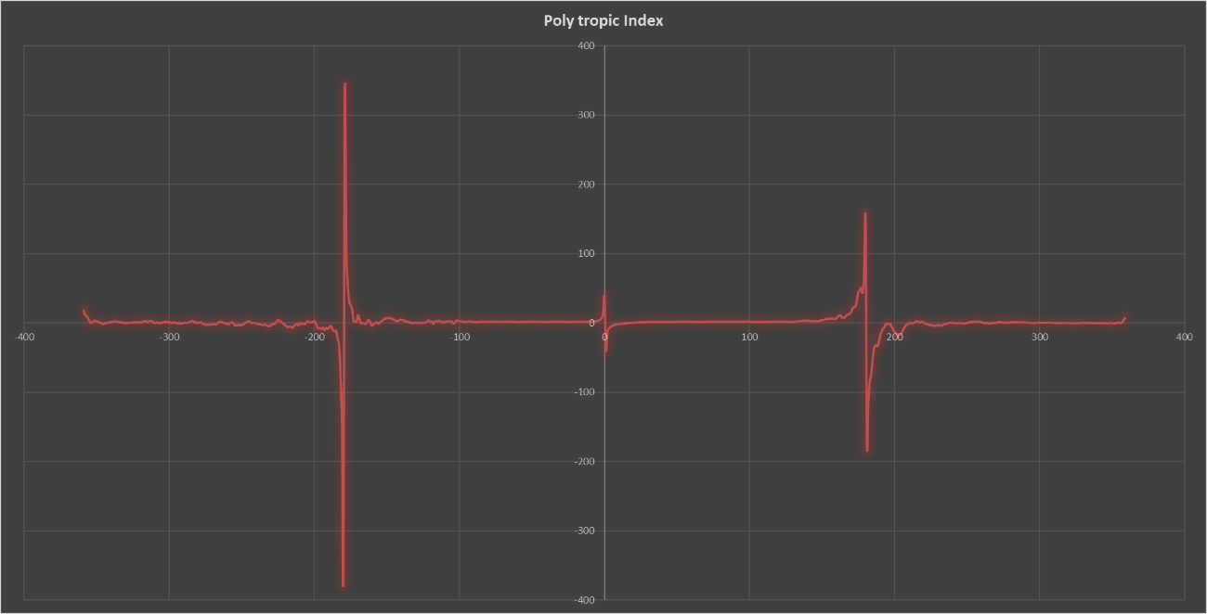
Figure 6
Figure 6 shows the polytropic index changing with crank angle.

A more useable value for the polytropic index can be found graphing Log (Pressure) and Log (Volume) and taking a gradient of the Compression and Expansion phases
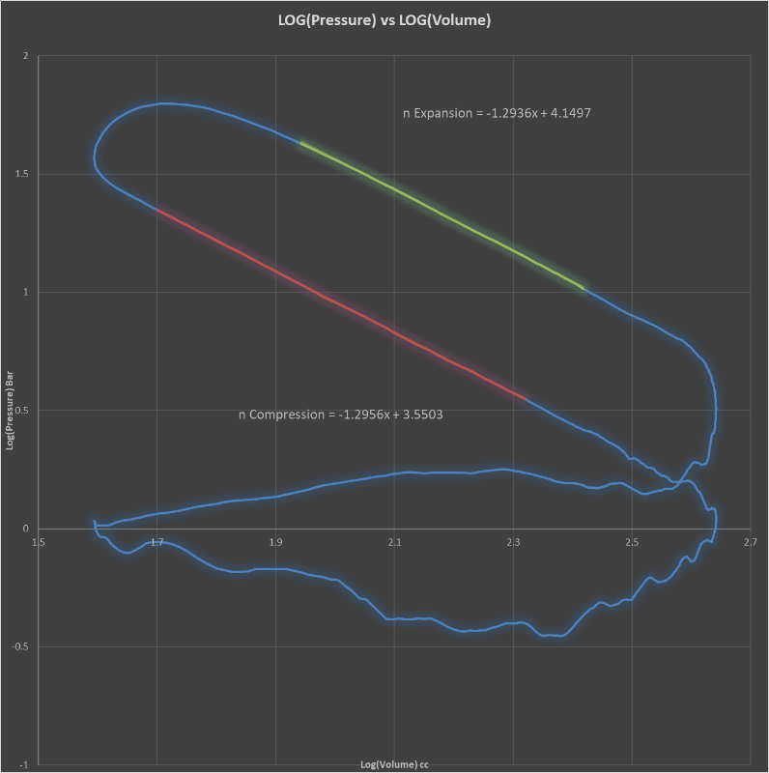
Figure 7
Using the polytropic values found the pressures can be simulated in task 2
To calculate pressures without combustion the polytropic index found in figure 7 was used. They were then compared to the recorded values.
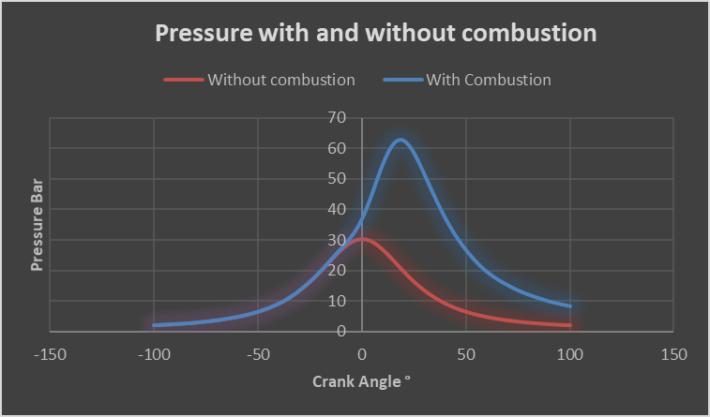
Figure 8
This comparison was helpful for identifying the degree at which ignition starts

Work done
$$Wd=P×∆V$$
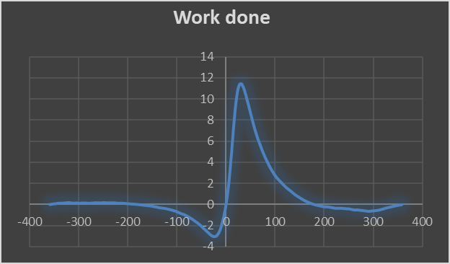

Mass Fraction Burned

MFB
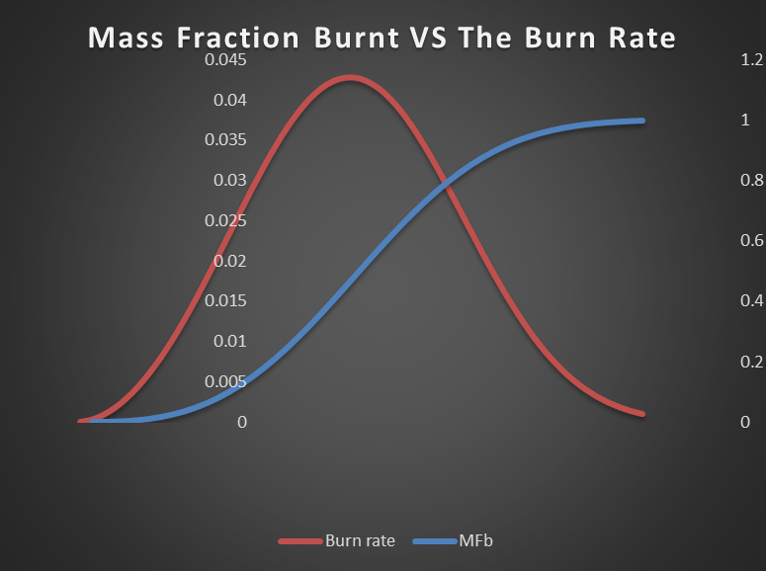
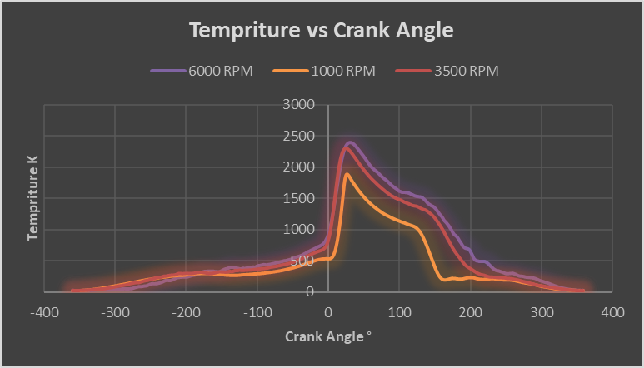

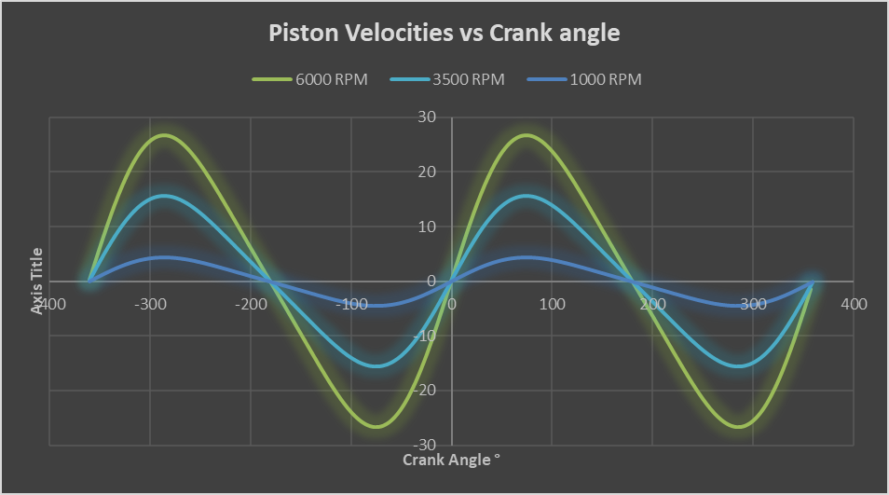
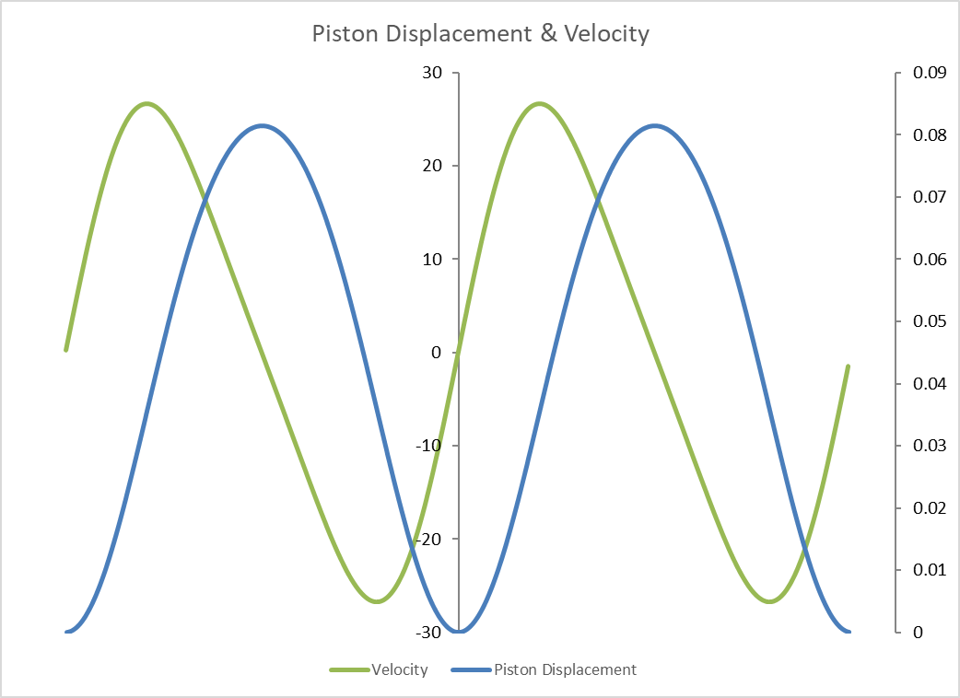
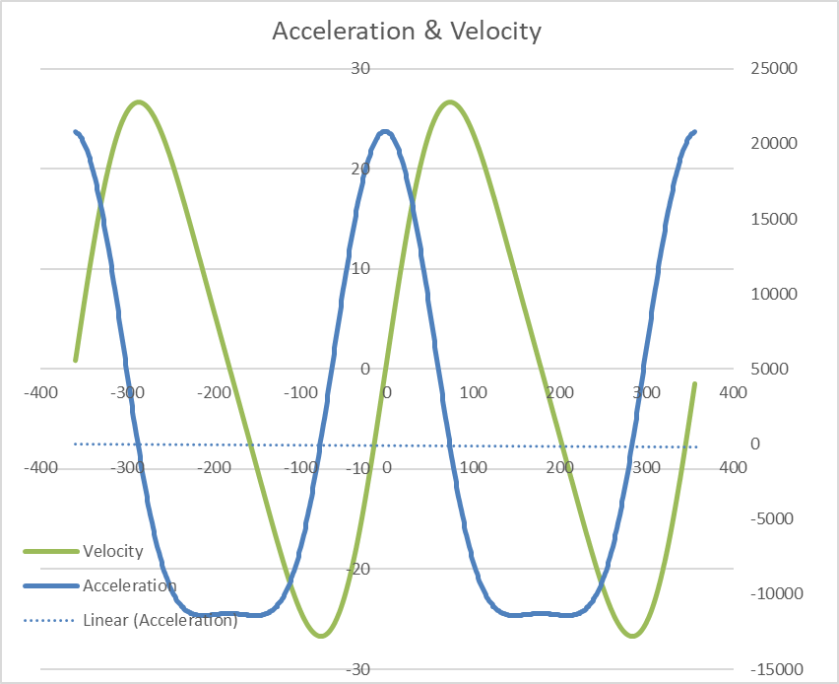
Task 2


