Josh Rowland
P145133
Advanced Web
Advanced Web Part 1
Michael Dacey

Part A

Singleton Pattern
The Singleton pattern is used when there is a single object that is used across the system and it should only be used when only one instance of a class is allowed and when the single instance should be allowed to extend with a subclass[1]. The benefits of the Singleton pattern include but are not limited to the following as seen in [1]:
- The strict control it has over and when the client interacts the instance because the Singleton class encapsulates that single instance.
- It is an improvement over global variables as it avoids polluting the namespace with global variables that store a sole instance.
- The Singleton class can be subclassed and is easily configured to an application with an instance of the extended class.
Singletons are very useful however they do have issues and are looked down upon by many people due to their pointless overuse. Singletons are generally used as a global instance that can be used anywhere in the code which is a problem as it hides dependencies. Many people do look down on the Singleton pattern and see it as anti-pattern because it is used unnecessarily which can add restrictions where there is no need for it. There are also other patterns which can be implemented using the Singleton pattern such as the Abstract Factory or Builder patterns[1].

Factory Design Pattern
The Factory pattern is a creational pattern that uses factory methods to deal with the creation of objects without the need to specify the class of the object and is one of the most used patterns because of its advantages as seen in [2]:
- A major advantage of this pattern is that it has lose coupling which allows the objects to be created independently of the class implementation.
- The client can remain unware of the class that creates an object. It is only necessary to know the interface, methods and parameters that must be passed to create objects.
- It is easy to add classes to the factory without changing the client code.
- This pattern allows the reuse of existing objects, but the client does direct the creation of objects and will always create a new object.
In the Factory pattern the developer will always create at least one interface that is used to create the objects however the subclass decides the class that will be instantiated, and it relies on inheritance rather than instantiation, but it also allows the return of the same instance or subclass instead of an object. A common issue with the factory pattern no matter the language is that is can be complex and messy if there are large number of interfaces and abstraction is can be easy to lose track of certain aspects of the application which can be overwhelming for those who are new to the programming as it does require a solid understanding of key concepts otherwise it may result in a step learning curve.

MVC (Model View Controller)
The MVC patterns revolves around three key pieces the model, view and the controller. The models contain and represent the data that the users will be involved with such as a view model that shows the transfer of data between the views and controllers or the domain models which contain the data for a business domain and the operations, transformation and rules that are needed for manipulating the data[3]. To put it simply the purpose of MVC is to separate business logic and presentation also known as the separation of concerns making the code easy to read and keeping things separate and simple as possible[3]. The model represents everything that the application supports and also the operations that can be used to manipulate the data in the model and it is also responsible for preserving the state and consistency of the data[3]. Models don’t handle processing request or rendering the UI these are the duty of the views and controllers. The views contain are used for displaying elements of the model to the users and they do not have any awareness or communication the model[3]. Controllers are the bridge that connects the model and views because requests come from the clients and are processed by the controller which then selects the appropriate views and if needed a certain operation to perform on the model[3]. Every part of the MVC is well-defined and self-contained and is known as the separation of concerns as seen by the logic that manipulates data in the model is contained in only the model, the data that is used to display information is kept only in the view and the code that handles requests and input is contained in just the controller so because of this divide between each piece it allows the application to be easily maintained and extend no matter how large the application becomes it will always allow for easy maintenance and improvements[3]. There are both advantages and disadvantages to using the MVC pattern to develop applications, advantages include:
- Fast development – Due to there being separate parts of the MVC one programmer can develop the view while another does the model and another the controller which allows for rapid and parallel development[4].
- Unit testing – It is important to be able to do unit testing, so you can prove the a method works correctly and in MVC you can easily replace the real implementation with a test harness to ensure it works correctly[5].
- Test Driven Development – For this you would write the test case first and the write the code so pass said test which is more time consuming the unit testing but it allows for better testing which suits the MVC pattern[5].
- Modification – Modifying the code does not effect the whole model because the model does not depend on the views so its easy to edit code without affecting the architecture[4].
- Flexibility with the use of hard coding the HTML the developer is not limited to drag and drop or other restrictions[6].
- Separation of concerns – Keeping the different parts separate allows for the code to be easy to test, read and develop due to its separation of each of the three parts.
Disadvantages of MVC can include:
- Best used with multiple programmers to do each part of the MVC[4].
- There is a large learning curve when the developer is coming from other technologies and isn’t used to the way MVC works[6].
- MVC is complex compared to some other methods as it requires numerous files and a lot of testing and code[6].
- Many developers may have to learn HTML code in order to use MVC correctly as it is entirely hard coded with no drag and drop options[6].
These are only some of the advantages and disadvantages of MVC, some of which are debatable as actual advantages and disadvantages of MVC, but regardless of the disadvantages MVC is primarily used because of its ability to separate concerns to make the code simpler and easier to read and maintain the application. In summary MVC is a very useful technology with the advantages outweighing the disadvantages especially for those who are new to web development aspects as it allows for easy understanding and organisation of what they are developing or those who have experience in programming and wish to learn more about web development.

Part B

The website developed is the Party Palace party company which is a private party hosting company with several jobs that the user can pick from and contact them in the event they are interested. The website has PDO features and ‘old’ code styles as certain feature are easier to read and write without the use of PDO features as it can make the code appear over complicated, complex and disorganised. The database contains the staff and job data that is used for logging in/ registering while the job data is used in the search, editing, inserting and deletion of data.

The home page of the website Party Palace. As seen below it has a simple navigation menu to the main parts of the website. On every page it will say “Hi!” with a unique message to the logged in user with their unique username.
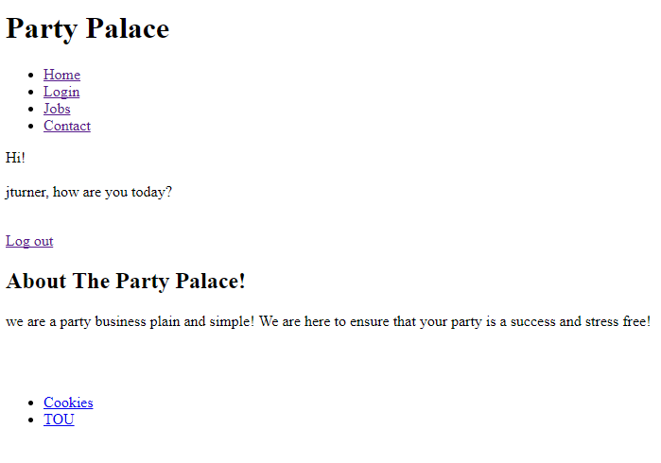
The logout webpage that will refresh after three seconds or if it takes longer the user can select to return to the home page.
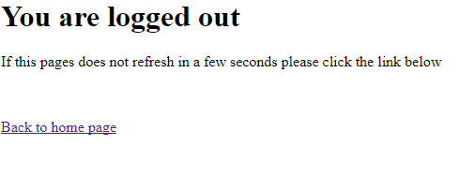

Those who are not logged in will see the following home page where they can register or login if they already have an account.
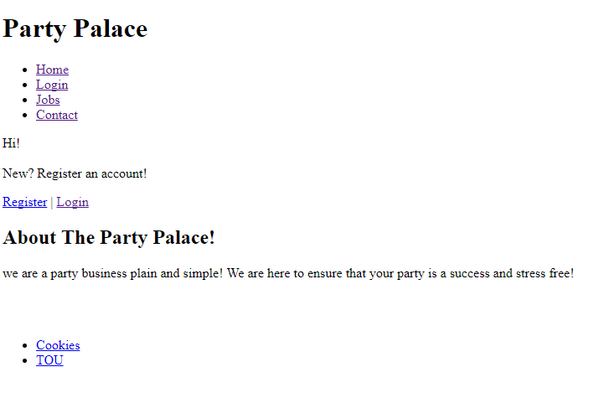

Below you can see the login page where the user will input the username and password that matches the information on the database. The password text box has been set to password and all methods have been set to post in order to ensure some security.
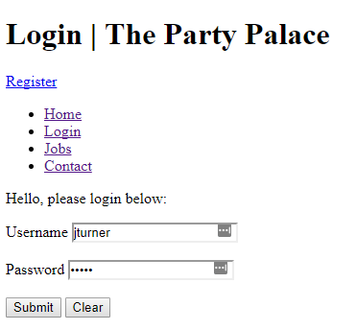
If the user inputs incorrect data, they will see the following and then after 3 second be sent back to the login screen.
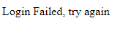
If the user successfully enters the correct details then they will be sent to the follow screen which also redirects them after 3 seconds.

If the staff need to register a new account for a new member of staff the user can go to the register page and input the details as seen below. All inserts on the website are created using PDO.
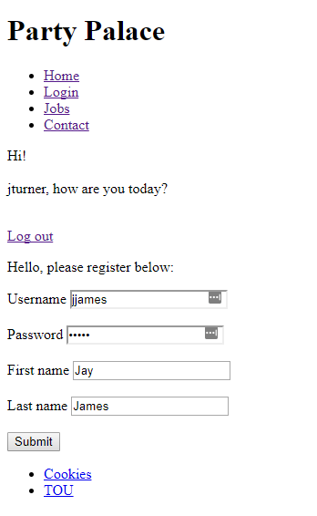
Once the user has input their registration information they will be directed to the page as seen below and then redirected to the home page after 3 seconds.
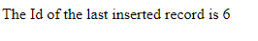
The Jobs page shows all of the jobs that the company offers as seen below each job can be edited or deleted by pressing the correct button. There is also the insert button which brings the user to the insert page where they can create a new job. The search bar is also show where the user can search for any job. The search is preformed using PDO methods.
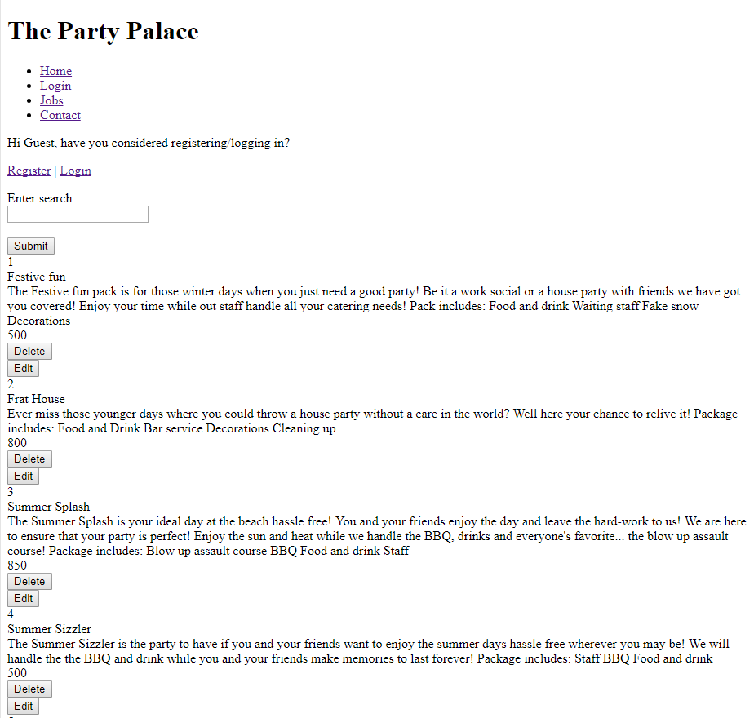

The below images show the result of searching “f”, in doing so will result in all the job names with the letter f in them.

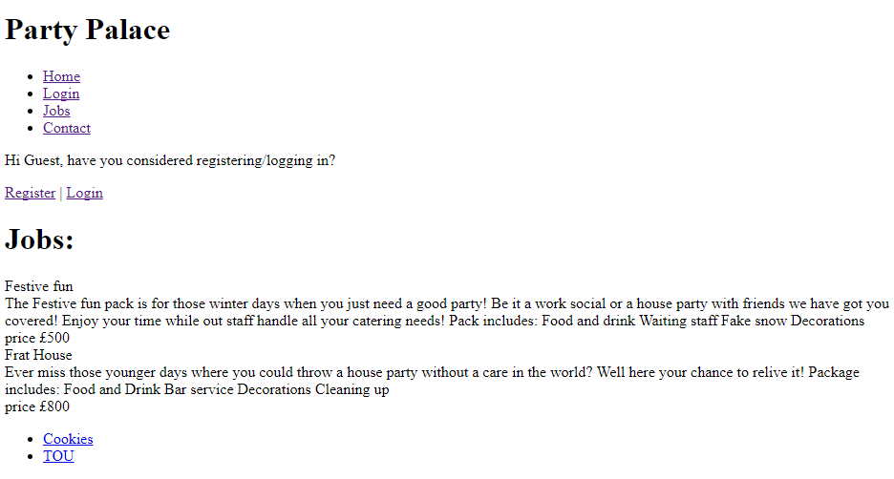

The below image shows the insert screen where the user can insert job details and add them to the database. Once submitted the user is directed to a similar screen to that of when a user registers and it is also refreshed after 3 seconds.

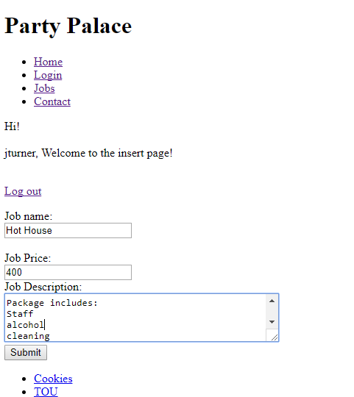

When the user wishes to edit job details they must click on the edit button and are sent the screen below with a blank description for them to write in new details.
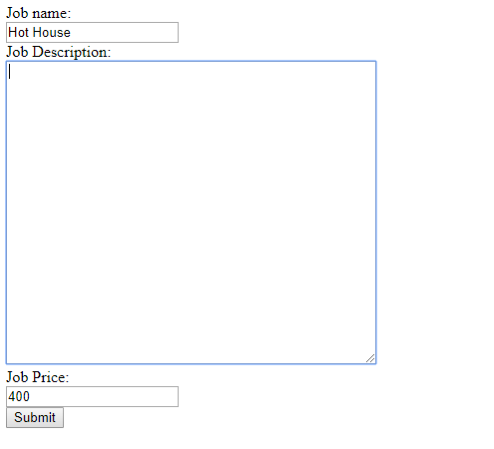

If the user wishes to delete a job they only have to press the delete button and the job will be deleted form the database and the page will refresh as seen below.
Before deletion
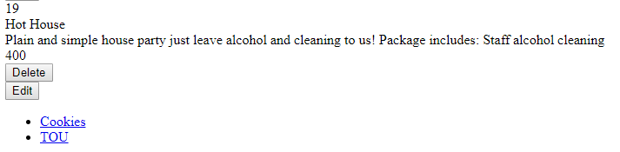

After deletion

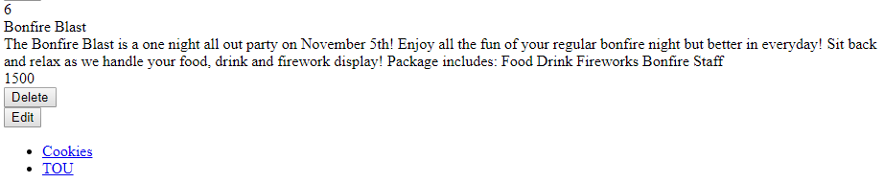

There is then the contact page that displays the social media name and email for if any users wish to contact and learn about the different jobs available.
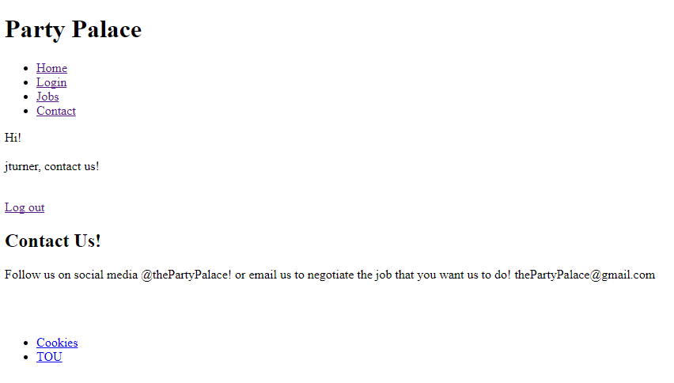

There are several issues on the site that must be addressed:
- There can be duplicate jobs and staff details
- There is no need to login for users to edit delete and insert information, however it is designed for staff members only to be able to use as an ‘internal control’ of the website.
- Lack of CSS
- It has a login system as seen above back does not log searches or logins which is a major issue.

Appendix
index.php
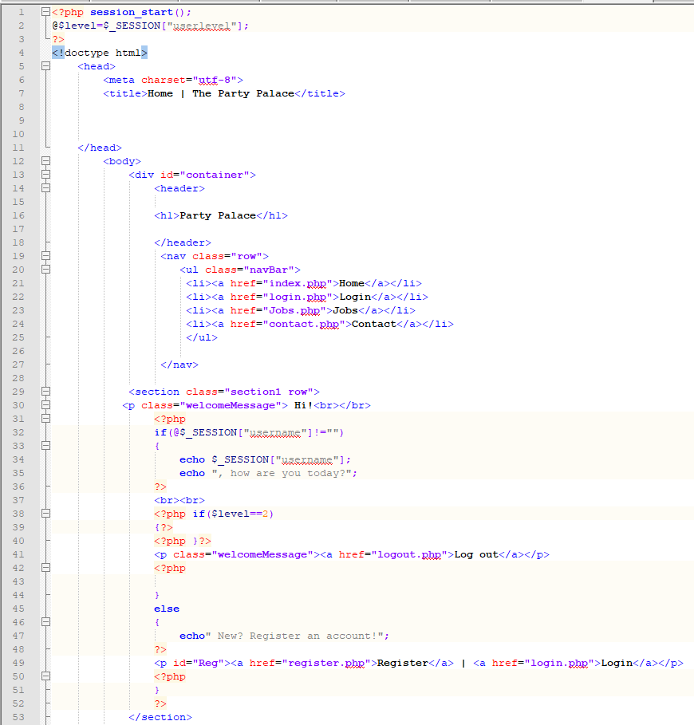
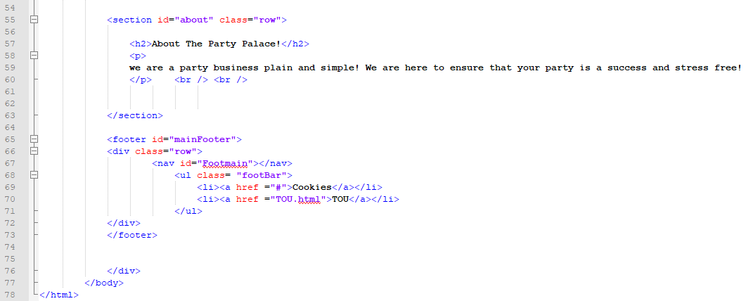

Jobs.php
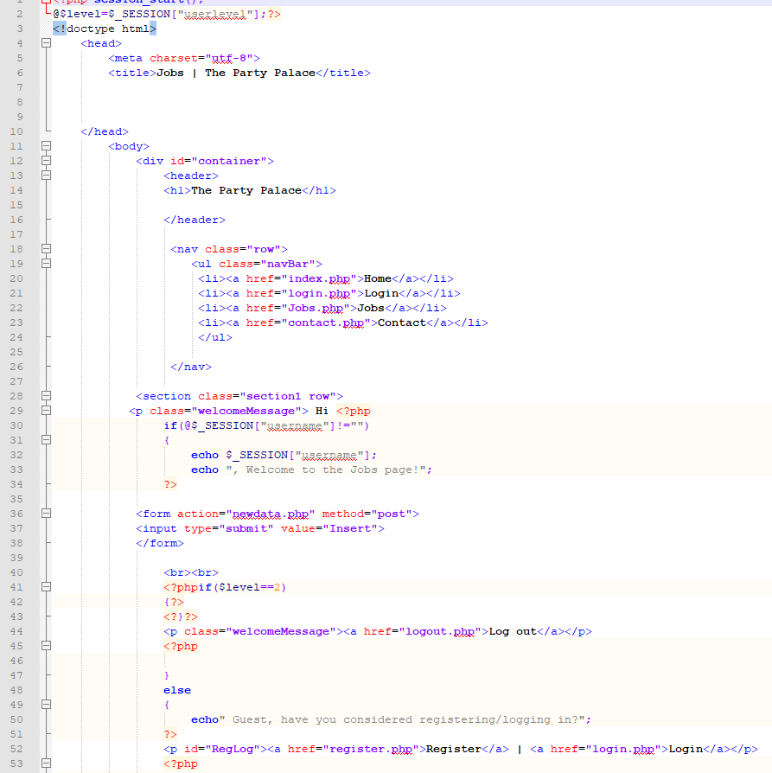
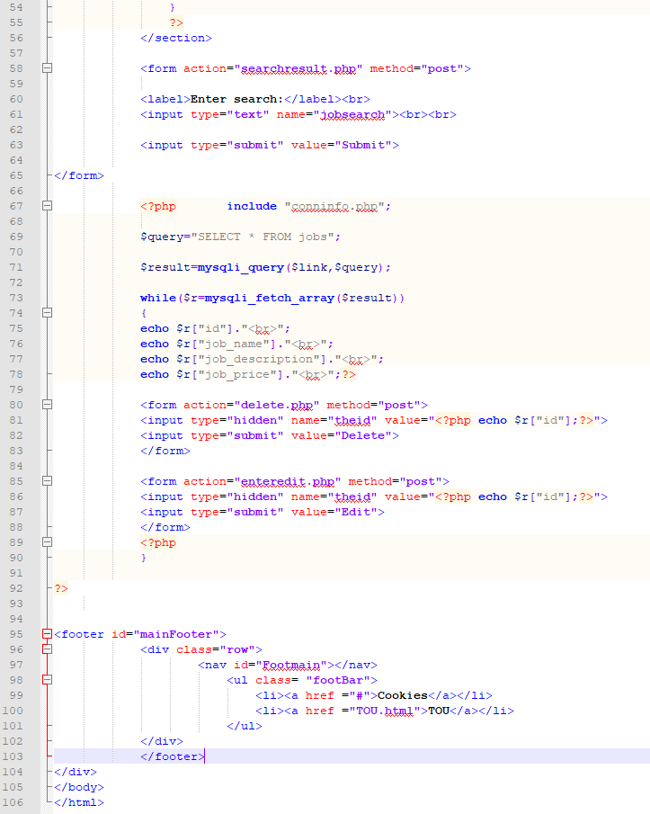

Searchresults.php
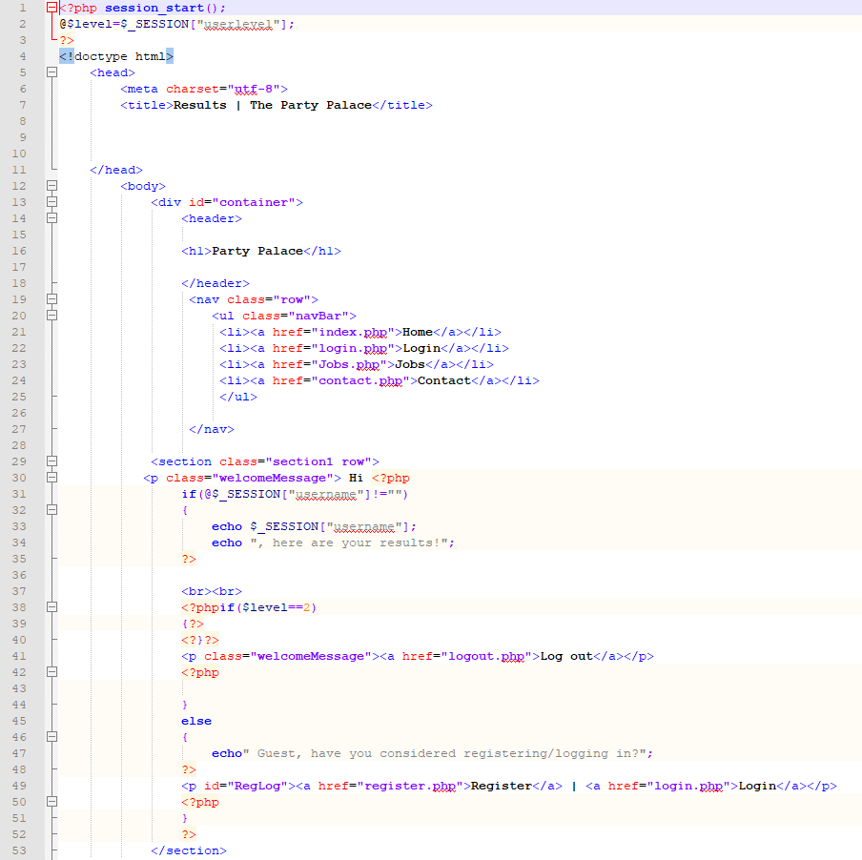
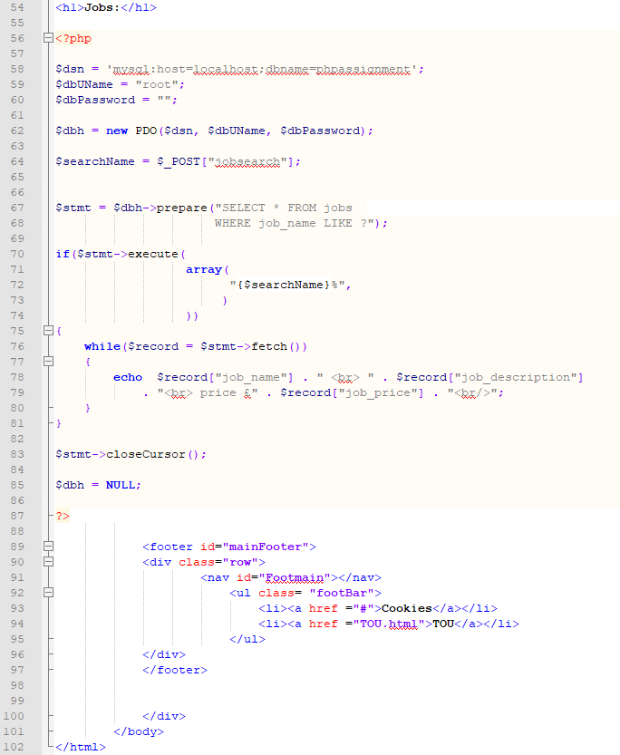

Newdata.php
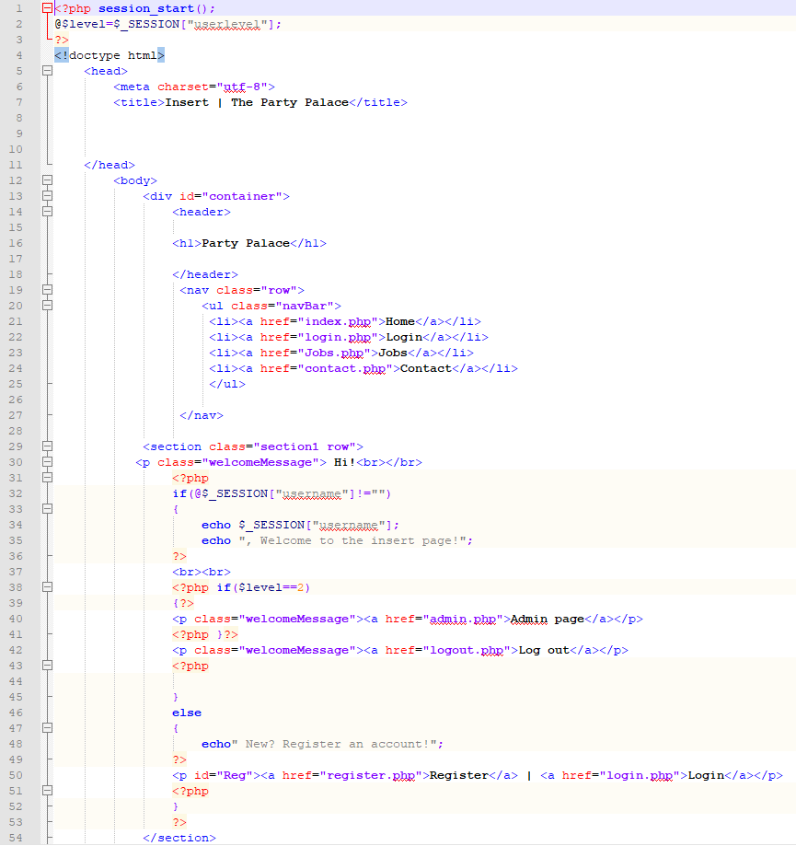
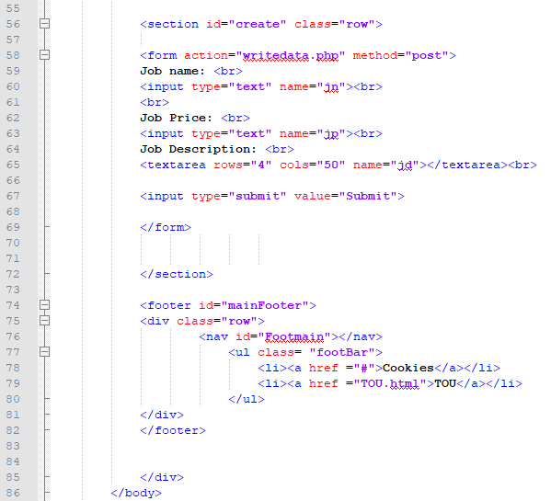
Writedata.php
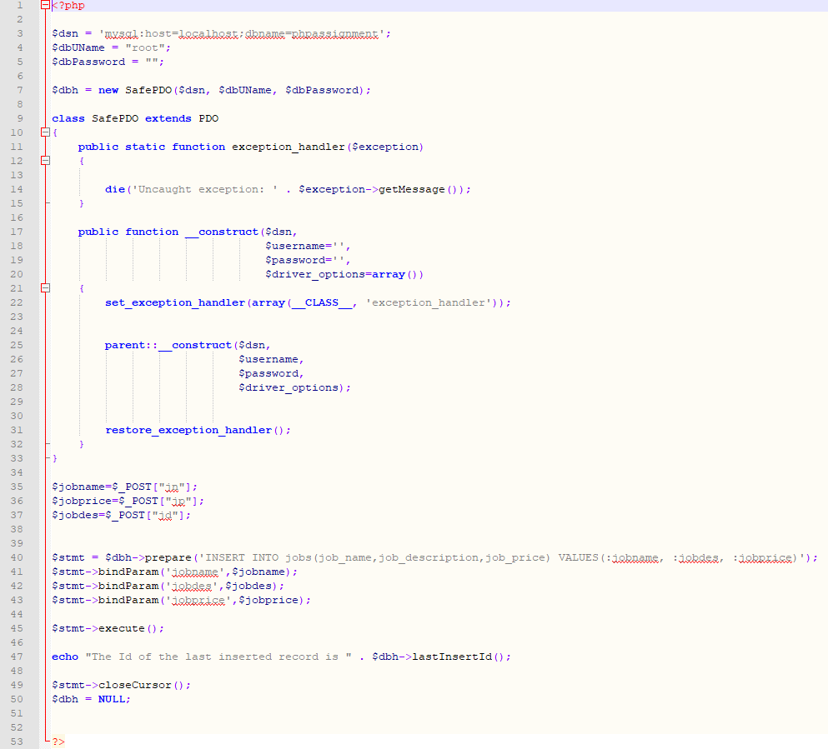

Delete.php
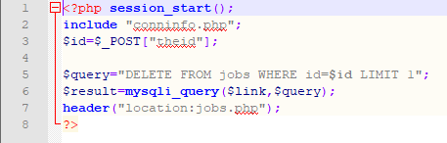

Enteredit.php
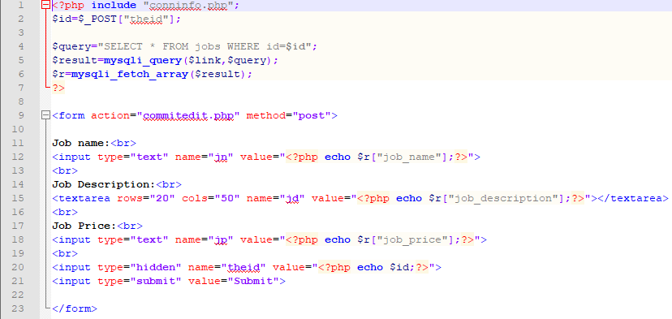
Commitedit.php
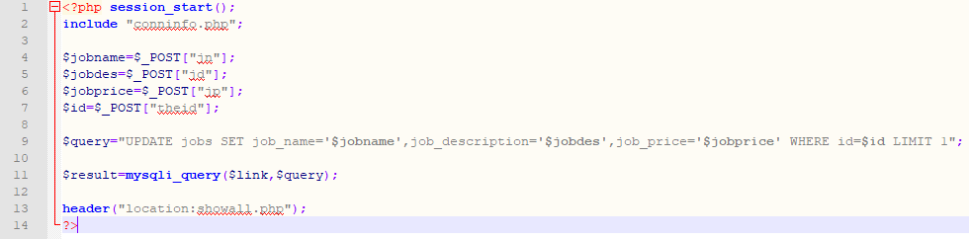

Login.php
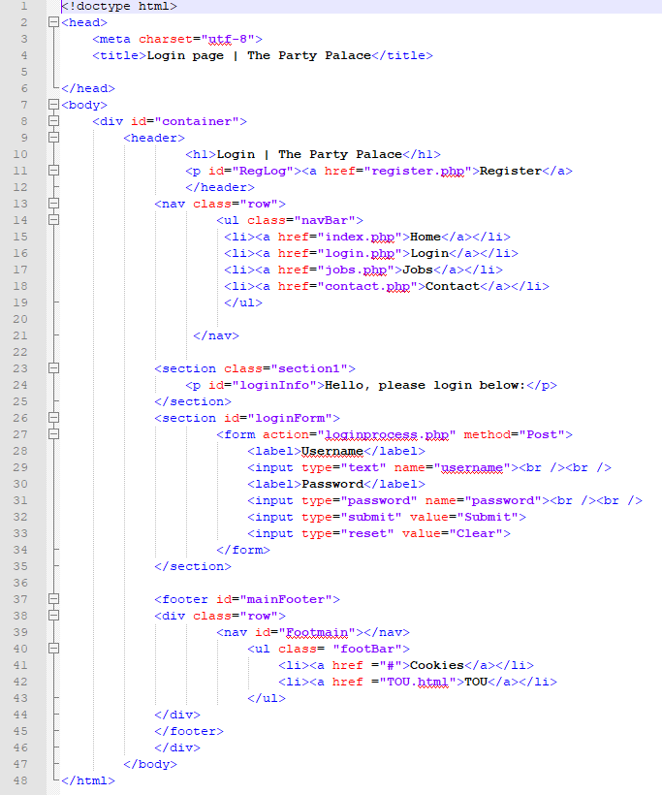
loginprocess.php

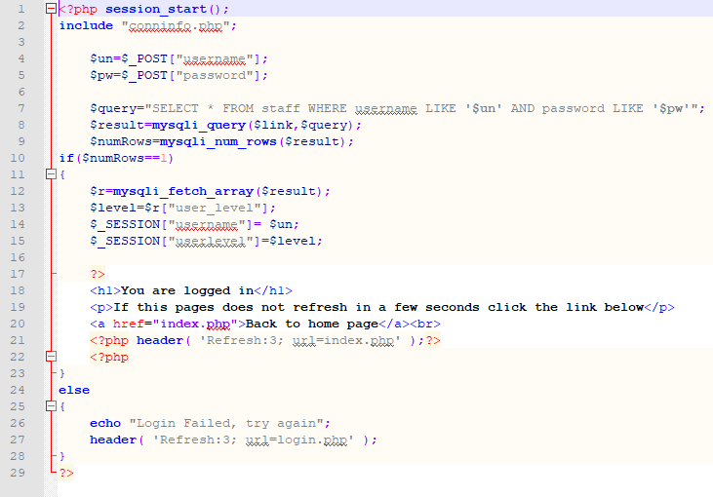
Logout.php
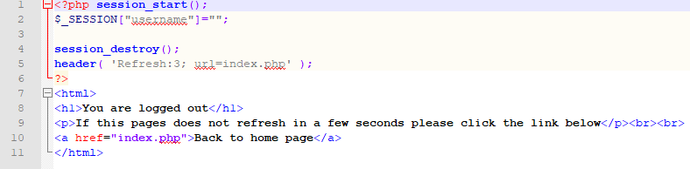

Register.php
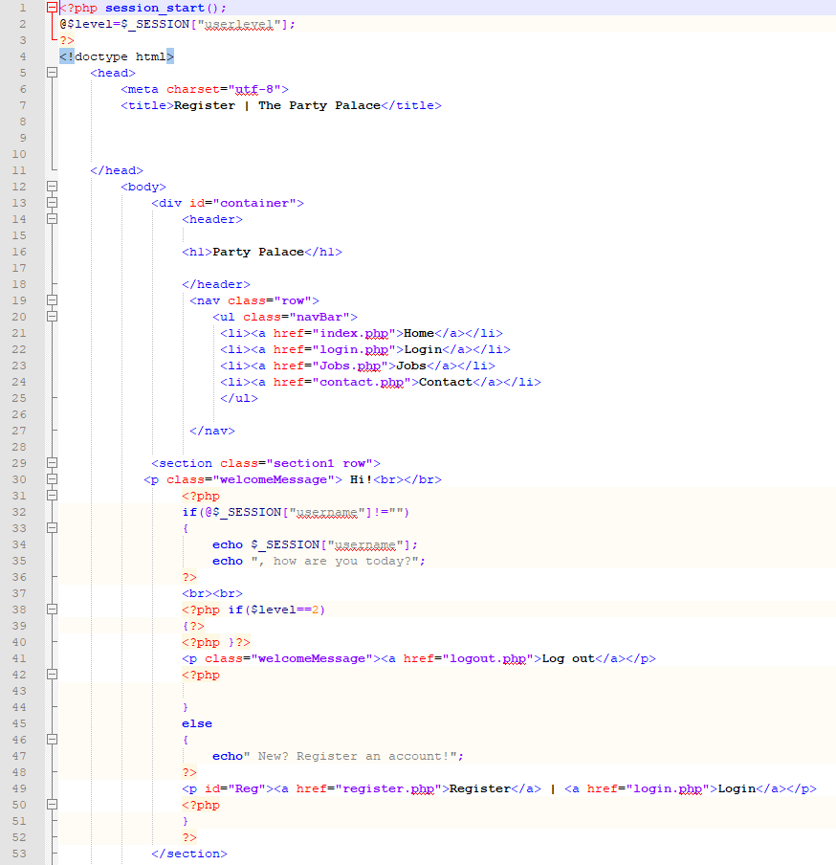
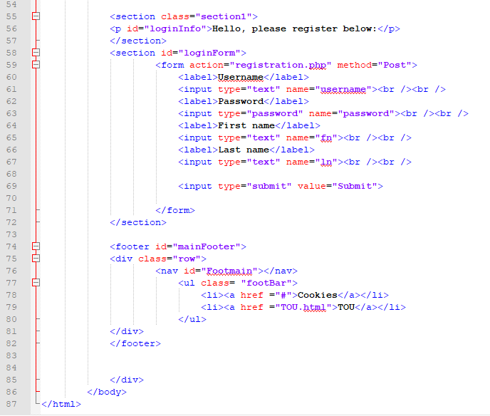
Registration.php
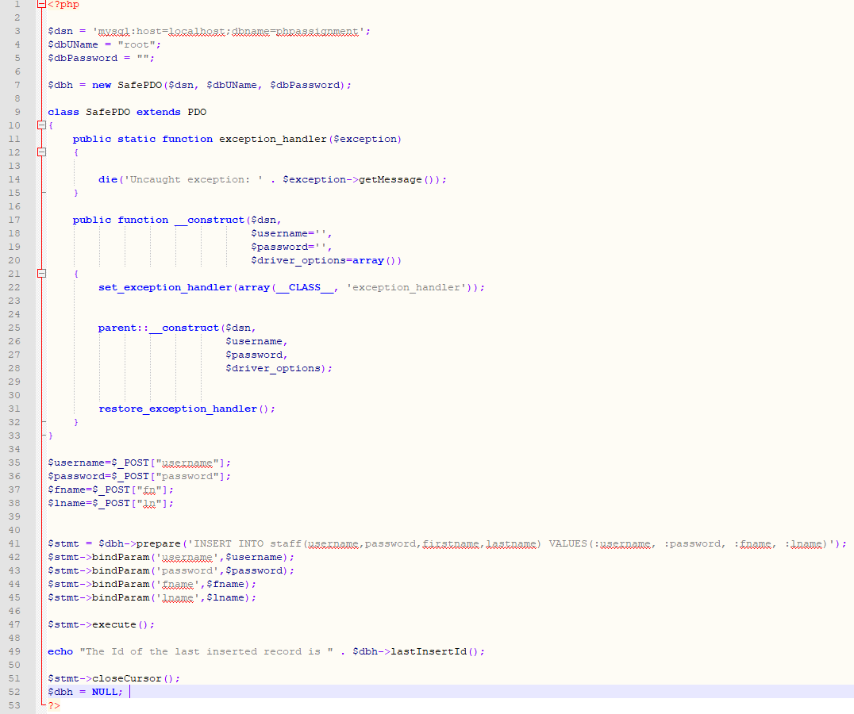
Conninfo.php
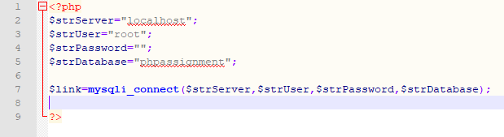
Contact.php


