Brad Tonner - 2314152


L4 - Network and Cybersecurity Essentials (ACCA4024)

Table of Contents
Cybersecurity Policy Report for FinSecure Ltd (FSL) 2
Introduction 2
Brief overview of cybersecurity threats globally 2
The impact of cybercrime on financial institutions 3
Importance of cybersecurity policies for FinSecure Ltd 4
Identification of Threats 6
Internal Threats: 6
External Threats: 7
Security Policies 8
Mitigation Measures 10
Monitoring and Response 12
Training and Awareness 14

Cybersecurity Policy Report for FinSecure Ltd (FSL)

Introduction

Brief overview of cybersecurity threats globally

In today’s digital era, cybersecurity has emerged as one of the most pressing challenges worldwide. Organizations, governments, and individuals face constant threats from cybercriminals seeking to exploit vulnerabilities for financial gain, data theft, and disruption of services. The rise in remote work and the widespread use of mobile devices—including laptops, tablets, and smartphones—have further amplified these risks, making cybersecurity a top priority for businesses of all sizes. These are the 10 biggest cyber threats in the modern day:
1. Ransomware
2. Vulnerabilities
3. Defense evasion
4. Drive-by compromise
5. Phishing attacks
6. Malware
7. DDoS attacks
8. Supply chain attacks
9. Insider threats
10. Business email compromise [1]

The impact of cybercrime on financial institutions
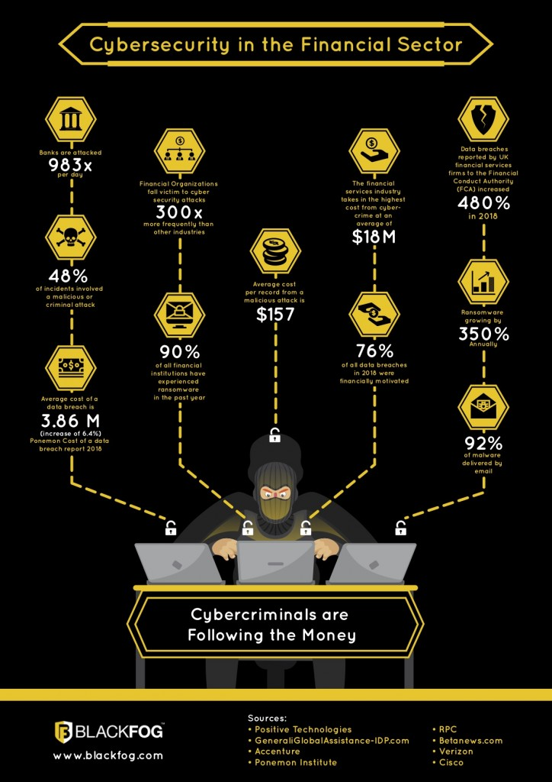
Financial services companies like FinSecure Ltd (FSL) are prime targets for cyber threats due to the sensitive nature of their data. Cybercriminals often target financial firms for fraud, unauthorized transactions, identity theft, and data breaches. The consequences of an attack can be severe, resulting in financial losses, reputational damage, legal penalties, and loss of customer trust.
According to IBM’s Cost of a Data Breach Report 2024, the global average cost of a data breach reached $4.88 million, a 10% increase from the previous year and the highest total ever recorded. Organizations using security AI and automation extensively in prevention reported average cost savings of $2.22 million compared to those that didn’t. however, the setup costs for this are extortionate and require a large background infrastructure. Beyond these staggering statistics, financial institutions face even greater fears in lost business costs, including increased customer turnover, lost revenue due to downtime, and the rising cost of acquiring new business due to diminished reputation. [2]
[10]

Importance of cybersecurity policies for FinSecure Ltd
A cybersecurity policy is a structured framework that defines an organization’s approach to protecting its information systems, networks, and digital assets from cyber threats. It includes documented guidelines, procedures, and security controls that align with the organization’s security objectives.
Cybersecurity policies outline roles, responsibilities, methods, and technical safeguards to ensure the confidentiality, integrity, and availability of data. They also address key security attributes such as authenticity, accountability, and non-repudiation, ensuring that all digital interactions are verifiable and secure.
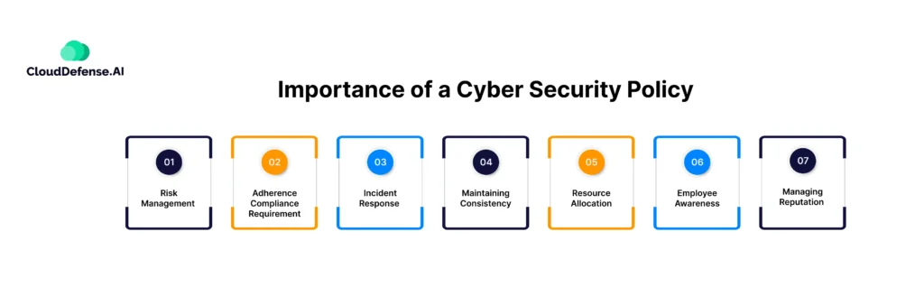
These policies vary based on an organization’s needs. Some are high-level strategic guidelines, while others include detailed technical procedures, such as Bring Your Own Device (BYOD) protocols, risk management frameworks, and incident response plans. [3]
Cybersecurity policies are fundamental to safeguarding an organization’s sensitive data, financial assets, and operational integrity. For a financial services company like FinSecure Ltd (FSL), the implementation of a comprehensive security policy is essential to:

1. Protecting Sensitive Data

2. Preventing Financial Losses

3. Maintaining Business Continuity

4. Enhancing Employee Awareness and Compliance

5. Strengthening Customer Trust and Reputation

6. Ensuring Regulatory Compliance

Identification of Threats

Internal Threats:

Employee Negligence

Employees may inadvertently compromise security by:
- Using weak or reused passwords
- Falling victim to phishing scams
- Improperly handling sensitive financial data
- Using unsecured personal devices for work

Insider Threats
Malicious insiders can abuse their access privileges for financial gain or to sabotage company operations. Insider threats may include:
- Unauthorized data access and leaks
- Manipulation of financial records
- Selling confidential information to competitors or hackers

Lack of Cybersecurity Awareness
Employees who are unfamiliar with cybersecurity best practices may:
- Fail to recognize phishing emails and social engineering attempts
- Be unaware of compliance regulations
- Improperly store or share company credentials

External Threats:

Phishing attacks targeting employees
A Phishing Attack is defined as, ' the fraudulent practice of sending emails claiming to be from reputable companies in order to induce individuals to reveal personal information, such as passwords and credit card numbers.’ [4]

Malware (ransomware, spyware, trojans)
Malware is developed as harmful software that invades or corrupts your computer network. The goal of malware is to cause havoc and steal information or resources for monetary gain or sheer sabotage intent. [5]
- Data Theft – Extracts critical information such as emails, strategic plans, and highly sensitive credentials like passwords.
- System Lockdown and Financial Coercion – Disables networks and computers, rendering them inoperable. When used to demand payment for restoration, it is known as ransomware.
- Network Sabotage and Digital Vandalism – Corrupts or eliminates computer systems, severely impacting network integrity and functionality.
- Financial Exploitation – Cybercriminals target organisations for economic gain, often through fraud, theft, or extortion.

Security Policies
It is vital that the following policies are implemented as a minimum for FinSecure LTD:
Access Control Policy: Restricting data access based on roles
- Define user roles and access levels within the network.
- Use Multi-Factor Authentication (MFA) for high-privilege accounts.
- Implement role-based access control (RBAC) for internal systems.

Data Encryption Policy: Encrypting sensitive data to prevent breaches
Encryption ensures that sensitive financial and customer data remains protected, even if intercepted by cybercriminals.
- Encrypt all financial transactions to prevent data interception.
- Utilize end-to-end encryption for internal communications.
Multi-Factor Authentication (MFA): Ensuring secure user logins
The most unique and secure way of authentication is a way of confirming your identity when you try to sign in to one of your accounts. For example, a password is unique to you. The three most common kinds of factors are:
- Something unique that you can remember or make note of - Like a password, or a PIN number.
- Something you have easy access to - Like a mobile phone, or a secure USB key.
- Something entirely unique to your body - Like a fingerprint, or facial recognition. [6]
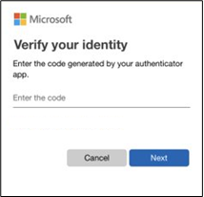
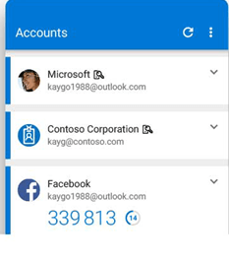

Incident Response Policy: Defined steps for handling security breaches
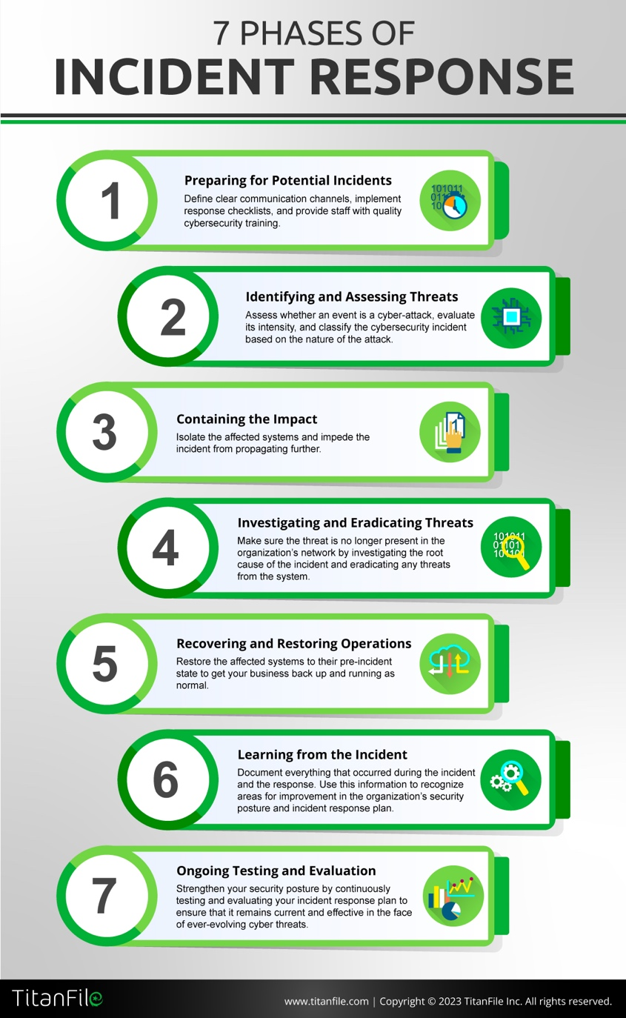
Incident response is the process of identifying, managing, and mitigating cybersecurity threats and breaches within an organisation. When a security incident, such as a data breach, ransomware attack, or unauthorised access attempt occurs, a well-defined incident response plan ensures a swift and effective reaction to minimize damage, restore operations, and prevent future incidents.
[11]

Mitigation Measures
Endpoint Security: Antivirus, anti-malware, and intrusion prevention
Endpoint security involves safeguarding entry points of end-user devices—such as desktops, laptops, and mobile devices—against cyber threats and malicious activity.
Modern endpoint security solutions defend these devices whether they are part of a network or cloud infrastructure, protecting them from various cybersecurity risks. This approach has advanced beyond traditional antivirus software, now offering comprehensive protection against sophisticated cyberattacks, evolving threats, and previously unknown zero-day vulnerabilities. [7]

Network Security Enhancement
- Ensure that the organization has top quality firewalls implemented with strict policies. This requires a highly skilled group of network and security engineers.
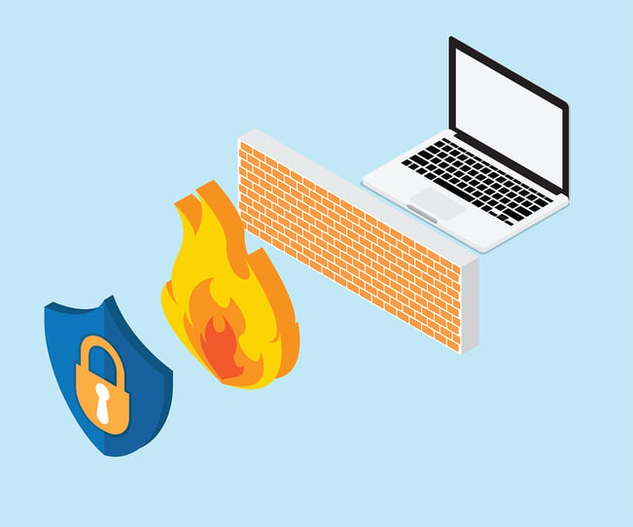
- Use Intrusion Detection Systems (IDS) and Intrusion Prevention Systems (IPS) to identify and block threats.
- Segment the network to limit access to sensitive data and isolate critical systems.
- Encrypt data transmissions using SSL/TLS protocols.

Employee Cybersecurity Training: Regular workshops and phishing awareness
Incident Response Team: Quick reaction to security events
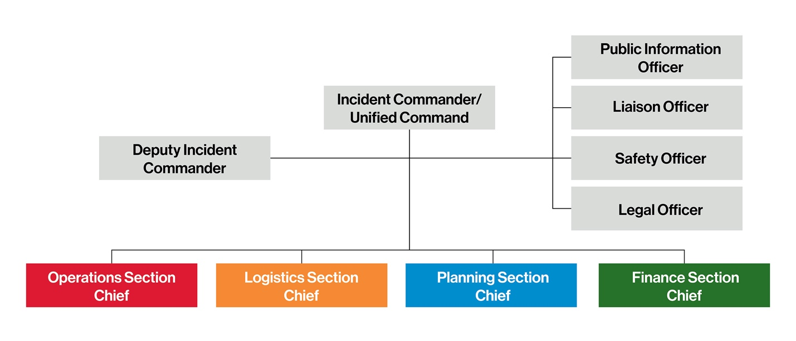
Below is an example of the structure of an incident response team. Everyone must be highly competent and skilled in their roles to ensure the best incident response plan can be undertaken.

Monitoring and Response
Security Information and Event Management (SIEM)
- Security information and event management, or SIEM, is a security solution that helps organizations recognize and address potential security threats and vulnerabilities before they have a chance to disrupt business operations.
- SIEM systems help enterprise security teams detect user behavior anomalies and use artificial intelligence (AI) to automate many of the manual processes associated with threat detection and incident response. [8]

Intrusion Detection Systems (IDS): Alerting potential security breaches
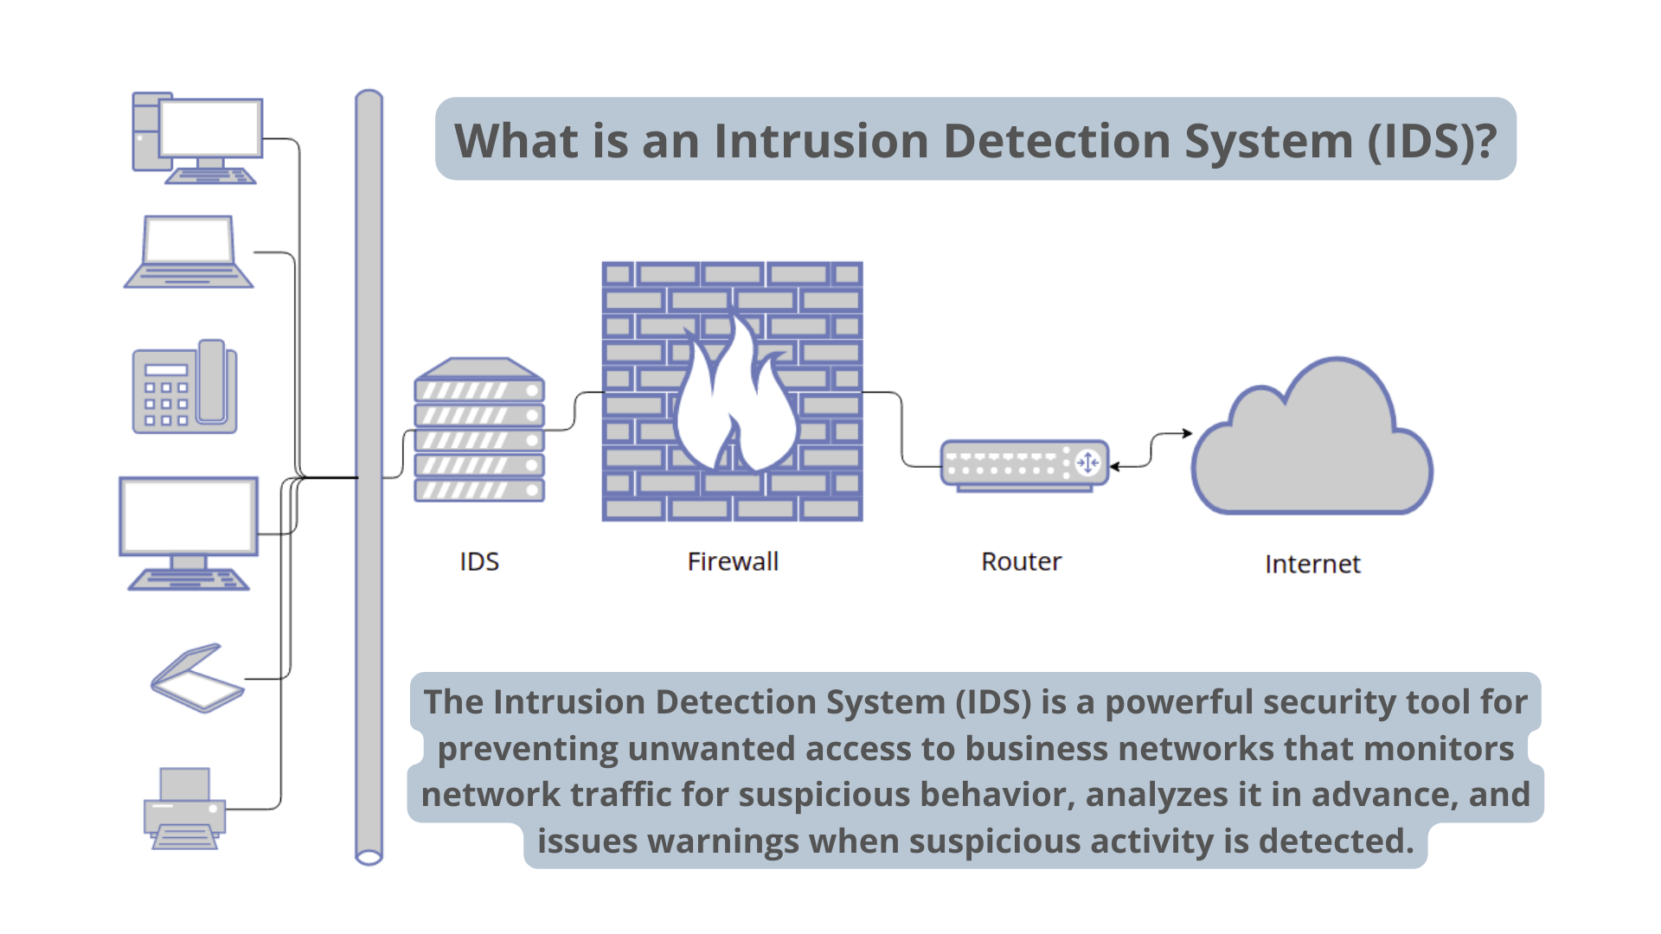
IDS stands for Intrusion Detection System, a cybersecurity tool designed to monitor network traffic and detect potential threats or unauthorized activity. IDS is important because:
- Detects potential cyberattacks in real time
- Prevents data breaches by identifying suspicious behavior
- Helps organizations comply with security regulations
- Enhances overall cybersecurity posture by providing proactive threat intelligence

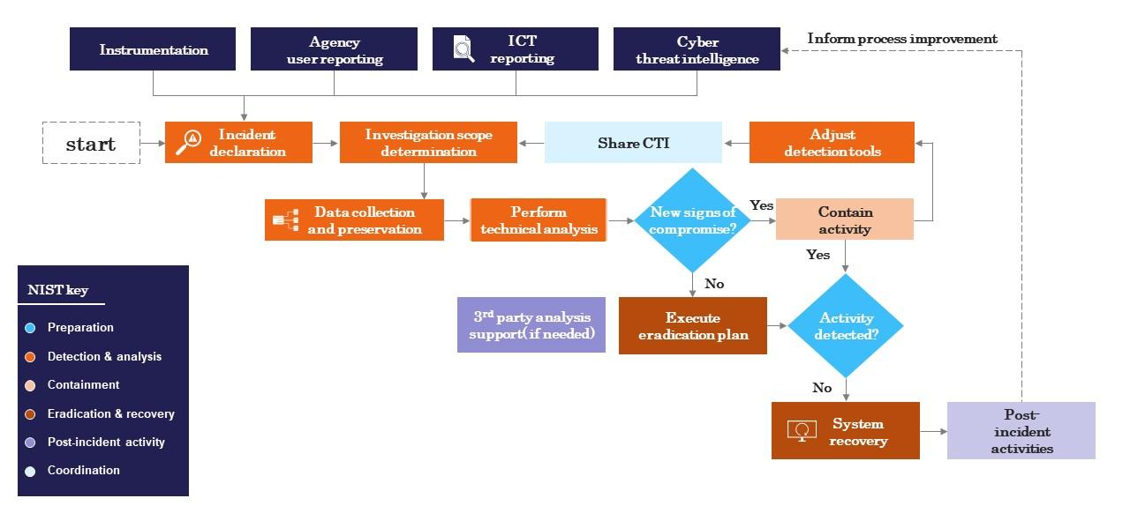
- Flowchart (Diagram): Visual representation of the security response process

Training and Awareness
The following sessions need to be held with internal staff to ensure the highest level of security and the least accidental breaches:
- Monthly cybersecurity awareness sessions
Sessions should be held with staff members to cover the following topics:
- Introduction to cybersecurity risks (phishing, malware, insider threats).
- How to recognize suspicious activity and prevent attacks.
- Secure browsing habits and safe handling of company data.
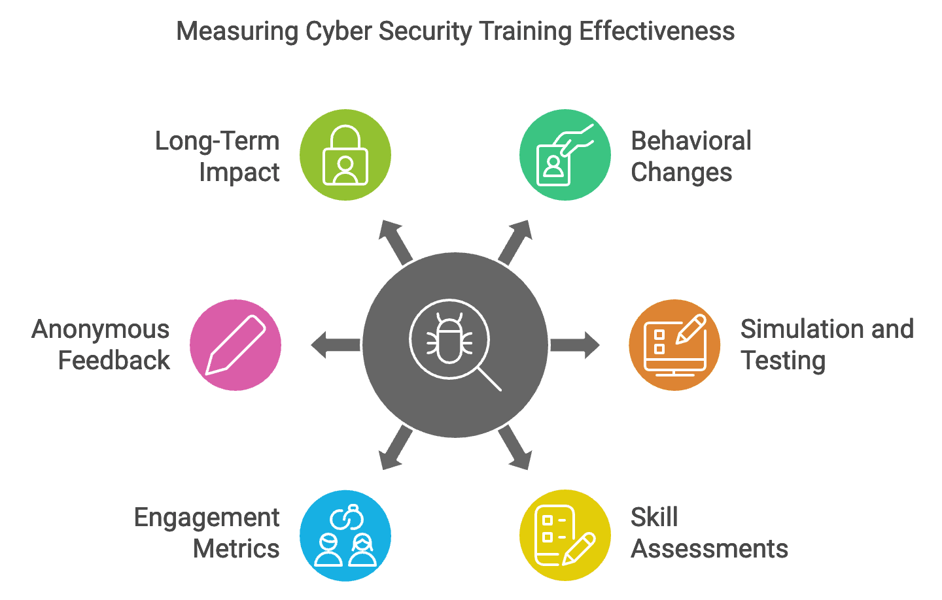
- Compliance with cybersecurity regulations (GDPR, PCI DSS).

- Secure password management workshops
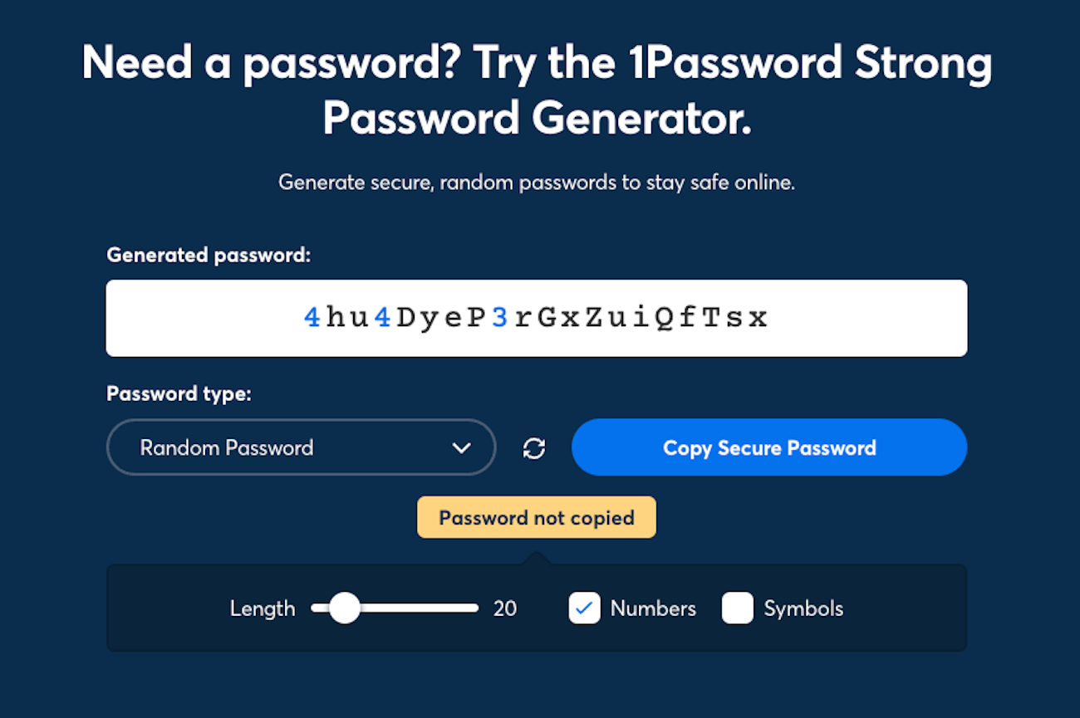
Staff should be aware of what is considered a strong and a weak password. There should be company guidelines such as number of characters, special characters, capital letters and numbers. Staff must adhere to these standards. Staff should also be encouraged to change their password on a monthly basis.

- Incident reporting guidelines for employees
Staff should have guidelines provided to them in the case that they need to report a cyber incident. These guidelines should be along the lines of:
- Recognise Incidents – Employees should be trained to identify potential cybersecurity incidents, such as phishing attempts, unauthorised access, malware infections, or data breaches.
- Immediate Reporting – Staff should report incidents as soon as they are detected to the designated IT or security team.
- Use Official Channels – Organisations should establish clear reporting channels, such as a dedicated email, hotline, or incident management system.
- Provide Key Details – When reporting, employees should include relevant information such as the time of occurrence, affected systems, and any suspicious activity observed.
- Follow Response Protocols – Organisations should have predefined response procedures, including containment, investigation, and mitigation steps.

- Simulated phishing attack exercises
- Identify available training resources and educate employees on recognizing phishing.
With advancements in technology and the rise of social engineering techniques, spotting phishing attempts has become increasingly difficult as they often include seemingly legitimate details. Employees should be trained to recognize common signs of phishing emails, such as unexpected or unusual requests, often accompanied by urgent language that pressures immediate action. They should verify the email address and consider whether the request seems realistic. Keep in mind, emails might appear to come from a familiar source whose account may have been compromised.
- Inform employees about potential risks and consequences.
Engage your IT provider or designate a security manager to monitor the latest cybersecurity threats. Have this person regularly update you on current scams and vulnerabilities, so you can keep employees informed between formal training sessions.
- Foster a culture of vigilance.
Don’t rely solely on annual training to ensure your staff is well-prepared. Form a culture of cyber responsibility where employees are clearly instructed on how to report suspicious emails or potential phishing attempts. [9]

Bibliography

[1] | B. Medlock, "Connectwise.com," 19 02 2025. [Online]. Available: https://www.connectwise.com/blog/cybersecurity/common-threats-and-attacks. [Accessed 28 04 2025].
[2] | "Everbridge," [Online]. Available: https://www.everbridge.com/blog/the-impact-of-cybersecurity-risks-on-financial-services/. [Accessed 29 04 2025].
[3] | A. Arora, "Cloud Defense," [Online]. Available: https://www.clouddefense.ai/importance-of-cybersecurity-policy/. [Accessed 29 04 2025].
[4] | "Aztech IT," 09 01 2024. [Online]. Available: https://www.aztechit.co.uk/blog/what-is-phishing. [Accessed 01 05 2025].
[5] | "Cisco," [Online]. Available: https://www.cisco.com/site/uk/en/learn/topics/security/what-is-malware.html. [Accessed 01 05 2025].
[6] | "Microsoft Support," [Online]. Available: https://support.microsoft.com/en-gb/topic/what-is-multifactor-authentication-e5e39437-121c-be60-d123-eda06bddf661. [Accessed 08 05 2025].
[7] | "Trellix," [Online]. Available: https://www.trellix.com/security-awareness/endpoint/what-is-endpoint-security/. [Accessed 09 05 2025].
[8] | "IBM," [Online]. Available: https://www.ibm.com/think/topics/siem. [Accessed 06 05 2025].
[9] | "Cisa," [Online]. Available: https://www.cisa.gov/secure-our-world/teach-employees-avoid-phishing. [Accessed 08 05 2025].
[10] | B. Robb, "Black Fog," 27 03 2025. [Online]. Available: https://www.blackfog.com/cybercrime-in-the-financial-sector-follow-the-money/. [Accessed 28 04 2025].
[11] | "Titan File," [Online]. Available: https://www.titanfile.com/blog/phases-of-incident-response/. [Accessed 08 05 2025].

Appendix


