Student Number: 1801809
BA course title: Advertising and Brand Design
Word count 1558
Tutors’ names: Ryan L. Moule, Rob Jones, Julia Lockheart, Gwenllian Beynon, Scott L. Smith, Martin Bush

“The Lesser Evil”

Contemporary reality is a confusing one. Just by letting a woman in the doorway, you can be accused of “benevolent sexism” (Gül and Kupfer, 2018) but you can read the article "How to prepare of a turkey for Thanksgiving" with a clear conscience.
According to Lyotard modernity destroyed traditional, deeply sedimented social relations and reconstructed them as modern ones. (Jowers, 1994) This process called “derealisation” questions what constitutes reality (Jowers, 1994). When morality in society is considered relative can all human acts be justified?
The philosophical theory that determines the superiority of human beings held by most people is anthropocentrism. This “default ethic” (Botzler and Armstrong, 1998) is probably one of the older ethical positions in Western civilization (Hughes, 1975) and may have its source in religious or secular philosophies.
One of the models is Kant, who declares that people have negligible or no obligation towards animals (Botzler and Armstrong, 1998). Also Guthrie insists that as long as people are not forced to experience or witness possibly offensive acts, they must allow others to exploit organisms (Guthrie, 1967).
Modern anthropocentrism claims that man is the highest animal and fact that he alone is capable of making such judgement is in itself part of the evidence that he is correct (Simpson, 1949). This way of reasoning is abstract and self-acceptable. Philosophical systems such as Christianism also assume the dualism of man and animals but insist that it's in God's will that man exploit nature for his proper ends. The key here is to accept that proper ends may promote human values, ​​not destruct them (Botzler and Armstrong, 1998).
There is also “Franciscan” belief proclaimed among others by Jordan who said: “The time will come when civilized man will feel that the rights of all living creatures on earth are as sacred as his own” (Smith, 1970).
Exhibitions have functioned to represent some totality or entity greater than themselves. This one is meant to wake the consciousness (Greenberg, Ferguson and Nairne, 1996). “The lesser evil” is an exhibition examining values, human morality and it’s depth. It challenges people’s point of view on the humanity by putting them in different spectrums of ethics with blurred ends. Display will have “environmental significance” (Greenberg, Ferguson and Nairne, 1996) being in place such as old prison. Exhibition will rip pieces out of their "natural habitat" for which they might have been created. It will free them, give them an insignificant meaning. Pieces will create a walk-through collage. Acknowledging that spectrum of the vision is not limited to those on immediate path this exhibition will create one piece narrating correlations between objects (Dernie, 2006).
As you can see in Figure 1, the building's structure will be a main square block with a square wall surrounding it. The building consists of three floors, however, the exhibition will be held on the lowest of them. Exhibits will be in deserted cells separated from each other unevenly. Except one of them.
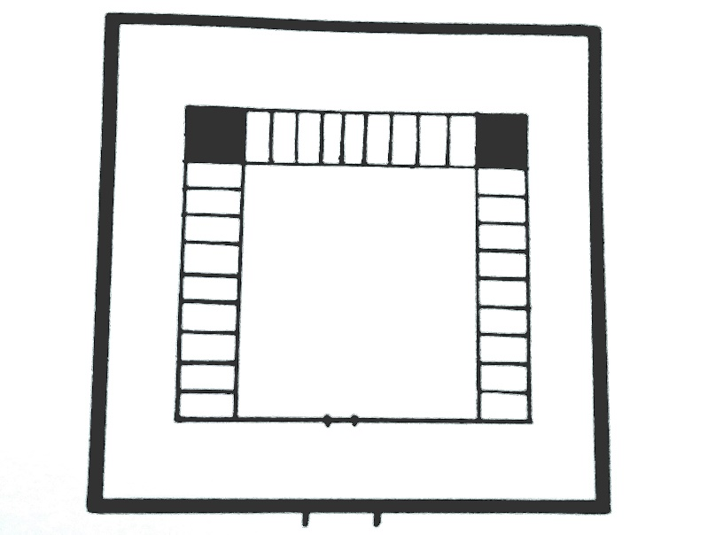 Figure 1 “Prison plan” by Mroz

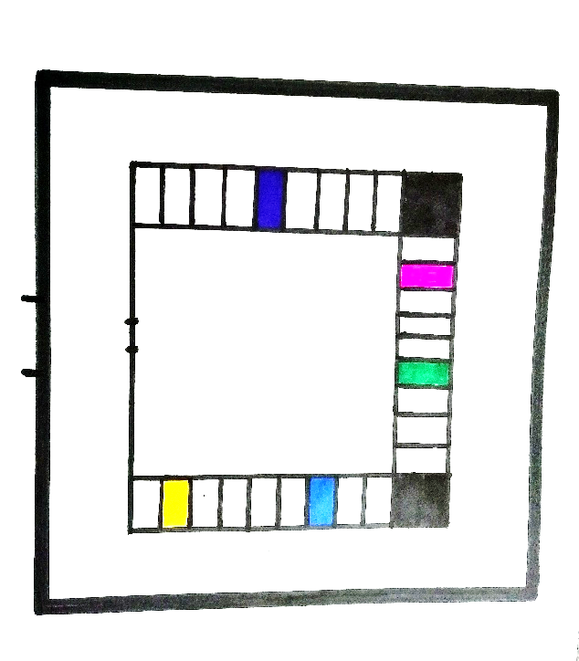Figure 2 “Artworks placement” by Mroz
Legend:
-yellow “Helena”
-blue “Forgive me Helena”
-green “Sensitive”
-pink “Animal Pyramid”
-deep blue “Esther”
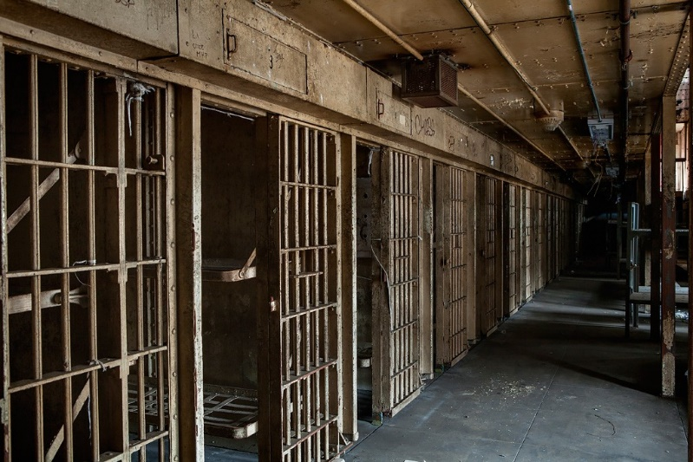 Figure 3
 Figure 4 “Cells in Rikers Island Prison in New York”
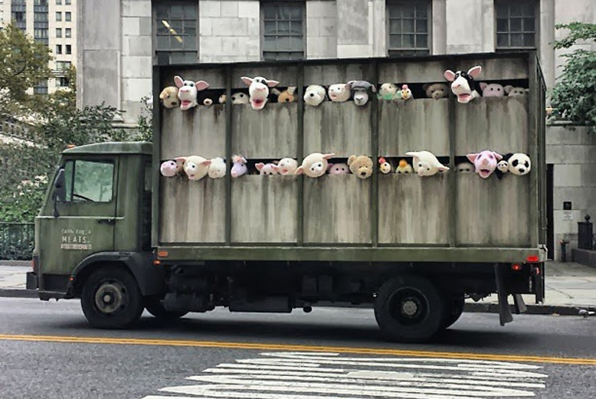 Figure 5 “meat truck”
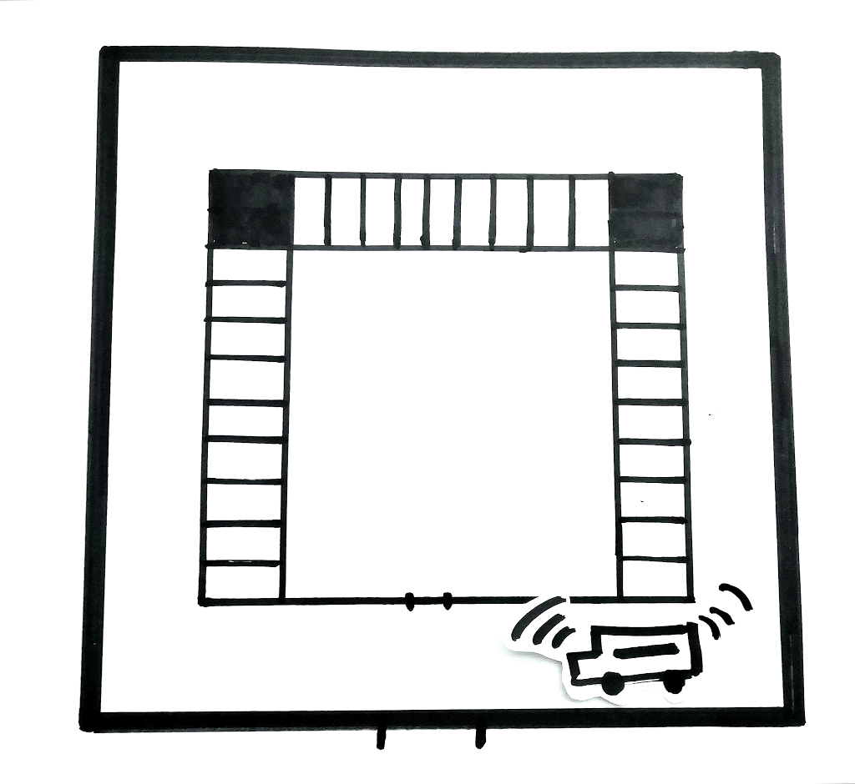Figure 6 “visualization” by Mroz
Participants crossing the main gate will certainly experience indirectly or directly the first and bold piece. It is mobile installation called "Sirens of the Lambs" created by street artist- Banksy. First shown in October. 2013 when strange truck was spotted on streets of New York. It is green “depressed slaughterhouse” (Geer, 2013) delivery truck, labelled Farm Fresh Meats filled with sixty soft toys animals. The plush group create a cacophony of sounds playing in the background (Cronin, 2013). It will welcome the viewers and accompanying them throughout the event. Some artists like Banksy gone beyond the reflective function of conventional art forms and gone for the reactive function of activist art (Sacramento and Zeiske, 2010). By using innocence of toys and bringing casual cruelty to daylight Banksy managed to address issues people evade on daily basis (Dooling, 2013). Every aspect of this art installation has meaning. The title references Greek mythology by "luring sirens” and American pop culture by the Hollywood horror-thriller ‘The Silence of the Lambs”. Sirens can also mean warning sound. Is Banksy attempting to enlighten? Or maybe alert us?
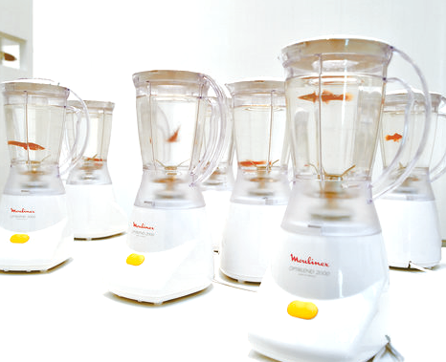 Figure 7
Although viewers can discover the exhibition in any way, the first work, placed on the right is "Helena". When they get to the cell they will see ten blenders set up next to the wall. In each of them is a small goldfish. It’s piece created by Marco Evaristti back in year 2000. The display was first shown at the Trapholt Art Museum in Denmark and shook the world of art. Guests were invited to the exhibition consisting of plugged in blenders ready to turn on. Visitors were given a choice: kill the fish, or leave the button alone (BBC NEWS, 2003). Evaristti predicted that his exhibition can show three kinds of people: the sadist, the voyeur or the moralist. If a person is a sadist he or she will press the button on the blender because is able to do so. Is the person a voyeur, he/she excitedly observes whether others will press the button (EVARISTTI STUDIOS, 2019).
Some people decided to kill. Exhibition made a lot of controversy and led to museum director being acquitted of animal cruelty. “All this cruelty originates from me being a humanist” said Evaristti. Does he mean that cruelty is a part of being human? His work although not cruel in nature was cruel in reality. He let cruelty be. Isn’t it Guthrie’s idea? In the case of "Lesser evil", no animal will suffer. The blenders will be connected, but the knives will be motionless. Pressing the button will be accompanied by short tons of twirling sound and flash of light. The blenders will be equipped with a mini camera that will take a picture of the person pressing the button. These pictures will be displayed by projector on the wall opposite. It can cause a lot of feelings starting with guilt. By exploring temptation to destruct it also brings the effect to moral evaluation. It facilitate a relationship of ethic concern and respect based on need of self-approbation (Cross, 2018).
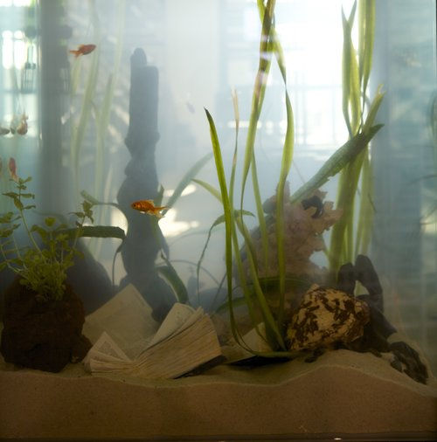 Figure 8
A reference to this work is the next installation created by Evaristti eleven years later. After “Helena”, the artist made a different direction, still referring to the golden fish. Piece will be shown in separate cell in few steps distance.
As he said: When I created “Helena” with the veil tails in the blenders, the person could decide on the life and death of the fish. My new work “Forgive me, Helena” is a hope and a cry that the three major monotheistic religions can get along with each other better. The Bible, the Koran and the Torah are lying in an aquarium full of water, sand, plants and veil tails. With time they will dissolve and be returned to the great cycle of Nature. (EVARISTTI STUDIOS, 2019).
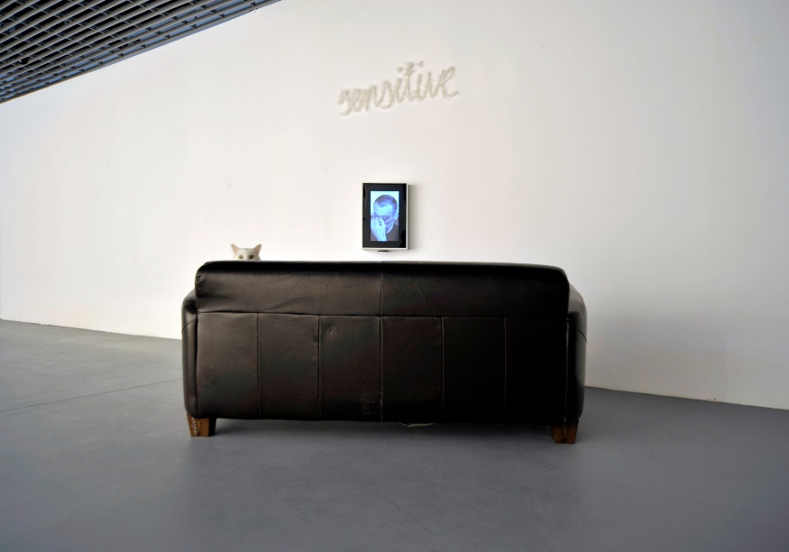 Figure 9
Next piece is a work made by two Polish artists: Golec and Czekalska. Artists represent a posthumanist attitude which they express by undermining the anthropocentric perspective. In their works animals and other living creatures are placed as equal to humans. This duo often appear as curators of processes pointing, investigating mutual relations between organisms and their environment. (Nowak, 2018).
The main piece of installation called “Sensitive” is a video showing a convicted murderer watching a slaughterhouse. During the projection he begins to cry, he is touched by the suffering which the animals experience. If it affects the murderer, why are "good" people not paying attention? Or maybe only someone who caused similar suffering is able to understand this? "Sensitive" makes questions. Is evil evil, only in the face of acts committed against another man, or does each of us carry his burden destroying other living and sentient beings? (Ciabach, 2015).
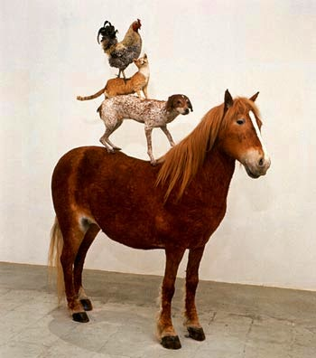 Figure 10
Another work presented is “Animal Pyramid “ made by Polish critical artist Katarzyna Kozyra. To make this piece artist used stuffed animals - a chicken, a cat, a dog and a horse. She admitted that the dog and cat were already dead, while the horse and hen were destined to die. The convention was supplemented with video recording depicting the death of the horse. As she claims: "I wanted to see the lowest level - killing. The fact that you have to get your hands dirty, that it stinks, that you're stirring around in the guts.” (Kozyra, 2014).
To show artwork in annihilation it will be placed in the middle of an empty cell. Video showing death of the horse will be displayed on the wall opposite. The value of this installation is based on a completely new approach to ecology and exploring taboos.
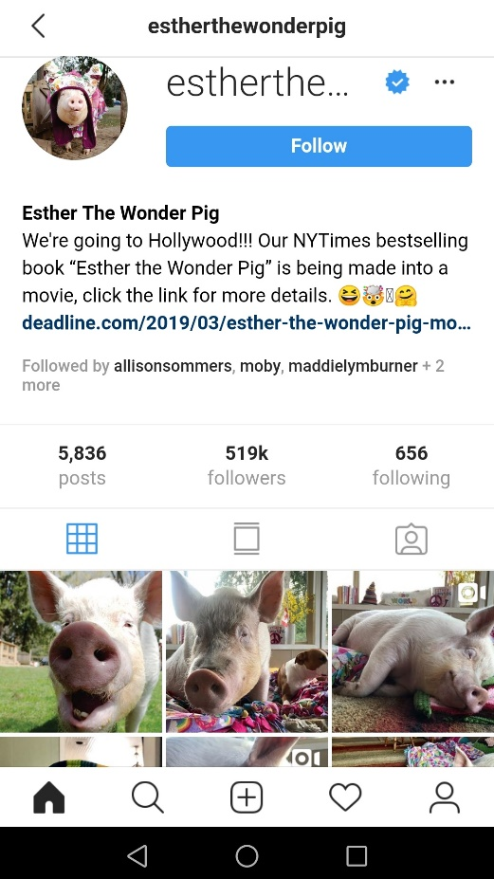 Figure 11 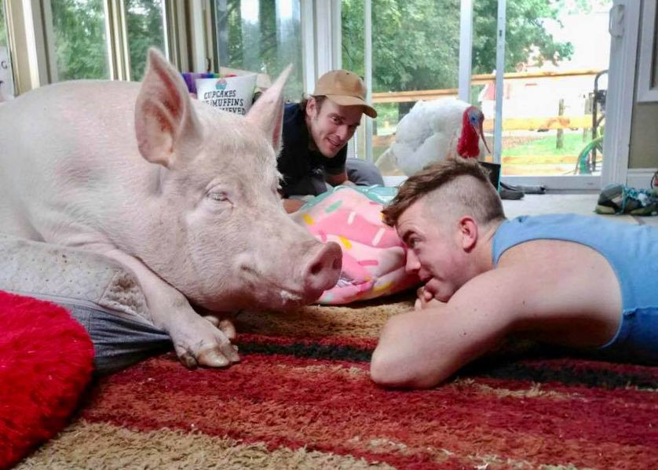 Figure 12
 Figure 13
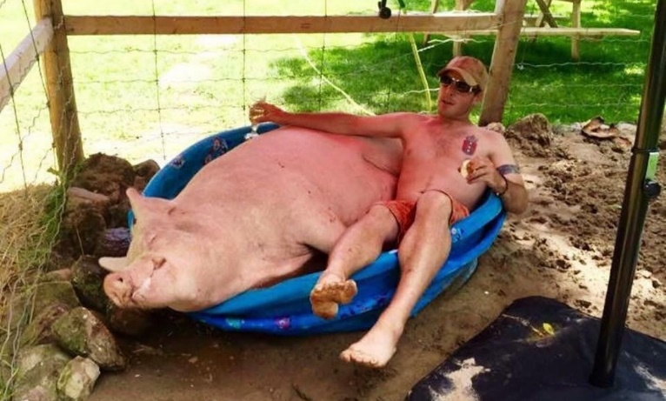 Figure 14
 Figure 15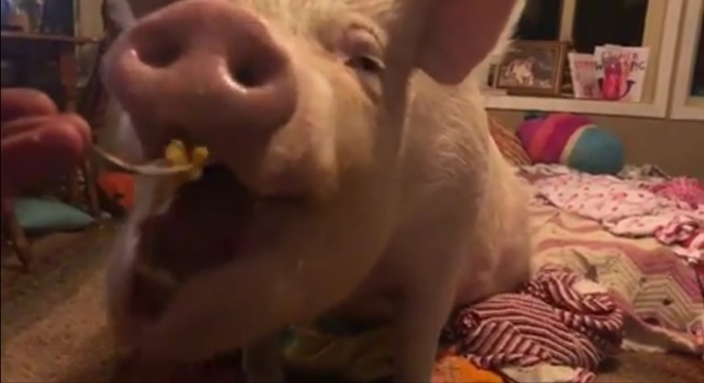 Figure 16
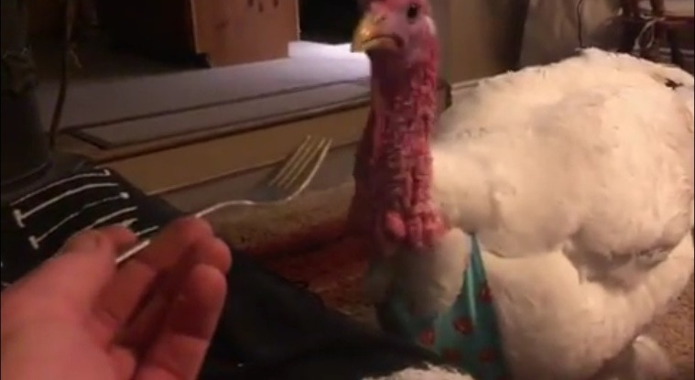 Figure 17
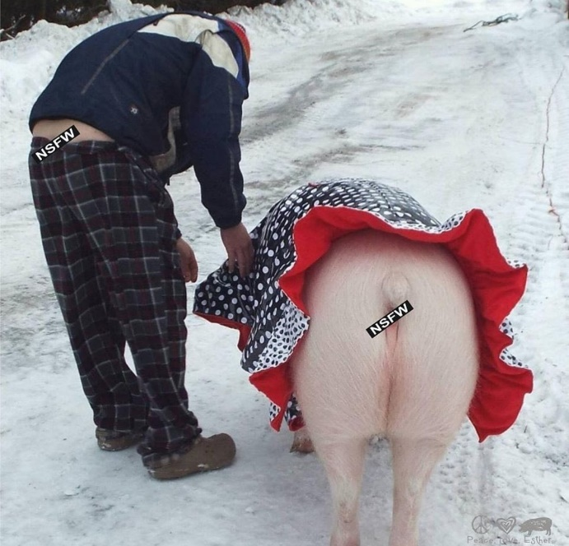 Figure 18 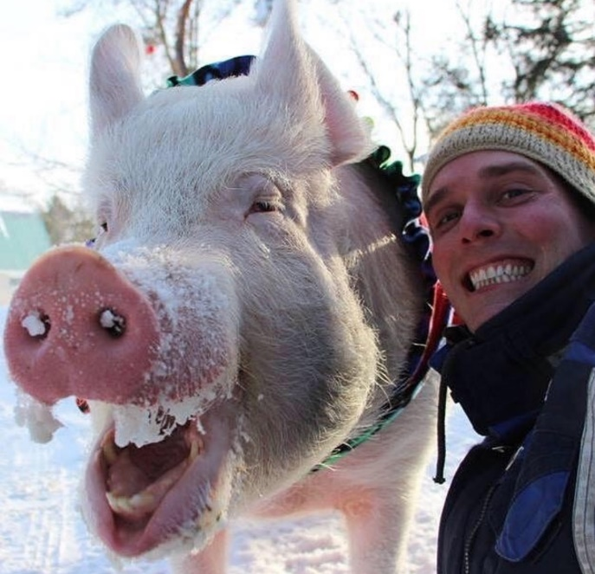 Figure 19 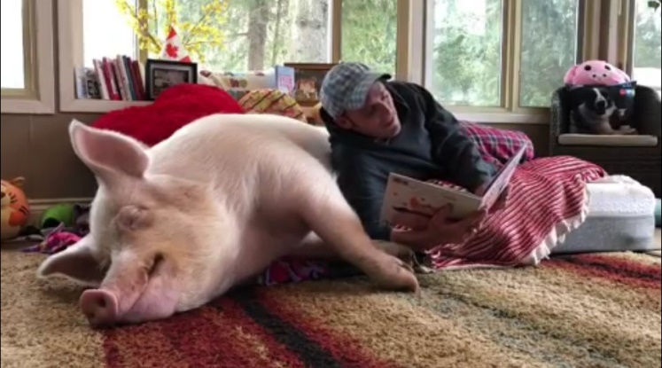 Figure 20
The work I consider the last one is unusual even in the face of the others. This practice is going to take place outside of the art world in the name of the idea that: Some of the most interesting attempts are those that reframe not- necessarily-art practices or places by seeing them through the eyes of art (Sacramento and Zeiske, 2010). This piece is a collage of photos and videos posted on Instagram by @estherthewonderpig displayed on the wall of one of the cells. It shows an incredible history of love and true kindness. That could give the needed calm and show that there there is another way and those high moral values can happen in real life.
List of Figures:
Figure 1 artwork by Mroz, K.
Figure 2 artwork by Mroz, K.
Figure 3 Available at: https://www.google.com/search?q=old_prison_block+essex+county+penitentiary&safe=strict&source=lnms&tbm=isch&sa=X&ved=0ahUKEwiiioWdpojiAhUsSBUIHadgDTYQ_AUIDygC&biw=1366&bih=657#imgrc=ua-buyurD-IHXM: (Accessed: 2nd April 2019)
Figure 4 “Cells in Rikers Island Prison in New York” Available at: https://www.businessinsider.com/prison-cells-prisoners-around-the-world-2018-3?r=US&IR=T#rikers-island-in-new-york-was-named-one-of-the-uss-10-worst-prisons-by-mother-jones-the-prison-is-known-for-inmate-violence-and-abuse-at-the-hands-of-staff-members-2 (Accessed: 2nd April 2019)
Figure 5 “meat truck” Available at: https://grist.org/article/banksys-latest-project-shows-screaming-stuffed-animals-being-taken-to-slaughter/ (Accessed: 2nd April 2019)
Figure 6 artwork by Mroz, K.
Figure 7 “Helena” Available at: https://www.evaristti.com/helena-el-pescador-1 (Accessed: 2nd April 2019)
Figure 8 “Forgive me Helena” Available at: https://www.evaristti.com/forgive-me-helena (Accessed: 2nd April 2019)
Figure 9 “Sensitive” Available at: http://www.terminal08.org/pl/2018/05/sensitive-tatiana-czekalska-leszek-golec-natalia-janus-malewska-artur-malewski-2-06-8-07-2018/czekalskagolec-sensitive/ (Accessed: 2nd April 2019)
Figure 10 “Piramida zwierzat” Available at: http://typowajamarysia.blogspot.com/2014/03/piramida-zwierzat-katarzyna-kozyra.html (Accessed: 2nd April 2019)
Figure 11 Available at: https://www.instagram.com/estherthewonderpig/ (Accessed: 2nd April 2019)
Figure 12 Available at: https://www.mnn.com/family/pets/stories/esther-wonder-pig-cancer (Accessed: 2nd April 2019)
Figure 13 Available at: https://www.instagram.com/p/BtY6g5KA145/ (Accessed: 2nd April 2019)
Figure 14 Available at: https://www.instagram.com/p/Btlx0URgkG4/ (Accessed: 2nd April 2019)
Figure 15 Available at: https://www.instagram.com/p/Bt6WBpNA_Nd/ (Accessed: 2nd April 2019)
Figure 16 Available at: https://www.instagram.com/p/BuCrlsJAkD6/?fbclid=IwAR3mvIugaNfQDeX2Syixb5swsEapK1rcgc9ECTJXWO6M9NVbGP1s6D9XJ6Q (Accessed: 2nd April 2019)
Figure 17 Available at: https://www.instagram.com/p/BuCrlsJAkD6/?fbclid=IwAR3mvIugaNfQDeX2Syixb5swsEapK1rcgc9ECTJXWO6M9NVbGP1s6D9XJ6Q (Accessed: 2nd April 2019)
Figure 18 Available at: https://www.instagram.com/p/Bubp_Eng_A7/ (Accessed: 2nd April 2019)
Figure 19 Available at: https://www.instagram.com/p/BuHAlI2Aawh/ (Accessed: 2nd April 2019)
Figure 20 Available at: https://www.instagram.com/p/BtjVE8iAJKU/ (Accessed: 2nd April 2019)

References:
BBC NEWS (19th May 2003) ‘Liquidising goldfish 'not a crime'’ Available at: http://news.bbc.co.uk/1/hi/3040891.stm (Accessed: 19th April 2019)
Botzler, R. G. and Armstrong, S. J. (1998) Environmental Ethics : Divergence and Convergence. 2nd ed. Boston: McGraw-Hill
Ciabach, A. (2015) ‘Czekalska + Golec. 69% CRUELTY FREE’ Available at: http://news.o.pl/2015/10/28/69-cruelty-free-czekalska-golec-mazowieckie-centrum-sztuki-wspolczesnej-elektronwnia-radom/#/ (Accessed: 26th March 2019)

Cronin K. (2013) ‘SIRENS OF THE LAMBS: ART, ACTIVISM, AND CULTURAL INVISIBILITY’ Available at: https://www.ourhenhouse.org/2013/10/sirens-of-the-lambs-art-activism-and-cultural-invisibility/ (Accessed: 19th April 2019)

Cross, A. (2018) ‘The Animal Is Present: The Ethics of Animal Use in Contemporary Art’ Available at: https://onlinelibrary.wiley.com/doi/abs/10.1111/jaac.12587 (Accessed: 17th April 2019)

Katarzyna Kozyra quoted in Childs, N. A. (2014) ‘Suppressing My Inner Caravaggio’ Graduate School of Art Theses. ETD 25, Available at: https://openscholarship.wustl.edu/cgi/viewcontent.cgi?referer=https://l.facebook.com/&httpsredir=1&article=1003&context=samfox_art_etds&fbclid=IwAR01eNJLZh0nsCIKRVOAWUgnkWWcG36VJsZXvcZp4Cm0Bg3fOafWsL-nhEQ (Accessed: 19th April 2019)

Dernie, D. (2006) Exhibition Design. London: Laurence King

Dooling, B. (2013) ‘Art and Factory Farming: Banksy’s ‘Sirens of the Lambs’ takes NYC’ Available at: https://www.onegreenplanet.org/news/art-and-factory-farming-banksys-sirens-of-the-lambs-takes-nyc/ (Accessed: 19th April 2019)

EVARISTTI STUDIOS (2019) ‘Helena & El Pescador’ Available at: https://www.evaristti.com/helena-el-pescador-1 (Accessed: 18th April 2019)

EVARISTTI STUDIOS (2019) ‘Forgive me, Helena’ Available at: https://www.evaristti.com/forgive-me-helena (Accessed: 18th April 2019)

Ferguson, B.W. Greenberg, R. and Nairne, S. (1996) Thinking about Exhibitions. London: Routledge

Geer, A. (2013) ‘Does Banksy’s ‘Siren of the Lambs’ Help Confront Animal Cruelty?’ Available at: https://www.care2.com/causes/does-banksys-siren-of-the-lambs-help-confront-animal-cruelty.html (Accessed: 19th April 2019)
Guthrie, D. R.(1967) ‘The ethical relationship between humans and other organisms.’ Perspectives in Biology and Medicine, 11,52-62 pp.
Gül, P. and Kupfer, T.R. (2018). ‘ Why women – including feminists – are still attracted to ‘benevolently sexist’ men’ Available at: http://theconversation.com/why-women-including-feminists-are-still-attracted-to-benevolently-sexist-men-101067 (Accessed: 30th March 2019)
Hughes, D. (1975) Ecology in Ancient Civilization. Albuquerque: University of New Mexico Press, 181 pp.
Jordan D. S. quoted in Smith, H. M. (1970) Biologist, 52, 56
Jowers, P. (1994) ‘Towards the Politics of a Lesser Evil: Jean-Francois Lyotard’s Reworking of the Kantian Sublime’, in Weeks, J. (ed.) The Lesser Evil and the Greater Good : The Theory and Politics of Social Diversity. London: Rivers Oram
Nowak, B. (2018) ‘SENSITIVE Tatiana Czekalska, Leszek Golec, Natalia Janus-Malewska, Artur Malewski 2.06-8.07.2018’ Available at: http://www.terminal08.org/pl/2018/05/sensitive-tatiana-czekalska-leszek-golec-natalia-janus-malewska-artur-malewski-2-06-8-07-2018/ (Accessed: 26th March 2019)
Sacramento, N. and Zeiske, C. (2010) ARTocracy : Art, Informal Space and Social Consequence : A Curatorial Handbook in Collaborative Practice. Berlin: Jovis
Simpson, G. G. (1949) The Meaning of Evolutio. New Heaven, CN, Yale University Press
Bibliography:

BBC NEWS (19th May 2003) ‘Liquidising goldfish 'not a crime'’ Available at: http://news.bbc.co.uk/1/hi/3040891.stm (Accessed: 19th April 2019)
Botzler, R. G. and Armstrong, S. J. (1998) Environmental Ethics : Divergence and Convergence. 2nd ed. Boston: McGraw-Hill
Ciabach, A. (2015) ‘Czekalska + Golec. 69% CRUELTY FREE’ Available at: http://news.o.pl/2015/10/28/69-cruelty-free-czekalska-golec-mazowieckie-centrum-sztuki-wspolczesnej-elektronwnia-radom/#/ (Accessed: 26th March 2019)

Cronin K. (2013) ‘SIRENS OF THE LAMBS: ART, ACTIVISM, AND CULTURAL INVISIBILITY’ Available at: https://www.ourhenhouse.org/2013/10/sirens-of-the-lambs-art-activism-and-cultural-invisibility/ (Accessed: 19th April 2019)

Cross, A. (2018) ‘The Animal Is Present: The Ethics of Animal Use in Contemporary Art’ Available at: https://onlinelibrary.wiley.com/doi/abs/10.1111/jaac.12587 (Accessed: 17th April 2019)

Katarzyna Kozyra quoted in Childs, N. A. (2014) ‘Suppressing My Inner Caravaggio’ Graduate School of Art Theses. ETD 25, Available at: https://openscholarship.wustl.edu/cgi/viewcontent.cgi?referer=https://l.facebook.com/&httpsredir=1&article=1003&context=samfox_art_etds&fbclid=IwAR01eNJLZh0nsCIKRVOAWUgnkWWcG36VJsZXvcZp4Cm0Bg3fOafWsL-nhEQ (Accessed: 19th April 2019)

Dernie, D. (2006) Exhibition Design. London: Laurence King

Dooling, B. (2013) ‘Art and Factory Farming: Banksy’s ‘Sirens of the Lambs’ takes NYC’ Available at: https://www.onegreenplanet.org/news/art-and-factory-farming-banksys-sirens-of-the-lambs-takes-nyc/ (Accessed: 19th April 2019)

EVARISTTI STUDIOS (2019) ‘Helena & El Pescador’ Available at: https://www.evaristti.com/helena-el-pescador-1 (Accessed: 18th April 2019)

EVARISTTI STUDIOS (2019) ‘Forgive me, Helena’ Available at: https://www.evaristti.com/forgive-me-helena (Accessed: 18th April 2019)

Ferguson, B.W. Greenberg, R. and Nairne, S. (1996) Thinking about Exhibitions. London: Routledge

Geer, A. (2013) ‘Does Banksy’s ‘Siren of the Lambs’ Help Confront Animal Cruelty?’ Available at: https://www.care2.com/causes/does-banksys-siren-of-the-lambs-help-confront-animal-cruelty.html (Accessed: 19th April 2019)
Guthrie, D. R.(1967) ‘The ethical relationship between humans and other organisms.’ Perspectives in Biology and Medicine, 11,52-62 pp.
Gül, P. and Kupfer, T.R. (2018). ‘ Why women – including feminists – are still attracted to ‘benevolently sexist’ men’ Available at: http://theconversation.com/why-women-including-feminists-are-still-attracted-to-benevolently-sexist-men-101067 (Accessed: 30th March 2019)
Hughes, D. (1975) Ecology in Ancient Civilization. Albuquerque: University of New Mexico Press, 181 pp.
Huxley, J. (1963)The Human Crisis Seattle: University of Washington Press
Jordan D. S. quoted in Smith, H. M. (1970) Biologist, 52, 56
Jowers, P. (1994) ‘Towards the Politics of a Lesser Evil: Jean-Francois Lyotard’s Reworking of the Kantian Sublime’, in Weeks, J. (ed.) The Lesser Evil and the Greater Good : The Theory and Politics of Social Diversity. London: Rivers Oram
Nowak, B. (2018) ‘SENSITIVE Tatiana Czekalska, Leszek Golec, Natalia Janus-Malewska, Artur Malewski 2.06-8.07.2018’ Available at: http://www.terminal08.org/pl/2018/05/sensitive-tatiana-czekalska-leszek-golec-natalia-janus-malewska-artur-malewski-2-06-8-07-2018/ (Accessed: 26th March 2019)
Remnant, J. and Thompson, N. (2015) JR - Can Art Change the World?. London: Phaidon Limited
Sacramento, N. and Zeiske, C. (2010) ARTocracy : Art, Informal Space and Social Consequence : A Curatorial Handbook in Collaborative Practice. Berlin: Jovis
Simpson, G. G. (1949) The Meaning of Evolutio. New Heaven, CN, Yale University Press
Townsend, M. A. (2003) Beyond the Box : Diverging Curatorial Practices. Banff, AB: Banff Centre

