
Development Across the Lifespan Physical development Emotional and social development Cognitive development

Lottie Shute

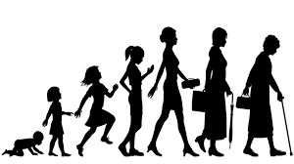
Development is multidimensional, meaning it occurs in many distinct aspects, including physical, biological, cognitive, and socioemotional. Development across the lifetime is how people grow and evolve across all phases of their lives.

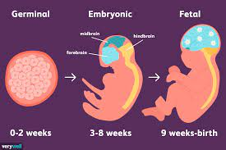
The first development I will be looking at is Physical development, the changes in body shape and characteristics. The prenatal development process is divided into 3 phases, germinal, embryonic, and foetal. A person's physical development begins during these stages in pregnancy, and can last anywhere from 37 to 42 weeks.

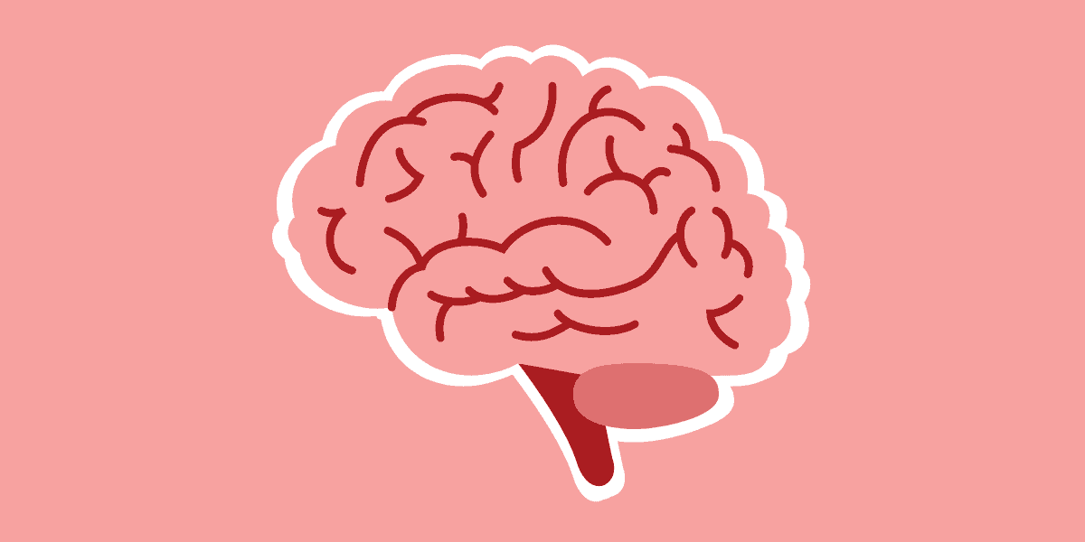
Brain development
The three trimesters of pregnancy correspond to different stages of brain development.
The neural tube develops in the first trimester, the brain reaches complete development in the second, and the foetus's brain contains as many neurons as an adult brain in the third trimester the final prenatal stage (Sosa, Roundy 2023)
Each parent gives a child a set of chromosomes that contain genetic instructions. This is our genotype the "blueprint" for development.
Foetal period
The final stage of pregnancy, known as the foetal phase, begins at or around the ninth week and lasts until delivery. At this point, the embryo formally becomes a foetus; it is assigned a gender at this point but cannot be observed by medical personnel until later. (Cleveland clinic, 2023)
Embryonic Period
Beginning in the third week of pregnancy and lasting until roughly the eighth, is the embryonic phase. Once a blastocyst, a cluster of growing cells created by the fertilised egg, begins to display distinctive human traits, it is referred to be an embryo. Organs and structures including as the neural tube can be seen developing into the brain, spinal cord, head, eyes, mouth, and limbs during this period. (Cleveland clinic, 2023)

Gestation
egg join to create a zygote during the contraceptive phase, which marks the beginning of the germinal period. This phase involves the zygote dividing to prepare for implantation into the uterine wall; following successful implantation, the embryonic stage starts.
Fertilisation
Prior to these three stages of foetal development, fertilisation takes place. Men can create 300 million sperm each day, while women can normally release 400 eggs for fertilisation. The egg attracts the egg and a sperm cell penetrates the egg, the shifts to the egg membrane restricts any more sperm from accessing the egg.
Gesell theory of physical development (Gesell at yale, 2010)
In 1925, American educator, paediatrician, and clinical psychologist Dr. Arnold Gesell created the Maturational Theory of child development.
Dr.Gesell saw trends in children's development and recorded them. Gesell highlighted that development always follows a set path with predictable phases or steps. From the time an embryo is formed until it is born, sequential development takes place.
Although each person moves through these phases at their own speed, the order is fixed. Gesell suggests that growth might be interpreted as a cyclical spiral. Gesell's developmental cycles consist of six distinct stages that recur throughout an individual's lifetime. Each cycle of the spiral involves the time it takes to progress through the six phases. Observe that the duration required to finish a cycle of the six steps decreases with age, starting out rather quickly.
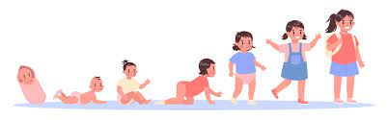
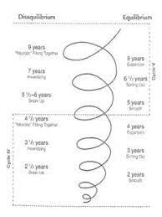
5 stages of physical development for children
(child development institute)
(motor skill learning 2024)

Stage 1 Newborn to 1 year, Birth to Mobility
At this phase, the child's sensory abilities are enabling them to distinguish between basic visual, auditory, tactile, scent, and taste distinctions. In addition, they perceive colour and discomfort. They also engage in oral exploration. Babbling, cooing, grunting, and crying are among the sounds that children at this age can also localise. Their eye, head, and arm muscles can be controlled; they can also grip objects, roll over, crawl, sit alone, and stand. Babies can walk by the time they are 12 months old because of improvements in their strength and balance.

Stage 2 Age 1 to 3, Mobility to basic motor skills
Children's growing mobility skills between the ages of one and three allow them to engage in situations that help them develop basic motor skills. They have the ability to run, leap, kick a ball, walk, build structures, and control their bowel and bladder. Their ability to draw lines on paper will improve as their fine and gross motor skills grow. They can speak in short sentences and have a vocabulary that is expanding to around 200 words at this point.

Stage 3 Age 3 to 7 Fundamental motor skills
The child's mobility development reaches its height at this stage. This is the perfect time in a child's life to study, build focus and motor skills since they are developing high levels of competency in all of their basic motor abilities, which will enable them to play and learn any sport with confidence. Since they are prepared to start participating in sports. The child's mobility skills enable them to move with more speed and agility while maintaining their balance. At this point, they can also clearly draw shapes and dress themselves.

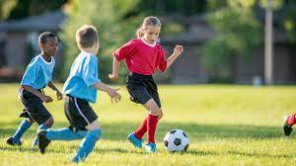
Stage 4 Age 7 to 10 Skill development
During this stage, the child's main focus is on enhancing the skills they had previously acquired and continuing to develop their muscle strength and coordination, such as throwing, catching, and kicking.

Stage 5 Age 11 to 17 Physical changes
At this phase, pubic hair development, a height surge, and skin changes are all signs of puberty. Men will have facial hair growth, and women will experience breast development and menstruation. Children who are still playing sports at this stage will be introduced to competition, practice, and intentional training to enhance abilities, techniques, strategies, and physical and mental capacity.

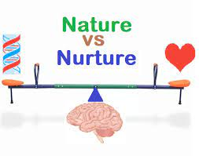
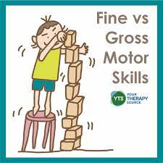
Nature vs nurture
Nature = Heredity, Genetic predisposition/animal instinct, Inborn abilities, and traits
Nurture = Environment, taught to do, moulds genetic tendencies
The debate between nature and nurture focuses on the relative contributions of both to an individual's traits.
Some who agree to the nurture theory contend that a person's traits are mostly shaped by their upbringing and education, while others who support the nature theory contend that genetics plays a major influence in a child's development.
Fine motor skills
Fine motor abilities, involves small muscles that interact in coordination and manipulation to regulate motions in parts of the body like the hands, fingers, lips, mouth, and eyes. These muscles function in collaboration with the brain and neurological systems. Children who have developed their fine motor skills are more skilled to be able to eat, tie their shoes, hold pencils correctly when writing, and put on clothes.
Gross motor skills
Gross motor abilities include the use of the entire body's larger muscles, an improvement in balance, coordination, strength, and reaction time. Gross motor skills include things like sitting, crawling, sprinting, jumping, and ball tossing.
Gross motor development differences are more individualised and show less sex differential.
Freuds Psychosexual Theory
Maslow’s Hierarchy of needs

Stage 1 | Stage 2 | Stage 3 | Stage 4 | Stage 5
Oral Stage | Anal Stage | Phallic Stage | Latent Stage | Genital stage
Birth to 1 year | 1 to 3 years | 3 to 6 years | 6 years to puberty | Puberty to adulthood
The mouth, sucking and swallowing  (Ego develops | The anus, withholding or expelling faeces | The penis or clitoris, masturbation  (Superego develops) | Little to no sexual motivation present | The penis or Vagina, sexual intercourse
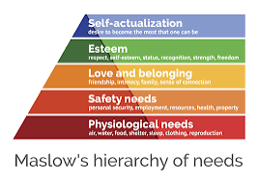
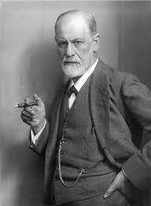
Protection from assault and theft, mental stability and well-being, health security, and financial security are all examples of demands related to safety.
Needs for love and belonging are related to interpersonal relationships, friendships, and familial ties with both biological and adopted families.
involves closeness on a physical and emotional level as well.
ego-driven wants, self-respect and self-esteem, recognition and respect from others, self-assurance, and independence are among the demands that drive one's needs.
Self-actualization demands involve education and skill development and define reaching your maximum potential.
(Masterclass 2021)

This hypothesis according to which behaviour is determined by five categories of human wants. These needs include those for physiology, safety, love and belonging, esteem, and self-actualization.
The first of the lowest needs in Maslow's hierarchy are physiological needs. The most fundamental requirements for human survival are for food and drink, enough sleep, clothes and shelter, general health, and reproduction. According to Maslow, in order for people to advance to the next stage of fulfilment, these fundamental requirements must be satisfied.

According to Freud, a child's personality develops in five phases, with each stage involving a distinct way that sexual energy is manifested through various body parts. These phases, which are characterised by desire fixation on various body parts, are called psychosexual stages. Certain bodily parts become significant as a person matures physically and might be sources of potential joy, irritation, or both. To use this control and steer the craving for fulfilment towards avenues that are acceptable to society, the ego and superego form.
The second development is Emotional and social development.
Emotional development is crucial because it helps children develop a feeling of self-awareness and self-regulation.
The intricate process of emotional development starts in early childhood and lasts until maturity. Joy, anger, sadness, and fear are the first feelings that may be identified in newborns. More complex feelings like shyness, surprise, ecstasy, embarrassment, shame, guilt, pride, and empathy surface as children's sense of self grows. As kids grow older, they also start to notice that people feel a variety of emotions. They also learn to recognise these emotions and comprehend the reasons behind them. Children initially focus on their outward emotions, but as time goes on, they learn how to appropriately control their feelings and realise that feelings can also have internal causes. Children must learn how to communicate their feelings and control their mood in addition to experiencing emotions. Crowley (2014)

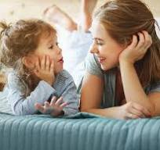
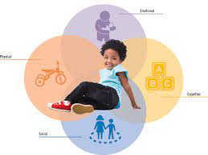

A child's social development the process by which they learn how to interact with others is linked to their emotional development. This includes teaching kids how to collaborate, communicate, and share. It's critical that children learn these abilities so they can function in the world.

A child's sense of self is the main goal of early social and emotional development. Creating a positive self-image, acquiring emotional control, and building trust with others are all necessary for this. It's crucial to provide kids with opportunities to acquire social skills like sharing and taking turns, like encouraging them to share their toys. Since educating your kids how to share and communicate effectively helps them express greater social and emotional abilities, this falls within the nature vs. nurture debate. Happiness and well-adjusted behaviour are more common in children who have healthy interactions with others. Children should therefore be given the chance to develop socially and emotionally.

There are numerous strategies to support children's social and emotional development, such as creating a safe and nurturing home atmosphere, allowing them to express their emotions, teaching them coping mechanisms for difficult emotions, exercising patience, and supporting good self-talk and behaviour. (Twinkl)
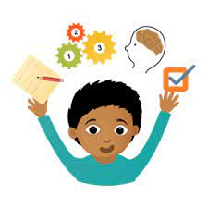
Cognitive development (Changes on thinking and memory)

“Cognitive development refers to the changes in one’s mental abilities that take place throughout our lifespan. It is an enormous topic including attention, decision making, memory and critical and creative thinking.” (Doherty and Hughes 2014)

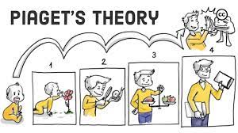
Sensorimotor, Birth to 18/24 months - Object permanence
The newborn concentrates on physical sensations and developing motor skills at this stage. A variety of cognitive skills, including self-recognition, also emerge. The child experiences the present because it lacks a mental image of the world and a sense of object permanence throughout this period of development. By the time toddlers reach this stage, they can use one thing to stand in for another through play, and when they discover that words can be used to represent both objects and emotions, words start to form. This is when the general symbolic function starts to emerge. Many factors can influence the rate at this point. One such factor is cultural practices; in certain cultures, babies are carried around all day on their mothers' backs. This constant contact and variety of stimuli can affect how a child views their surroundings and their sense of object permanence. ender norms represent the second individual difference. Toys given to infants can vary according to gender expectations. Giving a male more action figures or automotive toys and a girl, more kitchen sets or dolls can have an impact on the child's early relationships and sensory experiences.

According to Jean Piaget's theory of cognitive development, children go through four distinct stages of intellectual development that correspond to the growing complexity of their mental processes. Each kid progresses through the stages in the same sequence, albeit not all at the same rate.
Piagets Theory
The expansion of a child's capacity for thought, reasoning, learning, exploration, and memory is known as cognitive development. It has been found by academics and modern thinkers that babies are in fact constantly thinking, learning, and exploring their environment. A child's early years are a time of great curiosity and significant developmental milestones. Many parents are concerned about fostering their children's intellectual growth. Thankfully, children have a strong desire to learn from the very beginning. There are numerous ways to promote learning, including asking lots of questions, fostering learning situations at home, and demonstrating knowledge to kids. (Cherry 2022)
Preoperational, 2 to 7 years old – Symbolic thought
During this early period, the infant does not use operations, therefore logical reasoning is not as influential in their thinking as appearance. Kids have an egocentric view of the world and believe that everyone else sees it the same way. Play becomes increasingly significant as children reach the preoperational stage, egocentrism decreases, and they start to enjoy when other kids join them in their games. Through language and mental images, toddlers and early children learn to reflect the world internally. A child's perspective of the world is shaped by its appearance rather than its actual nature. It is not yet able to think logically, or to solve problems. Children have made some headway in separating their ideas from the real world by the time they are two years old. have not yet acquired the latter stages' logical (or "operational") cognitive traits. Cultural storytelling is one of the two distinct differences; myths and stories are specific to each culture. Based on their cultural narratives, children from different origins may perceive and comprehend symbolic elements in different ways. Race and representation represent another individual distinction. A child's racial identification might impact how they play pretend. For example, a lack of diverse representation in toys and media may cause children of colour to recreate settings that don't reflect their background or experiences.

Formal operations, Adolescence to adulthood – Scientific reasoning
As teenagers move into this stage, they develop higher order thinking skills, the ability to integrate and classify things in more sophisticated ways, and the ability to think abstractly. Formal operations are performed on concepts, while concrete operations are performed on objects. Formal operational thought is completely independent of perceptual and physical limitations. Teenagers are capable of handling abstract concepts at this point (e.g., understanding division and fractions without having to consider chopping up cakes or sharing sweets). They don't need to consider instances when following the structure of an argument. During this phase, scientific reasoning begins to take shape, producing abstract ideas and hypotheses in response to issues. Different cultural and abstract thought processes highlight different forms of rational thought. For instance, in communities with a strong oral history, the capacity to hold complicated narratives may emerge as a prominent skill. This phase marks the beginning of scientific thought, the development of abstract conceptions, and
Disparities in gender and ethics can also be influenced by gender norms. For example, in certain cultures, females are pushed to prioritise community harmony while boys are encouraged to prioritise individual rights.
Every stage is accessible, although children advance through them at different rates depending on the person, and some people may never reach the later phases. (Mcleod 2024)
Concrete operational, Ages 7 to 11 years – Logical thought
Children start to reason logically about tangible occurrences throughout this stage. Children start to grasp the idea of talking and learn that while objects may alter in appearance, some characteristics never change. Children also become less egocentric and start to consider the feelings of others throughout this time. However, the child must be asked to reason with physically present materials in order for operational thought to be effective in this situation. When asked to reason about hypothetical or abstract problems, children at this age often make mistakes or become overwhelmed.
The individual differences in the cultural context of conversation tasks: children may exhibit conversational skills earlier in a society where resources are scarce because of the cultural emphasis on material preservation and reuse. Stereotypes regarding gender aptitude, such as "boys are better at maths," might affect how kids approach logical issues or categorise objects based on assumed gender standards. Gender and learning are two more areas where individuals differ.
References
Cherry.K (2022) cognitive development milestones https://www.verywellmind.com/cognitive-developmental-milestones-2795109 ( Accessed 17 January 2024)

Child development institute, stages of human development birth to 5 years https://childdevelopmentinfo.com/child-development/normaldevelopment/
(Acessed january 5 2024)

Cleveland clinic (2023) Fetal Development https://my.clevelandclinic.org/health/articles/7247-fetal-development-stages-of-growth#:~:text=The%20embryonic%20stage%20lasts%20from,eyes%2C%20mouth%20and%20limbs%20form. (Accessed on 2 January 2024)

Crowley.k (2014)
Child development a practical introduction, London: SAGE

Doherty.J and Hughes.M (2014) child development theory and practice, Harlow: Pearson

Gesell at yale (2010) Gesell Theory https://www.gesell-yale.org/pages/gesell-theory
(Accessed on 2 January 2024)

Masterclass (2021) A guide to the 5 levels of Maslow’s hierarchy of needs https://www.masterclass.com/articles/a-guide-to-the-5-levels-of-maslows-hierarchy-of-needs#:~:text=Art%20of%20Negotiation-,What%20Is%20Maslow%27s%20Hierarchy%20of%20Needs%3F,%2C%20and%20self%2Dactualization%20needs. (Accessed on 5 january 2024)

Mcleod. S (2024) Piagets theory and stages of cognitive development https://www.simplypsychology.org/piaget.html (Accessed 19 January)

Mcleod (2024) Freuds psychosexual Theory and 5 stages of human development https://www.simplypsychology.org/psychosexual.html (Accessed on january 17 2024)

Motor skill learning academy Switzerland (2024) typical stages of physical development for children https://www.motorskilllearning.com/blog/TypicalStagesofPhysicalDevelopmentforChildren
(Accessed 16 January)

Sosa, Roundy (2023), Prenatal Brain development, stages, and factors
Available at: https://study.com/learn/lesson/prenatal-brain-development-timeline-stages-fetal.html#:~:text=The%20prenatal%20stages%20of%20brain%20development%20are%20divided%20into%20the,neurons%20as%20an%20adult%20brain. ( Accessed 2 January 2024)

Twinkl social and emotional development in early childhood https://www.twinkl.co.uk/blog/social-and-emotional-development-in-early-childhood
(Accessed on January 14 2024)

