Level 5 Electronics I – ACDA5002
Matthew Batkin – 2406517
Contents
Introduction 2
Background Research 2
Programmable Interface Controller (PIC) 2
Advantages 2
Disadvantages 3
7 -Segment display/LEDs 3
Traffic light system 4
Proteus 5
PCW compiler (CCS) 5
Circuit Design 6
Flow Chart 7
Software Listings 8
Simulation pictures 8
Testing Details 12
Conclusion 13
References 13

Table of Figures
Figure 1 - Flow Diagram of the System Workings 7
Figure 2 – PCW program (1) 8
Figure 3 - PCW program (2) 9
Figure 4 - PCW program (3) 9
Figure 5 - Simulation Part 1 0-10 Seconds 10
Figure 6 - Simulation Part 2 10-20 Seconds 10
Figure 7 – Simulation Part 3 20-30 Seconds 11
Figure 8 – Simulation pedestrian crossing 30-40 seconds 11
Figure 9 - Simulation 40 seconds before resetting back to the start 12

Introduction
The task has been given to create a traffic light system, with the use of a PIC controller, LED’s and a 7-segment display to count from 0-40 seconds to set the traffic lights correctly to manage the cars at a T-junction. The software used to help design the circuit will be proteus along with the use of Hexi decimal code through PCW software.
The requirement for the circuit is to configure the system to allow the traffic lights to change every 10 seconds to give a smooth traffic flow. Then after 30 seconds all the traffic lights need to be set to red, this is to leave the last 10 seconds for the safe crossing of pedestrians.

Background Research
There are various components to be used in the development of this systems so that it will work correctly and allow the safe use of the traffic lights these will be researched and discussed below:

Programmable Interface Controller (PIC)
PICs are widely used within industries to help control production lines or as timers, they are electronic circuits that can be programmed to carry out a variety of tasks. This type of controller is one of the most popular in the world and is made of specialised microchips.
The PIC controller chip is made up of a processor core, memory and input/output peripherals for the interface. These are used to implement computing functions for specific tasks like controls, sensors and counters etc.
There are two PIC devices being considered for this task these are and the characteristics being:
PIC16F877A – High performance 8-bit flash – I/O pins upto 40 – 64KB flash, 3.8K RAM – UART, SPI, I2C, ADC, Timers
&
PIC18F67K22 – 8-bit MCU with hardware Crypto Engine – upto 21 GPIO pins – 32KB Flash, 3.7K RAM – Multiple UARTs, ADC, comparators etc.
[1]

Advantages
- They have a low time required for performing operations
- Easy to maintain and perform troubleshooting
- Multiple tasks able to be completed together
- Small and compact
- Can interface additional RAM and I/O ports
- Less expensive than other computer chips
- Can process information in real time and give rapid responses

Disadvantages
- Limited amount of executions
- Structure can be complex
- No analogue I/O
- Memory is limited
- Are less powerful than other types of computer chips
- Can have limited function due to not be able to connect to external devices
- Programming can become challenging due to limited support compared to others
- Number of executions are limited
In conclusion a PIC microcontroller is an asset to a system being an embedded solution they are small, cheap and carry out specific tasks. They are widely used in electronics, automotive and automation industry. There are notable advantages to using a PIC controller such as previously mentioned however there needs to be consideration to the specific application it is being used for so the correct microcontroller can be chosen. For this project it has been determined that the PIC16F877A this is due to it having all the capabilities needed with sufficient pins rather than needing additional controllers, it allows for the user to look at issues and diagnose program issues, this is a good addition to have when beginning to program. [2]

7 -Segment display/LEDs
When looking at 7-segent displays they are made up of 7 Light Emitting Diodes (LED) the colour of these is determined by the spectral wavelength which is a mix of impurities that the LED relies on being added to the semiconductors during the manufacturing process, these colours range from green to orange to red. There are varies advantages to these types of lights compared to conventional lamps/lights, they are a lot smaller in size and last longer. As stated earlier there are various colours available, they are also less expensive, this makes them ideal for digital circuits and can be used with a magnitude of electronic modules. As mentioned, they are known to be small this allows multiple to be placed together in a tight small bundle which produces a 7-segment display.
All the LEDs have a section within the display and its pins are thread out of the package to allow for connection they each have a label from a to g the other pins from the LED are all joined to construct the pin that is common. This then allows each LEDs pins to be forward biased when needed to be able to light some segments whilst the others are off. This means that the display will generate a number from 0 to 9, you can add additional displays to be able to form 0-99.
There is 2 different types of 7-segment displays which is determined by the displays common pin as each LED will have 2 pins, Anode & Cathode. These will allow for a common cathode display or common anode display, the name tells you what each one is, the common cathode has all the 7 LEDs cathodes connected and the common anode has all the 7 LEDs anodes connected. These can then be lit up in the following way, common cathodes LED segments are formed together to logic ‘0’, and each LED is lit by providing a logic ‘1’ which has a forward bias current limit resistor to each of the anodes. The common anode works in the opposite, all the LEDs are joined together to logic ‘1’ and can lit up by applying logic ‘0’ through a current limit resistor to the relevant cathode of an LED.
This type of display is used generally for count operations or timers and is considered a good component to include in the project as there is a need to count from 0-40 seconds which is determined using a logic principle. The use of the common anode display will be used for the project as it is seen that the logic circuit can sink more current.
[3]

Traffic light system
Traffic light systems are used across the world and in various circumstances however not many people understand how they work or the technology they use. They will need to be programmed generally from historical data and data analysis of traffic flow, the time lights spend on green and red can determine if there is going to be traffic build up. They must be controlled to be able to maintain a safe road and pathways for vehicles bicycles and pedestrians.
The traffic light display consists of three different colours green, amber/yellow and red; these can be made up of LEDs in each specific colour which can be costly or could be white LED with a protective cover that is a specific colour. There are two types of systems that are mainly used these are dynamic control and fixed time.
Dynamic control systems are very complicated and use multiple components to be able to adapt to traffic flow in certain times, this is done using detectors which communicate with the control system to change the control times to help the flow of traffic. This type of system allows the lights form each section talk to each other to provide information to prevent accidents this is all done through the main controller that passes signals across the system. These systems can be costly so would not really be considered in the project being carried out.
The second system is a fixed time system that allows the lights to change in turn once a timer has got to a specified count in the sequence which will power the next step of light set up. It can hold lights for a specified time or allow them to flash. This is set by the programme written within the microcontroller and allows the lights to display a preset sequence to be observed, once a pedestrian presses the button to cross then it would activate a timer to turn all traffic lights red to allow them to cross.
This fixed time method of traffic light system is ideal for the project as the task is to have the lights change in a sequence for 30 seconds before stopping to allow pedestrians to cross for the remaining 10 seconds.
[4]

Proteus
Proteus software has been designed to be used for preparing schematic diagrams and circuit boards, it is able to allow for an easy use of PCB design this is due to the tools in Proteus being ideal for design and schematic capture.
This software will enable the user to look at the behaviour of a circuit before actually producing it for real as it is able to simulate the designed circuit. This allows for virtual testing to be carried out to find any faults that may in the design or improve the design before manufacture starts. Protes also allows for simulation of microcontroller-based circuits so you can visually see what is happening within the circuit and how all the components interact with one another. This will allow the user to save money and time as a lot of the testing can be conducted prior to build. Making the whole method low risk when it comes to embedding it into a system. Some of the components that can be used within the software are microcontrollers and various electronic components which will cover all that is required in the project.
When it comes to proving the system then proteus allows the circuit to live simulate so that each one of the components behaviours can be witnessed and understand the operation of the components together. Not only the components but the microcontrollers capability can be tested, this is done by compiling a program in PCW compiler and importing it into proteus. This is done externally to proteus, but it still saves time and is a more cost-effective way of progressing a product/system without building it first.
The discussion above proves that Proteus software is ideal system to be used for the design and testing of the project by being able to simulate the traffic lights to ensure safety.
[5]

PCW compiler (CCS)
The compiler used is code composer studio (CCS) which is an integrated development environment (IDE) this compiler is generally used on microcontrollers and processors. It uses various tools for developing and can debug the system. As the programme is being built and compiled the software will outline any anomalies before it is able to be compiled and used in the system for simulation. This allows for time saving as everything needed to test the system can be done through simulation it will also save money for the user.
It does allow the user to find the errors within the system it will just give an idea of what formatting issues there is. It will raise an error against each line that has an issue. To make full use of its capabilities the user will need more experience of program writing and understanding of the workings to change the program to get full functionality.
The software being used is a good fit for the project as it works well with proteus allows for a small amount of indication of error, where the user can learn how to correct any issues which allows for their own intuition.

Circuit Design
The project is asking for to design a traffic light system at a T-Junction this will require many components to be able to display lights at each point of the road along with having a set at each of the pedestrian crossing points. The microcontroller has 4 ports A-D to be used for output signals these consist of 0-7 channels. The signals for the traffic lights connection are connected to B0-5 for the first 6 signals then the last traffic light is connected to A0-2 this allowed for all the signals to be used in any orientation needed and sequence. This set up allowed for all the traffic lights to turn red during the pedestrian crossing stage.
For the pedestrian crossing lights they were connected to port B6&7. All the lights in the system were energised when the programme was written for them to be on, there needed to be a complete circuit for them to work so each LED had a path to ground connected.
Lastly there needed to be the 7-segment display which had a common anode, as there was 2 required to display number from 0-40. 14 outputs were required so they were connected to port C&D, these displays counted from zero to nine on one and from 0-4 on the other to be able to display all seconds needed. To allow for a clear design the wires have been replaced with remote pins which work as long as the name correlates to where it is going.

Flow Chart
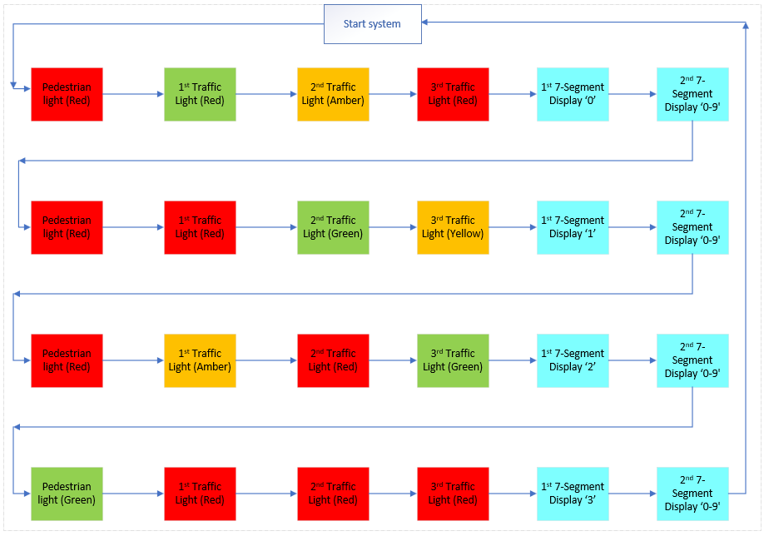
Figure 1 - Flow Diagram of the System Workings

Software Listings
There were 2 software listings used during the project these were Proteus and PCW.

Simulation pictures
The below images Figure 1, Figure 2 & Figure 3 shows the written programme to simulate the system.
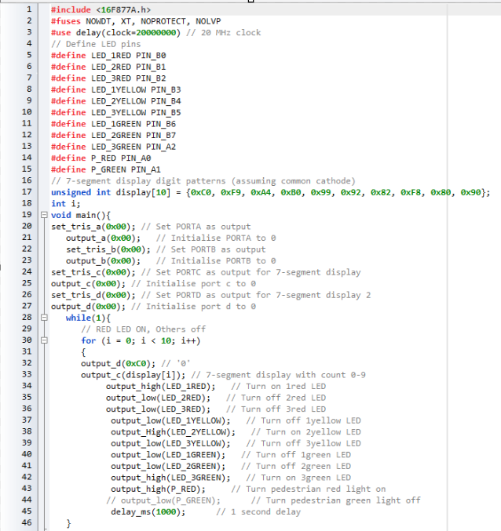
Figure 2 – PCW program (1)
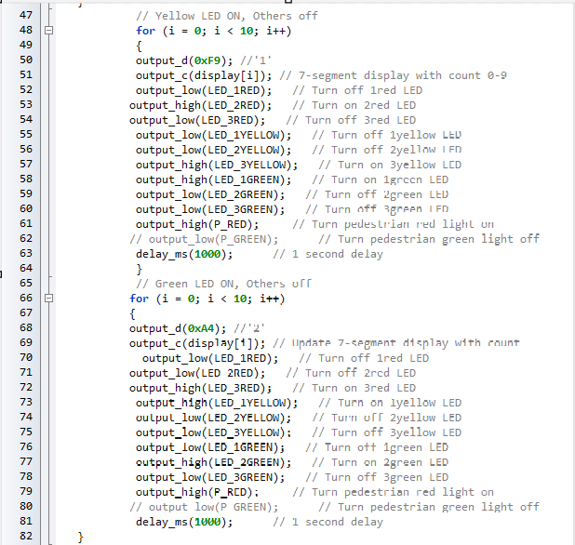
Figure 3 - PCW program (2)
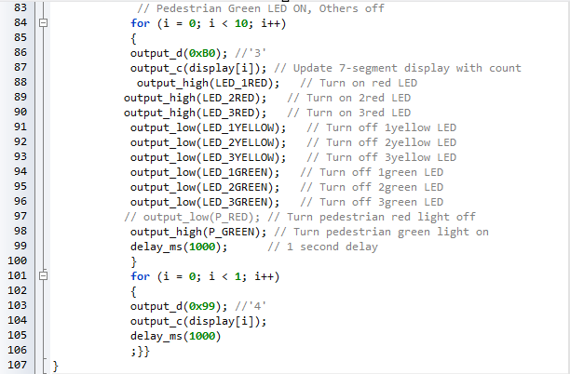
Figure 4 - PCW program (3)

The below images Figure 4, Figure 5, Figure 6, Figure 7 & Figure 8 show the project working through the simulation in different stages.
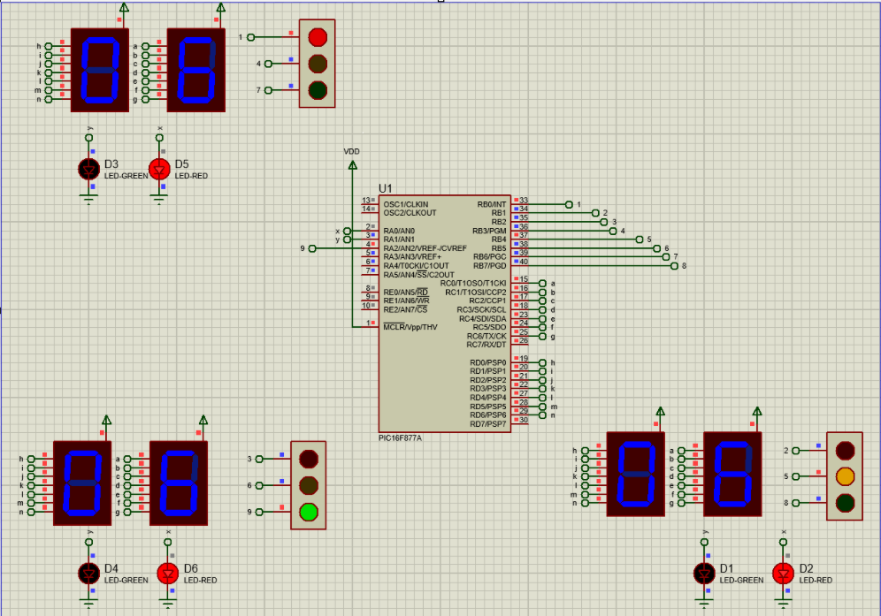
Figure 5 - Simulation Part 1 0-10 Seconds
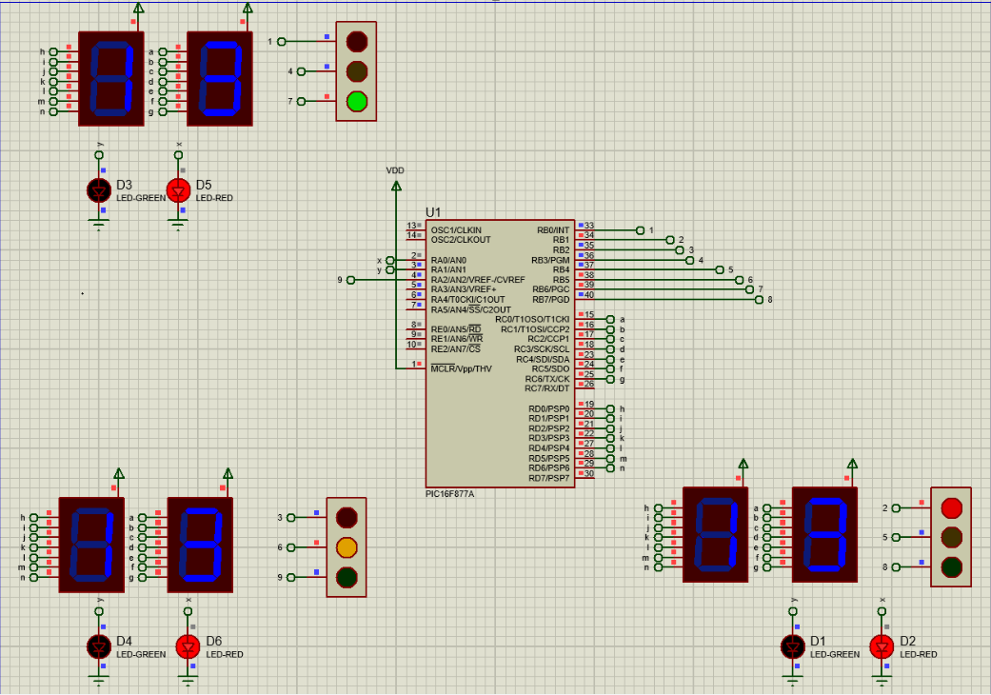
Figure 6 - Simulation Part 2 10-20 Seconds
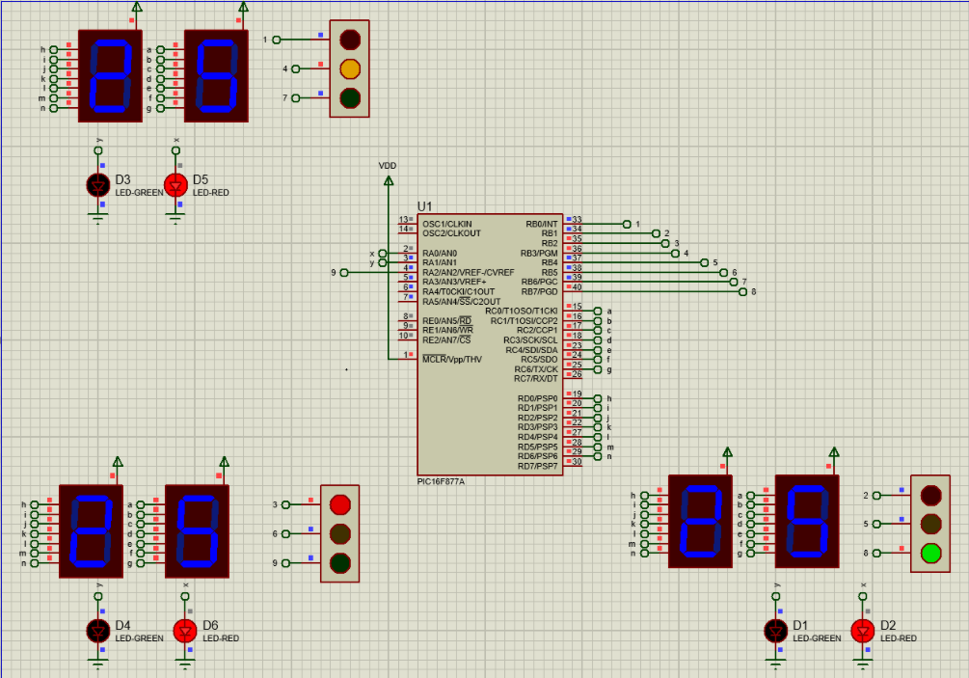
Figure 7 – Simulation Part 3 20-30 Seconds
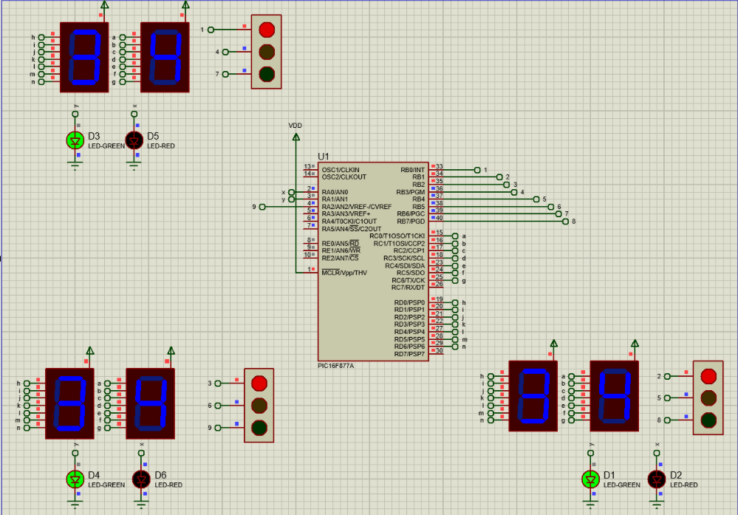
Figure 8 – Simulation pedestrian crossing 30-40 seconds
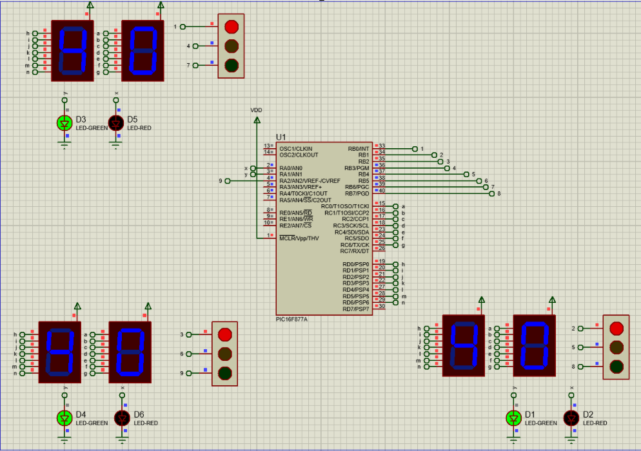
Figure 9 - Simulation 40 seconds before resetting back to the start

Testing Details
When it came to testing the circuit and programme there were a few errors seen firstly when drafting the code there were some semi colons missing along with wrong defining of pins for some of the outputs. This was made easy to do by simulating and compiling the code before implementing.
Once the compiled test was ready, it was transferred into proteus to allow for actual simulation with components this thew up some more errors where some of the pins were connected in the wrong ports or not assigned to the correct one in the program. This was also the case when it came to changing the programme to include the use of all red traffic lights whilst the pedestrian light is green. Also, there was the error of wrong sequencing when it came to the lights which was a change required in the program to make sure they wee all set to ‘high’ or ‘low’.

Conclusion
When it comes to looking at this system and how it functioned overall it has been a positive process. The micro controller is at its maximum working capacity so if the system was made more complicated, then some of the components would need to be considered for change.
When it came to the build of the circuit, proteus was sufficient with having access to all the correct components needed this allowed for the circuit to built sufficiently with all references to ground and a suitable power supply to allow for a complete circuit. To programme the micro controller there was a written programme completed on CCS PCW compiler which allowed for the programme to be created before compiling it to be imported to the microcontroller on proteus. When compiling the programme on CCS it shows errors in the format to adjust, this means that transferring the file to proteus is easy so that it can be included into the simulation on proteus.
While using both these programmes the project of traffic light system was demonstrated successfully, where each of the traffic lights displayed a different LED every 10 seconds then after the 30 seconds, all the traffic lights went and the pedestrian light went green to allow a safe crossing for pedestrians for 10 seconds, so then a complete 40 seconds were complete then it reset and started again and the pedestrian light went back to red.
To finalise this, it is shown that the traffic light system is proven to operate safe and efficiently for all traffic and pedestrians. The system can be further improved to be safer by having a push button to operate the pedestrian lights by letting the system know someone is waiting if it is not pressed then it runs for 30 seconds and restarts and the 10 second pedestrian only happens if pressed. The other option I thought of was to have the green pedestrian light flashing but that would have just been for aesthetics.

References
[1] RayMing (2021). What is PIC microcontroller ? RAYPCB. Available at: https://www.raypcb.com/pic-microcontrollers/.
[2] geeks for geeks (2020). Advantages and Disadvantages of Microcontroller. GeeksforGeeks. Available at: https://www.geeksforgeeks.org/advantages-and-disadvantages-of-microcontroller/.
[3] Electronics Tutorials (2018). 7-segment Display and Driving a 7-segment Display. Basic Electronics Tutorials. Available at: https://www.electronics-tutorials.ws/blog/7-segment-display-tutorial.html.
[4] Secosouth (2021). How Do Traffic Light Control Systems Actually Work? Secosouth. Available at: https://secosouth.net/2021/10/how-do-traffic-light-control-systems-actually-work/.
[5] PCB, R. (2022). Advanced Capabilities, Features, and Benefits of Proteus PCB. Printed Circuit Board Manufacturing & PCB Assembly - RayMing. Available at: https://www.raypcb.com/proteus-pcb/.

