Data Handling & Business Intelligence

LCBB5000

Assignment Title: Data Analysis & Visualisation

Name:Desislava Radeva
Student ID: 2030540
Table of Contents
Part 1: Processing, Analysing and Visualisation of data 3
Evaluation of the database 3
Prepossessing 4
Data Analysis 4
Part 2: Text mining and Analysis 14
Initial reporting of the given data set 14
K-means clustering and interpretation 19
Data mining and testing method 23
Advantages and disadvantages of SPSS and Excel 24
Reference List 27

Part 1: Processing, Analysing and Visualisation of data

Evaluation of the database
It has been observed from the given dataset that there are a range of different factors which are influencing the increasing or decreasing crime rates in the UK. These rates are being considered by focusing on several consideration factors. The given data set is primarily used for establishing several relationships between different factors. Therefore, the execution of crime dataset is being broadly accepted and found to be highly essential to analyse the crime rates in the UK. It helps in addressing the crime rates and its superiority in different locations of crime in the UK.
In this context, it has been observed that Northern and Southern junctions of the UK are two considerable factors which contribute in presenting the data across different locations of the UK. The dataset has been prepared by considering different variable factors such as population of youth, education level, total number of males and expenditure rate over the course of a year. There are also other implications aligned in this preparation of the dataset (Aransiola and Ceccato, 2020). In order to prepare these differences a major graphical interpretation has been conducted to show the required differentiation of data.
These entries variables of the dataset are highly important in order to carry the inferences of crime rate and its impact in different areas of the UK and its surrounding population. It has been observed that the variable related to education helps in measuring the literacy rate of the population of the UK areas. The unemployed rate of the mature population suggests those populations who are not employed yet. The factors related to wage suggest the remuneration or salary acceptance and rate of population. This population has employment scope in different regions of the UK. The size of the state aims to reflect the values attributed in the states where their values are taken into consideration (Welsh and Farrington, 2018). The factors related to below wag suggested those population of UK who are belonging to the below wage rate group. It is helpful in presenting the below age group category. Here in order to evaluate the combined influences of the different factors on the crime rate of the UK several factors which have strategic significance are being taken into consideration. The preparation of this dataset is highly important in order to show significant traits of the evolving crime rates of with the understanding of its implications and strategic benefits of the entire model.

Prepossessing
Prepossessing is considered as an essential part where unstructured information has been formed with proper structure for evaluating the information for different purposes. Primarily in the first steps of pre-possessing the inconsistency from the given information structures is being removed by focusing on the operational values. Thereby, in this context the Southern and Northern values are being replaced from 0 to 1 with measurement of their equivalent string value which is significant in this context of data evaluation. Here the utilisation of IF function is being considered to create a new range of columns for judging the rate of crime. The value is high if it shows a greater value than 100. The value is moderate if it shows a value of less than 100.
In addition, the regression analysis is being done by considering different factors and its evaluation by focusing on independent and dependent variables. The independent variable here is crime rate and the other associated factors are considered as dependent variables. Here the factors related to economics are considered as highly important measurements to measure the crime rate according to the interpretation of different signified and gathered values. However, the interpretation of data is being done with the consideration of different utilised excel functions such as PIVOT table and IF. In this context, a broader range of required strategic decisions needs to be implemented in order to measure the different levels of crime rates and its relevance in the UK. Here The decision factors are also considered properly to conduct the overall interpretation of data.

Data Analysis
Sum of CrimeRate | Column Labels
Row Labels | Northern | Southern | Grand Total
Northern | 40.97% | 25.69% | 66.66%
Southern | 30.82% | 2.52% | 33.34%
Grand Total | 71.79% | 28.21% | 100.00%
Table 1: Crime Rate and Youth unemployment
The data representation of the above table focuses on evaluating the crime rates and the influence of youth unemployment on the emerging crime rate in different areas of the UK. It has been observed that the majority of the youth unemployment has been observed in the Northern region. It is showing a positive influence on the emerging crime rate of different
locations of the UK. Besides, 30.82% of the youth population are from the southern region who also contributed to the development of the crime rates in different locations of the UK.

Figure 1: Crime Rate and Youth unemployment
The above bar chart is showing specific significance regarding the variables related to “youth” and “crime influence” in order to show relevant insights about the crime rates and number of populations.
Crime rates and More Males
Sum of CrimeRate | Column Labels
Row Labels | Northern | Southern | Grand Total
Northern | 45.96% | 20.70% | 66.66%
Southern | 33.34% | 0.00% | 33.34%
Grand Total | 79.30% | 20.70% | 100.00%
Table 2: Crime Rate and More Males
(Source: created by the learner)
The visibility of the above data shows the relevance and evaluation of increasing crime rates in the UK Northern and Southern Region by focusing on the male population living in these locations. It has been observed that 45.96% of the population within the Northern Region is closely associated with different activities of crime. On the other hand, the rate of crime in the Southern region is found to be declining compared to the Northern region up to 33.34%.

Figure 2: Crime Rate and More Males
(Source: created by the learner)
The above evaluation through graphical representation is showing the regions of Northern and Southern locations are divided. It is beneficial and significant for analysing the crime rate of this given data set for the increasing rate of male population.
Rate of crime across the region
Sum of CrimeRate | Column Labels
Row Labels | High | Moderate | Grand Total
Northern | 42.93% | 23.73% | 66.66%
Southern | 19.37% | 13.97% | 33.34%
Grand Total | 62.30% | 37.70% | 100.00%
Table 3: Rate of crime across the region
(Source: created by the learner)
The increasing rate of crime in the Northern and Southern regions have been shown from the implementation of the above table. The tables help in demonstrating the crime rates indifferent regions. It has been visible from the above table that most of the crimes are being visible in Northern Regions which is found to have 42.93%. Besides, Southern region is showing comparatively a smaller number of crime rates than Northern regions of UK. the rate of crime rate in southern region is found to be 19.37% which suggests higher level of crime are. However, in moderate levels the crime rate is visible up to 13.97%.

Figure 3: Rate of crime across the region
(Source: created by the learner)
The above graphical representation suggested that the crimes based on different regions are helpful in analysing differentiation of crime rates in different regions. The increasing rate of crime has also increased the levels of uncertainty in the social scenario of the region.
Males and youth towards crime rate
Row Labels | Sum of Males | Sum of Youth
High | 51.32% | 50.96%
Moderate | 48.68% | 49.04%
Grand Total | 100.00% | 100.00%
Table 4: Males and youth toward crime rate
(Source: created by the learner)
The above graphical representation signifies the percentage of youth and male population who are being linked with the increasing ranges of criminal activities. It has been observed from the above table that 51.32% of male population are aiming to contribute to higher rates of crime than the 48.68% male population who are being considered the criminals of moderate levels. From the perspective of Youth population, it has been found that 50.96% youth population of UK are doing higher level of crime while as only 49.04% youth population are doing moderate level of crime in the different locational region of UK.

Figure 4: Males and youth toward crime rate
(Source: created by the learner)
The above graphical figures show the relevancy regarding the sum of males and youth population which have been associated with the interpretation of data. This bar chart is providing relevant insights regarding the rate of youth and male population crime on higher and moderate levels.
SUMMARY OUTPUT
Regression Statistics
Multiple R | 0.827164383
R Square | 0.684200916
Adjusted R Square | 0.559795216
Standard Error | 19.17008367
Observations | 47
ANOVA
 | df | SS | MS | F | Significance F
Regression | 13 | 26274.52 | 2021.117 | 5.499755 | 3.62E-05
Residual | 33 | 12127.24 | 367.4921
Total | 46 | 38401.76
 | Coefficients | Standard Error | t Stat | P-value | Lower 95% | Upper 95% | Lower 95.0% | Upper 95.0%
Intercept | -258.3036314 | 192.4354 | -1.34229 | 0.188665 | -649.816 | 133.2091 | -649.816 | 133.2091
Youth | 0.864982195 | 0.353186 | 2.449086 | 0.0198 | 0.14642 | 1.583544 | 0.14642 | 1.583544
Region | 0.569661318 | 12.04365 | 0.0473 | 0.962559 | -23.9333 | 25.07266 | -23.9333 | 25.07266
Education | 6.431185894 | 3.750328 | 1.714833 | 0.095754 | -1.19891 | 14.06129 | -1.19891 | 14.06129
ExpenditureYear0 | 0.712709172 | 0.20199 | 3.528437 | 0.001254 | 0.301757 | 1.123661 | 0.301757 | 1.123661
LabourForce | 0.107708854 | 0.122808 | 0.877052 | 0.386799 | -0.14215 | 0.357563 | -0.14215 | 0.357563
Males | -0.183826438 | 0.236565 | -0.77707 | 0.442654 | -0.66512 | 0.297468 | -0.66512 | 0.297468
MoreMales | 17.33920029 | 15.83577 | 1.094939 | 0.281471 | -14.8789 | 49.55731 | -14.8789 | 49.55731
StateSize | -0.098946497 | 0.11444 | -0.86461 | 0.393492 | -0.33178 | 0.133883 | -0.33178 | 0.133883
YouthUnemployment | -0.091727901 | 0.461323 | -0.19884 | 0.843611 | -1.0303 | 0.846841 | -1.0303 | 0.846841
MatureUnemployment | 0.687760671 | 0.994911 | 0.691279 | 0.494225 | -1.3364 | 2.711922 | -1.3364 | 2.711922
HighYouthUnemploy | -4.498056942 | 10.82134 | -0.41567 | 0.680345 | -26.5142 | 17.51812 | -26.5142 | 17.51812
Wage | 0.191891937 | 0.089505 | 2.143934 | 0.039499 | 0.009793 | 0.37399 | 0.009793 | 0.37399
BelowWage | 0.55335581 | 0.206926 | 2.674174 | 0.01156 | 0.132362 | 0.97435 | 0.132362 | 0.97435
Table 5: dependency based on the independent and dependent variable
(Source: created by the learner)
The above statistical representation suggested that the dependency of the crime rates within the youth population is showing highly significant results as the p value is showing 0.02 which is a lesser value than 0.05. However, the value of coefficient suggested that 0.86 which suggested that the represented value is showing higher relevance in a positive way. The factors which are showing region wise statistics are not showing any significant statistical relevance. It is because the rate of crime does not depend on the region. In this context the rate of education is again considered as one of the highly significant traits in the measurement as the value is showing statistically insignificant value where the p value is less than 0.05. In addition, the relation between crime rate and expenditure is showing higher statistical significance due to the p value of 0.001. These factors have higher relevance in this stat set to show positive significance. The p value between crime and wage rate is also suggesting positive correlation. Therefore, it can be said that there is positive significance between the relationship of these two variables.

Part 2: Text mining and Analysis
The survey data is considered to be significant here in obtaining relevant information for school students. The data set has been interpreted using SPSS software to show the statistical relevance. The tool of SPSS has higher benefits in order to interpret the statistical results than the use of MS Excel which has been used before.

Initial reporting of the given data set
In order to show the level of frequency between the data and its statistical interpretation this below table can be followed:

ice_cream
 |  | Frequency | Percent | Valid Percent | Cumulative Percent
Valid | Vanilla | 95 | 47.5 | 47.5 | 47.5
Valid | Chocolate | 47 | 23.5 | 23.5 | 71.0
Valid | Strawberry | 58 | 29.0 | 29.0 | 100.0
Valid | Total | 200 | 100.0 | 100.0

Table 1: Frequency of Ice cream flavours
(Source: created by the learner)
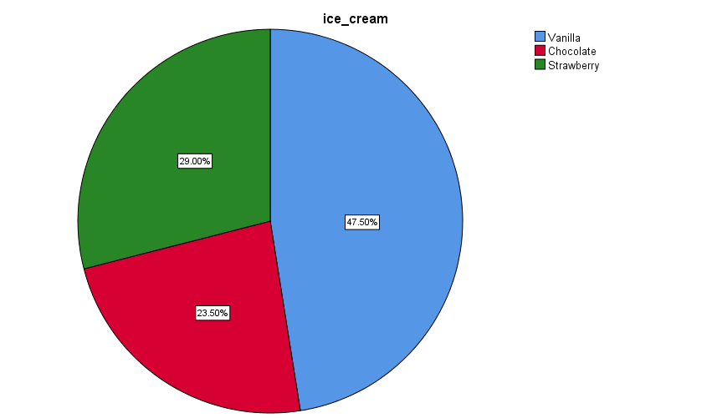

Figure 1: Pie chart for the ice cream flavours
(Source: created by the learner)
1) How many students like vanilla flavour?
From the given details of table 1 it has been observed that 95 students from a total 200 students prefer Vanilla flavour than other flavours. Therefore, statistically there are 47.5% students who like the vanilla flavour.
2) How many students are Male and Female?

Gender
 |  | Frequency | Percent | Valid Percent | Cumulative Percent
Valid | Male | 91 | 45.5 | 45.5 | 45.5
Valid | Female | 109 | 54.5 | 54.5 | 100.0
Valid | Total | 200 | 100.0 | 100.0

Table 2: Frequency of Gender
(Source: created by the learner)
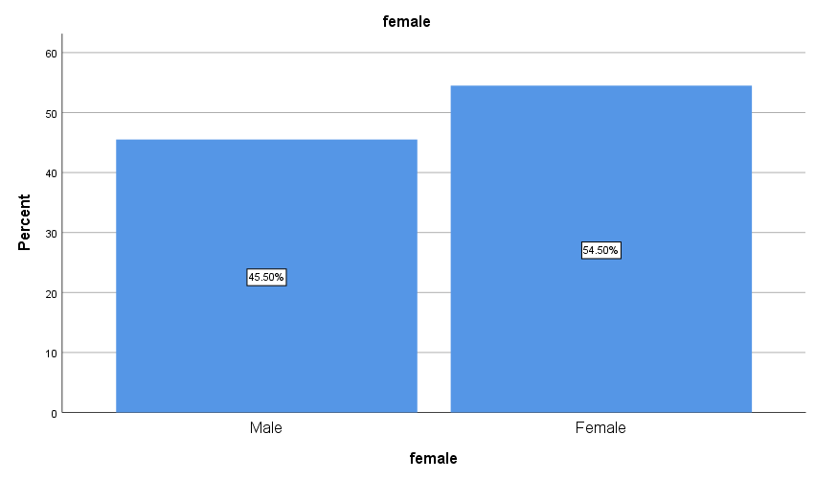

Figure 2: Bar chart of Gender
(Source: created by the learner)
3) What are the Mean and Median of participants who like chocolate and strawberry flavour?

Statistics of Chocolate flavour ice-cream
ice_cream
N | Valid | 47
N | Missing | 0
Mean |  | 2.00
Std. Error of Mean |  | .000
Median |  | 2.00
Mode |  | 2
Std. Deviation |  | .000
Variance |  | .000
Std. Error of Skewness |  | .347
Std. Error of Kurtosis |  | .681
Range |  | 0
Minimum |  | 2
Maximum |  | 2

Table 3: Statistics of Chocolate flavour ice-cream
(Source: created by the learner)
Statistics of strawberry flavour ice-cream
ice_cream
N | Valid | 58
N | Missing | 0
Mean |  | 3.00
Std. Error of Mean |  | .000
Median |  | 3.00
Mode |  | 3
Std. Deviation |  | .000
Variance |  | .000
Std. Error of Skewness |  | .314
Std. Error of Kurtosis |  | .618
Range |  | 0
Minimum |  | 3
Maximum |  | 3

Table 4: Statistics of Strawberry flavour ice-cream
(Source: created by the learner)
The above statistical figures have helped in showing the relevant insights into presenting mean and median value of the participants. These participants are fond of strawberry and ice cream flavour ice creams.

K-means clustering and interpretation
K-means clustering is considered as an unsupervised data representation which contains an algorithm. Thai algorithm has higher effectiveness and beneficial aspects in order to solve the problems related to data science platforms and machine learning or ML platforms (Er Kara and Oktay Fırat, 2018).
However, from the present analysis it has been found that there are 3 different clusters which are defined by different puzzle videos of different students with the associated gender factors. These are properly analysed to conclude in the following evaluation of results.

Initial Cluster Centers
 | Cluster
 | 1 | 2
video | 29 | 74
puzzle | 26 | 66
female | 1 | 0

Iteration Historyª
Iteration | Change in Cluster Centers
Iteration | 1 | 2
1 | 21.990 | 18.383
2 | .739 | .631
3 | 1.084 | .969
4 | .215 | .219
5 | .285 | .262
6 | .000 | .000
a. Convergence achieved due to no or small change in cluster centers. The maximum absolute coordinate change for any center is .000. The current iteration is 6. The minimum distance between initial centers is 60.216.

Final Cluster Centers
 | Cluster
 | 1 | 2
video | 45 | 58
puzzle | 44 | 60
female | 1 | 1

ANOVA
 | Cluster |  | Error |  | F | Sig.
 | Mean Square | df | Mean Square | df | F | Sig.
video | 8700.783 | 1 | 54.579 | 198 | 159.415 | .000
puzzle | 12815.244 | 1 | 51.116 | 198 | 250.709 | .000
female | .030 | 1 | .250 | 198 | .120 | .729
The F tests should be used only for descriptive purposes because the clusters have been chosen to maximize the differences among cases in different clusters. The observed significance levels are not corrected for this and thus cannot be interpreted as tests of the hypothesis that the cluster means are equal.

Number of Cases in each Cluster
Cluster | 1 | 95.000
Cluster | 2 | 105.000
Valid |  | 200.000
Missing |  | .000

Table 5: Cluster analysis for video Puzzle and gender-based on preferred ice cream flavour
The above table shows significant analysis which shows the termination after the conclusive termination of 6th iterations. Here convergence has been achieved with the presence of small differences within the cluster centres. For example, from the ANOVA table it has been observed that the changing patterns of clusters are showing statistically significant results. The p value between puzzles and video suggests the value of 0.05. Thereby these test results are suggesting positive correlation with statistical measurement. It also signified the difference between two fundamental cluster divisions by focusing different variables for the test cases which are selected.

Data mining and testing method
Data mining is considered to be highly beneficial in order to predict necessary decisions and achieve relevant insights regarding the data interpretation of the research. It helps in conducting proper strategic decisions for achieving useful initiation of data management (Aziz and Aftab, 2021). The approach of test mining is also recognised as a similar approach by focusing on text data. It helps in evaluating significant understanding and interpretation of practical requirements. The use of data mining procedures including classifications, tracking of data and all such effective approaches are essential for conducting a systematic inventory management. It is also suitable for conducting essential customer purchasing predictions. These are better advantages to improve the organisational stocks and essential maintenance of working times (Salihoun, 2020).
Besides, the prediction and regression approaches are highly useful with the execution of machine learning approaches. It is highly useful in order to predict the revenue and sales of an organisation. It is also suitable to measure and predict the customer purchasing decision in order to make suitable improvement of customer management strategies. These techniques in the execution of sustainable business management are highly important for providing better understanding and support. It is also helpful in ensuring different processes of business in the execution of organisational sales operations. In addition, these approaches are also highly essential in order to conduct the relevant development of financial aspects of organisations. Financial aspects of business are highly important in order to achieve flexibility of business management. Here the applicability of effective technique will be required.
However, the use of text mining techniques such as natural language processing of NLP, Content Analysis and sentiment analysis are the essential approaches for showing the relevancy of text data. It is helpful in obtaining prosperity within business purposes. For instance, the use of sentimental techniques is being used to observe product or service reviews of specific organisations. It focussed on reviews and comments shown in the social media profiles.
Besides, it has been found that the utilised content analysis technique is highly beneficial for conducting the evaluation of essential legal documents of organisations. It is hereby useful for conducting fraud detection within a specific organisation. Besides, it has been observed that the utilisation of NLP technique is considered as an important tool which is associated with the conducting process of survey. This is highly essential for observing the requirements and needs of the consumers.

Advantages and disadvantages of SPSS and Excel
Excel and SPSS are the important software to conduct data analysis which are highly essential for gaining important information regarding the data. In addition, interpretation of these data is highly important in order to develop new and necessary business strategies. Through this, the companies can ensure effective business management strategies. The advantages and disadvantages of these software are as follows:

 | Advantages | Disadvantages
SPSS | - The application of user interface is very easy in SPSS  - Larger data can be handled through this software  - These is complex operation which is helpful interpreting data with less issues  - The output results can be saved and interpreted with less complexities  - It helps in reducing errors and explanatory features helps in evaluating the results properly. | - This software requires paid subscription to use its features. Therefore, the software is considered as costly.  - Advanced data mining is not supported in this software.  - Data outputs cannot be executed in the updated version  - It has certain irrelevant features  - Complex graphical representation makes the results more complex.
Excel | - Organisation of excel is comparatively easier  - It has supported with automatic calculation features  - It is helpful in preparing balance sheet and other financial analysis  - It is supported with advanced calculations with statistical interpretations features  - It has multi-user support and it has a positive impact on the operations | - It is not useful in interpreting the results of larger database  - The advance analysis function is not supported in this software  - There are security concerns due to multiple user acceptability  - Some advanced training is required to handle different features  - There are higher chances of errors
Table 6: Advantages and disadvantages of SPSS and Excel
(Source: Vorina and Ojsteršek, 2019)

Reference List
Aransiola, T.J. and Ceccato, V., (2020). The role of modern technology in rural situational crime prevention: A review of the literature. Rural crime prevention, pp.58-72.
Aziz, N. and Aftab, S., (2021). Data Mining Framework for Nutrition Ranking: Methodology: SPSS Modeller. International Journal of Technology, Innovation and Management (IJTIM), 1(1), pp.85-95.
Er Kara, M. and Oktay Fırat, S.Ü., (2018). Supplier risk assessment based on best-worst method and K-means clustering: a case study. Sustainability, 10(4), p.1066.
Salihoun, M., (2020). State of art of data mining and learning analytics tools in higher education. International Journal of Emerging Technologies in Learning (iJET), 15(21), pp.58-76.
Vorina, A. and Ojsteršek, T., (2019). Analysis of relationship between leadership styles and employee engagement. Balkans Journal of Emerging Trends in Social Sciences Balkans JETSS, 2(1), pp.107-114.
Welsh, B.C. and Farrington, D.P., (2018). Assessing the economic costs and benefits of crime prevention. In Costs and benefits of preventing crime (pp. 3-19). Routledge.

