-

This Photo by Unknown Author is licensed under CC BY-SA

BMSK4005
Professional Career Development
TERM 3
Student Name: Lucien Yao
Student ID: 1916224
Student Name: Noemi Baglieri
Student ID: 1916148
Lecturer: Sylvia Hoffman

Table of Content
. Role Play
Hotel Management Interview
(hotel manager)
. Role Play Part 1
Noemi Baglieri: act as Interviewer
Lucien Yao: act as Interviewee
. Role Play Part 2
Lucien Yao: act as Interviewer
Noemi Baglieri: act as Interviewee
. Introduction
. Reflective on my role play

Introduction: Task 1
This task is meant to develop our professional career skills and employability, by acting as both interviewee and interviewer in a role play.
Task 2: The aim of this task is to demonstrate my skills by writing a report, containing a personal reflection on the role play and career development planning, demonstrating and understanding of the skills and knowledge which contribute toward working effectively to my readiness for employment, an understanding of personal strengths and areas for further development, as well as establishing my employment goals by developing a personal action plan.

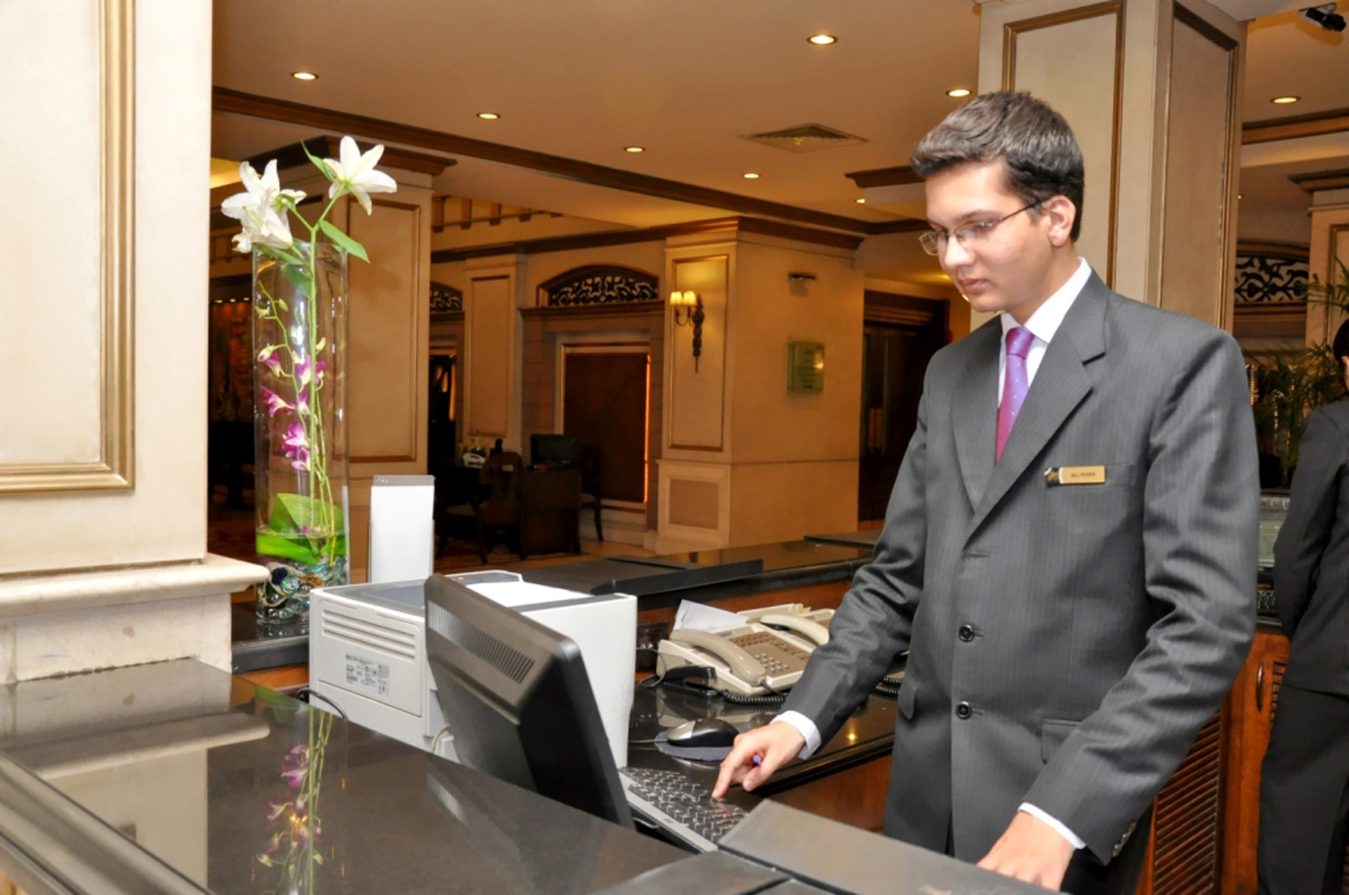
This Photo by Unknown Author is licensed under CC BY-SA
Role play as interviewer: Noemi Baglieri
Noemi: Tell me about yourself and why do you want this job?
Lucien: I am very hard working, I am a good team worker, I am great with customers and I will always look to improve and grow within the role.
I want this job because having looked at the job description and the person specification, it is a role I believe I can make a quick and positive impact in, and it is also in an area I am very passionate about.
Noemi: Why do you want to work for us?
Lucien: I would like to work for you for three reasons. Number one, your company history, your standards and the excellent products and services you sell give me the confidence I can stay working here for a long period of time.
Noemi: What experience do you have relevant to this position?
Lucien: I have read the job description and I feel the experience I have is a strong match for all the essential criteria.
I have experience of dealing directly with customers and clients, and I always make sure the standards of communication and the service I provide are second to none. Afterall, without customers, there would be no business. I have experience of working alone and as part of the team, I feel very comfortable in both situations.
Noemi: What are your strengths and weaknesses?
Lucien: My strengths include the fact I am commercially aware. What I mean by this is, I understand your business needs to be profitable and it will only achieve that if I do my job properly and provide excellent service to your customers and clients. Another of my strengths is the fact I am a fast learner. If you give me a job to do. I will go away and complete it to a good standard.
My weakness is that I find it difficult to let go of projects at times. However, I am also someone who is always willing to learn and develop.
Noemi: why do you want to leave job?
Lucien: for the simple reason that I am ready for a new and fresh challenge with an exciting and ambitious company with a team of people who are all working together and going in the same direction.

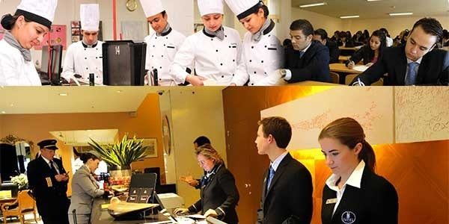
This Photo by Unknown Author is licensed under CC BY-SA-NC
Role Play as Interviewer: Lucien Yao
Lucien: tell me about yourself and why do you want this job?
Noemi: in my last job, I had responsibility for responding to customer queries and I always treated every customer with urgency, with good communication skills and with a pleasant and helpful tone.
We spend a lot of time at work, so it’s important I choose a job that I know I will enjoy and one that I can make a positive difference in.
Lucien: why do you want to work for us?
Noemi: I am looking for long-term employment and this is somewhere I feel I can stay. Number two, all the customers reviews left online, and the reviews left by current and former employees on the website, tell me you care about your customers and you care about the working conditions of your employees.
Lucien: what experience do you have relevant to this position?
Noemi: I have experience of working under pressure. For example, in my last job I was often given time sensitive tasks by my manager that had to be completed by the end of the working day. I enjoy working under pressure because you get to test yourself and put your skills to good use.
Finally, I have experience of problem solving. I am quite a creative person, so if there is problem that needs sorting out, I like to get involved and see if I can help rectify it.
Lucien: Have you ever had to calm an unsatisfied guest? How did you approach the situation?
Noemi: When I was working as a front desk clerk on the night shift, a guest came downstairs and said they were unhappy with their room service and wanted their money back. They did not want something else from the menu, but our policy stated that we could give no refunds after a meal was consumed. To keep the guest happy, I explained our policy and offered a free meal at our hotel restaurant the following day.
Lucien: why do you want to leave job?
Noemi: my employer has been fantastic. I have learned a tremendous amount and I will leave there on good terms.
I have achieved a lot whilst I have been working there and they have been good to me, but I genuinely want this job and it feels like the right time for me to be leaving.

Conclusion of the: Role Play Task 1
This practical professional development exercise such as role-playing interviewee and interviewer develop our professional career skills and employability as it’s very important in all industries, both for ourselves as a graduate looking to develop ourselves it also helps to demonstrate to potential employers our employability skills.
“Many job seekers focus so much on answering interview questions that they forget they need to ask questions as well. Asking questions is important for two reasons: First, when done correctly, the question you ask can confirm your qualifications as a candidate for the position. Second, remember that are interviewing the employer as much as they are interviewing you; it is critical to learn if the organization is one you would like to work for.” (Quintanilla, k.M. and Wahl, S.T. 2017)

Task 2

Reflective thinking on my role play
“I believe a good Manager is the one who effectively plan and manage the deployment of the administration team of staff, in the line with TMC policies and procedures. Effective day to day planning and management of staff resources, recruit, develop and maintain a flexible and experienced administration team by ensuring the safeguarding of leaners by been accurate and timely reporting and analysis of all funding and compliance activity, also liaising with HR Advisor as necessary.
Provide a comprehensive and effective administration service that supports contract monitoring. Provide and maintain effective and efficient data relating to finance, personnel and learners.” (www.indeed.com/interview-questions-for-hotel-manager)
By doing this assignment I had a practice job interview as Hotel Manager. I believe it’s a good ideal to do at least one mock interview before the real thing. At UWTSD where I am a Student, I learnt in PCD (Professional Career Development) which include Employment Legislation, careers and employability service, really helped me to practice my interview technique, also write and practise answers to common interview questions with my Lecturer Sylvia Hoffman.
Types of interview: There are several different types of interview. In some cases, you’ll only need to succeed at one of these to land the role.
- Face-to face: The traditional and still most common form of interview. You will attend the employer’s office and be questioned on your suitability for the job by an individual or panel.
- Telephone: Most often used by employers early in the application process to filter large numbers of applicants down to a more manageable number. And if eventually you are successful you will be invited to a face-to-face interview.
- Video: specially during this pandemic (Covid 19) video interview is increasingly popular among large employers by using: Teams or Zoom.
- Assessment centres: Applicant will attend an assessment centre with others and take part in task to enable employers to compare the performance of lots of candidates at the same time.
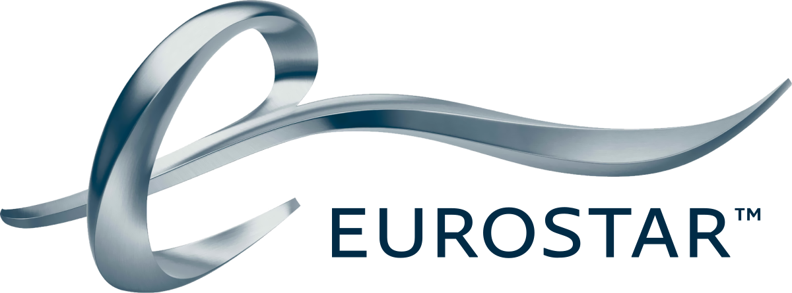
This Photo by Unknown Author is licensed under CC BY-SA
A job interview I had more than one. But there is always one you do remember even many years after, like yesterday. That was my case when I went for my Interview in 1998 with Eurostar.
This interview was mostly base on Honesty and Integrity than a personal qualification and skills as a full training was meant to be before the start of employment.
At the interview I was asked: if someone have the same knowledge as you as a waiter and on top of that the same person knows how to hold a bar and both of you are applying for the job, who do you want me to choose? You or the person with more experiences?
Very tricky question, but knowing the job involved handling a lot of cash therefore this interview was not very base on decision making or people management rather than honesty and Integrity. Despite my willing to have the job I was obliged to say the job should be given to the one with more experience than me, but the last question took me out of my feet when I was asked, why him to have the job and not you? I was obliged to admit that the one with more skills was the most suitable for the job. By saying that, I was accepting to give my job away but more than that, I swallowed my pride by saying that the gentleman front of me was better than me.
Out of 150 applicants only 10 got the job of Steward with Eurostar. very strange by been honest and modest and accepting defeat land me the job.
My job with Eurostar was not as a restaurant manager but as a Steward. My role was involving guiding people to the right train carriage before the departure of the train, then after working in the main bar by serving and selling food, coffee, and drinks. Also working with the trolley bar selling the same product all along the carriages. In the end of the shift, I must make a full account with the shift supervisor before we reach destination, and it was the same routine when going to France or Belgium as returning to England. This was the part where honesty and Integrity was playing a big role as enough cash was involved. As I was doing my work with full commitment it never occurred to me to keep part of the cash, because the education received from my parents and as a devoted Christian, I could not allow myself to do that.
For the full 2 years I have worked there I was organised and presented a good work for what I was designated for as I was supervised by the team leader, I developed a few skills such as: be part of a team, liaised and co-ordinated with other member of the team, I manage to be organised and to deliver my work before the end of my shift. During my time with Eurostar, I showed honesty and integrity with good satisfaction to myself.
Therefore, I decided that to any Interview I will be subject I will be honest, because it’s about being real with myself and others, it's about living my most authentic life just by about telling the truth as honesty enables me to develop consistency and sharpens perception, it’s allows me to observe everything around me with clarity as Christian since my young age and from a Christian catholic family I will say honesty is part of the foundation of my core values and principles. As honesty goes through deception by cutting is way through deceit and lies. Honesty led me to fulfil free life with no regret and guilt.
The skills acquired with Eurostar and at different work placement I have been, I have put in practice such: developing and questioning attitudes and new perspectives, responding effectively to new challenges and I have learned from one situation to other situations. I think their all-important skills that will help me in the future to achieve a perfect job interview.

Conclusion
A good hotel manager is the one who build customer retention as well as loyalty, the manager should resolve customer issues by listening to the customer complaints and solving them in a customer-oriented way, first needs to be a good planner, remember to bear in mind, what should be done ahead of time instead of being short-handed at time of busy schedule, a good hotel manager should be one who is able to multi-task between various tasks such as: answer calls, manage staffs, mingle with customers, in one word have a Leadership. I believe by studying hard and being organise with the skills I will acquired during my life experience I may become a good hotel manage.

References
www.indeed.com/interview-questions-for-hotel-manager
Maund, A. Schriek, M. and Tinker, P. (2017)
Quintanilla, K.M. and Wahl, S.T. (2017)

