

University of Wales Trinity Saint David
Group Project

Ordnance, Munitions and Explosives Bachelor of Engineering Programme (BEng)

Academic Year: 2021 - 2026

Craig Maclellan

Group Project Portfolio

Supervisor: Dave Holley
Internal Verifier: Gareth Collett
April 2024

This thesis is submitted in partial fulfilment of the requirements for the degree of Ordnance, Munitions and Explosives (Safety)

© UWTSD 2024. All rights reserved. No part of this publication may be reproduced without the written permission of the copyright owner.


Academic integrity declaration
I declare that:
- the thesis submitted has been written by me alone.
- the thesis submitted has not been previously submitted to this university or any other.
- that all content, including primary and/or secondary data, is true to the best of my knowledge.
- that all quotations and references have been duly acknowledged according to the requirements of academic research.
I understand that knowingly submitting work in violation of the above statement will be considered by examiners as academic misconduct.

Abstract
AESI has been commissioned by the British Army to redesign the Rapid Cratering Kit (RCK) for desert and hot climate operations, named CK24. This project focuses on meeting Insensitive Munition (IM) compliance standards and enhancing performance.
A team of Suitably Qualified Experienced Persons (SQEP) will conduct a comparative analysis of the new Resonance Acoustic Mixed (RAM) explosive formulation, TAW-EX-2022, against existing formulations, considering safety implications. The design phase will propose specifications for CK24, helping AESI with the Concept Assessment Development Manufacture implementation and Disposal (CADMID) cycle for CK24.
To ensure compliance with MTDS requirements, a series of trials will be proposed, with defined success criteria and methodologies for validation. Throughout the process, a systems engineering approach will be adopted, involving thorough research into existing cratering kits, such as the United States Army's 40lb cratering kit and the North Atlantic Treaty Organisation's (NATO) RCK Mk2.
The design process will be guided by Requirement Sets, Quality Function Deployment (QFD) analysis, Functional Means Analysis (FMA), and Feature Importance evaluations. Noise and Control Factors will be identified to manage system performance parameters effectively. Visual design elements for the CK24, including colour schemes, fonts, and branding considerations, will be aligned with British Army standards and operational requirements.
Concept drawings of the main charge and the top initiating charge, as well as sketches of the CK24 casing, will be developed. The team will use Computer-Aided Design (CAD) modelling and 3D printing for prototyping to refine design iterations. Collaboration between the Research and Design teams will ensure accurate explosive compound selection and precise volume calculations. Simulation technologies will also be employed for testing and evaluation, providing insights into energy distribution within the CK24 casing.

Table of Contents
1. Introduction 1
1.1. Overview of the Design Task 1
1.2. Team Composition and Roles 3
2. Design Process 4
2.1. Initial Design Solution 5
2.1.1 Functional Assessment 5
2.1.2 User Experience Evaluation 5
2.2 United States (US) Army 6
2.3 The North Atlantic Treaty Organisation (NATO) 8
3. Systems Engineering Approach 9
3.1 Requirement Set 9
3.2 Quality Function Deployment (QFD) 10
3.3 Functional Means Analysis (FMA) 11
3.4 Feature Importance 13
3.5 Noise & Control Factors 14
4. Visual Design Elements 15
4.1. Colour 15
4.2. Font 15
4.3. Branding 16
4.4. Font Colour 16
5. Concept Stage 17
5.1 Concept Drawings 18
5.2 Computer-Aided Design (CAD) Modeling / Prototypes 20
5.2.1 3D Printing 21
5.2.2 Charge A V1 22
5.2.4 Locking Mechanism 24
5.2.5 Charge A V3 24
5.2.6 Dimensions 27
5.2.7 Charge B V1 28
5.2.8 Charge B V2 29
5.2.9 Charge B Lid 31
5.2.10 CK24 Assembly 33
5.2.11 Simulation 35
6. Discussion 36
7. References 37

List of Abbreviations
AESI - Advanced Explosives Solutions International
CAD - Computer-Aided Design
CADMID - Concept Assessment Development Manufacture Implementation Disposal
C4 - Composition 4
CBRNergetics - Custom Military Demolition Explosive Equipment
CK24 - Cratering Kit 2024
FMA - Functional Means Analysis
HMX - High Melting Explosive
IM - Insensitive Munition
MTDS - Manufacturing to Disposal Sequence
NATO - North Atlantic Treaty Organisation
QFD - Quality Function Deployment
RCK - Rapid Crater Kit
RAM - Resonance Acoustic Mixed
RDX - Research Department Explosive
ROF - Royal Ordnance Factory
SQEP - Suitably Qualified Experienced Persons
TNT - Trinitrotoluene
US - United States

1. Introduction

Overview of the Design Task
Advanced Explosives Solutions International (AESI) has been asked by the British Army to redesign a particular piece of Ordnance Munition and Explosive (OME) called a Rapid Cratering Kit. AESI will provide a team of Suitably Qualified Experienced Persons (SQEP), each with defined roles within the team. The project duration is 3 months, with a design review scheduled midway to assess progress and ensure alignment with design expert requirements. Toward the end of the project, a presentation on the team’s chosen solution will be prepared and presented. Feedback from the presentation may then be used to optimize the final iterations of the system.
The Charge, Demolition Rapid Crater Kit (RCK) Mk2 has been standard equipment for many years and is in service with the North Atlantic Treaty Organization (NATO) Armed Forces, with similar kits being used by the United States (US) Military. The NATO RCK Mk2 is delivered by CBRNergetics who deliver custom military demolition explosive equipment to armed forces and law enforcement agencies worldwide. It has played a crucial role in recent conflicts, allowing forces to establish defensive positions rapidly and safely. The shaped charge used in this kit was manufactured at Royal Ordnance Factory (ROF) Chorley and filled with ‘Run Off’ or waste explosive from the shell filling process, typically RDX/TNT 60/40 ratio.
For the next iteration, the kit will go by CK24, meaning Cratering Kit 2024. The customer has specific requirements for an Insensitive Munition (IM) compliant cratering kit. They propose filling it with a new Resonance Acoustic Mixed (RAM) explosive called ‘TAW-EX-2022’. The primary focus is on desert and hot climate operations, although having all-climate capability worldwide is desirable. Additionally, the system should be transportable via both fixed-wing and rotary-wing transport aircraft, as well as tracked and wheeled road transport.

Compare the performance of the new formulation with existing formulations. | - Analysis comparing the performance of the new formulation with existing formulations.  - Graphs or charts illustrating the comparative data.
Obtain safety data | - Presentation of safety data obtained for the new formulation.  - Summary of safety considerations and implications for design.
Propose a design for the cratering kit | - Detailed proposal for the design of the cratering kit, including specifications and considerations for the new formulation.  - Schematic diagrams or renderings of the proposed design.
Recommend a production route | - Recommendation for the production route of the cratering kit, considering factors such as efficiency, cost, and scalability.  - Explanation of the chosen production method and rationale behind it.
Describe the Manufacturing to Disposal Sequence MTDS | - Description of the MTDS, outlining the lifecycle of the product from manufacturing to disposal.  - Flowchart or diagram illustrating the MTDS process.
Propose transport | - Proposal for packaging the cratering kit, ensuring safety, ease of transportation, and compliance with regulations.
Propose a series of trials to prove the device meets the MTDS requirements | - Outline of the series of trials proposed to validate the device's compliance with MTDS requirements.  - Criteria for success and methodologies for conducting the trials.
Figure 1 - Project Component Overview

- Team Composition and Roles
The team [Table 2] consists of 7 people who all have delegated roles. Each member of the team is expected to work alongside each other and give details/info to anyone who requires their expertise.
Research & Design Engineer | Ewan Simpson
Design Engineer | Craig Maclellan
Production and Manufacturer Lead | Alex Nichols
Test and Evaluation Manager | Finn Mallon
Safety Lead Engineer | John Gallacher
Transportation Engineer | Katie Byrne
Disposal Engineer | Will Young
Figure 2 - Team Members and Roles

2. Design Process
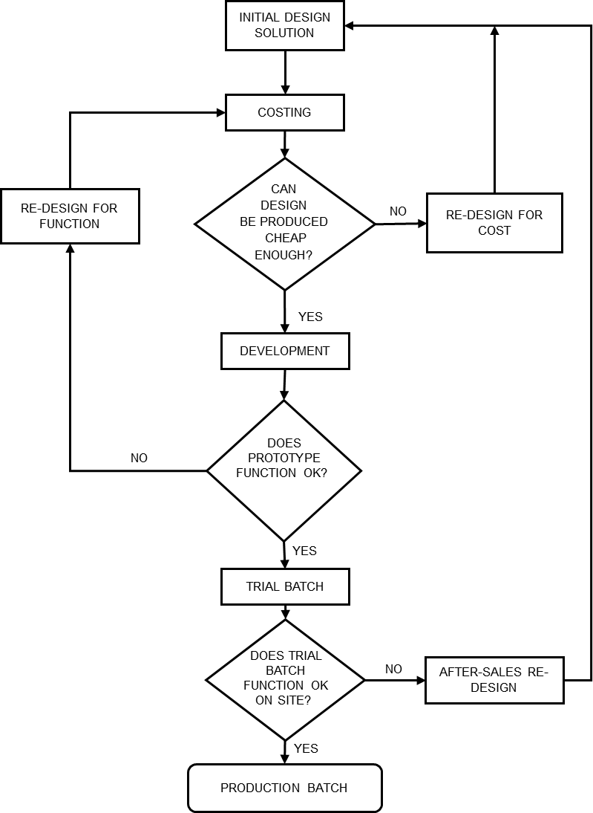
Figure 3 - Design Process
- Initial Design Solution
The initial phase of the design process involved thorough research into existing products, examining the features, costs, functionalities, and overall design aesthetics of the products. This comprehensive exploration provided valuable insights into current market trends, user preferences, and technological innovations, laying a solid foundation for the design process. By employing the systematic approach of systems engineering, the team was able to define the problems that the design aimed to tackle. By breaking down the problem into different elements and analysing the details, the team gained a better understanding of the challenges at hand. This analytical process gave clear and concise design objectives, ensuring that the design process was purpose-driven and aligned with the project goal. This methodical approach laid the groundwork for the development of innovative and effective solutions to address the identified problem within the design.

Functional Assessment
The RCK Mk2 uses a shaped charge to create the initial hole for the High Explosives, despite its relatively high cost. This design feature allows for the placement of explosives below ground level, enhancing their effectiveness and resulting in the formation of larger craters.
The detonator used in the system is both inexpensive and highly reliable, making it the preferred choice for initiating detonation for this type of system. Its cost-effectiveness and efficiency make it the most commonly used initiator, ensuring optimal performance without the need for extravagant features.
When assessing the durability and reliability of the kit's components across various environmental conditions and operational scenarios, the RCK Mk2 stands out for its performance and dependability. The kit meets customer requirements for international usage, particularly in hot climates, while remaining operational in colder environments. Overall, the design of the RCK Mk2 is robust and reliable.

- User Experience Evaluation
Ergonomics is a discipline that applies principles from physiology and psychology to analyse how workers or groups interact with tasks, tools, support equipment, and their physical environment. Its primary goal is to generate effective and efficient recommendations/requirements aimed at decreasing the occurrence and severity of injuries and/or illnesses [1].
The ergonomics of the RCK Mk2 are suitable for the intended situation. They are designed to be straightforward without unnecessary complexity while prioritizing safety and secure deployment. The weight of the kit is an important factor due to the fluctuating conditions and environments soldiers may encounter. Transportation methods may vary, and in instances where vehicular transport is unavailable, soldiers may need to rely on walking. Therefore, the customer requires a lightweight and easily transportable kit to accommodate such scenarios. Due to the customer's likelihood of this equipment being used in a combat situation, the customer requires equipment that can be quickly deployed to create a crater when needed.
There is no available information indicating whether the current version of the RCK Mk2 is compliant with Insensitive Munition (IM) standards. However, the customer has expressly requested that AESI develop a product that adheres to IM compliance requirements. IM compliance typically involves ensuring that munitions are less susceptible to accidental detonation from external stimuli such as impact, fire, or heat. This includes factors such as the choice of explosives, packaging, and safety features.

United States (US) Army
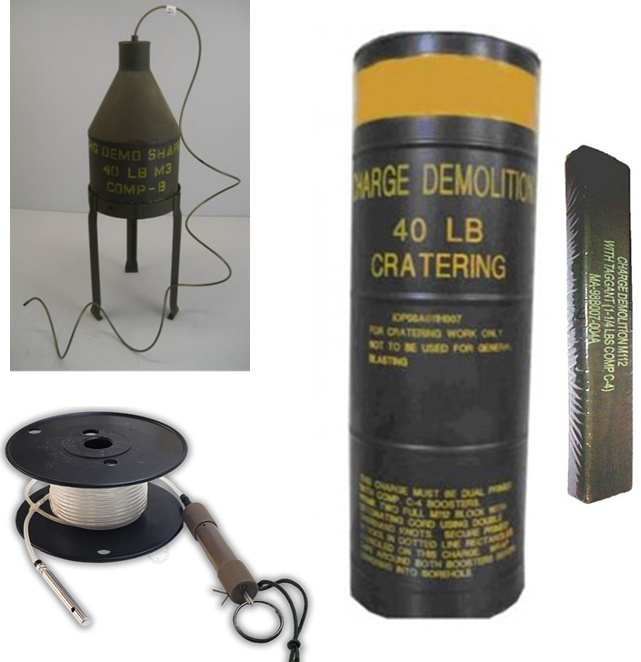
Figure 4 - Image of US RCK

The United States Military uses the shaped charge technique to create a hole for the High Explosive, which is crucial for forming the desired crater. A 40-pound (18.2kg) demolition charge is then inserted into the hole. The charge is initiated by C4 which is cut by hand using a knife and then taped to the outside of the demolition charge, acting as a booster. This charge isn't limited to military applications/operations and is used across various industries. Apart from its primary function of forming craters, it's also effective in demolishing structures due to its significant explosive power and practical design. The user experience with this piece of kit and its configuration is generally regarded as efficient and effective, contributing to its widespread use in various military and industrial applications, including cratering, ditching, and demolition tasks.
The US 40lb cratering kit has a variety of components [Fig.5] with unique specifications. Each component's unique capabilities ensure precise and timely crater formation while meeting operational requirements.

Component | Quantity | Specification | Description
M112 Demolition Block | 1 | C4 | Booster for the main charge.
M3 40lbs shaped charge | 1 | Comp-B | Forms initial hole for High Explosive.
M19 shock tube detonator | 1 | HMX | Transmits powerful signal through shock tube to detonator.
40lbs Demolition charge | 1 | Comp-B | Main charge to form a crater.
Figure 5 - Table of US 40lb Crater Kit components and materials
Shaped Charge x 1 | Demolition block x 1 | Main charge x 1
M3 | M112 | 40lbs Demolitions charge
Composition B | C4 | Composition B
Net Weight 40lbs, RE 1.35 | Net weight 1.25lbs, RE 1.34 | Net Weight 40lbs, RE 1.35
TNT NEQ = 24.49kg | TNT NEQ = 0.759kg | TNT NEQ = 24.49kg
TNT NEQ = 49.739kg
Figure 6 - Properties of US RCK
The production of each component within the US RCK adheres to strict protocols to ensure effectiveness and safety. Shaped charges, crucial for creating initial holes for explosives, are meticulously crafted using Composition B, a blend of RDX and TNT, within controlled environments. Similarly, the manufacturing of demolition blocks, or C4, requires specialised equipment and rigorous safety measures to ensure controlled explosive force. The main charge, also composed of Composition B, undergoes meticulous manufacturing processes to maintain consistency and reliability. Throughout production, adherence to safety protocols is paramount, covering storage, handling, and transportation to mitigate inherent risks.
Collaboration between manufacturers, military personnel, and safety experts is essential in upholding safety standards and ensuring the efficient operation of the CK24 Cratering Kit. By prioritising stringent safety measures and comprehensive training, manufacturers and military personnel collectively strive to uphold the highest standards of safety and effectiveness in the deployment of the CK24 [2].
Pros:
- Suitable for various surfaces,
- Handle for lowering charge safely (ergonomics)
- The Comp B explosive has a relatively low detonating velocity producing a pushing or heaving effect, making it suitable for cratering and ditching operations.
Cons:
- Loss of energy due to the kits being taped to the side of the demolition block. Energy is not being dissipated from a central location.
- Taping explosives to the side of the demolition block isn’t practical or safe and requires multiple personnel.
- The North Atlantic Treaty Organisation (NATO)
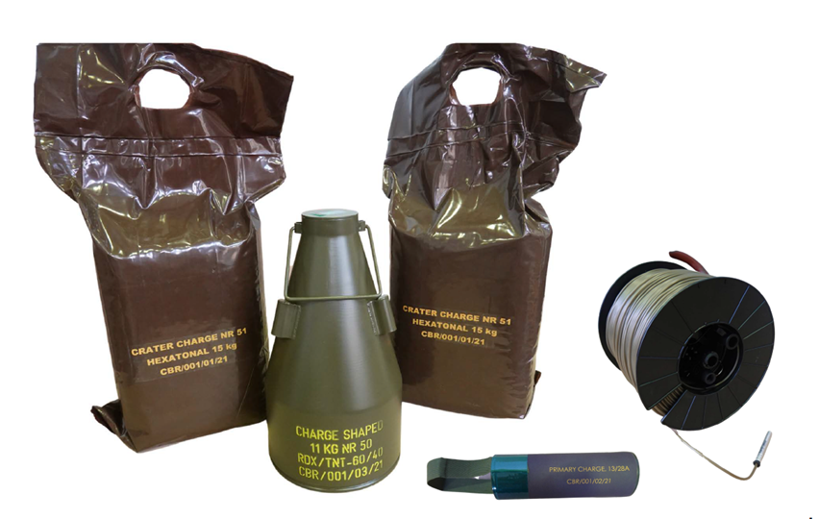
Figure 7 - Image of Rapid Cratering Kit Mark 2
The current RCK Mk2 has updated shaped charges, modern packaging, and an initiation via a shock tube system. The system consists of multiple parts that all work together to deliver its desired effect. Similar to the US, the RCK Mk2 serves the purpose of enabling NATO forces to create craters in diverse terrains for both military and engineering objectives. The kit has engineered safety measures to mitigate risks to personnel and ensure proper handling of explosives. Overall, the RCK Mk2 is effective creates craters as required.
The RCK Mk2 includes specialized tools and equipment designed for efficient cratering tasks, such as explosives, shaping charges, and detonation mechanisms. These components are engineered to be durable, reliable, and easy to transport, deploy, and operate in the field.

Component | Quantity | Specification | Description
15kg Hexatonal charge | 2 | TNT / HMX | Booster for the main charge.
11kg MR 50 Shaped Charge | 1 | RDX (60) / TNT (40) | Creates initial hole for High Explosives.
M19 shock tube detonator | 1 | HMX | Transmits powerful signal through shock tube to detonator.
Primary Charge 28A | 1 | RDX | Main charge to form crater.
Figure 8 - Table of NATO RCK Mk2 components and materials
The production of the Shaped Charge, Primary Charge, and Crater Charge within the CK24 Cratering Kit also adheres to stringent manufacturing standards to ensure both efficiency and safety. The Shaped Charge, designated as NR 51, is carefully manufactured using a blend of RDX and TNT in a ratio of 60% to 40%. Similarly, the Primary Charge, denoted as 13/28A, utilizes PE-8 explosive material, demanding precise handling and controlled conditions to maintain safety. The Crater Charge, designated as NR 50, employs a combination of HMX and TNT in a 60/40 ratio, undergoing meticulous manufacturing processes to achieve consistent performance.

Shaped Charge x 1 | Primary Charge x 1 | Crater Charge x 1
NR 51 | 13/28A | NR 50
RDX/ TNT, 60% / 40% | PE-8 | HMX/ TNT, 60/40
15KG, RE 1.6 / 1 = RE 1.36 | 2kg, RE 1.34 | 15KG 1.7 / 1 = RE 1.42
TNT NEQ = 20.4kg | TNT NEQ = 2.68kg | TNT NEQ = 21.3kg
TNT NEQ = 44.38kg
Figure 9 - Properties of NATO RCK
Collaboration among manufacturers, military personnel, and safety experts is crucial in upholding safety standards and ensuring the effective operation of the CK24 Cratering Kit's explosive charges. By prioritizing rigorous safety measures and comprehensive training, manufacturers and military personnel collectively strive to uphold the highest standards of safety and efficacy in the deployment of these explosive charges.
Pros:
- Current in-use system and complies with relevant regulations.
- NATO and armed forces are familiar with the kit's useability.
Cons:
- Metal Liner will leave debris in bunker after explosion, could have adverse effects on bunker capability ie sharp shards Injuring personnel.
- Explosives are poured, leading to human error.
- Weight distribution of pour could be off.
- Shaped charge is a bit excessive for the initial crater.

Systems Engineering Approach
  - Requirement Set
The Requirement Set [Fig.10] is a system engineering tool that outlines what the RCK needs to achieve and how it should perform. It guides the design process and ensures the team is on the same page about project goals. Requirement sets also provide criteria for testing the system to ensure it meets its intended purpose. Overall, the Requirement Set is a foundation that is used to build more systematic methods.

Figure 10 - Requirement Set Table

Quality Function Deployment (QFD)
Quality Function Deployment (QFD) [Fig.11] is a robust tool used to transform vague and imprecise Customer Requirements into measurable Technical Requirements. Through a series of matrix charts, QFD offers a structured systematic methodology used to capture and arrange the requirements.
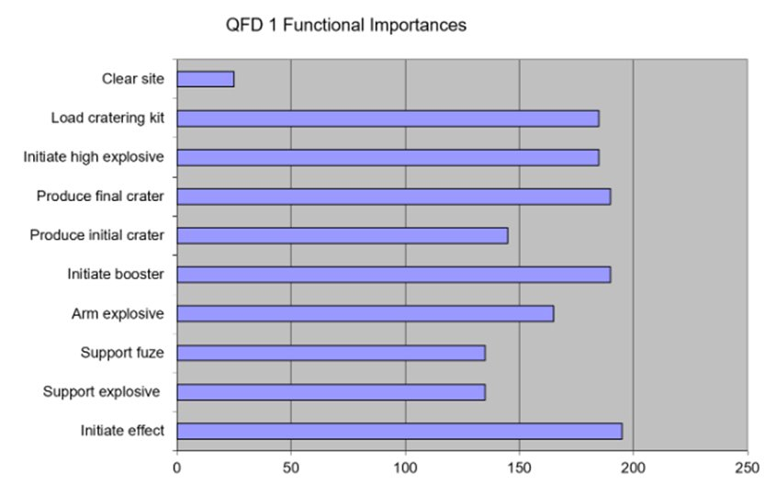
Figure 11 - QFD 1 Functional Importance Chart
QFD enabled the team to translate customer needs and preferences into specific design requirements and held significant importance in the design process. By systematically capturing and prioritizing customer requirements, the design engineer can ensure that the RCK will meet or exceed the customer's expectations. This also helped to identify potential risks and challenges early in the design process. The QFD involved collaboration from various parts of the team ensuring that all aspects are considered and integrated into the final design. This was done by encouraging feedback from all parts of the team which helped to refine and enhance the design.
Overall, the QFD process helped the team to identify what functions had the most functional importance. The QFD 1 chart [Fig.11] shows that initiating the effect of the RCK was the most prominent and therefore will be considered highly in the design process along with the functions that followed (i.e. “Initate booster” and “Produce final crater”). This gave an idea of what type of product needs to be designed to be robust and align with customer needs and preferences.

Functional Means Analysis (FMA)
A FMA serves as a critical tool for design engineers to allow them to understand the intricate workings of the system they are designing/improving. It involves systematical methodology by breaking down the system into its functional components and exploring how each function is achieved through various means [3].
Overall, the FMA provided insights into the kit's behaviour and pinpointed opportunities for improvement, showing the team where to innovate and refine the design. Furthermore, the analysis required enhanced communication and collaboration among the team. By combining functional means analysis with functional metrics, the team was able to gain insights into which functions are most critical to system performance and how well they are being executed.

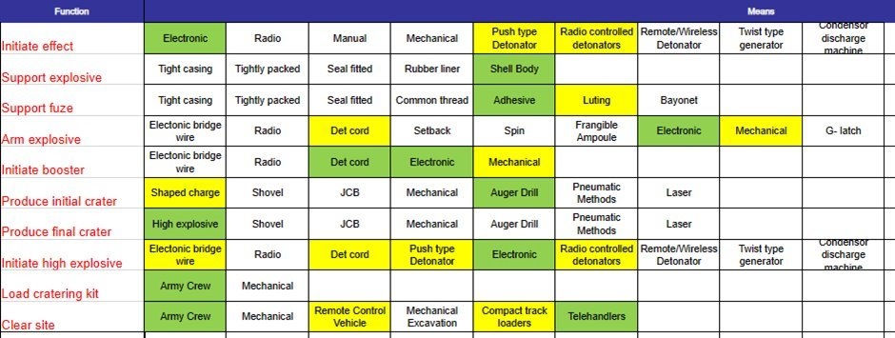
Figure 12 - Functional Means Analysis on Rapid Cratering Kit
The results of the FMA gave a comprehensive understanding of the RCK. Through functional decomposition, the analysis broke down the kit into its essential functions, highlighting the core objectives it must achieve and how it will achieve them using different ranges of components, processes and technologies.

Feature Importance
Feature importance analysis provides valuable insights into which aspects of the system are most critical for its success. This analysis ensures that the team is aligned on project priorities, allowing for efficient resource allocation towards areas with the greatest impact on achieving objectives. By understanding the importance of different features to customers or end-users, the team can focus efforts on meeting user needs and delivering a product that aligns with expectations.
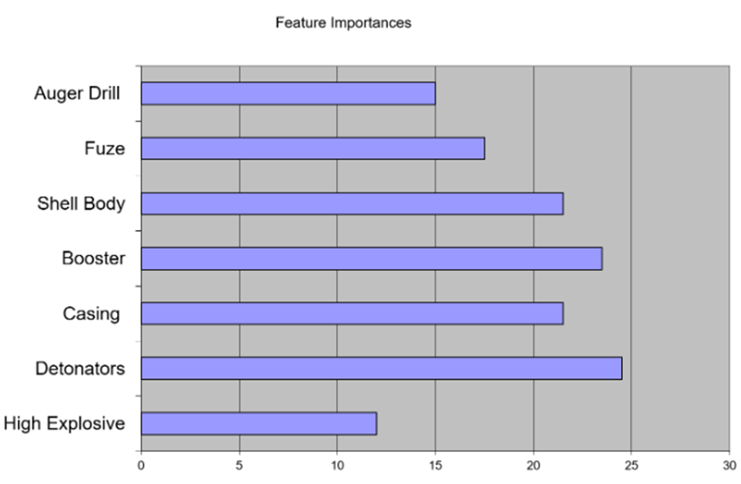
Figure 13 - Features Importance
The Feature Importance framework [Fig.12] systematically evaluated the importance of each feature to the RCK’s performance and user satisfaction. It enabled the team to focus on developing and refining the most critical features first. This prioritization ensures that design resources are allocated efficiently, directing attention to areas that will have the greatest impact on system success [4].

  - Noise & Control Factors
Noise and/or control factors are determined through a systematic approach called Prime “What Why” which is a problem-solving tool. In this process, various factors are identified and play significant roles in determining the performance of the system.

Figure 14 - Prime “What Why” Control Factors Results
These factors [Fig.14] encompass a range of parameters, from dimensional variations to environmental fluctuations and stress parameters. Each factor holds relative importance, measured by its impact on meeting performance criteria through control measures. For instance, dimensions, explosive variations, environmental factors, temperature fluctuations, stress parameters, and blast penetration all contribute differently to the overall performance. By understanding and managing these noise factors, the team was able to navigate through the complexities of the design for the CK24, ensuring optimal outcomes [5].

- Visual Design Elements

Colour
The Cratering Kit 24 (CK24) will be finished in a deep bronze green paint. This colour corresponds with the British Army's adoption of green as its primary colour. The colour is deeply rooted in the army historical tradition, dating back to the late 19th and early 20th centuries when khaki uniforms were introduced for troops serving in colonial campaigns, providing effective camouflage in diverse landscapes such as the Indian subcontinent and African savannahs; this choice continues to serve practical purposes today, offering soldiers effective concealment in natural environments while also embodying cultural associations of resilience and adaptability [6].
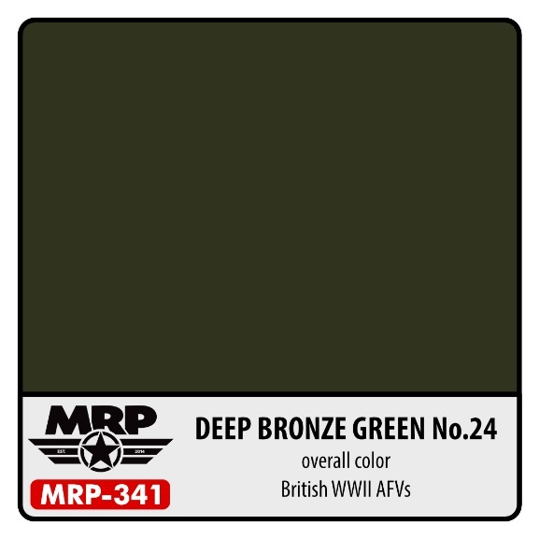
Figure 15 - Image of Deep Bronze Green used in CK24
- Font
While specific details regarding the exact font used may not be publicly available due to security or operational considerations, the British Army often employ clear and easily legible sans-serif fonts on such systems as the RCK Mk2. The same font will be adopted for the CK24 as these fonts are chosen for their readability at various sizes and distances, ensuring that important information can be quickly and accurately understood in diverse operational environments.

- Branding
When looking closely at the RCK Mk2, it can be noticed the little to no branding on the kit. The absence of branding on military equipment serves multiple crucial functions. Primarily, it enhances operational security by preventing adversaries from easily identifying the equipment's origin or manufacturer, thus safeguarding sensitive information. Furthermore, the lack of branding fosters interoperability, as standardized equipment across various units and branches facilitates seamless integration and coordination during joint operations. Additionally, the absence of branding reduces the likelihood of equipment being targeted by adversaries, as logos or branding can inadvertently draw attention on the battlefield. Lastly, prioritizing functionality over branding ensures that equipment like the CK24 is optimized for its intended purpose without unnecessary distractions, ultimately bolstering mission success and soldier safety [7].
- Font Colour
All parts of the CK24 will be marked in yellow, providing practical benefits for visibility, identification, safety, and military compliance. When used against its green background, the addition of yellow elements aids visibility and identification, especially in environments like forests or jungles where green dominates. This contrast helps soldiers easily locate and distinguish their equipment, even in densely vegetated areas. Yellow's association with caution and visibility makes it valuable for enhancing recognition, particularly in low-light conditions or fast-moving situations. Additionally, yellow is commonly used in safety signage and signaling devices due to its high visibility. Incorporating yellow elements ensures compliance with military regulations, contributing to operational effectiveness and soldier safety across diverse environments and conditions.
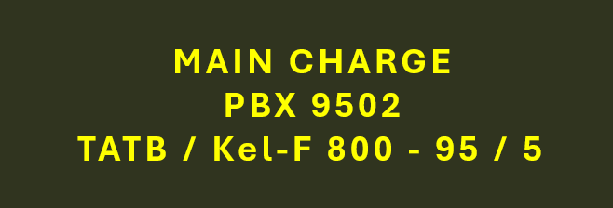
Figure 16 - Yellow Text on Deep Bronze Green background

- Concept Stage
The concept stage is an important part of the design process as it lays the foundation for the entire product development. This stage is cost-effective because concepts can be easily modified but is also crucial to ensure accuracy as errors here can lead to costly mistakes in later stages. AESI has embraced the systems engineering approach to mitigate such risks and adopted the “big thinking” methodology to ensure a sound foundation for the designs.
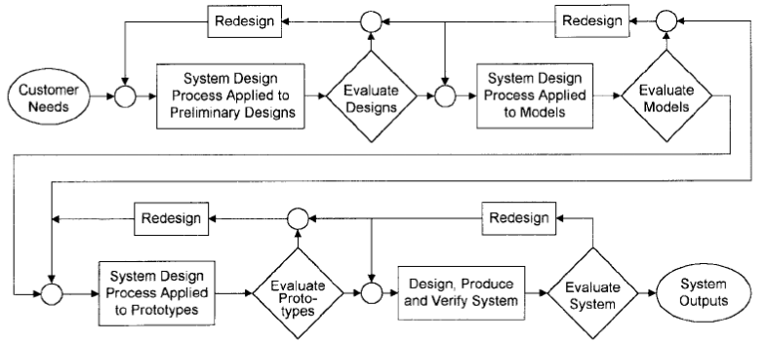
Figure 17 - Design portion of the Systems Engineering Process [8] [9]
Figure 5 represents the concept stage well by using loops to show how parts are often revisited several times before delving into the technical details. The upper left section of the diagram specifically represents the concept stage of the design and shows the ability to revisit parts. This stage is cost-effective and doesn't require too much change whereas the bottom right section, representing the prototype and final product stage requires big changes as it is deep into the design process [9]. Overall, this stage was a highly creative phase in the design of the CK24, characterised by brainstorming sessions utilising whiteboards, paper, and computer tools to generate and refine concepts [10].
Using the results from the Systems Engineering tools and research, AESI has decided to rethink the traditional methods used in RCK for the new and improved CK24. This is to enhance efficiency and safety. The team has introduced auger shovels as primary digging tools, offering precise control over excavation. This will replace the shaped charge but will still form an effective crater.
In parallel, the team streamlined the placement of explosive charges by pre-making them instead of relying on bags, minimising deployment risks. With pre-made charges in hand, operators will seamlessly insert them into pre-dug holes.

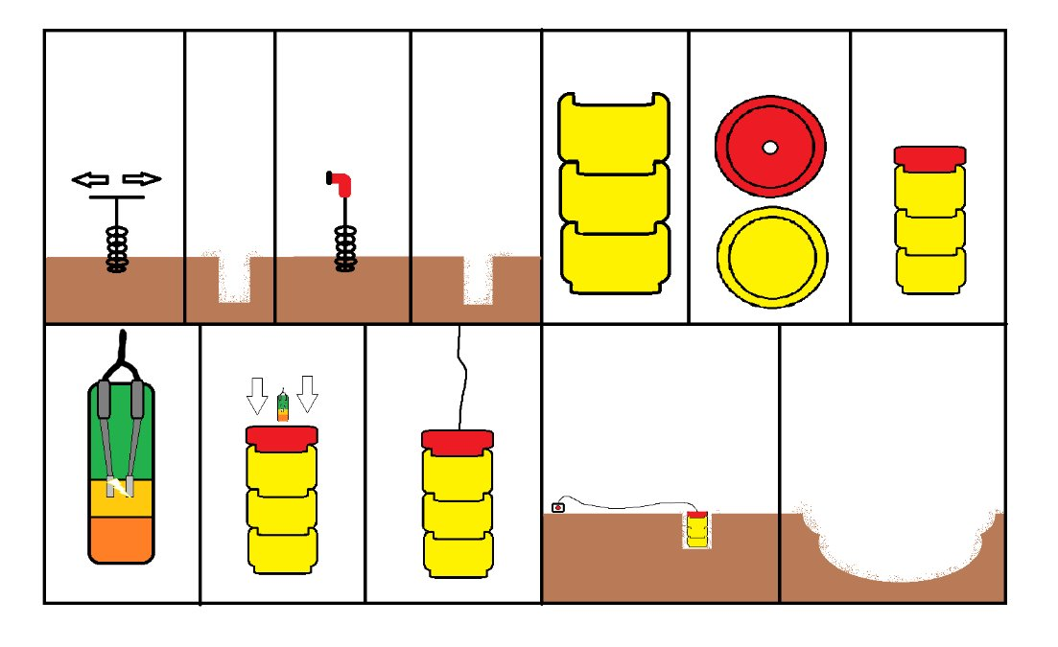
Figure 18 - Schematic of how the CK24 will work
The CK24 step-by-step schematic [Fig.18] shows how the kit will be used and shows the simplicity and efficiency of the design. The shaped charge is an unnecessarily expensive piece of kit. By using an auger drill, the price of CK24 will be cheaper than its pre-assessor.

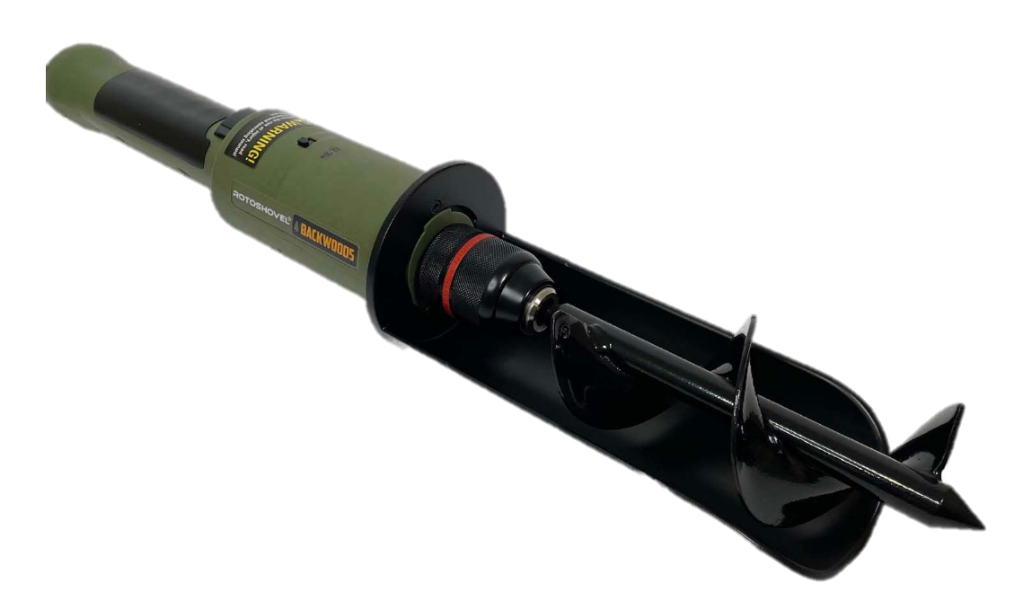
Figure 19 - Auger Drill (Rotoshovel)
- Concept Drawings
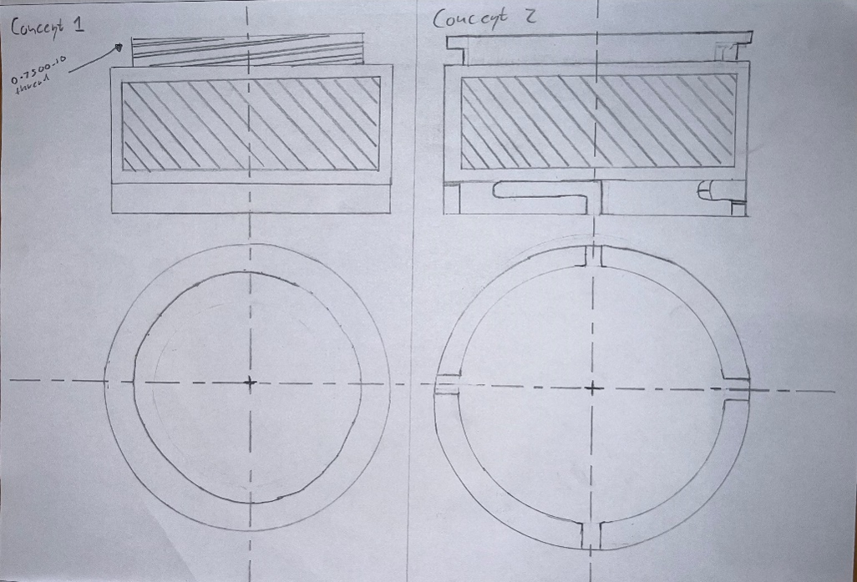
Figure 20 - Concept drawings of the main charge and the top initiating charge
  Figure 21 - Drawing of Casing | 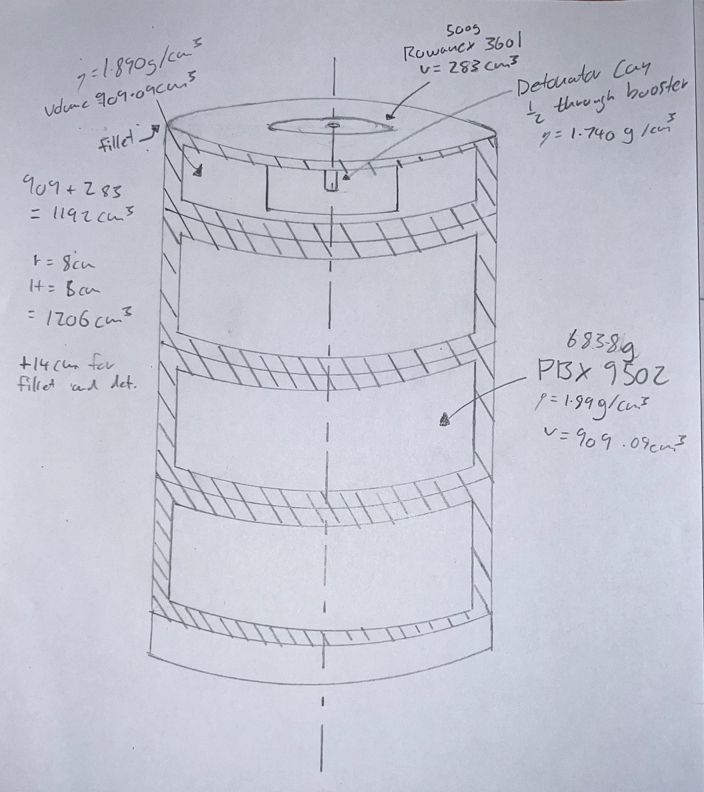  Figure 22 - Drawing of CK24 Casing Assembled

The design team worked closely with the Research team and Manufacturing to come up with a product that met the customer's requirements identified in QFD 1. The noise factors result [Fig.14] for the CK24 indicated that attention needed to be on explosive variation.
Designing a product is never a simple task, especially with so many inputs coming from different parts of the team. Even when following this process, there were still issues that emerged in later stages. Ultimately, the team aimed to design the best product possible, and if that meant changing the design to meet a better specification, then that is what had to be done. The Research & Design Engineer suggested using a different type of explosive, which led to remodelling the main charge and the detonator. This stage represents a highly creative phase in the design of the new cratering kit, characterized by brainstorming sessions utilising whiteboards, paper, and computer tools to generate and refine concepts [10].

Computer-Aided Design (CAD) Modeling / Prototypes
As companies increasingly shift from physical modelling to virtual environments, Computer-Aided Design (CAD) becomes a fundamental tool in the engineering design process. This transition challenges engineers to adapt their critical thinking skills and embrace new techniques for product design. Engaging with computers instead of physical models has many benefits and requires engineers to explore innovative ways during the concept stage. The integration of CAD reflects the evolving landscape of systems engineering, where virtual tools play a central role in streamlining design processes and enhancing efficiency [11].
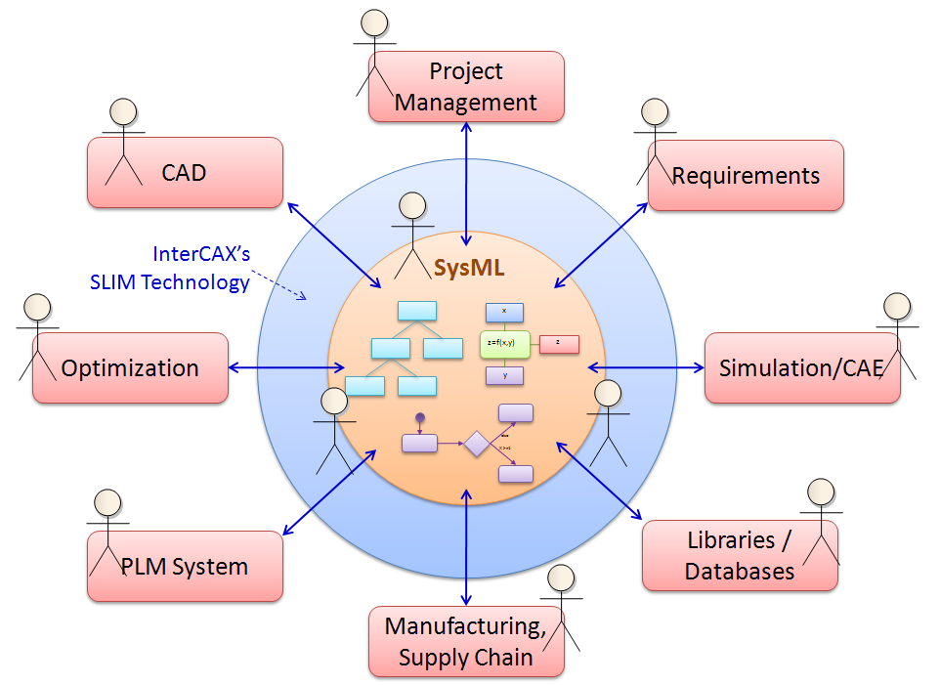
Figure 23 - CAD in Systems Engineering: Sourced from InterCax

- 3D Printing
Utilising 3D printing for functional prototyping not only advances product development but also enables the creation of multiple physical versions before committing to production, allowing companies like AESI to reduce costly errors and refine designs. These prototypes, made with materials resembling the final product, facilitate thorough testing during development, empowering companies to identify and rectify errors before investing in expensive injection moulding tools [12].
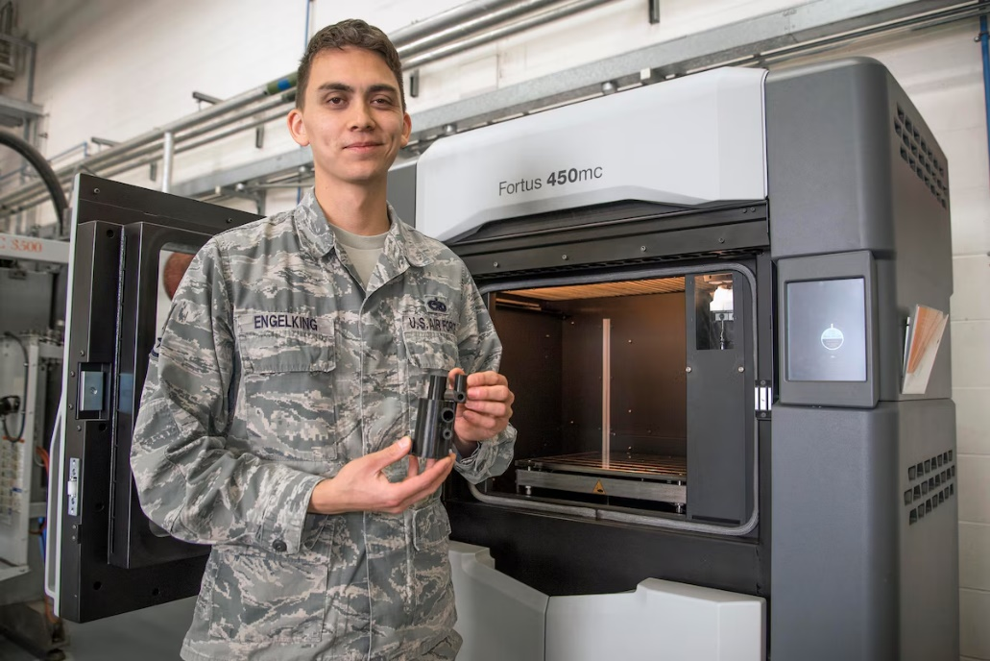
Figure 24 - US Air Force 3D Printer: Sourced US Air Force
Industrial 3D printing, or additive manufacturing, revolutionises manufacturing by creating solid 3D objects from digital files. With materials such as thermoplastics, elastomers, and metals, 3D printing operates through additive processes, building objects layer by layer, and offers diverse opportunities in product design [13] [14].
The versatility of 3D printing ranges from prototyping simple toys to manufacturing complex parts for defence equipment, cars, Formula 1 and aeroplanes. Its efficiency in reducing development times and costs has led to ongoing research in niche materials and applications. 3D printing has impacted the design process for AESI and also the defence industry, with the likes of the US Airforce Lifecycle Management Center regularly using 3D printing to manufacture obsolete parts for several legacy fighter jets including fleets of B-52s, the massive C-5M Super Galaxy, and the B-2 Stealth Bomber [15].

- Charge A V1

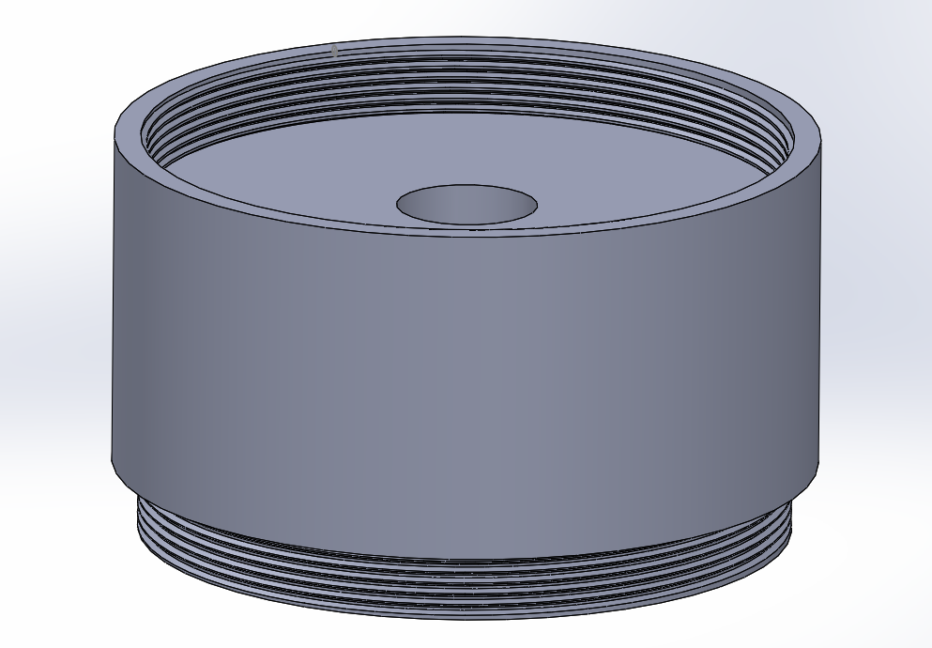
Figure 25 - 1st Concept for Charge A on CAD
This was the first concept that the team thought of. It used a thread to attach all the parts. The original plan was to use metal for the casing so this idea was quickly changed. This is because the metal thread could cause friction therefore being a safety hazard and not helping with the CK24 being IM compliant.
This concept was the team's initial choice due to its simplicity and ease of assembly. The use of a threaded mechanism to attach all the components seemed straightforward and intuitive. Upon further consideration, the team recognised potential problems associated with this approach.
The original plan was to use metal for the casing, but this idea was quickly reconsidered. Threading is a controversial method in the OME world as it comes with more problems than it is worth. Threads are subject due explosive material contamination getting into the small crevices and could initiate an explosion raising issues with IM compliance [16]. As a result, the team opted to explore alternative materials and decided on ABS Plastic.

- Charge A V2
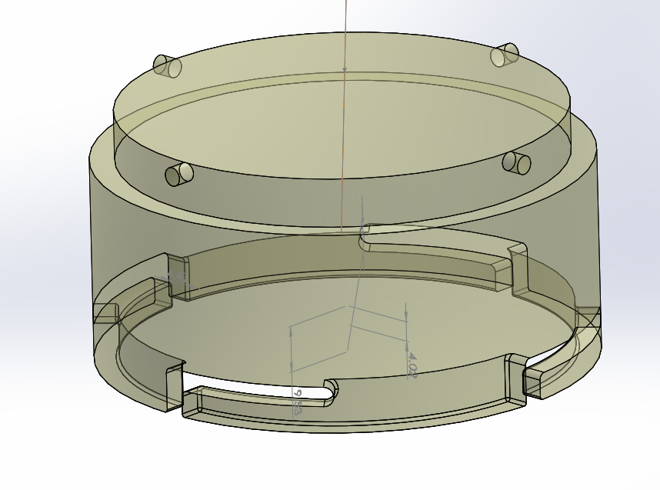
Figure 26 - 2nd Concept for Charge A on CAD
The team chose a twist locking mechanism over threading to connect the parts, prioritizing simplicity and safety in the design. This decision made the assembly process more user-friendly as it was easier for operators to understand and implement. The adoption of a locking mechanism minimised potential safety hazards associated with threaded connections, ensuring a safer working environment for personnel. By opting for a locking mechanism, the team showed how important risk management is and the adherence to safety standards.

- Locking Mechanism
The twisting concept proposed by the team presented a significant drawback as once twisted, there was no method to firmly secure the part in place. The transition from threaded to twist lock was aimed at maintaining security while enhancing safety. To ensure the effectiveness of this system, a locking mechanism has to be introduced.
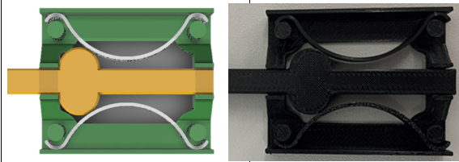
Figure 27 - CAD & 3D Printed Model of the Locking Mechanism
Introducing a linear locking mechanism provides a straightforward and reliable solution for securing components in place, accompanied by the satisfying click sound upon engagement. A linear locking mechanism is a mechanism that uses linear motion to secure or release components. Linear locking mechanisms are often preferred for their simplicity and reliability. They are relatively easy to understand and operate, making them suitable for the CK24. Additionally, linear locking mechanisms can provide strong and secure fastening, offering peace of mind in terms of safety and security [17].
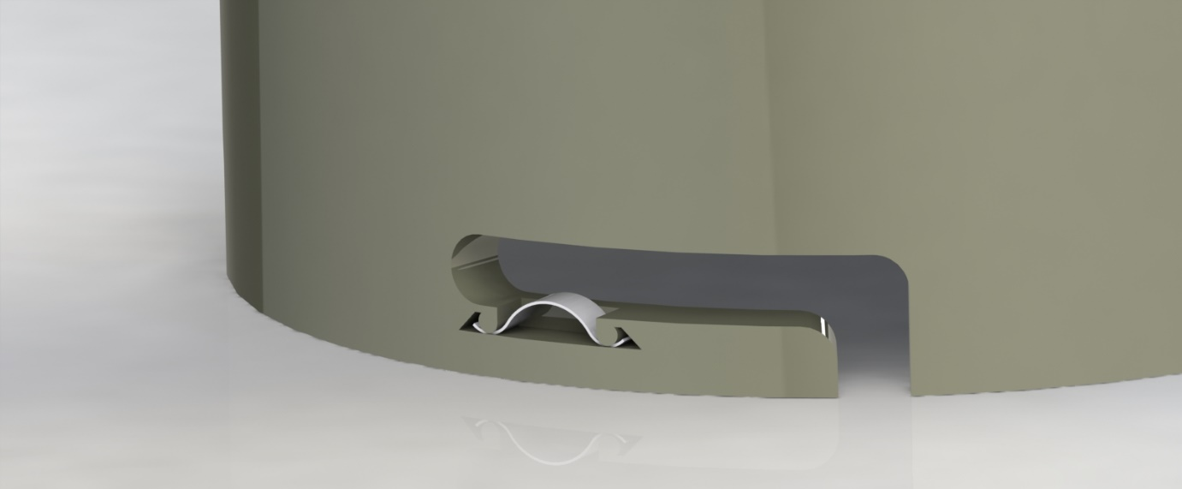
Figure 28 - Render of locking mechanism

- Charge A V3
At this stage, the research team provided the design team with the correct explosive compound, allowing for precise volumes to be calculated. This crucial collaboration ensured the accuracy and effectiveness of the munition system design, highlighting the importance of teamwork and communication in complex projects.
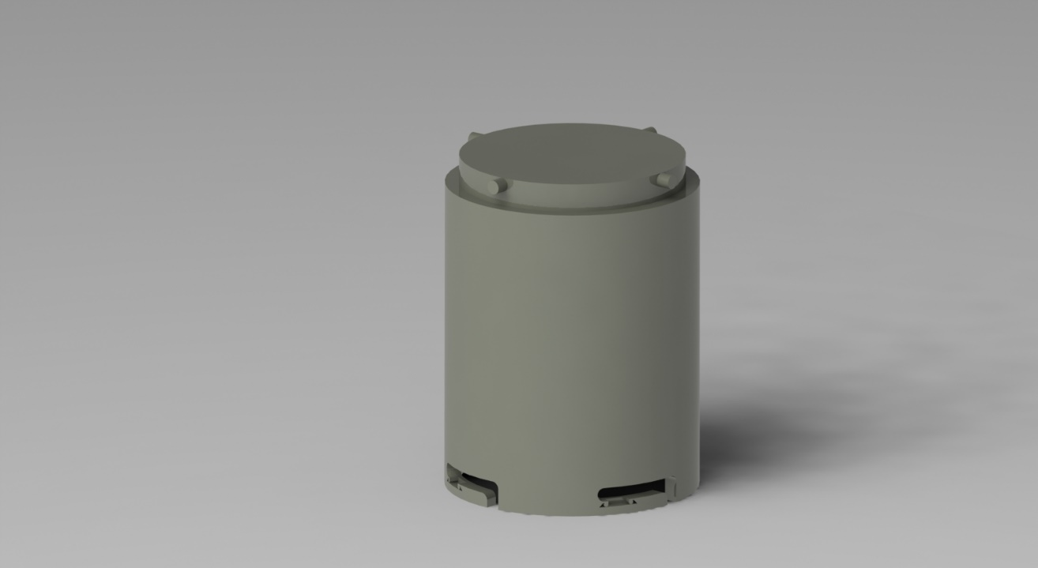
Figure 29 - Render of Charge A V3
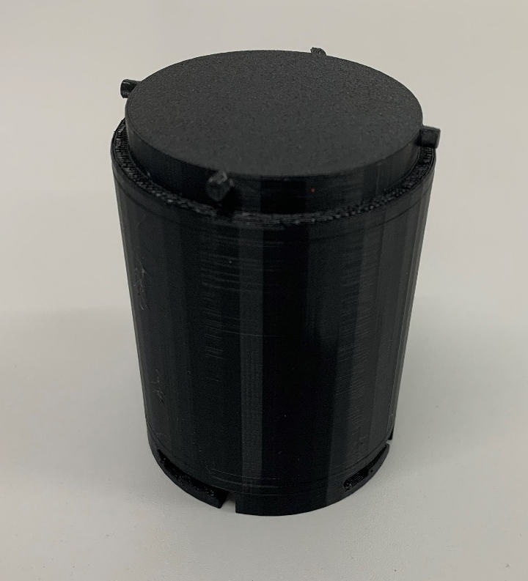
Figure 30 - 3D Printed Charge A V3

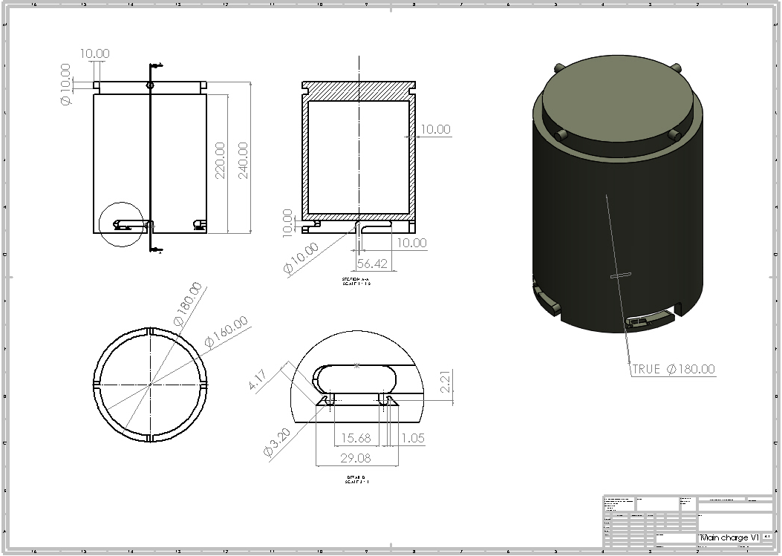
Figure 31 - Engineering Drawings for Charge A

- Dimensions
With the precise properties and weights [Fig.32] provided by the Research and Development team, the design team can accurately calculate the required volumes to design to-scale cases (1cm wall thickness) for the CK24. Using the formula for volume 𝑉=𝑚𝜌, where 𝑚 represents mass and 𝜌 denotes density, the team determined a volume of approximately 3617.989cm^3 for the explosives used in Charge A. Additionally, employing the formula for the volume of a cylinder 𝑉=𝜋𝑟2ℎ, where 𝑟 signifies the radius and ℎ represents the height, the team obtained a volume of 3619.115cm^3 for the case. These calculations show that the dimensions for the CK24 case are compatible with the explosive charges.

Booster x 1 | Starter Charge x 1 | Main charge x 3
Rowanex 3601 | PBX 9502 | PBX 9502
​ TATB + RDX + Viton Binder | TATB + Kel-F 800 Binder | ​ TATB + Kel-F 800 Binder
60% / 35% / 5% | 95% / 5% | 95% / 5%
Net weight 0.5gk, RE 1.41 | Net weight 1.7kg, RE of 1.17 | Net weight 6.838kg, RE of 1.17​
TNT NEQ = 0.705kg​ | TNT NEQ = 2kg​ | TNT NEQ = 8kg
TNT NEQ = 26.705kg
Figure 32 - Properties of CK24 Explosives

$$V=\frac{m}{p}$$
$$V=\frac{6838g}{1.89g/{cm}^{3}}$$
$V=$ 3617.989${cm}^{3}$

$$V= πr^{2}h$$
$$V= πx8^{2}x18$$
$$V= 1152 π$$
$$V= 3619.115{cm}^{3}$$

This same process was carried out for all parts of CK24 and dimensions can be seen in the engineering drawings.
- Charge B V1
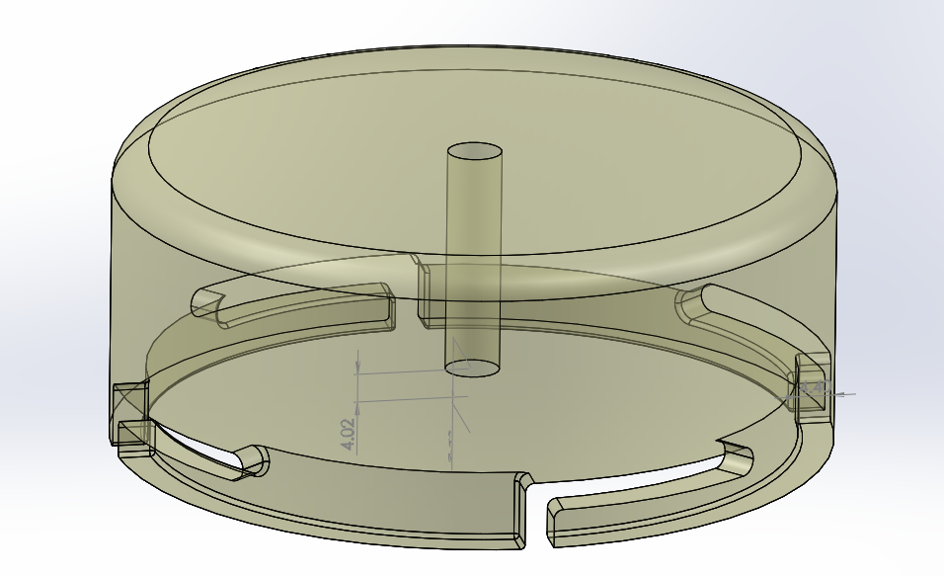
Figure 33 - 1st Concept for Charge B on CAD

Charge B [Fig.33], similar to Charge A, also utilises a twist-locking mechanism. However, it features distinct characteristics, notably a filleted finish along the edges and specific dimensions. This design variation is attributed to the reduced quantity of TATB explosives within this component. Additionally, Charge B necessitates the incorporation of a hole to accommodate a booster and a slot for a detonator insertion. Precision in positioning the detonator is paramount to achieving optimal performance and efficacy in functionality.

- Charge B V2
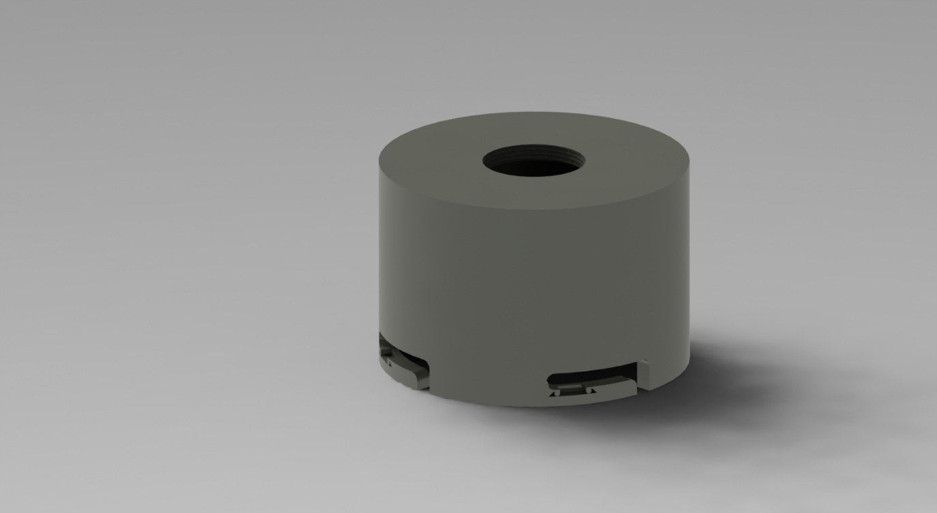
Figure 34 - Render of 2nd Concept for Charge B
The addition of a hole around charge B [Fig.34] facilitates the insertion of the booster and detonator, ensuring precise alignment. This feature, combined with the introduction of a locking mechanism from Charge A, enhances safety and reliability by securely holding the detonator and booster charge in place.
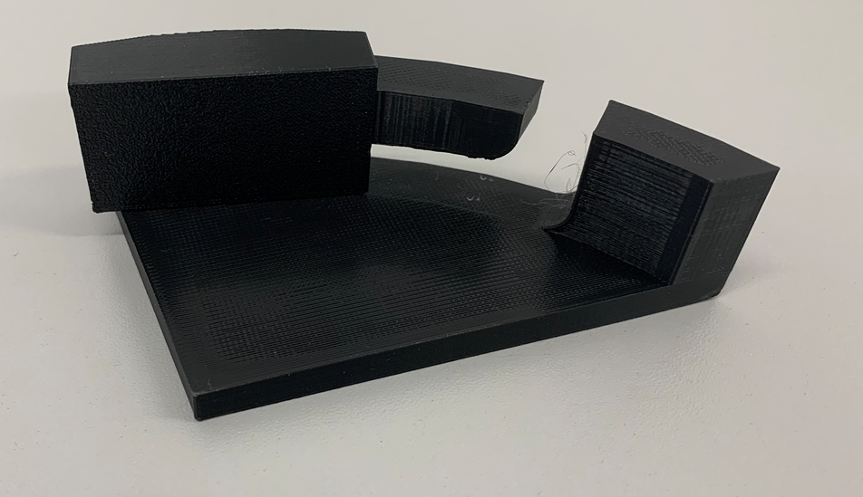
Figure 35 - 3D Printed 1:1 Scale Model of interlock
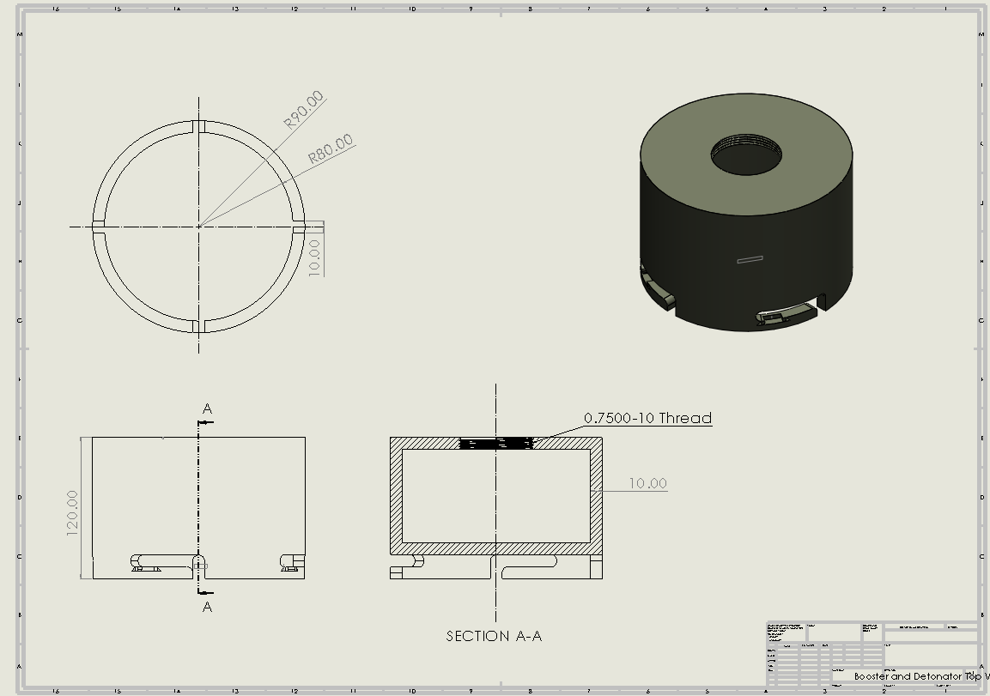
Figure 36 - Engineering Drawings for Charge B

- Charge B Lid
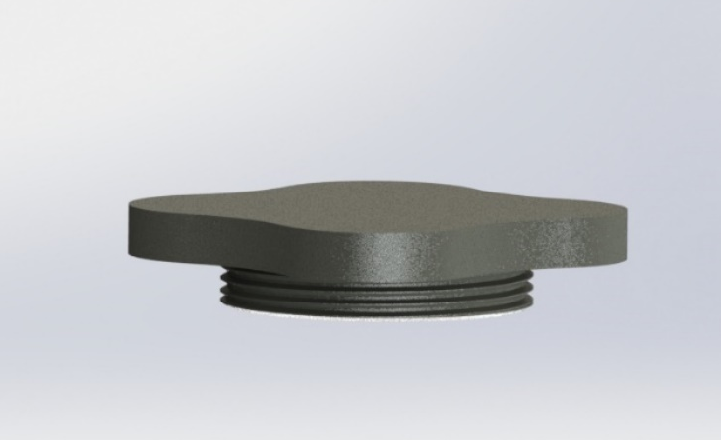
Figure 37 - Render of Lid for Charge B
The threaded lid [Fig.37] serves as a crucial component for charge A to allow for the installation of both the booster and detonator. Its threaded design ensures a secure seal, preventing any explosive materials from being exposed while also providing easy access for the insertion of the booster and detonator components.

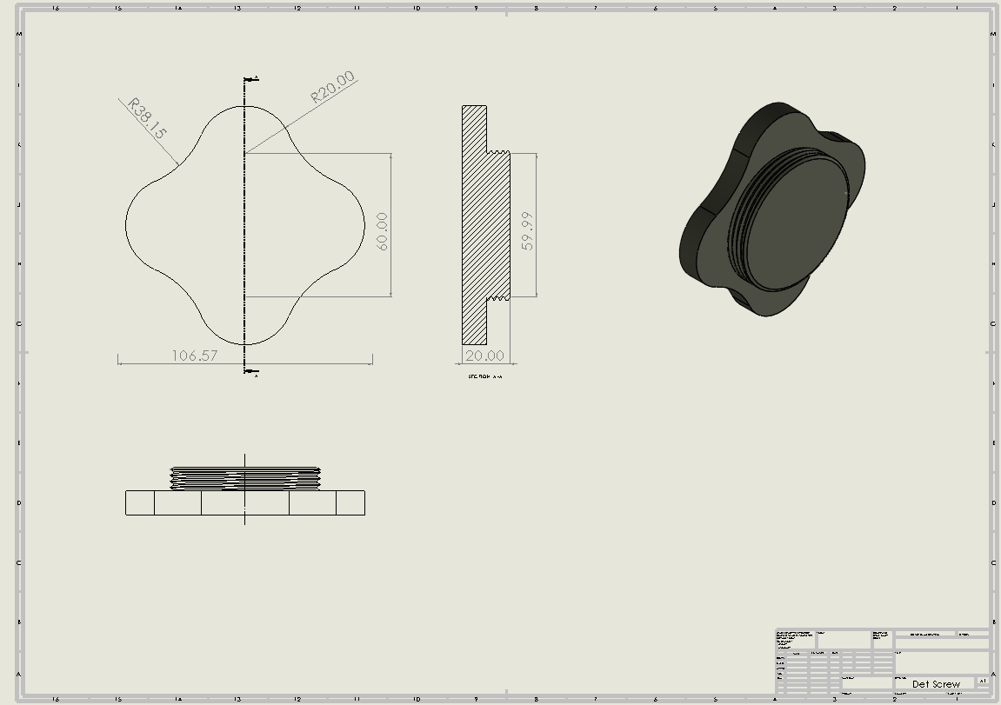
Figure 38 - Engineering Drawer of Lid for Charge B

- CK24 Assembly
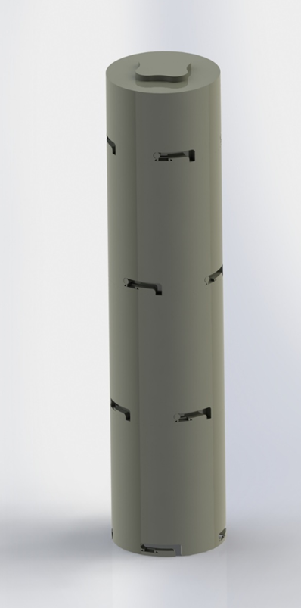
Figure 39 - Render of CK24 Fully Assembled
Figure 33 presents a rendered image showcasing the fully assembled CK24 system, providing a comprehensive visual overview of its intricate assembly. This rendering offers a detailed representation of how the various components of the CK24 are integrated and assembled. The spatial relationships between different parts can be seen, gaining insights into how each component fits together to form a fully functional unit. Beyond its illustrative value, this image serves as a valuable communication tool for other members of the team and most importantly the project stakeholders.

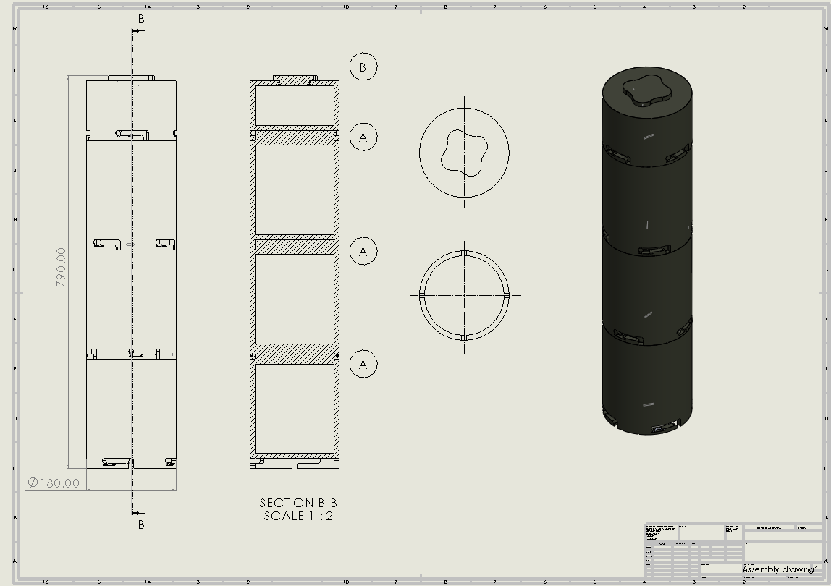
Figure 40 - Engineering Drawer of CK24 Fully Assembled

- Simulation
Simulation technologies offer loads of benefits across many industries, providing cost-effective testing, risk mitigation, and accelerated design iterations. By simulating various scenarios, organisations can easily address safety concerns, optimise designs, and make data-driven decisions. Simulations also contribute to environmental sustainability by identifying opportunities for energy efficiency and waste reduction. Overall, simulations are valuable tools used to improve product design, optimise performance, and drive innovation across different applications and sectors.
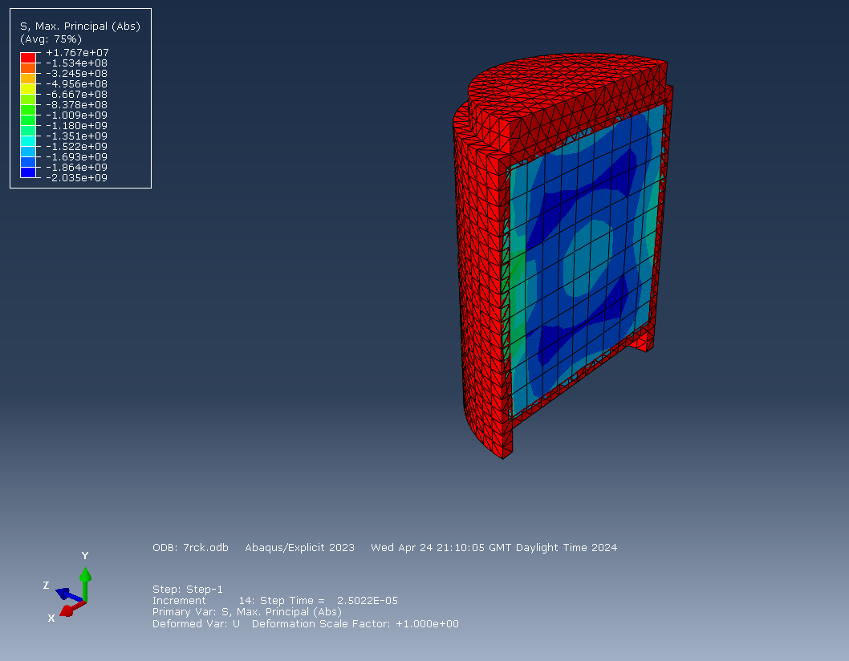
Figure 41 - Screenshot of simulation of Charge A Casing on Abaqus
The CK24 casing simulation [Fig.41] demonstrates that the energy is equally distributed throughout the casing, as indicated by the Max Principle. This finding suggests that the casing effectively absorbs and disperses the explosive energy, minimising localised stress concentrations and potential weak points. By achieving equal energy distribution, the casing exhibits robust structural integrity, enhancing its ability to withstand external forces and environmental conditions but also allowing the explosive energy to be released.

Discussion
This portfolio details the evolution of the CK24 Cratering Kit and provides valuable insights into the innovative redesign process undertaken by AESI. Through a systematic approach guided by Systems Engineering tools and extensive research, AESI has successfully reimagined traditional methodologies to enhance both efficiency and safety in cratering operations.
One of the key highlights of the report is AESI's decision to replace the traditional shaped charge with auger shovels as primary digging tools. This strategic shift not only offers precise control over excavation but also presents a cost-effective alternative to the expensive shaped charges. By leveraging auger drills, AESI aims to streamline the excavation process while maintaining the effectiveness of crater formation, thus demonstrating a commitment to operational excellence.
Furthermore, the portfolio discusses the placement of explosive charges by pre-making them, eliminating the need for bags and reducing deployment risks. This innovative approach not only enhances operational efficiency but also underscores AESI's dedication to safety standards and risk management in manufacturing/engineering.
The portfolio showcases the intricate 3D models of the CK24, reflecting the significant time and effort invested in its visual representation. Each detail, from the dimensions of the components to the assembly process, is rendered to provide a comprehensive understanding of the kit's design and functionality. The highly detailed models exemplify the dedication of the design team to accurately represent every aspect of the CK24, ensuring clarity and precision in visualising the final product. Through extensive collaboration and iterative refinement, the portfolio presents a visually stunning depiction of the CK24, demonstrating the commitment to excellence in design and engineering.
The step-by-step schematic provided in Figure 18 offers a visual representation of the CK24's redesigned process, showcasing its simplicity and efficiency. By integrating auger drills and pre-made explosive charges, the CK24 promises to revolutionize cratering operations, offering a cost-effective solution without compromising on effectiveness.
Moreover, the report portfolio underscores the importance of collaboration and interdisciplinary teamwork in achieving project success. AESI's utilization of Systems Engineering tools and collaboration between research and design teams highlights the value of a holistic approach to engineering design, ensuring that the CK24 meets the diverse needs and requirements of its end-users.
In conclusion, the portfolio provides a comprehensive overview of the CK24's evolution, from concept to final design and has all of the necessary information for the manufacturing team to progress to the next stage of the CADMID cycle. Through innovative design choices, decision-making, and collaboration, AESI has successfully developed a cutting-edge cratering kit that promises to set new standards in military engineering.

References

[1] | K. D. Kelley, “AN ERGONOMIC EVALUATION AND ANALYSIS FOR IDENTIFYING CUMULATIVE TRAUMA EXPOSURES IN THE OFFICE WORKPLACE,” University of Wisconsin-Stout, Wisconsin , 1999.
[2] | T. B. a. L. M. R.J. Swinton, “A Critical Diameter Study of the Australian Manufactured Underwater Explosive Composition H6,” DSTO Aeronautical and Maritime Research Laboratory, Melbourne, 1996.
[3] | D. S. Burge, “A Functional Approach to Quality Function Deployment (Putting the Function back into Quality Function Deployment),” BHW & Systems Engineering Company, 2007.
[4] | P. H. a. P.-Y. S. Andreas Classen?, “What’s in a Feature:A Requirements Engineering Perspective,” PReCISE Research Centre, Faculty of Computer Science, University of Namur, Budapest, 2008.
[5] | S. Burge, “ROBUST DESIGN,” Burge Hughes Walsh Partnership, 2016.
[6] | C. Elliott, “British Army Green Paints,” Clive Elliott , UK, 2017.
[7] | R. B. J. L. J. David W. Marshall, “AN EXPLORATORY STUDY INTO THE ROLE OF BRANDING ON MILITARY CLOTHING ACCEPTABILITY,” University of Edinburgh, Edinburgh, 2000.
[8] | IEEE, “IEEE TRANSACTIONS ON SYSTEMS, MAN, AND CYBERNETICS—PART C: APPLICATIONS AND REVIEWS, VOL. 28, NO. 4,” IEEE, 1998.
[9] | A. T. B. &. B. Gissing, “Re-evaluating Systems Engineering Concepts Using Systems Thinking,” 1998.
[10] | M. T. Greene, “Systems Design Thinking: Identification and Measurement of Attitudes for Systems,” University of Michigan, Michigan, 2019.
[11] | P. Starosta, “CAD Usage in Modern Engineering and Effects on the Design Process,” University of Virginia, Virginia, 2021.
[12] | I. C. I. W. A. R. P. M. I. U. H. P. Anketa Jandyal, “3D printing – A review of processes, materials and applications in industry,” School of Mechanical Engineering, Shri Mata Vaishno Devi University, Katra, Jammu and Kashmir, Dudura, India, 2022.
[13] | “3D Printing saves RAF Mildenhall time and money,” August 2018. [Online]. Available: https://www.mildenhall.af.mil/News/Article-Display/Article/1616338/3d-printing-saves-raf-mildenhall-time-and-money/. [Accessed April 2024].
[14] | Ogle Models & Prototypes Ltd, “Your Guide to Industrial 3D Printing,” 2022. [Online]. Available: https://www.oglemodels.com/wp-content/uploads/2022/11/Industrial-3D-Print-Guide_Iss1.0.pdf. [Accessed 2024].
[15] | T. S. J. J. Matthew J. Louis, “3D opportunity in the Department of Defense,” 2014. [Online]. Available: https://www2.deloitte.com/content/dam/insights/us/articles/additive-manufacturing-defense-3d-printing/DUP_1064-3D-Opportunity-DoD_MASTER1.pdf. [Accessed 2024].
[16] | U.S. Department of Energy, “Explosives Safety,” U.S. Department of Energy, Washington D.C, 2019.
[17] | Bayer MaterialScience LLC, “Snap-Fit Joints for Plastics,” [Online]. Available: https://fab.cba.mit.edu/classes/S62.12/people/vernelle.noel/Plastic_Snap_fit_design.pdf. [Accessed 2024].
[18] | M. a. B. T, “Some Properties of Australian-made Explosive Composition H-6,” MRL-TN-525, 1987.

- Appendix

QFD 1
QFD 2
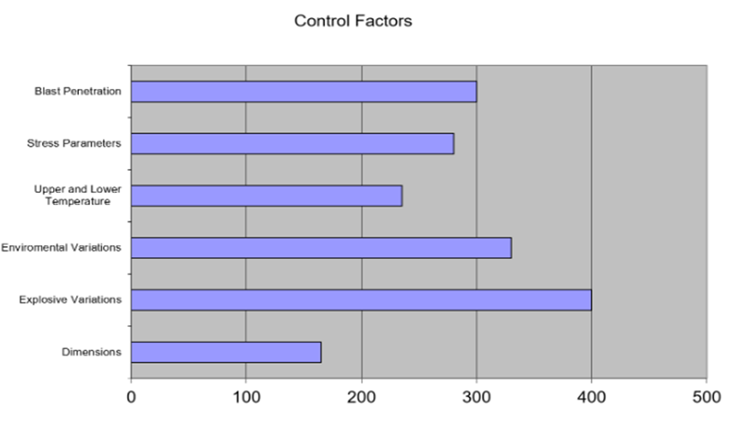
Control Factors
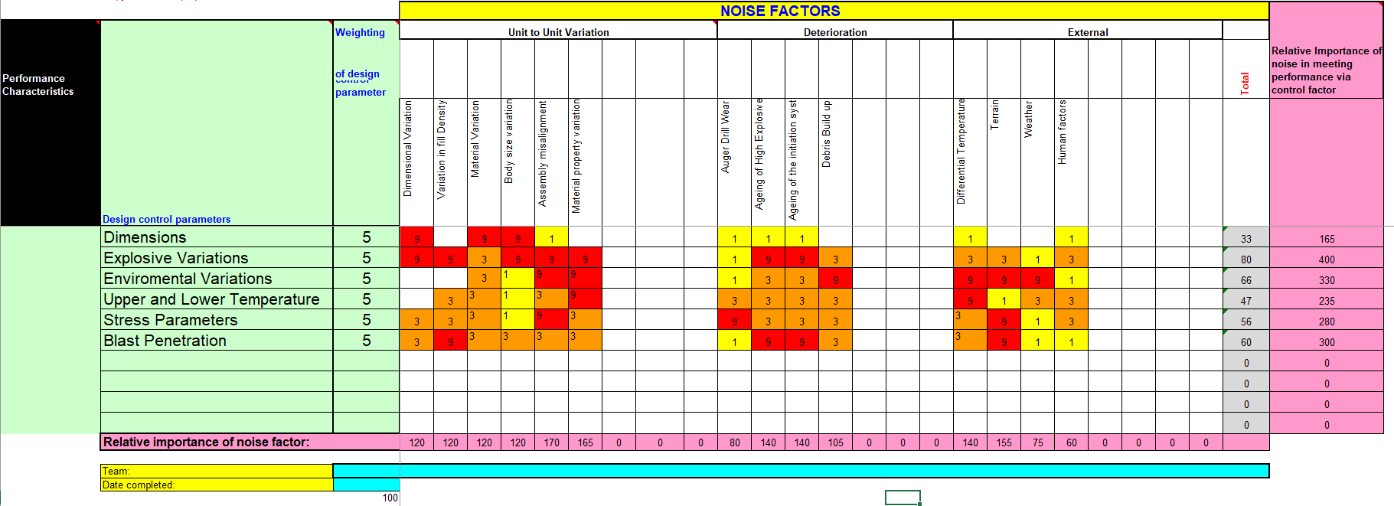
Prime “What Why”

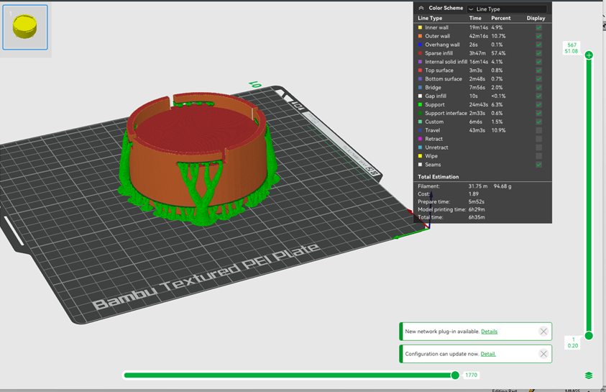
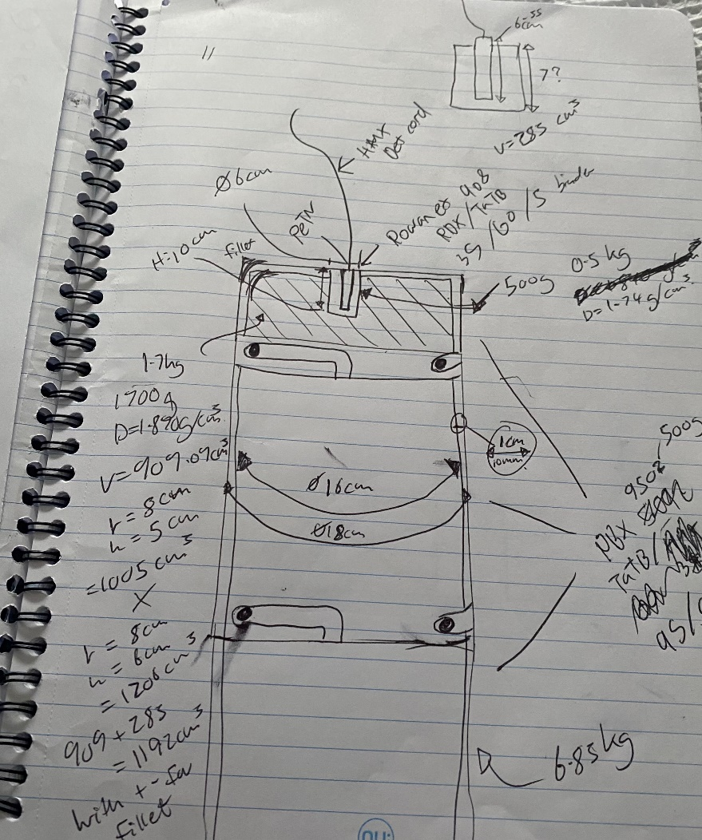

In North America, Scandinavia and elsewhere, ditch blasting, that is, the use of explosives instead of mechanical tools, is a well-known construction method of draining ditches in level, waterlogged terrain.

