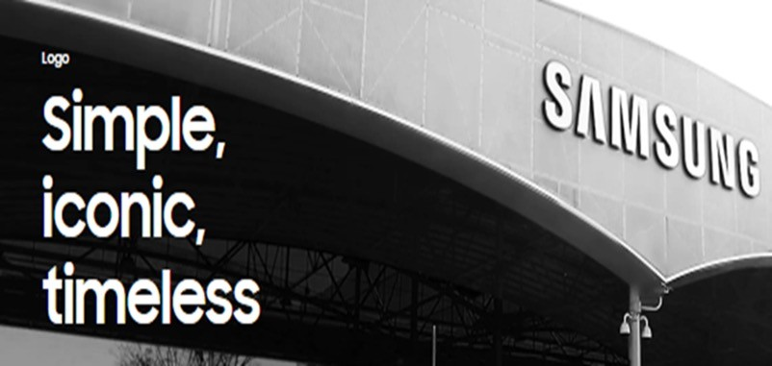STUDENT NAME ROXANA ZAMFIRA JOLANTA ZENELAJ NICOLETA BUZATU
NIKOLAOS LIAKOPOULOS
STUDENT NR 2027886
2029743
2029862
2029796
TOPIC
BACKGROUND OF THE ORGANIZATION
THE CHALLENGES BEFORE INTRODUCTION OF MODERN TECHNOLOGY
INSIGHTS TO THE MODERN TECHNOLOGY INTRODUCED
THE IMPACT OF TECHNOLOGY INTRODUCTION

Introduction
BY Roxana Zamfira

Technology has many diversified impacts. In business organization it helps to ensure efficiency and and improve ability of employees in the workplace. Technology makes functions and operations of the business much easier, flexible and productive.


the impact of technology will be presented in terms of different perspectives such as-
- challenges without technology,
- insights of technology and
- impact of technology

These elements will be presented from an organizational perspective- Samsung which is the 8th most valued brand and conglomerate business organization

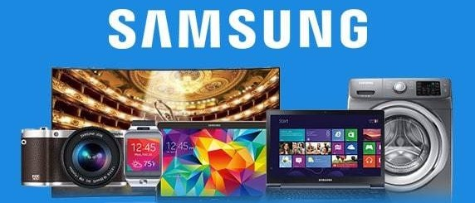
Background of the

organization

Products and services

- Samsung is a South Korea based multinational business established in 1938 and its head office is situated in Seoul, South Korea.
Products:
- Consumer | Services:
electronics, | - Advertising,
- Electronic | - Entertainment,
equipment, | - ICT,
- Telecommunication | - Health care,
- Accessories, | - Retail,
- Automotive | - Construction,
chemical,

- Its business operation is expanded worldwide with different brands and thus it falls under the category of conglomerate or multi-industry.
- Samsung group is the collaboration of 80 companies providing different types of products and services in different industry in the name of Samsung.

- Semiconductors,
- Shipping,
- Clothing,

etc.


Background of the organization

Mission and vision of Samsung
⇒to make progress in innovative excellence, artificial intelligence
⇒to find out new opportunities,
⇒promote growth of the company and
in these milestones to add value in people’s lives with advanced technologies in products and services.

Background of the organization

Research and development


  - developing business through 10000 researchers for research and development in mobile communication, consumer electronics and to find what future will make lives easier, flexible and more effective.
  - It has 14 R&D centers and 7 Artificial Intelligence centers worldwide.
  - ensures high value for its stakeholders through continuously better performance, superior products and services, protecting employee rights and investor relationships.


Background of the organization

Major achievements

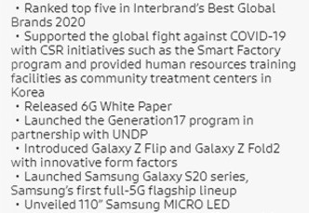
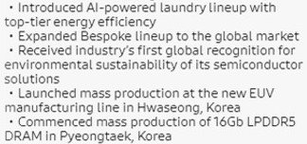
Major achievement of Samsung in 2020 (Samsung us. 2021)

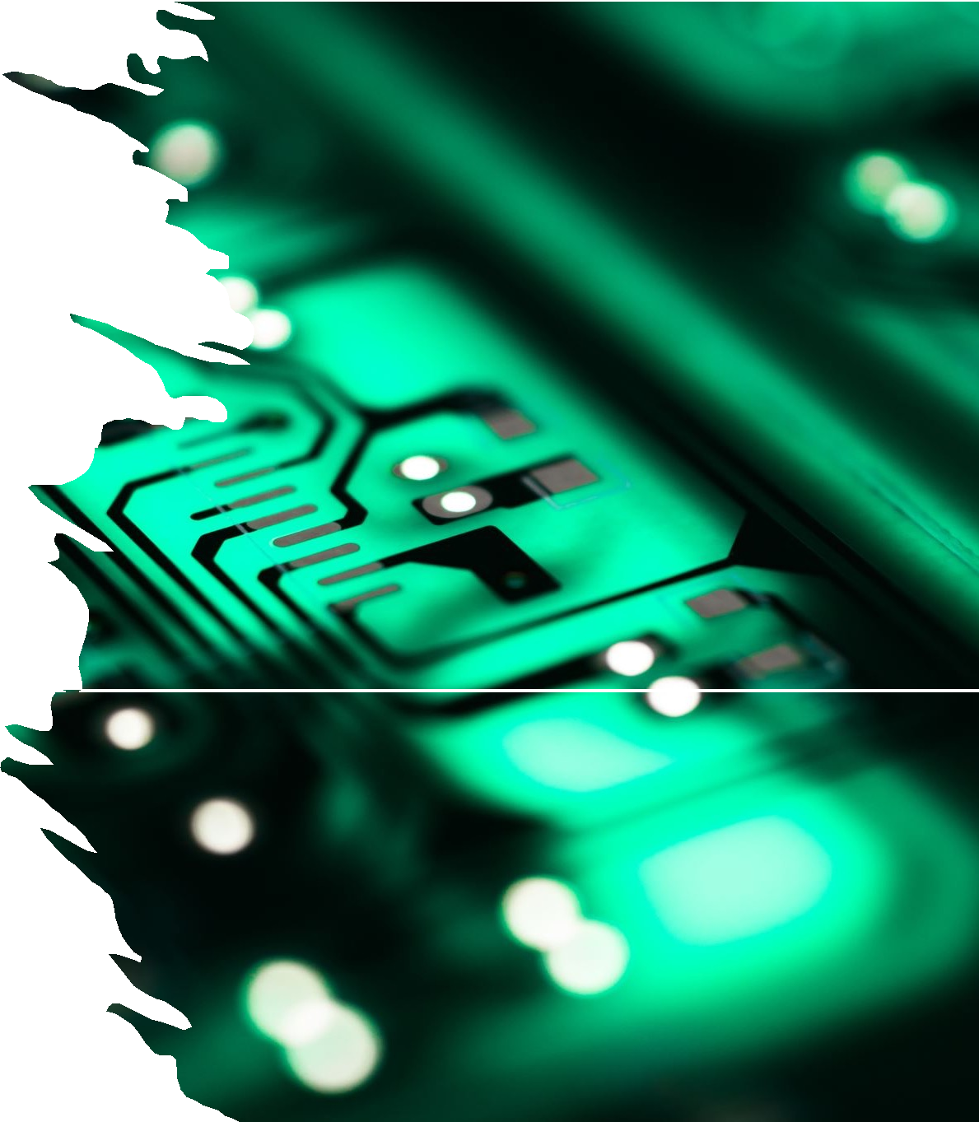The challenges before introduction of modern technology

BY JOLANTA ZENELAJ


Over the last 10 years Samsung has become leading electronic firm in the global market

It has been a difficult journey for Samsung to become the top branded and successful company


But before introduction to modern technology Samsung faced challenges

Back in the day the major challenge for Samsung was competitors in electronic industry. Also company lack of innovation and needed experts in design.
Samsung needed system development to grow the business.

Advertisement method was not in place as there were no social media to promote the business.
Another challenge they faced was to bring the customers and save time

To increase profits , improve productivity and improve communication was a challenge for Samsung.
They didn’t have online website where customers can purchase their products from the comfort of their home.

Samsung had no direct link to customers so had to rely on sales people in shops,traditional adverts on tv and in mainstream media. Before the introduction of social media it was more difficult to get endorcements from celebrities and business leaders in paid partnerships

Insights to the modern technology introduced

BY NICOLETA BUZATU

Amolded Displays
- Samsung introduced in 2010 the first smartphone with a Super Amolded Display. This opened the way for
Amolded tehnology to become the standard in the industry. Amolded also opened the era of large screen smartphones.The Galaxy S10’s Dynamic Amolded display introduced the next level of color accuracy
and the blue light reduction .

The S Pen
- In 2011 Samsung introduced intuitive tools . The S Pen is the signature style for the Galaxy Note (2011).Starting with the Galaxy Note 3 Pen the tehnology was
created to offer the users a real writing experience.

Samsung Knox
- Samsung Knox was first featured on the Galacy Note3 .
This security platform offers users simple and secure
environment for sensitive data.Samsung Knox made it easy for users to safeguard apps and more from
malware and viruses.

Biometric Authentication
- On the Galaxy S5 in 2014 it was the first time featured the Biometric Authentication . In the last 10 year Samsung improved and kept lineup with the latest
advancements in biometric tehnologies.

Wireless Charging
- It was first festured on the Samsung S6 in 2015. After introducing the wireless charging Samsung took the tehnology to a whole new level with adding Wireless Power Share on the Galaxy S10. This gived users the power to share their device.s battery.

The impact of technology introduction

BY NIKOLAOS LIAKOPOULOS

The impact of technology introduction

  - Technology affects the way individuals communicate, learn, and think. It helps society and determines how people interact with each other on a daily basis.
Technology plays an important role in society today. It has positive and negative effects on the world and it impacts daily lives

  - Recent years have yielded significant advances in computing and communication technologies, with profound impacts on society. Technology is transforming the way we work, play, and interact with others. People are connected as never before; with the Internet now accessible through mobile devices, tools such as e-mail and video chat have become commonplace, and numerous social media platforms enable us to share and curate pieces of our identity with others. When we begin to type messages, computers can often complete our words. We no longer need to remember phone numbers, appointments, names, or directions.

From these technological capabilities, vast new industries and business models are emerging. Personal health devices, computers that respond to our voices, ride-sharing services, and robot-controlled warehouses are becoming commonplace. Online shopping services allow us to find what we want, comparison shop, and purchase instantly. With the flick of a finger, we can order takeout, call a cab, or open a news article tailored specifically to our interests. Some automobiles can even park themselves. These new capabilities offer convenience and novelty, making some things easier and changing how we interface with the world. Today’s changing technological capabilities prompt an examination of what it means to exist in this new, digital world. Some point to how technologies improve our quality of life. Others wonder if they change what it means to be human. What role should technology play?

  - Samsung Electronics has developed from a company that was insignificant on the world stage, and known for producing cheap, low quality products, to a world leader in electronics. It has recently become the number one seller of smart phones in the world, exceeding the sales of its primary competitor, Apple Inc. This report examines the strategic technology and innovation that is present at Samsung Electronics and considers the way that the organisation has positioned itself within the industry and the outcomes of this positioning. The discussion focuses on the smart phone and mobile device component of the organisation, as this has been a particularly important area of growth within the last decade.

Reference
- Samsung us. 2021. Mobile | TV | Home Electronics | Home Appliances | Samsung US. [online] Available at:
<https://www.samsung.com/us/> [Accessed 29 July 2021].
- Design.samsung.com. 2021. Inside Samsung Design. [online] Available at:
<https://design.samsung.com/global/contents/design-
career-2/> [Accessed 29 July 2021].
- Samsung us. 2021. Samsung Logo | Brand Identity | Samsung US. [online] Available at:
<https://www.samsung.com/us/about-us/brand- identity/logo/> [Accessed 29 July 2021].

